

Corneliu Ovidiu Dinica
Student number:1918442
Tutor: Dale Clarke
Module: Community Engagement (LCBB4002_BIRM)
Assignment part 2- Reflective Report

Contents
Introduction 3
Definition 4
Learning styles 4
Personal experience. 5
Conclusion 7
References 8

Introduction

If I had an hour to solve a problem, I’d spend 55 minutes thinking about the problem and 5 minutes thinking about solutions.
-Albert Einstein-
(AZ quotes)
What do we do when we encounter a problem? Well, most of us will jump straight in the middle of it, doing the best we can to help but most of the times will have no result or make things worse then already are and the reason behind is that we do not have a solution and just acting based on our instincts. However, what if we could find a way to stop before acting and understand the problem, find the ‘’what, why, and how’’ and then come up with a resolve that can really make a difference? Though, it sounds too good to be true, fortunately we have plenty of tools that can help us achieve the best result possible and spend less time but be more productive and successful in day to day activities and with a great impact on your personal and professional plan. All of that can be accomplished through reflective practice.
The aim of this report is to highlight the importance of reflective practice, based on personal experiences and the challenges encountered as a student or within the work place and the tools used to overcome and succeed in most of the cases and when failed, to know why and what can be done different next time.

Definition
Reflective practice is defined as the ability to reflect on one's actions so as to engage in a process of continuous learning, Schön, Donald A. (1983). Moreover, it involves a huge amount of focus on the practical values and theories which typify day to day actions and eventually leading to personal development. However, the experience alone is not enough in the process of learning, which is why reflection on experience is mandatory. Loughran, J. John (January 2002). It is a term that rapidly grown between activities as teaching, medicine and our social environment, considered a mean which can be used as a learning tool and can be used by everybody.
Even though the terms of reflective practice and reflection is defined in literature, there is no wright or wrong way of doing it. It is entirely on the individual choice on what approach should take.

Learning styles
In 1984 David Kolb released his first theory of learning styles and believed that everyone is different when approaching a learning style and that the ability is developed based on personal life experiences, genetics, and environment. Kolb also developed a learning model, which is a more of a hands-on approach and encourages learning by doing and contains four stages.
- Concrete experience
- Reflective observation
- Abstract conceptualisation
- Active experimentation
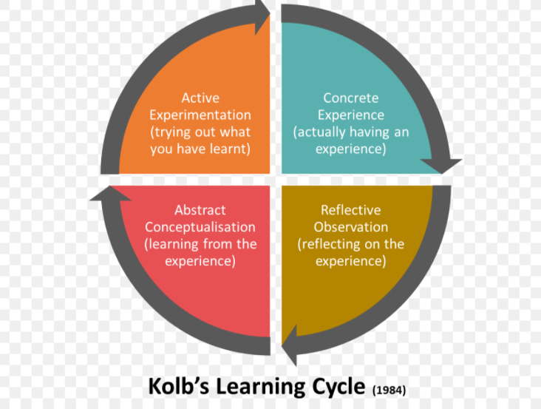
This model suggests that we start with something that we have been through in the past or could be something new, then we start by observe what happened and make note of anything that we may have missed or that is new to us. We then, proceed by learning from that experience and learn about everything that went wrong and why, what can we do different this time and the last stage is to act on it by bringing in all the new ideas to the new circumstances, therefore we learn based on own experiences and reflection.
As we can see above, this model is very simple, but it can be very productive when used at its full potential and all the steps followed in the correct worder and it can only bring benefits to an individual, especially that is based on previous experiences. For example: if you ate something that did not satisfied you enough and some time after you find yourself in the same situation with the same food what would you do?

Personal experience.
In the next few hundreds of words, I will share a personal experience related to the organization discussed in assignment number 1, as well as a detailed opinion on what I have personally, learned throughout this module.
Though I have thought thorough to what I will write and how will I structure this, and said myself that is going be so easy I find myself, in this moment with no inspiration and imagination, guess I have always lacked these two when it comes on writing about myself, which means I have been in the same situation, many times, for example when writing a cover letter that can make a big difference in obtaining a good job or holding an interview, and I am as nervous as I would be in front of dozens of people and not alone in my room. I guess I just want to make it wright and end up by putting too much pressure on myself. But that’s me, always reflecting to much on things that I shouldn’t. Enough with moaning, let’s get to work.
I have start chasing a position as operations Supervisor at ALDI in 2018, when already working as a team leader for another big company. The reason behind me being interested working for ALDI was simple: ALDI is a very different company, that has an original approach of their way of doing business and I have instantly fell for it. Any position hold within the company is very demanding and can break you or you can choose to break them and be the guy that made things ALDI way, but in a different way. I was so convinced that I can pass the interview and be successful for the position of supervisor and start applying.
However, at the time ALDI did not have anything that could work for me and not including a move in another city, therefore I kept checking for new jobs posting every week. It took me approximately two years to have the opportunity to arise and when it did, I have applied straight away. I was so excited when three days later received a positive answer, that the company is very impressed with all my actual and previous experience and decided to go forward with my application and sent me an invite to an online interview with myself. All the instructions followed shortly, and it was all a recording interview, I mean you look at the camera and read the question, followed by 90 seconds on thinking about your answer, then start talking.
Easy enough, you would think. Prior to the interview I have made a thorough research of the company background, actual position and future plans, and practiced for hours, at the end of the day, it is just a record, no pressure, I am prepared, how hard can it be? Well, I can say it was the most difficult interview I have been faced with, I was so nervous and couldn’t find my words anymore and looked like a guy that never had an interview, ever or any professional experience. It only took me 12 minutes to complete the recording, that has been automatically sent to the hiring manager. And I knew, I knew that I messed up bad and there is no chance I can pass to a face to face interview to make it wright, because that is my strength, I am very good and can turn things my way when the interview is conducted in person.
It only took them two days to send me an email stating that I did not met the criteria and at this stage a face to face interview cannot take place. I cannot say I was surprised, I was very disappointed though, I was disappointed that I’ve failed, I was angry on myself and angry with them, asking myself why they do that and why they chose to recruit this way and not choose to meat the people instead and see exactly what they have to say, but I guess that is the way these days. Why bother and wasting time? It is what it is, and you must keep up and get better every day. Therefore, I have spent days and days wondering what I could have done better and how, but not a moment thinking what I would do if I would find myself in a similar situation again. Well, back then I wasn’t studying this module, Community Engagement. Things have start changing when now, after the near completion of this module I’ve learnt that prior to it, I knew nothing, that bad it was. I realised that due to my way on approaching things in general and how I choose to deal with problems and challenges in day to day life, it was all wrong.
The things I’ve took from this experience is that reflection is very important and that past is very important, it is a must to look in the past so you can control the outcome of future challenges develop and reinvent yourself every single day.
I did not know that there are so many ways and tools at my disposal that can help me achieve better and better results just by doing simple things using simple tools that were at my finger tip all this time. I have learned that if I encounter a more complex problem, I can use a fishbone diagram to solve it, and that you can stop a problem by simply treating its symptoms. Also learning about the Gant chart which is an excel chart that is used in project management and is one of the most useful tools and way of showing activities against time of completion, For example:
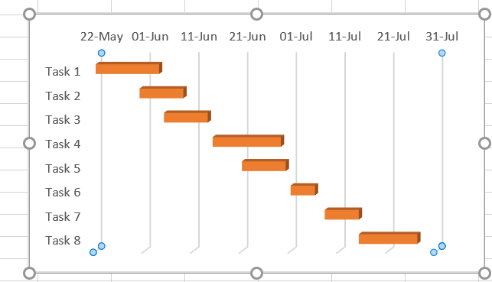

During the module we had plenty of activities, that kept us engaged and challenged to come up with the best of us, great group activities that usually led to arguing between us, but stopped in time by our lecturer and his attitude and experience proved me wrong every time, which was a great thing, because that way I have learned more and more and feel that I am at a whole different level.
I have enjoyed every single moment of this module, though I fell there are so much more things I could have achieved, but that is due to my time management and sometimes not taking thing seriously. However, I have recognised this as a major weakness, and I am constantly working towards a better solution by following my tutor advices and practice everything that I have been thought.

Conclusion
Based on the evidence gathered from the published literature and the personal experience that is mentioned above, it can be stated that in worder to be successful on both plans, personal and professional, a balance is needed, knowledge is a must and the ability to adapt fast to any situation and keep it under control is definitely something that is mandatory. However, it is not easy, it takes years of experience, practice, and calm. We are humans and we need to keep pushing ourselves to the edge and never stop learning and keep using all means that we have at our disposal.
Everyone is capable of great things, even sometimes we do not see it this way, and that is one of the problems, because we don’t see it this way and we spend so much time and energy practicing destructive reflection instead of putting all that energy in something that could make a difference. Furthermore, to achieve great results is needed to think great even at small scale, because some small scale can make such a big difference.

References
Stice, J.E., 1987. Using Kolb's Learning Cycle to Improve Student Learning. Engineering education, 77(5), pp.291-96.
Schön, D.A. (1983). The reflective practitioner : How professionals think in action. New York: Basic Books.
Muscat, M. and Mollicone, P., 2012. Using Kolb's learning cycle to enhance the teaching and learning of mechanics of materials. International Journal of Mechanical Engineering Education, 40(1), pp.66-78.
Fook, J., 2015. Reflective practice and critical reflection. Handbook for practice learning in social work and social care: Knowledge and theory, 3.

