STUDENT NAME: LEKAN AHMED NURENI
STUDENT NUMBER: 1815860
LECTURER: Dr. GULNAR ALI
MODULE NAME: EFFECTIVE TEAMWORK AND COMMUNICATION
MODULE CODE: BSMW4002

The way we conduct our administrative duties is inseparably connected to our communication, this determines our relationship with others. Thus, the ability to understand the elements of effective communication will largely determine our success in life
The framework of this report is communication within a workplace; communication is a major tool for the survival of humans which makes it the bottom-line of human existence.
The society according to the proponents of the perspective represented by George Hebert Mead emerges out of the interactions of its members and continues to exist because human beings possess the ability to take to one another’s role and self – consciously direct their conduct based on the interpretations.
What is Communication?
Communication can be described as a process where individuals exchange information and in general deal with each other.
Various institutions are chained in functions to build what is referred to as society, but the lifeline of that chain is communication. In every society, communication consciously and unconsciously performs its basic responsibilities and functions that make it indispensable.
Biologically, man undoubtedly evolved from communication through copulation between a matured healthy male and female which the sperm fertilizes egg that resulted in pregnancy. At various stages of the pregnancy, the foetus communicates life by kicking and turning.
So, communication has always been part of humanity as it is essential in man’s quest to build and maintain social order. Communication process can be defined as all acts of transmitting messages to channel which link people to the languages and symbolic codes which are used to transmit messages, a means by which messages are received and stored and the rules, customs, and conventions which define and regulate human relationship.
Communication does not commence only when we speak, it begins long before. for example before one moves closer to greet an old friend with whom contact one had lost for a while, there is high tendency one would first pause to observe him well and be certain that he is really the one and then one would think of what to say and how which lead us to one of the forms of communication ‘intrapersonal communication’.
The social importance of communication is extricable linked to the wellbeing of individuals on this note; the report will also highlight the major elements of communication.
Elements of Communication
Stimulus: is the process of generating an idea; It is the ideation stage when the idea springs up. The stimulus for communication may be received internally through mental impulse or external occurrence in one’s environment. When the beat of a song you love comes up or probably when you see something frightening triggers a reaction which is as a result of communication taking place
Source: After a stimulus reaction recipient, who is now the sender responds to what was received; translate what is received into codes or language for the receiver to understand him. For his intended message to disseminated, the meaning of his communication must be present in the receiver and not in words. It is what the receiver perceives that is the message
Context: This is the circumstances surrounding a message, it could be political, social, economic and emotional set for generating and consuming communication messages the element of context is easily noticeable through the interpretation it foists by the receiver.
Message is the translation of communication behaviour into appropriate verbal and non-verbal codes.
Channel: is the means employed where communication is exchanged by the sender and the receiver. It implies both the source and the receiver must have access to the channel for communication to take place as gives room for feedbacks
Receiver: is the person for whom the message intended, the receiver may be an individual or group of people, but the important part is for communication flow and interactive the receiver must not be passive as his role is crucial because the receiver gives the whole communicate the ultimate meaning to the message
Feedback: coined by Nobert wiener in 1948 which simply means how information from the system is returned to a system is feedback into it and how the system adjusts to it. It is simply a response to a previous communication fed back to the source but if the source is unaware of the reply, he cannot reply.
Due to the complex nature of Communication, only major forms of communication will be discussed for this report as each differs in several participants, feedback, noise and the relative freedom that goes with their use.
Intrapersonal Communication is with and within the biological self. It involves only one participant who consciously or unconsciously is both the source and the receiver. It frequently manifests outward behavioural correlates which makes it difficult for an average person to hide their true feelings.
Bitner (1991) describes it as the basis of all other forms of communication. Before we make contributions in meetings, at conferences. Seminars or write proposals we usually think to gather and clarify our thoughts.
Interpersonal Communication is the process that involves sending and receiving information within a small group, usually in a face to face situation where feedback is immediate and when it is not face to face situations the tone of a letter written to another person or telephone conversation between two individuals can be interpersonal. This form of communication highly adopted by all human as it tends to take place everywhere daily with friends, colleagues, and encounter with business associates which places a strong emphasis on the listening behaviour of participants. Poor listening can render interpersonal communication ineffective.
Non-Verbal communication portrays the communication without words, a silent language, within language covering body language, gestures, how we dress or act, where we stand. There are many subtle ways that we communicate (perhaps even unintentionally) with others. For example, the tone of voice can give clues to mood or emotional state, whilst hand signals or gestures can add to a spoken message.
Verbal communication which includes face-to-face, telephone, radio or television, and other media
Written communication includes letters, e-mails, social media, books, magazines, the Internet and other media
Human Communication is a major tool for the survival of humans, it facilitates the exchange of meaning among human beings in different human races. Another way to examine human communication is to examine the role of communication in human affairs in this case how it is made effective in a business Organization (Management)
What is Management?
There would not be a management without communication as it is formed through communication. Management is individuals or groups communicating that share similar understandings to achieve a certain, it thrives on communication to achieve its daily activities (administrating). Communication is the source of our productivity at work, the effectiveness of our communication largely determines our leadership opportunities, our knowledge and understanding and our ability to persuade others.
An employment counsellor at the workers' service reported that sixty percent of all jobs listed require specific communication competency. Worker satisfaction also directly correlates with the atmosphere in the workplace. Communication skills translate into worker productivity. (Randal S. Chase, ‎Wayne Shamo – 2012)
Managerial communication is present in all aspects of the work, having the role of ensuring the operationalization of management functions, increasing the individual and collective performance, establishing correct and effective relations between the members of the organization, both vertically and horizontally.
Any small or large business around us we will see that the level of success that the business has attained largely depends on its capacity of communication. Communication defines the amount of success that the business house has archived. So here are some of the major objectives of business communication
The main objective of a business is to pass on information and making people more informed, E.g.- all the advertisement activity that we see around as are an attempt to inform and pass the information on to others, and in case of business houses this information is mostly about the product or services that they have to offer. But the mode of communication may be verbal, written, visual or any other.
Businesses flourish on information relevant to their business activity. They must have good knowledge about the market, their competition, the government rules, the kind of credit that they can benefit from; the current economic position, etc. Relevant information is the key to a successful business.
David Berlo, in his SMCR (Source, Message, Channel, Receiver) model (1960), stresses the importance of communication skills, attitudes and knowledge brought in communication encounter by the source and the receiver.
My line Manager (Source) is Italian and his accent can be noise at times when trying to pass instructions (Message) to me (receiver) on Radio (Channel) as a forklift driver so after reaching me on the radio he also sends a Text message or WhatsApp message (Message). He understood the fact that we both struggle to communicate on Radio despite it being the channel of communication for the job but chose to make use of Text message to avoid obstructions or Noise. Well for us at work we have even developed some signs that serve as a form of communication apart from talking on the radio

NOISE
Noise in this content is not just the physical noise such as the sound of forklift engine, trucks or other machines, it is any form of distortion, distractive and obstruction that reduces the clarity of the message sent from a source to the receiver.
The process of communication requires the interrelations in some elements of communication, the noise signifies a breakdown in another element of the process, and it will affect the entire communication out which could be caused by as follow:
Psychological Noise: is caused by the inability to process the message psychologically, anger, hatred, fatigue, religion, culture, are some conditions responsible for psychological noise.
Environmental Noise is the distraction like sounds of engines or machines, television, conversation from other colleagues, a clattering typewriter that hinders communication.
Channel Noise can be weak telephone signals, hitch signals transmitted from television or radio, blurred pictures, they emanate from the travel path of the communication message.
Linguistic Noise is the inability of the communicator to use communication language properly just likes my line manager who sends a text message because his English is not that good to avoid a phonological, semantic, grammatical or morphological error.
Noise can be managed, reduced or eliminated based on how effective the communication skills of the sender and receiver, especially the sender. For environmental noise, distracting sounds of radio or television can be reduced by either switching off or moving away. Telling the children to keep quiet while on the phone can reduce distractions.
Channel Noise caused by a poor network can be corrected by moving to a place with better signal or times text message or even raising one's voice and repeating the message over and over until the receiver says oh, i got it or repeats your statement means your message has gotten through which is regarded as Feedback
Feedback, as stated earlier in this report as a response of the receiver to the source, is very important in communication; it is essentially communication in reverse (Hibert et al: 1988).
This brings us to Shanon and Weaver model which added feedback to the element of communication unlike SMCR model earlier stated in this report.
I stated earlier in this report how my Manager who happens to be an Italian messages me when he can’t properly convey an instruction on radio and at times due to bad reception as well, when he sends me the message i reply (feedback) to let him know i understand what the instructions say because there was a day where he thought i got the message meanwhile i did not even check my phone and we had some mix-ups, this signifies the strength of feedbacks in communication.
Conclusion
Trust and loyalty are key factors in any relationship, and both can only be achieved by communication, which is focused on meeting individual needs, conveying important information and providing feedback – positive and constructive and importantly being a good listener who can relate and express a clear and concise message.
Communication is inevitable in running a successful business, though business depends on so many things but a good business plan still won't deliver the company's set goal without effective communication, how do you get the plans together without communication and how are you supposed to share the plans with others, both your staffs and the public without it.

References
Elements of Effective Communication: 4th Edition 2012 Randal S. Chase, Wayne Sham Plain & Precious Publishing; 4 edition (February 22, 2013)

Berger, P. & Luckmann, T. (1966). The Social Construction of Reality: A Treatise in the Sociology of Knowledge. Garden City, New York: Anchor Books

Introduction to Communication Skills Published by Skills You Need Limited. March 2016

Certificate in Higher Education: Skills for the Workplace Student Yearbook: Andrew Maund, Michaela Schriek, Paul K. Tinkler

Schramm, Wilbur (1965) “How Communication Works” in Wilbur Schramm. The Process And Effects of Mass Communication, University of Illinois, Press, Urbana, USA.

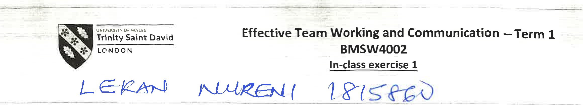
Ex.2. Read the following brief and write a business email according to the instructions.
You are Director of Communications at your company and you would like an employee, Jack Daniels, to join your Communications Training team.
- Tell JD why you are writing
- Say what you have observed and like about his communication skills
- Tell him why you think he would be an asset to the team
 |  | C•, ulc
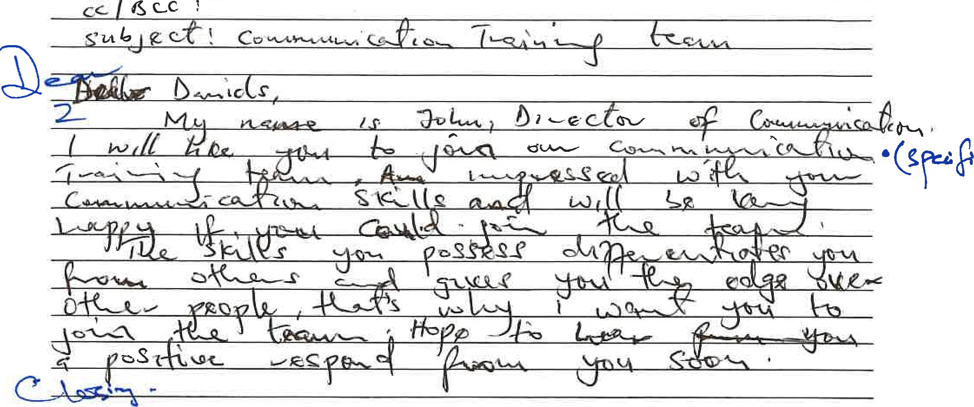


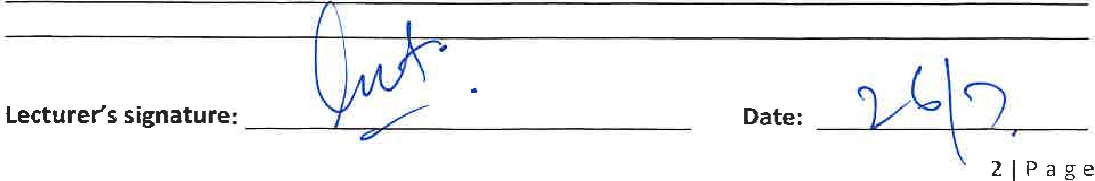
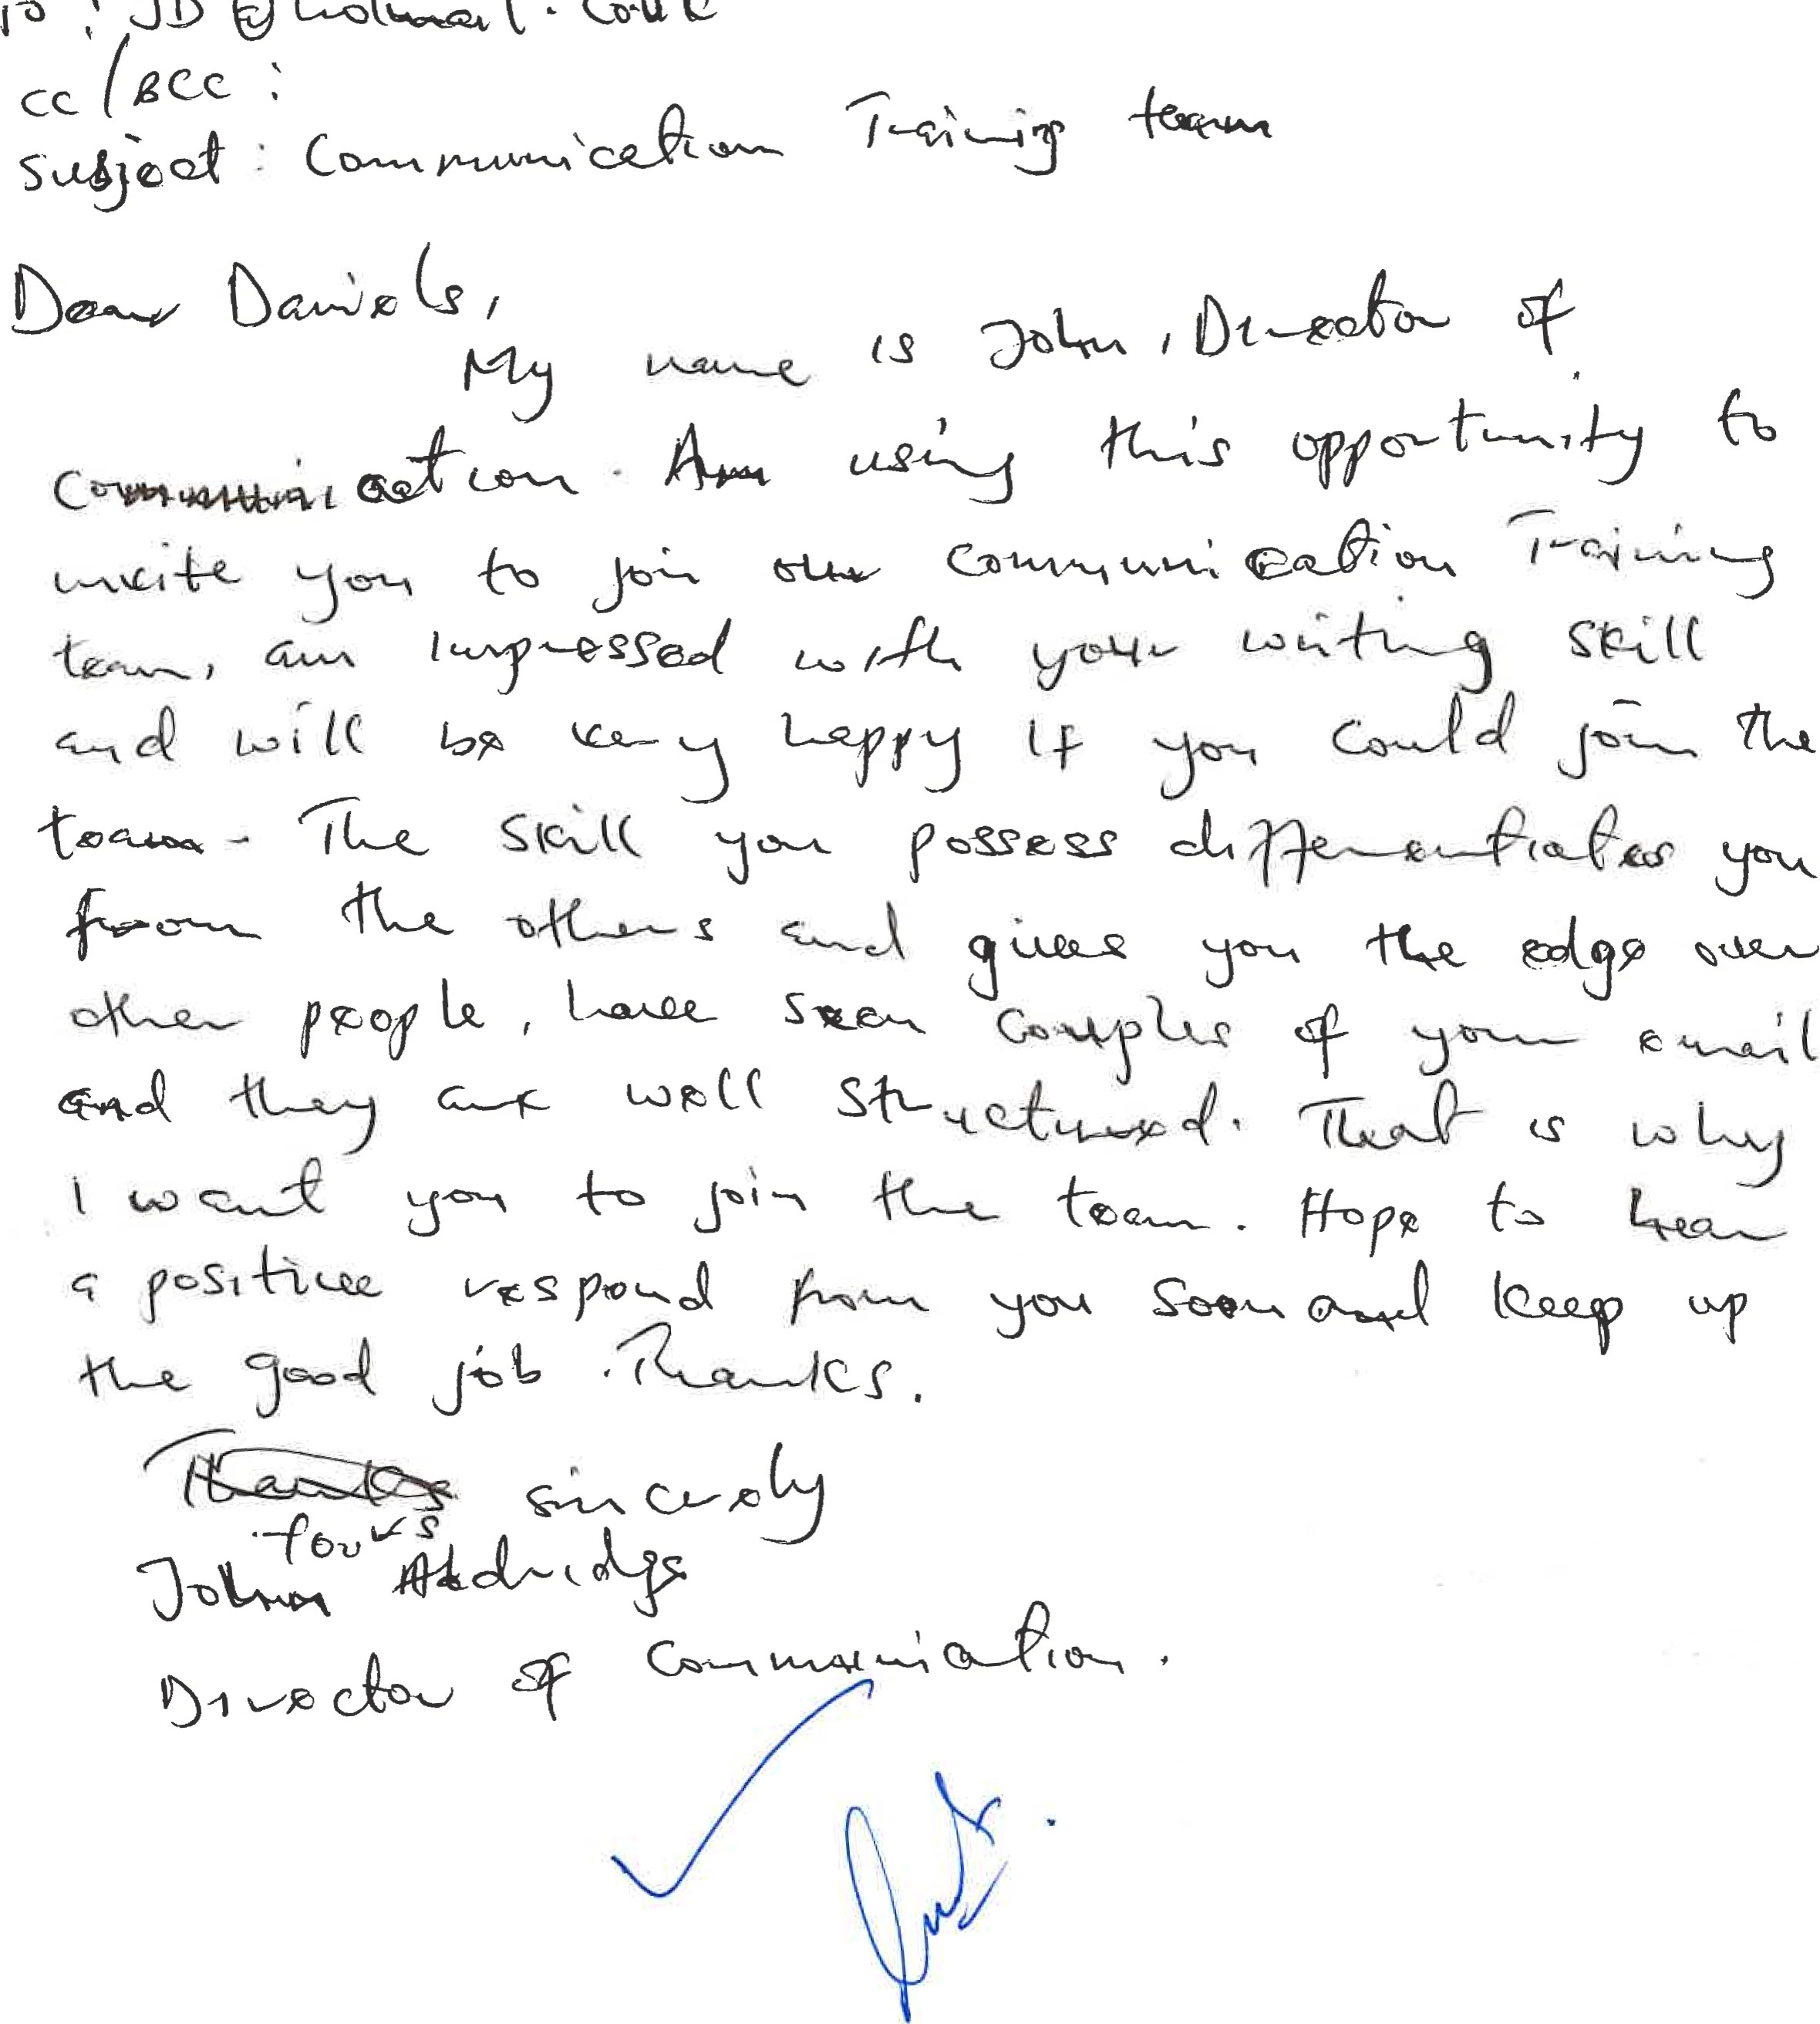し せ0
。
、
、
300
一
い

Effective Team Working and Communication -Term 1
BMSW4002
In-class exercise 2
Student Name: ENI L E-lsprN Student ID:
Time allocated: 1 hour.
Please return your paper to the lecturer upon completion. It will be returned to you at the next session. You will need to include a scanned copy of this exercise in the form of an appendix together with ypur Task 1 (part of the Assignment for this module).
Ex.l. Read the following passage and answer the questions on the next page.

Case Study: A Day With The Chief
Mark is a top-performing salesperson at a pharmaceutical supply company. As a reward for his performance, he is treated to a trip to the corporate office in California to meet the chief executive officer, Ms. Mills. Ms. Mills is known arpund the office as the "Wicked Witch ofthe West" because of her short and sometimes abrasive demeanour.
Mark's co-workers share ^{i}'horror Stories" of their encounters with her, stating that she rarely makes eye contact, never smiles, and dislikes being approached unless she initiates the conversation.
Although he is excited to travel, he is also nervous about what he and Ms. Mills might talk about. He prepares by thinking about how he can share his sales strategies and techniques. On the day of the meeting, he waits patiently for Ms. Mills' assistant to call him into her office. When he is escorted in to meet her, he is shocked to see a petite woman behind the large desk smiling back at him with kind eyes. He approaches, shakes her hand, and waits for her permission to sit.
Ms. Mills is nothing like the horrible person they made her out to be. Ms. Mills asks Mark several thoughtful questions about why he is successful, ways the staff can be supported, and how the company fits in with his professional goals. Mark feels more and more comfortable as she leans forward to listen intently to what he is saying.&ark looser his tie, crosses is I%S, and begins sharing stories of how he feels his immediate supervisor has dropped the ball on more than one occasion and that the team would be better if more money were allocated to incentives and bonuses. Mark immediately sees Ms. Mills' eyes begin to squint and her brow furrow. She stands up abruptly and says in a gruff voice that their time is up and that her assistant will show him out.
Lecturer's signature: Date:

Effective Team Working and Communication — Term 1
BMSW4002
In-class exercise 2
- 1. Given the•professional context, what would you håve done the same:and/or differently if you were in Mark's position?
2. Do you think Mark accurately evaluated the context? Why or why not?
- 3. Whatæmnunica.tinn..åÄQ.cs led to the change in the chief executive officer's disposition?
4. How could Mark improve his communication skills?
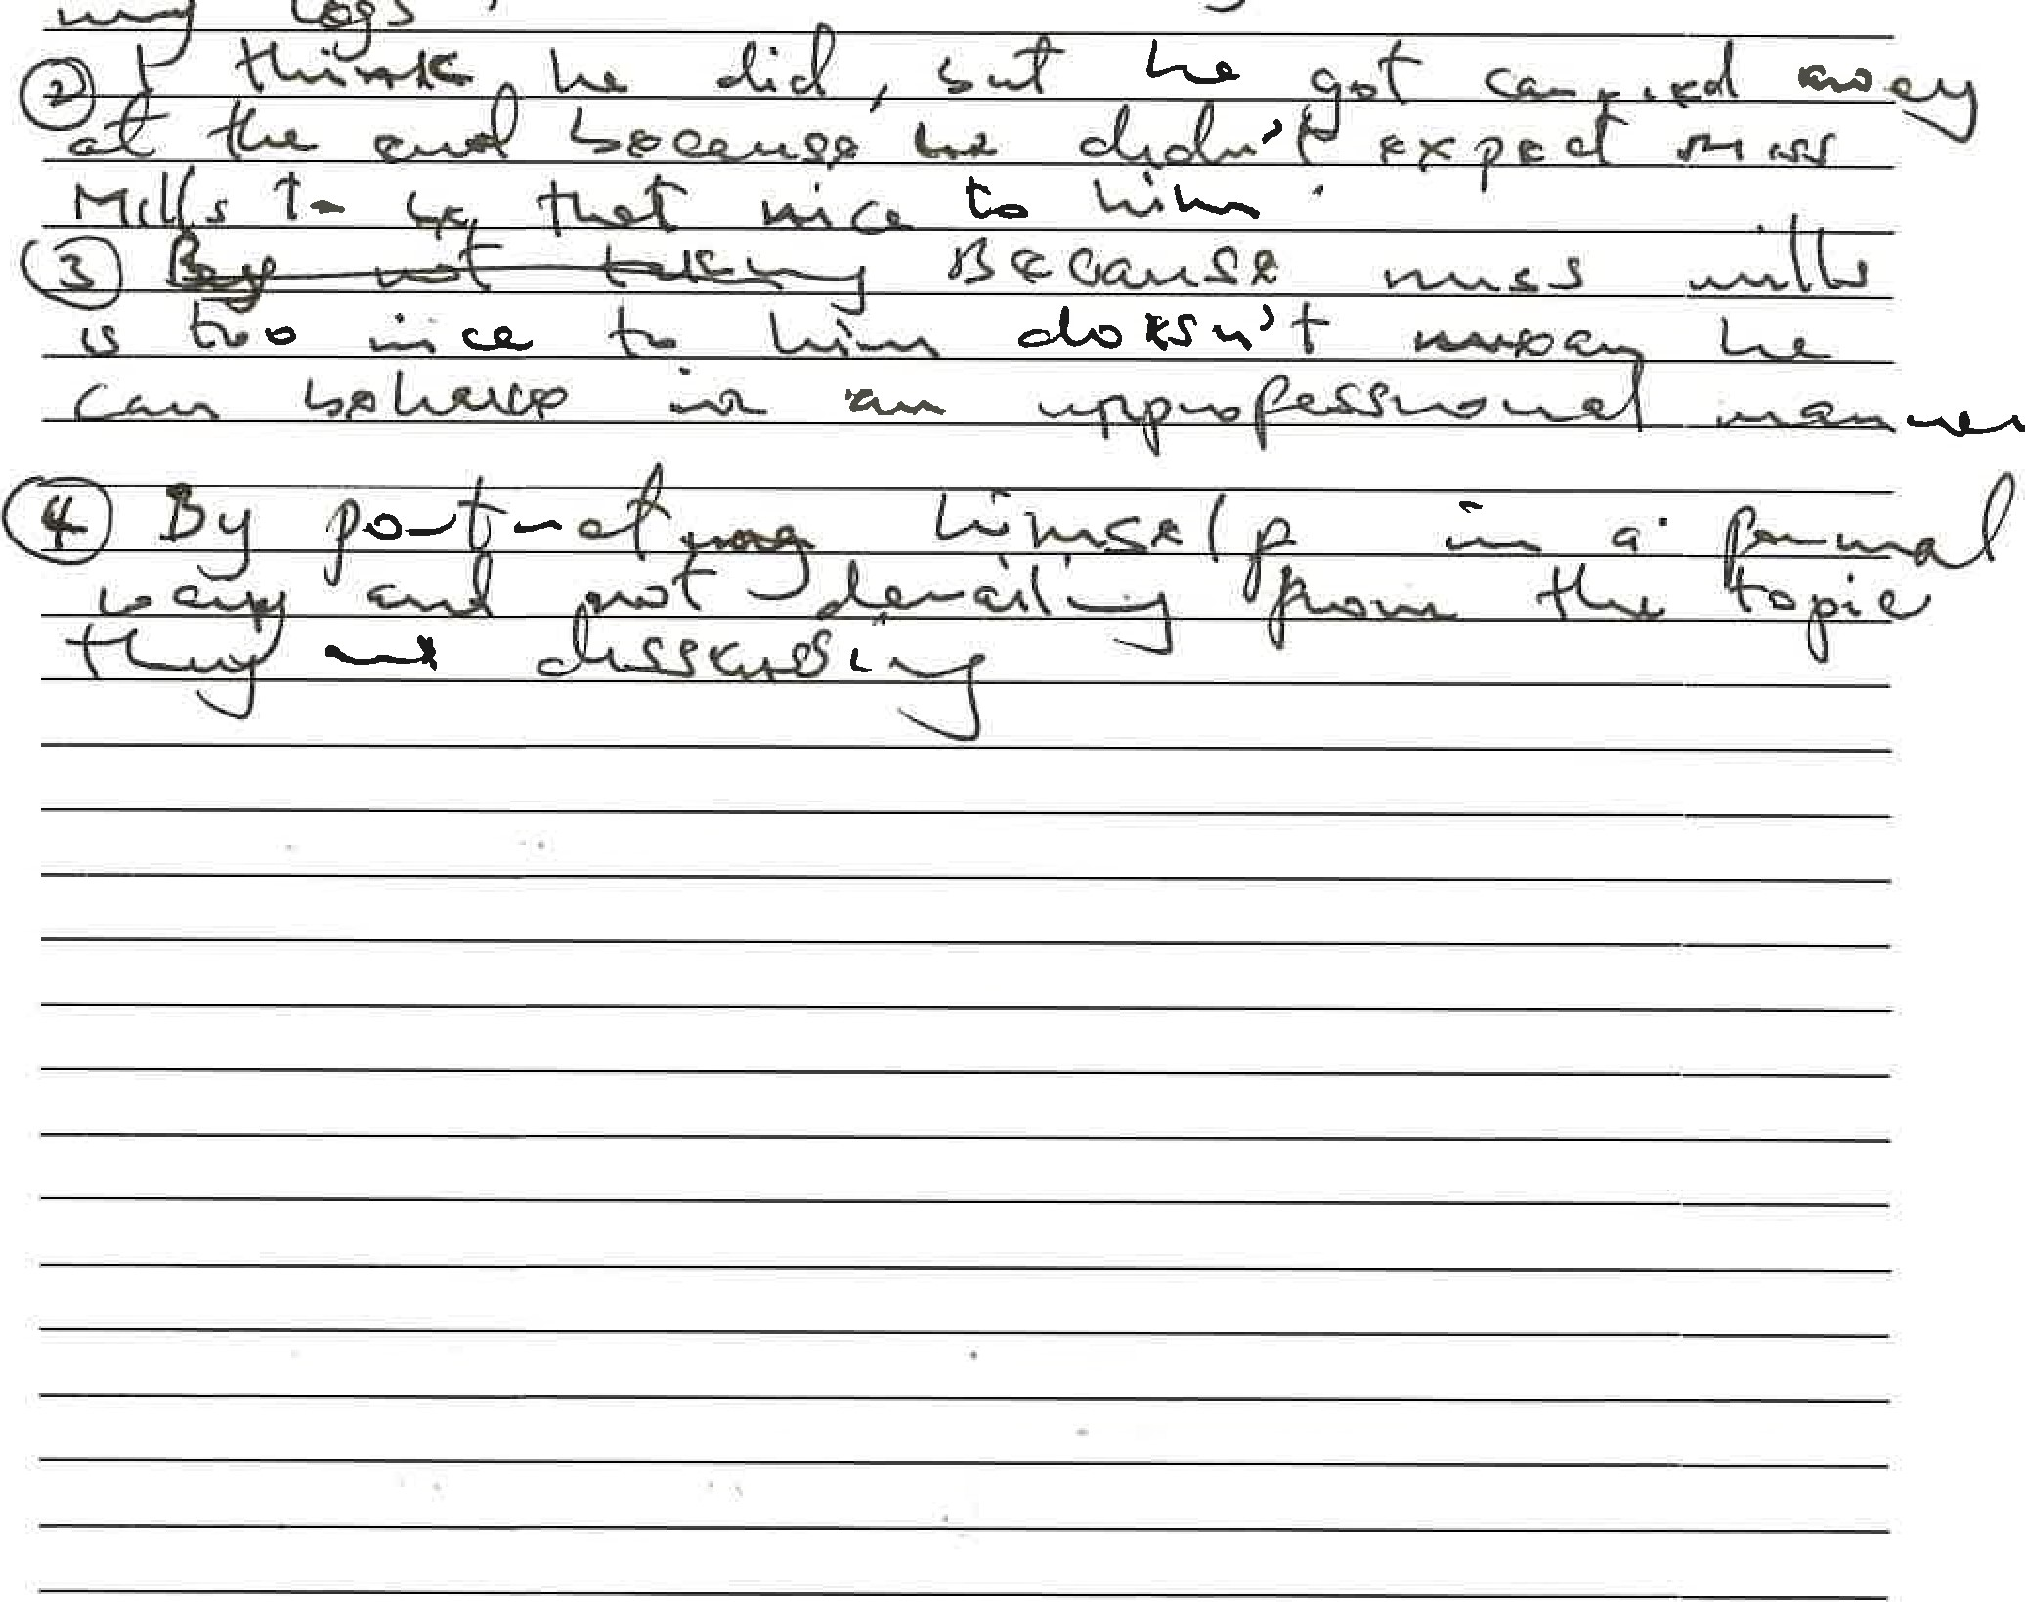
s
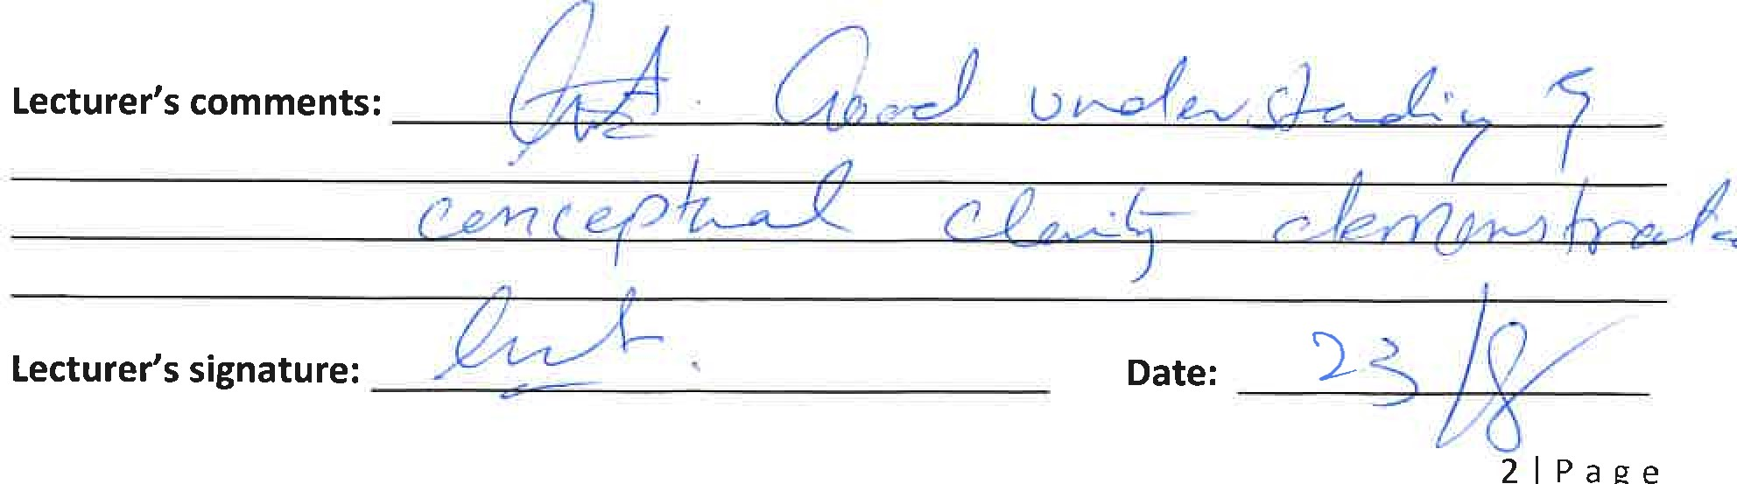
WRITING A BUSINESS E-MAIL
You are Professor of English at a University and you receive this email from a student.
Cc:
SUBJECT:
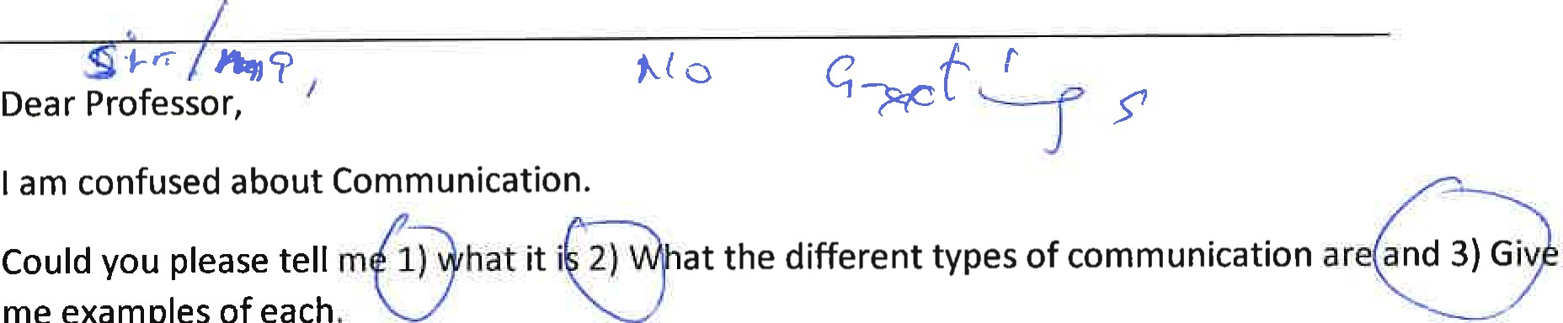
me
examples
of
each
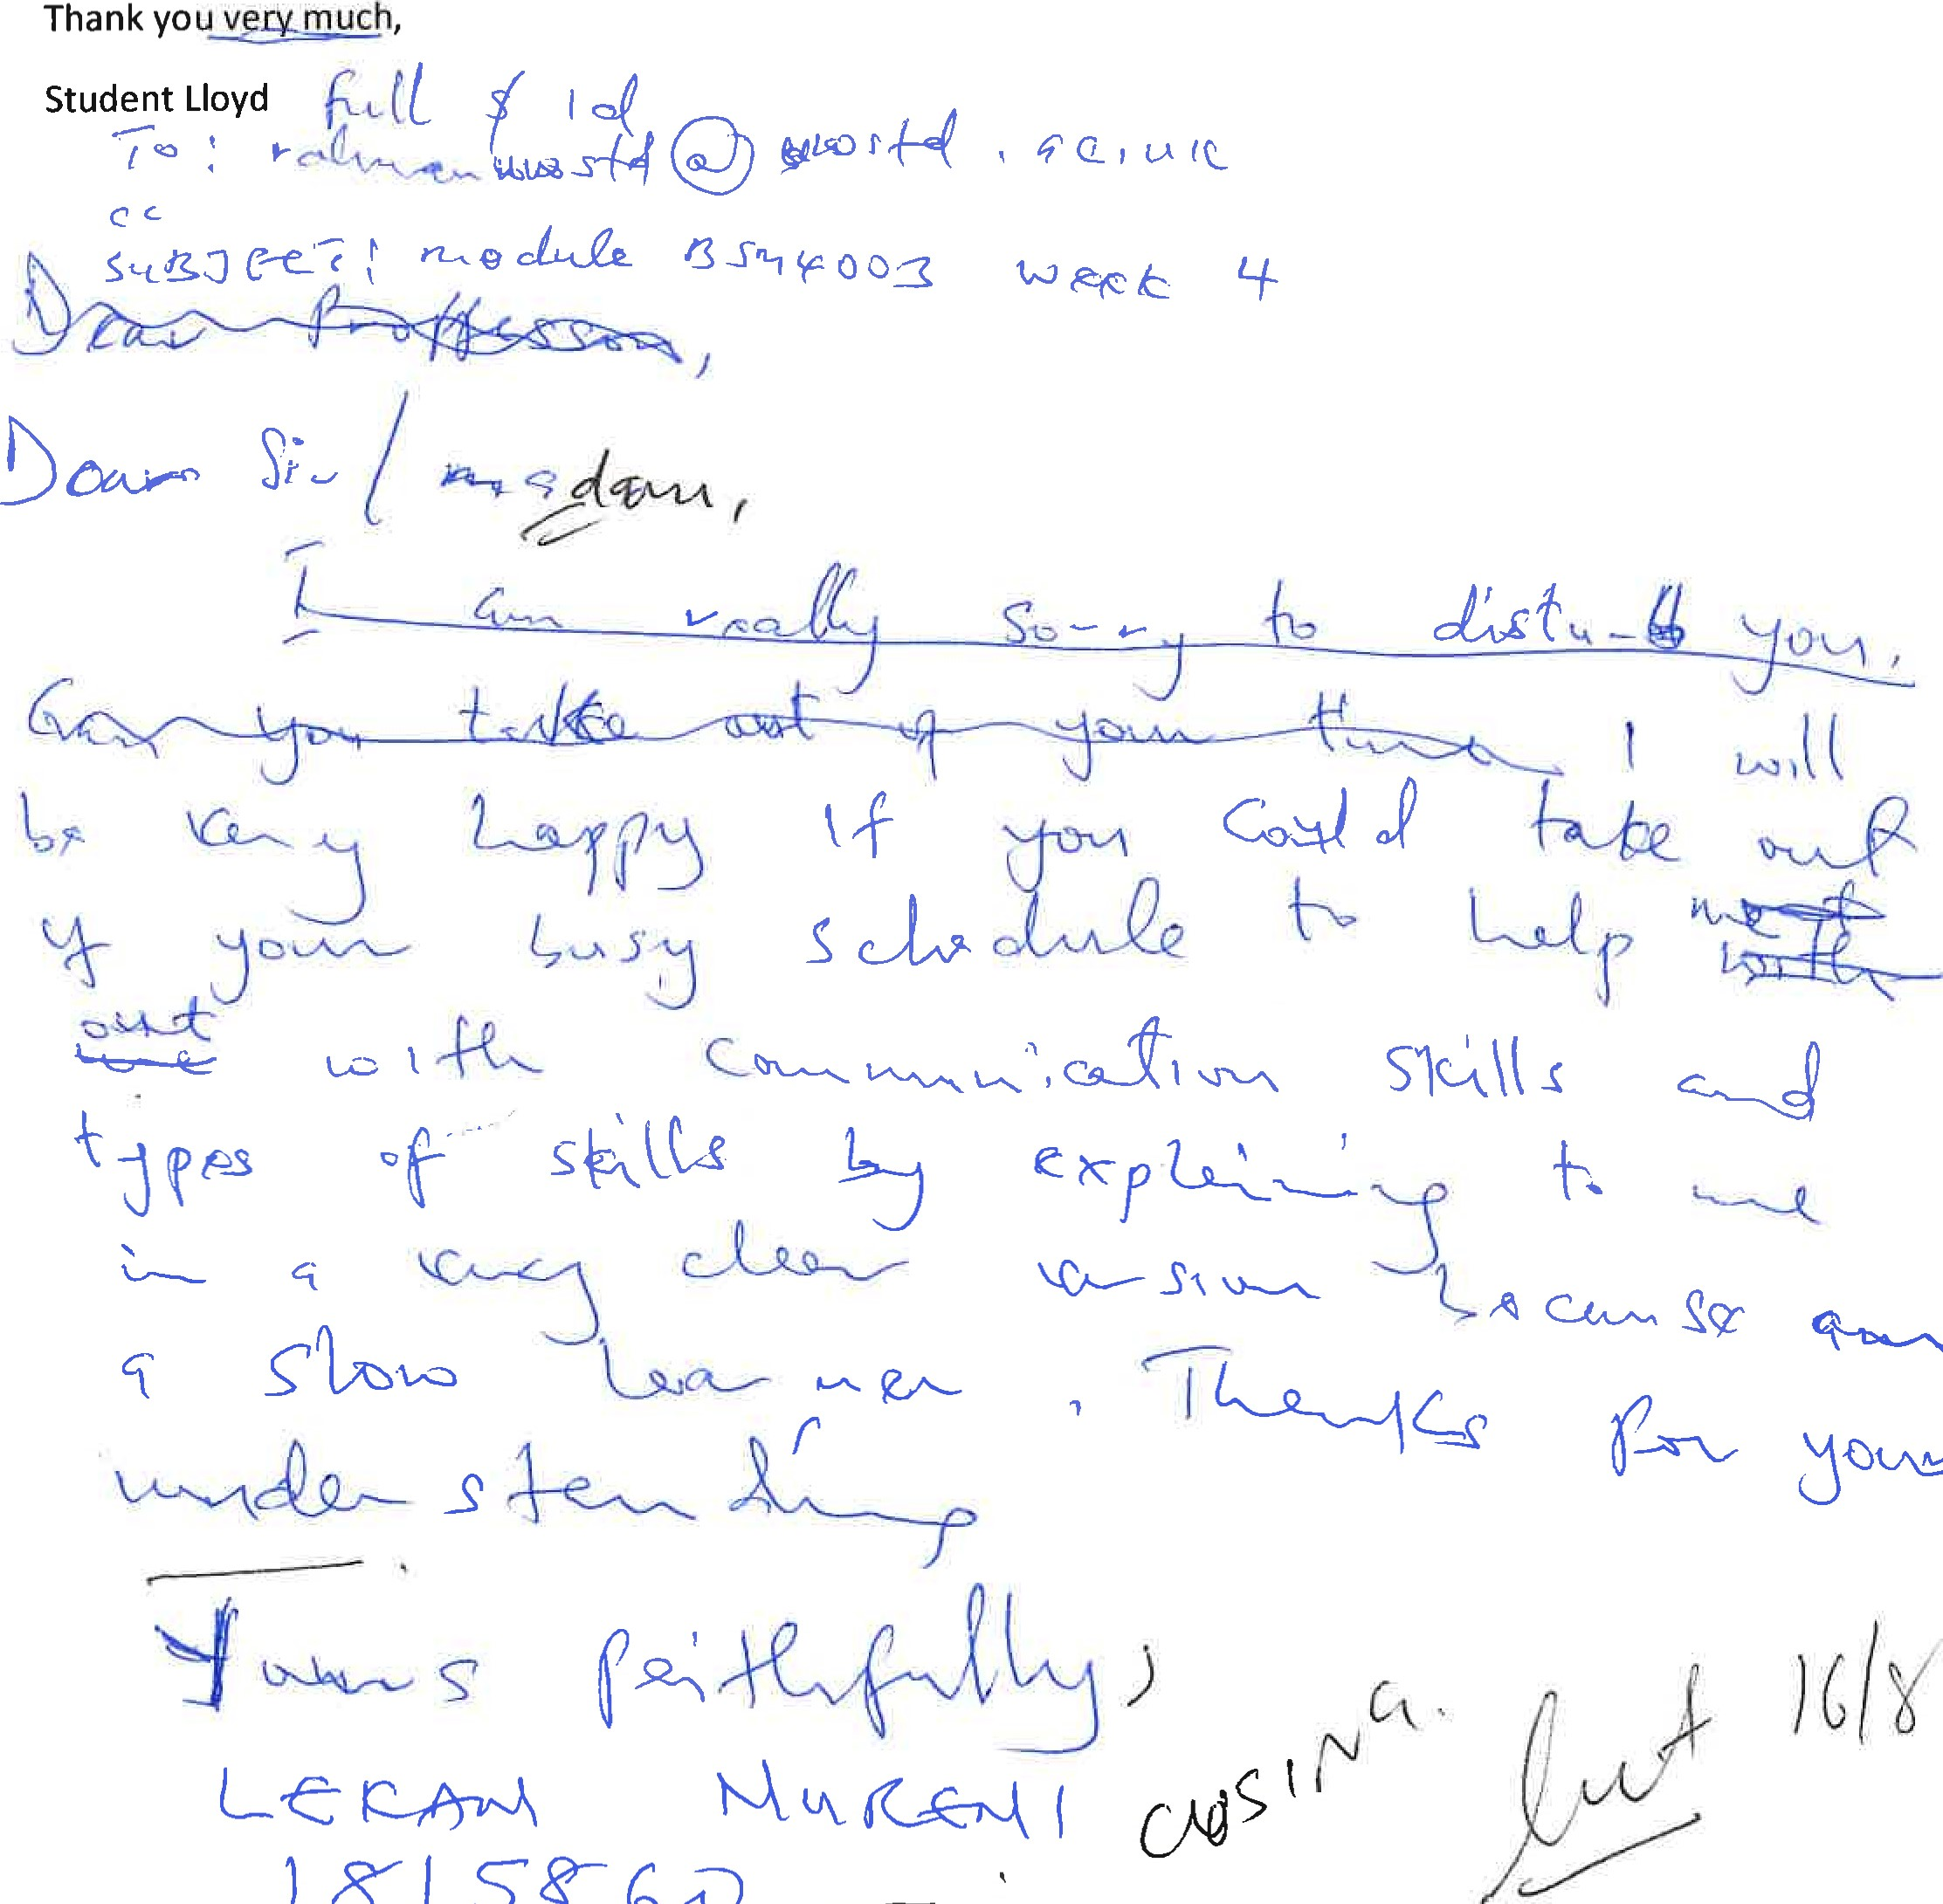



L ERA-N IRI
MARIA and PEDRO
Pedro works on a building site and Maria is his wife.
One day Maria phoned Pedro.
'Hello, Pedro, when you're coming home, see if you can get me a chicken.'
'Okay,' replied Pedro.
When he got home, Pedro took off his boots and coat and went into the kitchen.
'Maria, where are you?' He said.
'Here — in the sitting room,' she said.
When Pedro went into the sitting room, Maria said, 'Where is the chicken?'
'What Chicken?' Asked Pedro.
The one I asked you to get on your way home.'


Oh, no! I thought you said when I come home I will see you in the kitchen!
Q: Why do you think Pedro misunderstood Maria?
Q: Whose Model of Communication explains this confusion and why? Q: How could this have been prevented?
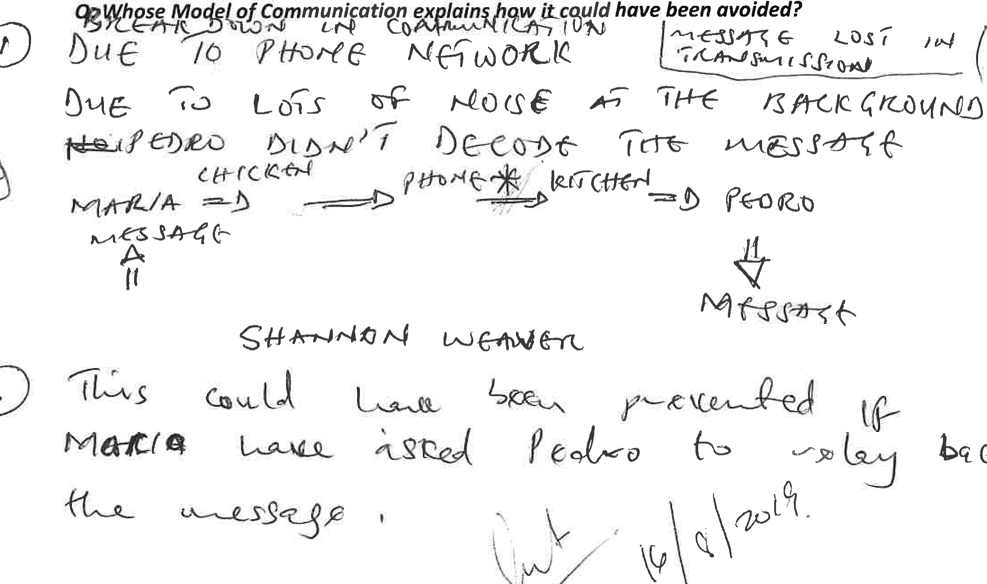CuC
have
been
avoided?



Worksheet..„....-............-............your Name.......
Communications Strategy....-.Your group's ideas..........-..................Other groups' ideas
Communications Strategy
Target Groups
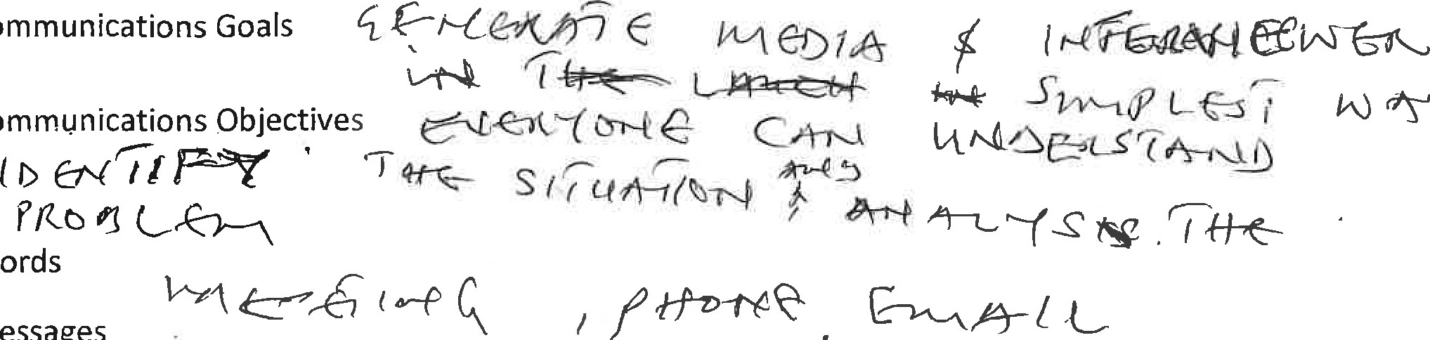
Communications
Communications
Words
Messages

Media 
Briefing
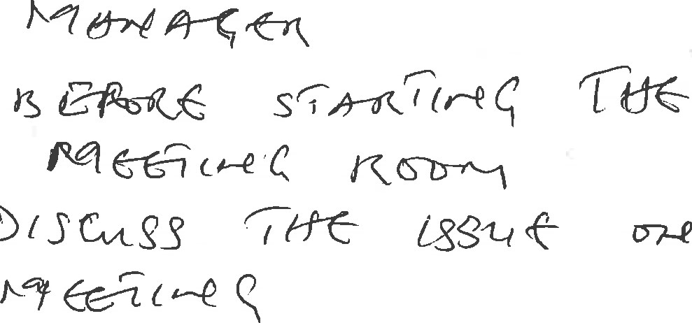
who
When
Where
Why (u.ze 
How 
Refer 
Maund et al. 2017 Chapter 3 Chapter 4 and Chapter 5
Maund 2017 Chapter 4 Table 2.1 "Non-Verbal Communication Codes: Consider the
Professional Context"
Morgan 2017 Cultural Difference p.285
2
ETW Term 1 (June 2018) - In Class exercise for Week 6
Review any lecture content not covered. See Weeks 1-6 on moodle.
Exercise: Classroom divides into self-defined groups of 4-5 persons. (5 minutes)
Reference: Essential Texts from the Module Outline, Maund et. al. 2017 and Morgan 2017
The situation: (Read aloud and clarify keywords and discuss anything ambiguous)
The team are the management of a huge BMW dealership in London and the South East. (Pick another car brand if you do not like BMW)
They have been caught discounting vehicles ag st other dealers to close sales. The Brand owners in Germany have asked them to relinquish their distributorship4æyese electric car brand is eager to find a British partner to test the market for electric cars. They have made an ex loratory phone cal! to management.
he work force knows something is wrong and people have started informally to ask questions to management. Management have replied with "we are still BMW dealers as at this moment.... You must concentrate on your work in front of you".
The work force has key members who are taking days off without warning or due cause. BMW have given them a deadline by which they must cease activity as a main dealer.
TASK:
l.ldentify stakeholders (individuals and groups)
- Create a communications strategy
- Identify target groups,
- identify goals or objectives,
- Describe a way of communicating with these groups to achieve your objectives Words and Messages, and Media.
- Develop a briefing for each of these stakeholders groups, organised as if they were here in front of you, use as many people as possible and reach these groups.
Presentation
Each group presents the main features of their communication strategy to the other groups present
1
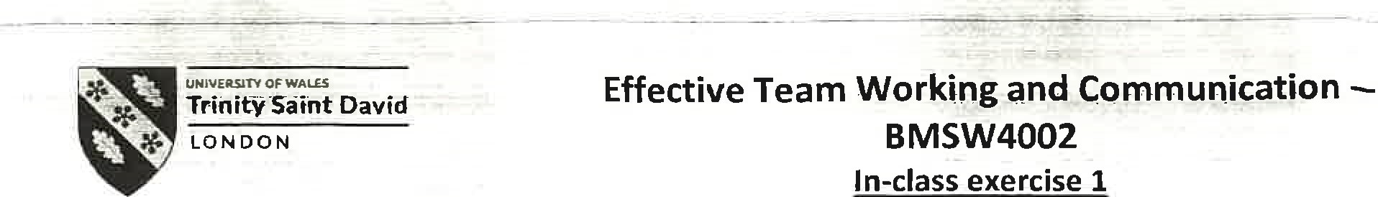Term 1
return yourpaperto thedectureruporr compfetiorr-ttwifl-be returned to you at the next session. You will need to include a scanned copy of this exercise in the form of an appendix together with you Task 1 (part of the Assignment for this module).
Student Name: L E k7ATJ AHme.o Student ID: I C/ sec o
Ex.l. Read the following passage and answer the questions.

The professor and the village people
A Professor of English at a well-known Welsh University lived in a large house not far from a little village. He never went into the village, bur shopped in the town near the University because he had nothing in common with the village people, who were largely uneducated and did manual jobs. One night, the professor fell asleep while smoking his pipe and the pipe fell onto the carpet and started a fire.
When the professor awoke and saw the house on fire, he rushed into the village, screaming:
'The edifice is being consumed by a great conflagration !'
'The edifice is being consumed by a great conflagration!'
The village people looked at him and continued doing what they were doing.
'Don't you understand?' He said. 'tThe edifice is being consumed by a great conflagration!' They ignored him.
When the Professor returned home, he saw that his house had been completely destroyed. He sat down on the ground and wept. The next day, he went into the village crying. 'Why, oh why didn't you help me? My home has been destroyed by the fire. I came and begged you last night.' He wept.
'But Professor, why didn't you say that your house was on fire? We would have helped.'
QI: Why didn't the village people help the Professor?
Q2: What should he have done to get them to help him?
Q3: Whose model of communication do you think can explain this situation?





