

MODULE CODE: Digital Skills for Personal Development and Business Growth BMSW4008

ASSESSMENT COMPONENT: PORTFOLIO

STUDENT NAME:Shannon O’Connell

STUDENT NUMBER:2429748

LECTURER: Philipa fitzgerald

DATE:11/02/2026
Contents
Task 1 3
Assessment of Digital Skills 3
References 3
Task 2 4
LinkedIn Learning Certificates for Office365 4
Task 3 5
Essay on Relevance of Excel in professional and personal life. 5
References 5
Task 4 6
7 Minute Reflective Presentation 6
References 6

AI Acknowledgement
Examples of statements If you have not used AI
I confirm that I have not presented any AI generated materials as my own work.
I confirm that I have copies of my drafts, notes, and other resources I used, which I may be asked to provide in evidence.
Examples of AI statements if you have used AI
Example 1:
I acknowledge the use of Grammarly (https://www.grammarly.com/) on Date to check my work using the prompt(s):
1. Please check the following text for readability, grammar and syntax.
I confirm that I have not presented any AI generated text as my own work. I confirm that I have copies of my drafts, notes, and other resources I used before, and after the use of AI tools which I may be asked to provide in evidence.
Example 2:
I acknowledge the use of SciSpace (https://typeset.io/) on 7 March 2024 to support my research using the prompt(s):
1. Please provide me with materials on the biology of the liver.
2. Please provide me with materials on liver cells.
I confirm that I have not presented any AI generated text as my own work. I confirm that I have copies of my drafts, notes, and other resources I used before, and after the use of AI tools which I may be asked to provide in evidence.
Example 3:
I acknowledge the use of ChatGPT (https://chatgpt.com/) on 13 April 2024 to write my notes into submission format using the prompt(s):
1. Please write up these bullet points as an essay paragraph at university level.
I confirm that I have not presented any AI generated text as my own work. I confirm that I have copies of my drafts, notes, and other resources I used before, and after the use of AI tools which I may be asked to provide in evidence.
Example 4 - acknowledgement of the use of multiple AI tools:
I acknowledge the use of SciSpace (https://typeset.io/) on 28 June 2024 to support my research using the prompt(s):
1. Please provide me with materials on the American Civil War.
2. Please provide me with materials on the reception of Gone with the Wind.
I confirm that I have not presented any AI generated text as my own work. I confirm that I have copies of my drafts, notes, and other resources I used before, and after the use of AI tools which I may be asked to provide in evidence.
I acknowledge the use of Adobe Express (https://www.adobe.com/express/) on 24 June 2024 to edit photographic material:
1. Remove background from Figure 1.
I confirm that I have not presented any AI generated materials as my own work. I confirm that I have copies of my drafts, notes, and other resources I used before and after the use of AI tools which I may be asked to provide in evidence.

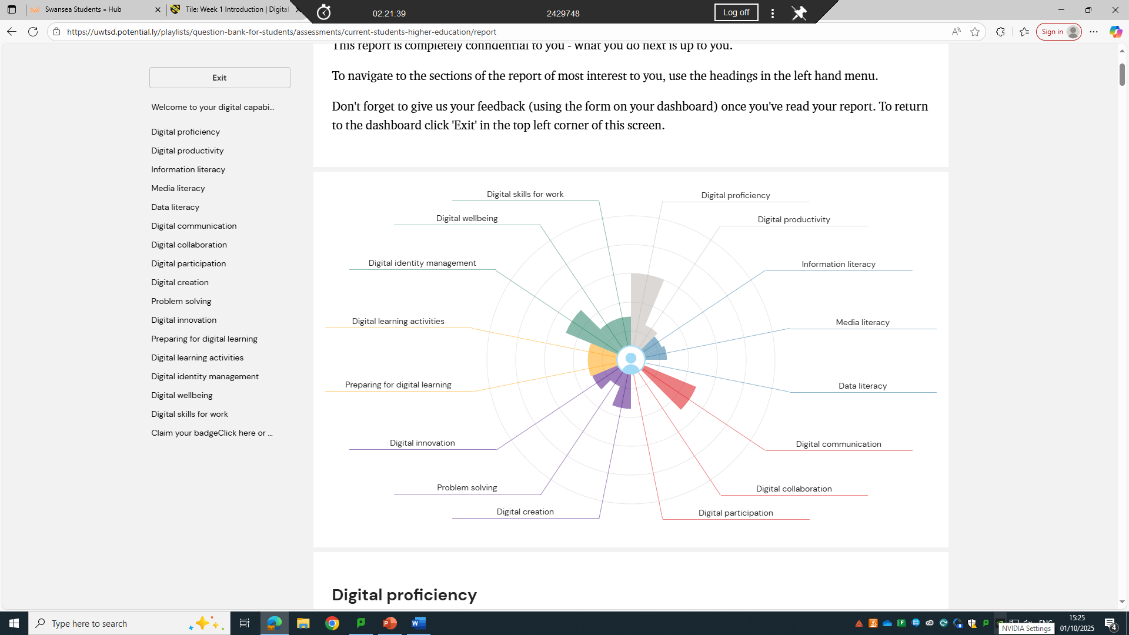

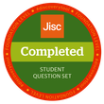
Introduction
Digital skills are essential in modern education and employment. Students are expected to use digital tools to communicate, collaborate, research information, and manage their work. Employers also expect workers to be confident using digital systems to organise data, solve problems, and make decisions. Because of this, understanding and developing digital capability is important for both academic success and future employability.

The JISC Digital Capability Framework provides a structured way to assess digital skills across key areas, including communication, information literacy, content creation, and digital wellbeing (Jisc, 2023a). Reflecting on these results helps learners identify strengths and areas for improvement (Jisc, 2023b). This assignment reviews my JISC Digital Capability results, identifies two key strengths and two main weaknesses, and presents a SMART action plan to address priority areas. It also explains the relevance of Microsoft Excel and how it can be used to manage the income and expenditure of a typical family of four.

Summary of JISC Digital Capability Results

The JISC Digital Capability assessment showed that I have a mix of strengths and development needs across the six digital capability areas. My strongest results were in digital communication and collaboration and information, data, and media literacy. These areas support effective communication, teamwork, and academic research (Jisc, 2023a).

However, the assessment highlighted weaknesses in digital creation and content production and digital wellbeing and self-management. While I am confident using basic digital tools, I lack confidence when creating advanced digital content. I also find it challenging to manage distractions, screen time, and digital organisation. These weaknesses can affect productivity and the quality of academic work. Overall, the JISC results show that while I am confident using digital tools for communication and research, I need to improve my technical skills and digital habits to become a more effective and balanced digital learner (Jisc, 2023b).

Strengths

Digital Communication and Collaboration

One of my strongest areas identified by the JISC assessment is digital communication and collaboration. I am confident using digital tools such as email, Microsoft Teams, and virtual learning environments to communicate with tutors and classmates. These tools allow me to take part in online discussions, collaborate on group work, and attend virtual sessions (Jisc, 2023a).

Strong digital communication skills are important in education, as many courses rely on online platforms for learning materials, assessment submission, and group work. My confidence in these tools helps me stay organised, meet deadlines, and contribute effectively to shared tasks. These skills are also valuable in the workplace, where many organisations use digital platforms to support teamwork and communication (OECD, 2023).

Information, Data, and Media Literacy

Another key strength is information, data, and media literacy. I am able to locate academic sources, understand research materials, and evaluate whether information is reliable. In a digital environment where misinformation is common, these skills are essential for producing accurate and well-supported academic work (Cottrell, 2021; Jisc, 2023a).

Strong information literacy supports academic success by helping me use credible sources and avoid unreliable information. These skills are also important for future employment, as many roles require employees to analyse information, prepare reports, and make informed decisions. This strength gives me confidence when researching topics and completing assignments (Jisc, 2023b).

Weaknesses

Digital Creation and Content Production

One of the main weaknesses identified in my JISC results is digital creation and content production. While I can use basic tools such as Microsoft Word and PowerPoint, I am less confident creating advanced presentations, infographics, or visual content (Jisc, 2023a). This can limit how clearly I communicate ideas and affect the overall quality of my work.

Digital content creation skills are important in education, as students are often required to present information visually. They are also important in the workplace, where professional presentations and reports are commonly used. Improving this skill would help me communicate more effectively and meet academic and professional expectations (Jisc, 2023b).

Digital Wellbeing and Self-Management

Another area for improvement highlighted by the JISC results is digital wellbeing and self-management. I sometimes struggle with managing screen time, staying focused, and organising digital files (Beetham, 2019; Jisc, 2023a). Notifications and multitasking can distract me and reduce productivity. Poor organisation can also make it difficult to find important documents quickly.

Research suggests that poor digital wellbeing can increase stress and reduce learning effectiveness (Beetham, 2019). Improving my digital habits would help me work more efficiently, stay focused, and better manage academic responsibilities (Jisc, 2023b).

SMART Action Plan

Goal 1: Improve Digital Creation Skills
• Specific: Learn to use Canva, advanced PowerPoint features, and Microsoft 365 design tools
• Measurable: Create at least three digital items, such as a poster, infographic, and presentation
• Achievable: Use free online tutorials and JISC-recommended learning resources (Jisc, 2023b)
• Relevant: Improved digital creation skills will support academic presentations and improve communication of ideas
• Time-bound: Complete within eight weeks

Goal 2: Improve Digital Wellbeing and Organisation
• Specific: Reduce distractions, improve file organisation, and develop healthier screen-time habits
• Measurable: Track screen time, focus levels, and organisation habits using a digital log for two weeks
• Achievable: Use focus modes, notification settings, and structured folders
• Relevant: Improved digital wellbeing will increase productivity, focus, and academic performance
• Time-bound: Implement improvements by the end of the semester

Here are my linkeden certificates

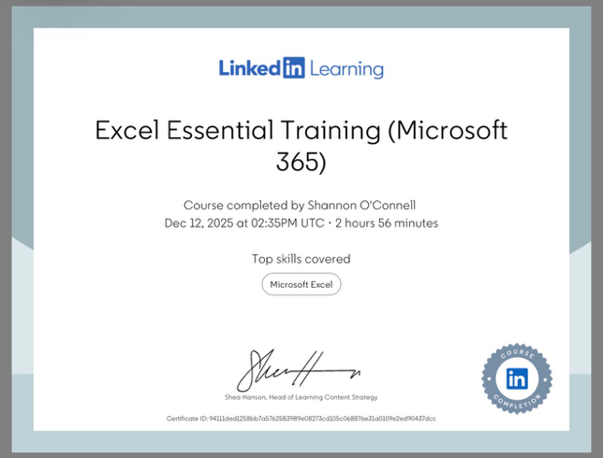
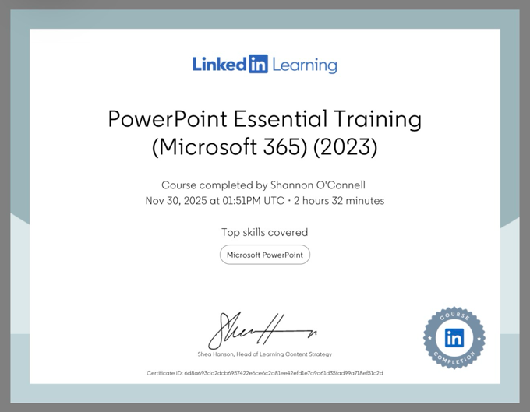

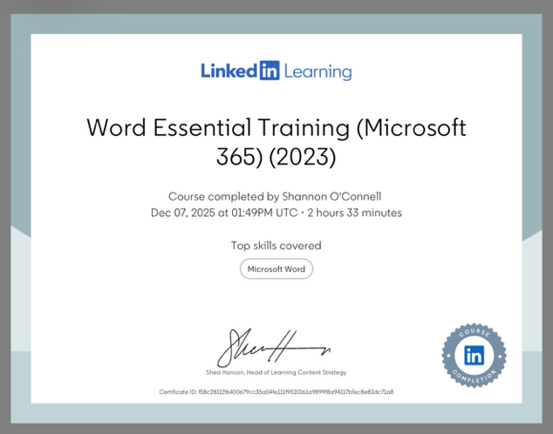

The Relevance of Microsoft Excel

Microsoft Excel is a widely used digital tool that supports organisation, data management, and decision-making. It is commonly used in education, workplaces, and everyday life. Excel allows users to store information in spreadsheets, perform calculations automatically, and present data visually using charts and graphs (Walkenbach, 2015).

One key benefit of Excel is organisation. Information such as budgets, plans, and lists can be stored clearly in rows and columns. This reduces errors and makes information easier to find. Excel also performs calculations automatically, which saves time and reduces mistakes when working with numbers (Frye, 2018). For example, income and expenses can be calculated instantly using formulas.

Excel also helps users understand data visually. Charts and graphs make it easier to see patterns and trends, which supports better decision-making. In addition, Excel supports teamwork through cloud-based sharing, allowing multiple users to work on the same spreadsheet at the same time. These features make Excel a valuable digital skill for both academic study and future employment (Alexander and Kusleika, 2019).

Excel Spreadsheet: Family Income and Expenditure

An Excel spreadsheet can be used to manage the annual income and expenditure of a typical family of four. The spreadsheet should include clear headings and separate sections for income, monthly expenses, and annual totals. Realistic figures would be used for wages, benefits, rent or mortgage, utilities, food, transport, childcare, and leisure.

Formulas would calculate totals automatically. The SUM function can total monthly and annual income and expenditure. Subtraction formulas can show remaining income after expenses. Conditional formatting can highlight key areas, such as high spending categories or savings. Using Excel in this way supports organisation, financial planning, and informed decision-making (Powell, 2022).

Conclusion

The JISC Digital Capability assessment has helped me understand my digital strengths and areas that require further development. My strongest areas are digital communication and collaboration, and information, data, and media literacy. Weak areas include digital content creation and digital wellbeing. By following the SMART action plan, I can improve these skills and become a more effective digital learner.

The Excel task demonstrates how digital tools can be used to manage real-life situations, such as household finances. Together, these skills support academic success and prepare me for a digital-focused workplace (Jisc, 2023a; Walkenbach, 2015).
Below is my reference list and excel spreadsheet

Reference List

Alexander, M. and Kusleika, D. (2019) Excel 2019 Bible. Hoboken: Wiley.

Beetham, H. (2019) Developing digital capability: A toolkit for learners. London: Jisc.

Cottrell, S. (2021) Skills for success: Personal development and employability. 4th edn. London: Macmillan.

Frye, C. (2018) Microsoft Excel 2019 step by step. Redmond: Microsoft Press.

Jisc (2023a) Digital Capability Framework. Available at: https://digitalcapability.jisc.ac.uk/ (Accessed: 7 December 2025).

Jisc (2023b) Jisc digital capability tool: Learner guide. Available at: https://digitalcapability.jisc.ac.uk/guide/ (Accessed: 7 December 2025).

OECD (2023) Digital education outlook. Paris: OECD Publishing.

Powell, S.G. (2022) Business analytics: Data analysis and decision making. Boston: Cengage Learning.

Walkenbach, J. (2015) Excel 2016 Bib

Excel spreadsheet
https://uowtsd-my.sharepoint.com/:x:/g/personal/2429748_student_uwtsd_ac_uk/IQByF2pKTAFwQKEUhggqWFgwAdLY0MqufYGK-cXIrdKM7N0?email=2429748%40student.uwtsd.ac.uk&e=GVbbTs
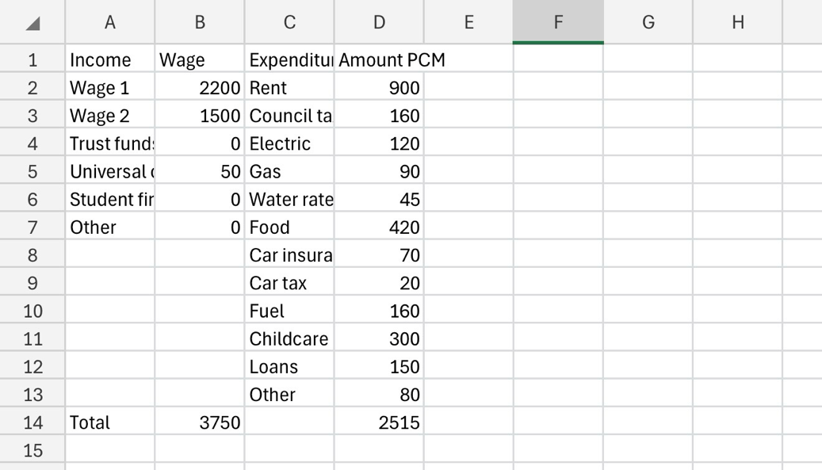
https://uowtsd-my.sharepoint.com/:x:/g/personal/2429748_student_uwtsd_ac_uk/IQByF2pKTAFwQKEUhggqWFgwAdLY0MqufYGK-cXIrdKM7N0?email=2429748%40student.uwtsd.ac.uk&e=GVbbTs


