
Skills for the Workplace
Module Assignment Submission
Student Name: | Jamil Kayani
Student Number: | 1711579
Module No: | BMSK4003
Module Title: | Digital Skills and Research

Statement of Confirmation of Authenticity
By the act of making this submission, the student declares that this is the work of the student named above. The work has not, in whole or in part, been knowingly presented elsewhere for assessment, or where assessment has been built on a previous assessment, this has been identified. Where materials have been used from other sources it has been properly acknowledged. If this statement is untrue, the student acknowledges that an assessment offence has been committed.
Attention is drawn to the plagiarism and unfair practice policies of both the University and of ILM.

Table of Contents
Introduction 3
Cloud Storage 3
OneDrive Vs Dropbox. 3
Advantages and Disadvantages 3
Web Conferencing 4
Skype Vs WebEx 4
Advantages and Disadvantages 4
Increasing Employability 5
Conclusion 5
Social Media 6
Facebook 6
Twitter 7
LinkedIn 8
Bibliography 9

Introduction

This report is focused on the use of Digital Technology and its effect in the work place. New technology can have both positive and negative impacts on businesses on companies. These impacts can either increase or cause setbacks for small businesses and corporations. New technologies may prove to be more useful and cost effective than using actual humans to do the work. For example, many mail companies now use machines to sort packages than humans. The positive impact of this is that work is completed more efficiently, and they don’t get distracted as humans do. However, a major setback of using machines instead of manpower is that machines can break down and it costs a lot to repair them. This report discusses the use of technologies such as cloud storage and web conferencing in the workplace.

Cloud Storage
Cloud Storage is designed to help people quickly and easily store files, documents, photos and videos as well as remotely access these documents. This technology has the capacity to transport large bundles of files and information regardless of their type. It is also highly cost effective as it comes free with a Microsoft, Google or Dropbox account. There are also a wide range of cloud storages to choose from; personal cloud storage is usually free and helps to back photos, videos and other information stored on smartphones on a daily basis. Files stored to a cloud server can also be shared with other users through emails or through the services sharing features. Most providers allow their users to set permissions when sharing files with other users such as a read-only document which doesn’t allow the second-party to make any changes to the document.

OneDrive Vs Dropbox.
OneDrive and Dropbox are two of the major providers to businesses and individuals all over the world. Both providers offer a vast majority of storage space to their users – around 15GB of storage is also available for free when users initially make their account. Other similarities between the two services also include synchronised files across all devices. Both service also encrypt the stored files for the user’s safety.

Advantages and Disadvantages
There are many advantages and disadvantages to cloud storage. The advantages being that initial storage is free and users can then pay upwards 0f £0.79 per month to increase their storage space. OneDrive also allows its users to earn free storage for every individual referred by a current user that also opens a OneDrive account. Another advantage of cloud storage is that files are easily organised, and users can search for individual files through the search icons in their chosen service. Both providers also allow access and synchronisation to social networking sites such as Facebook, Twitter and LinkedIn. cloud storage is cost effective as well eco friendly as it helps to save money on supplies, manging and organising files.
However, there can also be some disadvantages to cloud storage such as privacy concerns regarding cybercrimes and malware. Due to a high-profile nature of these providers they can be susceptible to being hacked. This also causes concerns for a breach of privacy as the documents and files stored on cloud servers can be sensitive and confidential. However, most servers combat the threat of potential hackers by providing their users with two-factor authentication codes.

Web Conferencing
This term defines a range of online collaborations between employees or even across different companies and organisations. These can range from online business meetings, webinars and webcasts. This technology is vital in the professional and educational field as it is a way of having real time face to face communications.

Skype Vs WebEx
Skype and WebEx both offer online conferencing for businesses and are two o the major providers for these services. They order video conferencing for up to 200 users at once. However, Skype can offer more at 300 users per conference. They also offer other services such as secure meetings; file sharing; brainstorming tools; live support from advisors as well as the ability to record the meetings. One major differences between the two providers is that Skype also offers instant-messaging through an internet connection whereas WebEx does not. Overall, Skype has many more features to offer to its users such as being able to add participants in a group video call anytime during a session; it also allows users to switch between devices in one session; provides users with features such as call forwarding, muting and holding. Another benefit to using Skype over WebEx is that it is automatically synchronised with OneDrive and come free with the purchase of Office 365. Like cloud storage it also has file-sharing along with permissions.

Advantages and Disadvantages
Web conferencing is time efficient as well as cost effective as people from different locations from all over the world can take part in a business meeting or a webinar without having to spend money on travel costs. It also increases productivity as it reduces the time spent on booking and preparing a meeting room and printing resources the time saved from that can be used towards something more important. It also makes training new employees easier as they can take important training classes and exams in their own time. It is also flexible as it allows meetings to take place on a short notice. However, web conferencing also has disadvantages such as it can be susceptible to hackers and malware. A risk of hacking can also lead to breach of privacy.

Increasing Employability
In the 21st century it is important that employees have digital literacy which allows employees to gain the necessary functional and communication skills to operate modern technology as well being able to communicate data, files and folders through technologies such as cloud storage, web conferencing and web mail. Digital literacy makes employees more attractive to employers as it helps the company save time and money that would have been spent on arranging meetings or arranging for physical storage systems. Digital skills also help to keep everyone connected whether they are colleagues, relatives or even potential employers.

Conclusion
Digital technologies can be beneficial to a company or business’s growth when used properly. It is important that businesses use the right products and providers for their needs. When choosing these providers, the main thing to consider should be the level of security it provides such as two-factor authentication and file encryption. Other things to consider can also include the cost and additional services it may provide for example, having an outlook account provides users with free skype, free 15GB of OneDrive storage space as well free access to Microsoft online.

Social Media

Facebook
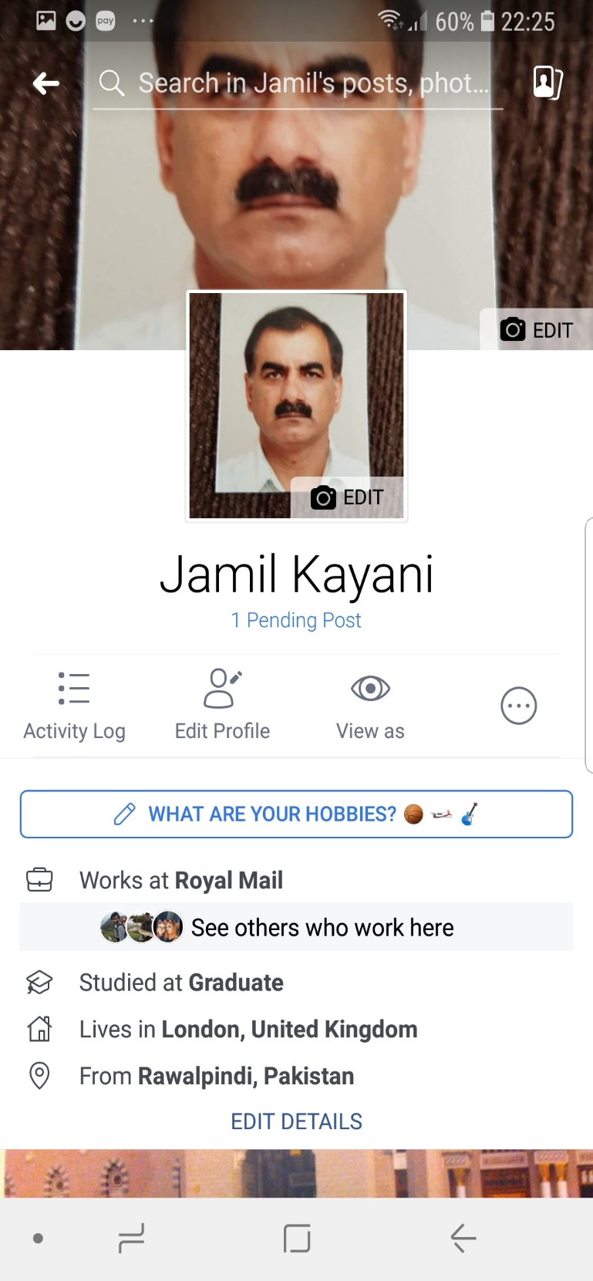

Twitter


LinkedIn
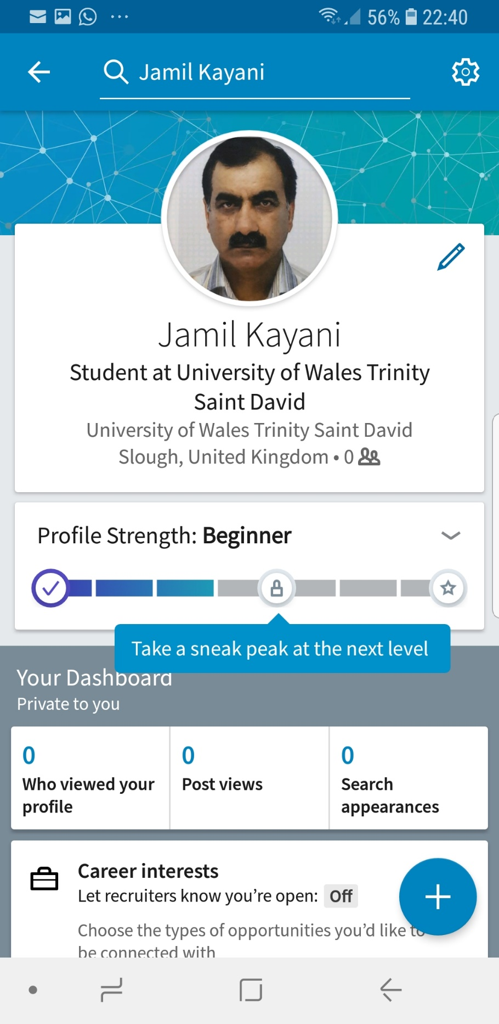

Bibliography

https://pencloudmanifasto.org
https://answers.microsoft.com
https://en.m.wikipedia.org
https://www.eztalks.com/video-conference/pros-and-cons-of-web-conferencing.html

