
Certificate of Higher Education in
Employability Skills
LEVEL 4
Module Name – BMSW4011 –
Managing Enterprise
Module Lead: Mel Squire
DAN TIMIRCAN
Student id:2118870
Table of Contents
Task 1 Business plan and reflection 3
Business plan 3
1.0 Introduction 3
2.0 Business plan 3
2.1 Business Details 3
2.2 Name of business and type of business ownership 3
2.3 Mission statement, USP, aim and objectives of the business 4
2.4 Physical existence details 4
2.5 Human resources 4
2.7 Market Research 6
2.8 Financial resources 7
2.9 SWOT analysis 9
3.0 Conclusion 10
Reflection 13
1. What new business skills and knowledge have you acquired during the process of formulating and developing your business plan? 13
2. Evaluate your entrepreneurial strengths 13
3. Share an entrepreneurial trait you have identified that you need to develop and how you propose to develop this. 14

Task 1 Business plan and reflection

Business plan

1.0 Introduction
Marketing paves the way for success for business organisations as it helps business organisations connect with their potential audience and helps boost the sales flow of a company (Whittington et al. 2023). The report will shed light on the business plan of a new transport company NIGHT-STAR Shuttle Ltd. The report will discuss different details related to the business and will state the type of business ownership. Moreover, the resort will consider discussing the mission statements and objectives of the mentioned business. Moreover, the report will shed light on the details of the physical exitance of the business followed by its human resources and marketing activities. Lastly, the resort will highlight the financial resources of NIGHT-STAR Shuttle Ltd followed by a SWOT analysis of the business.

2.0 Business plan

2.1 Business Details
NIGHT-STAR Shuttle Ltd is the name of the new transportation business. The reason for the launch of the new company is to solve the lack of transportation services in Wales and England at night. The company is a UK headquartered company that will provide minibus shuttle services to people of Wales and England at night. The company is developed to provide convenience to UK people for daily commuting.

2.2 Name of business and type of business ownership
Limited liability companies consist of partners where one partner is free from the burden of debts of another partner (Whittington et al. 2020). The pros and cons of a limited liability business are the flexibility to adopt different structures of taxation, the ability to restructure the business without the need for the approval of regulations of business and business liability responsibilities not belonging to shareholders. The cons of limited liability business are challenges in raising funds due to variations in taxation structure and variation in organizational structure. Moreover, limited liability businesses might be expensive to operate in comparison to businesses with other structures (Indeed, 2025). The name of the business is NIGHT-STAR Shuttle Ltd which is a limited liability company.

2.3 Mission statement, USP, aim and objectives of the business.
The mission statement of NIGHT-STAR Shuttle Ltd is to provide transportation services to passengers in Wales and England at night. The aim and objective of NIGHT-STAR Shuttle are to provide minibus shuttle services at night to passengers in Wales and England. Due to the unavailability of other transportation services at night in Wales and England. The unique selling point (USP) of the mentioned company will be filling the gap of transportation at night in Wales and England. Moreover, the USP is to provide a safe and comfortable journey to passengers of Wales and England.

2.4 Physical existence details
Different transportation locations that are used by transport companies are located near railroads and locations like airports or sea ports. This provides the scope for a transportation company to get access to a huge number of customers (Rodrigue, 2023). The use of Google Maps visual provides the scope for a transportation company to transform the experience of the trip by giving precise information regarding drop off location or destinations of a passenger and also helps in determining the traffic condition precisely (Google Maps Platform, 2025). NIGHT-STAR Shuttle Ltd will be located in Edwards Business Park, in Llantrisant, near Cardiff, Wales CF72 8QZ, with very close access to M4. https://maps.app.goo.gl/DQZiCu8yM6Vhhrk47. This will help the company to pick up customers at night from such locations as Bridgend, Neath and Port Talbot. Moreover, the company will use good map visuals to get delta insights into passenger pick-up and drop-off locations.

2.5 Human resources
Different job roles in transportation companies involve governance department-related jobs, jobs related to logistic coordination, transportation planner jobs, transportation engineer jobs and customer service representative jobs (Handshake, 2025). An organizational chart provides insights into ways for optimizing the use of tools and resources by a company like a transportation company (Creately, 2025). NIGHT-STAR Shuttle Ltd will hire 150 employees initially to operate in Wales and England. The organisation will possess employees to manage governance, employees for transport engineering, employees for dealing with customers, employees for planning transportation and employees for logistics coordination. The company will also comprise of finance management department.

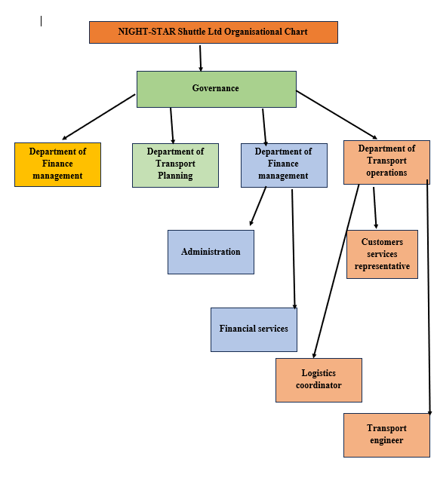
Figure: Organisational chart of NIGHT-STAR Shuttle Ltd
Source: (Self-developed)
2.6 Marketing activities
Services: Services in marketing give insights into different types of offerings given by a company to its customers (Baron and Hmieleski, 2018). NIGHT-STAR Shuttle Ltd will provide minibus shuttle services to customers of Walesa and England at night. The reason is to fill in the gaps of transportation at night in the UK. The company will keep the fare for shuttle services affordable to engage customers.
Promotion: It involves marketing strategies used by a company to create awareness of its services and products to customers (Tay et al. 2025). NIGHT-STAR Shuttle Ltd will promote its brand through offline promotional activities and via print media. The company will promote its brand by making advertisements in newspapers and magazines like the Times and Forbes. NIGHT-STAR Shuttle Ltd will promote its brand by selling flyers along with newspapers and magazines. Moreover, the company will perform online promotional activities like advertising the services offered by it on Facebook and Instagram.

2.7 Market Research
The current market condition of public transportation in the UK shows that transportation services are projected to grow by 7.9% from 2024 to 2030. The public transportation of the UK is expected to generate revenues of 12446.51 million pounds by 2030. This shows that the transportation services for the public in the UK have high growth potential. NIGHT-STAR Shuttle Ltd company will provide mini shuttle bus services to people in Wales and England at night. The value proposition of the company mentioned will be providing night transportation services to nullify the issues of scarcity of transportation at night in Wales and England.
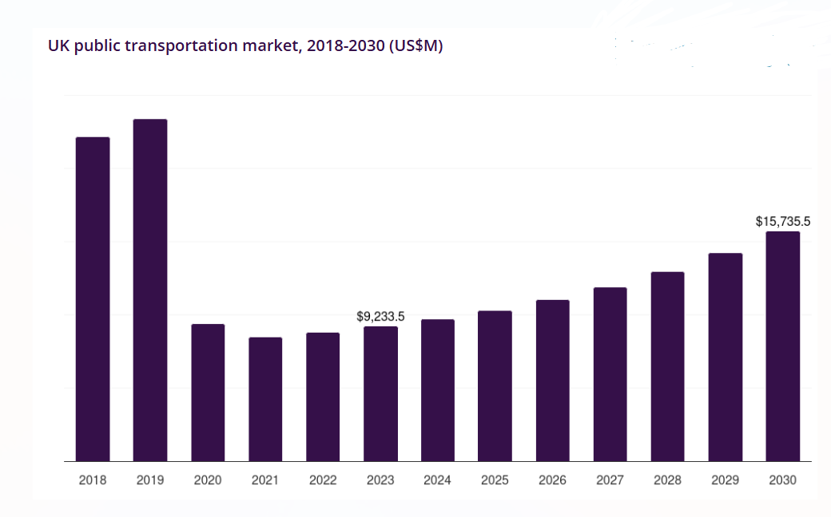
Figure: Public transportation market condition in the UK
Source: (Grandview research, 2024)

2.8 Financial resources
- Cost of Business Running:
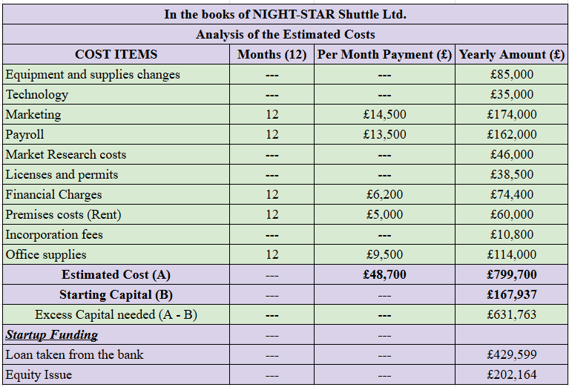
Figure: Startup cost and sources of funding
Source: (Self-Made, 2025)
The purpose of this statement is to consider the total amount of costs that can be required by the startup company. From this analysis, it can be seen that the company will require about £631,763. On the other hand, the company will provide the funding by using owner's capital, loans from the bank and issues of equity capital.
- Cash Budget for 12 months:
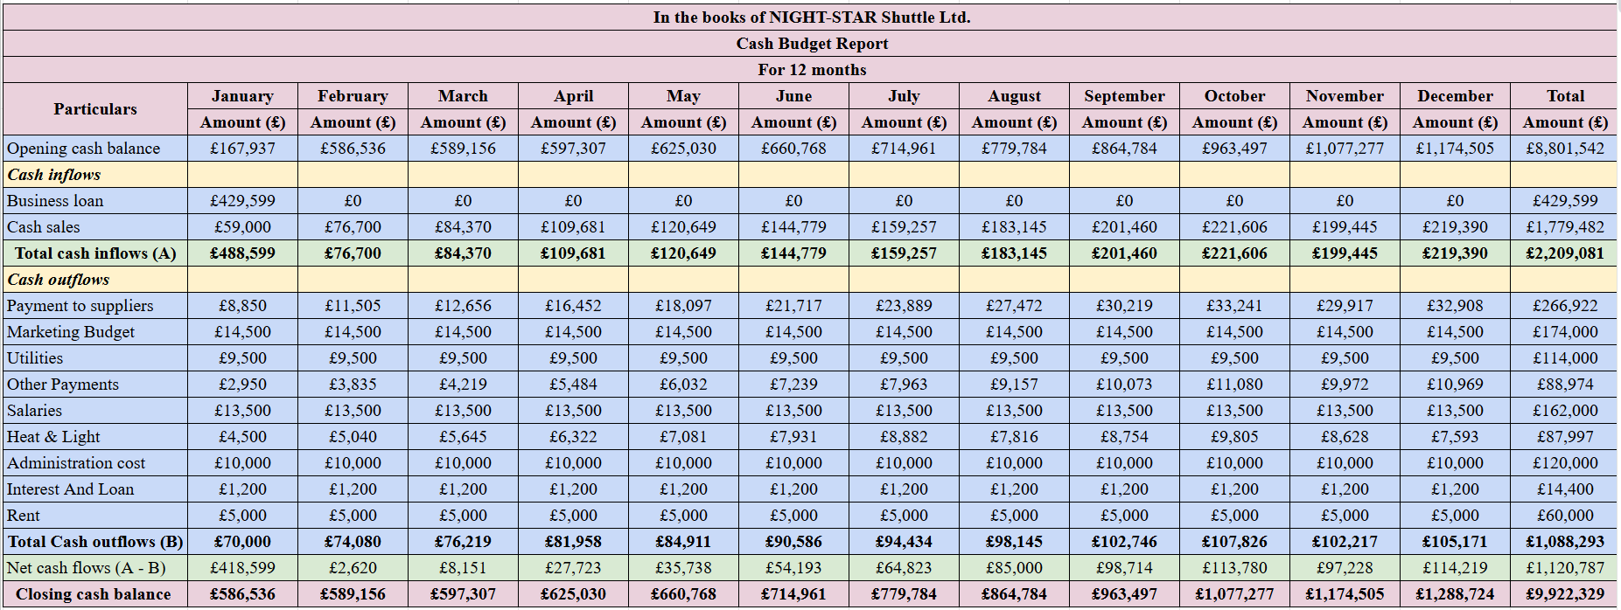
Figure: Cash Budget analysis
Source: (Self-Made, 2025)
This statement analyses the cash budget of the company for a year. This analysis is done based on the forecasted assumptions. From the analysis, growth in the overall cash balance can be seen.

2.9 SWOT analysis
Strengths: A high accessibility of transportation provides the scope for public transport companies to address the transportation needs of a huge number of customers. It eventually enhances the sales flow of public transport companies (Saif et al. 2019). One of the biggest strengths of NIGHT-STAR Shuttle Ltd is the accessibility of transport services offered by the company. The company will operate nearby railroads and ports like airports and seaports. This might help the company to gain a large number of passengers at night. Moreover, the use of digital technology like Google Maps Vision might help the company to precisely determine the pickup and drop-off location of customers.
Weaknesses: The lack of experienced drivers in public transportation is one of the big weaknesses that led to the development of scopes for accidents. This pushes a transportation company to face uncertainties in its business eventually lowering the customer's experience of the company (Ji-Hyland and Allen, 2022). Due to lack of appropriate infrastructure in public transportation services increases the caches of slowdown of business processes of public transport companies and also declines the profitability of a company (Belanova et al. 2022). One of the big weaknesses that could be faced by NIGHT-STAR Shuttle Ltd is the shortage of experienced drivers which might increase the probability of accidents. Moreover, NIGHT-STAR Shuttle Ltd can have weaknesses in terms of popper infrastructure operating effectively at night in Wales and England. This might diminish the customer's experience of the company.
Opportunities: Adopting new technologies like digital technology for real-time tracking aids a public transport company to provide best-in-class services to customers due to precisely locating pick-up and drop-off locations of passengers (BusinessDojo, 2025). NIGHT-STAR Shuttle Ltd can provide best in class shuttle services to customers at night and could ensure the safety of passengers due to the use of Google Maps vision in its shuttle buses.
Threats: Public transport companies face threats due to rising prices of fossil fuels. This forces a company to increase the fare prices, eventually increasing the competitive threats for a public transport company (Bagloee et al. 2016). NIGHT-STAR Shuttle Ltd can face challenges due to the rising process of fossil fuels. This is because the problems mentioned might force the company to increase the prices of its tickets which could eventually disappoint its potential customers. The company might face competitive problems due to other public transport in the UK.

3.0 Conclusion
Concludingly it can be said that marketing helps a company to establish strong bonds between customers and a company. The report sheds light on the business plan of the transportation company NIGHT-STAR Shuttle Ltd. The report highlighted details regarding the bruises and type of ownership of the company. Moreover, the resort highlighted the mission vision of NIGHT-STAR Shuttle Ltd followed by highlighting the details regarding the physical existence and human resources of the company. The report further gave insights into the marketing strategy, market research and financial resources of NIGHT-STAR Shuttle Ltd followed by sharing details regarding the strengths and weaknesses of the company using SWOT analysis.

13.0 References
Bagloee, S.A., Tavana, M., Asadi, M. and Oliver, T., (2016). Autonomous vehicles: challenges, opportunities, and future implications for transportation policies. Journal of modern transportation, 24, pp.284-303. DOI 10.1007/s40534-016-0117-3
Baron, R.A. and Hmieleski, K.M., (2018). Essentials of entrepreneurship second edition: Changing the world, one idea at a time. Edward Elgar Publishing.
Belanova, N., Ershova, N., Pyatkova, N. and Alpackaya, I., (2022). Assessment of the risks of construction of transport infrastructure facilities. Transportation Research Procedia, 63, pp.1660-1667. DOI: 10.1016/j.trpro.2022.06.179
BusinessDojo (2025) The SWOT of a transportation company (with examples), BusinessDojo. Available at: https://dojobusiness.com/blogs/news/transportation-company-swot (Accessed: 24 February 2025).
Creately (2025) Organizational Chart for Transport Company, Creately. Available at: https://creately.com/diagram/example/gsy3ayzi8/organizational-chart-for-transport-company (Accessed: 24 February 2025).
Google Maps Platform (2025) Solutions for transportation & Logistics, Google Maps Platform. Available at: https://mapsplatform.google.com/solutions/transportation-and-logistics/ (Accessed: 24 February 2025).
Grandviewresearch (2024) UK public transportation market size & outlook, 2030, UK Public Transportation Market Size & Outlook, 2030. Available at: https://www.grandviewresearch.com/horizon/outlook/public-transportation-market/uk (Accessed: 24 February 2025).
Handshake (2025) Top 10 transportation industry jobs and who’s hiring, Handshake. Available at: https://joinhandshake.com/blog/students/transportation-jobs/ (Accessed: 24 February 2025).
Indeed (2025) 10 types of business ownerships (with pros and cons) | indeed.com. Available at: https://www.indeed.com/career-advice/career-development/business-owner-types (Accessed: 24 February 2025).
Ji-Hyland, C. and Allen, D., (2022). What do professional drivers think about their profession? An examination of factors contributing to the driver shortage. International Journal of Logistics Research and Applications, 25(3), pp.231-246. https://arrow.tudublin.ie/cgi/viewcontent.cgi?article=1052&context=buschmanart
Lusardi, A. and Mitchell, O.S., (2011). Financial literacy around the world: an overview. Journal of pension economics & finance, 10(4), pp.497-508. https://www.nber.org/system/files/working_papers/w17107/w17107.pdf
Rodrigue, J.-P. (2023) 2.3 – transport and location: The Geography of Transport Systems, The Geography of Transport Systems | The spatial organization of transportation and mobility. Available at: https://transportgeography.org/contents/chapter2/transport-and-location/ (Accessed: 24 February 2025).
Saif, M.A., Zefreh, M.M. and Torok, A., (2019). Public transport accessibility: A literature review. Periodica Polytechnica Transportation Engineering, 47(1), pp.36-43. DOI: https://doi.org/10.3311/PPtr.12072
Tay, K.X., Chan, J.K.L. and Mohamad, D., (2025). Do the 4Ps of marketing mix strategy assuage fears of travelling?. Journal of Vacation Marketing, 31(1), pp.37-51. DOI: 10.1177/13567667231181953
Whittington, R., Angwin, D., Regnér, P., Johnson, G. and Scholes, K., (2023)Welcome to Exploring Strategy.
Whittington, R., Regnér, P., Johnson, G., Angwin, D. and Scholes, K., (2020). Exploring strategy. Pearson UK.

Reflection

1. What new business skills and knowledge have you acquired during the process of formulating and developing your business plan?
The new business skills and knowledge developed while making the plan are cognitive skills and problem-solving skills. The aforementioned business plans provided me with helpful insights that were leveraged by brainstorming potential and helped me solve problems. The business plan helped me to identify different opportunities and threats that might come in the way of developing a business. It is seen that this provided me with the knowledge to boot my logical reasoning capabilities and helped me identify ways that could help in nullifying different issues in developing a business, Moreover, due to high cognitive skills developed while conducting the business plan of NIGHT-STAR Shuttle Ltd by creative potential is enhanced. This bestowed me with the capability to resolve a conflict developed while conducting the business plan in an innovative way.

2. Evaluate your entrepreneurial strengths
My decision-making skills are on the high side. The reason for high decision-making capabilities is due to intensive research done to conduct the business plan of NIGHT-STAR Shuttle Ltd. This bestowed me with the capabilities to make prompt decisions for abolishing different challenges associated with managing the public transportation business. I can make decisions to improve the customer experience of a business. Apart from these. My innovative skills are on the high side. This is due to my critical thinking ability to identify ways of conflict resolution in business. I have gained the knowledge for showcasing my innovative skills impeccably due to the high intellectual skills developed while conducting the business plan. Besides these, my adaptability skills are on the lower side. This might open the risk of facing delays while conducting a task in a dynamic environment. Moreover, due to a lack of adaptability skills, I might not be able to meet the deadline of a task. This is because of a lack of flexibility in me which negatively impacts my resilience potential.

3. Share an entrepreneurial trait you have identified that you need to develop and how you propose to develop this.
I need to develop my adaptability skills to leverage my resilience capability. To develop the entrepreneurial traits mentioned, I need to review my learning process to identify different opportunities and challenges. However, I need to develop an open mindset to consider new changes that might be fruitful for me to develop adaptability skills. Moreover, I need to communicate with others proficient in adaptability skills. I need to get feedback from such people to develop adaptability skills in an effective and agile way. Moreover, I need to work on my emotional intelligence for proactively listening to others and understanding others to develop adaptivity skills.

