MANAGING PEOPLE
Module code: LCBB5004

Student Name:Elena Oniga
Student ID:1905210
Lectures name:Mary March
Assessment Title:Assignment 1

Executive Summary
Human resource development (HRM) is the most important and responsible work in a business organisation as this department manages employees, staffs and also help the organisation to take proper strategy development. In this essay report Morrison Company’s HRM function has discussed, recruitment is long and expensive process but Morrison company has taken innovative idea to save money and this discussion will help to make better development strategy.

Table of Contents
Task 1 4
HR professionals according to the professional map 4
Task 2 8
Introduction 8
Morrison’s Company profile 9
Planning 9
Reason of planning 10
Stages of human resources planning 10
Recruitment 11
Selection 12
Conclusion 13
Reference 14

Task 1

HR professionals according to the professional map
A Human Resource (HR) manager needs several levels of knowledge, and skills to work effectively in that particular role. CIPD framework helps to outline that knowledge and skills together with the fundamental behaviours of any successful HR manager. According to the new CIPD Profession map of 2018, there are several levels of knowledge and skills which are specialist knowledge, core knowledge, and core knowledge. Moreover, the purposes of CIPD programs are also categorized into three different categories. These are evidence-based purposes, outcomes-driven purposes and principle-led outcomes. All of these are depicted in the image below:
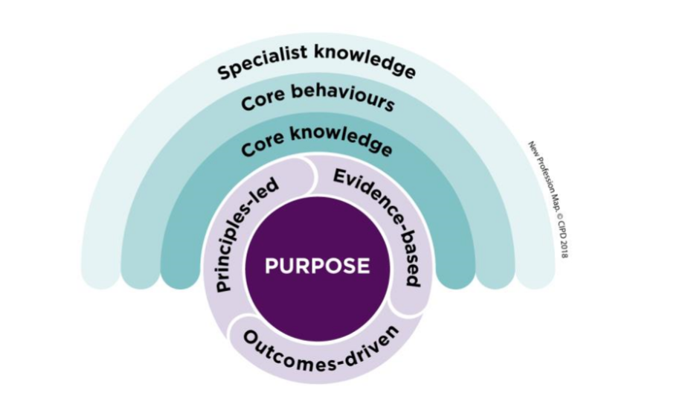
Figure 1: New profession map of CIPD-2018
(Source: peopleprofession.cipd.org, 2020)
One can access this profession map and examine the level according to the four impact level described in the map. The levels are made so many types of HR managers can relate to one or more than one level. Besides that, the levels can help to understand and improve knowledge and behaviour required to manage people. These levels are reviewed below:
Foundation level: This level is not graded for CIPD professional membership but it is helpful to gather information and use information in your job. At this level, workers are responsible to deliver the job immediately or as short-term outcomes (peopleprofession.cipd.org, 2020).
Associate level: At this level, the managers work according to the operational complexities and analyse information to take actions. Workers at this level are called associate CIPD.
Chartered member level: Chartered Members or MCIPD workers are at this level where they strategic thinking to handle complexities. They are responsible to evaluate information before making judgements Works of these member influence a wide range of stakeholders for a long time.
Chartered fellow level: HR functions or functions of other workers are same like MCIPD but the thinking of Chartered FCIPD is based on evidence. They are responsible to drive people so they can adopt the changes easily (peopleprofession.cipd.org, 2020). This is one of the main functions for HR managers who guide people through organizational changes.

Figure 2: Level of impacts
(Source: Created by Researcher)

Apart from this, the CIPT framework explained two kinds of knowledge which are specialist knowledge and the core knowledge and behaviour that is core behaviour. There are nine different specialist knowledge identified by HR professionals. These are depicted in the picture below:
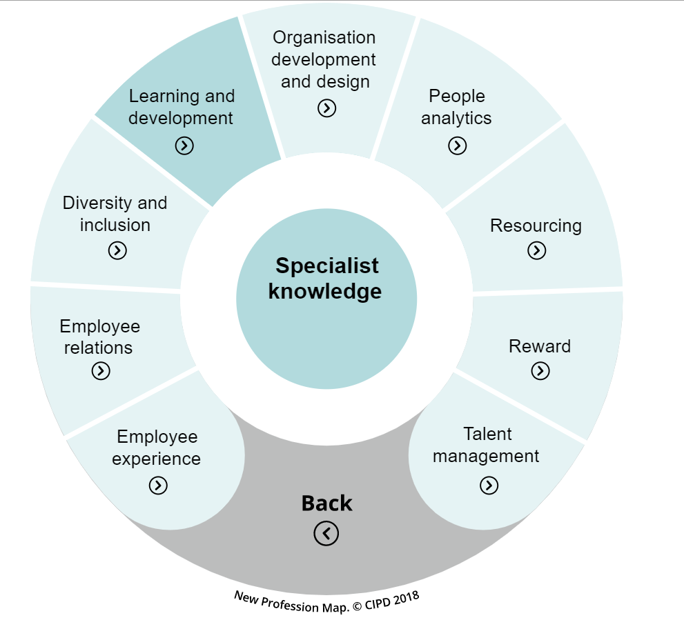
Figure 3: Specialist knowledge identified for HR professionals
(Source: peopleprofession.cipd.org, 2020)
One of the main purposes of the CIPD map is to make working and working lives better for people. The professional map is responsible for creating new roles like HR managers, opportunities, and the working environment as well. Besides this, the eight core behaviours are identified after conducting academic research and taking feedback from the professions. These core behaviours are given below.

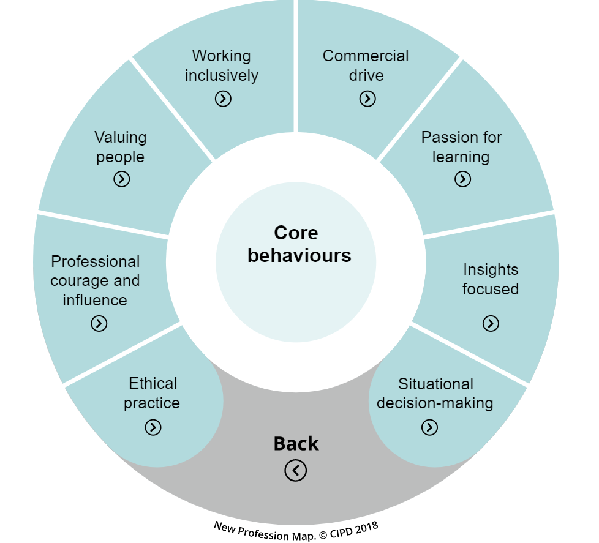
Figure 4: Core behaviours for professional explained in CIPD-2018
(Source: peopleprofession.cipd.org, 2020)
The core behaviours are guiding professional to manage people with effective thinking and acting which is very necessary for HR managers. At last five core-knowledge are also recognized such as digital working. For example, different HR applications are used by HR managers to manage people in organizations. The core knowledge required to be an expert HR professional are:
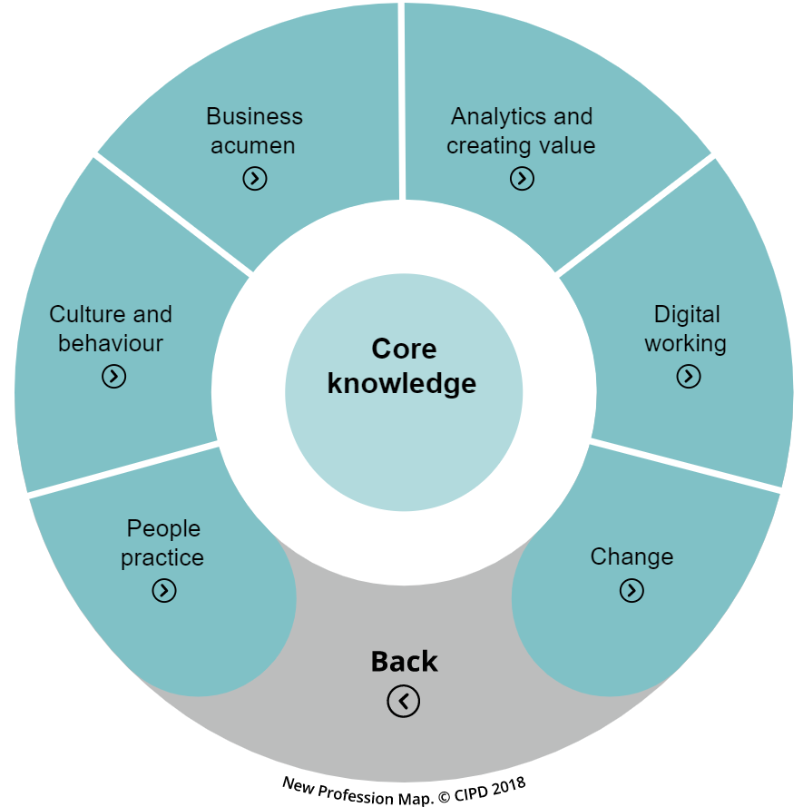
Figure 5: Core knowledge to become an expert professional
(Source: peopleprofession.cipd.org, 2020)

Task 2

Introduction
A human resource objective is an important part of a business organisation as it has direct link with organisational strategic planning, achievements and goals. Human resource can be defined as a set of some division who are responsible for employee recruiting, selecting and training of job applicants. Human resource department people are planning, directing in order to co-ordinate in organisational administrative function (Soonthodu and Shetty, 2020). In addition, this departmental people manage employee, handle conflicts and make good employee relation, payroll and effective employee training. In this paper Morrison Company’s organisational objectives and strategic plans are discussing in three main sections such as planning, recruitment and selection. This paper will help to analyse company’s HR objectives and other planning strategies.

Morrison’s Company profile
William Morison has established Morison Company in the year of 1899 in Bradford and later Ken Morrison has scaled up the company’s operation and business performance and now it has become the fourth largest supermarket in the Supermarket industry of U.K. Currently, the company has been captured 15% share of the U.K. grocery market (Throsby, 2017). The company has made strategy based on service, value and freshness as the company has stated to sell products at lower price than other competitors. The company has organized most of its commercial operations in-house, including processing, manufacturing, packaging, distribution, and transportation thus providing proprietary control over its operations and building ownership to build a strong market player. According to the company’s report, the company has 110,000 employees and has about 494 stores across various countries (Wawer, 2018).
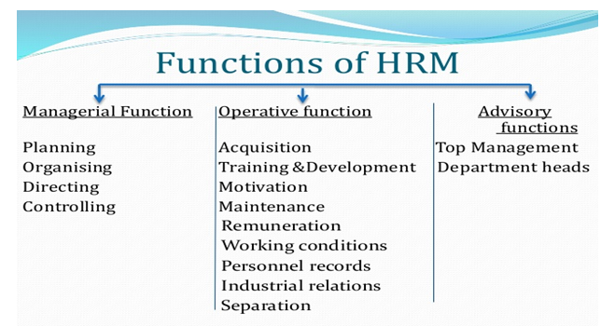
Figure 1: Functions of Human resource development
(Source: Puhovichova and Jankelova, 2020)

Planning
Human resource management has focused on the effective strategy planning and efficient workflows in the entire organisation as it can help to evaluate organisational goals and objectives. It is a modern approach of handling employees and other workers according to their strength and weakness as in this field employees are treated are the main key asset of the organisation. Human resource management plays a crucial role in a business organisation as the team has much responsible to achieve the goals. The functions are planning, organising, directing, managing, maintenance, performance appraisal and so on.

Reason of planning
Human resource planning can be interpreted as a procedure that helps management in decision making. By using this method the company improves its manpower from the current state to the desired situation. The goal of human resource planning is to meet the needs of manpower. The key factors of the planning are as follows:
- Future organisation needs: Human resource management team always fulfil the requirement of man power whenever the organisation require and this department assure that company never think that due to lack of available manpower, the entire business is going down (Puhovichova and Jankelova, 2020).
- Proper utilisation of resource: In case of Morrison Company, planning is used to utilize resources properly through which candidates can get designation as per their expertise subject. Planning is required in order to use the capable employees in proper position which is required most.
- Changes adaption: In an organisation, the changes are very frequent as the manpower plan is designed in an organization that addresses social, economic, environmental, political and technological changes with the time.
- Uncertainty: Uncertainty is a big problem in any organisation but it can occur in any time and so the organisation always requires an advance planning to tackle any condition.
- Proper development of human resources: Human Resource Planning assists in the recruitment of skilled workers and provides timely training and development to adapt its staff to changes.

Stages of human resources planning
Human resource planning is most important in order to manage consumers and employees and it is the most effective planning which can satisfy consumer’s requirement as well as employee satisfaction (Okolie, 2020). Morrison Company has acquired some different stages which are involved in human resource planning and those are as follows-
- Data collection: The organisation has collected the data information in order to meet goals analysing the data information in regards of company.
- Assess the organisational objectives: through analysing internal and external environment of the organisation and the analysing is conducted on budget, company’s turnover, estimate cost and also set future budget.
- Estimate the requirement of employee: In order to maintain the quality of product and service and the company requires to maintain staffs and employees, if there is any big gap between availability and expectations it will be great issue for the company. Morison Company has hired people in order to fulfil yearly turnover.
- Formulation of plan: Human resource planning is for managing people in order to maintain internal and external environment as the HR department requires to think that the company never face issues from key authorities (Piwowar-Sulej, 2017).
- Monitor, control feedback: In the final stage of the HR planning, monitor and analyse the feedback of the work. In case of Morisions Company, selected candidates are sent to store to monitor their work and activities and call for final selection.
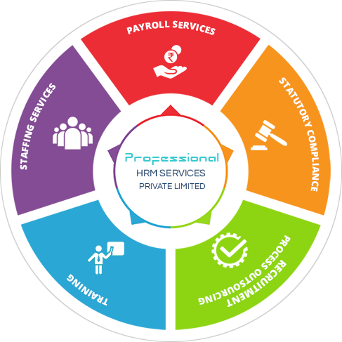
Figure 2: Human resource development services
(Source: Okolie, 2020)

Recruitment
In order to create a powerful employee team, there are some process conducts by analysing job vacancy, requirements, this process is called Recruitment which includes review applications, short listing, screening and select the right candidate. There are some effective steps in order to complete recruitment process such as prepare job description or job profile, finding candidates, manage the application forms and select right candidates. Most of the companies gives advertisement in websites or social media platforms and accept the curriculum vitae and then start the recruitment steps (Okolie, 2020). In case of Morison Company, the recruitment process scenario is different from other companies as the company does not accept any direct curriculum vitae from any candidates. Morison Company is posted every position of the job vacancy in the company website and in the website candidate can apply for the desired post through the given link. According to the job profile, candidates have to submit personal data information otherwise the candidate will be rejected for the next stage. Before face to face interview, the company has conducted a telephone interview which will be conducted over phone call. Over the phone call, candidates are asked various questions according to the job profile and from the candidates the selected candidates are informed for next level which is a face to face interview in the organisational premises. In the face to face interview, company throws some questions related to the job position and academic know ledges and go through related documents (Ngwangwama et al. 2019). Psychometric tests and aptitude tests which should make the process more visible and easy before the interview by knowing the mental state of the candidates before the interview and consequently help them on the screen and save a lot of money for the organization.
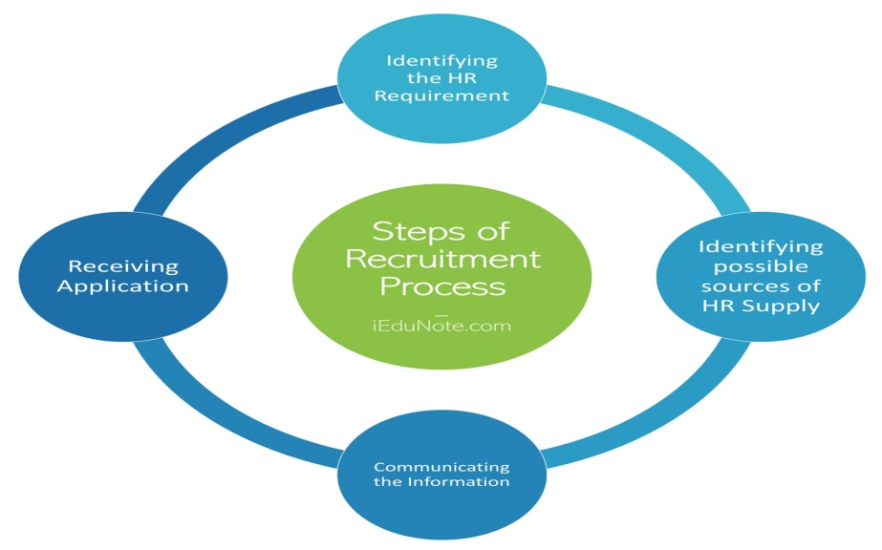
Figure 3: Steps of recruitment process
(Source: Héder et al. 2018)

Selection
HR has important responsibility in the selection process as it is the final stage of recruitment and in this process candidates are selected in order to make an effective organisation. After developing a recruitment plan and now there are number of candidates and need to chose from those candidates. The selection process includes various steps while choosing right employee as there is need right qualification, right value, attitude and skills to work in the organisation (Héder et al. 2018). Although, managers and supervisors are mainly responsible for hiring the candidates and Human resource development just guides managers in selection plan, steps. Selection process is expensive as there are various steps like document verifications conduct interview process and choose. Moreover, in order to test the candidates need to bring those candidates to the out of town. According to a report of US Department of Labour and Statistics, it is stated that in order to hire a new employee the estimated cost will be about $40,000 including direct and indirect cost. There is required to develop policies in human resource planning and training in order to set up an effective organisational structure. After selecting, company HR function should ensure that the company has right balance of employee and staffs. In addition HR function has to arrange training and development programmes so that new employees can enhance skills and knowledge in the specific job section. There are two types of selection process one is traditional method and another is internet based method. Traditional method includes careers fairs, posters, mouth of words, news paper advertisement, paper based CV and internet based method includes web page, online application form, email and online CV submission (Das and Kodwani, 2018). After selecting, Morrison Company has offered an employment contract letter and main objective of this employment letter is to ensure that both employer and employee have clear understanding about the job description. It also help employee to understand about the company’s law, regulations which is need to maintain while working. After all, HR function has the responsibility to know abut the jobs, rules, regulations, training and appraisal performance.

Conclusion
Human resource function has big responsibility in a business organisation as right employees and staffs can develop company. In the above section, three steps planning, recruitment and selection has discussed in perspective Morrison Company and techniques, approaches of this company has discussed. It is concluded that Morrison company has taken an effective concept in human resource management it will be helpful in long term.

Reference
Das, R. and Kodwani, A.D., 2018. Strategic human resource management: a power based critique. Benchmarking: An International Journal.
Héder, M., Szabó, S. and Dajnoki, K., 2018. Effect of labour market changes on HR functions. Anali Ekonomskog fakulteta u Subotici, (39), pp.123-138.
Ngwangwama, M.M., Ungerer, M. and Morrison, J., 2019. Management practices and activities influencing the effectiveness of organisations in Namibia. Southern African Business Review, 23(1).
Okolie, U.C., 2020. Effect of diversity management on human resource management: Recruitment and selection in focus. Annals of Spiru Haret University. Economic Series, 20(2), pp.63-86.
peopleprofession.cipd.org, 2020, professional map. Available at: https://peopleprofession.cipd.org/profession-map [Accessed on 1st December 2020]
Piwowar-Sulej, K., 2017. Achieving HR Function Consistency as a Challenge for HR Practitioners in Project-oriented Organizations. Electronic Journal of Knowledge Management, 15(3).
Puhovichova, D. and Jankelova, N., 2020. Changes of human resource management in the context of impact of the fourth industrial revolution. Industry 4.0, 5(3), pp.138-141.
Soonthodu, S. and Shetty, S., 2020. Innovative Technology and Human Resource Management. In Global Challenges and Strategic Disruptors in Asian Businesses and Economies (pp. 257-269). IGI Global.
Throsby, C.D., 2017. Human resources development in the Pacific. Canberra, ACT: National Centre for Development Studies, Research School of Pacific Studies, The Australian National University.
Wawer, M., 2018. The Use of HR Metrics in Human Resources Management. Przedsiębiorczość i Zarządzanie, 19(3.2), pp.303-317.

