ACADEMIC AND EMPLOYABILITY SKILLS

Introduction:
This essay is designed in order to help the graduate students to understand about the skills and competencies that are required by them in order to be eligible for employment after their studies. Being a student myself, I always wonder about what exactly I am supposed to do after I am done with my studies. Hence, I came up with this module to help myself as well as my fellow student friends with the actual areas that we all need to work upon in order to be eligible for jobs after finishing our studies. I used the Gibb’s reflective model in order to carry out this study is a more easy, elaborative and informational way (Knott & Scragg, 2016). The below module provides details about my personal views, feeling, analysis, evaluation and the action plan that I may undertake in order to build in the required compatibilities in me.
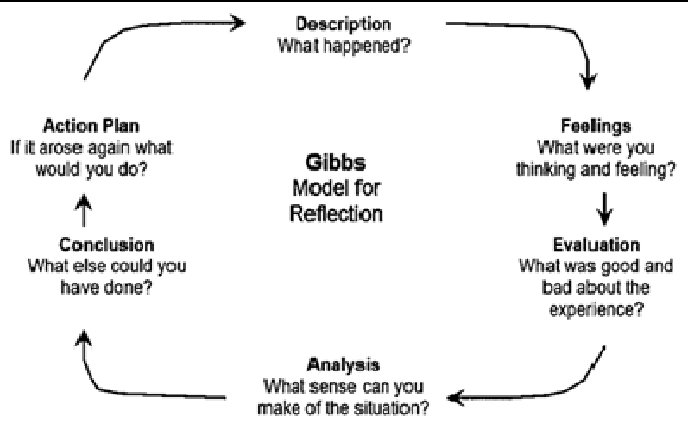
Figure 1: Source: (Knott & Scragg, 2016)

Description:
Unlimited fun and unemployment is good, however, as I am at the verge of completing my studies, I think that getting back to the real world is now necessary for me. I am fascinated about computers and software’s; hence, in order to live this passion of mine I joined a programme for software development. In this programme, I got a chance to attend lectures which concentrated on the academic skills required for business. This topic interested me as it helped me with many additional skills that are required by students in order to pursue their future academics as well as employability skills. Then finally we were given an assignment to write on this topic. I took this as a challenge as this session of the programme was designed to help students in developing their language and skills, as well as analyse our progress on our own.
When we received this assignment, our lecturer had provided us with instructions regarding what we were supposed to write about. Firstly, I had to evaluate all the lecturers happened in the classes and then prepare a reflective essay which would analyse about the strategies and skills required by students to carry on their higher studies, help them to take responsibility of their learning’s, explanation about employability skills like time management, reflection, presentation skills and so on.

Feelings:
When we started with the first chapter of our course, our mentor explained to us about the skills that employers usually look for in the candidate’s In General as well as the skills that we learn as students. From the literature and the knowledge I received from my mentor, I could figure out that there are total of five major qualities that employers usually look for in candidates ‘In General’ which are – Communication, work stability, human relations, capability of research and planning, and finally leadership. Well, all these qualities are required to be available in a candidate who is opting for a managerial position in addition to the academic qualification which is required for such posts.
I came across points that, a good manager is a person who is responsible to plan the proceedings of the organisations, hence, should be a good conversationalist in order to motivate his subordinates to work as per his directions; he should also be able to justify his points as well as fight for his idea and survival in the organisation.
This is the point where I felt that I was a little bad into conversing freely and confidently. This comes under the human relation factor, and now I knew that I had to work hard on this section to achieve my goals in future. This module help me understand that if I wanted to achieve a reputable position in the organisation I would work for in the future, then being good with communication is one of the most important quality that I should possess mandatorily.
Working on communication skills would need to work on many factors like – negotiating, providing appropriate feedback (negative and positive), interviewing, motivating, handling nonverbal messages appropriately and many more. While I was thinking about all these factors, I felt as if I was now being transformed from a teenager to an adult who was thinking about his future very seriously and taking sincere efforts working towards it. I was now clear that I had to make changes to my present life and make it more disciplined and organised in order to imply the skills that I have mentioned above. While working on this assignment I realised that the path towards success is definitely not easy and needs a lot of compromises and dedication, and this sincere effort and sacrifice makes the success fruitful.
Thankfully we have our high schools with all their literatures and academic courses that help us with developing such skills as students. Meeting deadlines is one of the important skills that such academic assignments teach us. I am pretty much aware of the importance of this word in the corporate world. In addition to this the various other skills that I evaluated to carry out the further studies as well as to be eligible for my dream job are as below;
- Time Management: A student’s life is full of assignments, courses, tuitions as well as leisure and fun. On the other hand a manager’s life is full of work, work and work. Hence, Time Management in both the situations is very necessary (Tracy, 2014). As a student time management helps in organising studies and completing the given assignments on time, and as a manager, time management is essential to carry out the daily business activities efficiently and meeting the deadlines. I feel that a lazy person like me needs to develop this skill a lot and I need to work very hard towards it.
- Leadership: Academic studies give us opportunities to work in groups. As we all know every group may be small or big, may be formal or informal is lead by a leader where others usually follow him. It’s necessarily not needed that a person who can lead an informal friends group is eligible to be a good corporate manager. Leadership is an inbuilt quality (Pich & Messenger, 2017). Being an introvert I know leadership is something that I am lacking behind but I need to work towards it to make sure that by the end of my academics I am competent enough with this skill.
In addition to these there are many more qualities required which are problem solving, decision making, administrative skills and so on.
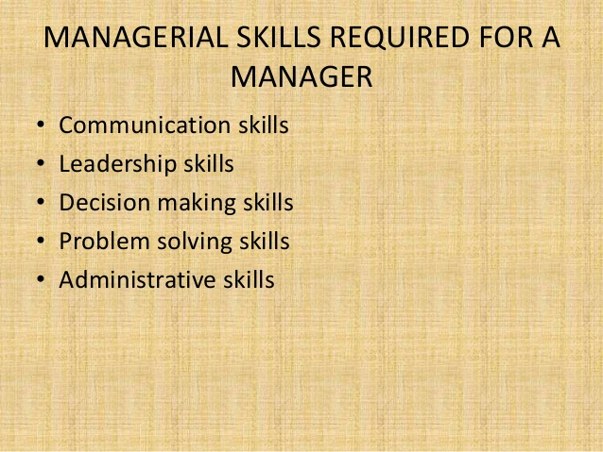
Figure 2: Source: (Abbajay, 2018)

Evaluation:
In order to evaluate about the bad and good about myself and to know how compatible I am with the qualities mentioned above, I decided to understand my strengths and weaknesses by doing a SWOT analysis on myself. Below are few of the good and bad things I recognised about myself while working on this assignment (Manktelow & Birkinshaw, 2018);
- Strengths: We were made to work in groups in our high school while working on various assignments given. Remembering my performances as a group member I felt that though I was a little back in communication, still I was always able to put forth my suggestions and thoughts effectively in front of others. I know I need to work on my effective communication, still the ability to easily explain my views and thoughts can be added as my strength. As I said earlier, I have love for computers and technology, hence, my technical skills are sound and I usually do well in my learning’s as well. These two qualities are also important for me to be a successful employee in future.
- Weaknesses: Having no experience about employment is one of my weaknesses; I can overcome this by opting to join a part time job along with my studies so that I get an experience of being employed under a manager. Communication is also my weaker section; I also face difficulties in problem solving.
- Opportunities: If I get an experience certificate as an employee along with the academic certificates, then I would be more employable as compared other students of my year. Working in groups and team would help mw with building corporate skills of team work, maintaining deadlines, setting targets, etc.
- Threats: As the trend of employability is increasing on a huge rate, the threat of job scarcity always prevails and hence I should be grabbing the opportunities without wasting much time.
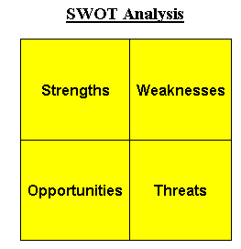
Figure 3: Source: (Manktelow & Birkinshaw, 2018)
Working on the assignment was very exciting; the good part was that I could evaluate some qualities about myself which are essential for me to succeed in both my academics as well as career. The only bad part is that the threat of scarcity of job can become even more for me due to my weaknesses, hence, working on my weaknesses would be my priority hence forth.

Analysis:
At present I am into a learning phase. The present situation is highly feasible for me to develop my skills to achieve my future goals. I think that the literature theories that are taught to us in the academic courses are very helpful for us to develop the skills and capabilities that most of the employers would look for while hiring us for their business. While working on this assignment, I was able to know more about my capabilities and qualities as well as the steps and actions that I can take in order to excel my weaknesses. I have decided to do a part time job to get the experience in the field that I want to excel in future. I think that this decision developed in me only because of this assignment. I know that my weaknesses are serious, especially the lack of communication, hence, working with an experienced team would help me develop good communication quality in me. Getting feedback from my managers and supervisors will help me to analyse their behaviour at the management position. Referring to the previous modules of the same topic helped me to work on this assignment more easily. At the beginning I was completely unaware of what exactly is required by me to achieve my set goals, however, as I proceeded with this study, I could understand that the skills that are required by me to complete my academic studies efficiently are apparently the same which are required to be a successful manager in the future as well.

Conclusion:
After I am done with the assessment, I can say that now I am pretty confident about the skills and competencies that are required by me to complete my academic studies as well as become a successful employee in the chosen faculty. However, I think that rather opting to work for any available job, I should rather prefer to work in the field that I want to be a part of in the future. As my section is computer and software learning’s, I should search for job which is related to this section. I know scarcity of job and lack of experience can be a constraint for me to get hired as a member in such industry at present, however, I think I should first start searching for a job in this section and then I should divert to other sections.

Action Plan:
Presently, my only action plan is to concentrate on the skills that I have identified above. These skills would help me to excel in all the tasks I would be undertaking as a student as well as a manager in future. It’s very essential for me to develop these skills and work hard towards overcoming my weaknesses at the earliest. My strengths need more strengthening. Though this assignment is completed, but I believe that it has given a kick start to my efforts of being successful in my career. I understand that to be successful, learning and evaluating new skills and competencies is a never ending task. Apart from communication, there are many more areas that I need to work on like – decision making, people handling, being up-to-date with my technical knowhow’s, and so on. I know with proper practice, hard work and determination I would definitely be able to achieve my goals. All thanks to this module that made me feel so confident about my career choice.

References:

Abbajay, M., 2018. Managing Up: How to Move up, Win at Work, and Succeed with Any Type of Boss. New Jersey: John Wiley & Sons.
Knott, C. & Scragg, T., 2016. Reflective Practice in Social Work. 4th ed. Exeter: Learning Matters.
Manktelow, J. & Birkinshaw, J., 2018. Mind Tools for Managers: 100 Ways to be a Better Boss. New Jersey: John Wiley & Sons.
Pich, D. & Messenger, A., 2017. Leadership Matters: 7 Skills of Very Successful Leaders. Brighton VIC: Major Street Publishing.
Tracy, B., 2014. Time Management (The Brian Tracy Success Library). reprint ed. New York: AMACOM.

