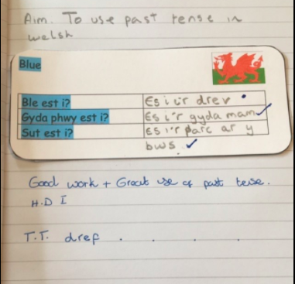

This evidence shows a marked piece of work. The learner had misspelt dref. This was therefore marked with a blue dot and addressed in a tiny task underneath the work.

