Elliott Oakes
Health, Safety and Risk Assessment
Pitch
Trapped is a short film set in 1980 where a radioactive spike has recently been discovered. Over the past month a substantial amount of unusual activity has been reoccurring near Dolouchi Gold Mine. Local civilians have been mystically disappearing including the beloved wife and children of the protagonist. The curiosity of a 25-year-old miner has become intolerable, leading him to inevitably investigate the abandon mine.
After mining for 2 weeks progression has been made however, not quick enough for the egger protagonist. In a desperate attempt to discover what happened to his family, disaster strikes. Dynamite is used to demolish the mines walls. The explosion causes a substantial amount of rocks to collapse, consequently blocking the entrance. This leaves the Rhys trapped, alone and terrified.
Scenario outline
Scene eight, Disaster Strikes (INT– site of Dolouchi Gold Mine): The scene begins with Rhys inside the cold, dim lit mine slowly chipping away at the wall. Each pickaxe swing becomes slower against the jiggered rock formation. Due to exhaustion Rhys collapses unexpectedly. A medium close-up shot will be used as Rhys attempts to position himself against the rough grey rocks. To reminisce about his family, he slowly pulls out an old crumbled photograph. The camera is positioned over Rhys’s shoulder as it slowly zooms onto the family photograph.
A flash back transpires engrossing the audience into the sentimental value of the photograph. The memory comprises of Rhys’s wife and two children skipping in a circle holding hands. The camera will slowly rotate around the family encapsulating their cheerful facial expressions. Once the camera rotates behind Rhys the family vanishes. To stimulate the audience’s emotions a mid-shot of a tear slowly dripping down his face will occur. Integrating a flash back engulfs the audience into his historical past.
The Scene
The next shot is a wide-angle tracking shot of Rhys wiping away his tears. A sudden urge of determination arises after memorizing his family. The camera slowly pans down towards the floor revealing 3 sticks of dynamite. A mid close upshot will be used to show Rhys smiling to himself as an idea arises.
The next shot is slowly zooming out as Rhys picks up the dynamite. A mid-side shot will be used revealing three sticks of dynamite being strapped to the wall. To make the scene more dramatic and aesthetically pleasing an extreme static close up will be used to show the dynamite igniting. The camera will then slowly pan out as Rhys runs away to find shelter.
Due to the massive explosion the cave starts to unexpectedly collapse. A wide angle lends will be used to immerse the audience as the massive rocks fall from the ceiling. The camera will shake erratically but staying in the same position as the rocks fall. This will make the scene look more dramatic and realistic.
The final shot is the caves entrance collapsing consequently blocking the entrance. To capture this frame the camera will remain stationary whilst positioned outside the cave. This leaves the Rhys trapped, alone and terrified.

Mood Board

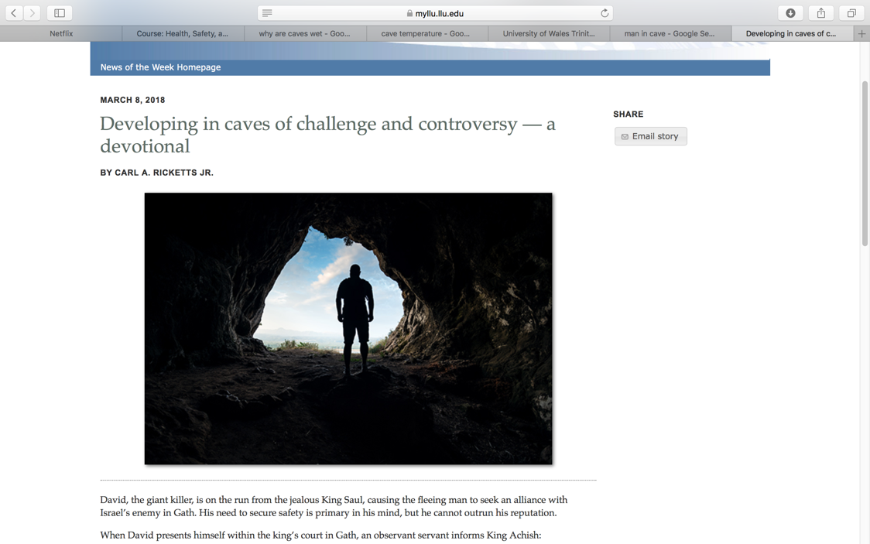
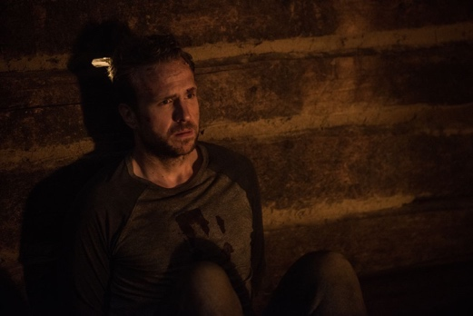
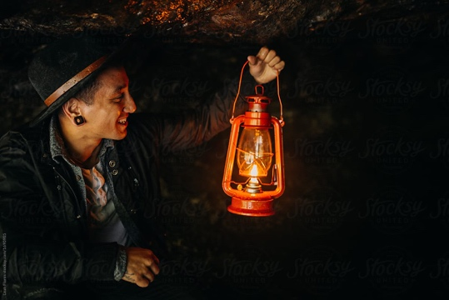
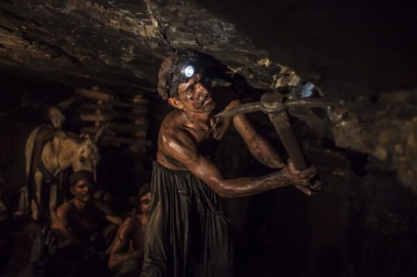
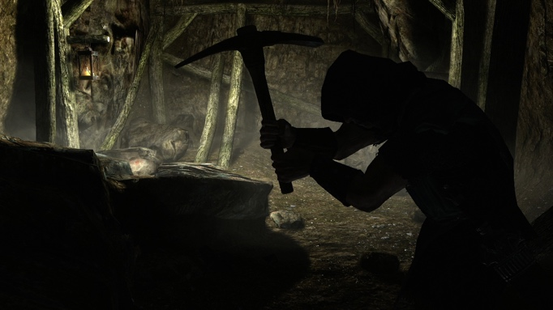
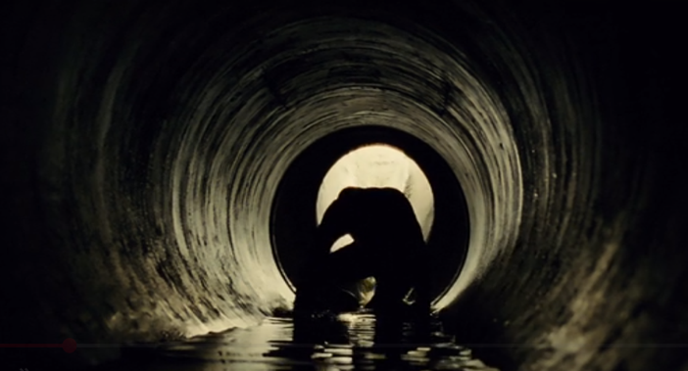
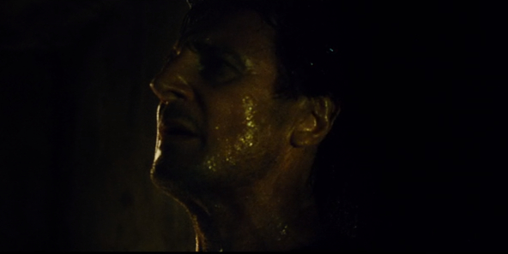
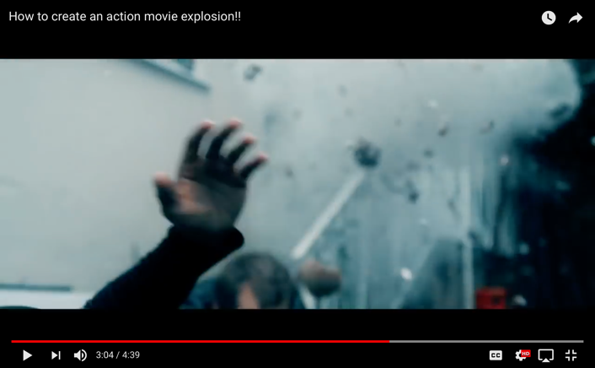
To gain a visual representation of what the short film will look like I decided to create a mood board. This is extremely advantageous because aesthetic look and tone can be determined.

To provide a visual representation the pictures above are extracted from numerous films. The frames captured are similar to the ideas generated within the films storyboard below. The inside of the mine is extremely dark due to very little natural light entering the facility. Comprising multiple images together enabled me to understand how other films created light inside dark environments. A variety of different shots have been implemented such as close up, tracking and mid shots. Theses shots are idealistic for the environment due to the confine space. Its interesting to see how other films worked within a similar environment. For my film the majority the shots above will be incorporated due to the overall aesthetics achieved.

Dynamite explosion scene
The explosion scene consists of a significant number of health and safety concerns. Its fundamental none of the cast and crew members become injured, therefore certain procedures and regulations must be enforced. There are two primary ways to create the explosion scene via CGI or specific equipment.
Using CGI to create the explosion would be a fantastic way of ensuring nobody gets hurt. It is relatively cheap method however, time consuming. There are some fantastic software’s out there such as Adobe Aftereffects that have the functionality to create an astonishing explosion. However, there are some draw backs to using CGI. For example, it would be difficult to digitally create a realistic explosion that is bouncing off the actor or the debris falling and interacting with the scene.

The other alternative is to use practical effects. Although slightly dangerous it is still significantly better than using real explosives. Films such as “Saving Private Ryan’s” directed by Steven Spielberg and “Glory” by used an air canon to replicate the explosions. An air cannon is a fantastic practical, safe and realistic method to create the effect on an explosion.

In conclusion the effect of an explosion will be created using an air cannon instead of CGI. Implementing the correct health and safety regulations will ensure that none of the crew or cast are at danger. Using an air canon would create a realistic effect making the film aesthetically pleasing for the audience to watch.

To ensure the air canon is safe to use, specific regulations and control measure have to be put into place. It’s important Dolaucothi Gold mine is aware
- The cast and crew have to be at least 14 away from the explosion
- The air cannon is strategically situated and secure
- A fire extinguisher will be required in case of an emergency
- Mark where the explosions will occur
- Emergency arrangement’s
- Easy accessibility to a fire exit

Collapsing Rocks

To create the impression the rocks are collapsing certain effects and probs will be used. The rocks will be constructed from polystyrene therefore, poses very little treat to the crew and cast. The rocks will look realistic due to the shape and tones incorporated.

To make the scene look as realistic as possible certain in camera effects will be used. To make the walls collapsing look aesthetically pleasing I will gain inspiration from existing films.
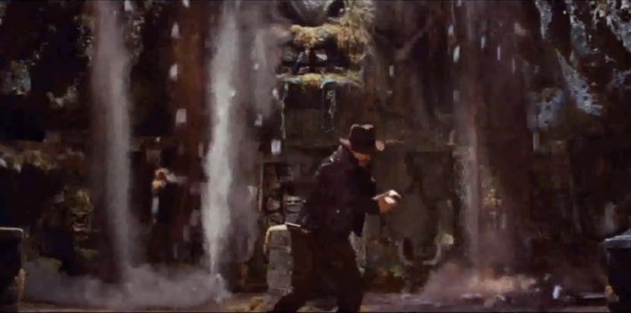
The picture to the left is a scene from India Anna Jones and the Temple Of Doom. To make the scene look realistic certain aspects have been incorporated. Dust is falling from the ceiling; the camera is shaking, and rocks are falling from the ceiling. All three aspects are in camera effects that made the scene look extremely realistic and safe to perform.
The techniques used to create this scene work exceedingly well. For my short film I will use the same practical effects due to how safe and realistic the end result was. CGI could have been used however it would be more time consuming and expensive.

 | Risk Assessment Form –  Part A

Production Name:  Which Assessment? | Trapped | Module: | Health, Safety, and Risk Assessment
Emergency Services Contact:  E.g Police, Fire service etc | Llandovery Hospital SA20 0LA Tel: 01550 722200  Brecon Mountain Rescue 32 Ffrwdgrech Rd, Brecon LD3 8LA Tel. 01874 611347
Start date | 20/11/2019, 7:00am | End date | 24/11/2019, 14:00pm
Distribution  Who gets a copy of the assessment | Executive Manager, Producer and Location Director
Outline of risk assessment  Summary of what is proposed in terms of sequences and set ups. | Filming inside Dolaucothi Gold mine as the miner attaches 3 sticks of dynamite to the wall. The camera will be situated behind the miner’s shoulders capturing the event. The next sequence is the rocks collapsing barricading the entrance of the cave.
Team members / experts / contractors / contributors etc.  List those involved | Producer Will Sharp Executive Producer James Lewis Production Manager Kan Chung Yu Production Coordinator Liam Tripp 1st Assistant Director Joe Barthorpe
Locations  Outline locations involved – indicate any which are hostile environments | Dolaucothi Gold mine, Pumsaint, Llanwrda SA19 8US
Assessor Name  Signature | Elliott Oakes | Date completed | 25/10/19
Authoriser Name  (if not Assessor) Signature |  | Date authorised

Hazard list – select your hazards from the list below and use these to complete Part B
Situational hazards | Tick | Physical / chemical hazards | Tick | Health hazards | Tick
Assault by person |  | Contact with cold liquid / vapour |  | Disease causative agent
Attack by animal |  | Contact with cold surface |  | Infection
Breathing compressed gas |  | Contact with hot liquid / vapour |  | Allergic reaction
Cold environment | x | Contact with hot surface |  | Lack of food / water
Crush by load |  | Electric shock |  | Lack of oxygen
Drowning |  | Explosive blast | x | Physical fatigue
Entanglement in moving machinery |  | Explosive release of stored pressure |  | Repetitive action
High atmospheric pressure |  | Fire |  | Static body posture
Hot environment |  | Hazardous substance |  | Stress / anxiety | x
Manual handling |  | Ionizing radiation |  | Venom poisoning
Object falling, moving or flying | x | Laser light
Obstruction / exposed feature |  | Lightning strike |  | Environmental hazards
Sharp object / material | x | Noise |  | Litter
Shot by firearm |  | Non-ionizing radiation |  | Nuisance noise / vibration
Slippery surface | x | Stroboscopic light |  | Physical damage
Trap in moving machinery |  | Vibration |  | Waste substance released into air
Trip hazard | x |  |  | Waste substance released into soil / water
Vehicle impact / collision |  | Managerial / organisational hazards
Falls from height |  | Management factors (lack of communication, co-operation, co-ordination and competence)

Risk matrix – use this to determine risk for each hazard i.e. ‘how bad and how likely’ | Likelihood of Harm
Severity of Harm | Remote  e.g. <1 in 1000 chance | Very unlikely  e.g. 1 in 200 chance | Unlikely  e.g. 1 in 50 chance | Possible  e.g. 1 in 10 chance | Likely  e.g. >1 in 3 chance
Negligible e.g. small bruise | Trivial | Trivial | Trivial | Low | Low
Slight e.g. small cut, deep bruise | Trivial | Trivial | Low | Low | Medium
Moderate e.g. deep cut, torn muscle | Trivial | Low | Medium | Medium | High
Severe e.g. fracture, loss of consciousness | Low | Medium | High | High | Extremely high
Very Severe e.g. death, permanent disability | Low | Medium | High | Extremely high | Extremely high

Risk Assessment Form – Part B

Activity¹ – The cave walls collapse, barricading the entrance. |  |  | Location – Dolouchi Gold Mine | Dates / times:
Hazards²  List what could cause harm from this activity  e.g. falls from height, trip hazard, fire, etc. | Who exposed  List who might be harmed from this activity  e.g. staff, contractors, contributors, public, etc. | Risk³  For each hazard, decide level of risk as if you were to do the activity without your controls | Control measures  For each hazard, list the measures you will be taking to minimise the risk identified  e.g. appointing competent persons, training received, planning and rehearsals, use of personal protective equipment, provision of first aid, etc. | Risk³  For each hazard, decide level of risk once all your controls are in place
Sharp objects | The Crew and Cast | Medium | Before entering the mine, everybody will be provided with the correct safety equipment. The mine has a substantial number of sharp / rough surfaces therefore, it’s imperative the correct equipment is warn. To minimise the risk of injury hard hats with touches attached will be provided by the staff at Dolouchi Gold Mine. Prior to entering the mine, the crew and cast will be informed of the health and safety regulations. | Trivial
Slippery surface | The Crew and Cast | High | Prior to entering the mine the cast and crew will be given a health and safety debriefing. Its imperative everybody is informed to ensure each individual is aware of specific hazards. To diminish the risk of anyone falling its fundamental appropriate shoes are warn. Walking boots are idealistic due to the grips incorporated, this will drastically improve stability. Certain areas within Dolouchi Gold Mine are extremely slippery, wet and dark. To reduce the possibility of anybody slipping a head touch will be provided. This will enable the crew and cast to have better visibility when inside the mine. Due to the floor being extremely slippery rubber walkways will also be placed down. This will drastically minimise the risk of the crew and cast slipping. | Trivial
Trip hazard | The Crew and Cast | Medium | Dolouchi Gold Mine is extremely dark due to no natural light entering the vicinity. This means lights will be required to light up the location. The cables will run alongside the cave wall to prevent people from tripping over them. The wires will be kept together with glow in the dark cable ties therefore, minimising the trip hazard. The mine has a significant number of uneven surfaces. Its fundamental the crew and cast attend the health and safety briefing to ensure individuals know what to anticipate before entering the mine. | Trivial
Cold environment | The Crew and Cast | Medium | The inside of Dolouchi Gold Mine is relatively wet and cold. This is primarily due to time of year the scene will be shot. During November the weather is mainly raining, consequently increase the occurrence of water dripping from the ceiling. To ensure the crew and cast are comfortable and warm its essential waterproof clothing is warm. This will prevent individuals from becoming cold and wet. A heated shelter will be provided to ensure everyone is kept out the cold environment and warm. I highly recommend wearing warm clothing underneath the waterproof clothing to reduce the possibility of becoming cold. | Trivial
Object falling, moving or flying | The Crew and Cast | Medium | Inside of Dolouchi Gold Mine the likelihood of rocks falling naturally is extremely low. The primary reason for this is because the site is a tourist attraction therefore, specific health and safety regulations had to be met. However, a specific scene with the short film consists of rocks collapsing blocking the entrance. Artificial rocks will be constructed from polystyrene to ensure none of the cast or crew become injured. Its fundamental everybody is informed / briefed that the rocks used aren’t real. It’s also important that no one is around the surrounding area when the rocks collapses, this will drastically reduce the chances of anybody becoming hurt. | Trivial
Explosive blast | The Crew and Cast | High | Using an air canon can be very dangerous. To reduces the risk of anybody hurting themselves it’s important that the crew and cast are at least 10m away. The reason this distance is appropriate is because the debris will not reach that far therefore safe. Its important googles are warn | Trivial
Stress / anxiety | The Crew and Cast | Medium | Some of the crew and cast might suffer from claustrophobia. To reduce the risk of an attack occurring its important a debriefing ensues prior to entering the mine. This would help individuals who suffer from claustrophobia aware of the environment before entering. In an event of a claustrophobia attack a fire exit is available. Before filming its fundamental the crew and cast are made aware the dynamite and rocks are constructed from rubber and polystyrene. This will reassure everybody that the probs used aren’t real and safe to be around. | Trivial

Executive Producer: James Lewis  Producer: Will Sharp  Director: Elliott Oakes  1st Assistant Director: Joe Barthorpe  Production Manager: Kan Chung Yu  Production Coordinator: Liam Tripp | Trapped | DATE: 20/11/19  SHUTTLE INFO:
WEATHER:      Sunrise Sunset  06:40 5:00  First Aid kit and fire extinguisher at the craft table. | CALL TIME  07:00  Check grid for individual call times | LUNCH  13:00

Production Office |  |  |  | Nearest Hospital to Set
Llandovery Hospital SA20 0LA
Tel: 01550 722200
LOCATIONS
# |  | Location | Address |  | Parking |  |  | Contact
1 |  | Dolaucothi Gold Mine | Pumsaint, Llanwrda Sa19 8US |  | Street Parking available at the front of the facility |  |  | Eddie  C: 01558 650177
Scene | Description |  |  |  |  | Cast | Pgs |  | Loc
8 | Rhys is resting against the caves wall as the flash back finishes. |  |  |  |  | Rhys | 10,11 |  | Dolaucothi Gold Mine
8 | Rhys notices the 3 sticks of dynamite, smiling to himself as an idea arises. |  |  |  |  | Rhys | 11,12 |  | Dolaucothi Gold Mine
8 | The three sticks of dynamite are strapped to the wall, ready to be exploded |  |  |  |  | Rhys | 11,12 |  | Dolaucothi Gold Mine
8 | Rhys ignites the dynamite and runs away to find shelter as the fuse becomes shorter |  |  |  |  | Rhys | 12,13 |  | Dolaucothi Gold Mine
8 | The dynamite explodes, causing the cave to shake |  |  |  |  | Rhys | 12,13 |  | Dolaucothi Gold Mine
8 | The explosion causes a substantial amount of rocks to collapse, consequently blocking the entrance |  |  |  |  | Rhys | 13,14 |  | Dolaucothi Gold Mine
 |  |  |  |  |  |  | TOTAL PAGES: |  | 4
# | Cast | Role | Call Time | Pick Up Time | MU/WD | Set Call
8. | Rhys | Miner | 7:00 | 6:00 | No | 9:00
8. | All crew |  | 7:00 | 6:00 | No | 8:00

Extras/Background
N/A
Transportation
Minibus
Craft – Hot & Ready @
Cast/Crew Subs x 6 @ 13:00
Catering
Cast/Crew Lunch x 6 to be Hot & Ready @ 13:00 to be served @ 13:10
SET REQUIREMENTS
Props: polystyrene rocks, rubber dynamite and pickaxe
Special Effects: Air canon
Vehicles: N/A
Wardrobe: Old brown donkey jacket, black steel toe cap boots, loose fitting blue denim trousers, white hard hat, grey old t-shirt, lantern and rubber dynamite

Makeup: Rhys (the miner) will have his face covered in dirt

Set Dressing: Miners clothing

Stunts: fake explosion, collapsing ceiling

Producer  NAME Will Sharp  PHONE NUMBER 07895633567 | Executive Producer: NAME James Lewis  PHONE NUMBER 07836123549 | Production Manager  NAME Kan Chung Yu  PHONE NUMBER 07245829563 | Production Coordinator  NAME Liam Tripp  PHONE NUMBER 0716352854 | 1st Assistant Director  NAME Joe Barthorpe  PHONE NUMBER 0763385319

PRODUCTION NOTES
Production Note 1: Hard hats with a touch attached must be worn when inside the mine.  Production Note 2: Food is available at Dolaucothi Gold Mine cafeteria.  Production Note 3: A first aid kit will be provided inside the cafeteria for easy accessibility. | Note: No guests are allowed to enter the facility until filming is  complete.  Note: Due to cold weather and slippery surfaces it’s imperative the  correct equipment is worn to prevent injury.  Note: Brief the crew and cast that the dynamite is a prob.

DEPT | NAME | IN | DEPT | NAME | IN
PRODUCTION |  |  | ART DEPT
Producer | Will sharp |  | Production Designer
Producer |  |  | Art Department
Director | Elliott Oakes |  | Art Department
Production Manager |  |  | HAIR/MAKEUP/WARDROBE
Production Coordinator | Liam Tripp |  | Key
Production Assistant |  |  | Assistant
Production Assistant |  |  | Assistant
AD’S |  |  | CONTINUITY
1st Assistant Director | Joe Barthorpe |  | Script Supervisor
2nd Assistant Director |  |  | LOCATIONS
3rd Assistant Director |  |  | Locations Manager | Joe barthorpe
CAMERA DEPT |  |  | SOUND
Director of Photography |  |  | Production Sound Mixer
1st Assistant Camera |  |  | Boom Operator | Kan Chung Yu
2nd Assistant Camera |  |  | STUNTS
Camera Trainee |  |  | Stunt Coordinator | Kan Chung Yu
GRIP & ELECTRIC DEPT |  |  | CATERING/CRAFT
Key Grip |  |  | Catering
Best Boy Grip |  |  | Craft
Grip |  |  | DRIVERS
Gaffer |  |  | Driver Coordinator
Best Boy Electric |  |  | Driver
Electric |  |  | First aider | Liam tripp
Swing |  |  | Driver

Emergency Plan

In case of an emergency its fundamental an emergency plan is implemented. If a serious injury ensues such as, electrocution or an explosion, specific procedures are executed. It’s extremely advantageous having an energy plan because it can drastically reduce the consequences of an injury. Effective and quick action may reduce the likelihood of the situation spiralling out of control. Unfortunately, in emergencies people rarely respond reliably unless they are:
- Competent and trained
- Regularly participated in realistic situations

To ensure the crew and cast are safe it’s imperative an emergency plan is briefed. Everybody must know how and what emergency services number to call.

1.To make the premises safe during the collapsing ceiling and explosion scene its important the crew and cast is reasonable distance away.
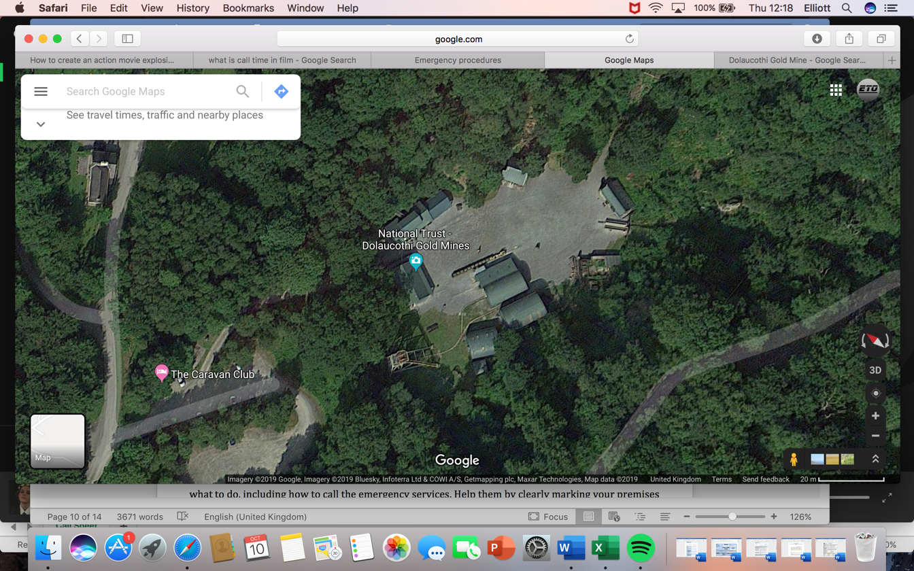
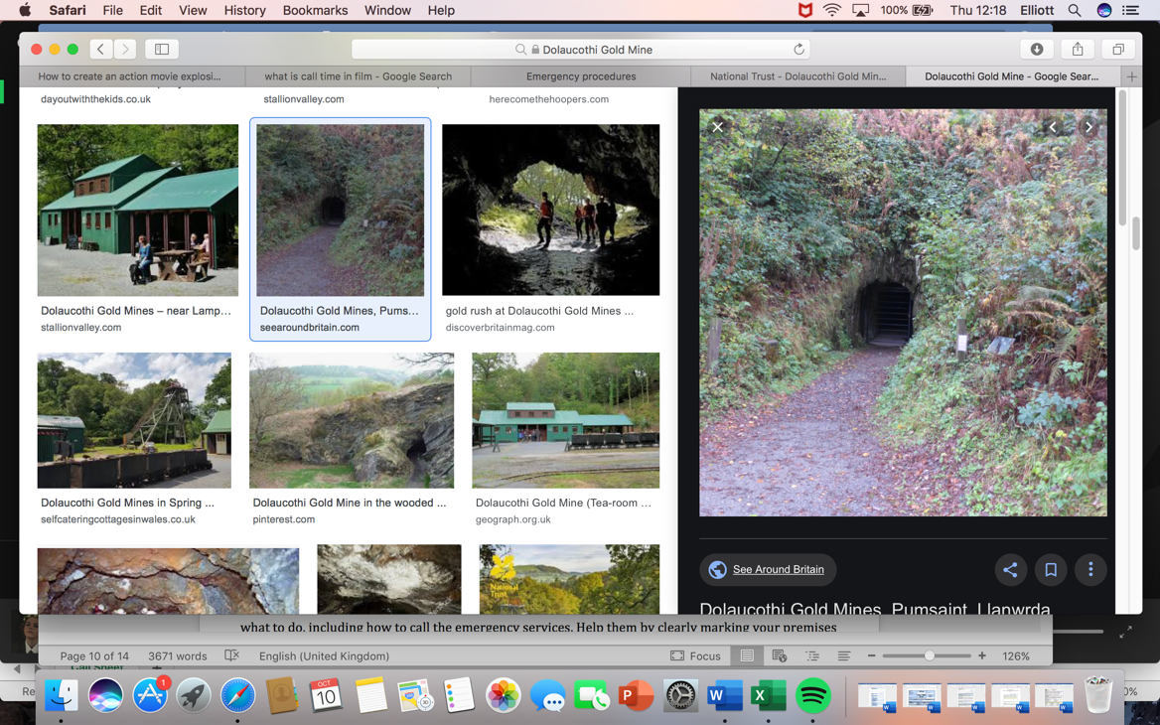
No one is allowed near the mine whilst the collapsing ceiling and explosion scene is occurring.

Safe zone

2. In case of an emergency the crew and cast must reach a place of safety. The image below shows the emergency meeting point.

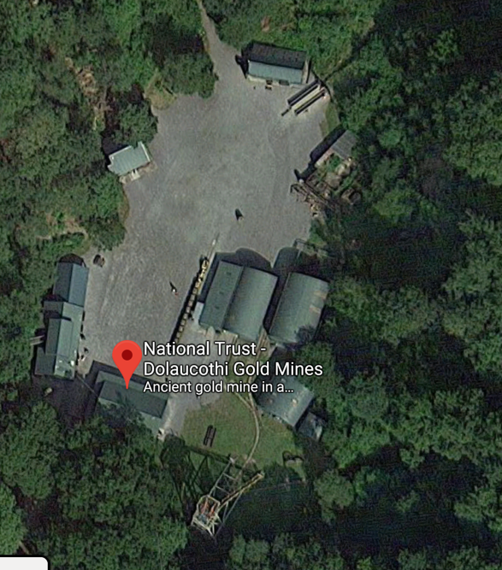

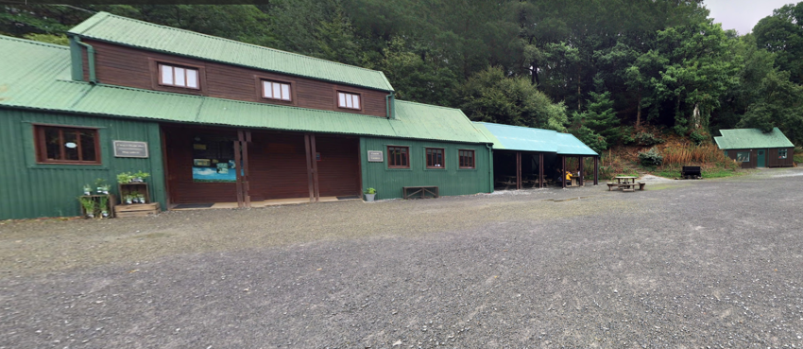

The building provides shelter and is a reasonable distance away from the mine in case of an emergency.

3. Liam Tripp is a competent individual who is first aid trained. This is idealistic because he has the correct knowledge, necessary skills and experience. This means he also has the role and responsibility of a first aider.

4. Dolaucothi Gold Mine is a straight tunnel that has 3 fire exists available. These fire exits are situated at the front, end and middle of the tunnel. The entrance gate will remain open in case a fire outbreak. It’s essential the escape routes are clearly marked and unobstructed.
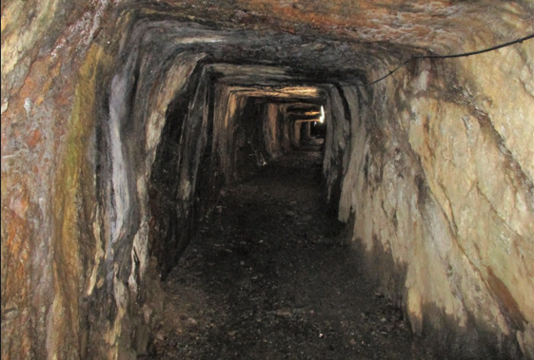

The picture to the right is the inside of Dolaucothi Gold Mine. It’s evident the mine is quite narrow therefore, its important everybody know exactly where to go in an event of an emergency. The fire exits are light up therefore, can been seen in the dark.

Camera Shot List

Scene | Shot | Shot angle | Movement | Time of day | INT/EXT | Shot Description | Notes
8 | 1 | Mid Shot | Slowly pans down toward the right | Morning | INT | The camera slowly pans down towards the floor revealing 3 sticks of dynamite | Dripping water can be heard.
8 | 2 | Close-up shot | Tracking slowly towards the right | Morning | INT | A close-up shot is used to capture Rhys smiling to himself. | A slight exhale is heard as he smiles
8 | 3 | Mid shot | Still | Morning | INT | A mid-side shot will be used revealing three sticks of dynamite individually being strapped to the wall
8 | 4 | Extreme close up | Still | Morning | INT | An extreme close up showing the dynamite igniting | Fuse burning can be heard
8 | 5 | Wide shot | Pans out | Morning | INT | Rhys runs away from the ignited dynamite | Erratic panting whilst running
8 | 6 | Mid shot | Shaking | Morning | INT | Dynamite explodes | Explosion
8 | 7 | Wide shot | Dolly run | Morning | INT | Massive rocks collapse from the ceiling | PPE must be warn
8 | 8 | Mid shot | still | Morning | EXT | The explosion causes a substantial amount of rocks to collapse, consequently blocking the entrance

Participant Fitness Review

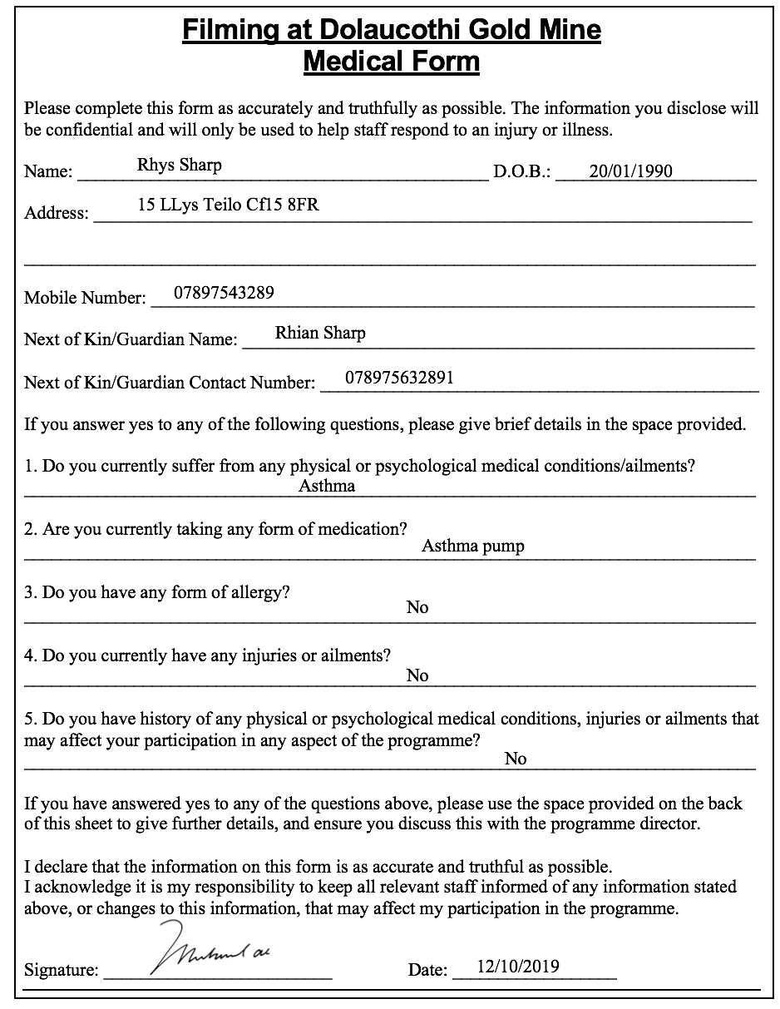
To ensure the crew and cast are physically fit its important a fitness review is carried out. It’s important to understand what medical issues individuals suffer from because certain scenes are physically demanding. Understanding people’s fitness levels will enable the shoot to be significantly safer. In the event of an emergency the medical form will provide relevant information concerning the individual’s current medical conditions.
Please use the space provided below to expand on any of the information you have given overleaf.

Diagnosed with asthma since the age of 8.

After reviewing the form, it is apparent that Rhys suffers from asthma. This won’t affect the scene because very little movement is required. However, it is imperative an asthma pump is brought with him in case an asthma attack occurs. To reduce the chances of Rhys having an asthma attack regular breaks will be offered.

Recce Sheet

Title of production Trapped Date of recce: 10/11/2019
Location: Dolaucothi Gold Mine
Present: Producer Will Sharp Executive Producer James Lewis Production Manager Kan Chung Yu Production Coordinator Liam Tripp 1st Assistant Director Joe Barthorpe

Please indicate Comments/Details
Yes/No for each area
Local Condition:  • Any known problems  If yes, please detail (including source of information)  • Aid needed  If yes, please detail name, address and contact numbers for each person/organization  • Permission needed  • Protective clothing needed  If yes, please detail | No □ Yes □  No □ Yes □  No □ Yes □  No □ Yes □ | N/A  N/A  To gain accessibility to Dolaucothi Gold Mine permission has to be attained from Eddie the manager.  - Hard hat with touch attached  - Walking boots  - Appropriate warm clothing  - Waterproof cloths
Viewpoints:  • Appropriate viewpoints isolated  • Any obstructions  • Easy to reach and safe  If no, please detail requirements | No □ Yes □  No □ Yes □  No □ Yes □ | The scene takes place within a mine therefore, once inside the crew and cast are no longer visible. The inside of the mine has good visibility due to the head touches warn. The mine has a few corners therefore, not appropriate viewpoints. To overcome this walkie talkies will be provided.  N/A  In an event of an emergency the mine can be accessed via three different routes.
Requirements:  • Power available  If no, please detail alternative arrangements  • Lighting appropriate  If no, please detail alternative arrangements  • Sound equipment (please detail)  Anticipated problems:  • Sound  If yes, please detail  • Picture  If yes, please detail  • People  If yes, please detail  • Other  If yes, please detail | No □ Yes □  No □ Yes □  No □ Yes □  No □ Yes □  No □ Yes □  No □ Yes □  No □ Yes □ | To generate electricity a generator will be required. It’s imperative the operators are wearing composite insulating gloves class 3 to drastically reduce the possibility of getting electrocuted.  To acquire appropriate lighting specific equipment will need to be purchased. 3-point lighting is idealistic to create perfect lighting in dark environments. The lights will be purchased from Amazon .  To capture the sound a Tascam will be used. This will be purchased from Dawsons
Dripping water from the caves ceiling.

N/A

N/A

N/A
Other considerations (please provide details for each):  • Security considered  • Welfare considered (transport, food, First Aid etc.)  • Set dressing required  • Props required | No □ Yes □  No □ Yes □  No □ Yes □  No □ Yes □ | The site is secure  A minibus will collect the crew the cast from a set location to Dolaucothi Gold Mine. A first aider will be available on set in case of an emergency. A cafeteria and toilet are assessable on site.  N/A  The probs will be purchased from eventprophire. The company produce realistic and affordable probs. Once created they will be transported to sight.

Manual Handling Assessment

THE TASKS: Do they involve
Holding loads away from the trunk? |  | y n
twisting? |  | y n
stooping? |  | y n
reaching upwards? |  | y n
large vertical movements? |  | y n
long carrying distances? |  | y n
strenuous pushing or pulling? |  | y n
unpredictable movement of loads? |  | y n
repetitive movements? |  | y n | There is a lot of repetitive incorporated within the scene. To prevent the crew injuring themselves regular breaks will be taken. The correct equipment will also be used.
insufficient rest & recovery periods? |  | y n
a work rate imposed by a process? |  | y n
THE LOADS: are they
Heavy? |  | y n | The cameras are relatively heavy therefore, specific equipment is required. A manned electric slider will be used. This is extremely advantageous because the camera operator doesn’t have to hold the camera for long durations of time.
bulky/unwieldy? |  | y n
difficult to grasp? |  | y n
unstable or unpredictable? |  | y n
intrinsically hazardous (sharp edges etc.) |  | y n
The environment: are there |  | y n
constraints on posture |  | y n | Certain areas of the mine have low ceilings. This consequently means the crew and cast will have to duck whilst filming / resting. To prevent injury regular breaks have be taken.
poor floors? |  | y n | The floor is slippery therefore, precaution must be taken. Its fundamental walking boots are warn and everyone takes their time whilst walking though the mine.
uneven surfaces? |  | y n | The floor is relatively uneven therefore, walking boots must be warn. To ensure the camera movements are smooth and cinematic a camera dolly track will be placed down.
hot, cold or humid conditions? |  | y n
strong air movements? |  | y n
poor lighting conditions? |  | y n | There is unfortunately no natural light entering the facility. To overcome this issue a three-point lighting system will be implemented. All the hard hats have a light incorporated therefore increasing visibility.
THE INDIVIDUALS: does the job require
require unusual capabilities? |  | y n
hazard those with health problems? |  | y n
hazard pregnant workers or nursing mothers? |  | y n
require special training or information? |  | y n | Before entering the mine a brief will be provided explaining the health and safety regulations.
OTHERS:
Does PPE interfere with any aspect of the task? |  | y n | The PPE must always been warn by the crew, however the hard hats lights are to be turned off whilst filming. The actor will remove all PPE when filming. To ensure he remains safe after the shot is filmed PPE is immediately put back on.
TOTALS:
The totals of YES & NO answers should guide you in your evaluation of risk, the more YES answers the higher the risk.
Is the risk adequately controlled? |  | y n
ASSESSOR | Elliott Oakes |  | DATE | 10/11/2019

Safety Vetting Form

Company name (in full) | Sabertooth Productions
Name of parent company (if applicable) | N/A
Company address | 79 Overwood Circle Cardiff CF13 4QT
Number of employees | 14
Please indicate (Y/N) the nature of the production commissions which you wish to be considered for within the next three years:  Please answer all questions | Radio No TV Yes
 | Low-Medium risk i.e. non-hostile locations, ready access to emergency services, non-inflammatory subject matter | Yes
 | High risk: i.e. hostile and/or remote locations, undercover stories, highly sensitive subject material, etc. | No
Low-Medium risk Radio productions – answer all questions excepting: 4, 5, 7, 10
Low-Medium risk TV productions – answer all questions excepting: 7, 10
High risk productions – answer all questions
Have you been safety vetted by another broadcaster within the previous 3 yrs?  (if ‘yes’, please state who/when) | No
Name of person completing this form | Elliott Oakes
Job title | Director & Producer
Date completed | 15/11/2019
Declaration: By submitting this form you declare that, to the best of your knowledge, the information is true and accurate; and that you will inform the commissioning company of all changes that significantly alter the information provided.

Health and Safety Management
1. Do you have a Company H&S Policy?  (If “yes”, please attach) | Yes
It is a legal requirement for companies employing 5 or more people to have a written health and safety policy in place. You can write it for yourselves, obtain it from your source of H&S Assistance (see below) or customise an established one (e.g. from PACT or your parent company). The policy should specify who is responsible for health and safety at managerial and day-to-day levels, what arrangements are in place to manage safety and the emergency procedures you have.
2. Who is ultimately responsible for health and safety in your company? | Name and job title: Elliott Oakes (Director, Producer and Location Manager).
A single individual should take overall responsibility for making sure the company’s health and safety obligations are met and any issues are addressed. The responsible person should be an employee with influence within the organisation and is generally a Managing Director, Chief Executive, or other Director / board member. It should not be a person who makes day-to-day decisions about safety.

Health and Safety Assistance
3. Where do you go for H&S advice and support? | Company: British Safety Council  Contact name: Richie Seaton  Contact details: 029 20890756, customer.service@britsafe.org.
4. Please confirm that they meet IOSH accredited competence criteria:  (If not, please specify what safety competency they do hold) | Yes
Your company needs to have someone to go to for Health and Safety Assistance. This person might be a sole trader, an employee of a consulting company, or could be one of your own employees. To be considered sufficiently competent to act in this role, they need hold a relevant and accredited health and safety qualification, sufficient to enable them to be on the Occupational Safety and Health Consultants Register (OSHCR) and/or achieve Grad IOSH membership status (or better).
5. Please confirm that your source of H&S Assistance is appropriately insured? | British Safety Council & Health and Safety Executive.
Those who provide professional safety advice need hold Public Liability insurance (PLI) and Professional Indemnity insurance cover. As a guide, £1m Professional Indemnity or £3m PLI would be an acceptable level of insurance for a production with standard risks.

Health and Safety Competence
6. What core safety training does your company set for those in positions of responsibility on productions?  (Please describe any mandatory courses, who needs to complete them and how often) | Sabertooth Productions caries out a safety training course which lasts for 1 day. The course is lectured by OMS from 9:30AM till 4:00PM on Tuesday the 20th each month. OMS also provide an Emergency first aid course which task place most Tuesday of each month. The next lecture is Fri 29th Mar 2019. The courses cost £123 per person.  https://oms.uk.com/training-courses/worksafe-first-aid/
7. What safety training does your company set for those working in ‘high risk’ situations?  (Please describe any mandatory courses, who needs to complete them and how often) | High risk training is provided by HSS Training which will be taking place on the 08-04-2019 London – Staples Corner. The courses last 3 days at a cost of £469.67.  https://www.hsstraining.com/course/working-in-confined-spaces-high-risk
All production staff should receive H&S training appropriate to their role. ScreenSkills offer bursaries for a number of H&S training courses. Those on productions who are in a position of responsibility for the safety of others and who have completed a Production Safety Passport (PSP) accredited course (such as ‘Safe Management of Production’) within the previous 5 years, will be considered suitably competent by the main broadcasters and PACT members. Alternative training courses will also be considered, including IOSH’s Working Safely and Managing Safely.
8. Please outline your procedures for engaging and managing contractors / sole traders on productions? | Sabertooth Productions follows the same ‘best practice’ procedures as the BBC outlined at https://www.bbc.co.uk/safety/generalsafety/thirdparties/contractors  including: all significant safety risks to third parties arising out of our business are being suitably assessed and managed.  We have a duty to communicate clearly what it is that we want from a contractor, and then co-ordinate their activities with our own.

Risk Assessment
9. Please confirm you have attached a copy of a recently completed (i.e. < 6 months old) production risk assessment form of yours? | Yes -
10. Please describe the sign-off procedure for risk assessments involving ‘high risk’ activities? | N/A
Risk assessment is the cornerstone of health and safety management and it should form the basis of your company’s health and safety procedures as well as providing a structured way of looking at workplace hazards on production. Risk assessments should be completed by somebody who is knowledgeable in the process and understands the hazards associated with the task in hand.

Accidents / incidents and Enforcement Action
11. Outline your procedures for reporting and investigating serious accidents on productions? | Sabbertooth Productions follows the same internal reporting guidelines as the BBC procedures:  see https://www.bbc.co.uk/safety/resources/aztopics/accidents-reporting-and-investigations  Serious accidents will be reported to the appropriate authorities including the Police, and follow RIDDOR guidelines.
12. Outline any RIDDOR ‘reportable’ you have had in the previous 12 months, and the learning points you drew from these? | No accidents occurred
13. Outline any enforcement action that has been taken against your company by the HSE or a Local Authority within the previous 3 yrs? | No enforcements in last 3 years
Accident reporting can be done via an internal paper or online form, or by using the HSE BL510 accident book. Your procedure should include responsibility for reporting under the Reporting of Injuries, Diseases and Dangerous Occurrences Regulations 2013 (RIDDOR)

Accident Report Form

In the event of an emergency its fundamental the form is filled in. The primary reason for this is it allows better / different control measure into place to prevent further accidents.

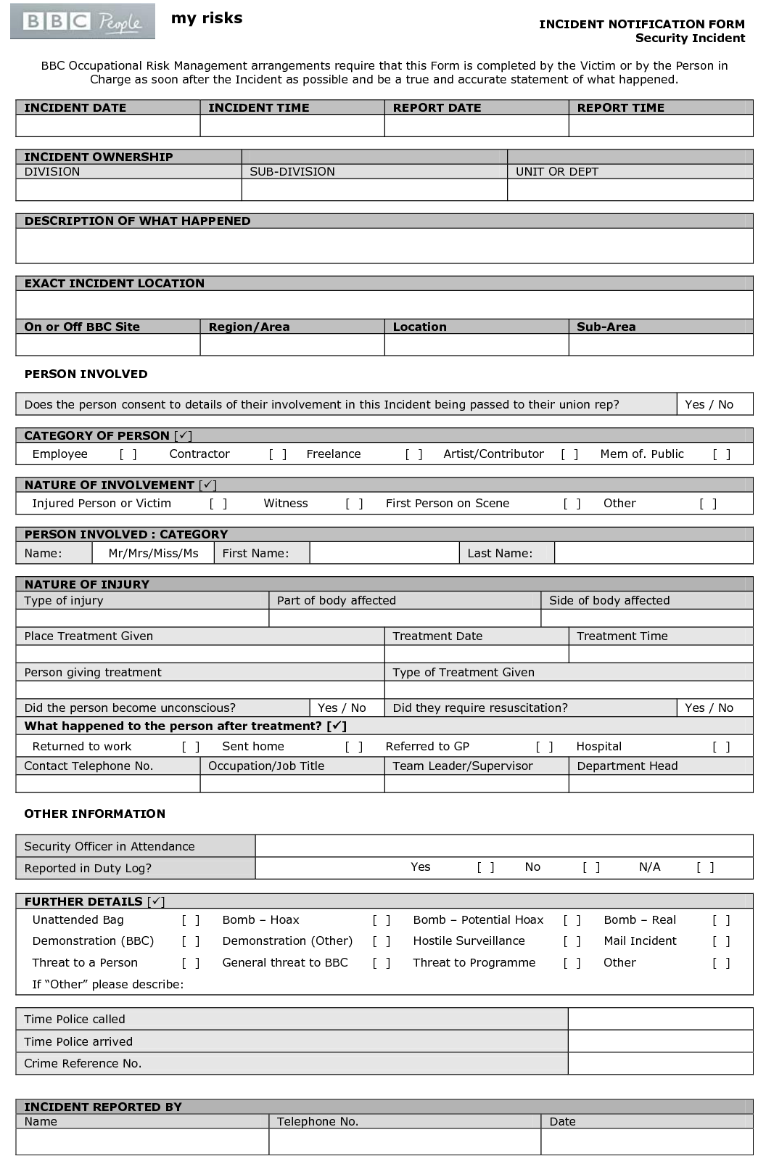

Control Measures Check List

Note: Its important this is finished on the day of filming. All control measures must be complete to ensure that all crew and cast remain as safe and secure as possible. If any control measures are not complete, contact Elliott Oakes (07463529264).

Cold and wet environment

Control Measure | Tick $√$ if complete
Rain

- Is it raining?

- If it is raining, it’s important to ensure the crew and cast are wearing the correct boots (walking boots)

Slippery surface

- Lay down a heavy-duty rubber mat on the slippery surfaces to provide a safe walkway for all cast and crew.

Crew and cast

- Its fundamental spare pare warm clothes are available. This consists of walking boots, waterproof coat. It’s important spare cloths are available in case someone has not brought the appropriate clothing and needs to be given it to prevent them from becoming cold.

- Make sure everybody has the correct clothing before entering the mine. if not give them spare clothing. This has to be complete to prevent any cast or crew from becoming cold.

PPE (Personal protection equipment)

- 6 hard hats with lights attached should be available in the storage room.

Note: all 6 hard hats must be worn by all the cast and crew members at all times especially where the ceiling is low. If any equipment is missing the filming must come to a halt until they are found.

- All 6 hard hats must be checked to ensure they are safely attached before entering the mine.

Note: hard hats must be checked every day.

Crew and cast

- All crew members should be given a walkie-talkie to call for others members in case of an emergency?

Note: if not all crew have a walkie-talkie, they must be in shouting distance of one who does have one so they can call for help.
- All of the crew and cast must be a hard hat and appropriate equipped. E.g walking boots and a waterproof coat.

Note: all the crew and must wear their PPE once inside of the mine. If anybody refuses to put on the PPE, they will unfortunately be asked to leave the set.

Obstructions

Exposed Hazards

- Mark off the entrance of the cave when the collapsing rocks scene occurs.

Trip Hazards

- Lay cable covers where appropriate.

Electric Shock

- Insulating gloves must be worn when operating the generator.

First Aid Provision

- Have the completed Personal Fitness & Medical Forms.

- Show Emergency Contact and Location details on site.

Fire Prevention Measures

- Appoint Fire extinguishers and exits prior to entering the mine.

- Show the emergency meeting point to all crew and cast in the event of an evacuation.

Emergency/Major Incident Procedures

- Make sure the emergency plan is completed before entering the mine.

Report

Summary of Project Aims
The intention of this project was to understand the fundamental concepts and principles of health and safety practice within film production. To achieve this a short film concept was designed to comprehend the health and safety legislations. The scenes are designed to be exhilarating and captivating for the audience. To accomplish this some scenes included are relatively dangerous therefore, the correct health and safety requirements needed to be reflected.
The project also aims to make you understand a range of risks that need to be considered when planning a shoot. Certain documents such as risk assessments ensure the safety of the production crew and public.
Specification
To ensure the short film is a success its fundamental that specific requirements are met to make the film more dramatic a cave was idealistic for the location. The reason for this is because it allows me to create the effects I desire. Dolaucothi Gold Mine was the perfect location because it met the specification of having very little natural light, not much space and a long straight line inside the cave.
The protagonist has to have the right appearance to ensure he fits the style of the film. The actor was perfect as he has had pervious acting experience therefore knew how to interact with the crew and camera.
Research Summery
Throughout this project I have learnt a substantial amount of new information. I have never performed a health and safety report before therefore, the majority of the information was completely new to me.

The emergency plan was extremely interesting to learn about because it made me consider the safety of the crew and cast. My problem-solving skills were tested because I had to take into consideration a wide variety of different factors. For example, I had to analyse the environment and establish safe zones. It was fascinating constructing an emergency plan because it enabled me to understand how to safely plan for an emergency. For example, I used Google Maps to provide a visual representation of what areas are safe to enter whilst certain scenes are taking place. This was advantageous because it enabled the crew and cast to comprehend the surrounding environment before going to the sight.

The emergency plan worked extremely well when filming. During the fake ceiling collapsing nobody was injured. This was idealistic because that means the safe zones were situated in the correct location. The same principle applied for the entrance of the mine becoming barricaded scene.

Another aspect I found interesting was the risk assessment. I’ve never performed a risk assessment before therefore, learning about hazards and ricks was useful. The form created has an extremely good layout therefore, on the day of filming it makes it easy to identify what the risks are. I learnt how to successfully reduce the risks; this was achieved by implementing the correct control measures. Completing the control measures improve upon my decision-making skills because I had to think of ways to ensure the crew and cast remained safe. For example, what equipment is appropriate for the environment to ensure nobody injures themselves.

On the day of filming everybody wore the correct equipment. This meant nobody injured themselves whilst inside of the cave. The only problem encountered was inside of the mine it was colder than anticipated this consequently meant not many people had warm clothing. Everybody had waterproof clothing however, because there was some standing around certain individuals become cold. To overcome this issue more breaks were taken to warm up those who were cold.

In this project I also learnt how to create a manual handling assessment. This was extremely advantageous because it made me think about situations I wouldn’t initially think about. I learnt how to deal with a wide variety of different situations and how to overcome them. The equipment worked extremely well on set, nobody injured themselves. Sticking to the plan enabled everybody to feel comfortable.

Technical Review

The health and safety considerations implemented worked extremely well. The PPE selected was appropriate for the environment therefore, no body injured themselves whilst on set.

Outcome

Within the project there was a wide variety of different positives. The location was perfect for the scene filmed due to a variety of different factors. For example, due to us not having a massive budget the location met all the specification points and criteria. The location made the shots look aesthetically pleasing and unique. The shot list worked extremely well within the environment; this was advantageous because it made the shots look more professional. The negatives of this projects were some of the control measures put into place. Unfortunately, the weather was colder than anticipated therefore the crew became cold when stationary. To overcome this more breaks were taken, this consequently meant the shoot continuously keep getting interrupted therefore some time was wasted.

Overall, I am extremely satisfied with how the planning and filming was executed. The crew and cast did a fantastic job of their assigned role and responsibility therefore, the overall production ran smoothly. The collapsing ceiling look extremely realistic due to the probs and camera angles implemented. Planning the scene before hand was advantageous because everybody knew exactly what to do. For next time I would definitely organise the document into chronological order therefore, making it easier to read and follow. I am satisfied with the overall plot and appearance of the footage and look forward to filming in the future.

