Python Exercises 3b – Input and Calculations

1. Write a program to allow the user to enter two temperature readings, in Celsius. The two readings are as follows: 28C and 21C.

Print out the average temperature (ie add them and divide by 2)

Print out the result. All inputs and the output should be of float type.
(Check this by using type())

Sample output:

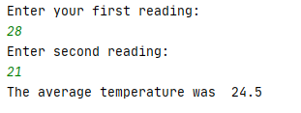

Solution:

print("Enter your first reading: ")
myTemp1 = float(input())
print("Enter second reading: ")
myTemp2 = float(input())
total = (myTemp1 + myTemp2) / 2
print("The average temperature was ", total)

2a. The area of a triangle is calculate by the formula ½ base * height

(Sometimes written base * height )
------------------
2 …or in programming (base * height) / 2

Write a program to allow the user to enter base * height and calculate the area of a triangle.
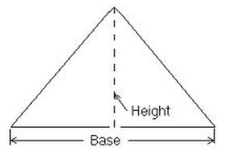

Sample output:

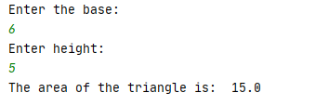

Solution:

print("Enter the base: ")
base = float(input())
print("Enter height: ")
height = float(input())
area = (base * height) / 2
print("The area of the triangle is: ", area)

2b. A person would like to calculate how much room there is in their tent. Here is a picture of the tent:

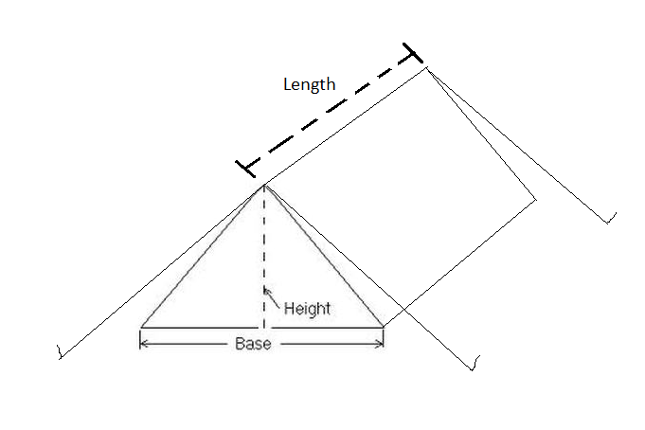
Adapt your program from 5a above to calculate the volume of the tent and print the result on the screen.

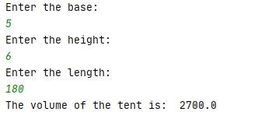

Solution:

print("Enter the base: ")
base = float(input())
print("Enter the height: ")
height = float(input())
print("Enter the length: ")
length = float(input())
volume = ((base * height) / 2) * length
print("The volume of the tent is: ", volume)

3. Post-Covid, I am going on holiday to USA. I have saved £230.55 to spend on American snacks I want to change my pounds to dollars in advance. Write a program to allow me to calculate the amount in dollars and print the result on the screen.

(Hint: you could use a website such as http://xe.com to look up the current exchange rate)

Sample output: (using the 0.73 currency rate shown below)

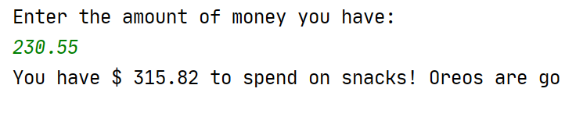

Solution:

print("Enter the amount of money you have: ")
mySavings = float(input())
usDollars = mySavings / 0.73
print("You have $", round(usDollars,2), "to spend on snacks! Oreos are go")

