UNIVERSITY OF WALES TRINITY SAINT DAVID

STUDENT NAME: STELA GEORGIEVA STUDENT ID NUMBER: 2118350

PROGRAM: BA BUSINESS MANAGEMENT
MODULE: DATA HANDLING AND BUSINESS INTELLIGENCE
MODULE CODE: LCBB5000
LECTURER: KHAZA AHMED
ASSIGNMENT TITLE: COURSEWORK (WRITTEN REPORT)

Table of Contents
1. Introduction 3
2. The meaning of data warehousing (DW) and business intelligence (BI) 3
3. Importance of DW and BI, including the DW architecture 4
4. Examples of current BI tools being used by businesses. 5
5. Impact of DW and BI on modern businesses 5
6. Conclusion 6
7. Reference 7

Introduction
The purpose of this report is to provide an overview of how business intelligence and data warehousing function in the corporate world. Massive technical development over the past ten years has led to an increase in business intelligence and data warehousing implementation. In the modern workplace, there is a requirement for a department that comprehends both the business needs and the influence on company technology due to the demands for business process improvement, responsive reporting, and internal business-customer interactions. The current state of data warehousing and business intelligence, as well as their importance for businesses, will be the main topics of this report. Additionally, a focus will be placed on understanding data warehousing (DW), the architecture of data warehousing (DW) and current business intelligence (BI) tools, examples of current business intelligence (BI) technologies, and how data warehousing (DW) and business intelligence (BI) affect modern companies.

The meaning of data warehousing (DW) and business intelligence (BI)
- In today's competitive business climate, data warehouses (DW), which were first launched in the early 1990s, have established themselves as the major foundation for tactical and strategic decision support systems. It has evolved into a crucial technology for building data management infrastructure and offered multiple benefits for various businesses Hammergren, T. (2009).
- Business intelligence (BI), which is a subfield of the decision support systems (DSS) field, is the process of integrating structured and unstructured data into useful knowledge and information that business managers may use to make better decisions (Rezende et al., 2015). Business intelligence is a term used to describe computer-based methods for locating, retrieving, and evaluating business data. These examples include sales revenue by items, departments, times, regions, or income. Business intelligence (BI) technologies offer perspectives of corporate processes that are historical, present, and forecast. Business intelligence (BI) technology is frequently used for reporting, analytics, data mining, text mining, and predictive analytics, among other things. Because it aims to help better business decision-making, BI is also sometimes referred to as a decision support system.

Importance of DW and BI, including the DW architecture
Data warehouses and business analyst intelligence have evolved into mission-critical applications for many enterprises as data analytics become increasingly crucial to businesses and organizations of all sizes. These companies have always looked for strategies to comprehend their customers better and anticipate their needs. As more and more elements of the real world are used as sources of digital data, the software is now able to interact with, analyse, and operate a variety of various types of equipment, people, and devices. From the fall of conventional advertising to the arrival of 3D printing in manufacturing, this has completely altered the economy. Digitalization has facilitated the creation of new business and management paradigms within organisations (Birkinshaw and Ansari, 2015). To help data warehousing (DW) with tasks like resolving data quality concerns and integrating data, they must lean on data warehouse architecture and other components. Data warehouse architectures (DWHAs) are created in sync with the development of data warehousing to primary support. Different DWHAs are presented to meet various needs and circumstances (Yang et al., 2017). The two main architectures of a data warehouse system are the data flow architecture and the system architecture. The data flow architecture explains the organisation of a data warehouse's data storage and the path that data takes from the source systems to the clients. The physical setup of the hosts, connection, software, data, and clients is covered by the system architecture Rainardi, V. (2008). The table below is the basic visualization of the data warehouse (DW) architecture model. The extraction of data from a variety of sources is the first step in the data transition process, which then combines the data to create a standardised, multi-dimensional interface that incorporates both form and structure. It is sometimes known as the data warehouse architecture seen in the table ('untitled',).
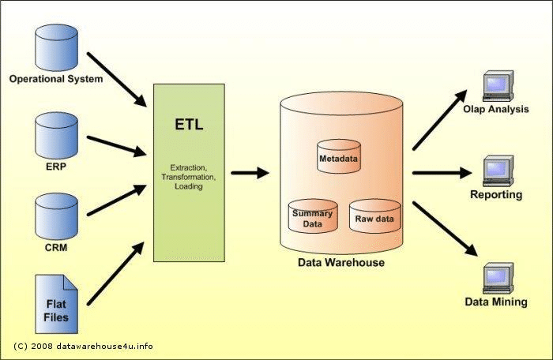

Examples of current BI tools being used by businesses.
More communication services are becoming available, which is a useful method to integrate corporate systems in real time, but they also provide a new data management difficulty for businesses trying to retain direct contact with a large number of consumers. Many businesses are using business intelligence (BI) tools and systems to analyse the past and estimate the future. Businesses have realised the value of using business intelligence principles to enforce the completion of the objectives outlined in their company plans (Ranjan,2009). Major organisations continue to dominate the market for commercial BI solutions because of their growing complexity, larger client bases, more challenging initiatives, and financial resources. The accessibility of data and its ability to create new value sources (such as Amazon, Tesco, etc.) are making it possible to analyse patterns of consumer behaviour and anticipate future consumer preferences (English and Hoffmann, 2018). This information can be used for many different types of decisions, such as marketing, sales promotions, future building needs, and so forth. By converting data into meaningful information and utilising several tools and apps, Business intelligence (BI) aims to assist key managers in making informed choices that can be put into practice. This new approach is also known as Big Data (Bayrak, 2015)

Impact of DW and BI on modern businesses
By evaluating their purchase patterns and creating user profiles with the aid of superior business analytics, businesses may better understand their customers. They are able to offer their customers better products and product experiences as a result. One way a business can use business intelligence (BI) to comprehend its clients better is through customer segmentation. Based on what they buy, when they buy it, and how frequently, customers could be categorised into a variety of categories. These segments are utilised to enhance the entire consumer experience through personalised product offers, reminders, and other features. This leads to a win-win situation for everyone concerned because it benefits the client and the business (Tong-On et al., 2021). Businesses that use business intelligence will be better able to manage their operating procedures. They are better knowledgeable about what is happening within the company. By successfully applied the processes and established practices, any issues can be corrected immediately. It also enables the company to adopt a proactive rather than a reactive approach. Understanding where and why the problems are happening, for example, could be very valuable to a distribution centre experiencing issues with late delivery. The level of internal knowledge they have could greatly enhance the services they offer (Tong-On et al., 2021).

Conclusion
In conclusion, a company's consumers are the primary factor in choosing its success. They are necessary for a company to function properly. As a result, companies must understand what customers desire. Businesses must quickly change to satisfy the fluctuating demands of their clients. Companies can utilise business intelligence to acquire data on industry trends and develop innovative products and services ahead of shifting consumer expectations. Competitors can be a major roadblock to a firm's progress. Their goals are the same as those of businesses, which are to increase revenue and satisfy clients. Businesses need to be one step ahead of the competition if they want to succeed.

Reference

Bayrak, T. (2015) ‘A review of business analytics: A business enabler or another fad’, Procedia - Social and Behavioral Sciences, 195, pp. 230–239.
Birkinshaw, J. Ansari, S. (2015) ‘Understanding management models: going beyond “what” and “why” to “how” work gets done in organizations.’ In: Foss NJ, Saebi T (eds) Business model innovation: the organizational dimension, Oxford University Press, Oxford, pp 85–103
English, V. and Hoffmann, M. (2018) ‘Business Intelligence as a Source of Competitive Advantage in SMEs: A Systematic Review’, DBS Business Review, 2.
Hammergren, T. (2009) Data warehousing for dummies. edn. Hoboken, N.J: For Dummies.

Rainardi, V. (2008). ‘Building a Data Warehouse With Examples in SQL Server’. Portland. Apress. pp29-47
Ranjan. J, (2009) ' Business intelligence: concepts, components, techniques and benefits', Journal of theoretical and applied information technology, Institute of management technology.
Rezende, S., Domingues, M., Soares, C. & Jorge, A. (2015)’ Web Mining for the Integration of Data Mining with Business Intelligence in Web-Based Decision Support Systems.’ In: A. Azevedo & M.F. Santos (eds.). Integration of data mining in business intelligence systems. Hershey: Business Science Reference, pp. 120–142.
Tong-On, P., Siripipatthanakul, S. and Phayaphrom, B., (2021).’ The implementation of business intelligence using data analytics and its effects towards on performance in the hotel industry in Thailand’. International Journal of Behavioral Analytics, 1(2).
Virtual Data Mart for Measuring Organizational Achievement Using Data Virtualization Technique (KPIVDM) - Scientific Figure on ResearchGate. Available from:
'untitled', Available at: file:///C:/Users/georg/Downloads/Virtual_Data_Mart_for_Measuring_Organizational_Ach.pdf.

