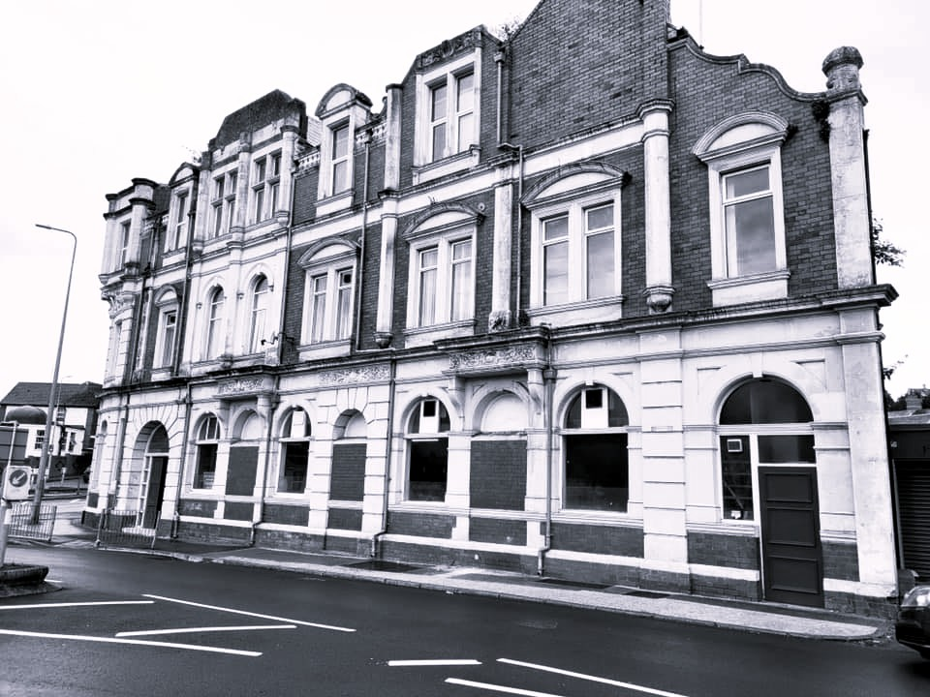
BMMB7026D
Managing Market Change
Sarah Parrish (2408799)

Future Developments in the Field of Marketing

Contents Page

Introduction | Page 3
Mini Marketing Campaign | Page 4 – 8
Outcomes | Page 7
Emerging Trends | Page 8 – 10
Case Analysis | Page 11
Personal Reflection | Page 12
Conclusion | Page 13
Recommendations | Page 14 - 15
References | Page 16 - 18

Introduction
The hospitality industry has long been competitive, however with the increase in social media, it is now heavily influenced and reliant on the digital environment. Customers now use social media to discover new venues, see what is on locally and share their experiences. As a result of this, marketing has transformed from traditional methods to digital strategies (Phenyx, 2024) as “traditional marketing, such as print and television advertising is increasingly losing its effectiveness in targeting specific audiences, while digital marketing offers flexibility and advanced analytics tools” (Loo, 2025). Platforms such as Instagram, TikTok and Facebook are no longer solely awareness tools, they are drivers for customer footfall and revenue generation.

The purpose of this report is to critically explore the future development of marketing within a member only club through the planning of a social media marketing campaign. The campaign aims to demonstrate how social media marketing can increase both physical footfall and financial performance, while supporting long-term brand development.

The campaign focuses on a member only club, The Cadoxton Conservative Club (the Club), which is situated within the Barry area. The Club was formed in 1894 and spent more than a century at the heart of a residential area. Its primary clientele is local residents who are looking for a venue to socialise and take part in community activities, such as darts and snooker. However, in recent years, due to ageing clientele and the impact of Covid-19, footfall has declined significantly, therefore severely impacting its financial situation.

Prior to the campaign, the Club relied on word-of-mouth marketing, which presented an opportunity to explore how social media marketing could enhance brand visibility and customer engagement.

This report examines how contemporary marketing tools can be applied effectively within the hospitality environment to increase footfall and awareness around a venue, ensuring it is financially stable moving forward and can continue to serve the community.
Mini Marketing Campaign

Overview and Objectives
The marketing campaign involves a 4-week social media campaign, which is aimed at increasing revenue and footfall into the Club. It centers on introducing Saturday night entertainment, as well as promoting the current events at the Club, which include weekly bingo. Due to the current financial situation, the Club is currently unable to provide paid entertainment, therefore, the focus of the campaign is to engage the local music community to find free or low-price entertainment.

The campaign sought to achieve the following objectives –
- Increase social media engagement by 25% over a 4-week period
- Promote awareness of weekly in-house events
- Encourage increased weekend footfall
- Strengthening the pub’s local brand identity and community presence

These objectives align with the SMART framework, which outlines that objectives should be specific, measurable, achievable, relevant and times (The Chartered Institute of Marketing, 2020)

Marketing Theory / Planning
When considering the campaign, it was felt that the most effective framework for analysing the Cadoxton Conservative Club would be the 7Ps of Marketing Mix. The framework, originally devised by E. Jerome McCarthy, and later expanded by Booms and Pinter. Due to the Clubs current financial situation, a theory was required which is based on individual situations and assists in considering how the objectives can be achieved.

Product – While the Club serves alcohol, this isn’t the only product which is on offer. The Club also offers experience for customers by providing a venue for events, entertainment and a welcoming atmosphere.

In order to remain successful, the Club must continue to assess what customers want. In order to achieve this, feedback should be sought and footfall to events monitored to gauge what works and what does not.

Price - While customers value competitive drink prices, the Club is not financially in a position to cut costs in this area, however, this is something that once the Club is financially stable should be considered. While the financial situation does not allow for permanent price reduction of beverages, promotions to encourage footfall are possible. The current campaign promotes a free shot of sourz for each try scored by Wales during the Six Nations.

Place – While not directly linked to the marketing campaign, the Club has reviewed its opening time to ensure that its opening times meet the requirements of customers. Moving forward, the club will open later 3 days a week, which are times when no customers attend the venue. Additionally, it is currently running a trial of opening at 1pm, instead of 3pm, on Saturdays through the Six Nations.

Promotion – Historically, the Club relied on in venue advertising and word of mouth, which has not been working. Moving forward, the Club will continue to promote the venue and events on Facebook, which to date, as shown by the statistics below, has been successful. To ensure that the Clubs social media continues to be engaging, it must ensure that posts are consistent and grab attention. To promote engagement, it should seek its followers’ thoughts and acknowledge upcoming national events, such as St Davids Day and Easter.

People – When it comes to promoting the Club, it is not just the physical building that is being promoted, it includes the staff and Committee members. Providing a friendly, fun and helpful atmosphere encourages customers to return to the venue.

Process – As mentioned above, customers do not just attend a venue for drinks, they want the whole experience. In order to ensure that customers have a positive experience, the Club will need to ensure that there are reasonable waiting times at the bar by ensuring that the required number of staff are on shift. Information should be easily accessible, whether that is through in-venue advertising or social media posts ensuring that there is clear communication of upcoming events.

Physical Evidence - Physical evidence helps new and existing customers want to return to the Club. In order to ensure the return of customers, the Club needs to ensure that it is clean, with attractive décor and comfortable seating. Additionally, if customers are happy, they are more likely to leave positive online reviews which will ultimately encourage new customers to visit the Club.

Overall, if the 7Ps are followed, the Club will be taking positive and proactive steps to strengthen its position by focusing on all the required elements. Continued monitoring of performance and engagement will ensure that the Club stays aligned with what its customers want and ultimately help it become more sustainable and successful in the future.

Strategy
The campaign focused on utilising Facebook, which was selected due to its use among the Clubs targeted demographic and sustainability for visual usage. The content included a combination of –
- Event Promotions
- Video Content / Reels
- Behind the scenes posts
- Customer generated content

The tone of the communications was informal and community focused, designed to reflect the Clubs brand personality. Posting was maintained at around three to four posts per week in order to maximize visibility without creating content fatigue.

Outcomes
The intended outcome of the campaign was to increase awareness around the Club, its activities and ultimately to increase footfall into the Club. In order to assess if the campaign, which started in early January, was successful, Facebook interactions were monitored and bar takings assessed.

When reviewing Facebook insights, 4 weeks after the campaign was launched, it was found that the number of views to the Clubs Facebook page had increased by 348.9% and interactions increased by 208.2%.

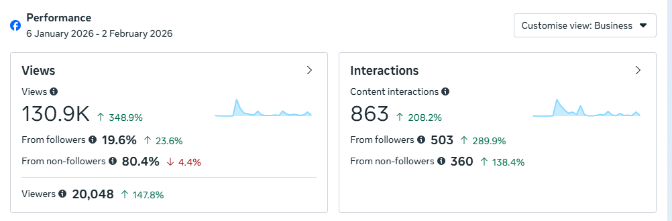

These interactions and views are notably around the post regarding events at the Club, which also had a direct impact on footfall into the venue. A typical Saturday night, prior to the campaign, resulted in an average bar taking of £250 on a Saturday night. However, since the launch of the campaign, this has increased to an average of £1200 which is a 380% increase.

The campaign has also included a survey of Facebook followers with the aim of gathering their opinions on what they would like to see entertainment wise at the Club. The results, when analysed, indicated that customers would like to see mid-week bingo, live bands and quiz nights. Therefore, to ensure that the Club remains appealing to customers, and build on the following and footfall gained through this campaign, the next stage is to utilise the bar area in the evening when it is free, by introducing Monday night activities such as a quiz night and bingo. In order to ensure that these activities reach as many people as possible, the Club will combine new social media marketing with their historical method of advertising posters within the venue and word of mouth.

Emerging Trends
Marketing within the hospitality sector is continuously evolving at rapid speed, requiring businesses to adapt their strategies to remain competitive and relevant. For small community-focused venues, such as the Club, effective marketing is essential for increasing visibility, strengthening customer relationships and ensuring financial stability. Key emerging trends, such as those discussed below, are vital to supporting the Clubs long-term growth.

Building Loyalty Through Tailored Offers
The hospitality sector increasingly emphasises personalised customer engagement and research shows that “companies that provide a personal experience of customers have a higher chance of retaining them and gaining a competitive edge in the market” (Gupta et al, 2023). Catering to customers individual needs fosters loyalty, which results in higher customer return rates and stronger positive reviews. In regard to the Clubs recent marketing campaign, the move towards targeted promotions, such as a free shot for Wales tries, is tailored towards building brand loyalty. This is also evidenced within the customer surveys to determine preferred entertainment options. These, align with research that tailored offers improve value and customer loyalty. Moving forward, to increase loyalty, the Club could look to reimplement its members’ initiative and create events and promotions specifically for its members.

Social Media
Social media is one of the most powerful marketing tools, it is both a primary promotional and engagement tool. Platforms, such as Facebook and Instagram, have driven customer decision making, brand awareness and engagement levels through visual and interactive content. Nauman (2025) states that “48% of consumers turn to social media when searching for places to eat and drink”, which further highlights its importance. The Clubs marketing campaign aligns with this trend. The increase in page views and interactions demonstrates how effectively social medica can showcase a venues presence and therefore encourage real-world action. The Clubs informal, community centered tone reflects best practice, which encourages authentic communication and storytelling to build stronger customer connections.

Invest in Training
Hospitality businesses rely on the delivery of good customer service as employees are the face of the company and provide the first impression for customers. Therefore, investing in learning and growth directly impacts customer satisfaction, loyalty and success (George). Research by Liao and Chuang (2004) confirmed that appropriate training contributes directly to the employees’ skills, which contributed to increased service quality and customer satisfaction. When considering the Club, the this is linked to the “People” and “Process” components of the 7Ps. Moving forward, the Club could move away from customer service training, onto specialised bar training such as cocktail making, in order to offer specialised cocktail nights.

Artificial Intelligence (AI) and Personalisation
AI is transforming the hospitality sector and is likely to play a significant role in the future development of marketing. AI enables organisations to analyse large volumes of customer data and identify patterns in consumer behaviour that would otherwise be difficult to detect, allowing businesses to create more personalized marketing campaigns, improve customer engagement and deliver relevant promotional content. Personalisation has become key within the hospitality sector, with customers expecting businesses to provide tailored experiences. Through the use of AI, organisations can recommend products, promote relevant events and communicate with customers at the most appropriate time, improving customer satisfaction, increasing customer loyalty and strengthening profitability (Zyminkowska, 2025). The Club currently operates on a small scale, however adopting elements of AI driven personalization could enable it to analyse social media engagement and customer responses to promotions more effectively.

Customer Relationship Management (CRM) and Data Analytics
CRM systems and data analytics are becoming more important withing marketing as organisations look to build stronger relationships with customers and make more informed decisions. CRM systems enable businesses to collect and analyse customer information, allowing them to better understand customer preferences and behaviours. Research suggests that hospitality organisations are using CRM to improve customer retention and deliver personalised customer experiences (Wheaton, 2026). The marketing campaign undertaken for the Club shows the value of this approach, as monitoring Facebook demonstrates the value of this approach, as monitoring the engagement alongside weekly bar takings made it possible to assess the effectiveness of the campaign and identify a positive relationship between social medica activity and customer footfall.
Case Study Analysis - Wetherspoons
Wetherspoons launched their loyalty program in 2019 and has grown to over 1 million active users (DCF Modeling). The program offers discounts and deals among registered customers, which demonstrates a clear success in retaining value driven customers who rely on predictable pricing. Additionally, the company is known for maintaining consistently low prices, which appeals to its customer base and strengthens customer loyalty through affordability.

Despite the loyalty program and low prices, Wetherspoons is behind its competitors in regard to personalized marketing such as digital offers and tailored rewards. Research suggests that 73% of customers expect personalise loyalty rewards, but only 45% of brands deliver them (Deloitte Digital). Weatherspoon relies heavily on mass appeal rather than engagement.

Surprisingly, Wetherspoons closed its social media channels across over 900+ pubs, despite many hospitality businesses relying on social media for branding, customer service and event updates. Instead, Wetherspoons relied on its website and news magazine. By missing out on social media, Wetherspoons has failed to adapt to this emerging trends.

Wetherspoons has a comprehensive training program, which sees them considered an industry leader in staff training and development. Its extensive award-winning training has been recognised by the Top Employers Institute and directly links to its strong staff retention and satisfaction.

Overall, Wetherspoons has adapted training and has been somewhat successful in loyalty building, however, it has failed to adopt social media engagement. While the chain remains successful due to its scale, pricing, brand recognition and operational efficiency, its resistance to digital engagement may limit long-term competitiveness.

Personal Reflection
As a Master’s student, conducting this marketing experiment has demonstrated the importance of evidence-based decision making within hospitality marketing. Prior to conducting the campaign, it had been assumed that the Club’s decline in footfall was attributed to external factors such as changing customer behaviours and the impact of Covid-19. However, the results indicate that the lack of digital marketing activity was a contributing factor. The campaign highlighted the value of social media as a low-cost marketing tool, capable of generating measurable business outcomes. The significant increase in Facebook engagement and Saturday evening bar takings demonstrate that small hospitality organisations can benefit from adopting contemporary marketing practices.

Additionally, the experience reinforced the importance of combining academic theories with practical application. The use of the 7Ps Marketing Mix provided a structured framework where marketing decisions could be evaluated and implemented. Applying the framework in a real-world scenario has improved my understanding of how marketing theory can be used to address operational challenges and support business growth.

Furthermore, the campaign highlighted the importance of data-driven decision making, customer engagement and relationship marketing. The use of customer feedback through surveys demonstrated how organisations can better understand their customers and adapt accordingly. This has improved my understanding of hospitality marketing by emphasizing the need to continually monitor customer behaviour, evaluate performance and adapt strategies to change market conditions.

Going forward, these insights will influence my future marketing strategies as I move forward with my role within the Cadoxton Conservative Club, ensuring that future decisions will be supported by customer data, engagement statistics and ongoing evaluation.
Conclusion
In conclusion, this report demonstrates that effective marketing in the hospitality sector relies heavily on digital engagement, customer-centered strategies and continuous adaption of emerging trends. The four-week social media campaign implemented by the Club shows how even small, financially constrained venues can use contemporary marketing tools to significantly enhance visibility, strengthen customer relationships and increase revenue. By applying the 7Ps Marketing Mix, the campaign successfully aligned promotional activity with customer needs, resulting in a rise in social media engagement and a 380% increase in Saturday night bar takings.

The findings also highlight the growing importance of loyalty building, social media marketing, and staff development. AI and data-driven decision making within the sector. As customer experiences continue to evolve, organisations must ensure they remain flexible and responsive to changing behaviours. The analysis of Weatherspoon’s shows that while strong pricing and employee development remain important, organisations that fail to embrace digital technologies may place themselves at a competitive disadvantage.

Additionally, the report highlights AI, DRM and data analytics as key future developments that can transform how businesses engage with customers. While the technologies may be associated with large organisations, the findings show that smaller venues can also benefit from adopting elements of these approaches. The success of the Clubs campaign shows that meaningful results can be achieved through simple and cost-effective marketing activities when they are supported by customer insight and ongoing performance monitoring. Overall, the findings confirm that by continuing to embrace data-driven insights, community focused digital marketing and targeted staff development, the Club can enhance its competitive position, ensure operational sustainability and remain an important social hub for its local community.

Recommendations
Small Hospitality Businesses
Small hospitality businesses should focus on lot-cost digital marketing, such as Facebook, Instagram and TikTok, to help maximise visibility and customer engagement. Social medica had become a key influence on customer decision making within hospitality and provides an affordable method of reaching customers whilst encouraging sharing of posts. Consistent posting schedules, customer generated content and community focused campaigns can strengthen customer loyalty whilst increasing business awareness. Additionally, businesses should encourage customers to share reviews, photographs and experiences online, as user generated content can be deemed as more trustworthy than business advertising alone.

Medium Sized Hospitality Businesses
Medium sized hospitality businesses should invest in CRM systems to support personalized communication and customer separation. CRM systems allow organisations to collect, analyse and utilise customer data to develop targeted promotions, loyalty rewards and personalized experiences. Research suggests that personaliused engagement is becoming a key driver of customer loyalty, revenue growth and long-term competitive advantage within the hospitality sector (Wheaton, 2026).

Additionally, customer feedback, email marketing campaign and mobile applications should be utilized to create integrated customer experience, while providing valuable insights into customer preferences and behavioural trends.

Large Hospitality Organisations
Large hospitality organisations should invest in technologies such as AI and marketing automation platforms. AI driven marketing tools allow businesses to analyse customer behaviour, predict purchasing patterns and deliver personalized recommendations on a large scale. These technologies can improve customer experiences, increase operational efficiency and strengthen customer retention (Schwarz, 2025).

Predictive analytics can also help organization to identify emerging customer trends, allowing businesses to response proactively to changing marketing conditions and maintain a competitive advantage.

Cadoxton Conservative Club
The Cadoxton Conservative Club should continue to invest in social media marketing given the positive results achieved through the campaign. It should maintain regular content creation, promote upcoming events and continue to engage with customers through comments, surveys and interactive posts. To strengthen customer loyalty, discounted event tickets and exclusive promotions should be considered.

The Club should also consider expanding its digital presence to Instagram and TikTok to attract a younger demographic, whilst maintaining engagement with existing customers on Facebook. Short video content is becoming increasingly popular within hospitality marketing and can be a useful tool to showcase events, customer experiences and community activities (Social Hospitality, 2025)

Additionally, implementing a basic CRM database would enable the Club to collect customer feedback, monitor attendance patterns, and deliver targeted communication. Finally, the Club should continue introducing quiz nights, bingo evenings and live music events, therefore ensuring that future decisions are informed by customer feedback and engagement data. This approach will help support long-term sustainability, strengthen community engagement and improve overall financial performance of the Club.

References

Bancm Team, 2024, Can a Traditional Pub Chain Like Wetherspoons Stay Relevant in a Tech-Driven Food & Beverage Landscape?, available from Can a Traditional Pub Chain Like Wetherspoons Stay Relevant in a Tech-Driven Food & Beverage Landscape? - BANC Magazine, accessed on 03.02.2026

DCF Modeling, J D Wetherspoon PLC Ansoff Matrix, available from J D Wetherspoon plc ANSOFF Matrix Analysis – DCFmodeling.com, accessed on 03.02.2026

Deloitte, 2024, The keys to a successful customer experience personalization strategy, available from Customer experience personalization with loyalty, apps | Deloitte Digital, accessed on 03.02.2026

Force Recruiting, available from Forces Recruiting | JD Wetherspoon - Forces Recruiting, accessed on 03.02.2026

Gupta. Shiv, 2023, A Study on the Impact of “Personalized Marketing” on Customer Satisfaction and Loyalty in Retail Fashion in 2023, available from A Study on the Impact of "Personalized Marketing" on Customer Satisfaction and Loyalty in Retail Fashion in 2023, accessed on 03.02.2026

Hanlon, Annmarie, 2023, How to use the 7Ps Marketing Mix, available from How to use the 7Ps Marketing Mix strategy model?, accessed on 03.02.2026

IMM Institute, 2023, From traditional to digital: Exploring the shift in marketing strategies, available from From Traditional to Digital: Exploring the Shift in Marketing Strategies - IMM Institute, accessed on 01.02.2026

JD Wetherspoon, 2025, People, available from People - J D Wetherspoon, accessed on 03.02.2026
Kilani. Yanal, 2021, S.M.A.R.T Business Role in Supporting Marketing Strategies among Telecommunication Organizations Injordan, available from (PDF) S.M.A.R.T Business Role in Supporting Marketing Strategies among Telecommunication Organizations Injordan, accessed on 03.02.2026

Landman. Patrick, 2025, Must-Know Trends in Hospitality Marketing for 2025, available form Must-Know Trends in Hospitality Marketing for 2025 | By Patrick Landman, accessed on 03.02.2026

Loo. Petrus, 2025, Transfromation of Traditional Marketing Strategy to Digital ; Challenges and Opportunities for Retailers, available from (PDF) Transfromation of Traditional Marketing Strategy to Digital ; Challenges and Opportunities for Retailers, accessed on 02.02.2026

Nauman, 2025, Impact of social media in the hospitality industry explained, available from Impact of social media in the hospitality industry explained, accessed on 03.02.2026

Oxford College of Marketing, Understanding The 7Ps of The Marketing Mix, available from The 7Ps of The Marketing Mix | Oxford College Of Marketing, accessed on 03.02.2026

Pereira. M, 2025, Factors of Customer Loyalty and Retention in the Digital Environment, available from Factors of Customer Loyalty and Retention in the Digital Environment, accessed on 03.02.2026

Phenyx, 2024, The evolution of marketing: From traditional to digital, available from The Evolution of Marketing: From Traditional to Digital - PHENYX, accessed on 01.02.2026

Schwarz. L, 2025, AI in Hospitality: Advantages & Use Cases, available from AI in Hospitality: Advantages and Use Cases | NetSuite, accessed on 22.07.2026

Social Hospitality, Hotel Marketing: Top Hospitality Digital Marketing Trends, available from Hotel Marketing: Top Hospitality Digital Marketing Trends - Social Hospitality, accessed on 22.07.2026

The Chartered Institute of Marketing, 2020, Back to Basics: How to set SMART objectives, available from Back to Basics: How to set SMART objectives | CIM, accessed on 02.02.2026

The Chartered Institute of Marketing, 2025, The 7Ps of Marketing, available from The 7Ps of marketing | CIM, accessed on 03.02.2026

Wheaton. L, 2026, CRM Driven Personalization: Moving Beyond Automated Messages to Predictive Guest Experiences, available from CRM Driven Personalization: Moving Beyond Automated Messages to Predictive Guest Experiences | Hospitality Technology, accessed on 22.07.2026

Zyminkowska. K, Zacgurzok-Srebrny. E, 2025, The Role of Artificial Intelligence in Customer Engagement and Social Media Marketing—Implications from a Systematic Review for the Tourism and Hospitality Sectors, Journal of Theoretical and Applied Electronic Commerce Research, Volume 20, Issue 3, available from The Role of Artificial Intelligence in Customer Engagement and Social Media Marketing—Implications from a Systematic Review for the Tourism and Hospitality Sectors, accessed on 22.07.2026

