May 8, 2024
Gareth Jenkins
Student number 99091195

Lanscape CHARACTERISATION: HOW did glaciation create the landscape of the Aeron valley.
Into the Field. HPAR 4001
Landscape characterisation. How did glaciation create the landscape of the Aeron Valley?

Abstract.
The landscape of Britian and Ireland bears witness to ice ages that covered the land for millions of years. It is a landscape which has been shaped by the processes of glaciation. During the Devensian period, about 27,000 years ago, the Welsh Ice Cap emerged as a distinct and independent feature. Glaciers change and influence the landscape in very subtle ways. This report will examine the processes of glaciation and deglaciation and how they create a landscape. The report will examine the evidence for the last British Ice Sheet and consider its influence on the landscape of the Aeron Valley.
Keywords: Quaternary, glaciation, landscape, Aeron.
Introduction.
The world climate has fluctuated between ice ages throughout the last 2.6 million years, a period known as the Quaternary. During these ice ages, thick ice sheets covered much of the northern hemisphere, including most of Britain and Ireland. The landscape bears witness to the ice sheets' history, as they produced countless landforms (geomorphology), which has helped to establish the size and shape of the ice sheets (Clark, 2018; University of Sheffield, 2024). This report will examine the processes of glaciation and deglaciation and how they create a landscape. The report will examine the evidence for the last British Ice Sheet and consider its influence on the landscape of the Aeron Valley between Lampeter and Aberaeron.
Method.
“Geology teaches us that the massive power of an expanding glacier is capable of re-sculpting hills and valleys” (Pryor, 2022, p.42). By examining a variety of scholarly articles, papers, models, and studies this report will outline what is meant by the processes of glaciation and de-glaciation, and by doing so, interpret and understand how these processes created the Aeron Valley.
Discussion.
The Aeron valley extends from Aberaeron on the Ceredigion coast to its source at Llyn Eiddwen. The name 'Aeron' means 'berries' in English, implying that the Aeron valley is bountiful. Local names suggest the shape of the valley. Ciliau Aeron refers to where the river has multiple narrow bends (ciliau), whereas ystrad (from the Latin 'strata'), as in Strata Florida, refers to where the valley is wide. The Aeron valley's steep sides are wooded. The word 'llanerch' translates into English as 'a forest glade', which is a suitable for the picturesque setting of Llanerchaeron, one of several estates along the Aeron Valley. The natural springs that emerge from the valley floor of the Aeron used to provide the water for Llanllyr Source bottled water (Ceredigion County Council, 2024).

Figure 1 is taken from 2 miles to 1 inch map of the Lampeter area. The blue line has been added to show the extent of the Aeron Valley, from the source of the Aeron River at Llyn Eiddwen to the coast at Aberaeron.
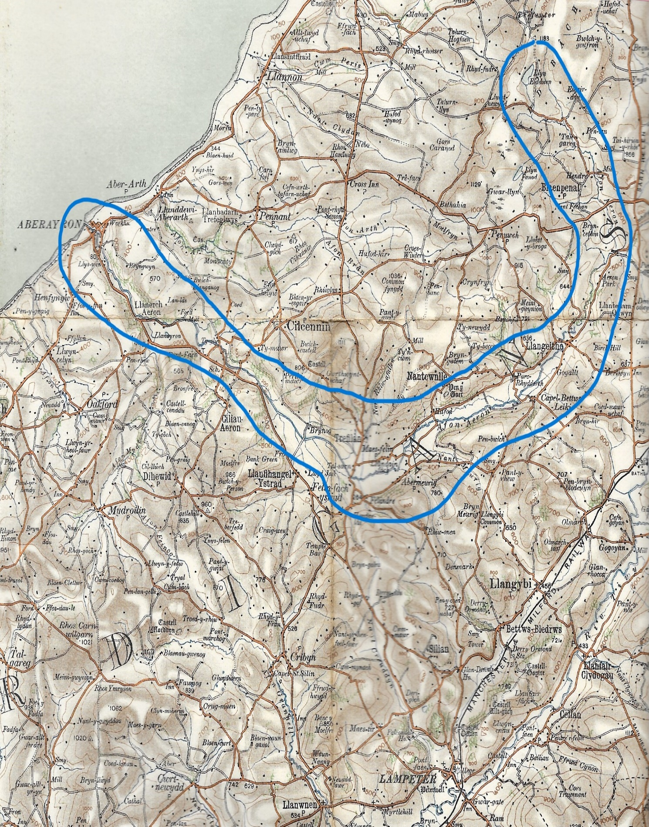
Figure 1. Ordnance Survey map, Sheet 21 Lampeter (Authors collection).
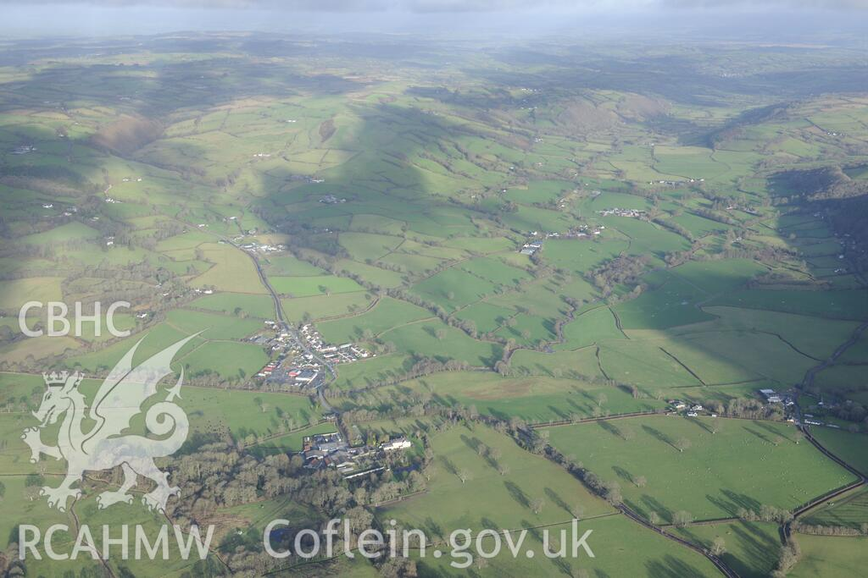
Figure 2, Aerial photo of the Aeron Valley at Llanllyr & Talsarn looking NE (RCAHMW, 2024)
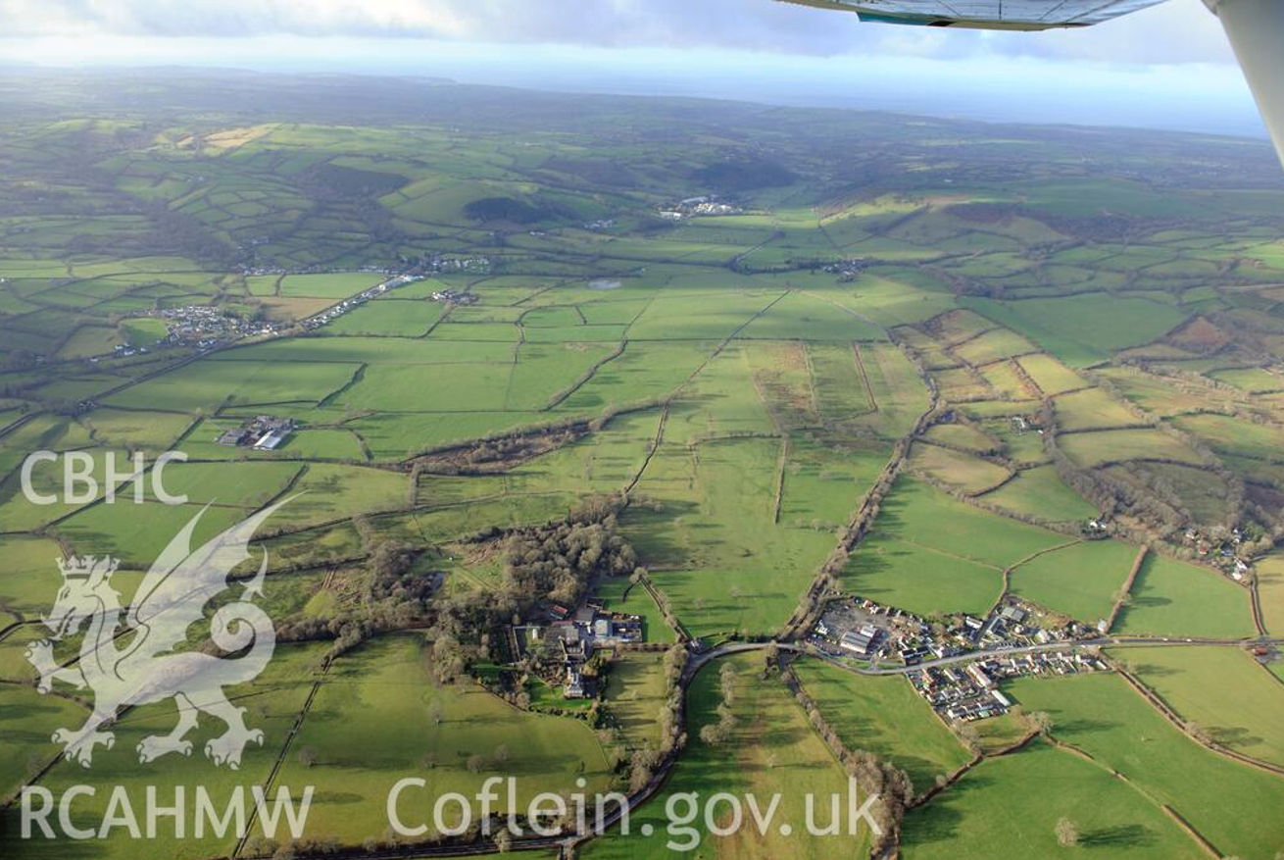
Figure 3, Aerial photo of the Aeron Valley at Llanllyr & Talsarn looking west towards Aberaeron (RCAHMW, 2024).
(Both these images are Crown copyright and are reproduced with the permission of the Royal Commission on the Ancient and Historical Monuments of Wales (RCAHMW), under delegated authority from The Keeper of Public Records).
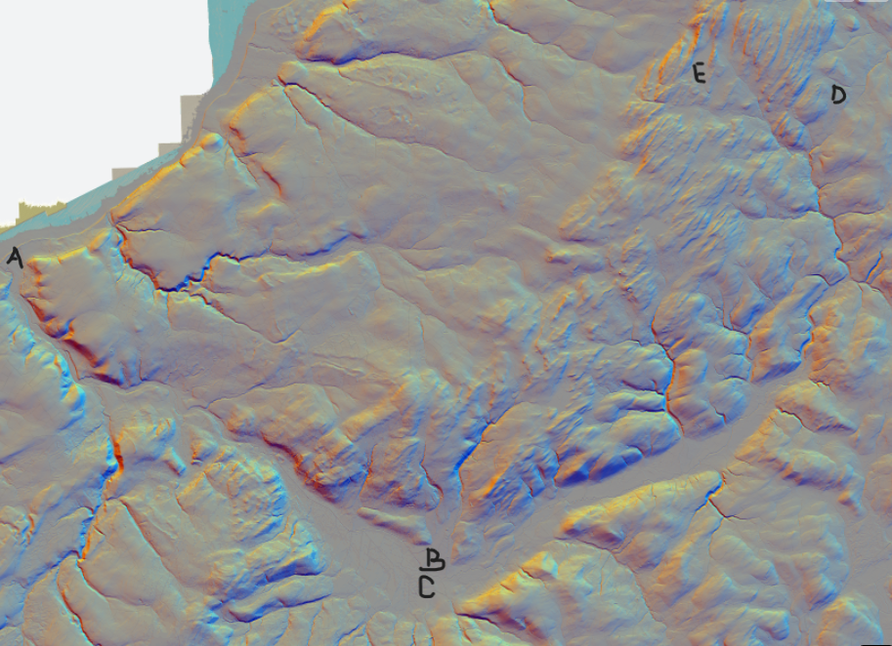
Figure 4, LiDAR DTM 50cm-1m of the Aeron Valley (National Library of Scotland, 2024).
The LiDAR image of the Aeron Valley and shows the carved valley landscape. For reference the following areas are labelled; A = Aberaeron, B = Talsarn, C = Llanllyr, D == Mynydd Bach, E = Llyn Eiddwen.

The area's bedrock geology consists of late Ordovician and early Silurian sedimentary rocks. Rock formation consists of repeating sequences of sandstones, siltstones, and mudstones, in varying amounts. The sediments which occur in this valley have their origins in either the Irish Sea or the Welsh, Ice Sheets. These Ice Sheets converged on each other and very nearly covered the whole area. When the Ice Sheets melted rivers re-occupied the valley, and the melt water created large lakes, such as Llyn Eiddwen (Natural Resources Wales, 2014, pp.1-7) .

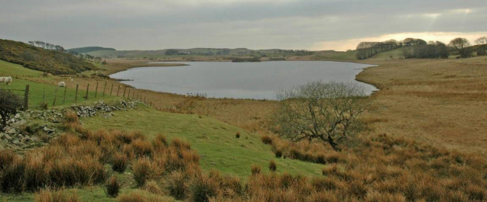
Figure 5. Llyn Eiddwen, a post glacial lake at Mynydd Bach (Natural Resources Wales, 2014 p.4).

The British-Irish Ice Sheet covered Britain and Ireland at various times during the Quaternary Period. In geological terms, the Quaternary period covers the last 2.4 million years up to the present. It consists of two geological epochs: the Pleistocene (ca. 2.4 mya to ca. 11,700 years ago) and the current interglacial period, the Holocene (ca. 11,700 years ago to the present).The sedimentary record in Britain and Ireland contains evidence of at least three major ice sheets. They were the Anglian (478,000 to 424,000 years ago), the Wolstonian (300,000 to 130,000 years ago), and the Devensian, about 27,000 years ago, during the Last Glacial Maximum (Emery, 2020, p.1; Lillie, 2015).
The Devensian glacial period began with significant cooling around 115,000 years ago and lasted until the end of the Pleistocene epoch. Glaciation peaked between 23,000 and 14,000 years ago, but by 13,000 years ago, the ice had mostly vanished. Approximately 25,000 years ago, snowfall had intensified, resulting in glaciers and ice sheets, with a peak approximately 17,000 years ago. These ice sheets spread south, with those over Wales reaching more than 1000 metres thick. It is thought that the Devensian glacier was a brief episode lasting roughly 14,000 years, preceded by a long cold but non-glacial period. It was followed by the climatic warming of the Holocene Epoch, in which we currently live (Toghill, 2000, p.176).

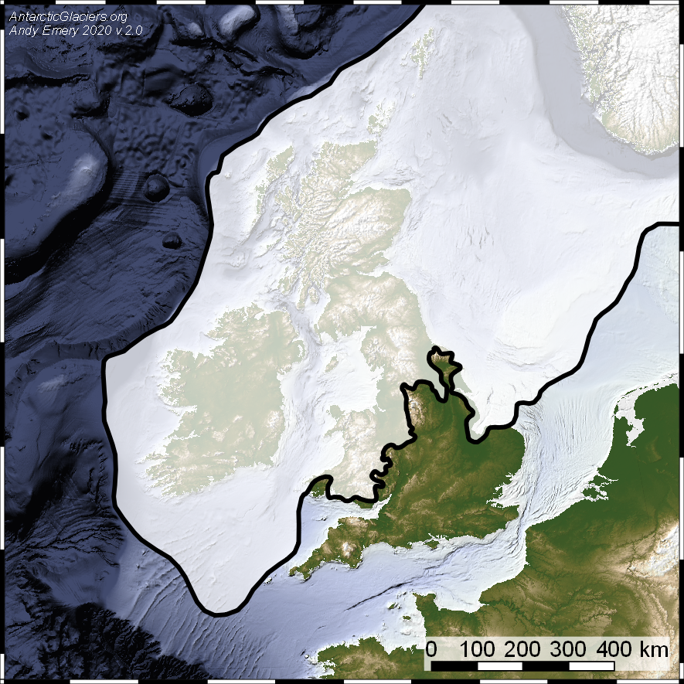
Figure 6 shows the maximum extent of the Devensian British-Irish Ice Sheet (Emery, 2020 p.2).

According to modelling studies and academic observations, the Welsh Ice Cap was a dynamic and rapidly changing component during the last British-Irish Ice Sheet. Geomorphological and geochronological studies suggest that at the Last Glacial Maximum, (27,000 years ago), the British-Irish Ice Sheet was made up of multiple tiny, semi-independent ice caps or ice dispersal centres. The Welsh Ice Cap is one of these centres. During the Devensian period, the Welsh Ice Cap emerged as a distinct and independent feature (Glasser et al, 2018, pp. 1-2).
The Aeron River valley, as well as the adjacent Teifi and Ystwyth River valleys and the flanking upland areas of the Cambrian mountains and Mynydd Bach were covered by the Welsh Ice Cap, with some areas converging with the Irish Sea Ice Stream (Glasser et al, 2018).

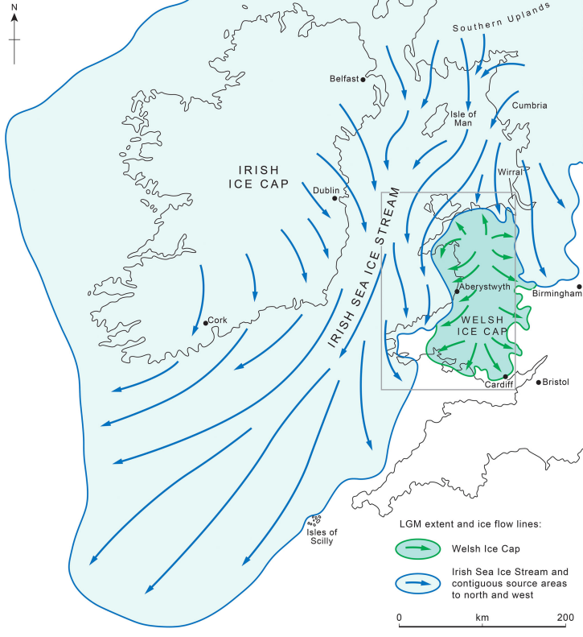

Figure 7, Overview of the Last British-Irish Ice Sheet at the Last Glacial Maximum (Glasser et al, 2018, p.2).

Glaciers change and influence the landscape in very subtle ways (Pryor, 2022, p.42). As the ice moves it erodes everything in its way and creates different landforms, such as Arêtes (steep-sided ridges), Glacial troughs (steep-sided valleys with a flat floor), and Corries (formed in hollows where snow accumulates) in Wales they are called Cwms (Cartwright, 2024; Toghill, 2000, p. 178).
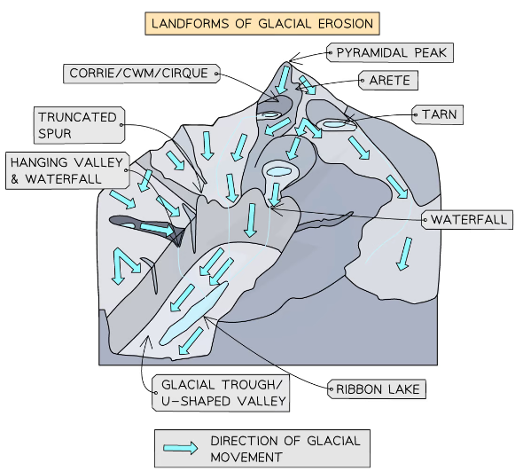
Figure 8, Landforms of Glacial erosion (Cartwright, 2024).

As it moves along a valley, like a bulldozer, the glacier scrapes the ground and pushes earth, pebbles, rocks, and boulders ahead of it. This material is known as moraine. When the glacier comes to a halt, usually when it reaches the coast or when the temperature warms, the moraine remains in situ and is known as a terminal moraine. Boulders were left behind, frequently standing on polished rock surfaces known as glacial erratics (Pryor, 2022, p. 42-43; Toghill, 2000, p.169). As well as the terminal moraine there are other types of moraines, such as lateral moraine, (deposited along both sides of the glacier) and medial moraine (material in the middle where two glaciers meet and continue to flow downhill together) (Cartwright, 2024).
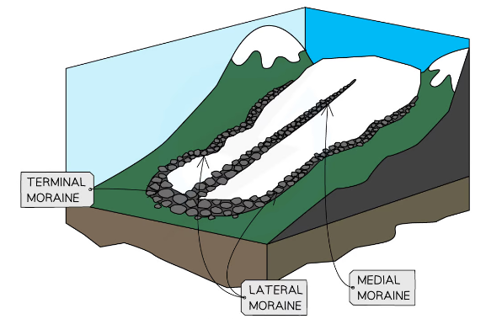
Figure 9, diagram of different types of moraines (Cartwright, 2024).

Ice dammed lakes, which frequently developed between retreating ice and high ground, were among the most significant features formed (Toghill, 2000, p.183). In Ceredigion melting glaciers caused rivers to reoccupy valley systems. It caused the emergence of a diverse spectrum of river and former glacier melt water lakes. In the Aeron Valley near Ystrad Aeron, layers of lake clay and silts up to 50m thick have been discovered beneath post-glacial river deposits (Natural Resources Wales, 2014). Figure 10 shows the extent of proglacial lakes in the Aeron Valley and Teifi Valley, Ceredigion (Clarke et al, 2018).
Figure 11 is a “Integrated geomorphological and deglaciation model for the Welsh Ice Cap and Irish Sea Stream in south-west Wales showing putative ice fronts at the Last Glacial Maximum and at stages during their retreat” (Glasser et al, 2018, p.11). It shows the moraines present in the Ystwyth and Rheidol valleys and the largest proglacial lakes.
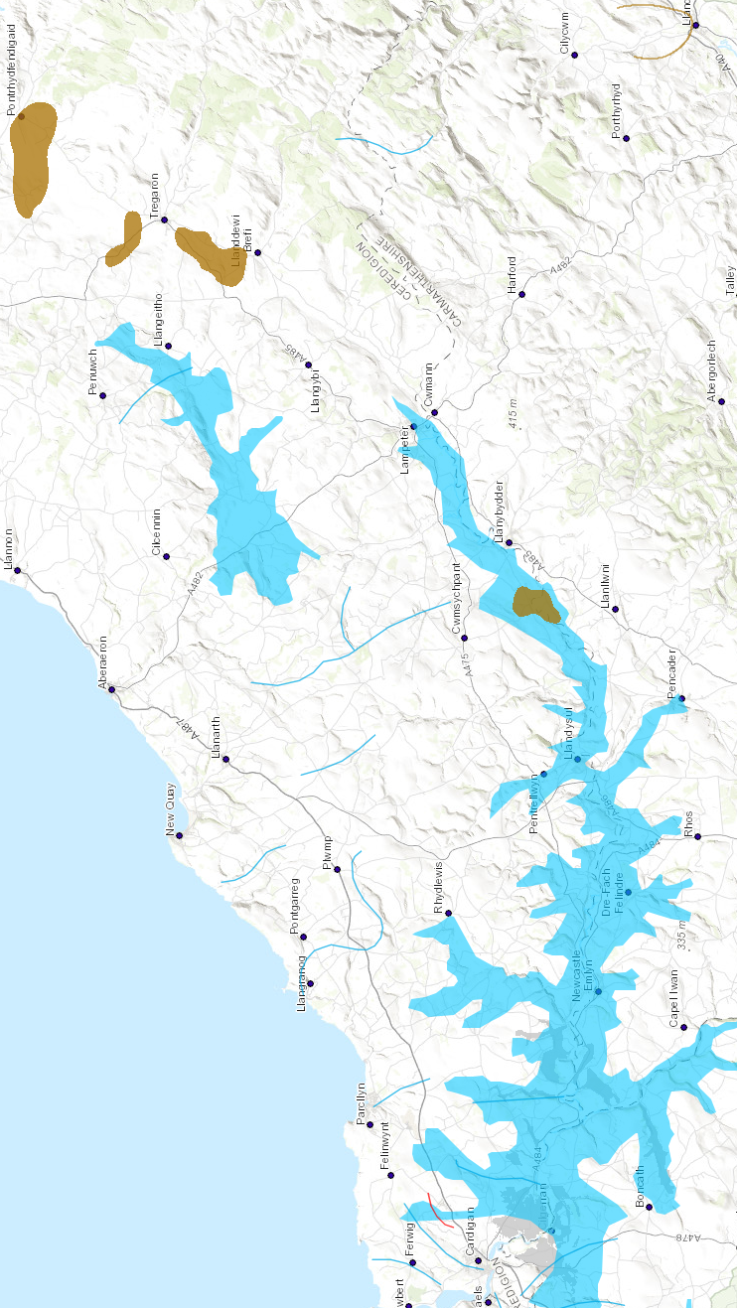
Figure 10.
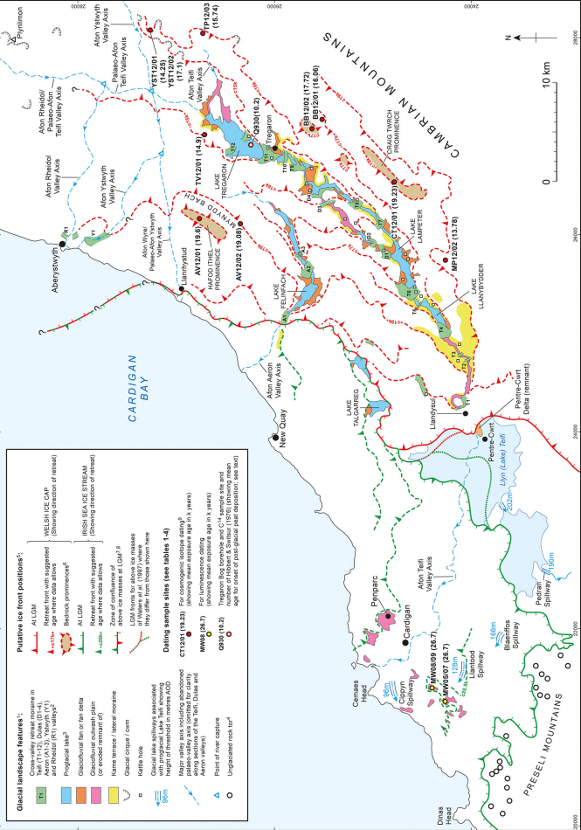
Figure 11.

Conclusion.
Glaciers are moving ice masses that have the power to transform entire landscapes. They create mountains, carve valleys, and transport massive amounts of rock and sediment.
Many lowland areas of Wales were affected by the Ice Sheets, including the Aeron valley. The Welsh Ice Cap deglaciation most likely began soon after the Last Glacial Maximum. The upland regions became ice-free, and outlet glaciers occupied and began to recede up the Aeron and Teifi valleys. The Irish Sea Ice Stream had completely separated from the Welsh Ice Cap, and both ice masses had retreated from the coast of South-West Wales. By around 15 thousand years ago, the Aeron watershed and much of the Cambrian Mountains plateau were ice-free (Glasser et al, 2018, p.13).
These lowland valleys were layered with sheets of boulder clay, sand and gravel left behind by the Ice Sheets and distributed by their melt waters. Although the glacial lake that once covered much of the Aeron valley has receded, the source of the river Aeron remains at the glacial lake of Llyn Eiddwen (Natural Resources Wales, 2014, p. 5). The Aeron valley today is focused on agriculture and industry. More recent history dominates. But if one looks closely, evidence of the power and impact of glaciation that occurred thousands of years ago is still visible in the landscape.

References.
Cartwright, J. (2024), Glacial Landforms. Available at: https://www.savemyexams.com/gcse/geography/aqa/18/revision-notes/3-physical-landscapes-in-the-uk/3-4-glacial-landscapes-in-the-uk/3-4-2-glacial-landforms/ (Accessed: 28 April 2024).
Clark, C. D. et al, (2018) ’ BRITICE Glacial Map, version 2: A map and GIS database of glacial landforms of the last British-Irish Ice Sheet’, Boreas, 47, pp.11-27. Available at: https://shefuni.maps.arcgis.com/apps/webappviewer/index.html?id=fd78b03a74bb477c906c5d4e0ba9abaf (Accessed:14 April 2024).
Ceredigion County Council, (2024) Darganfod Discover Ceredigion. Available at: https://www.discoverceredigion.wales/areas-of-ceredigion/ceredigions-river-valley-routes/aeron-arth-and-wyre/ (Accessed: 26 April 2024).
Emery, A. (2020) The LGM British-Irish Ice Sheet: an introduction. Available at: https://www.antarcticglaciers.org/glacial-geology/british-irish-ice-sheet/last-glacial-maximum/the-british-irish-ice-sheet-an-introduction/ (Accessed: 20 April 2024).
Glasser, et al, (2018), ‘Late Devensian deglaciation of south-west Wales from luminescence and cosmogenic isotope dating.’ Journal of Quaternary Science, 33(7), 804-818. John Wiley and Sons Ltd.
Lillie, M. (2015), Hunters, Fishers and Foragers in Wales: Towards a social narrative of Mesolithic lifeways. Oxbow Books. Available at: https://www.jstor.org/stable/j.etrh1dqrs.7 (Accessed: 19 April 2024).
National Library of Scotland, (2024), Georeference maps: LiDAR DTM 50cm-1m Eng. Scot. Wales. Available at: https://maps.nls.uk/geo/explore/side-by-side/#zoom=12.8&lat=52.24665&lon=-4.04823&layers=1&right=LIDAR_DTM_1m (Accessed: 29 April 2024).
Natural Resources Wales, (2014) National Landscape Character, NLCA25, Bro Ceredigion. Available at: cdn.cyfoethnaturiol.cymru/media/682599/nlca25-bro-ceredigion-description.pdf?mode=pad&amp;rnd=1315505894431000000 (Accessed: 26 April 2024).
Patton, H., Hubbard, A., Glasser, N.F., Bradwell, T. and Golledge, N.R. (2013), ‘The last Welsh Ice Cap: Part 1’. Boreas, 42: 471-490. https://doi.org/10.1111/j.1502-3885.2012.00300.x (Accessed: 28 April 2024).
Pryor, F. (2022) Scenes from Prehistoric Life: From the Ice Age to the coming of the Romans. Head of Zeus Ltd.
Royal Commission on the Ancient and Historical Monuments of Wales, (2024), COFLEIN: Aerial photographs. Available at: https://rcahmw.ibase.media/en/view (Accessed: 29 April 2024).
Toghill, P. (2000) The Geology of Britain: An Introduction. Airlife Publishing.
University of Sheffield, (2024) BRITICE Glacial Mapping Project. Available at: https://www.sheffield.ac.uk/geography/research/projects/britice (Accessed: 20 April 2024).

