Name / Enw
Student number / Rhif myfyiwr
E-portfolio report
ADRODDIAD E-BORTFFOLIO
Learning in the Digital Era / Dysgu yn yr Oes Digidol – BMPL4007/BMPS4009
Table of Contents / Tabl Cynnwys

Task 1 – Written summary / Crynodeb Ysgrifenedig 2
Task 2 – Mind map / Map meddwl 3
Task 3 – Presentation / Cyflwyniad 4
Task 4 – Reflection / Myfyrdod 5
Reference list / Rhestr Cyfeirnodi 6

Task 1 – Written summary / Tasg 1 - Crynodeb Ysgrifenedig
A written summary of 300 words, with at least one supporting image, on the topic of “Preparing for Higher Education.

The first part of this assignment seeks to explain how l prepared myself for higher education.
In preparation for this noble educational journey, l took a step of securing an admission by making sure l meet all the requirements to gain admission. I also ensured that l was financially prepared to funding for the fees and applying for student grant, UCAS, (no date).
After the admission and the finances are fully sorted, my next step was creating the right study environment. I realised that during the academic year l will spend almost 900 hours studying independently, hence l decided to prepare for a conducive study space that was comfortable and productive.

It was also important that l choose the best time to study so l planned my study session and established a routine. I chose to study at my own pace from home and benefited from online learning with flexible hours, less distractions while using my own facilities and savings J Smith (2022).

I also prioritise all my given tasks by using Eisenhower's Urgent/Important Principle. Using this principle can help me decide which of the tasks l need to complete are most important and which are less so.

To do so tasks are divided into four categories as illustrated in the diagram below Emerald works (no date):

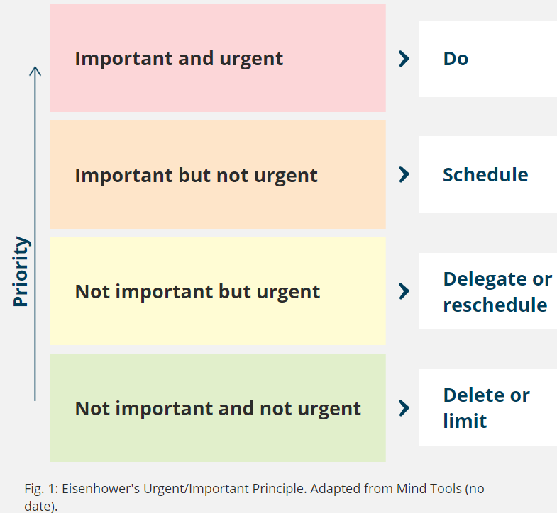

Lastly, l decided to practice strategies to overcome procrastination and perfectionist behaviours. Procrastination is the avoidance of starting certain tasks (Moore et al, 2010). The first step to overcome procrastination is understanding why we are procrastinating, T Urban (2016).

Task 2 – Mind map / Tasg 2 – Map meddwl

A mind map on the topic of “Becoming a Digital Learner”

As a Digital Learner the first step was to navigate the library web pages. The library offers a wide range of resources to me with my studies. There are many options to find the library web pages including the following:
- URL: www.uwtsd.ac.uk/library
- Search for ‘UWTSD library’ in your chosen search engine.
- Click the ‘Library’ tile on UWTSD Hwb
- Use the ‘Quick Links’ on (www.uwtsd.ac.uk), uwtsd hwb (Moodle)
After becoming aware of how to locate information and services as well as where to ask for help using the library web pages, the next thing is to understand the importance of information in our society, understand and identify ‘fake news’ and to critically evaluate a range of resources and identify credible academic information.
In order to determine whether a source of information is appropriate you can use the CRAAP Test uwtsd hwb (Module).
According to R H Renirie (Nov 2022), the CRAAP Test check the information for:
- C - Currency – The timeliness of the information
- R – Relevance – The importance of the information for your needs.
- A – Authority – The source of the information
- A – Accuracy – The reliability, truthfulness and correctness of the content
- P – Purpose – The reason the information exists.
After the above, the next task is to be able to think and write critically by demonstrating the ability to integrate a range of resources by putting my findings into my own words, recognise the consequences of plagiarism and how I can avoid this to ensure academic integrity and to be able to understand referencing and why it is important to reference, identify when you need to reference and produce in-text citation/footnotes and references the style used in your programme uwtsd hwb (Moodle).
The last point on the topic of “Becoming a Digital Learner” is using Microsoft tools for presenting my work and creating a video presentation using Microsoft stream.
Microsoft word and PowerPoint are the most widely use software in the 21 century.
The diagram below illustrates the notes above. Please refer to the notes.

A mind map of “Becoming a Digital Learner”
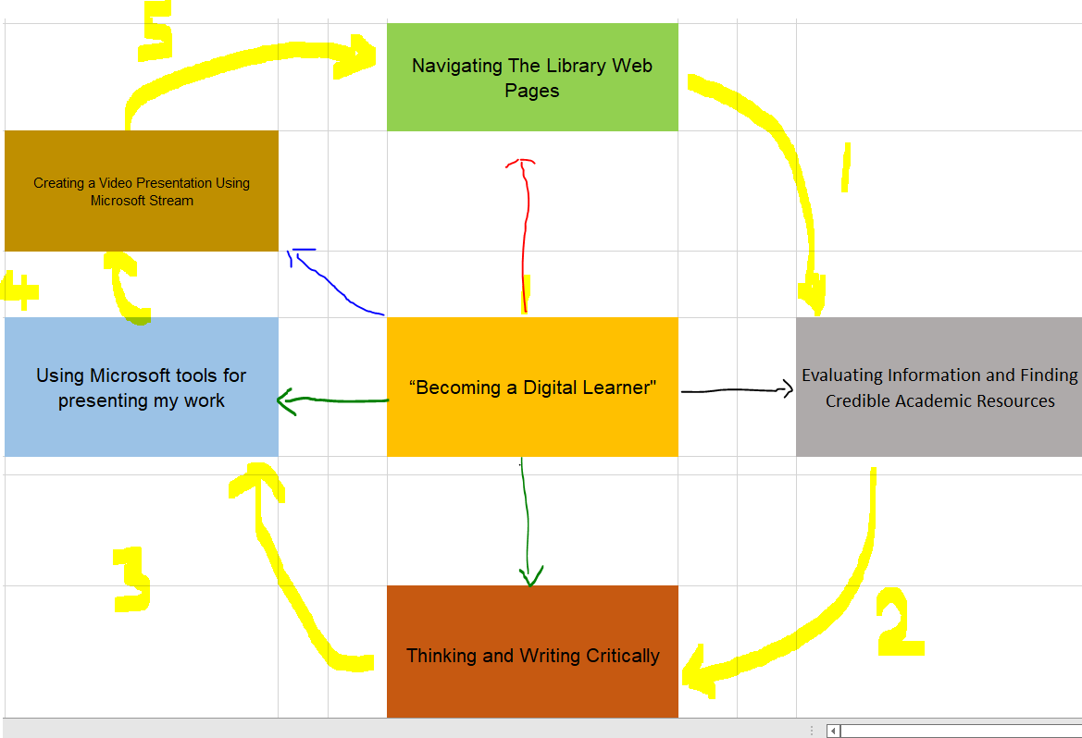

Task 3 – Presentation / Tasg 3 - Cyflwyniad
Please follow this link to view my presentation: / https://youtu.be/mFx46EDg04k
“Becoming a Team Player – Please find the YouTube link
A team is define as a group who set out to achieve a common goal. Ideas of personal and social identity, as explored in this section, often impact on people’s ability to work as a team. Team member identity can also affect trust within the team, the clarification of roles, and explicit expectation of group identity.
Ones sense of place is deeply related to the people and the organisations one belongs to.
One must be mindful that he/she is a member of certain group and therefore take the time to develop meaningful relationships with the people within a particular groups.
For a group to become a team it is always necessary to go through some stages:
Based on group development model by Bruce Tuckman, there are 5 stages of team development including:
- Forming – Forming include questioning, socializing, displaying eagerness, focusing on group identity and purpose, and sticking to safe topics. Strategies for this phase include taking the 'lead,' providing clear expectations and consistent instructions, and quick response times, S M Graffius (2018).
- Storming -Traits of Storming include resistance, lack of participation, conflict, competition, high emotions, and moving towards group norms. Strategies for this stage include normalizing matters and encouraging leadership, S M Graffius (2018).
- Norming - Features of Norming include reconciliation, relief, lowered anxiety, members are engaged and supportive, and developing cohesion. Strategies for this phase include recognizing individual and group efforts, providing learning opportunities and feedback, and monitoring the 'energy' of the group, S. M Graffius (2018).
- Performing - Characteristics of Performing include demonstrations of interdependence, healthy system, ability to effectively produce as a team, and balance of task and process orientation. Strategies for this stage include celebrating, 'guide from the side' (minimal intervention), encouraging group decision-making and problem-solving, and providing opportunities to share learning across teams, S M Graffius (2018).
- Adjourning - Traits of Adjourning include a shift to process orientation, sadness, and recognition of team and individual efforts. Strategies for this phase include recognizing change, providing an opportunity for summative team evaluations, and providing an opportunity for acknowledgments.
Team skills are essential for any career. When worked closely with others you can streamline the process and produce high-quality pieces faster than if you were to try and do it all on your own.

Task 4 – Reflection / Tasg 4 – Myfyrdod
Using Borton’s reflective Model
This part of the assignment seeks to look at my experience when l started university, getting to grip of online learning and resources, and the process of writing my first assignments as well as reflecting on how to resolved it. I will be using the Borton model as a reflective tool in this discussion. According to Paul Templar (2021), Borton describes this model as a fluid process where no part of it can exclude another – it is a “continuous integrated flow” with no beginning or end. The model is based on 3 questions What, So what and What now?

The start of my university education coincided with series of circumstances such as the death of my father, divorce proceedings as well as accommodation problems. The combination of the above mentioned challenges placed a significant impact on both my physical and mental wellbeing at the initial part of my studies. It all started with a breakdown of communication over a period of time that triggered divorce with legal processes and eventually moving out. Situation worsened when I began a search for suitable accommodation as a single man which led to financial difficulties.

Due to all the above personal circumstances, it became apparent that my focus and concentration were lagging behind whence my inability to keep up with the online learning and accessing available resources. These multiple demands placed on me made my experience stress and brought about the feeling of frustration and anxiety with intense lack of motivation to access the online teaching and learning.

The circumstance surrounding my dad’s untimely death brought about constantly panicking and nervous especially during discussions in class, with colleagues and social settings. All these took place at the same time I was writing my first assignments so I found it difficult to concentrate on my entire studies.

The above mentioned challenges contributed to my poor assignment results, lack of understanding of online learning and resources as well as deepened financial situation.

I finally admitted that, in order to survive and thrive during these uncertainties and challenges, I resort to personal resilience as a coping mechanism, to remain calm and productive. It is sometimes refers to as the ability to bounce back Owen (2020)
According to Cooper, Flint and Pearn (2013) resilience is based on four elements: confidence, social support, adaptability and purposefulness. I therefore decided to build self-confidence by doing what was right despite opposition. I also adapted to new lifestyle by understanding any failures, reflecting on them, being open to new ideas and situations and finding ways to complete difficult task rather than giving up.
Another change was to build social support by building positive relationship with others and seeking support.

In summary, I would Iike say that the begining of my university education coincided with series of circumstances which made me experience stress and brought about the feeling of frustration and anxiety. However, l finally bounce back by building self-confidence by doing what was right despite opposition, adapted to new lifestyle and build social support by building positive relationship with others and seeking support.

UCAS (no date), Prepare For university & Your Studies – How to Get Ready, Prepare For University & Your Studies - How to Get Ready (ucas.com) date accessed 09/11/2022.
Jemma Smith, Editor Prospects · (August 2022), 5-tips-for-studying-at-home, https://www.prospects.ac.uk/applying-for-university/university-life/5-tips-for-studying-at-home date accessed 09/11/2022.
Tim Urban (2016), TED Talk blogger, https://www.ted.com/talks/tim_urban_inside_the_mind_of_a_master_procrastinator date accessed 09/11/2022.
UWTSD Hwb (Moodle 2022), Navigating the Library web pages https://moodle.uwtsd.ac.uk/mod/scorm/player.php?a=4562&currentorg=unit_1_topic_1_ORG&scoid=9971&sesskey=VNP6q8O5PH&display=popup&mode=normal date accessed 11/11/2022
UWTSD Hwb (Moodle 2022), Understanding the importance of information in our society https://moodle.uwtsd.ac.uk/mod/scorm/player.php?a=4562&currentorg=unit_1_topic_1_ORG&scoid=9971&sesskey=VNP6q8O5PH&display=popup&mode=normal date accessed 11/11/2022
Rebecca Hill Renirie (2022) CRAAP Test https://libguides.cmich.edu/web_research/craap date accessed 11/11/2022

Scott M. Graffius (2018), Use of Tuckmans Model of Team Dynamics https://agilescrumguide.com/blog/files/Use-Tuckmans-Model-of-Team-Dynamics.html

Paul Templar (2021), https://www.linkedin.com/pulse/bortons-model-reflection-paul-templar/

Reference list / Rhestr Cyfeirnodi

