Strategic Analysis and Growth Recommendations for Pip & Nut Ltd

Student name: Loredana Cornelia Rosu
Student number: 2310027
Lecture name: Ibrahim Rufai
Module Code: LCLM 6001
Module name: Strategic Management for Business

Executive Summary

This report analyses the strategic direction of Pip & Nut Ltd, SME in London based in the food manufacturing industry. The business was established in 2015 to develop natural nut butters and snacks that are oriented towards sustainability, healthy and ethical sourcing. The report aims to evaluate the current strategic status of Pip and Nut, and make recommendations about further strategies that will help the company to continue growing in a competitive market environment.

It is analysed with several strategic frameworks such as SWOT, PESTEL, Porter Five Forces, Porter's Generic Strategies and Porter's Five Forces and evaluates internal strategic capabilities and strengths, external forces and the demands of any stakeholder. The analysis concludes that strong brand identity and a differentiation strategy is the competitive advantage, whereas increasing costs and production capacity is a serious challenge.

The report put forward 4 strategic options: enhancements in operational efficiency, expansions in the European markets, efficient diversification through innovation, and formalisation of sustainability initiatives. The net effect is a plan that will enable Pip & Nut to maintain its ethical brand image, which will ensure profitable performance and sustainability in the dynamic food manufacturing sector.

Table of Contents
Strategic Analysis and Growth Recommendations for Pip & Nut Ltd 1
Executive Summary 2
1. Introduction 4
2. Current Strategic Direction 5
3. Environmental Scan and Competitive Positioning 6
Internal Environment: SWOT Analysis 6
External Environment: PESTEL Analysis 7
Industry Competitiveness: Porter’s Five Forces 8
Competitive Positioning 9
4. Strategic Growth Choices 10
Porter’s Generic Strategies 10
Ansoff Matrix 11
Sustainable Growth Orientation 12
5. Stakeholder Analysis 12
Identification of Key Stakeholders 12
Stakeholder Power and Interest 13
Stakeholder Engagement and Management 13
Critical Reflection 13
6. Strategic Recommendations 14
Improve Operational Efficiency and Supply Chain Control 14
Expand Internationally through Targeted Market Development 15
Drive Innovation through Product Diversification 15
Strengthen Sustainability and Corporate Responsibility 15
Establish Monitoring and Evaluation Mechanisms 15
Implementation Plan and Responsibilities 16
Summary 16
7. Conclusion 17
Reference List 17

1. Introduction
Pip & Nut Ltd is a small-to-medium-sized food producer based in London, established by Pippa Murray in 2015. The business manufactures high-quality natural nut butters and snacks that are free of palm oil and artificial additives using high-quality ethically sourced ingredients. It seeks to simplify, make healthy eating enjoyable and sustainable and remain ethical in its business practices both locally and internationally. The brand officially focuses on health-conscious customers who prioritise plant-based products and environmentally friendly packaging.
UK food manufacturing is a highly competitive sector where large corporations dominate the market but it is under the impact of smaller niche brands that rely on authenticity and innovation (Burch and Lawrence, 2019). Pip & Nut has managed to differentiate itself by the quality of the products, ethical sourcing, and innovative marketing. The younger, more environmentally conscious individuals are especially attracted to the brand due to its youthful image (Smith, 2022). It has structured its business model based on innovation, partnership and sustainability with its products being sold in large retailers like Tesco, Sainsburys and Waitrose and via online platforms. Nonetheless, as a cost-sensitive market, finding the balance between profitability and its ethical commitments is one of the primary challenges (Grant, 2020).
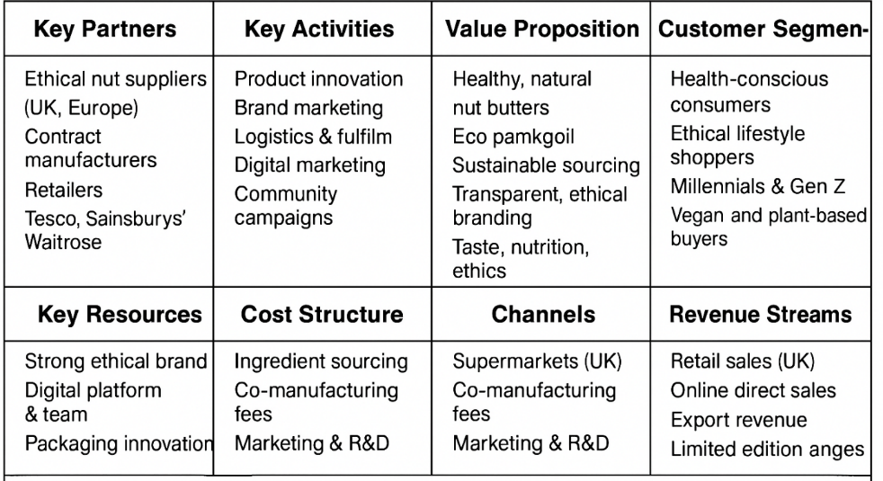
Figure 1: Business Model Canvas for Pip & Nut Ltd
(Self-Developed)

2. Current Strategic Direction
The mission of producing natural, healthy, and sustainable food products as the reflection of the current consumer values directs the strategic direction of Pip and Nut. Simple, transparent and ethical responsibility is the philosophy of the company in all its operations. It has a vision of becoming the most reliable natural food brand in the United Kingdom and diversifying internationally in a responsible and sustainable manner (Murray, 2020).
Pip & Nut plans to enhance its market presence in the domestic market by promoting brand recognition, customer retention and supply chain efficiency in the short term. It also intends to come up with new product varieties which react to the shifting eating pattern. The company will establish new retail relationships and increase its online marketing efforts in the medium run to target younger, health-aware audiences (Smith, 2022). The future plan is to enter new markets abroad and to build a comprehensive traceable and green value chain (Grant, 2020).
The company uses differentiation strategy developed by Porter (1980) by concentrating on unique value by product quality, innovation and good brand communication. Its advertising is based on emotional narration, social media communication, and community to support its moral brand and generate trust (Hill, 2019). Founder-led organisation promotes creativity and fast-decision making, whereas the flat organisation contributes to teamwork and flexibility. Nevertheless, when the business expands, lack of formal management systems might complicate scaling operations (Johnson, 2021). Altogether, to be successful in the future, Pip & Nut needs to balance between its purpose and profit and adjust to the increasing market demands.
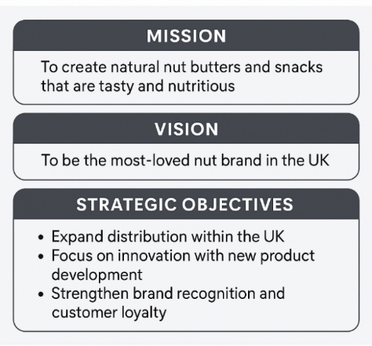
Figure 2: Summary of Pip & Nut Mission, Vision and Strategic Objectives
(Self-Developed)

3. Environmental Scan and Competitive Positioning

To grasp the extent of the strategic potential of Pip and Nut, a critical environmental analysis is necessary to establish the firm's current market position. The analysis of internal and external factors helps the company to identify opportunities and challenges that determine its competitive advantage. In this section, we use SWOT, PESTEL, and the Five Forces analysis model of Porter to analyse the operational environment of the firm in the UK food manufacturing industry.

Internal Environment: SWOT Analysis
The internal analysis reveals that the company's strengths include its strong brand reputation, innovative product portfolio, and ethical sourcing practices, as exemplified by Pip and Nut. It focuses on natural ingredients and sustainability, which sets it apart from larger competitors. The company's marketing approach, which focuses on authenticity and community relations, has also contributed to high customer loyalty (Smith, 2022). Such weaknesses as weak production capacity and reliance on outsourced manufacturing limit the flexibility and minimise the profit margins (Johnson, 2021).
The opportunities are seen in the growing consumer demand of plant-based and healthy snacks and the potential market growth in Europe. Competition with well-established names like Whole Earth and Meridian, unstable prices of raw materials, and the increasing influence of its competitors in creating own-label brands of the supermarket are all threats, though (Hill, 2019).
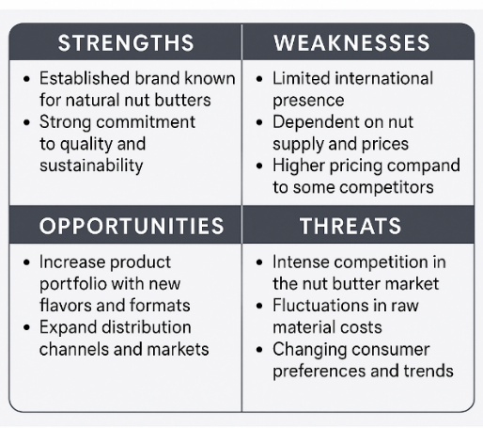
Figure 3: SWOT Analysis of Pip & Nut Ltd (Johnson, 2021)

External Environment: PESTEL Analysis
PESTEL framework gives an idea of the macro-environment. The UK trade policies since Brexit have added to the cost of importing raw nuts into the country with a negative impact on small manufacturers in Europe (Grant, 2020). Inflation and the increase in the cost of energy have placed additional pressures on production costs, economically. The social forces are positive because consumers are now more interested in natural, healthy, and eco-friendly food products (Burch and Lawrence, 2019).
The technological factors are the increasing significance of online marketing, online purchasing, and food traceability in supply chains (Porter, 2023). Pip & Nut has a strong online presence, but can further leverage technology to streamline production and logistics. The issues of environmental concerns, especially carbon emissions and packaging waste, are important sources of innovation. The company's environmentally friendly activities align with the environmental interests of consumers and regulators (Smith, 2022). Food safety standards and advertising regulations are legally mandated to be in constant compliance and observation particularly in the introduction of new products.
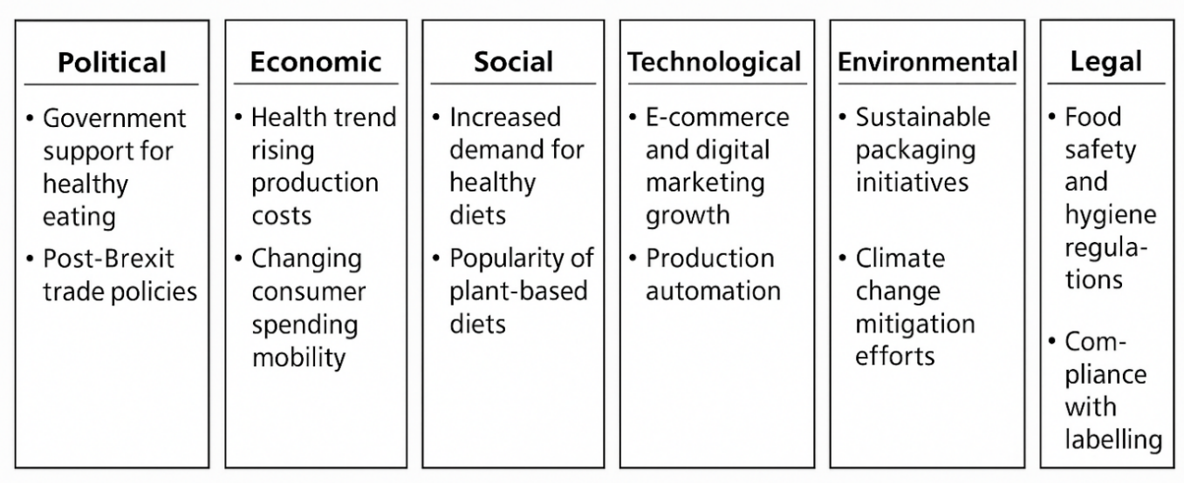
Figure 4: PESTEL Analysis of Pip & Nut Ltd (Grant, 2020)

Industry Competitiveness: Porter’s Five Forces
Food manufacturing industry is a very competitive sector in the UK. Competition within the existing companies is stiff with the numerous brands competing on quality, sustainability, and cost. Entry threats are moderate; the market is desirable, branding, certification and distribution cost barriers are barriers to entry (Porter, 1980). The supplier's bargaining power is also quite high, as Pip and Nut use imported nuts, which are vulnerable to fluctuations in global prices.
The power of suppliers is also high. Major retailers like Tesco and Sainsbury are putting pressure on the pricing and delivery conditions. The threat from substitutes is increasing due to the emergence of alternative spreads, protein snacks, and plant-based products offered by both new and established brands (Hill, 2019). In general, the analysis indicates that Pip & Nut operates in a dynamic and challenging environment, where differentiation and innovation are key to staying competitive.
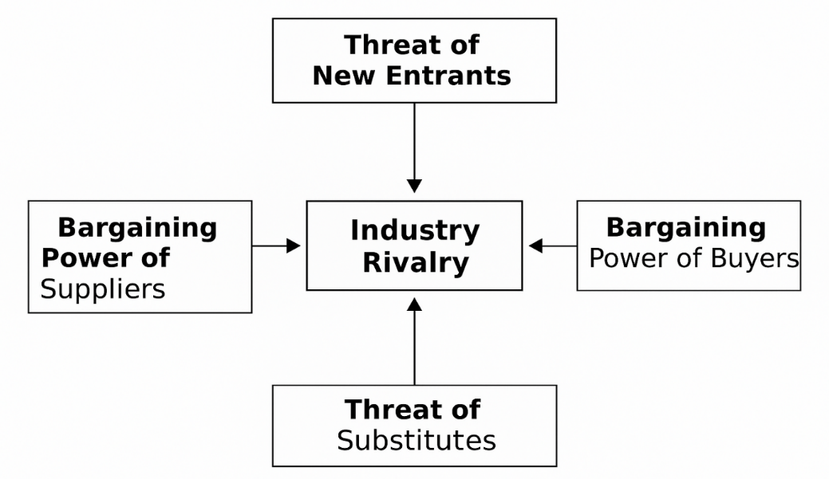
Figure 5: Porter’s Five Forces Analysis of Pip & Nut Ltd (Porter, 1980)

Competitive Positioning
Pip & Nut has a unique and focused position in the marketplace, defined by its ethical values and innovative products. Sustainability and authenticity are key values in the proposition, appealing to consumers who are willing to pay for products that offer transparency and quality. Limited economies of scale and increasing competition necessitate adjustments to the strategy, including enhanced operational efficiency, international expansion, and ongoing product innovation, to maintain a competitive advantage.

4. Strategic Growth Choices
For Pip & Nut, growth as a strategic goal is central to maintaining viability and long-term sustainability in the competitive food manufacturing sector. The existing differentiation strategy has resulted in a brand with strong values in terms of ethics and quality, however, more structured strategic choices are a prerequisite for continued development. Porter’s Generic Strategies and the Ansoff Matrix are applied to generate future growth options.

Porter’s Generic Strategies
Porter (1980) argues that competitive advantage is achieved through cost leadership, differentiation, or focus. Pip & Nut pursues a differentiation-focused strategy by targeting health-conscious consumers with high-quality, natural products. This allows the firm to charge high prices while preserving its loyal customer base. Central to this competitive positioning are its core brand values of sustainability, openness and creativity (Hill, 2019). There are, however, rising competitive pressures from the large food companies which are causing an increase in market pressures on Pip & Nut, leading to a need to refine its differentiation.
An increase in innovation in product development and improvements in its supply chain efficiency could lead to continued excellence in its market focus (Grant, 2020). Furthermore, it is not possible for a small firm to force through cost leadership because of the lack of production capacity, but judicious cost reductions in some areas (i.e. packaging costs, suppliers’ contracts) can be obtained, which will lead to a reduction in production costs, profitability increases without a fall-off in quality (Johnson, 2021).
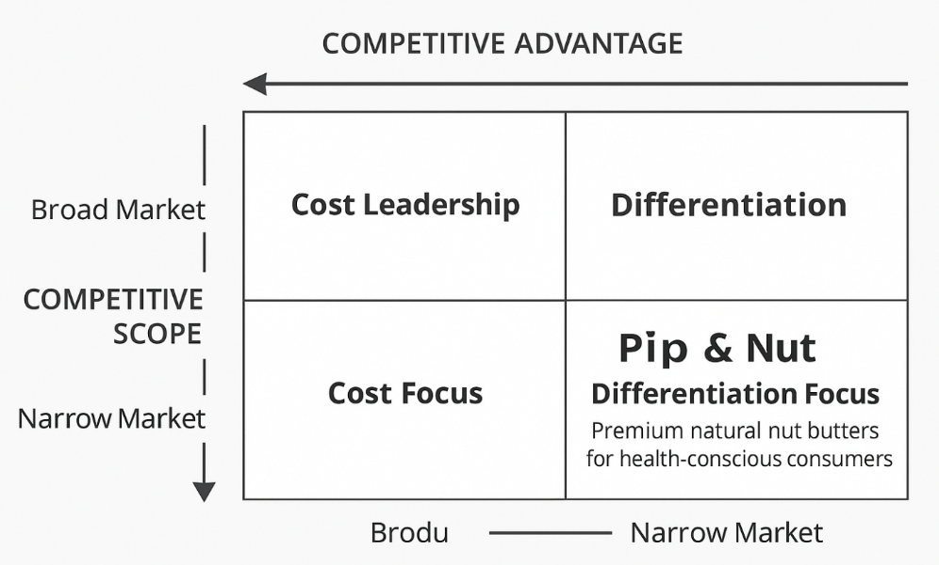
Figure 6: Porter’s Generic Strategies Applied to Pip & Nut Ltd (Porter, 1980)

Ansoff Matrix
Ansoff’s Matrix provides a methodology for identifying different routes for growth: market penetration (increasing market share within existing markets), market development (entering new markets), product development, and diversification (Ansoff, 1957). Pip & Nut could enhance market penetration in the UK by increasing brand visibility through enhanced digital marketing, collaborating with retailers to boost brand awareness, and offering special promotions. Opportunities in market development lie in expanding business in new European markets where demand for ethical food and plant-based diets is growing (Burch and Lawrence, 2019).
There are ample product development opportunities. Pip & Nut could expand its product range with protein dishes made with nut-based spreads, sugar-free alternatives, and healthy snacks on the go. Diversification offers more risk but here there may be opportunities through working with complementary sustainable food brands, or from developing healthy drink products produced as by-products (Hill, 2019). The initiatives fit comfortably with the company's vision of sustainable, credible growth.

Sustainable Growth Orientation
The long-term strategy of Pip and Nut is based on sustainability. The introduction of circular economy concepts, including recyclable packaging, waste minimisation, and ethical sourcing, will also distinguish the brand and align it with the new desires and expectations of consumers (Smith, 2022). Also, the implementation of technological advancements in production and logistics will aid in efficiency and traceability (Grant, 2020).
To sum it up, the most reasonable way for Pip and Nut to grow is by reinforcing their differentiation strategy, coupled with the incorporation of sustainable innovation and market growth. This two-pronged approach will make the company profitable and at the same time maintain its ethical image in the ever-competitive marketplace.

5. Stakeholder Analysis
Stakeholders play a critical role in shaping Pip & Nut’s strategic decisions and long-term sustainability. As a small and medium-sized enterprise, the company depends on strong relationships with both internal and external stakeholders to ensure effective implementation of its ethical and commercial goals. This section uses Mendelow’s Matrix to analyse the power and interest of key stakeholders and how their expectations influence the company’s strategic direction.

Identification of Key Stakeholders
The key stakeholders in Pip and Nut include customers, employees, suppliers, investors, retailers, and regulatory organisations. Customers are seeking uniform quality, transparency, and environmentally friendly practices. The employees demand good salary, promotion, and integration into the creative culture of the company. Suppliers aim for stable contracts and reasonable prices, whereas the investors and the owners expect the profitability and the brand development in the long run. Tesco and Sainsbury are the retail partners that require prompt delivery, innovative products, and stable pricing (Smith, 2022). Compliance with food safety regulations and input to social and environmental sustainability are needed by government agencies and local communities (Grant, 2020).

Stakeholder Power and Interest
The Matrix created by Mendelow categorises stakeholders according to their power and interest levels (Mendelow, 1991). High power and interests of investors and major retail partners make them key influences whose needs should be proactively handled. Regulatory authorities are highly empowered but often less interested, and they need to update their information frequently and report compliance regularly. The interest of employees and customers is usually high but less powerful; hence, they need to be informed and involved through transparent communication and feedback programmes. Local communities and small suppliers, who often have less power and influence, are nevertheless integral to the creation of the company's social image and reputation (Hill, 2019).
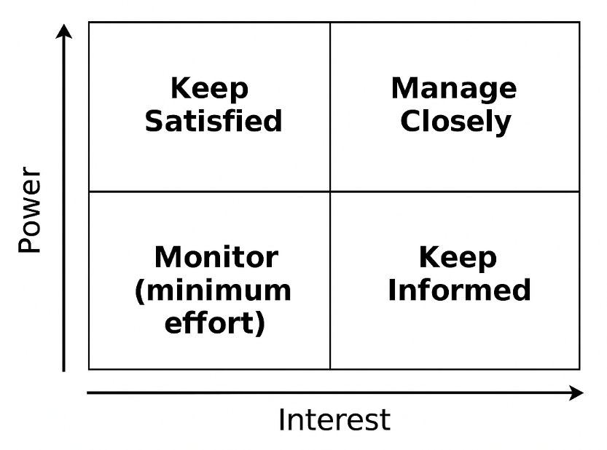
Figure 7: Mendelow’s Matrix for Pip & Nut Stakeholders (Mendelow, 1991)

Stakeholder Engagement and Management

Good interaction ensures that Pip and Nut strike a balance between the expectations of stakeholders and their strategy. The company promotes both upward and downward communication through digital platforms, social media, and collaboration with sustainability organisations. In-house, innovation and dedication are generated through free flow of information and teamwork. Outside, customer surveys and retailer cooperation provide insight into new trends and preferences (Burch and Lawrence, 2019).

The difficulty of the leadership team is to walk the fine line between the different needs of the stakeholders and brand authenticity. Focusing on ethical practice and transparency in supply chain operations contributes to creating trust and avoiding reputational risks (Johnson, 2021). Additionally, the approach of formal stakeholder management schemes and sustainability reporting might increase both accountability and the credibility of Pip & Nut among investors and regulators (Smith, 2022).

Critical Reflection
The performance of Pip & Nut is based on the ongoing cooperation of stakeholders. This ethical stance and community culture has provided a base of trust, yet further development needs to be more organised in terms of communication, accountability, and output of sustainability. Through increased stakeholder interactions, the company will be able to enhance brand value and ensure long-term strategic sustainability in a progressively aware and competitive market.

6. Strategic Recommendations

The recommendations below are based on an analysis of Pip & Nut's strategic position, and they are expected to enhance the company's competitive advantage, increase operational efficiency, and contribute to sustainable long-term growth. All recommendations align with the company's mission and other ethical values, addressing the key issues identified during the environmental and stakeholder analysis.

Improve Operational Efficiency and Supply Chain Control

The use of outside manufacturers by Pip & Nut adds expenses and decreases flexibility. The company must also look at partial internalisation of production through investing in small-scale production units through which they can have more control as well as flexibility in terms of quality. Such a strategy would minimise the reliance on third parties and enhance the ability to respond to market changes (Johnson, 2021). The adoption of digital supply chain products, such as inventory optimisation software and demand forecasting software, may enhance transparency and reduce waste (Grant, 2020). Moreover, long-term collaboration with suppliers of local and regional nuts will reduce transportation expenses and help sustainability.

Expand Internationally through Targeted Market Development

Expanding to chosen European markets, including Germany and the Netherlands, would enable Pip & Nut to capitalise on the high demand of plant-based and ethical products. The development of the market may begin with establishing export relations with long-standing distributors, supported by targeted digital marketing campaigns. The slow entry would reduce financial risk and test the consumer's response before widespread expansion (Smith, 2022). The company's ethics- and sustainability-oriented perception is an advantage over competitors in a country where consumers have similar expectations (Burch and Lawrence, 2019).

Drive Innovation through Product Diversification

The growth strategy of Pip and Nut should focus on product innovation. The company may launch new product lines like high-protein nut butters, snack bars and low-sugar options. Cooperation with nutritionists and food technologists may serve to ensure nutritional integrity and attract new lifestyle trends (Hill, 2019). Co-branding with wellness brands and seasonal limited editions would attract more consumer interactions and brand awareness. This kind of diversification can comply with the product development strategy proposed by Ansoff (1957), as it will increase market share without losing a natural and sustainable focus of the company.

Strengthen Sustainability and Corporate Responsibility

The primary distinguishing factor in Pip & Nut is sustainability, and it must be institutionalised as a quantifiable business approach. To achieve this, the company will need to establish particular carbon reduction targets, invest in recyclable or compostable packaging, and provide annual sustainability reports to show improvements (Smith, 2022). Collaboration with environmental organisations may also contribute to strengthening the brand and access to best practices in responsible sourcing (Grant, 2020). This is a long-term investment that will contribute to gaining consumer loyalty and satisfying regulatory demands.

Establish Monitoring and Evaluation Mechanisms
To ensure successful implementation, the management team should adopt a performance measurement framework based on the balanced scorecard approach. This system would monitor progress across financial, operational, and environmental dimensions (Kaplan and Norton, 1992). Regular internal reviews and stakeholder feedback sessions can ensure that the company remains aligned with its objectives and responds quickly to market developments.

Implementation Plan and Responsibilities

Implementing these strategic recommendations in a gradual approach with a clear leadership and accountability should be adopted in the implementation of these recommendations in order to make it effective at Pip and Nut. In the short term (0-6 months), the operations manager will have to be employed in the business which will help in balancing the shift to semi-in-house production and the integration of digital tools to control inventory and demand forecasting. Recyclable packaging pilot experiments and opening contracts with the local nut manufacturers in the region should also be initiated at this stage.

The Marketing and Business Development team would drive the expansion to European markets during the medium term (6-18 months), starting with Germany and the Netherlands. This should involve exporting partnerships, internet advertising and visiting ethical food fairs to create brand awareness. Meanwhile, the R&D department will need to develop new versions of the products (protein-enriched nut butters and less-sugar versions), and ensure that each new product is introduced as per the established nutrition and sustainability standards.

The benefit of the Sustainability Committee, led by the top management, is to publish the first annual sustainability report of Pip and Nut in the long-term (18-24 months), and check whether the carbon-reduction targets have been met. Performance reviews will be conducted using the Balanced Scorecard technique to regularly measure efficiency, profitability, and environmental outcomes.

Although implementation risks, e.g. delays in supplies or market uncertainty, could be experienced, they can be addressed by pilot testing, flexible contract agreements, and feedback from stakeholders to keep the strategy on track and resilient.

Summary
These strategic recommendations collectively support Pip & Nut’s long-term vision. By improving operational control, expanding internationally, diversifying products, reinforcing sustainability, and implementing effective performance monitoring, the company can achieve steady, ethical, and profitable growth. These initiatives will not only strengthen its market position but also maintain its reputation as a purpose-driven and socially responsible enterprise.

7. Conclusion

Pip and Nut Ltd's strategic analysis reveals that the company has established a good ethical and innovative image within the UK food manufacturing industry. It has established a dedicated and health-conscious customer base, thanks to its differentiation strategy based on the consumption of natural ingredients and sustainability. Nevertheless, the increased costs of production, competition, and business limitations demonstrate that a more systematised and scaled strategy approach is desired (Smith, 2022).

Pip and Nut exist in a dynamic environment where economic changes, technology as well as consumer demands affect them. To remain competitive, it is recommended that the firm be innovative, enhance its operational efficiency, and maintain high ethical standards (Grant, 2020). Implementation of sustainable production technologies would make the company more resilient through the reduction of long-term costs and the benefits of the supply chain.

The sustainability of Pip and Nut in the long term will lie in its capacity to become a professionalised SME capable of competing in the international market, but not in an ethical brand that is a niche. By being committed to transparency, quality, and environmental responsibility, the organisation can achieve sustainability in terms of profitability, which helps sustain the reputation of one of the most prominent brands in the natural food market (Johnson, 2021).

Reference List
Ansoff, H.I. (1957) Strategies for diversification. Harvard Business Review, 35(5), pp. 113–124.
Burch, D. and Lawrence, G. (2019) Rescaling food and agriculture: Sustainability and the new food economy. London: Routledge.
Grant, R.M. (2020) Contemporary strategy analysis: Text and cases edition. 11th ed. Hoboken, NJ: Wiley.
Hill, C.W.L. (2019) Strategic management: Theory: An integrated approach. 13th ed. Boston: Cengage Learning.
Johnson, G. (2021) Exploring strategy: Text and cases. 12th ed. Harlow: Pearson Education.
Kaplan, R.S. and Norton, D.P. (1992) The balanced scorecard – Measures that drive performance. Harvard Business Review, 70(1), pp. 71–79.
Mendelow, A. (1991) Environmental scanning: The impact of the stakeholder concept. Proceedings of the Second International Conference on Information Systems, Cambridge, MA: Harvard Business School Press.
Murray, P. (2020) Building a brand with purpose: How Pip & Nut redefined ethical snacking. Journal of Brand Strategy, 9(3), pp. 245–258.
Porter, M.E. (1980) Competitive strategy: Techniques for analyzing industries and competitors. New York: Free Press.
Porter, M.E. (2023) The changing dynamics of competitive advantage in the digital age. Strategic Management Review, 45(2), pp. 112–128.
Smith, J. (2022) Consumer perceptions of ethical food brands in the UK market. British Journal of Marketing Studies, 10(1), pp. 33–49.

