ACCA5023
Network Operating Systems and Services

Research, build, and deploy a Virtualised Enterprise network

Student Name: Omar Qassem
Student Number: 2316700

Index
Introduction..................................................................................................3
Hypervisors..................................................................................................4
IP Addressing..............................................................................................7
Network Services.........................................................................................8
Implementation of Topology.......................................................................10
Reflection....................................................................................................34
Bibliography................................................................................................35

Introduction
This coursework explores the design and implementation of a theoretical virtualised organisational network environment using hypervisor technology. It looks at the differences between Type 1 and Type 2 hypervisors and justifies the use of a Type 2 hypervisor for the solution of the problem provided.
This project demonstrates the configuration of Windows and Linux servers & clients, IP addressing, subnetting, routing, and proper network design and implementation concepts. The creation and configuration of multiple subnets and a transit network investigate the networking principles of packet switching, static routing, and communication between different networks.

Hypervisors
A hypervisor is a piece of software that allows one or more virtual machines to run on a physical machine by managing access to hardware resources.

Type 1 hypervisor
A type 1 hypervisor is sat atop the machine’s resources directly. It can interact directly and use the resources of the machine itself without the need for an operating system.
Characteristics:
- Often more performative and effective as there is no operating systemin between the hypervisor and the machine’s resources.
- Often more secure as again, there is no operating system controlling it, which lowers the attack surface.
- Type 1 hypervisors do, however, require dedicated hardware to run. [1][2][3]

Type 2 hypervisor
A type 2 hypervisor is disconnected from the resources. It runs within the operating system and has resources assigned to it via the operating system. It can only access as many resources as has been assigned, and control is done by the operating system.
Characteristics:
- Far easier to install and requires less knowledge
- Don’t usually require any dedicated hardware
- Easy to use for development or testing purposes
- However often less efficient as the OS is present and takes resources and adds overhead between the VM and the resources
- Potentially less secure as the host OS is present and provides a bigger attack surface.[1][2][3]
For this coursework, a type 2 hypervisor would be most appropriate, as there is no dedicated hardware for this project and must be run on one machine. A type 2 hypervisor can be implemented in its entirety on one machine.
Considering the topology required:
- Windows Server & client
- Debian server & client
- Multiple subnets (192.168.1.0/24 and 192.168.2.0/24)
- Transit network (20.0.0.0/30)
- Connectivity to the internet
- Each VM must be connected to several networks
- Routing between networks and differing operating systems
A type 2 hypervisor provides the necessary functionality to achieve this. It supports both Windows and Linux operating systems and allows them to operate simultaneously. It also allows for the creation of multiple virtual network adapters, NAT & internal connections which make accurately simulating subnets and routing possible. [4][6]
Additionally, Type 2 hypervisors provide easier and straight-forward install via a GUI and wizard-driven VM creation processes. This reduces deployment, maintenance, and troubleshooting complexity, making it possible for those with less-pecialised knowledge to create a solution that fulfils all requirements.
While a type 1 hypervisor provides greater security, the proposed Swansea and London networks will not be hosting live business data, so for this particular implementation, a Type 1 hypervisor would not be appropriate. [5]
If, however, this was a production environment in a real company, a type 1 hypervisor would be preferred for the following reasons:
- Better performance
- Stronger security
- Greater reliability
- High availability
- Failover support
In a real-world environment where there can be hundreds of hosts within a network, and authentication requirements for users, the performance improvements provided by a type 1 hypervisor would be worthwhile.
As the second topology for coursework 2 introduces identity services, certificate authorities, and potentially VPN gateways, there is a need for the ability to test in a sandbox environment. A type 2 hypervisor can:
- Snapshot functionality for rollback
- Easily add domain members/servers
- Test without affecting hosts and servers
- Allow for flexible resource allocation [5]

IP Addressing
Data moves across the internet using packet switching, a method that was developed to maximise bandwidth efficiency. Instead of reserving a line (originally a telephone line) for the entirety of a communication session, data is divided into small units called packets, each containing a payload and a header. “The header includes source and destination IP addresses, a protocol identifier, and a Time-To-Live (TTL) value to prevent routing loops”. Packet-switching allows many hosts to send over one line as the time is split between them. [10]
The Internet Protocol (IP) provides logical addressing and defines how packets are structured and is used to route packets between networks. Transmission Control Protocol (TCP) operates above IP to “ensure reliable delivery by attaching sequence numbers to packets, detecting loss, and requesting resending when loss occurs.” [7] [8]
Routers facilitate communication between networks by examining the destination IP address in each packet and consulting a routing table. Routing tables contain network information and next-hop addresses, allowing routers to forward packets toward their destination using the most efficient known path. The creation of routing tables is “supported by routing protocols such as OSPF (Open Shortest Path First) and BGP (Border Gateway Protocol), which dynamically update routing information across routers. Switches operate within local networks, forwarding frames based on MAC addresses rather than IP addresses”.[8] [9]
IPv4 addresses are 32-bit values written in dot-decimal notation (e.g., 192.168.0.1) and are split into network & host portions using a subnet mask. Subnetting allows for efficient organisation within a network as many networks can be created, depending on their needs. It also allows for many private addresses to be used within a network, meaning the world doesn’t run out of the finite IPv4 addresses. IPv6 uses 128-bit hexadecimal addresses (e.g., 2141:da8:0::a), providing a “vastly expanded address pool, simplified header structure, improved hierarchical routing, and features such as stateless address autoconfiguration” (Hagen, 2014).

Network Services
VPNs
Provide an encrypted, secure communication over an untrusted network. Often used for remote access and site-to-site connection. [11]
Service | Description | Key Features | Best Practices
VPN | Provide an encrypted, secure communication over an untrusted network. Often used for remote access and site-to-site connection. | - Encryption & Tunneling  - Authentication  - Traffic Segmentation and Filtering  - Bandwidth caps  - Access control [12] | - Use modern protocols (IKEv1/IPSec)  - Enable monitoring and logging for investigation  - Implement segmentation  - Use high availability in cloud environments for reliability [13]
DHCP | Automatically provides IP addressing and network configuration to clients | - Dynamic IP assignment & leasing  - Relay agent support  - Discover, Offer, Request, Acknowledge process (DORA) [14][15] | - Avoid running on Domain Controller for reduced attack surface  - Use a DHCP failover  - Segment networks  - Use DHCP relay agents instead of using a DHCP agent on every subnet [16] [17]
AD DS | Microsoft’s directory service for identity, authentication and centralised management | - Centralised authentication & authorisation  - Hierarchical structure  - Group policy application  - Replication between domain controllers [18] | - Apply appropriate policies and groups to reduce attack surfaces  - Enable auditing  - Use several domain controllers to provide redundancy  - Always keep up-to-date to avoid hacks/exploits [19]
CAs/PKI | Issue and manage digital certificates for authentication, encryption and establishment of trust | - Root CA & subordinate Ca hierarchies  - Issuance and revocation of certificates  - Integrates with AD DS via AD CS  - Can use hardware security modules (HSMs) for security  - Can be controlled via policy & configuration controls [20] | - Two-tier PKI – offline root CA and an online issuing CA  - Protect CAs with HSM  - Restrict CA server to only have this role to reduce attack surface  - Implementation of certificate lifecycle automation to avoid expired certificates [20][21][22]

Creation of topology

Download links for OS .iso files
Debian download link: https://www.debian.org/download
Windows Server 2022 link: https://www.microsoft.com/en-us/evalcenter/download-windows-server-2022?msockid=1749cd99bd426b98184bdb74bc7b6a8f
Windows 10 link: https://www.microsoft.com/en-gb/software-download/windows11?msockid=1749cd99bd426b98184bdb74bc7b6a8f

Installation of the Windows Server 2022 complete:
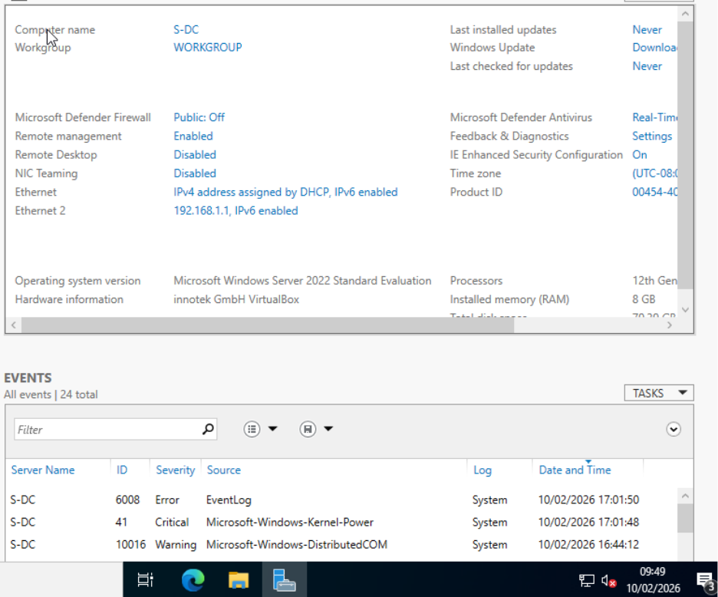

Installation of the Windows 11 client complete:

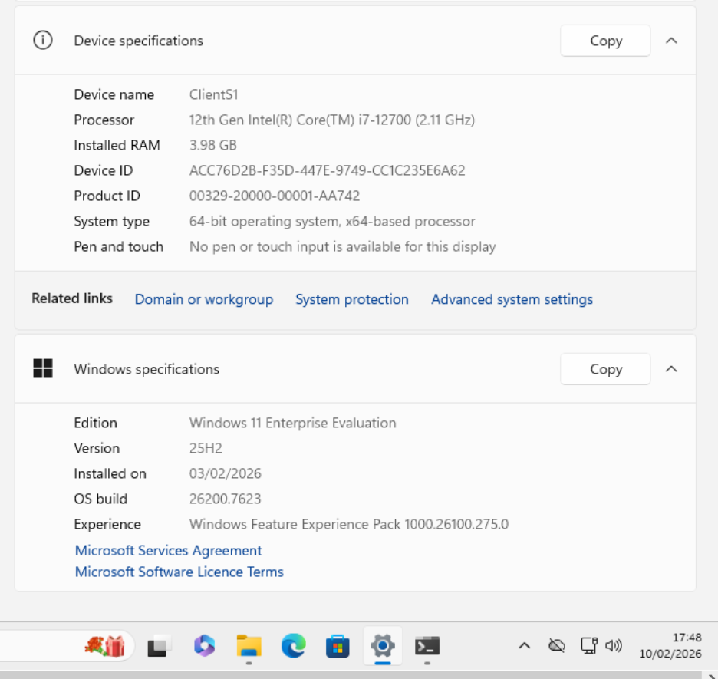

The first, default, ethernet adapter in the client is connected to the internet via a default gateway of 10.0.2.2.
A second ethernet adapter was added to the client. Client IP address has been configured on second ethernet adapter to have:
- IP address of 192.168.1.10
- Subnet mask of 255.255.255.0
- Default gateway of 192.168.1.1
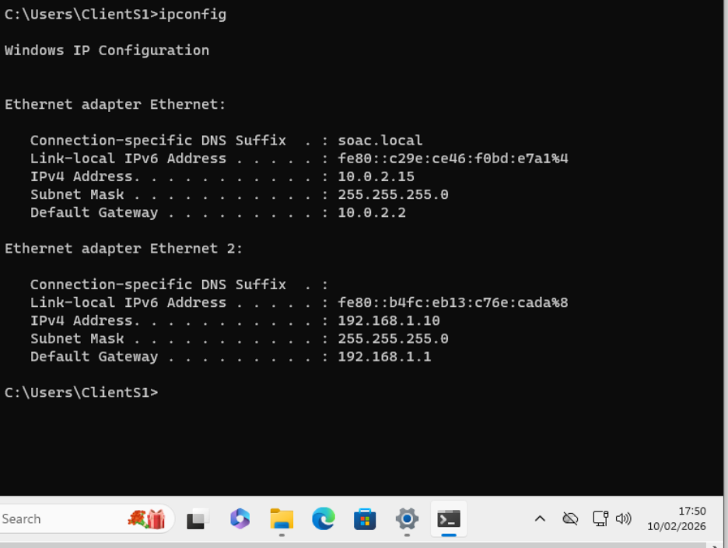

The first, default, ethernet adapter in the server is connected to the internet via a default gateway of 10.0.2.2/24
A second ethernet adapter was added to the server to allow clients to connect to it and use it as a default gateway. Server IP address has been configured on second ethernet adapter to have:
- IP address of 192.168.1.1
- Subnet mask of 255.255.255.0
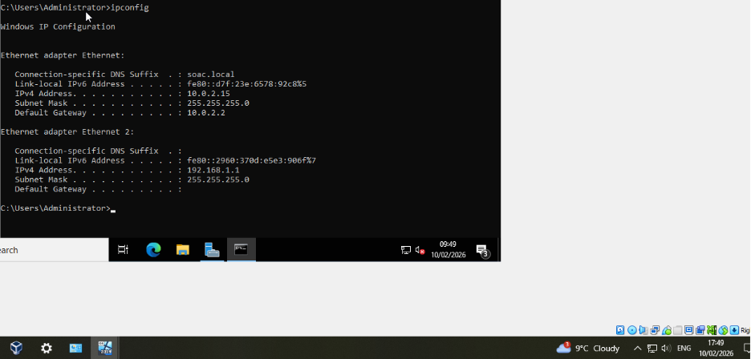

While attempting to ping the Windows client from the server the following error was encountered:
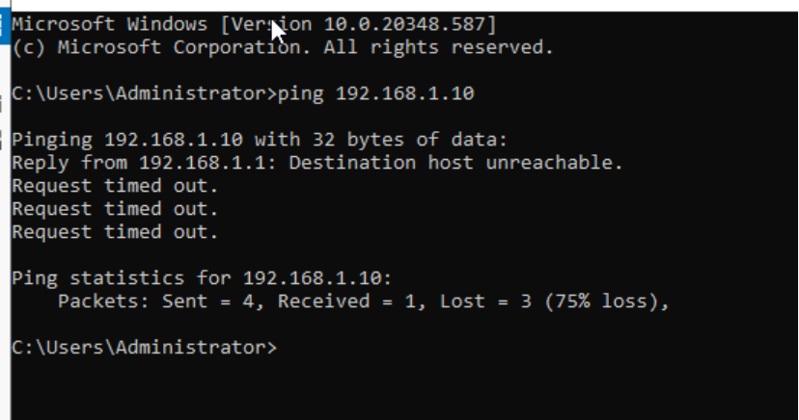

This is because the second ethernet adapter on the Windows 2022 server was set up as a NAT network and not an internal network, like it was on the client machine. This was rectified by removing the second ethernet adapter on the server and readding another using an internal network named “intswa”; the same as on the client machine. The firewalls also needed to be turned off on both the server and client machines.

Now the server can ping the client:
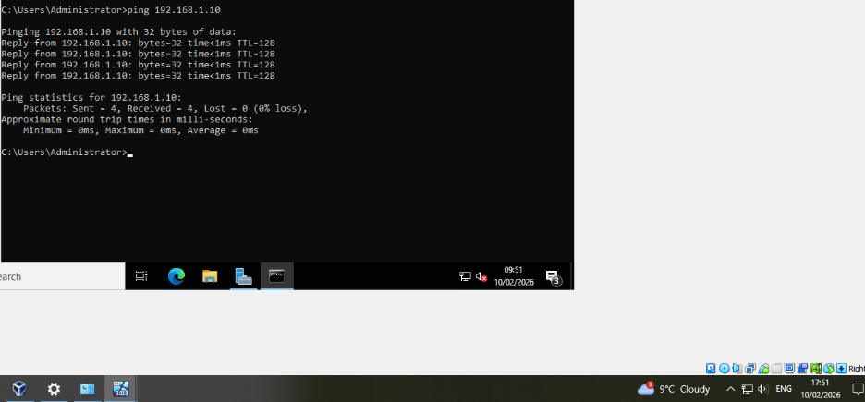
The client can also ping the server:
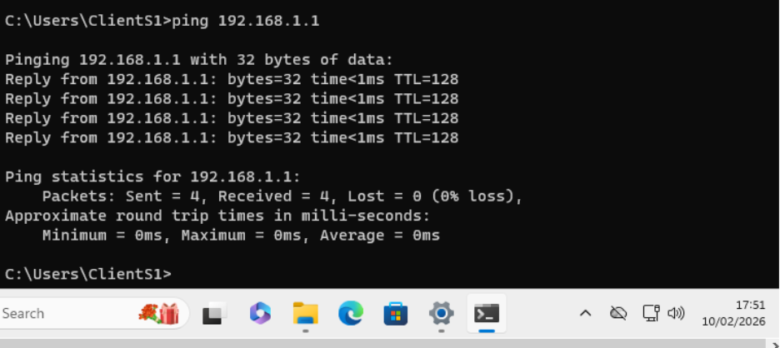

Once the Debian server had been installed in CLI mode and a second ethernet adapter had been added, to configure IP addresses and ethernet adapters requires the sudo privilege. When attempting to update sudo via the localadmin account, the following error was encountered, stating that the localadmin account is not in the sudoers file:
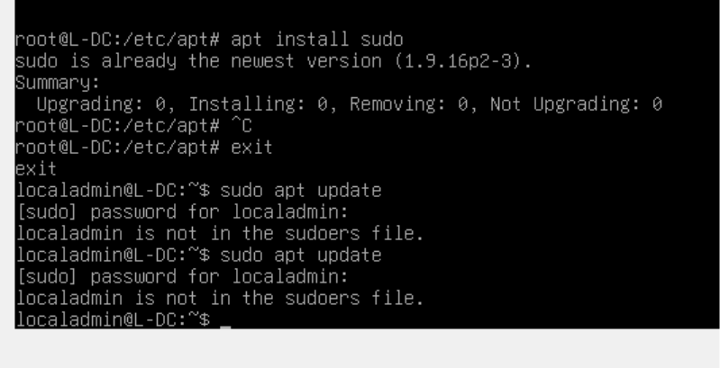
To add the localadmin to the sudoers file, the following commands were entered while in root account:
The server virtual machine was then restarted.

When entering the command “ip a” the following ethernet adapter configuration was shown:

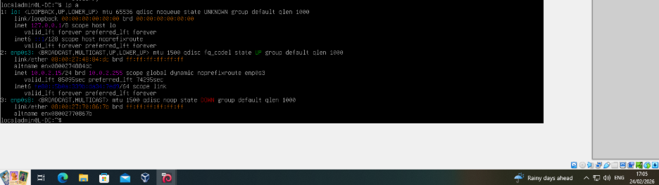
The third interface is “down”. To enable it, it needs to be configured in the file /etc/network/interfaces, which holds configuration for the ethernet adapters.

Adding the ethernet adapter to the interfaces file, as it wasn’t there initially:
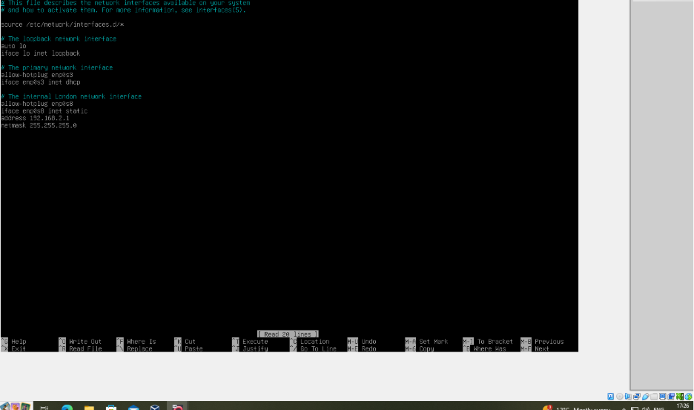
The ethernet adapter had the following configuration:
- IP Address: 192.168.2.1
- Subnet mask: 255.255.255.0

“Ip a” showed the interface that was added to the interfaces file as still down, so the server networking services were restarted using the command “sudo systemctl restart networking” and now it is up:
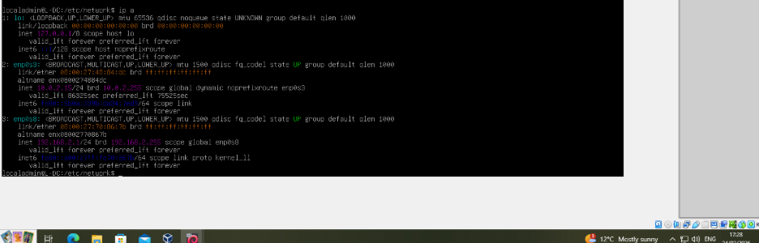

Once the Debian client had been installed and a second ethernet adapter had been added, it showed in the connectivity settings:
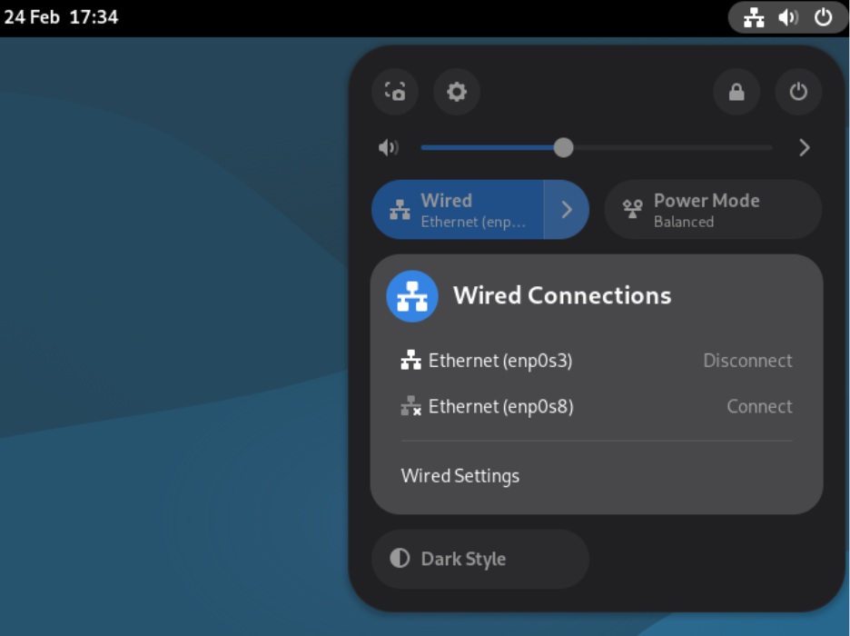

To enable it, this can be done in the network settings:
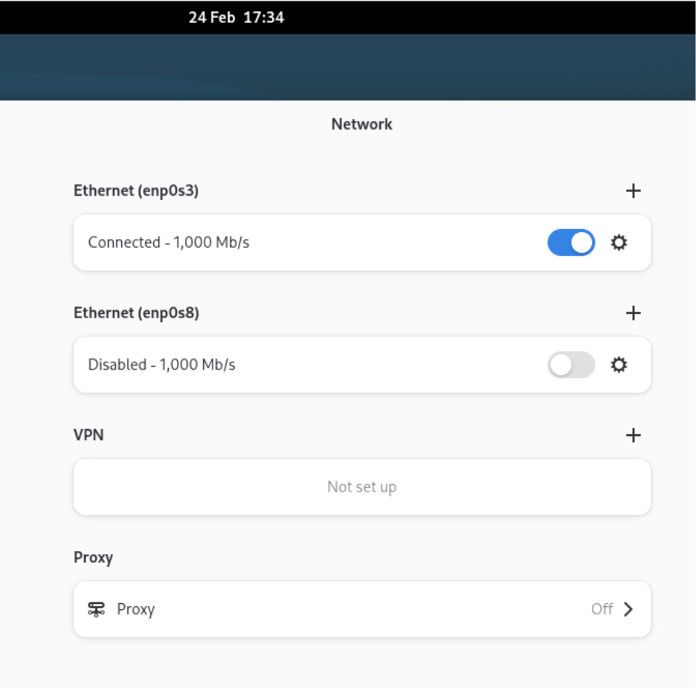

From here, the following IP configuration was added to the second ethernet adapter (enp0s8):
- IP address: 192.168.2.10
- Subnet mask: 255.255.255.0
- Default gateway: 192.168.2.1
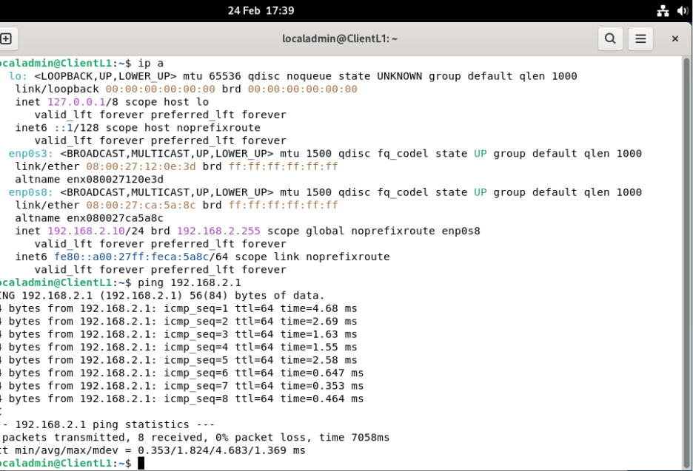
The ping from the Debian client to the Debian server can be seen in the screenshot above also.

Ping from Debian server to client:
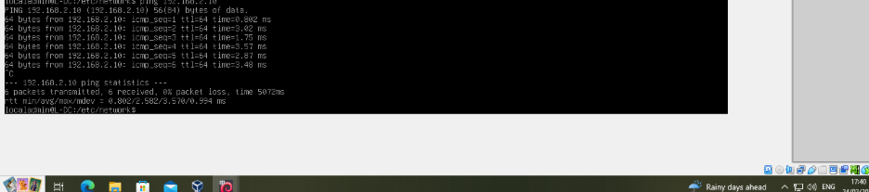

The servers now need to have a route created between them. This requires routing to be enabled on both the servers.
To allow this on the Windows Server, the remote access > routing tool service was installed, so the “Routing and Remote Access” centre can now be accessed:
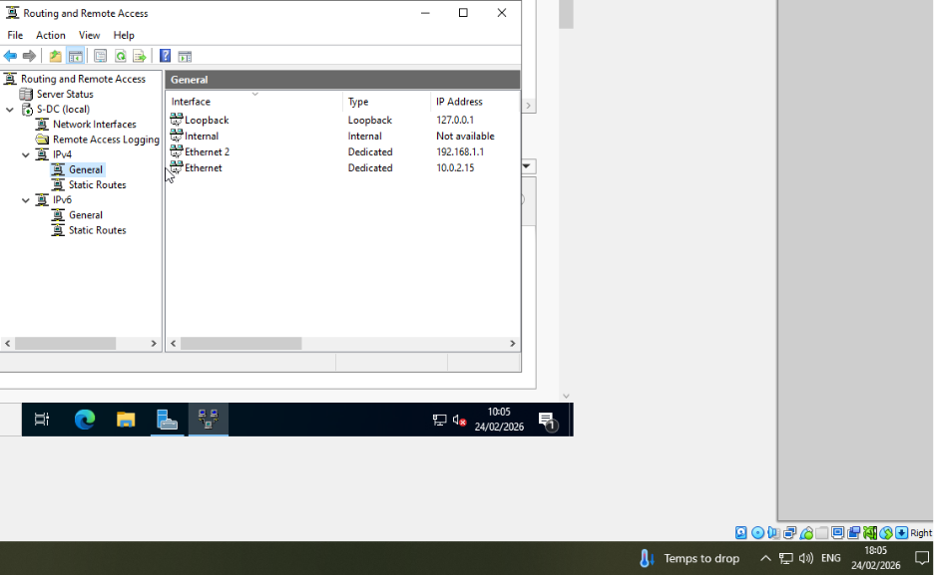
Ip forwarding was enabled on the Debian server:
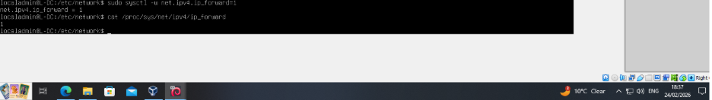

A new Ethernet adapter was added to both the Windows server and Debian servers.
Configuration of third Ethernet adapter on Windows server with configuration:
- IP Address: 10.10.10.2
- Subnet mask: 255.255.255.252
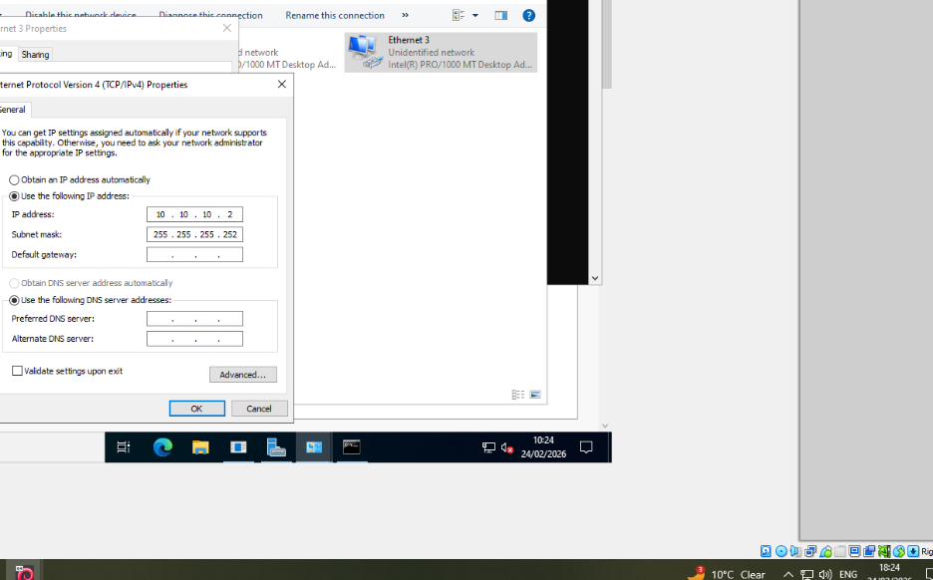

Configuration of third Ethernet adapter on Debian server with following configuration:
- IP Address: 10.10.10.1
- Subnet mask: 255.255.255.252

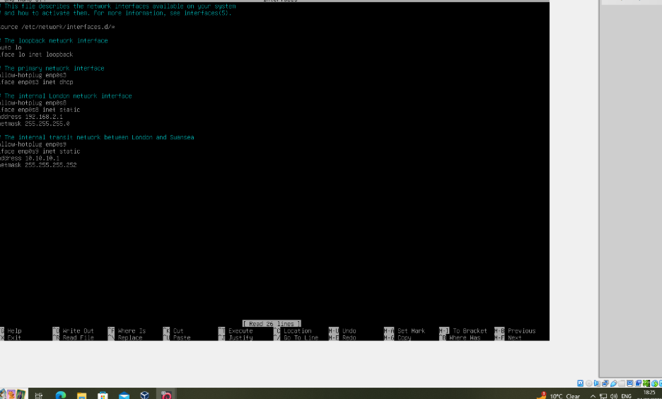
A static route between the servers, over the network 20.0.0.0/30 can now be established to allow the servers to communicate. This is called a “Transit network”.
Static route configured on Windows server to communicate with the 192.168.2.0 network via the 10.10.10.1 network:

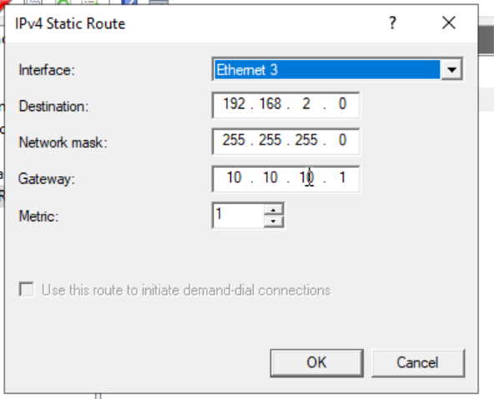

Static route configured on Debian server to communicate with the 192.168.1.0 network via the 10.10.10.2 network:


Pinging from the Debian server to the Windows server is now successful:

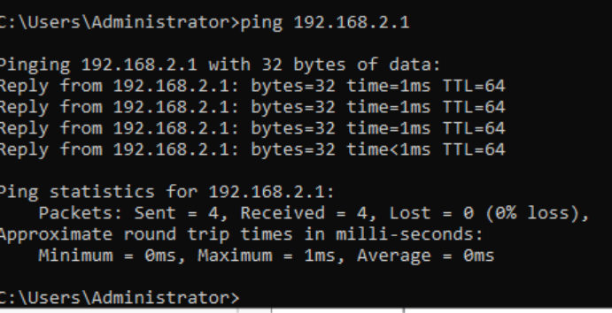

Pinging the Windows server from the Debian server:
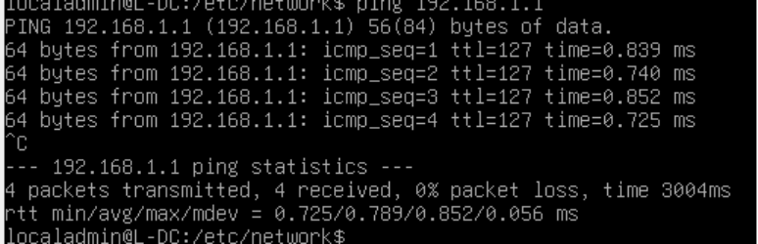

During testing above, it was determined that the Ethernet adapters throughout the topology were inappropriately named. They have now been renamed to account for their usage. The second ethernet adapter added to all hosts (servers and clients) were to allow for connection within internal networks.
On the Windows server, Ethernet Adapter 2 was renamed “intswa” as that is the name of the internal network used in that subnet, and Ethernet Adapter 3 was renamed “transit” as that is the name of the network between the servers for which it is used:
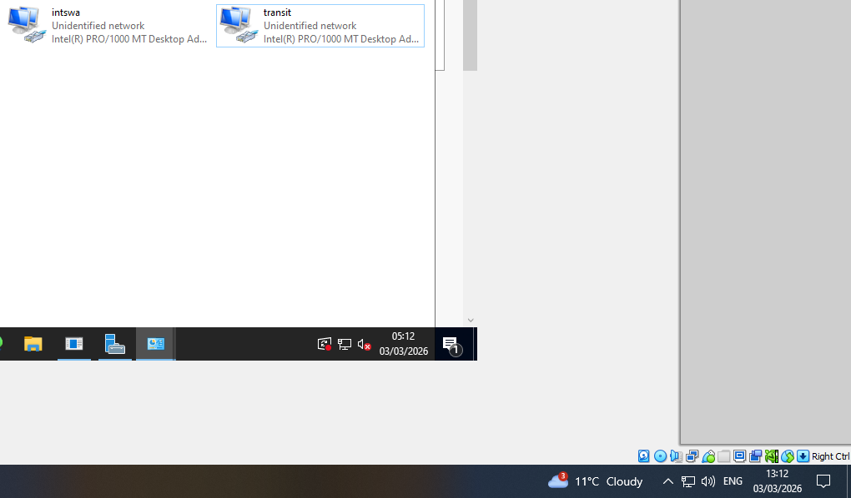

The Debian server’s second Ethernet adapter was renamed to “intlon” as it refers to that network and its third Ethernet adapter was renamed “transit” as it refers to the network that allows communication between the two servers:
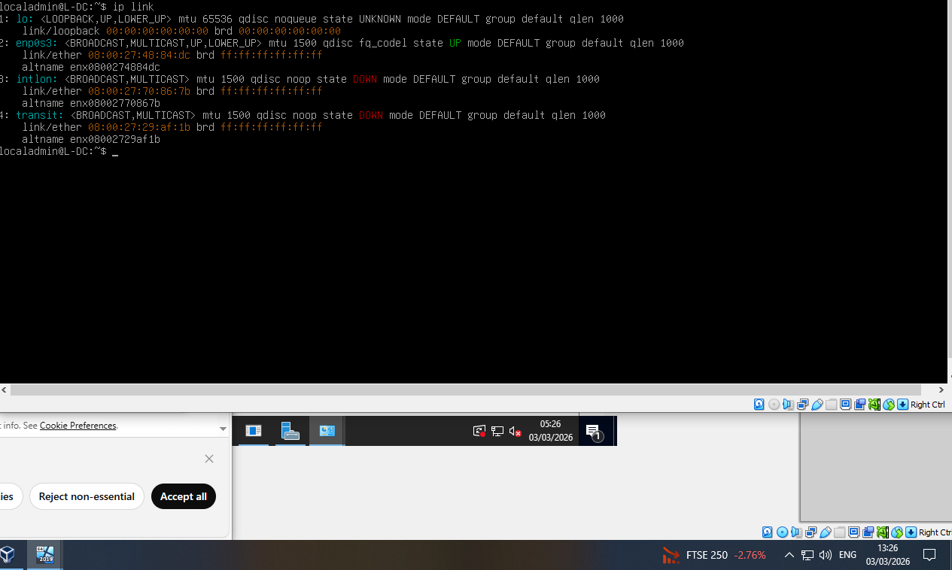
Renaming the Ethernet adapters on the Debian server was done by creating a .link file within the /etc/systemd/network folder:
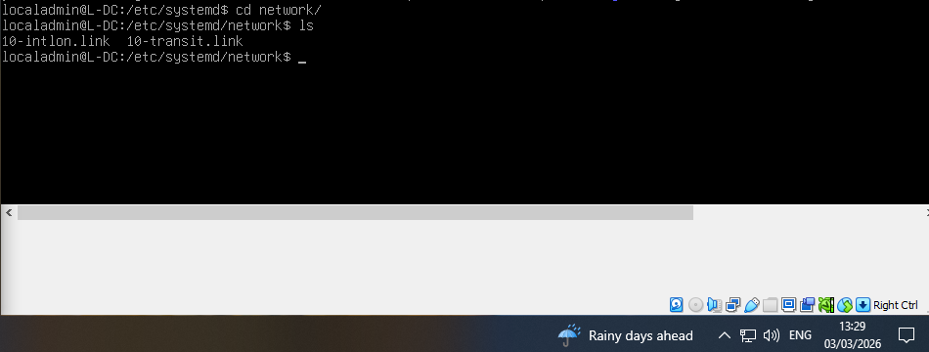
And then changing the configuration within the interfaces file to use these names instead of the default as shown above:
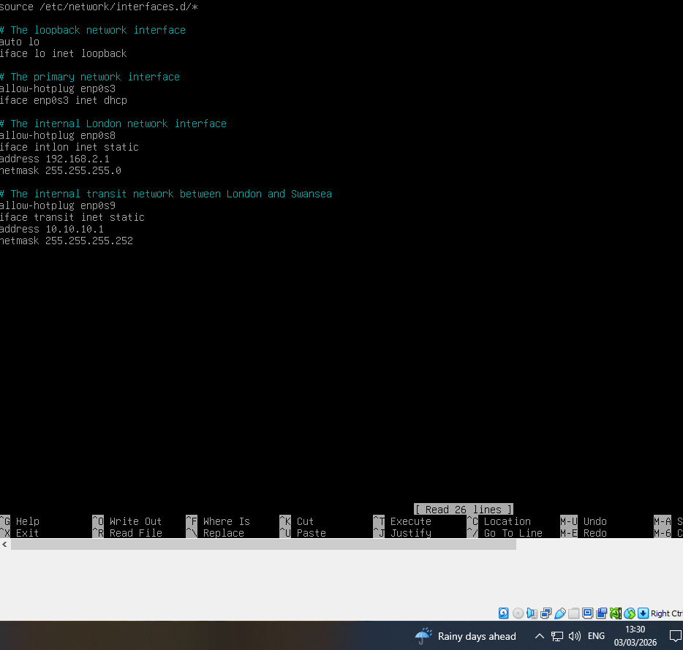

Renamed the Ethernet adapter on the Windows client to reflect the “intswa” network it is responsible for:
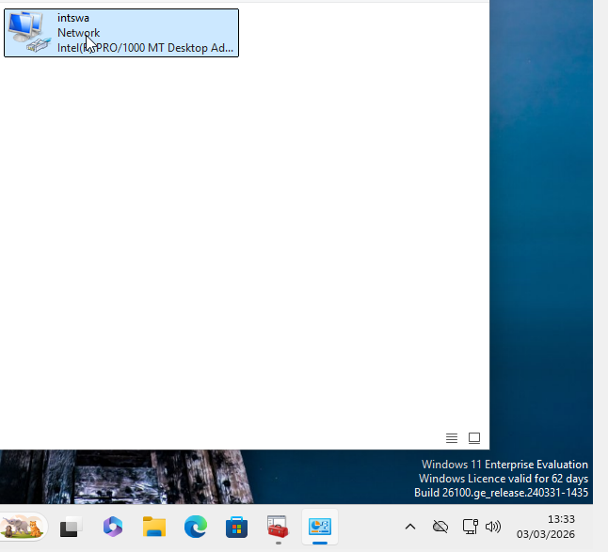

Renamed the Ethernet adapter on the Debian client to reflect the “intlon” network it is responsible for:
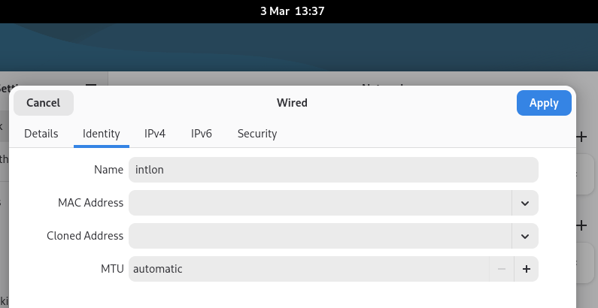

Reflection
There was successful connectivity between all hosts on the same networks:
- On the 192.168.1.0/24 network, the Windows machines can successfully connect to eachother.
- On the 192.168.2.0/24 network, the Debian machines can successfully connect to eachother.
- On the 10.10.10.0/30 network, the Debian server and the Windows server can successfully connect to eachother.
While the end-result is a successful implementation, there were many mistakes made during the creation of this topology:
- Incorrectly configuring the network names, which prevented internal communication.
- Incorrectly configuring the ethernet adapter default gateways, leading to ping commands failing
- Installing the wrong version of Debian, requiring reinstallation and reconfiguration
- Leaving the firewalls on and rejecting incoming packets
I also realised as I was doing the write up of this implementation that I had kept the Ethernet adapters as their original, default names. I had to rename them before submission. I should have done this as I was going along, during the creation of the topology.
I did create a backup of the virtual machines, however I did not send it to any backup. Going ahead this is a necessity as data may be lost and without a backup it cannot be restored.
However I learned about how networks are designed, implemented and segmented. I learned the importance of properly planning and designing IP schemes and subnets to ensure efficient routing and splitting up networks. The troubleshooting process helped me appreciate the importance routing tables, NAT and internal network configurations come together to allow communication between networks. It also gave me an appreciation of the usefulness of routing protocols that automate alot of this.
I also learned the difference between Windows and Linux network configurations and how they are managed, such as enabling and configuring interfaces and setting up static routes. The creation of a transit network between the servers made clear the image I had in my mind of how corporate networks work by introducing the concept of routing between different subnets.
Overall, this exercise improved my practical skills in virtual machine and virtual network setup, network troubleshooting and enhanced my understanding of real-world networking ideas and principles. It also embedded the importance and value of testing and verification of network deployments.

Bibliography
[1] Simic, S. (2023) What is a hypervisor? types of hypervisors 1 & 2, Knowledge Base by phoenixNAP. Available at: https://phoenixnap.com/kb/what-is-hypervisor-type-1-2 (Accessed: 29 January 2026).
[2] GeeksforGeeks (2025) Hypervisor, GeeksforGeeks. Available at: https://www.geeksforgeeks.org/system-design/hypervisor/ (Accessed: 29 January 2026).
[3] Type 1 vs type 2 hypervisors - difference between hypervisor types - AWS. Available at: https://aws.amazon.com/compare/the-difference-between-type-1-and-type-2-hypervisors/ (Accessed: 29 March 2026).
[4] Hypervisor-based virtualization - an overview | sciencedirect topics. Available at: https://www.sciencedirect.com/topics/computer-science/hypervisor-based-virtualization (Accessed: 03 February 2026)
[5] Kummara, R. (2025) European Journal of Computer Science and Information Technology [Preprint]. doi:10.37745/ejcsit.2013.
[6] Susnjara, S. and Smalley, I. (2025) What are hypervisors?, IBM. Available at: https://www.ibm.com/think/topics/hypervisors (Accessed: 03 February 2026).
[7] Comer, D.E. (2018) Internetworking with TCP/IP. Volume 1: Principles, Protocols, and Architecture. 6th edn. Harlow.
[8] Ostapiuk, R. Introduction to TCP/IP (part 1) - routers, switches and addressing, Introduction to TCP/IP (Part 1) - Routers, Switches and Addressing - Developer Help. Available at: https://developerhelp.microchip.com/xwiki/bin/view/applications/tcp-ip/routers-switches-addressing/ (Accessed: 05 February 2026).
[9] Hagen, S. (2014) IPv6 Essentials Silvia Hagen. Beijing: O’Reilly.
[10] Kurose, J.F. and Ross, K.W. (2021) Computer networking: A top-down approach. Hoboken, NJ: Pearson.
[11] Hoffman, C. and Lewis, N. (2023) What is a VPN, and why would I need one?, How. Available at: https://www.howtogeek.com/133680/htg-explains-what-is-a-vpn/ (Accessed: 15 February 2026).
[12] Cherylmc, Secure your VPN gateway deployment, Microsoft Learn. Available at: https://learn.microsoft.com/en-us/azure/vpn-gateway/secure-vpn-gateway (Accessed: 15 February 2026).
[13] Barker, E. et al. (2020) Guide to IPsec vpns [Preprint]. doi:10.6028/nist.sp.800-77r1.
[14] Robinharwood, What is DHCP server in windows server?, What is DHCP Server in Windows Server? | Microsoft Learn. Available at: https://learn.microsoft.com/en-us/windows-server/networking/technologies/dhcp/dhcp-top (Accessed: 15 February 2026).
[15] Chapter 4. providing DHCP services (no date) Chapter 4. Providing DHCP services | Managing networking infrastructure services | Red Hat Enterprise Linux | 10 | Red Hat Documentation. Available at: https://docs.redhat.com/en/documentation/red_hat_enterprise_linux/10/html/managing_networking_infrastructure_services/providing-dhcp-services (Accessed: 18 February 2026).
[16] DHCP overview (no date) Cisco.com. Available at: https://www.cisco.com/c/en/us/td/docs/routers/ncs4200/configuration/guide/IP/17-1-1/b-dhcp-17-1-1-ncs4200/b-dhcp-17-1-1-ncs4200_chapter_00.pdf (Accessed: 18 February 2026).
[17] Allen, R. (2023) Top 16 DHCP best practices: The ultimate guide, Active Directory Pro. Available at: https://activedirectorypro.com/dhcp-best-practices/ (Accessed: 18 February 2026).
[18] Active directory: Core concepts, architecture and best practices (no date) Windows OS Hub. Available at: https://woshub.com/active-directory/ (Accessed: 20 February 2026).
[19] Robinharwood (no date) Best practices for securing active directory, Microsoft Learn. Available at: https://learn.microsoft.com/en-us/windows-server/identity/ad-ds/plan/security-best-practices/best-practices-for-securing-active-directory (Accessed: 20 February 2026).
[20] Barker, E. and Barker, W.C. (2019) Recommendation for key management: [Preprint]. doi:10.6028/nist.sp.800-57pt2r1.
[21] Orin-Thomas PKI design considerations using Active Directory Certificate Services in windows server, in Windows Server | Microsoft Learn. Available at: https://learn.microsoft.com/en-us/windows-server/identity/ad-cs/pki-design-considerations (Accessed: 25 February 2026).
[22] Raj, V. (2025) Best practices for certificate authority management, SecureW2. Available at: https://www.securew2.com/blog/best-practices-certificate-authority-management (Accessed: 25 February 2026).

