Evidence of Learning

Tasleem Ramzan Kara
2132277
Learning in the Digital Era

Preparing to Study in Higher Education
Developing certain skills at university is essential. Maintaining a current knowledge base, reading, and writing can help develop these skills. Study skills are transferable life skills that are relevant to academic study and employability and developing them will enable you to study and learn efficiently. Aside from helping you pass exams, these techniques will give you skills you can use for the rest of your life.
The library offers books, articles, and computers that can help you develop a better understanding by reading and writing. To be able to study effectively, it is essential to have a comfortable study environment with minimal distractions. This helps with concentration and thinking, giving you a clear mind prior to and during study sessions. Managing your time when studying is critical because the right time is crucial to your success. In the event you only have a limited amount of time to complete your assignment, you will feel rushed to complete it. Planning beforehand will help you remember the important points and understand them better.
In addition, the more you understand, the more you will remember, which in turn makes it more enjoyable for you to keep working hard and achieving success. It is imperative to give credit to authors when you use their work. Take a moment to imagine working so hard on something and someone else taking credit.

You may not get along with studying some days, but you should always remember why you are here. Time management is all about motivating yourself to make the best use of your time. For example, you could motivate yourself with small treats at regular intervals for doing well. Do your best to avoid forming bad habits with your course, as this can be more difficult to break. In the future, you will thank yourself for starting the year the way you plan to continue.

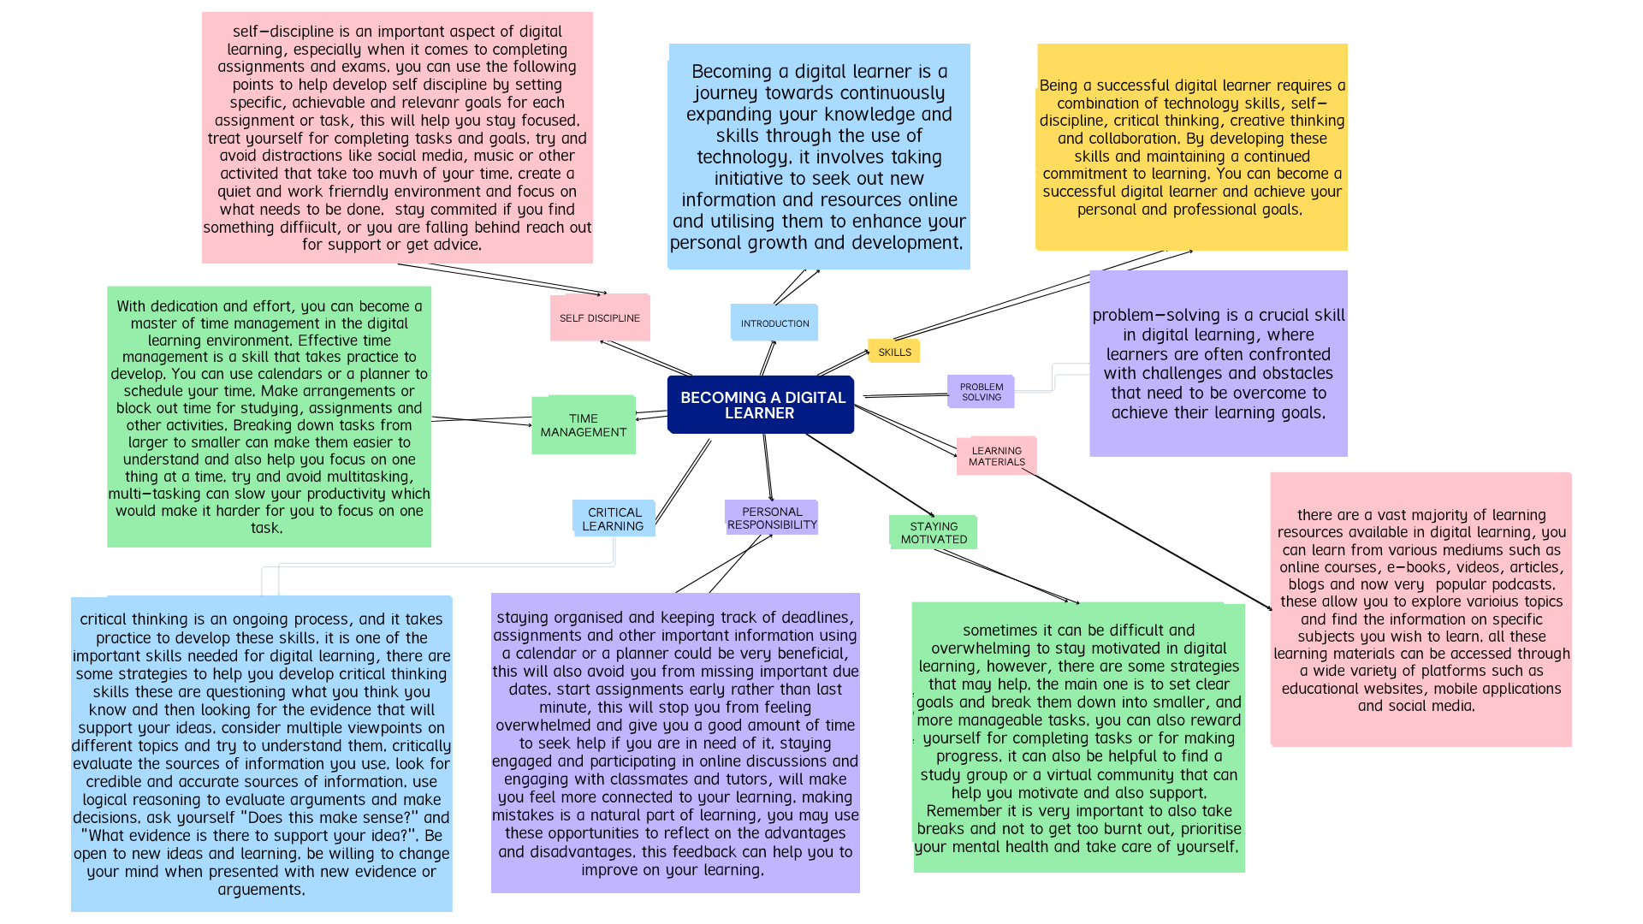

Evidence of Learning

As I reflect on my experience of starting university, coming to grips with online studying, and writing my first assignments, I realize how much I have grown and adapted to this new chapter. It has been a length of pleasure and challenges, requiring me to increase new abilities and undertake a particular attitude to succeed academically.
Starting university becomes a thrilling and nerve-wracking experience. The anticipation of assembling new human beings, exploring specific topics, and gaining independence became overwhelming (Reeves, Crippen and McCray, 2021, 9). But the transition from high faculty to university turned into now, with its problems. One of the essential changes to make change the extended stage of the self-area and duty required for impartial mastering (Wani, 2018, 132). In contrast to excessive college, in which instructors guided us thru the curriculum, college demanded self-motivation and proactive engagement with course materials.
Further, the shift closer to education brought through digital platforms is followed with the aid of its own unique set of demanding situations. After attending training, I needed help acclimating to the digital schoolroom environment. The ability to study was hindered by technical problems, including needing help accessing online systems and having an unreliable web connection (Farrah and Al-Bakri, 2020, 66). Moreover, because there have been fewer opportunities to speak face-to-face with each other student and instructors, it took more work to shape relationships with individuals and obtain immediate clarification of the situation. Remember that changed into being taught.
I became aware of the need to build powerful solutions for people to learn online to address those issues. Online studying is turning into increasingly famous (Sousa and Rocha, 2019, 9). I actively sought my instructors' advice and used the tools available to me so I could build my abilities in digital literacy. I also used the gear that had been to be had to me. I familiarized myself with the various online, getting to know structures and equipment, investigated their capability, and sought help if it changed into necessary. Because of this, I used to be capable of navigating the net classroom with a higher stage of self-guarantee and making efficient use of the resources that were made to be had to me.
Further, when I was in my first year of university, one of the most complex tasks I had to do turned into seeking to compose the primary tasks I had ever been given. My previous reviews had me anticipating lower expectancies and requirements for educational writing, but what I discovered this time changed into considerably higher than what I was aware of. My articles have been tough to organize in a manner that becomes logical, and I struggled to come up with arguments that made me feel, that I needed help correctly referencing my resources. My tension changed heightened due to the expectation that I might carry out nicely, which made the paintings of writing experience like it might be even more challenging to perform.
I sought assistance from the writing middle of the university. I registered in a few of the writing courses and seminars that have been given by way of the university to triumph over these problems. The websites furnished somewhat proper coaching on various topics, such as vital thinking and research methodologies and the arrangement of essays (Kaurav et al., 2020, 5). I accelerated my potential to properly manage my time by learning to interrupt significant duties into more minor, extra-viable chores. This not best helped me feel much less beaten. However, it additionally enhanced my ability to manage my time correctly. I could regularly improve my writing skills via constant practice and attention to others' feedback on my work. This helped me build confidence in my talents to articulate my ideas in a way that is appropriate for an educational setting.

Personal Development Plan (PDP)

Reflecting on the gaps in my abilities and understanding, I have advanced a personal development plan (PDP) to deal with those regions and contribute to my destiny aspirations. I will apply SMART targets to ensure my improvement desires are, measurable, conceivable, applicable, and time bound.
Improving Time management talents to improve my time control capabilities, I can create a weekly agenda outlining specific examine instances and project closing dates. The use of virtual equipment, which includes time-monitoring apps and productivity techniques like the Pomodoro technique, maximizes my awareness and productiveness. Through the give up of the semester, I intend to complete assignments beforehand of time and allocate a devoted look at durations for every subject.
Developing research and crucial thinking skills enhancing my studies and critical wondering abilities that will participate in workshops and seminars offered through the university's library and academic assistance offerings (Humrickhouse, 2021, 2). I will examine superior seek strategies, evaluate sources significantly, and practice synthesizing statistics effectively. Through the give up of the instructional twelve months, I goal to illustrate stepped forward studies abilities thru well-supported arguments and evidence-based assignments.
Strengthening writing competencies to reinforce my writing talents, I can hold to make use of the resources to be had at the college's writing centre. Seeking remarks from professors and friends to pick out regions of development and work on enhancing my essay structure, coherence, and readability (Turkben, 2021, 632). By the stop of the semester, I intend to supply properly based and properly referenced essays that meet the instructional standards of my subject of study.
Building effective communication competencies and spotting the significance of robust communication, can actively interact in class discussions, group projects, and extracurricular activities that promote teamwork and collaboration (Hidayat et al, 2020, 68). I can search for possibilities to enhance my public talking and presentation skills, including joining a debate membership or collaborating in scholar-led activities. With the aid of the give up of the academic year, I aim to, with a bit of luck, specify my thoughts and engage in meaningful instructional and social interactions.
I can make it a priority to attend to myself and my wellbeing by accomplishing self-care sports like going to the fitness centre on an everyday foundation, getting enough sleep, and making time for leisure sports. This can allow me to maintain healthful work-life stability. I can additionally reduce my pressure by engaging in relaxation sports like meditation and mindfulness. My goal is to have a lifestyle conducive to my academic fulfilment and my well-known properly-being by the point the modern faculty year comes to a close.
In conclusion, the process of starting university, adjusting to getting to know online, and finishing my first duties has been formative for me. The passage I have travelled via all those conditions has been constructive. I have had to triumph over several challenges alongside manner. However, I have been able to enhance both my educational overall performance and my emotional properly-being because I have maintained a tremendous attitude and made green use of the equipment to be had to me. If I perform my plan for private increase, I can keep my educational success and contribute to my lengthy-time period dreams. As part of this plan, I can improve my potential to manipulate my time correctly, do behaviour studies and essential wondering, write nicely, talk successfully, and prioritize self-care.

References Lists
Farrah, M. and Al-Bakri, G., 2020. Online learning for EFL students in Palestinian universities during corona pandemic: Advantages, challenges and solutions.
Hidayat, D.A.S.R.U.N., Anisti, P. and Wibawa, D., 2020. Crisis management and communication experience in education during the covid–19 pandemic in indonesia. Jurnal Komunikasi: Malaysian Journal of Communication, 36(3), pp.67-82.
Humrickhouse, E., 2021. Flipped classroom pedagogy in an online learning environment: A self-regulated introduction to information literacy threshold concepts. The Journal of Academic Librarianship, 47(2), p.102327.
Kaurav, R.P.S., Suresh, K.G., Narula, S. and Baber, R., 2020. New education policy: qualitative (contents) analysis and Twitter mining (sentiment analysis). Journal of content, community and communication, 12(1), pp.4-13.
Reeves, S.M., Crippen, K.J. and McCray, E.D., 2021. The varied experience of undergraduate students learning chemistry in virtual reality laboratories. Computers & Education, 175, p.104320.
Sousa, M.J. and Rocha, Á., 2019. Digital learning: Developing skills for digital transformation of organizations. Future Generation Computer Systems, 91, pp.327-334.
Turkben, T., 2021. Examination of classroom writing practices in the context of process-based approach to teaching writing. Journal of Language and Linguistic Studies, 17(S1), pp.619-644.
Wani, Z.A., 2018. Strategy implementation. Contemporary Research in Sciences and Humanities, p.115.

