

Assignment Title: Choice of Construction Procurement Methods and Contractual Arrangements
Name: James Cullen
Student Number: p151951
Course Title: Contract Practice and Procedures
Submission Date: 17/01/19

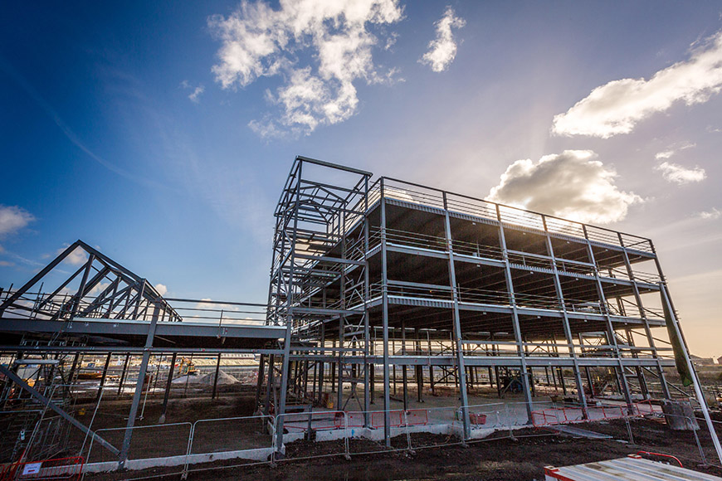

Table of Contents

Page 1: Introduction

Page 2: Scenario 1

Page 3: Scenario 2

Page 4: Scenario 3

Page 5: Scenario 4

Page 6: Conclusion

Page 7: List of plates

Page 8: Bibliography

Introduction

As the complexity and scale of construction projects across the globe has advanced and expanded, the procurement route and contractual arrangements that govern them have developed in tandem. This assignment will demonstrate the variety of choices available to clients today by exploring a number of scenarios and outlining the methods available to them.

Scenario 1

The construction of a new doctor’s surgery to accommodate four GPs, three nurses and two dentists. The new surgery is required to provide accommodation following the amalgamation of three different national health practices. It will be funded by the local health authority.

As a Local Health Authority, it is likely that the client in this scenario is inexperienced in procuring construction works. It is also probable that they would not possess their own in house architectural team, so they would need at least a “material level of design input from the contractor” (JCT, 2011). Due to the fact that the budget for the scheme is derived from public money, it is essential that the works are carried out with as much cost certainty as possible. For these reasons, the most suitable option to procure the services required would be via the Design and Build path. This would system would allow a swift start to construction without having to wait for full design which would be formulated by the contractor, drawing on their expertise and experience. Another benefit would be that the majority of the risk is allocated to the contractor, while the client will have just one point of contact to deal with as the construction firm “will be totally responsible for undertaking the design work outlined in the contractor’s proposals, for fabricating the building and for co-ordinating and integrating the entire process” (Murdoch et al, 2012).
The new surgery however will be need to be of sufficient quality, so the client may wish to engage an independent client consultant to oversee the construction. The design will be of a specialist and bespoke nature owing to the differing medical professions that will be housed there.
As an inexperienced client, the Health Authority should use a NEC3 (New Engineering Contract) contract as it is user friendly and accessible. The Engineering and Short Contract variety would be applicable as the project is a relatively small undertaking housing a small number of staff and there is no need for future collaboration between the parties.

Scenario 2

A new Tesco superstore for the town of Skewen it is to have a total floor area of 3400 m2 of which 1800 m2 will be sales area. Tesco wish the store to comply with their corporate image and to be open by September of 2019.

Tesco are a large company and a capable client when procuring services to construct new stores. They will want to maintain their corporate image, although their premises are constructed along a similar design. In this situation, the shop will be a large one but the quality of the construction is not vital. Due to these factors and the deadline date imposed for completion Tesco would more than likely use a form of Design and Built arrangement named ‘Develop and Construct’. Via this method, works would commence early but the design would be complete before the contractor is appointed. This is likely to suit Tesco as it is used “where the client has the design prepared to concept” (Constructing Excellence, 2004) and it is probable that they would wish to simply duplicate or utilise a very similar scope to one of their other properties.
Furthermore, this situation lends itself for procurement based a on a collaborative planning emphasis with the view of fostering “long-term relationships in the shape of framework agreements or strategic partnering” (Kapsalaki, 2017). This would produce a long term association between the parties who would develop a good knowledge of how the other company prefers to work and carry out business. It would also eliminate administrative procedures and re-bidding for future projects. The fact that the proposed new store is a large scheme and Tesco have a vast countrywide operational capability indicates they are capable of entering such an agreement.
A JCT (Joint Contracts Tribunal) Design and Built contract would be suitable to facilitate the procurement method and relationship detailed above. Tesco should possess the nous and manpower required to administer this contract which can be complex.

Scenario 3

The construction of a new boutique hotel for Hilton Hotels in Swansea Marina. The project is to be privately financed by a merchant bank which has set a firm cost limit for the project.

Hilton Hotels are a large multinational company who are likely to be able to call upon their own in house design team when planning the construction of a new hotel. In order to uphold the high specifications and standards of Hilton’s corporate profile and to produce a Boutique Hotel, they also require the best contractors available. To facilitate this, a suitable procurement method would be the Traditional Route. No time limit for the works have been specified which is compatible with this system, while the budget is likely to be large, a strict cost limit has been applied to the scheme which is also easily accommodated through this. The client in this instance will want to retain control over the design which could possesses some bespoke aspects as it is a ‘Boutique’ Hotel. The traditional route would ensure this and allow for changes to be made. Furthermore, “the construction industry has used the Traditional process for so long that it has become the most understood” (CIOB, 2010), indicating that an experienced client such as Hilton will have used this method previously.
Traditional procurement is transparent and competitive which would appeal to a high profile corporation such as Hilton. Their size, status and experience suggests they are an experienced client and will have personnel available to administer a JCT Intermediate Contract. Under the terms of this the works will be paid under a lump sum basis with interim payments, further cultivating cost certainty.

Scenario 4

Upgrading a small community Theatre in Merthyr Tydfil, the Theatre is managed by a group of volunteers who control the Theatre through a company limited by guarantee. This means that they might be liable for any losses the Theatre makes. The extent of the works is to refurbish the floor finishes, provided disabled toilet facilities and install a new kitchen that meets current hygiene standards.

Inexperienced clients with a low budget need to consider very carefully what procurement route to utilise. In the case of volunteer custodians of a theatre, a suitable route would be via the Traditional route. Although it is often seen and lengthy and laborious, when used in conjunction with a ‘JCT Minor Works Building Contract’ the process can be overseen by the layperson. Importantly, “the reason for its popularity is no doubt because it is short and simply expressed” (Chappell, 2012), while it still maintains a level cost certainty – a very important aspect for a volunteer group. This agreement would apply in this situation as a relatively basic scope is required which the client can supply and there is no specified time limit for work completion. In addition, the largely superficial work would only a take few months to complete and cost less than £190,000.
As there are a number of differing aspects to the scheme (flooring work, toilet and kitchen installation) which could utilise the services of several specialist contractors, other procurement routes such as ‘construction management’ could also be considered in this case. These involve dividing schemes into separate packages and appointing the most suitable sub-contractors. However, “no other procurement route is more sensitive to the capability of the client’s team” (Rawlinson, 2017), implying it would be extremely risky for the volunteer group to implement.
Although the client is likely to be inexperienced, the JCT Minor Works contract contains no complicated details and no warranties are needed to use it which should allow the group to procure services comfortably.

Conclusion
What is apparent is that the procurement route is crucial to all construction projects and should be considered very carefully by clients. Financial and spatial constraints are set to become even more fundamental to projects and as result as their contractual arrangements. It is probable that more bespoke and unique methods maybe employed in the future.

List of Plates
Cover Page Top: University of Wales Trinity Saint Davids (2017), View of Swansea SA1 Campus under construction, https://www.uwtsd.ac.uk/sa1/sa1-news/kier-awarded-national-skills-academy-for-construction-status-for-sa1-project.html
Cover Page Bottom: UCL Faculty of Laws (2018), Generic Picture of Contracts, https://www.ucl.ac.uk/laws/events/2018/nov/introduction-contracts

Bibliography
Chappell (2012), Understanding JCT Standard Building Contracts, Ninth Edition, Routledge, UK
CIOB (2010), A Report exploring Procurement in the Construction Industry, Chartered Institute of Building, UK
Davis et al (2008), Building Procurement Methods, CRC Construction Innovation, Australia
JCT (2017), Traditional / Conventional, https://corporate.jctltd.co.uk/products/procurement/traditionalconventional/, UK
Jones (2017), Choosing the Right Construction Procurement Method, http://www.procureware.com/choosing-right-construction-procurement-method/, UK
Kapsalaki (2017), What are the Main types of Procurement in the Construction Industry, http://www.buildup.eu/en/learn/ask-the-experts/what-are-main-types-procurement-construction-industry, UK
Malconlaw (2010), Introducing Management Contracting, Malaysian Construction and Contract Law, https://simplymalaysia.wordpress.com/articles/choice-of-contract/2078-2/, UK
Murdoch et al (2009), Construction Contracts – Law and Management, Fourth Edition, Taylor and Francis, UK
NEC (2018), Case Studies, https://www.neccontract.com/Case-Studies, UK
Noum et al (2015), Critical Review of Procurement Method Research in Construction Journals, Procedia Economics and Finance, Volume 21, pp 6-13, UK
Oyegoke et al (2009), Construction Project Procurement Routes: an in-depth critique, International Journal of Managing, Projects in Business, Vol. 2, No. 3, pp 338-354, UK
Rawlinson (2017), Construction Management, Arcadis, UK

