Student name: Eve Hanford

P Number: 1900620

Programme of Study: Surface Pattern Design

Module: M4X01560

Tutor: Gwenllian Beynon

Task One: Semiotic Analysis (Ryan Task) = 536 words

Task Two: Manifesto (Julia Task) = 478 words

Task Three: Reflection (Jon Task) =486

Task One: Semiotic analysis (Ryan task)

Over the past 20 years the escalation of social media has meant that mindless scrolling through instagram and facebook feeds has become a subconscious and relatable pastime for many of us, with those between the ages of 16 and 35 being the most frequent users of all social media platforms. (Statista, 2014) But with this numbness comes a reluctancy to accept that the images we scroll past on our instagram and twitter feeds daily, could actually be effecting our images of ourselves.

Many articles and journals have slandered social media sites for their lack of filter when it comes to celebrity promotional posts and ads. This is probably due to the large amount of women and young people who are said to be negatively influenced by such things. A survey of ‘227 university students revealed that women are generally influenced by peers and celebrities on facebook.’ (Fardouly and Vartanian, 2015) a figure that could easily increase without proper mediation from social media sites themselves.

The most frightening part of all this is the blatant lack of understanding that celebrities have of their influence as this is not only irresponsible but unsafe. Recently a media frenzy began when the reality television star Kim Kardashian took to instagram to promote an appetite suppressant lollipop. In order to discuss this further I will present the post here.

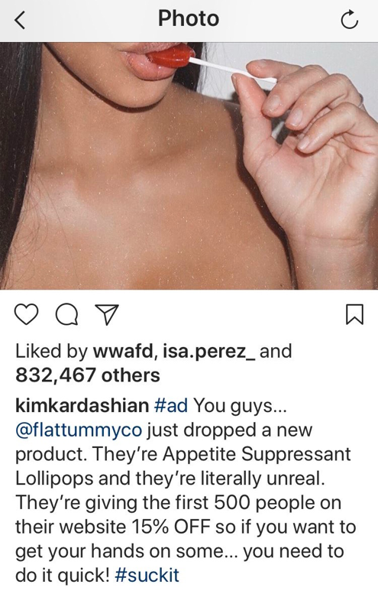
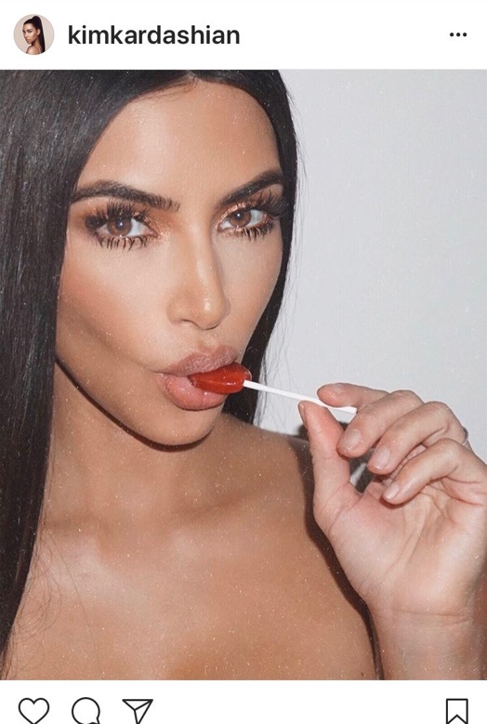
Kim Kardashian West, Instagram paid promotional post, 2016
Within this post Kardashian expresses a keen understanding as to what sort of language her audience responds to. The use of colloquial language such as ‘you guys.’ And ‘literally unreal’ give connotations of a relationship between the celebrity and the reader therefore putting them at ease. This relatability is pivotal to Kardashians social media persona and ‘self image’ (Liu and Suh, 2017). This then helps to promote and sell products to the masses.

The fact that Kardashian has included a discount code also implies that she wants to help and cares about the viewers of her post while also subtlety hinting at the fact that she understands the economic problems that non celebrity people are faced with, however this could not be further from the truth as Kardashian makes an average of ‘$1.27 million per instagram post’. (Nicole Lyn Pesce, 2019)

The image of Kardashian herself is an idealised image of female beauty with her long eyelashes and unrealistically perfect hair, skin and nails . This is also harmful to viewers as it promotes appetite suppressants by suggesting that they help to achieve this flawless look.
Another point to make about the image is the overly sexualised connotations that come from the lollipop paired with the hashtag ‘#suckit’ used in the image caption. This imagery suggests to the viewer that in order too be desired by others they need to look a certain way.

The idea of The Male Gaze’ (The Consequences of the " Male Gaze " and Sexual Objectification Written by: Gina Miller Rhetorical Theories and Professional Communication, n.d.) springs to mind when looking at this post through its use of hyper sexualised imagery of women and unachievable female beauty standards. The fact that social media not only showcases this, but promotes it through advertisement and does so knowing the detrimental effect that this has on impressionable viewers is unacceptable.
Bibliography

Fardouly, J. and Vartanian, L.R. (2015). Negative comparisons about one’s appearance mediate the relationship between Facebook usage and body image concerns. Body Image, 12, pp.82–88.

Liu, R. and Suh, A. (2017). Self-Branding on Social Media: An Analysis of Style Bloggers on Instagram. Procedia Computer Science, 124((12-20)), pp.12–20.

Nicole Lyn Pesce (2019). Kylie Jenner can make more money in one Instagram post than many people earn in a lifetime. [online] MarketWatch. Available at: https://www.marketwatch.com/story/kylie-jenner-can-make-more-money-in-one-instagram-post-than-many-people-earn-in-a-lifetime-2019-07-23.

Statista. (2014). Average age of social media users | Statista. [online] Available at: https://www.statista.com/statistics/274829/age-distribution-of-active-social-media-users-worldwide-by-platform/.

The Consequences of the " Male Gaze " and Sexual Objectification Written by: Gina Miller Rhetorical Theories and Professional Communication. (n.d.). [online] Available at: https://ginacalnan.pbworks.com/f/themalegaze.pdf.

Task Two : Manifesto (Julia Task)

- As a member of the fashion community I will make more of a conscious effort to use sustainable materials.
- Consumers have the right to be educated about what their fashion items are made from and how they can be disposed.
- Makers and designers need to stop creating fast fashion and focus on developing hard wearing materials and timeless styles.
- The U.K. government should develop a legislation that limits the amount of non environmentally responsible fabrics that one manufacturer can use per year.
- More education is needed about non ethical and unfair treatment and payment of staff and workers within the textile industry.
- More education is also needed on the production of fabrics so that the public knows what they are paying for.
- The government should fund research into ways of sustainably producing fabrics.

- The fashion community needs to make a conscious effort to use more sustainable materials.

The impact that the fashion industry has on the environment is unnecessarily large, with the fashion industry being the second largest polluter in the world (Sustain Your Style, 2019.). This is down to the production process and the use of a considerably high volume of chemicals for dying and treating fabrics. As well as this, the fact that most fabrics used in mass production are synthetic fibres that are non renewable and do not biodegrade is also harmful long term. This can be combated I’d designers and makers chose to “link a fibre with it’s life cycle” (Fletcher, 2008, p.4) and using more environmentally responsible materials and treatment methods to reduce their environmental impact. e.g responsibly farmed cotton and natural dying methods. Brands and companies that already implement these environmentally friendly techniques into their making process should be offered a small government funded grant that would allow them to research and work on these techniques in order to make the fashion industry as a whole more sustainable.

- Consumers need to be more informed about what their fashion items are made from and how they can be disposed.

It is estimated that £140 million worth of clothing goes into landfill each year in the U.K. (WRAP UK, 2019.) This is not only an issue environmentally, but also economically as consumers are needlessly wasting money. This problem can be tackled in a simple and effective way by fashion manufacturers if there was more stress placed on washing and care instructions by making them more bold and clear. This would reduce the risk of items being damaged and therefore increasing the longevity of the item. Also I feel that councils and recycling centres should offer more information to the public about resourceful ways of disposing their used fashion items, for example up cycling clothing and textiles and recycling responsibly. This not only helps with sustainability but also encourages the wider community to be more creative and innovative. As I designer I will make it a priority to create garments with wash labels that are more clearly instructional as well as making an effort to up-cycle garments instead of using new materials to combat the “overconsumption of fast fashion” (Brooks, 2015)

- Makers and designers need to stop creating fast fashion and focus on developing hard wearing materials and timeless styles.

Fast fashion is not only one of the UK’s most reckless spending habits with roughly
27 billion pounds being spent annually on clothes (Fairtrade.org.uk, 2018), but also it is both ethically and environmentally damaging. This is due to farm and factory workers being unfairly paid as well as chemicals and non environmentally responsible materials being used. As designers, we can break this cycle by using ethically farmed and procured materials that are sustainable and therefore less harmful to the environment. Also if we ensure that we only produce made to order garments in timeless, easy to wear styles that will never age , (Subramanian Senthilkannan Muthu, 2019), the consumer can own any one piece of clothing for years, therefore benefitting themselves financially as well as the wider world environmentally and ethically.

Bibliography

Brooks, A. (2015). Clothing poverty : the hidden world of fast fashion and second-hand clothes. London: Zed Books.

Fairtrade.org.uk. (2018). The true cost of fast fashion. [online] Available at: this https://www.fairtrade.org.uk/Media-Centre/Blog/2018/April/The-true-cost-of-fast-fashion.

Fletcher, K. (2008). Sustainable Fashion and Textiles. [online] London, UK: Earthscan, p.4. Available at:https://books.google.co.uk/books?id=7mtPFUzjzLYC&printsec=frontcover&dq=sustainable+fashion&hl=en&sa=X&ved=0ahUKEwjsxsOFm-rmAhUSm1wKHfN8BDQQ6AEIKTAA#v=onepage&q=sustainable%20fashion&f=false[Accessed 4 Jan. 2020].

WRAP UK. (2019). Clothing. Available: http://www.wrap.org.uk/content/clothing-waste-prevention. Last accessed 24th Nov 2019.

Sustain your style. (2019). What’s wrong with the fashion industry. Available: https://www.sustainyourstyle.org/en/whats-wrong-with-the-fashion-industry#anchor-environmental-impact. Last accessed 24th Nov 2019.

Subramanian Senthilkannan Muthu (2019). Fast fashion, fashion brands and sustainable consumption. Singapore: Springer.

Task Three: Reflection (Jon Task)

As a generation we are constantly being reminded that we are living during a climate emergency as it is said that we have just “11 years before a climate catastrophe” (Brown, 2019). This is a threat that constantly looms over millennials as we struggle to create resolutions to problems created by generations that have lived centuries before us.

Young people today are not only tasked with having to clean up messes made by the older generations, but also faced with the frustration of not being listened too. Many people even in positions of power refuse to admit that their lack of empathy for the environment has negatively affected the planet as they shoot scientists down and claim that they “don’t believe it” (Trump on climate change report: “I don’t believe it,” 2018).

With this in mind I set out to create a fashion piece that not only reflected the environment’s fragility but also its strength as it perseveres through human mistreatment. I chose to create a fashion piece as I liked the idea of creating wearable art and the way that this gives a piece another dimension.

When researching for this, I came across a book that showcased mushrooms and their benefits on both planetary and human health. From this I learned that “trees and other green plants could not grow and reach maturity without symbiotic associations with mushrooms.” (Stamets, P. 2005) This then implemented the idea of fungus within the garment I created.

I went on to research fabrics that were hard wearing and sturdy as I wanted the integrity of the garment to reflect the strength of fungus and mushrooms, therefore I chose to use a scuba fabric as my base and then layered with tulle and organza to create mushroom like shapes. I chose to use these fabrics as it is well known fact that synthetic fibres are useful due to their “durability and ease of care” (Cadigan, 2014)

Although these fabrics are synthetic, and therefore non renewable, I chose to create my garments with a zero waste approach so as to limit the amount of environmental damage I created. This meant that I only purchased the exact amount of fabric that I needed and used any small scraps to create appliqué and accessories.

I believe my garment is perfectly summed up within this quote “fashion has become increasingly less polished, reflecting the troubled times in which we live” (Djurdja Bartlett, 2019) as I did not set out to create a perfectly assembled garment but rather a thought provoking one that pearly reflected the environment. I believe I have achieved this and have also managed to interpret the state of environmental emergency that we are living in in an imaginative and creative way by focusing on the shape and structure of my garment and reflecting my fungal theme throughout, through the mushroom print and my choice of a grey and brown colour palette.

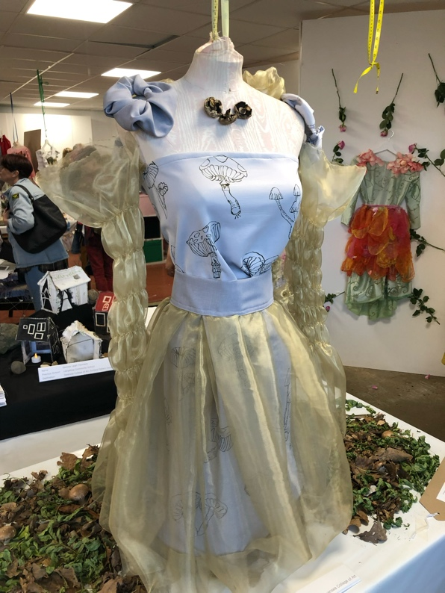
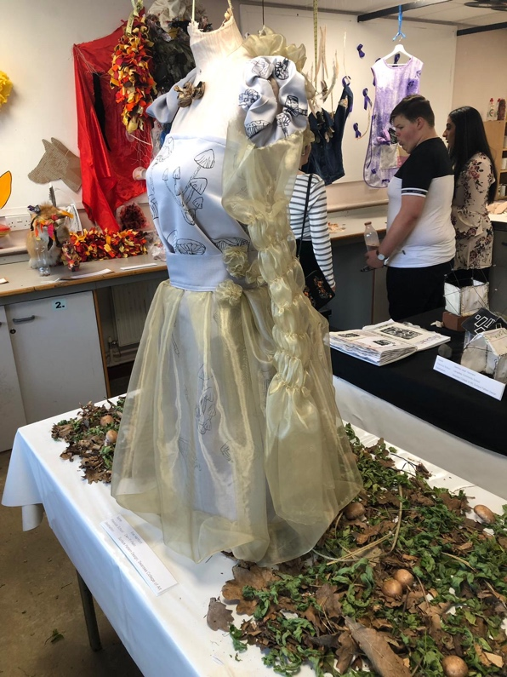
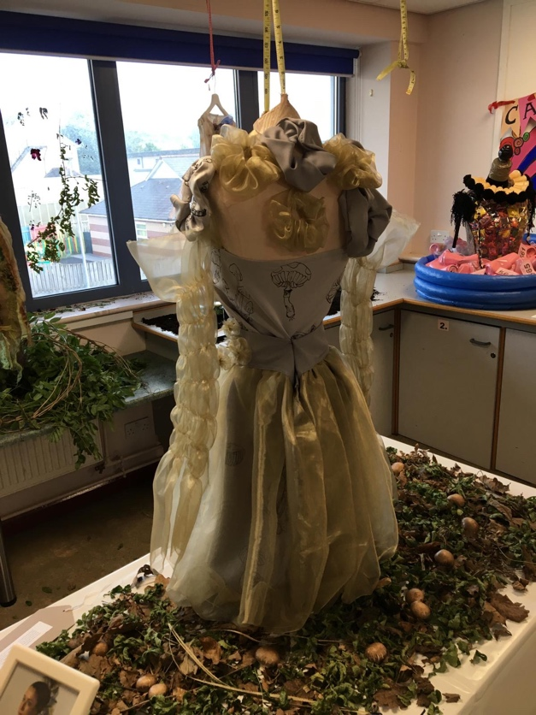
Fashion garment created by Eve Hanford for textiles A level exam.
Bibliography

Brown, L. (2019). Climate change: What is a climate emergency? BBC News. [online] 3 May. Available at: https://www.bbc.co.uk/news/newsbeat-47570654.

Cadigan, E. (2014). Sourcing and selecting textiles for fashion. London: Bloomsbury Publishing.

Djurdja Bartlett (2019). Fashion and politics. New Haven, Ct: Yale University Press.

Stamets, P. (2005). Mycelium running : how mushrooms can help save the world. Berkeley, Calif.: Ten Speed Press.

Trump on climate change report: “I don’t believe it.” (2018). BBC News. [online] 26 Nov. Available at: https://www.bbc.co.uk/news/world-us-canada-46351940.

