Assignment title: Marketing Management

Student Name: Neslihan Aydin
Student Number:1606007
Module Name: Marketing management
Module Tutor: Tushara Balendran
Word Count: 3796

Table of Contents
Introduction 3
Section 1: The Integrated Marketing communications 4-5
Section 1.2: The Communication and communication model 6-7
Section 1:3: Apple Current Promotional Concept of the company 7-9
Section 2: Recommendation of the Promotional Strategies 10
Section 2:1 The online and offline promotions 11
Section 2:2 The Branding and Brand Equity 12
Section 2:3: Keller's Model and advantages/Disadvantages 13-15
Section 3: Apple Customer Touch-points and Journey 15-16
Section 3:1: The Total Engagement Model 17
Conclusion: 18
Reference: 19-20

Introduction:

In this report the topic is to help maximize the companies customer's overall satisfaction by meeting their expectations. How an organization can help create a much more innovative market strategies to help raise awareness of the products or services they offer within the company. By ensuring the customer journey is successful met from the start of purchase till a certain time after purchasing the item. This can be introduced by using different types of communication channels to show the current and new stakeholders within the organization to ensure the expectations of the stakeholders are being fully met. By introducing integrated marketing communication and ensuring the organization is targeting the right customers with their wants and needs from a product or service they require.
The company I have chosen to research and analyze is one of the largest mobile phone seller's called Apple. Apple was first founded in April the 1st 1976 by Steve Jobs and Steve Wozniak the two Steve's who came up with the initial idea. Apple was the first to have a graphical interface computer by 1984. The first ever store to open up in the UK was on Regent Street in 2004. By June 2007 the first ever I-phone was released the I-phone 3, where we are currently on I-phone 12 and still going strong with three different models to choose from each time from a new release. First I pad was released in April 2010, by 2015 the first ever watch was related starting with series one currently on series 6. Apple is still to this day they are going very strong. Bringing out new and different products such as, air pods which are wireless headphones charging case included each time they seem to be updated with the latest technology to offer there loyal customers (Jones, 2016.)

Section 1:
The Integrated Marketing communications:
Having integrated marketing communications is necessary for any type of organization to help promote the brand they sell to ensure they beat other competitors but mainly to survive within trading for the long haul. Promoting brand awareness helps increase the sell of the service or products the organization offer.
The brand communication helps initiative by the company to ensure they make the products or services more popular among the users. This process helps identify the individuals which would be the best suited for the product in hand this can also be called targeting certain consumers on their needs.
Brand communication includes the following:
- The advertising
- The sales promotion
- The Public Relation
- The Direct Marketing
- The personal selling
- The media

The Integrated marketing communication means the integration to all the methods of the brand to help promote or increase sales within the targeted customers.
Integrated marketing has seven main components which are as followed:
- Foundation: Within the foundation stage an detailed analysis is involved. For the marketers it is essential for them to understand the brand itself, the offering as well as the end users. The target customers are important to know the wants needs and the real expectations of the product or service provided to them.

- Corporate Culture: The organization of the work culture needs to be on the same track with the service and the products provided. The vision of the organization is what the marketers need to bear in mind when products are being designed or offered.

- The Brand Focus: The corporate identity is what the brand mainly focuses on.

- The consumer experience: The marketers much focus mainly on the consumer experience which basically means how the customer felt about the product. Having good packaging and being appealing to the consumer eye is one of the main reason someone would pick up that product. The customer expectations has to be meet by the product itself.

- The Communication Tool: Communication tool itself different models of promoting the brand such as, direct sell or promoting through the power of social media.

- The promotional Tool: The brand is promoted through the promotional tool such as, the trading promotions and the personal selling. The company would need to make the relationship between the customers and external customers stronger.

- The integrated Tool: This is important part where you keep a regular track on your customers reviews left and feedback given as a whole. Having CRM a software like customer relationship management which helps increase the standard of integrated marketing tools within the organization (Juneja, 2015.)

Section 1.2:
The Communication and communication model:
Communication is used to send or receive messages by verbal or non-verbal such as, speech, writing or oral communication. Body language or behavior is a form of communication. Info graphics which can be charts, maps or even signs. Communication is said to be "the creation and exchange of meaning." Every creature on this planet has learnt how to show emotions to one another. What sets us aside from animals is that we as humans have the ability to use language and words to express our feelings (Nordguist, 2019.)

The Shannon and Weaver model of communication:
The Shannon and Weaver model of communication is a mathematical type of communication theory which helps human's communicate better with one another.

The following are Shannon and Weaver six concepts of the model:
- Sender
- Encoder
- Channel
- Noise
- Decoder
- Receiver

However, the theory got a newer version by Norbert Weiner who added an 7th concept which was Feedback which changed the model from being a Linear Model to the Cyclical Model. This model is known as the "mother of all models" as it tends to be very popularly. It can also be referred to as 'information theory' or the 'Shannon theory' as Claude Shannon was the first to develop the main theory (Drew, 2020.)

Communication Model:
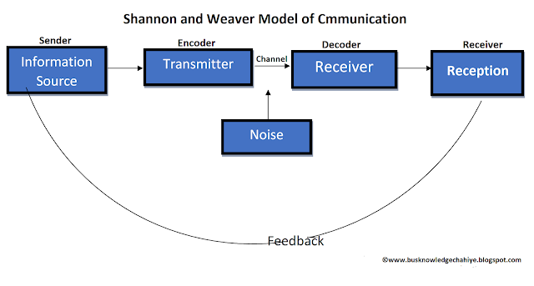
(Diagram 1: Shannon and Weaver model of communication: Source: (Study hub, 2020.)

Section 1:2:
Apple Current Promotional Concept of the company:
Apple marketing mix of the 4p's shows how the company contests within the business activities to the terms within the global market for things such as, information technology, online services and consumer electronics. The main focus of the market mix is on the 4p's which are product, place, promotion and price.

Product mix of Apple products:
In Apple case it includes services as well as goods which are either classified or an involvement of information technology.

Apple main product range are as followed:
- Apple Mac
- I-phone
- I-pad
- IPod
- Apple Watch
- Apple TV
- Digital content
- Software's
- The accessories
- Cloud service

The products range is in line with human resource utilization and processes of business based on divisions. These are characteristic of Apple corporate structure.

Marketing mix of place or distribution of Apple:

Element involves marketing mix which selection of appropriate venues where the organization is able to divide out Apple products. This could include company owned venues or other places which are authorized by the company to help sell products. These are the current venues which allow Apple products to be sold:
- Store's of Apple
- Company-owned webpage's or online stores via mobile or Desktop
- Authorized sellers
- Tele-communications companies

Apple Promotions Mix:
This section is where Apple gets there thinking hat on and starts to use tactics with way of communication which helps the organization to reach the customers on target. Apple uses its brand image and quality of premium to help sell or promote its products.
These are the tactics used within Apple Promotional mix:
- Advertising
- Selling personally
- Promotion of Sales
- Relations of the Public

Apple has many agreements set in place with various websites to promote or sell Apple products such as, Google's Digital Advertising and technology websites.

Prices and Pricing strategies of Apple:
This is where Apple uses marketing mix to set prices, price points and the range of prices for the products sold. Apple uses the price strategies as followed:
- Pricing strategy Premium
- Pricing strategy Freemium
This pricing strategy sells products at a premium, where the premium amount is added on top of common price of the product. Apple uses this type of pricing strategy which helps set higher prices for the product for example, I phones usually cost more than Samsung Smartphone. Apple SWOT analysis clearly shows this is a weakness on the company behalf however, premium pricing is in combination by branding and the creative of innovation (Greenspan, 2019.)

Section 2:
Recommendation of the Promotional Strategies:
Promotion Strategy means using a plan and tactics which are applied into the marketing schedule to show an increase from the product or service by making it in demand. It is a necessary role in any organization as it plays a big part with the product, price, placement and the promotion. This includes as followed:
- Audience you target
- The budget you have
- Action of Plan

Here are a few examples of the best Marketing Strategies:
- The marketing content
- Marketing of social Media
- Marketing of Email's
- Marketing of Referral
- Sponsoring events
- Influence
- The promotions
- Refunds being offered
- Loyal customer scheme (Claudia, 2019.)

For Apple as an overall company the best new promotional strategies I would personally recommended being a Apple Product fan is social media and email's. The reason for Social Media is because everyone uses it these days and a small advert or mention of a new product coming out would make people investigative future into the matter. However, Email's seems to be the best form and the cheapest way to help show awareness of the brand as every Apple Product user has their own personal account set up with I-cloud where Apple can reach out and send new product information directly to current user's.
Section 2:1
The Online and Offline promotions:
Online branding marketing is a term you can use several ways of marketing and advertising online. Currently there is so many different online websites and platforms which can you use to help brand your product. You can easily spread the word about your product branding on multiple different channels at the same time. By using social media sending out email's or even paying for ads by Google. The marketing targets the customers which visit certain websites or media by finding out where the audience mainly hang out (Harker, 2019.)
Apple offer a range of services online to their customers such as, trade in your old phone, pay monthly instalments but mainly over student discount online which you can add yourself whilst in checkout. The main different with online promotions with Apple is that you can physically see the product yourself but there is online videos and detailed summary of each product. Also helps show and compare an older model to show the difference in sizes or thicken of a product. (Apple, 2020.)

Offline branding marketing has a various of offline media to help make the brand aware and give it a boost. Offline marketing was something all organizations used many decades ago before the internet took over brand marketing (Harker, 2019.)
Offline promotion of apple would be in the apple stores or other telecommunications like EE, Three or Vodafone selling them directly to customers in the stores. Some people are still very old fashioned and like to feel and touch products before they buy. The main different with buying directly from Apple is that any issues other than the standard warranty Apple would be the first point of call and would deal with product related issues in store for the customer.
Section 2:2
The Branding and Brand equity
Brand awareness and brand equity is sometimes interchangeably but they are not which is very important to know. The branding items which all entrepreneur, business companies but mainly managers will need to know this. Which is brand awareness and brand equality needs to be on top of the list. These two terms which are both related to the audience perception and brand engagement.
The Brand
Making your brand awareness correctly can easily drive up the consumers to increase repeat purchases with the same brand. When a customer recognizes the brand straightaway, the chances of them choosing your brand over any other is higher chance against any competitors. Most people would prefer choosing the same brand they are familiar with or know of instead of a completely new brand which they have never heard or seen before. Brand Awareness needs to be tracked, once it is tracked it will increase awareness of the brand and show the company which areas they need to put more focus on to improve to help brand awareness to increase and grow.
Brand Equity
The word Brand equity actually means from the consumer perception of the brand. Brand equity is just as important as having brand awareness. Having a strong brand usually results in the brand equity being good as well. These factors also need to be consigned as well which play a big part such as, recognition of the brand, retention of the customer and brand quality. When a company has a strong brand equity the customers would have more confidence in buying. This tends to steal away the competitors in hand as a company you already know they will keep buying from the same branding (Siwiec, 2019.)
As Apple is a well known brand even though sometimes Samsung phones are much cheaper and sometimes has better features loyal customers like myself would always return to Apple products. This is because of the confidence built up and this where brand equity comes into play.
Section 2:3:
Keller's Model and advantages/disadvantages
Keller's brand equity model was founded by Kevin Lane Keller, who was professor of marketing. Keller Model has 6 main components which add value to customer branding equity and show how the consumers really feel about the brand in question.

These 6 components are as followed:
- The Salience- Relates to how often an brand is coming up on the purchase side of things.
- The Performance - Does the service or product you have provided become purposeful for the customers' needs.
- The Imagery- is the side where it deals with the products which helps the brand name try and meeting customers social or psychological inevitably.
- The Judgments- Mainly focus on consumers personal reviews or opinions of the brand.
- The Feelings- The reaction the customers gives when they see the brand, what they reaction is towards the actual brand.
- The Resonance- The relationship built between the customers and the brand to see if the customers are on the same page as the Brand (Avaremy, 2013.)

Advantages and Disadvantages of the Keller's Brand Equity Model:

Advantages:
- The brand pyramid is reviewed regularly to keep track on the communications of the marketing such as, loyal active formed relationships which could affect the brand equity (Keller, 2009.)
- This model being a strong CBBE model with the 6 components can be built successfully which any brand can use.

Disadvantages:
- Kuhn et al (2008) found out that feelings does not play a role within the market, they have suggested for this to be changed to show a more relevant purpose.
- The representatives a company has does play a major part in the foundation of brand equity, this element needs to be seen and shown in the brand equity model (Avaremy, 2013.)

Apple's Brand Equity:
Apple has 70% other assets and 30% Brand equity, this means a third of Apple as company has a third of its value. As Apple as a brand is well loved and valuable company they tend to get offers from small investment companies to advertise apple products. The benefit of a loveable brand is the advertising which makes profit for the company as Apple would get more viewers. The most positive reviews from customers have come from the experience they have had with the products they have purchased.
The most valuable brands:
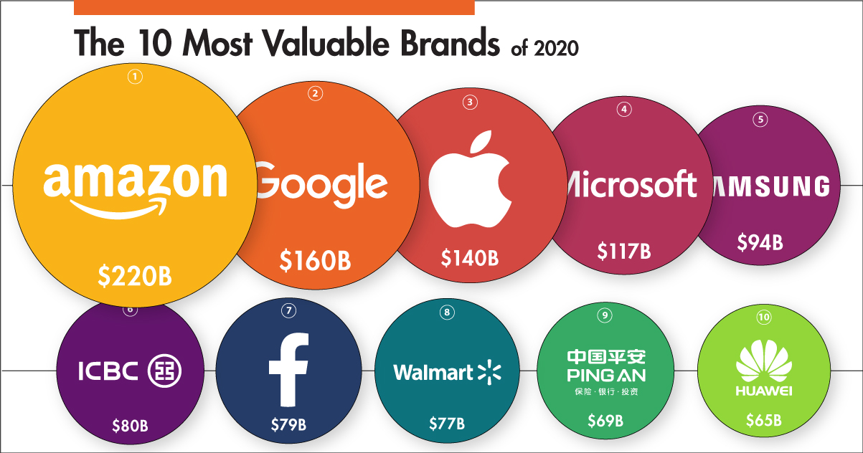
(Image 1: The 10 most valuable brands source's: (Jones, 2020.)

Below is Keller's Brand Equity Model:
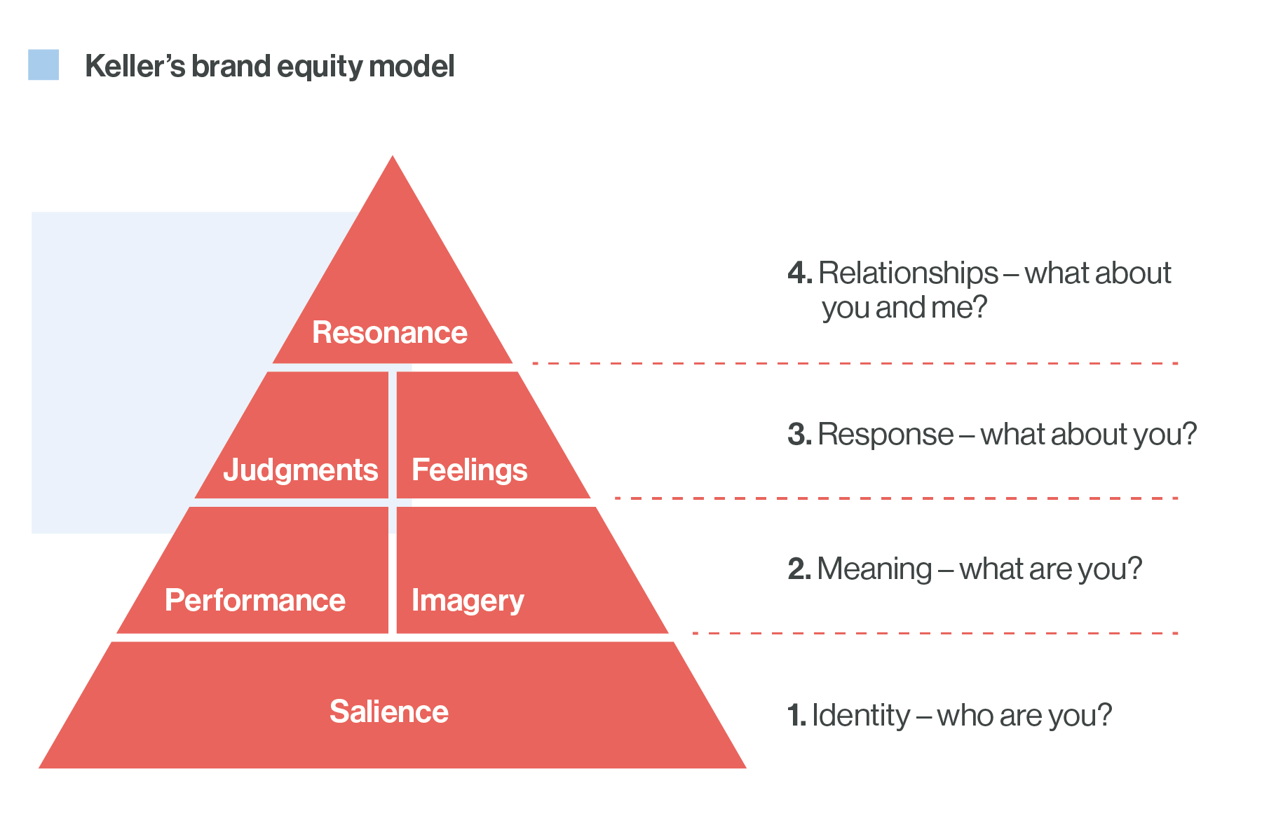
(Image 2: Keller's brand Equity Model source: Papirfly, 2019.)

Section 3:
Apple Customer Touch-points and Journey
Customer touch points is the way consumers experience a service or a product they have received from the start till the end of the product. Apple seemed to have mastered the brand touch points like no other has. One of the main reasons most organization fail is because they do not try out their own brands like the customers who buy them do. Every product or services received by a customer creates its own touch point map to the journey of the brand. Brand positioning and perception of the brand comes from touch points as it plays a vital role of it.
Here are just some of the touch points Apple has mastered:
- Easy to use website - easy to find products or information regarding each product or service. videos and comparing of other products included
- The package used for products- The package itself shows quality and design it is as if the packaging looks like magic opening up.
- Demo's of each product available in store's- Demo's make each customers life much easier whilst shopping around for a new product. Sampling a product is one of the most useful ways to tactic in the marketing industry.
- The attitudes and training given to staff members within the stores- Apple does not hold back on employing staffs as they do not like the customers waiting to be served. The hiring methods are very different as the people they employee tend to be more patient cooler or even hip.
- Clean store - no mess very smart design- lighting in the stores tends to be cheerful which tends to brighten up the customers as well. Even the receipt machine is placed out of sight underneath display tables.
- Locations of stores- They tend to be only in high end places like the city or well educated areas where most people are familiar with the certain area (Greenwald, 2014.)

Apple Customer Journey:
Find out what the customer's needs and wants are e.g. phone, ipad or Mac. Once you find out which product they are interested in ask them if they have had one similar before? If so show the latest version if not show a range of versions similar to one another. Once the customer decides on a product ask about memory size/colour and prefer on the product. Then start filling in the customers details e.g. name/telephone etc.. collect item from back store and set up the new product e.g. transfer old data from the I-cloud. Once all this is done pack the item away nicely into the bag and ask how the customer feels about the product and service they received from Apple today. Finally After care is very important on feedback and reviews on products and serviced produced by Apple.

Section 3:1:
The Total Engagement Model
Having engaged and happy customers is essential for long term formed customer relations. The way a company tends to grow is by implementing customer engagement, by using the total engagement model. Marketing usually requires the action to sell something. But modern digital technology has found a way to make the whole process much more fun and engaging all round. Also it does cost less with things such as, emails or using social media. The main purpose of the engagement model is to help see the brand what was the reason for the customer buying that product. In this process the company must manage the entire journey of the customer from start to end.
Engagement Model must have two vital parts as followed:
- The on boarding - This is part where you are trying to engage new customers by creating a good image to ensure you get plenty of visitors.
- The Retaining- The engagement of potential visitors and focusing on customers.
Apart from the two main stages the engagement model needs to fix the whole journey depending on the type of business. Creation and analysis is the main focus and how you can improve the whole customer satisfaction. Finally the engagement model should not dismiss any new interactions instead should always support automated actions.
Total Engagement Model:
- The Outreach - Getting to know your audience and the requirements.
- The Acquisition- Focus mainly on the why? why would the customer do business with you?
- Getting in contact- the whole process is where you lead and engage throughout the whole process.
- Maintaining- customer relationship and keeping them keen on the brand.
- The Nurture and Growing- Improving your relationship with your brand and customers. Appreciations emails can go a long way (Team, 2017.)
Conclusion:
Overall Apple as an company is a very well known brand and sell more products than any other leading company. People turn to Apple for a range of products as they kept inventing new products such as the Air-pods or apple watch. They seem to have met everyone expectations as there is something for everyone in the range. The brand is well known and has gain several loyal customers who regularly keep up to date with the latest technology. They have gained customer confidence in buying their products such as apple-care, offering extended warranty which makes customers more confidence in buying from them, but mostly from customer reviews and feedback they receive. However, even through the pricing of the products are a little over rated Apple has managed to build the brand equity which is why so many customers end up returning back. Branding is vital in any organization to build and grow the company and Apple has shown this year after year. I would say personally they have already maximized customer satisfaction in each product they sell as they seem to consume repeat customers coming back all the time despite the pricing range of the products sold to customers. This proves by the use of integrated marketing and Keller's Model has worked in an company like Apple who providing excellent care to their customers since 1976 and still standing strong in 2020.
Reference List :
Ameyo Team, (2017) 'customer engagement Model: what it is, why is matters and how to build one' ameyo.com/blog available at: https://www.ameyo.com/blog/customer-engagement-model-what-it-is-why-it-matters-and-how-to-build-one (Accessed 3rd of January 2021.)
Apple, (2020) https://www.apple.com/uk/?cid=oas-emeia-domains-apple.co.uk/ (Accessed 1st of January 2021.)
Avaremy, (2013) ' Brand Equity' avaremy.wordpress.com available at: https://avaremy.wordpress.com/2013/11/09/brand-equity/ (Accessed 3rd of January 2021.)
Chris Drew, (2020) ' Shannon weaver Model of communication - 7 key Concepts' helpfulprofessor.com available at: https://helpfulprofessor.com/shannon-weaver-model/ (Accessed 1st of January 2021.)
Claudia, (2020) ' 9 Marketing Promotion Strategies from concept to Top brands Practice' blog.bannersnack.com available at: https://blog.bannersnack.com/marketing-promotion-strategies/ (Accessed 1st of January 2021.)
Colin Finkle, (2020) 'what is Brand Equity' brandmarketingblog.com available at: https://brandmarketingblog.com/articles/branding-definitions/what-is-brand-equity/ (Accessed 3rd of January 2021.)
Daniel Farey Jones, (2016) 'Apple's history in nine innovations' campaignlive.co.uk available at: https://www.campaignlive.co.uk/article/apples-history-nine-innovations/1356079 (Accessed 1st of January 2021.)
Laura Harker, (2019) 'online vs. office brand marketing- which is best for you?' latana.com available at: https://www.latana.com/post/online-vs-offline-brand-marketing (Accessed 1st of January 2021.)
Papirfly, (2019) 'Customer brand equity and understanding Keller's brand equity model' papirfly.com available at: https://www.papirfly.com/knowledge-hub/retail-marketing/customer-brand-equity (Accessed 3rd of January 2021.)
Prachi Juneja, (2015) 'Integrated Marketing Communications' .managementstudyguide.com available at: https://www.managementstudyguide.com/integrated-marketing-communications.htm (Accessed 1st of January 2021.)
Roberta Greenspan, (2019) ' Apple Inc.'s Marketing Mix or 4ps (An Analysis)' panmore.com available at: http://panmore.com/apple-inc-marketing-mix-4ps (Accessed 1st of January 2021.)
Richard Nordquist, (2019) 'what is communication' thoughtco.com available at: https://www.thoughtco.com/what-is-communication-1689877 (Accessed 1st of January 2021.)
Stephanie Siwiec, (2019) 'Brand awareness v. Brand Equity? know the difference and How to Measure them' latana.com available at: https://www.latana.com/post/brand-equity-brand-awareness-guide (Accessed 1st of January 2021.)
Study Hub , (2020) 'Shannon and weaver Model of communication' jmcstudyhub.com available at: https://jmcstudyhub.com/shannon-and-weaver-model-of-communication-mass-communication/ / (Accessed 1st of January 2021.)

