Max Jones (2305556)

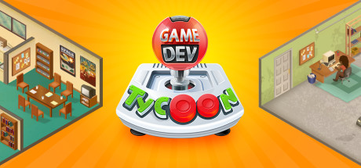
[1]
Assignment 1
Game review
Game Dev Tycoon
Contents
Introduction 2
Genre 2
Visual Style 2
Use of Audio and Visual Feedback and Its Impact 3
Game Structure 3
Challenge 3
Game Flow 4
Replay Value 4
Positive Aspects 4
Negative Aspects 4
Conclusion 5
References 5

Introduction
Within this game review I will be analyzing and writing a review of Greenheart Games’ “Game Dev Tycoon”. I will breakdown the content of the game; including the narrative, challenges this game presents and overall design elements. Greenheart Games published “Game Dev Tycoon” on 29th of August 2013 [1] on steam and has since been released on mobile and Nintendo Switch. “Game Dev Tycoon” is a company management simulator that follows a game developer throughout the decades starting in the 80s and progressively expanding their company throughout the ages. The game was released to mixed reviews leading to a Metacritic score of 68/100. However, the user score was much higher at 8/10 [2]. Steam states that the age rating is 12+ this is due to the somewhat complicated mechanics the game uses. The intended demographic for this game seems to be people who have an interest in management simulators or people with an interest in the history of game development. However, the game received some popularity on YouTube with entertainers such as “Jacksepticeye” covering the game due to its uniqueness.

Genre
A games genre may define what type of player will play your game, as gamers tend to have a preferred genre. A games genre is decided by the developer as to what their game most closely resembles as there are no governing bodies that establish a games genre like there is for age ratings such as PEGI [3].

As it states on the steam page for this game the genres that “Game Dev Tycoon” falls into are Single player management simulator [1]. This also falls in line with what is described as a simulator game by Abishek [3]. This is shown by the resource management game mechanics such as managing certain employees to certain tasks within development. The game review mechanic also simulates the effect game reviews have in the real world which adds to its validity of being an accurate simulator game this can also be said for the marketing and hype mechanic.

Visual Style
The visual style of a game is very important to its personality and its identity. “Game Dev Tycoon” has a very interesting visual style. The game is rendered as a 2D game with high resolution pixel art. Even though the game is 2D it is drawn in a way that provides a 3D look. This is enhanced by the fact that it is viewed from an isometric perspective. The simple nature of the artwork is very easy on the eyes which helps keep players playing longer. The game uses muted backgrounds to help draw the players eyes to the main area of play.
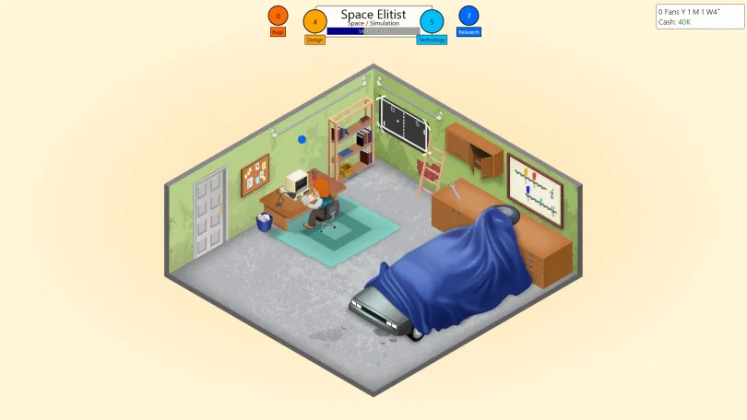[6]

Use of Audio and Visual Feedback and Its Impact
Audio and visual feedback are extremely important to the design of a game. These cues help a player realize when they have completed a task and have proceeded forward in the game. These sound and visual effects need to be non-intrusive so as not to break immersion yet recognizable enough that a player realizes what is happening without any extra context. In “Game Dev Tycoon” Greenheart Games decided to use a few audio cues to enhance the user experience. Some of these audio cues are special audio playing when a game receives high reviews partnered with a star graphic around the review if it is a 10/10. Another coupling of audio and visual effects that I would like to point out is when your developers are creating a game, they will produce points that lead to a game’s success such as the “Tech” and “Design” points as well as potential bugs in the game. When this happens a bubble with the corresponding colour rises to the point counter and a bubble sound effect plays. Finally, I would like to mention that when a game is released if the player levels up an aspect of development a sound effect plays to inform the player.

Game Structure
The basic structure of “Game Dev Tycoon” is that the developer you control creates a tech/games startup within the 1980s and you are tasked with creating games to make money. The basic gameplay loop is making and releasing games. This is done by managing which genre/topic a game will have and how many resources are put into each aspect of the game (as seen below). As time goes by new systems are released and you can develop for them. When the player has reached certain milestones (the first one being $1M) the player has the option to move into a new office. These offices give the player the ability to hire more employees who may be better at certain aspects of development. While the game technically ends after 35 years the player can choose to continue with the main goal to keep your company afloat. The game ends when a player is either -$50K in debt and cannot repay any outstanding loans or as previously stated the time reaches 35 years.
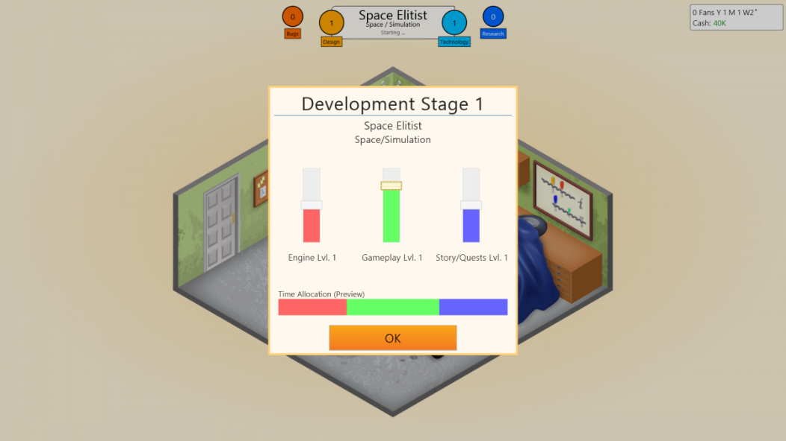[7]

Challenge
Games tend to have challenges to entice players and keep them engaged. These also help a player gather experiences that may help them in the future. There are many different types of challenges a player may encounter such as sensorimotor challenges which require a player to use a combination of their senses and reactions to help navigate these challenges [4]. “Game Dev Tycoon” uses what Chris Crawford would describe mainly resource management challenges to challenge the player’s ability to manage certain resources carefully, in this game you are tasked to manage money, time, Employee stress levels, and workload amongst employees. By doing these challenges it helps immerse the player. This lends itself to increasing the effect of the game flow.

Game Flow
A game’s flow is a quintessential part of why a player is kept immersed in the game. This may be done by rewarding the player as they complete certain tasks which helps them concentrate on the tasks [5], such as finishing a game in “Game Dev Tycoon” You are rewarded with level points, research points, and money to spend on new technology. A game’s flow may also change throughout the game such as difficulty ramping up which tends to reap higher rewards. In terms of “Game Dev Tycoon” the flow of the game gets more hectic with newer consoles and different game trends. A game’s flow may also refer to how the game moves the player throughout the narrative such as side quests giving context and lore that helps immerse the player into the world and story. In “Game Dev Tycoon” this context of flow is shown by the game moving throughout time at a set pace with the company’s expansion relying on the player's capability to create successful games.

Replay Value
As said on ‘Spacedraft.com’ “Replay value, or replayability is the extent to which a player might want to play a game again after completing it once or more.” [6] Replayability of a game is usually enhanced with a few different design choices, these design choices may include, achievements, alternative modes, multiple endings, or even expansion packs. Since you can go completely different routes regarding which games you develop and which systems you choose to develop for there is a good amount of replay value however once you’ve gone through the decades a few times there's little left to do, and this hurts the replay value massively as there isn’t much variation and the player knows what’s coming next. Another thing that “Game Dev Tycoon” does that helps the replay value is having a few achievements that may be hard to acquire on the first or second playthrough such as “Unobtanium” Where the player must reach 1 million copies sold without a publisher [1]. There is also an alternative mode to the game that was originally a form of antipiracy where the game sabotaged any game you released making you constantly fail. This acts as a hard mode in bought copies as it is almost impossible to acquire perfect scores.

Positive Aspects
“Game Dev Tycoon” is a unique introduction to the management simulator genre. The game isn’t overly bearing on tasks which allows newer players to the genre. There isn’t a steep learning curve which is good for a casual game that you may play to switch off. The game follows quite a few of the important design aspects such as not overbearing the player with audio and visuals. Greenheart also was accurate to the release of different consoles throughout the decades while being accurate to the trends of games that also passed which is commendable.

Negative Aspects
One of the main negative aspects of this game is that it can be quite repetitive. The main gameplay loop is quite consistent throughout with only minor differences such as additions of making game engines instead of making games. This means that once a player has a pattern, they follow to consistently release good games they tend not to derive. This can get boring and lose the players’ interest as there is very little for them to do. Another minor negative aspect I would like to mention is that the game can be quite unforgiving in terms of money as you pretty much have to start with a hit otherwise the player will be stuck in a loop of borrowing money or going bankrupt.

Conclusion

In conclusion, although it doesn’t fall under the typical genre I play, I am glad to have played it as I did enjoy my time playing. Greenheart Games did a good job of creating something unique in a field of what seems like a genre that doesn’t have much diversity. They made a game that’s simplistic yet drives you back until you complete it.

References
[1] Greenheart Games. "Steam store page." steam.com. https://store.steampowered.com/app/239820/Game_Dev_Tycoon/ (accessed 01/11/).
[2] "Game Dev Tycoon Metacritic." Metacritic. https://www.metacritic.com/game/game-dev-tycoon/ (accessed Nov 1,).
[3] Abishek, "Video Game Genres - The Ultimate Guide", Gameopedia, https://www.gameopedia.com/video-game-genres/ (accessed Nov 1, 2023).
[4] C. Crawford, Chris Crawford on game design, Indianapolis, IN: New Riders, 2003.
[5] H. B. 25. "Gameplay Flow – Designing for Player Immersion." Game Developer. https://www.gamedeveloper.com/design/gameplay-flow-designing-for-player-immersion (accessed Nov 1,).
[6] "Game Dev Tycoon Guide 2023 - Best Combinations and More - Gaming Route", https://gamingroute.com/game-dev-tycoon-guide-2023-best-combinations-and-more/ (accessed Nov 2, 2023).
[7] Greenheart Games. "Game Dev Tycoon Screenshots." Neoseeker. https://www.neoseeker.com/game-dev-tycoon/screenshots/ (accessed Nov 2,).

