Name: Yetunde Onasanya
Student Number: 1905364
Module Title: Digital Skills and Research Methods (BMSW4003)
Lecturer’s Name: Yajesh Kumar

Table of Contents

Introduction…………………………………………………………………………………… Page 3
Rationale……………………………………………………………………………………….. Page 3
Objectives………………………………………………………………………………………. Page 3
Methodology…………………………………………………………………………………. Page 3
Primary Data Analysis…………………………………………………………………….. Page 4
Secondary Data Analysis…………………………………………………………………. Page 6
Conclusion……………………………………………………………………………………… Page 8
Appendix……………………………………………………………………………………….. Page 9
References…………………………………………………………………………………….. Page 13

Introduction
This is a research report of the data collected based on how virtual learning experience (VLE) impacts students. A paper questionnaire was developed, and a telephone survey was conducted as a primary data collection tool using open-ended and close-ended questions. Also, by using the research of public material on the learning experience of students gathered and analysed as a secondary data collection tool, which is then interpreted using bar charts, pie charts and graphs.

Rationale
This research is to find out the impact that Moodle has on students’ learning by conducting primary and secondary research and analysing these results.
Objectives
To analyse and understand the impact that virtual learning experience, or VLE, has on students is the main objective of this research. To achieve this, questionnaires and telephone surveys as primary data as well as secondary data that has already been carried out in previous researches will be collected, gathered and analysed to reveal an overall conclusion. Data collected can be represented using pie charts and bar graphs to help clearly illustrate the answers provided in number form. Open-ended questions however will be portrayed in the form of qualitative data.

Methodology
In this research, numerous methodologies will be used to help reach the main objective such as quantitative data, qualitative data, primary research, secondary research and sampling.
Quantitative data is defined as the collection of quantities, and therefore the data would be in number form, that is typically placed in categories or some sort of order. Data is collected through the measuring of variables and analysed through ‘numerical comparisons and statistical inferences’, (McLeod, 2019). The aim of quantitative research is to obtain accurate results and come to a reliable conclusion that could be used to represent when completed on a large scale. Examples of quantitative data include questionnaires and numbers.
Qualitative data is different to quantitative data as it is in word form rather than numbers, (Punch, 1998). A much softer approach is taken when dealing with qualitative data whereas a more scientific approach is taken when dealing with quantitative data, (Denzin and Lincoln, 1994). The aim of this data type is ‘to understand the social reality of individuals, groups and cultures as nearly as possible as its participants feel it or live it’, (McLeod, 2019) and therefore produce a more valid outcome. Examples of this type of method include participant observation and face-to-face interviews.
Population is the entire group of participants that provide the information needed for certain research. Populations can be large or small. Public opinions survey of a large population of individuals can be conducted to know the sample and sample size.
Sampling and sampling size are another method used to help conduct this research. Data sampling is a very important factor which can determine the accuracy of any research result, (Singh, 2018). Any issue with a sample will reflect on the overall outcome. Types of sampling include strategic sampling, convenience sampling, stratified random and random sampling.
Primary data is ‘new information collected specifically for your purposes, directly from people in the know’, (Wolf, 2016). Primary data will be collected for this research in the forms of questionnaires and telephone surveys as due to the current pandemic, face-to-face interviews have been restricted. This was one of the methods used in this research.
Secondary data is the final method used into the research conducted. Secondary data is collecting information form another source rather than creating the data yourself like in primary data, (Allen, 2017). Articles, newspapers and books are all examples of secondary data. In this research, the form of secondary data used is an online published article on the impact of VLE on students. (Chou and Liu, 2005)

Primary Data Analysis
50 participants answered a series of questions through a telephone survey created by me for primary research

- What is your gender?

The graph shows that most of the participants are female. This chart also indicates that the number of female participants is in red, which is 37 and the number of male participants is in blue which is 13.

- What age group applies to you?

As this bar chart shows, majority of the participants belong to the 33-45 age category.

- How effective is Moodle in your learning journey?

According to the graph, almost 50% of the student participants agreed that Moodle proved to be effective in their learning journey.
- Would you recommend the Moodle to support another student’s learning?

This pie chart suggests that three quarters of the student participants would recommend Moodle to another student as a support system for their learning.

- How do you prefer your assessment platform?

Over one third of the participants preferred using Moodle as their assessment platform. However, over one quarter of the participants prefer checking other online resources to help them with their assignments. Almost one quarter prefer the giving out of handouts and the fewest number of participants prefer reading textbooks.

- What is your experience so far accessing Moodle?
One of the participants answered ‘my experience with using Moodle has definitely been a good one. The tool has really helped me understand more what has been taught in the lesson and it has also assisted me in my assignments. The fact that it is online also makes the access to the site much easier and flexible which helps me as it means I still get to spend time with my family and focus on work’. Although 2 of the participants stated that Moodle has not really had an impact on their learning, a majority of the participants agreed that their experiences in accessing Moodle have been positive that the virtual learning tool has been very useful towards their learning.

Overall, as part of their virtual learning experience, Moodle plays a positive role in this. This may be because Moodle provides a safe and secure educational environment as well as the fact that it is time and cost-effective. Using online learning tools like Moodle also means that learning can be flexible and is not confined to your typical environment of a school or college but can be taken elsewhere to a location of your choice for example to the comfort of your home. Virtual educational tools such as Moodle are also easily accessible as the only thing that’s needed to access them is the internet which, in this age of technology, can come in many forms whether it be a computer, laptop, tablet or a mobile phone. This flexibility also allows the learner to work at their own pace.
After asking the participants how often they used Moodle, 68% of them revealed that they accessed Moodle a few times a week and 17% said that they accessed Moodle with every chance they got which further supports the theory that virtual learning is essential for the academic progress of students. 76% of participants stated that they accessed Moodle through their computer or laptop and agreed that Moodle being an online learning tool has allowed them to engage more with their learning due to the easy access and practicality and has helped them to feel more at ease with their learning as they work at a pace that suites them and are also able to fit education in their daily schedules without any major adjustments. It was also found that Moodle has helped students to further understand what the teacher is teaching in detail.

Secondary Data Analysis
VLE or virtual learning experience has proven to have an impact on learning progress and uplift of university students. Some studies have agreed that this impact is said to be a positive one. A study was conducted by the University of Cumbria on the use of VLE by 248 sixth form students at a sixth form college in England. This was done via an online survey completed by the student participants. In the online survey, in order to investigate the impact of VLE (Moodle) on a student’s learning the participants were asked to answer the following questions: if the use of a VLE has a positive impact on student learning; whether or not the use of a VLE in teaching and learning helps improve learning independently, and if the motivation to learn is increased by the use of VLE. The results collected proved that using Moodle does indeed improve the motivation to learn and the learning itself, (Meer, 2013).
In another article, 111 undergraduate students in their first and second years of their degree became participants and filled out a questionnaire which consists of questions to do with learning online. Data was also collected from access system logs which would show how often students accessed Moodle. All the student participants had just begun using VLE and it was made sure that all the subjects had access to the internet at home as well as a site to access Moodle whether it be a computer or laptop. Three quarters of the participants used the Internet to research daily and others a few times a week. The results from the research concluded that ‘the higher the number of activity logs in a VLE the higher the final mark will be’, (Mogus, Djurdjevic and Suvak, 2012), meaning that there was a positive correlation between the two variables.
VLE also allows lecturers to view and monitor progress of students online, for example through the submission of assignments and therefore its beneficial to the lecturers as well the students as lecturers would be able to see where any improvement is needed and be able to help students in any way possible. One disadvantage of this experiment which was also common in my research was the number of participants. The student participants being few in numbers and the gender as well as age of the participants also was not balanced. If the representative sample is not adequate enough, it may be one-sided and inconclusive. For future researches, it is important to make sure that all relevant types of people are included in the sample and that the right mix of people are interviewed in order to achieve the best results, (Austin, 2014).

Conclusion
In conclusion, the reason for the conduction of this research was to find out whether VLE has an impact on the learning of students as well as how effective it is on student’s learning. With the help of both primary and secondary data analysis, it has been concluded that students consistently using VLE (Moodle) by has a positive impact towards their academic growth due to a number of factors discussed in this research such as being able to educate themselves at their own pace and location, easy access and the improvement in their learning.

Appendix
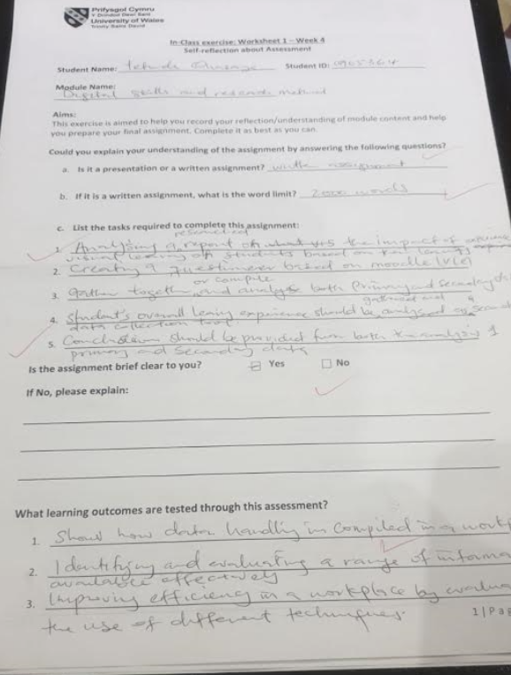

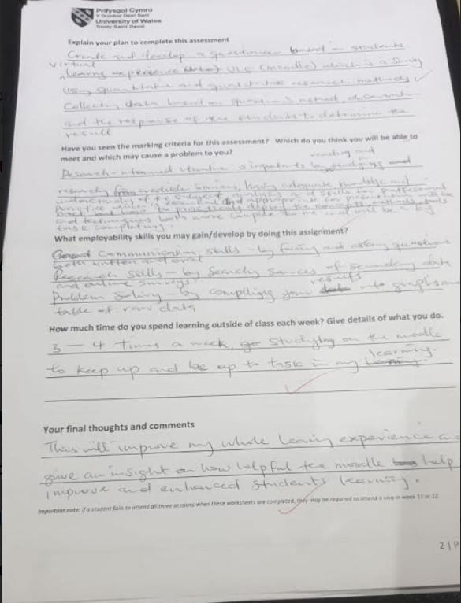


References
Allen, M., 2017. Secondary Data - SAGE Research Methods. [online] Methods.sagepub.com. Available at: <https://methods.sagepub.com/reference/the-sage-encyclopedia-of-communication-research-methods/i13206.xml> [Accessed 10 April 2020].
Austin, G., 2014. The Importance Of Representative Samples And How To Get Them | Austin Research - Market Research Consultants. [online] Austinresearch.co.uk. Available at: <https://austinresearch.co.uk/the-importance-of-representative-samples-and-how-to-get-them/> [Accessed 13 April 2020].
Chou, S. and Liu, C., 2005. Learning effectiveness in a Web-based virtual learning environment: a learner control perspective. Journal of Computer Assisted Learning, 21(1), pp.65-76.
Denzin, N., & Lincoln. Y. (1994). Handbook of Qualitative Research. Thousand Oaks, CA, US: Sage Publications Inc.
McLeod, S., 2019. What’s The Difference Between Qualitative And Quantitative Research?. [online] Simplypsychology.org. Available at: <https://www.simplypsychology.org/qualitative-quantitative.html> [Accessed 10 April 2020].
Meer, S., 2013. The Learning Impact Of A Virtual Learning Environment: Students’ Views - Insight. [online] Insight.cumbria.ac.uk. Available at: <http://insight.cumbria.ac.uk/id/eprint/1455/> [Accessed 12 April 2020].
Mogus, A., Djurdjevic, I. and Suvak, N., 2012. The impact of student activity in a virtual learning environment on their final mark. Active Learning in Higher Education, [online] 13(3), pp.177-189. Available at: <https://www.researchgate.net/publication/258124481_The_impact_of_student_activity_in_a_virtual_learning_environment_on_their_final_mark>.
Punch, K. (1998). Introduction to Social Research: Quantitative and Qualitative Approaches. London: Sage
Racheva, V., 2017. What Is Virtual Learning? | VEDAMO. [online] VEDAMO. Available at: <https://www.vedamo.com/knowledge/what-is-virtual-learning/> [Accessed 10 April 2020].
Singh, S., 2018. Sampling Techniques. [online] Medium. Available at: <https://towardsdatascience.com/sampling-techniques-a4e34111d808> [Accessed 10 April 2020].
Wolf, A., 2016. Primary Data Vs. Secondary Data: Market Research Methods. [online] Blog.marketresearch.com. Available at: <https://blog.marketresearch.com/not-all-market-research-data-is-equal> [Accessed 10 April 2020].

