‘School X’



School X is a primary school situated within the outskirts of the city of Swansea. The school consists of 243 pupils, with an average class size of 28 pupils. 39% of pupils receive free school meals (FSM), which is significantly higher than the national average. A contributing factor to unemployment in the area is the closure of a number of businesses in the local area in recent years, due to the recession. School attendance levels have worsened in the last 2 years, with the school’s average attendance currently at 89.2%. This has had a significant impact on attainment levels across both the Foundation Phase and Key Stage 2.
Within a recent report from an ESTYN inspection, the school was awarded an adequate for performance and progression and a number of targets were put in place to ensure improvement across all areas. One area that requires attention is the involvement of parents in the school alongside the current strategies that are used and this is something that is currently under review. The school works closely with other agencies such as social services to ensure that issues affecting the child’s ability to attend school are addressed, thus improving levels of attendance and in turn, attainment.

Rationale for chosen interventions

Many researchers have distinguished a clear correlation between poverty and low levels of attainment and this is an issue that greatly affects ‘school X’ as it is situated in an area with high levels of poverty and unemployment. There have been a number of suggested reasons for this relationship. These include an unavailability of resources within schools and the local community, little to no parental engagement for disadvantaged children and problems surround well-being and emotional and social development (Joseph Rowntree Foundation, 2007).
In their guidance for good practice (2012, p.2) ESTYN state that schools that ensure inclusive education for those who are living in poverty “listen to disadvantaged learners and provide opportunities for them to play a full part in
the school’s life”. With this in mind, it is evident that there is a need for pupil voice to be developed within ‘school X’ and this led to the decision to introduce a healthy school council, in which the children are provided with the opportunity to express their thoughts and feelings and make decisions on the food that is served throughout the school. Furthermore, the report states that good practice includes opportunities for children to “develop their social and emotional skills” and this inspired the idea to employ a full-time pastoral officer as someone who can cater to the needs of the children and aid them in their development.
By incorporating this idea, the school will be working towards meeting the ESTYN’s expectations and therefore, improve from the previous inspection feedback.
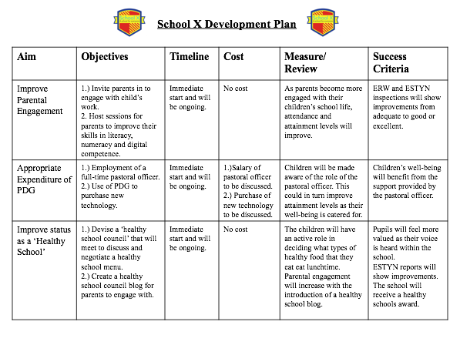

Evaluation

Throughout the module of ECAD6001: The Principles of Practice and Progress, it has been possible to develop knowledge of areas of teaching and learning that have not been explored in detail previously. The module proved to be very interesting and easy to engage with as some controversial issues were discussed within the sessions. The module has been very informative and introduced a lot of theories and strategies that will be used in future practice.

Strengths:
Within this module, I feel that I have developed my ability to select relevant sources as part of my wider reading. This could be due to the fact that I have been given the opportunity to research an area that I find particularly interesting and therefore, wished to continuously expand my personal knowledge. I also feel that I have improved on my critical evaluation of sources, especially when creating a research file to support the visual presentation. I believe that this, again, is due to my own passion for the topic of inclusive education for disadvantaged children living in poverty. This enthusiasm enabled me to delve deeper into the research and consider the ways in which it supported or contradicted the interventions that were decided upon for the assignment.

Aims for progression:
One way in which I will improve my future assessments is to work more creatively with regards to my delivery. An example of this is to use different software and technology to improve the general presentation of my work. My own digital competency is something that I am continuously working to improve on. Furthermore, I will continue to research topics that I am interested by in order to expand my knowledge further on interventions that can be implemented to ensure that education is accessible to all children, despite their personal backgrounds.

Bibliography

Arshad,R. , Wrigley, T., Pratt, L. (Ed by) (2012) Social Justice re-examined: dilemmas and solutions for the classroom teacher,London:IOE Press

Bradshaw, J. Main, G (2016) ‘Child poverty and deprivation’, in Bradshaw, J. The Well-being of children in the UK, Policy press

Clwyd Primary School, Safeguarding and Child protection policies,
Available at: http://www.clwydprimary.co.uk/policies/
[last accessed: 05/11/2018]

Cummings, C. Dyson, A. Millward, A. (2003) ‘Participation and democracy: What’s inclusion got to do with it? in Allan, J. (ed.) Inclusion, Participation and Democracy: What is the Purpose? Kluwer Academic Publishers

Donaldson, G (2015) Successful Futures. Cardiff. WAG

Education Endowment Foundation (2018) Parental engagement Teaching & Learning Toolkit,
Available at: https://educationendowmentfoundation.org.uk/pdf/generate/?u=https://educationendowmentfoundation.org.uk/pdf/toolkit/?id=139&t=Teaching%20and%20Learning%20Toolkit&e=139&s=
[last accessed: 06/11/2018]

Estyn (2012) Effective practice in tackling poverty and disadvantage in schools, Crown copyright,
Available at: http://learning.gov.wales/docs/learningwales/publications/140211-effective-practice-in-tackling-poverty-and-disadvantage-in-schools-en.pdf
[last accessed: 05/11/2018]

Gregory, E. (2000) ‘Recognizing Differences: Reinterpreting Family Involvement in Early Literacy, in Cox, T. (ed.) Combating Educational Disadvantage: Meeting the Needs of Vulnerable Children. London: Falmer Press

James, C (2010) ‘The contribution of parents’, in Aggleton, P. Dennison, C. Warwick, I. (ed.) Promoting Health and Well-being through Schools. London: Routledge

Jensen, E. (2013) How poverty affects classroom engagement, vol 70, number 8, ASCD

Available at: https://www.shastacoe.org/uploaded/Dept/is/LCAP-Local_Control_Accountability_Plans/Annual_Update_Training_4-15-15/2015-16/3-21-16/22_How_Poverty_Affects_Classroom_Engagement.pdf
[last accessed: 05/11/2018]

Joseph Rowntree Foundation (2007) Combating child poverty in Wales: are effective education strategies in place?
Available at: http://learning.gov.wales/docs/learningwales/publications/120817combatingchildpovertyen.pdf
[last accessed: 08/11/2018]

Joseph Rowntree Foundation (2018) Poverty in Wales in 2018,
Available at: https://.jrf.org.uk
[last accessed: 10/11/2018]

Maslow’s Hierarchy of Needs (image)
Available at: https://www.simplypsychology.org/maslow.html
[last accessed: 09/11/2018]

The Department of Work and Pensions (2018) Poverty statistics,

Available at: https://gov.wales/statistics-and-research/households-below-average-income/?lang=en

[last accessed: 31/10/2018]

Unicef, (1990) The United Nations Convention on the Rights of the Child
Available at: https://downloads.unicef.org.uk/wp-
content/uploads/2010/05/UNCRC_united_nations_convention_on_the_rights_of_the_child.pdf?_ga=2.260209165.1631208557.1509642426-1569310568.1509642426
[last accessed: 02/11/2018]

Welsh Assembly Government (2015) Pupil Deprivation Grant: Essential Guidance, Cardiff. WAG

