1st Model – Dumpster - 10/10/25
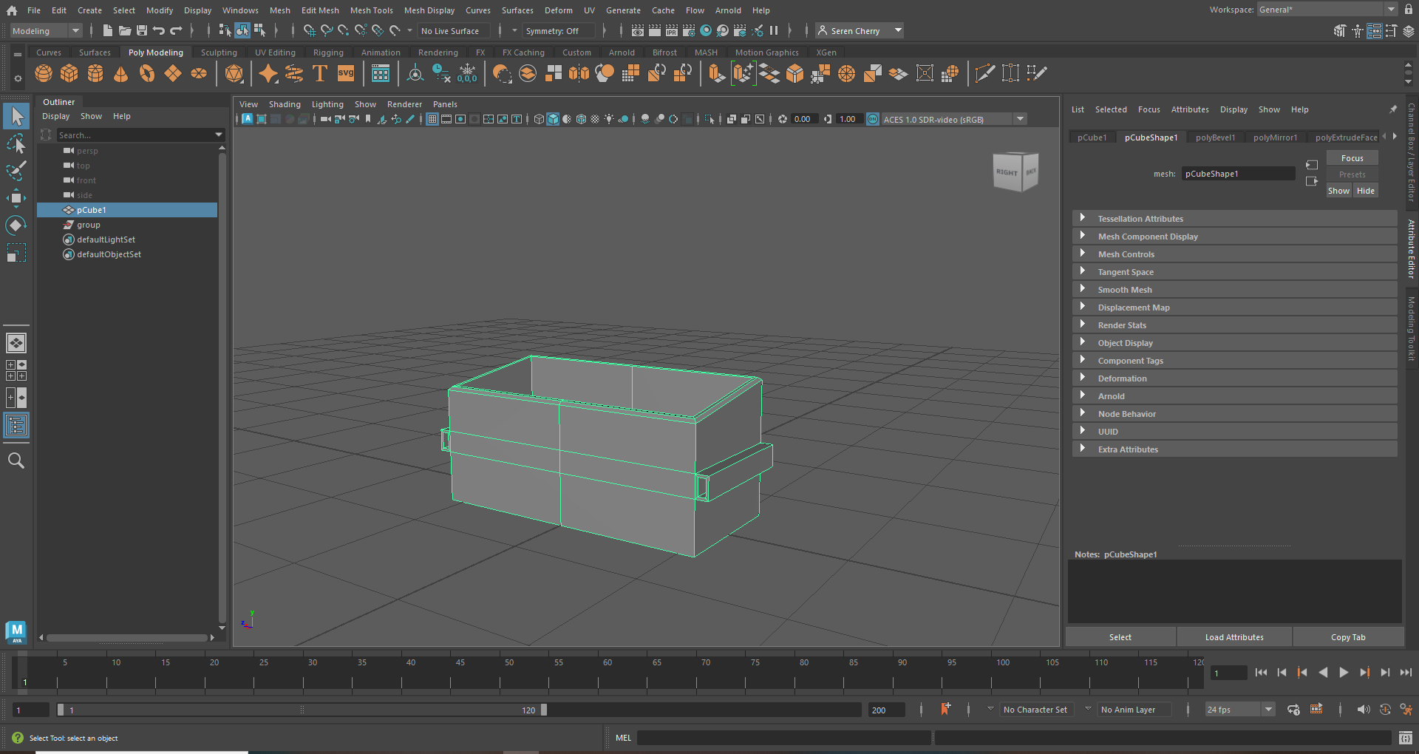This was the first proper model I made in Maya and the first of 5 expected of me in my 3d modelling lectures. This model provided no issues for me, in class we were instructed step by step so there was very little room for user error.
The model was created in Maya using the basic shapes, extrude function, bevel function, mirror tool and inserting edge loops.
To start I added a cube into Maya, scaled it up and stretched it out into a rectangle using the scale and move tools. When stretching the cube into a rectangle it is important to select a face (holding right click and selecting ‘face’) before using the move tool, or you will just be moving the whole object.
Then, clicking CTRL E to get into the extrude panel, I adjusted the off set to select a smaller area within the top face of the rectangle. After that, I hit CTRL E again to just select the inner face before using the move tool to bring that face down and essentially hollow out the rectangle. To finish of this shape, I held right click and selected the edge tool before selecting one of the long edges of my hollowed rectangle. Using the move tool, I moved that edge down just slightly to create that slant you can see in the photo above.
The final part is the little handles on the sides. For this, we were shown how to use the mirror tool so we only had to model one side. In the mirror tools panel I selected axis option to essentially cut the model ‘in half.’ While this tool is selected, whatever I do on the right is copied to the left and vice versa. Next, using the insert edge loop tool, I made two cuts which you should be able to see in the image above, where 2 parallel lines follow all the way around the dumpster. So, all you want to do is click to make those 2 lines, which has now created an extra section on the side of the dumpster. I then extruded this area out slightly selecting the face again like before to make a small rectangle on the side of the dumpster. To hollow out the handles it was the same method as before when I hollowed out the rectangle. Selecting the face and clicking CTRL E, adjusting the onset inward then CTRL E again and dragging face in.
This first model was a nice introduction to Maya as it was all built using basic shapes. Nothing too strenuous, technique wise, was required. It was a good opportunity to get the keybinds and basic techniques in my head and prepare me for future models.
2nd model – Lamp version 1 – 17/10/25
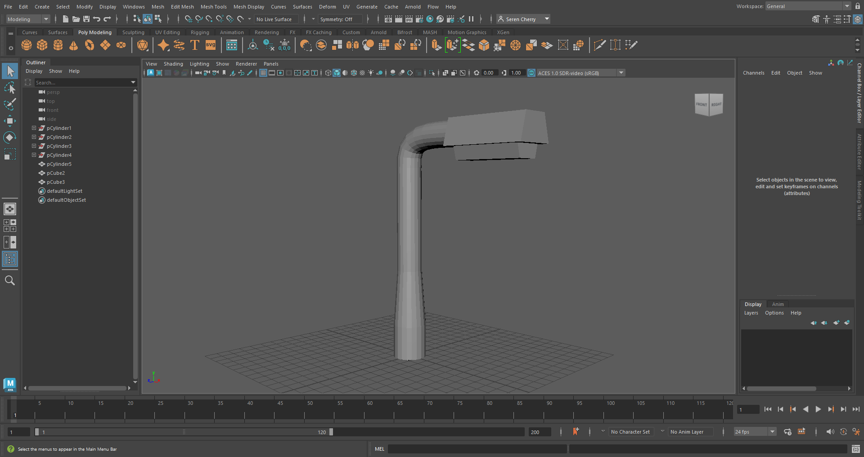
This was the first of 2 lamps I made today. The main takeaway was the bridge tool, which we were taught about today. It allows me to generate a bridge and connect two objects together. It is good for creating curves or just filling in gaps between two objects. The biggest drawback today was being 15 minutes late to lecture due to my bus being late. Luckily my tutor came over and walked me through how to make the lamp post so I didn’t fall too far behind.
This model was created in Maya using basic shapes, the extrude function, bevel function, bridge tool and insert edge loop tool.
I started with a cylinder and scaled it up a little bit before selecting the top face and extruding up about double the length of the current cylinder. Staying in the extruding mode, I scaled down which only made the top half smaller creating a gradual shift in size. From there I reselected the top face of the cylinder and extended it upwards a decent amount.
Now comes the new tool, the bridge tool. I added a new cylinder and scaled it to match the current width of the post. Then I turned it on it’s side, and positioned it a little higher than the top of the post and a little out from it. To use the bridge tool to create the curve seen in the image above, I highlighted both objects and combined them, it can be found in the meu on the right hand side of the screen or in ‘Mesh -> Combine’ tabs at the top off the screen. After the post and cylinder are combined, I selected both faces closest to each other and deleted them before selecting the edges of the now deleted faces. Then I clicked the bridge tool found in ‘edit mesh’ at the top of the screen. In the bridge screen, I changed the curve type to linear keeping the taper at about 1. This connected both cylinders and created the curve you can see in the image above.
To finish the model, I tweaked a square and lengthened it and shrinking the longer side of the upper half fore the top of the light. I copied it and flipped it upside down and scaled it down to create the light itself beneath, which is visible in the image above.
Looking back, I think the light section could be smaller and the post skinnier and longer, as the scaling looks wrong. But, I am not going to dwell on it as it’s a learning experience and I’ll use this critique for future models.
3rd model – Lamp version 2 – 17/10/25
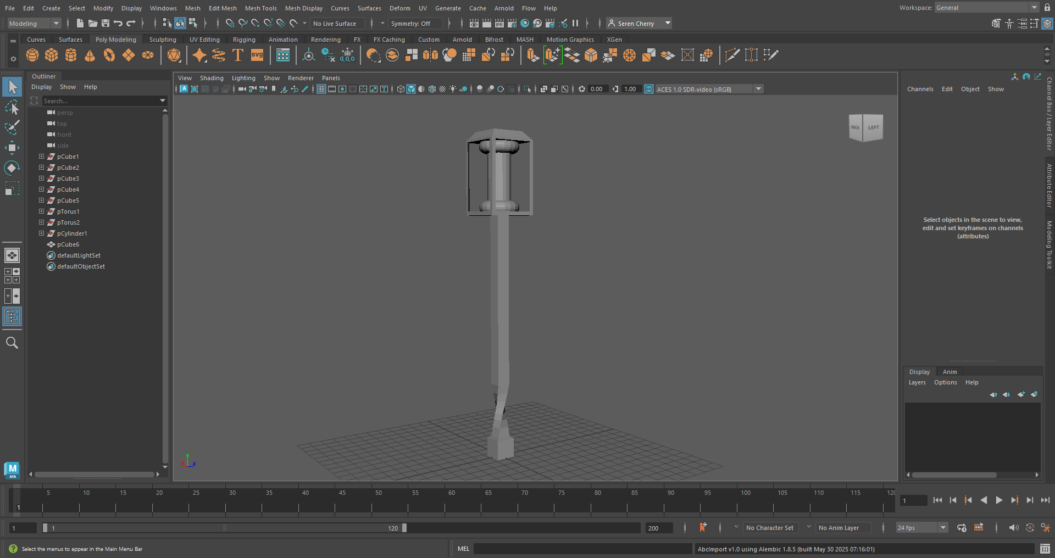
This was the second lamp of the day, with no problems occurring for this one and no extra research required. But, looking at it now I think with more experience I could make it more streamlined and fit together better, but for now I am quite pleased with my progress and ability.
For this model, as usual, I used the extrude tool, transform tools ad the multi cut tool.
I started with a cue, selected the top face and extruded up. After extruding, still I the selection, I rotated the section to create the twist you see in the image above. Then, I just extruded up normally.
Next, I created a cube and placed it at the top of my pole and scaled it up and made it an upright rectangle. The next step was to offset each face equally, leaving a rim, and deleting the inner face of each side. This gives me some room to add in a light that I put together with an extended cylinder and 2 donut shapes. To make the top roof part, I extruded up slightly. Then reselected the top face and scaled down to add that slope to the roof.

4th model – Cup + Saucer with Umbrella – 24/10/25
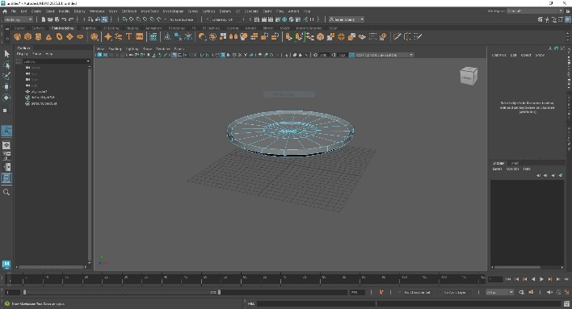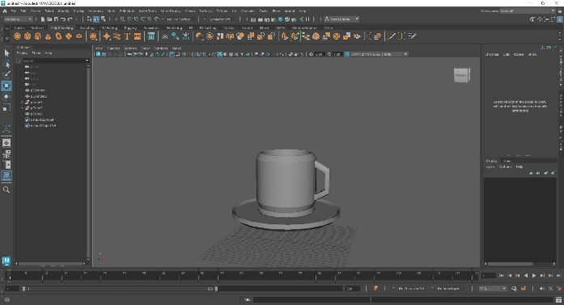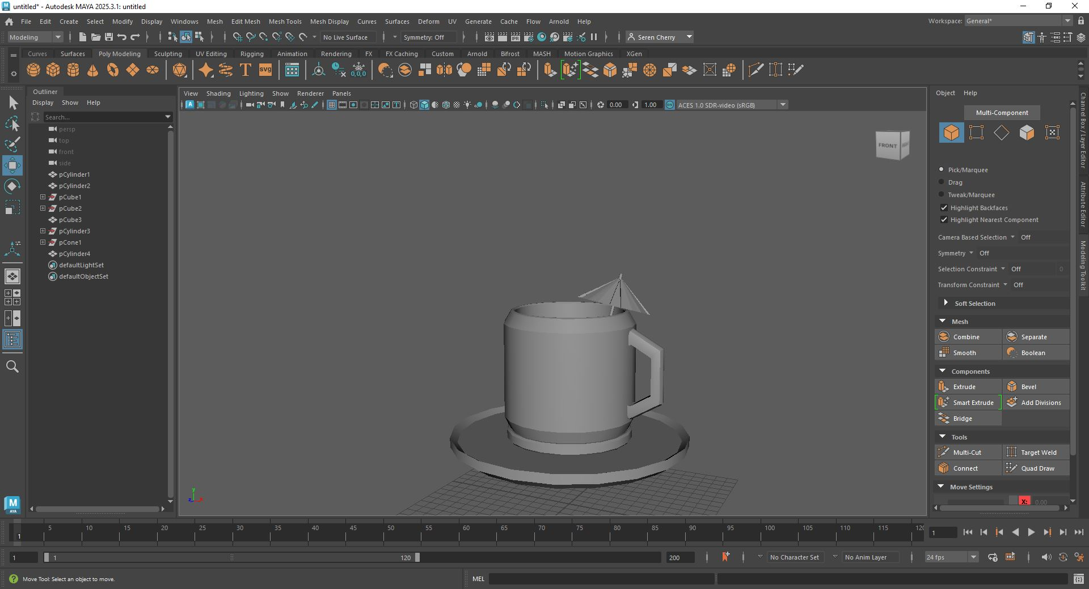

This is the cup and saucer created in Maya. The next model expected of me in my 3D modelling lectures. I did encounter some issues this time. I fell behind a little at first, since I had some issues making the saucer, trying to extrude a cylinder up. I don’t exactly know what the issue was, but I managed to solve it by myself by restarting. When you are so early into a model I think it is just quicker to start fresh if the problem seems obscure or a little random. Looking back after finishing the model, it could have genuinely been my fault of selecting something wrong, but I don’t regret starting again to make sure my model is issue-free.
Also, I did add something unique, which was the more geometric style and the small umbrella. I preferred the more geometric style of the handle, so I went along with it. I also had time at the end of the lecture so I created a little umbrella to add to the drink.
Again, this model was created in Maya using basic shapes, the extrude function, bevel function and multi cut tool.
I started with the saucer, a cylinder sized up but made almost completely flat for the very bottom of the saucer. I then extruded up just a little bit, reselected the face and extruded again and up a little once again before adjusting the offset to create the full size of the saucer to create that little dip they have in the centre. For the little lip on the outskirts I selected the edges of the saucer and using the move tool, I just moved the edges up slightly.
The cup is another scaled cylinder. I made it flat, like before, and extruded up and out before reselecting to extrude up, then up and in. All I needed to do then is extrude once more, adjust the offset slightly and reselect the face and move it down to hollow out the cup.
The next big step is the handle, where I revisited the bridge tool. To start, I placed 2 scaled down cylinders into the side of the cup where I wanted the handle to start and end. Like in my previous lamp model, I removed the outer faces of those cylinders, combined them and the selected the edges and clicked bridge. I switched the curve type to blend, and kept the divisions low to maintain that geometric look.
The final touch to this model was the small umbrella. I scaled a cylinder down by a lot, and extended it up, but made sure to keep it thin so its like the stick of an umbrella you’d get in a cocktail. For the top part, I scaled and flattened a cone shape and adjusted it so it slotted nicely atop the stick I had made. Then, selecting every other face along the cone, I extruded inwards to mimic the pattern the paper umbrellas have. I tried to not over complicate it given my skill level, and I was quite pleased with how it turned out.
I combined all the umbrella assets (I also combined the handle and cup) and slotted the umbrella into the cup to finish the look.
5th model – Monster Can – 24/10/25
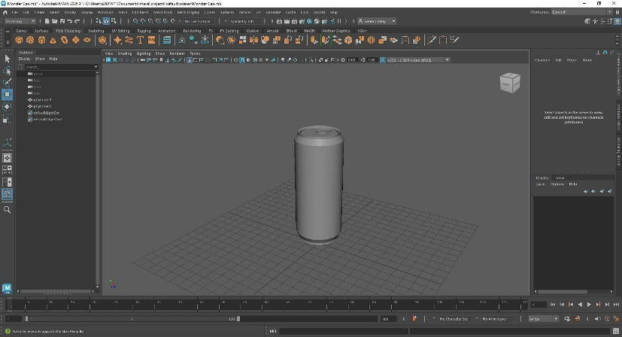
This model was the monster can, another model on the list required for us to model. This one I did alone, with no tutorials or help from tutors. I made it with future plans to keep updating it as I build more skills, e.g UV unwrapping to add textures and more Maya techniques.
I think this model has also been one of my favourites to do. It was nice to see it come together accurately with simple techniques. It felt really rewarding to make something that was shaped practically like the real thing. However, the only thing that bothers me with this model in the low quality ring pull, which I plan to fix when I have the techniques to be able to.
To make the monster can, all I did was increase the width and length of a cylinder and flatten it quite a bit. Then, using my favoured method, I selected the top face an extruded up and out slightly to create the curve out a can has on the bottom. From there, I just selected the top face once again and extended upwards, more than a usual soda can as I intended to create a Monster Energy mode, which is longer than something like a coke can. Then, I used my usual extruding method to create the slope inwards, selecting top face, extrude up a bit and then slightly scale inwards. Since the can has a dip in the top, I selected the entirety of the top face and in the extrude panel I adjusted the offset slightly inwards then dragged down without reselecting the face, this was to have a smoother dip in the top like a real can would. For the last part, the ring pull, I struggled to know what to do exactly. I knew the shape, just not how to get myself there fully.
So, I just kept it simple and went with a low poly sort of idea. I squished down a cylinder, and extended just the length, not the height or width, so it resembled a sort of flattened pill laying on it’s side. Just selecting the top faces at the end of each of the shape, I stretched the sides out so the length of the ends matched the width of the centre to have more of a rounded rectangle.
From there, I was happy with what I had. The object was readable and I could tell what it was at first glance, which I was pleased with given how intimidated I felt working with Maya at first. I also know from personal experience that messing around too much can sometimes make things worse, so I didn’t want to risk ruining a model I was happy with.
31/10/25
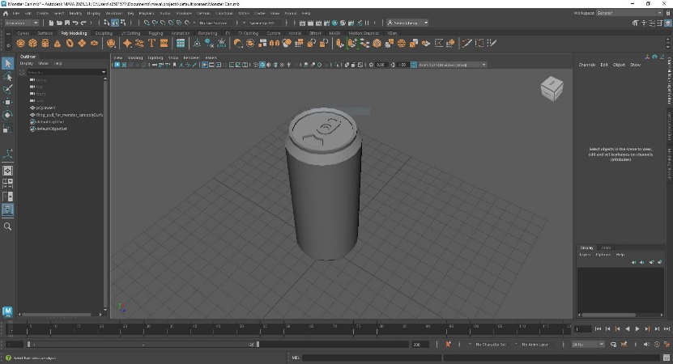
Fig. 1. reference image

The lecture after I was taught about the quad draw tool. In simple terms, it is a way to create your own shapes. So, I used it to trace an image of a ring pull, managing to get a much better looking one than my first attempt last week. The image I used to trace the ring pull is seen above.
Along with the ring pull, I also decided to use the draw tool to cut out an area in the can where the opening of the can would be. Using the face select and extruding down to hollow a little but out of the shape I made.
After these 2 changes, I am far happier with the outcome of my Monster Can. It really took it to the next level in detail, with just 1 tool and a bit more time.
6th Model Vader’s Castle - 14/11/25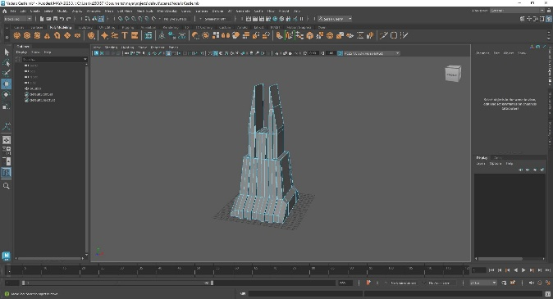
Fig. 2. Vader’s Castle reference
The final object we have been asked to do is a house and we could interpret it in our own way too. Since I am a big fan of Star Wars I decided to challenge myself and do Darth Vader’s Castle, using everything I have practiced and learnt about so far in my lectures and models.
From the official Star Wars Wiki (Wookiepedia) I found a good base image to work off of. Vader’s castle slightly varies across all media’s so I decided to pick one Image and work off that.
In this model, I used the basic shapes, extrude and insert edge loop. All modelled in Maya.
First I began with a square, scaling it up and then making it a little longer. I then extruded out either side of the main square I created, by about one square in length using the base Maya grid. Selecting the edge of the outer sides I lowered it down to create a slant on either side of the base shape. Selecting the top face of the base, I extruded upwards to create a decent amount of height. Then reselecting the top face I adjusted the onset inwards and extruded up once again, just a little less further than first time. The last thing I need to do for the base shape is to create the two spire like shapes at the top.
To create the two spires on the ends, I used the insert edge loop tool to create two sections on either end, and extruded them up. To make them pointed, I selected the inner edges of the spires made and dragged them down to create a slope. There was space still on either sides of the spires, so I repeated this same process, just not as high up, to create a bigger slope on both spires.
To make the ridges sticking out of the front of the castle, I used the insert edge loop tool to slice the model into equal chunks along the Y axis. Leaving two sections in the centre that would stay flat, and two on either side that would be the ridges. I then selected the chosen sections and extruded outwards to create the ridges seen in my reference.
I also created some more of those pointed slopes on the front of the castle to help some parts of the front flow more, like the four rectangular shapes running up the front of the spires.
Overall, I think this is my favourite thing I have modelled in Maya. It aligns with what I’m currently interested in so I had fun modelling it and also ended up with something I am quite proud of.

15/11/25
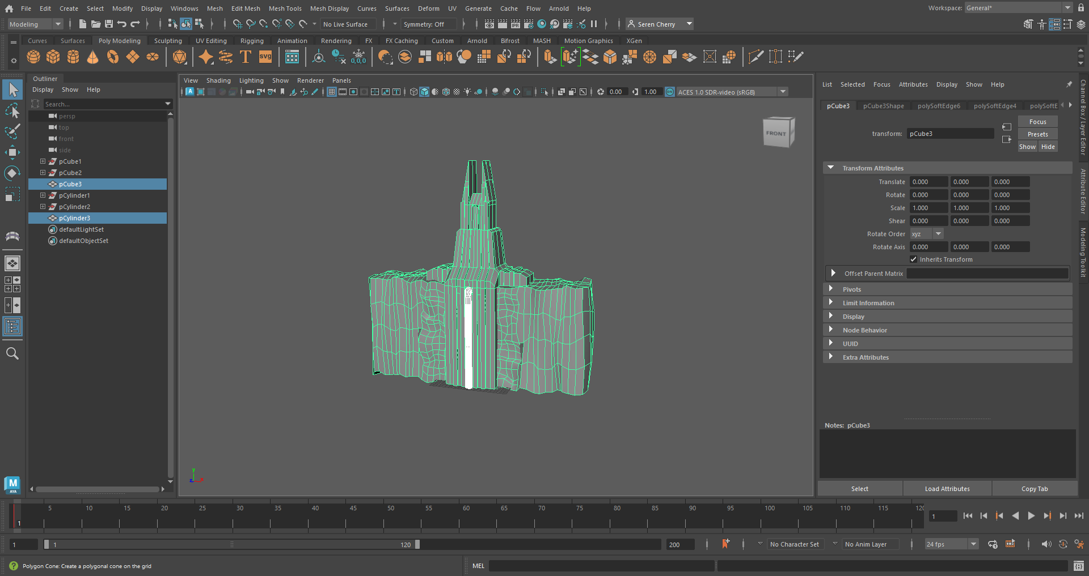

A day after I finished my initial Vader’s Castle, I didn’t think it captured the grandness of it. Coming back to the model was slightly underwhelming compared to the image I had used as a reference. That’s when I decided I would spend the day adding a bit more size to the main castle and building in some of the environment to help set the scene a little more.
To start, I scaled up one square into a long rectangle, height wise, to be much bigger than the main castle. Then extruded each side out a little more to have more room, since I also noticed the castle does have some sort of side rooms. To make those were quite simple, extruding out on each side, then again to have another smaller section. On those smaller outer sections, I selected the edges and brought them down to make an incline. Which should be able to be seen in the images above.
With the side rooms I also added to lines of ridges running over on each side to match the architecture of the rest of the castle. The front of the castle also runs down the front of the rocky terrain in the reference, so I also added that to my model. It was an easy addition. I moved the block that was acting as my terrain back to have a slight overhang, then selected the faces below the overhand and just extruded down. Extending that front part down the length of the terrain block.
In the top section between the spiers, I used the edge loops tool to be able to extrude a square shape inward to create a sort of doorway that can be seen in the reference. I did a similar edge loop and extruded at the front so I could have a small square opening to have the lava flowing from. To make the lava, I used two cylinders. One cylinder scaled to fit in the small opening I just made and the other at the very bottom of the terrain block, scaled up in height to meet the top cylinder. I combined both shapes, removed the faces and bridged them together to created that slight curve lava would have if it were to actually be flowing.
A final thing that bothered me was the flat terrain block. I subdivided the terrain block into a grid, so I would have more faces to work with. I knew I wanted to have a low poly rock effect, but I didn’t know how to do it. So, I went on google and searched how to create a low poly rock surface and discovered the randomise transformation tool from a tutorial on YouTube . I selected my terrain blocks faces, and went to ‘edit mesh,’ then to transformation. Next to transformation was a little panel, which brings up a menu where you can adjust the randomise values. Once I clicked apply, I could move the faces and they would create a randomised values to move in the direction I needed. I played a little with the rotation and movement until I was happy with some subtle bumps and ridges.
I think it adds a bit more life to the model, and that extra bit of detail I am proud of.
Bibliography
[1] AutoDesk, “Autodesk Maya | Get Prices & Buy Official Maya 2025 | Autodesk,” Autodesk.com, Jan. 19, 2021. https://www.autodesk.com/uk/products/maya/overview (accessed Oct. 10, 2025).
[2] R. Stock, “Ring-pull isolated on a white background.,” iStock, Feb. 26, 2016. https://www.istockphoto.com/photo/ring-pull-gm510797118-86398095?searchscope=image%2Cfilm (accessed Oct. 31, 2025).
[3] Contributors to Wookieepedia, “Fortress Vader,” Wookieepedia, 2025. https://starwars.fandom.com/wiki/Fortress_Vader?file=Vaders_Castle_FDKF.png (accessed Nov. 14, 2025).
[4] WorldofLevelDesign, “Maya: Guide to Randomizing Position for Vertices, Edges and Faces on Geometry,” YouTube, May 17, 2022. https://www.youtube.com/watch?v=TzNlZNbtCAk (accessed Nov. 15, 2025).

AutoDesk, “Autodesk Maya | Get Prices & Buy Official Maya 2025 | Autodesk,” Autodesk.com, Jan. 19, 2021. https://www.autodesk.com/uk/products/maya/overview
AutoDesk, “Autodesk Maya | Get Prices & Buy Official Maya 2025 | Autodesk,” Autodesk.com, Jan. 19, 2021. https://www.autodesk.com/uk/products/maya/overview WorldofLevelDesign, “Maya: Guide to Randomizing Position for Vertices, Edges and Faces on Geometry,” YouTube, May 17, 2022. https://www.youtube.com/watch?v=TzNlZNbtCAk (accessed Nov. 15, 2025).
R. Stock, “Ring-pull isolated on a white background.,” iStock, Feb. 26, 2016. https://www.istockphoto.com/photo/ring-pull-gm510797118-86398095?searchscope=image%2Cfilm (accessed Oct. 31, 2025).
Contributors to Wookieepedia, “Fortress Vader,” Wookieepedia, 2025. https://starwars.fandom.com/wiki/Fortress_Vader?file=Vaders_Castle_FDKF.png (accessed Nov. 14, 2025).

