Operating systems
Module Name: Computer Architecture & OS
Module Code: ACCA4022
Student Name: PAUL WHITE
Student ID:2530876
Lecturer Name: Dr Md Shantanu Islam

Submission date: 24/07/2026 TIME 2:00PM

Contents
Introduction 4
Key functions of general Operating Systems 4
Task Management: 4
Application/Program Management: 4
File/Directory Management: 5
Device Management: 5
Security Management: 6
Use of Windows OS CLI commands 7
Example 1: 7
Example 2: 7
Example 3: 8
Example 4: 8
Example 5: 8
Example 6: 9
Example 7: 9
Example 8: 10
Example 9: 10
Example 10: 11
Use of Linux OS CLI commands 11
Example 1: 11
Example 2: 12
Example 3: 12
Example 4: 13
Example 5: 13
Example 6: 14
Example 7: 14
Example 8: 15
Example 9: 15
Example 10: 16
Use of Windows OS scripts 16
Example 1: 16
Example 2: 17
Use of Linux OS scripts 18
Example 1: 18
Example 2: 19
Conclusion 20
References 20
Appendices 21

Task Management:
From information sourced from [2 ], task management is used for tasks supported by the management (working sets) of windows operating the same that operating systems manage memory fast with the capabilities of being able to fast-track switching, fast task resumption, and the access to easy reacquisition of the cognitive context connected to the associated task required.
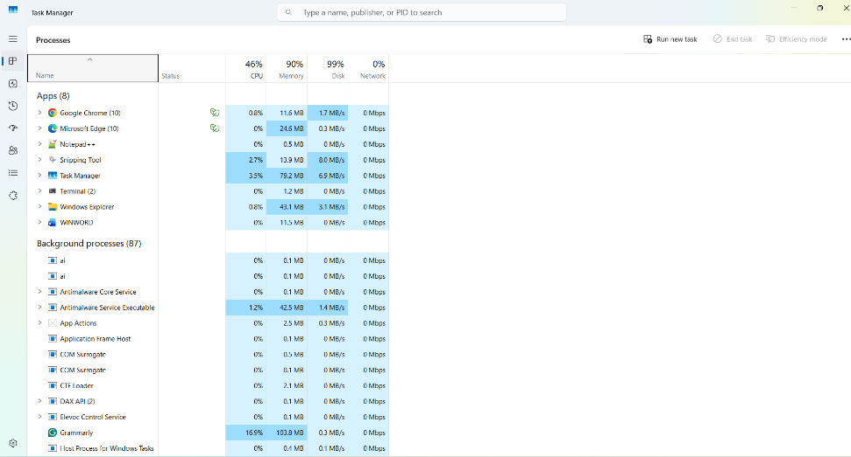
Figure 1: Description alm

Application/Program Management:

Information sourced from [3]. The computer system will analyze how the computer is performing as a whole and will include software and hardware taken from the storage device transferred to the application, as it may harm the device or computer. In terms of software, it can affect your product with usability and productivity.
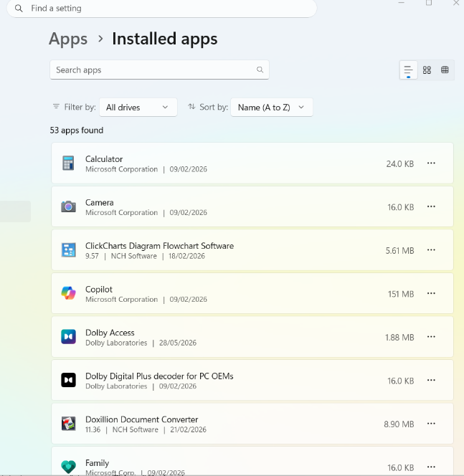
Figure 2: Description Is os/pathlab and shutil

File/Directory Management:

Information sourced from [4] UAC was introduced on Windows 10 and is a security feature allowing the user to perform common administrator tasks, and the user is supplied with a PIN number or password. Microsoft Windows 10 also came with an improved new internal build for future updates, with one of the most up-to-date releases of Redstone 5.

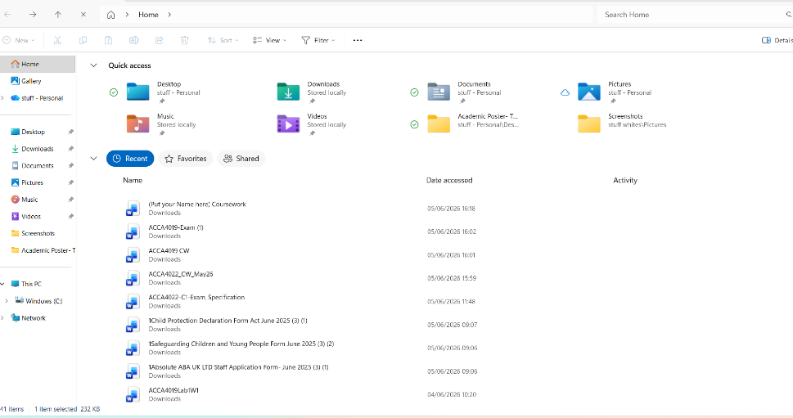
Figure 3: Description cac

Device Management:

From information sourced from [5], modern desktops are machines that can exist in various places and provide productive interaction for the user. Machines managed by on-prem technology are not allowed to manage devices; we must remove barriers; one is management policy. Microsoft Intune (cloud) for management of profiles, application software updating, and operating system upgrades.
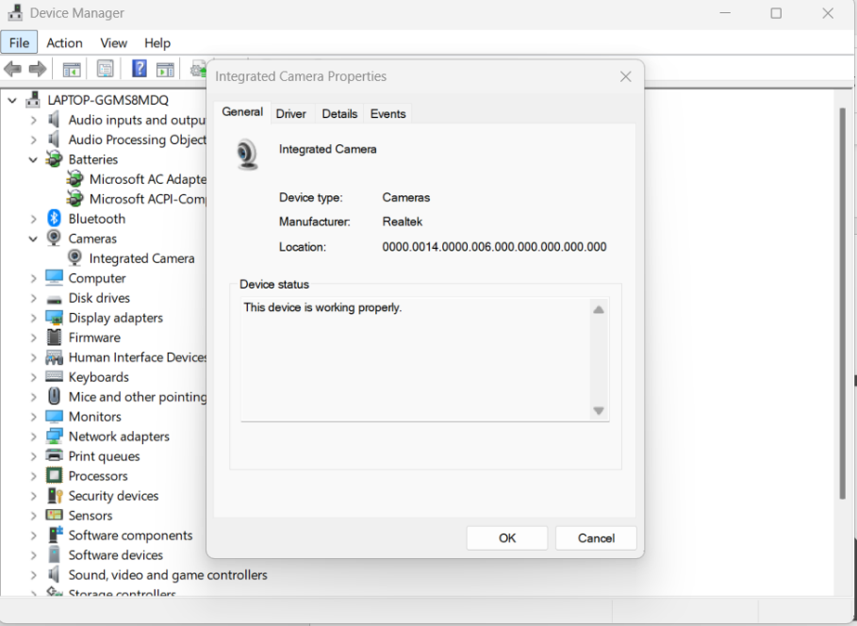
Figure 4: Description re

Security Management:

From information sourced from [6] in the Windows security model, there is Microsoft Defender anti-virus; however, security works better when joined with the protected processes and any process running containing tokens with debug privileges, with examples being an Administrator account, Process Explorer, and Task Manager, which require this access to ensure the user is provided functionality.

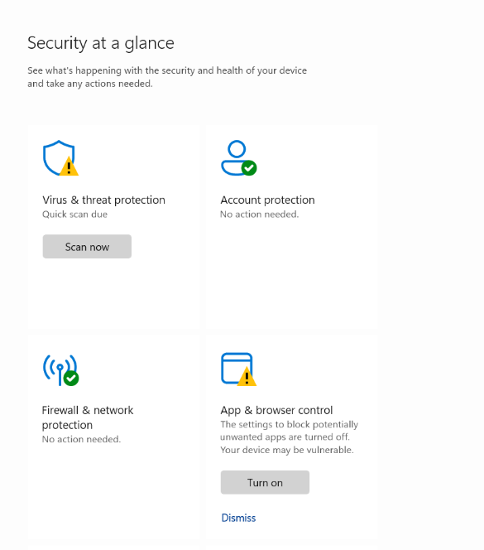
Figure 5: Description cmd

Use of Windows OS CLI commands
Information from [7]

Example 1:
The dir command lists all files and folders in the current directory (C:\Users\chant). The output displays 14 subdirectories, their creation dates, times, and available free disk space.

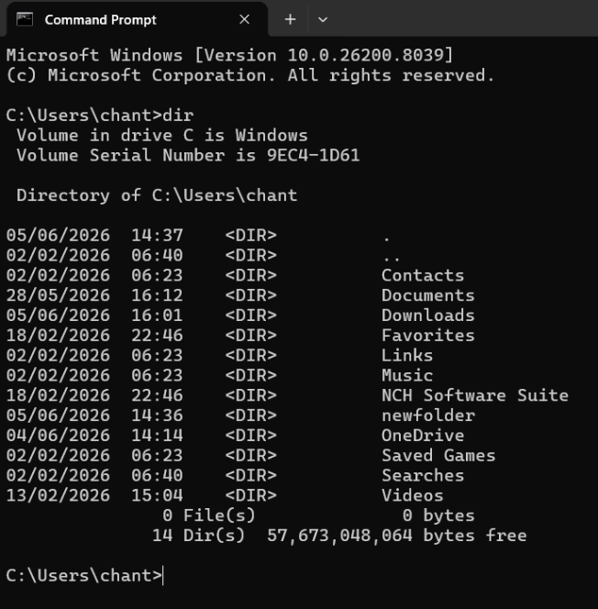
Figure 6:dir/ls

Example 2:

Starting Point: C:\Users\chant>
- Command Entered: cd Documents
- Resulting Path: C:\Users\chant\Documents>
Key Rules for Navigating
- Go forward: Type cd [Folder_Name] to enter a subfolder.
- Go backward: Type cd .. to go up one level.
- Handle spaces: Use quotes if the folder name has spaces (e.g., cd "My Documents").
- Check contents: Type dir to see a list of available folders in your current Figure 7: Description cd~

Example 3:

Description:mkdir new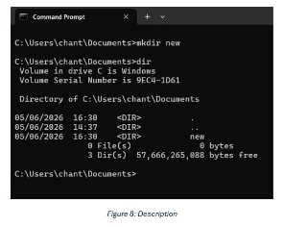: This command stands for "make directory." The user ran this to create a new folder

Verification: The output lists <DIR> new, confirming that the folder was successfully created at 16:30 on 05/06/2026.

Example 4: description: mkdir
The mkdir new command creates a new folder. The dir command lists directory contents. The output confirms the new folder was created successfully.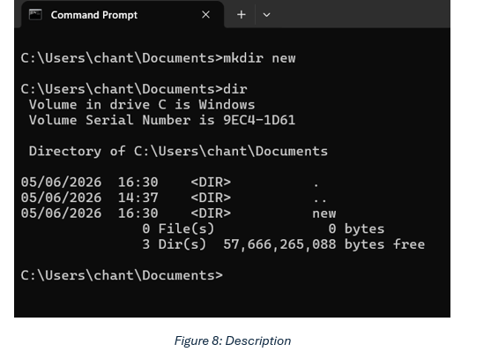
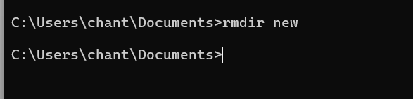
Figure 9: Description rmdir new
:
The Correct Command
Run this command in your command prompt:
cmd
rmdir /s /q new
Use code with caution.

Example 5:

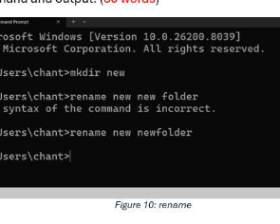
The image demonstrates the use of Windows Command Prompt to create / rename folders.
- mkdir new: Creates a folder named "new".
- rename new new folder: Fails because the target name contains a space, making the syntax incorrect.
- rename new newfolder: Successfully renames the folder to "newfolder" without spaces.

Example 6:

The ipconfig command displays network configuration details. The output reveals that only the Wi-Fi adapter is active, showing its IP address and gateway, while other adapters remain disconnected.

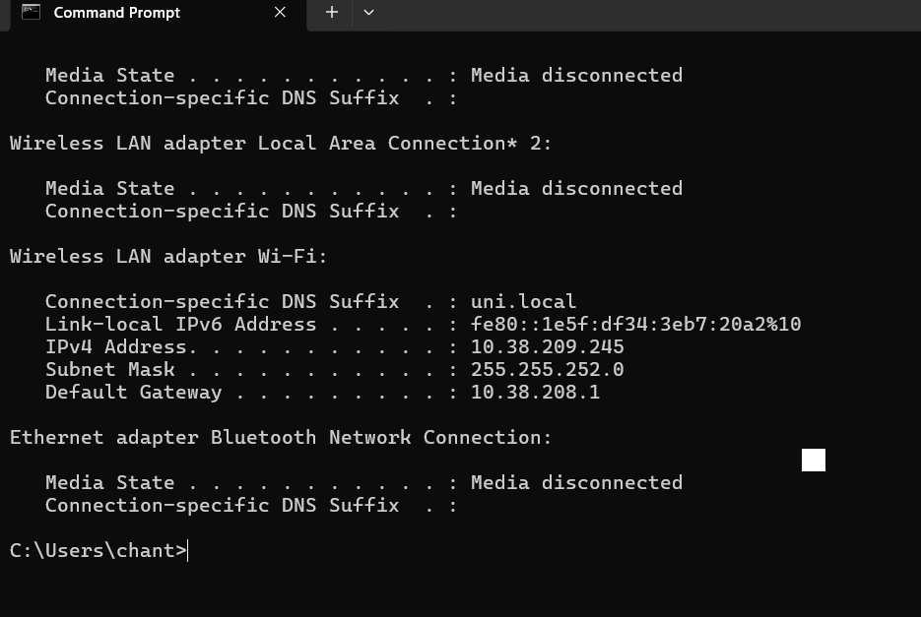
Figure 11: Description cmd

Example 7:
ipconfig command displays active network interfaces. The output shows the device is connected via Wi-Fi with IP address 10.38.209.245, while other network adapters are currently disconnected.
If you need help, let me know if you are troubleshooting a connection issue or configuring a static IP.

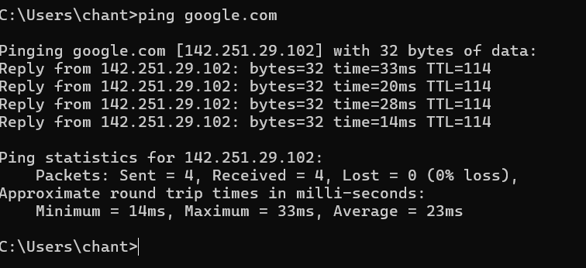
Figure 12: Description ping google.com

Example 8:
The ping command tests connectivity to google.com by sending four data packets. The output shows a successful connection with zero packet loss and an average response time of 23 milliseconds.
If you need help, let me know if you want to learn about specific metrics like TTL or how to troubleshoot network issues.

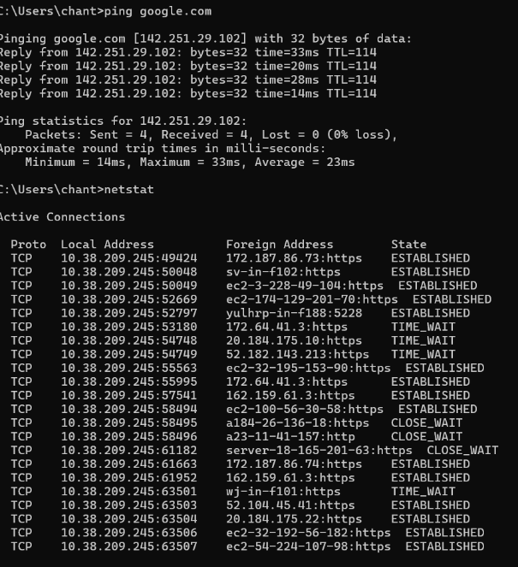
Figure 13: Description google.com

Example 9:

Description 13: ping google.com
- Purpose: Tests network connectivity to Google.
- Results:
  - Sent 4 data packets and received all 4 back (0% loss).
  - The average round-trip response time was 23 milliseconds.
  - This indicates a stable, working internet connection.
- Help you analyze a network issue you are currently experiencing

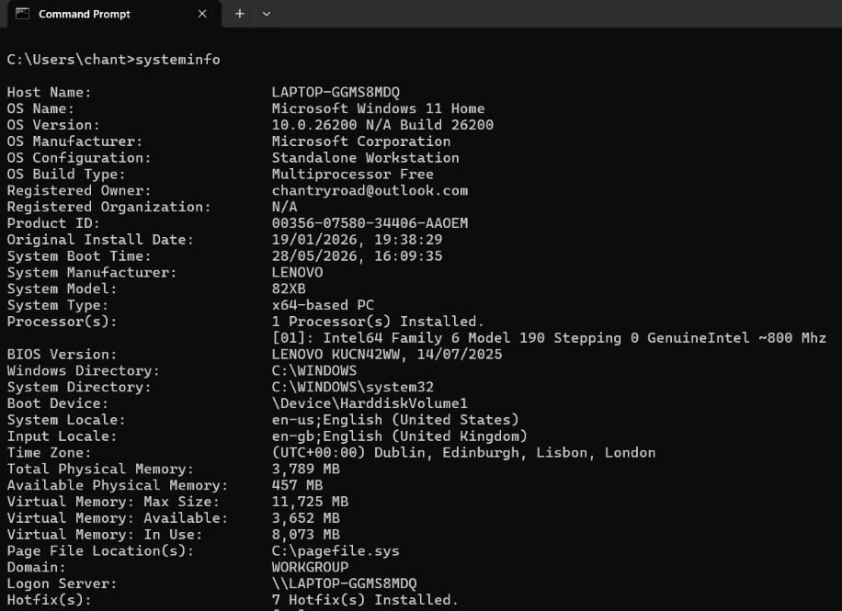
Figure 14: Description system info

Example 10:
The system info command displays detailed configuration information about a computer's operating system, hardware properties, and network settings. The output lists specific OS data, RAM capacity, and system specifications.

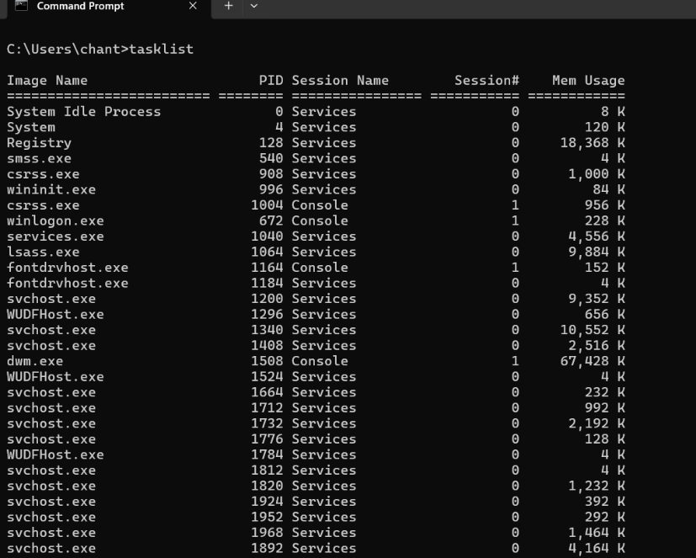
Figure 15: Description tasklist

Use of Linux OS CLI commands
Information sourced from [8]. Linux is free and is also supported. GUI-based tools enable the user to administer the operating system on their computer and, in turn, create accounts and change files and directories (although some operations can be handled using PowerShell commands).

Example 1:
The su command switches the user session. It defaults to the root administrator account. After entering the password, root access is granted—the prompt changes from $ to #.

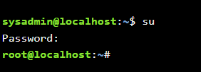
Figure 16: Description su

Example 2:

- Enter the folder: Type cd Downloads and press Enter.
- Verify location: Type pwd to confirm you are in /root/Downloads.
- View contents: Type ls to list the files inside that folder.
- Go back up: Type cd .. to return to the previous root directory.

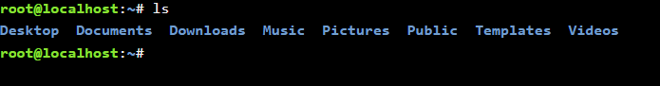
Figure 17: Description ls

Example 3:

- Command Executed: cd Desktop/ (Change Directory).
- User Identity: root (The administrative superuser accounts).
- Host Machine: localhost (The local system).
- Current Location: Changed from ~ (the home directory) to /Desktop (the Desktop directory).

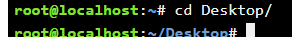
Figure 18: Description cd Desktop

Example 4:
The mkdir new command creates a new directory named "new". The ls command lists the current folder's contents, and the output confirms "new" was successfully created.
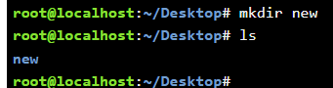
Figure 19: Description desktop

Example 5:
The mv new copy command renames the file or directory named "new" to "copy". Running ls lists the current directory contents, confirming "new" was successfully renamed to "copy".
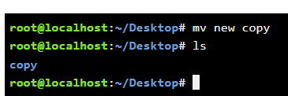
Figure 20: Description mv

Example 6:
The rmdir copy command deletes the empty directory named "copy". Running ls produces no output, which confirms that the Desktop directory is now empty.
If you are working on more Linux commands, I can help explain directory flags, error codes, or how to force remove non-empty folders.

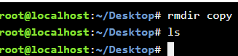
Figure 21: Description rmdir

Example 7:
The touch command creates an empty file named new.txt. Then, the ls command lists the directory contents, confirming its creation by printing new.txt to the screen.

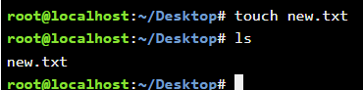
Figure 22: Description touch new.txt

Example 8:
The ifconfig command displays active network interfaces. The output details configuration settings like IP addresses, MAC addresses, and packet traffic statistics for the Ethernet (eth0) and loopback (lo) interfaces. Details like the subnet mask, or if you want to see the modern alternative command ip
If you would like to explore this further, let me know if you need help finding specific addresses.

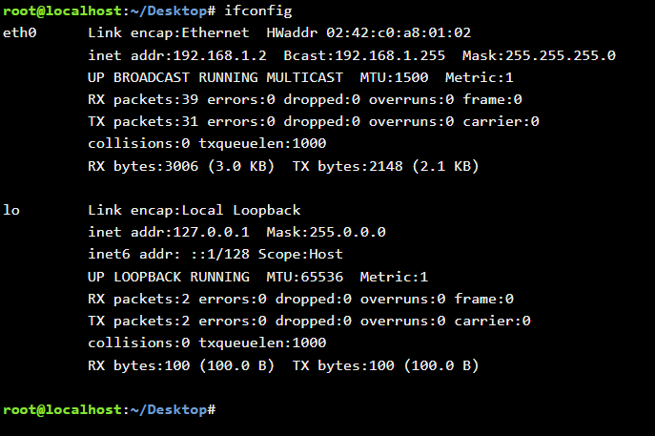
Figure 23: Description loop back

Example 9:

Output Breakdown
- Command: date prints system time.
- Day/Date: Friday, July 10th.
- Time: 14:39:23.
- Timezone: Coordinated Universal Time (UTC).
- Year: 2026.

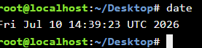
Figure 24: Description desktop

Example 10:

Terminal Breakdown
- Command: date
- Output: Fri Jul 10 14:39:23 UTC 2026
- Current Directory: ~/Desktop

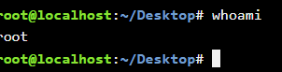
Figure 25: Description Linux terminal screen executing a basic command

- root@localhost: You are logged in as the root user (the system administrator with full access privileges) on the local machine (localhost).
- ~/Desktop: Your current working directory is the Desktop folder of the root user.
- # (The Prompt Hash): This symbol confirms that the terminal session is running with elevated root superuser privileges (standard users typically show a $ symbol).
- whoami: This command asks the system to print the username associated with the current effective user ID.

Use of Windows OS scripts
Information sourced from [9]. Batch scripts are stored in simple text files containing lines with commands that get executed in sequence, one after the other. These files have the special extension BAT or CMD. Files of this type are recognized and executed through an interface (sometimes called a shell) provided by a system file called the command interpreter. On Windows systems, this interpreter is known as cmd.exe.

Example 1:

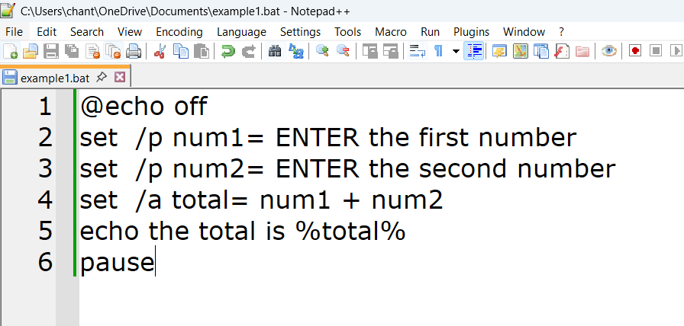
Figure 26: Batch script prompts a user for two numbers, adds them together, and displays the sum.
- @echo off: Hides the command text from being displayed on the screen during execution.
- set /p num1= & set /p num2=: Prompts the user with text to input the first and second numbers, saving them into variables num1 and num2.
- set /a total= num1 + num2: Performs an arithmetic calculation (/a), adding the values of the two variables together and storing the result in total.
- echo the total is %total%: Outputs the calculated sum text to the command prompt window.
- pause: Halts the script and keeps the command prompt open until a key is pressed.
Expected Output

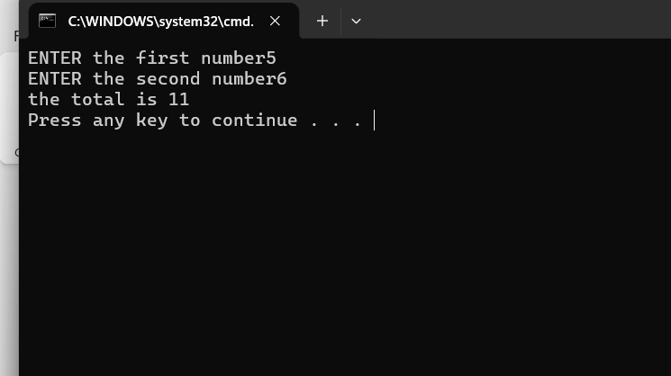
Figure 27: Description cpp
#include <iostream>int main() int firstNumber;
int secondNumber; std::cout << "ENTER the first number";
std::cin >> firstNumber;
std::cout << "ENTER the second number";
std::cin >> secondNumber; int total = firstNumber + secondNumber;
std::cout << "the total is " << total << std::endl; return 0;
}

Example 2:

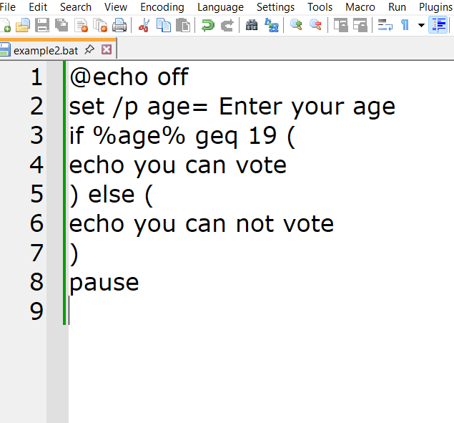
Figure 28: Description Batch script (.bat)
- Line 1 (@echo off): Hides the command text from showing up on the screen.
- Line 2 (set /p age=...): Prompts the user for input and saves it to the variable age.
- Line 3-7 (if / else): Compares the age against 19 using the "Greater than or Equal to" (geq) operator.
- Line 8 (pause): Stops the window from closing instantly so you can see the result.

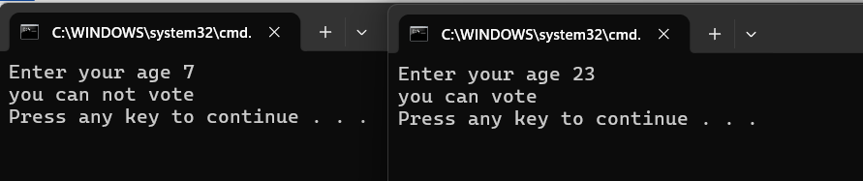
Figure 29: Description: complete C++ program that matches the program
C++ Source Code (cpp) #include <iostream>
using namespace std; int main() { int age;
// Prompt user for input

USE OF Linux OS scripts
Information sourced from [10]. Bash (Bourne Again Shell) is a powerful command-line interpreter, including a scripting language. The term “shell” refers to what users “see” within the computer operating system; the rest is hidden. When the system starts up, it will introduce the user to the input interface or equivalent that can be graphical or in text form plain text, string streams) Native to Linux &mac OS, Terse and compact (e.g., ps), Native Binary executables, and relies on utilities like awk, sed,jq.

Example 1:
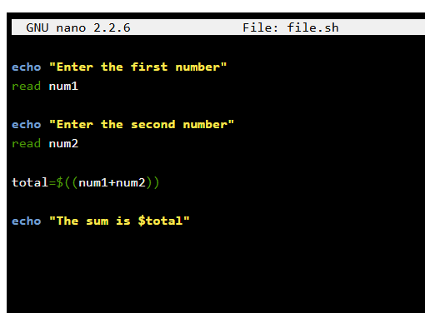
Figure 30: Description Bash shell

- echo "Enter the first number": Prints a prompt asking the user for the first number.
- read num1: Waits for user input and saves it into a variable named num1.
- echo "Enter the second number": Prints a prompt asking for the second number.
- read num2: Waits for user input and saves it into a variable named num2.
- total=$((num1+num2)): Performs arithmetic expansion to add num1 and num2, storing the result in total.
- echo "The sum is $total": Displays the final calculated sum to the user.

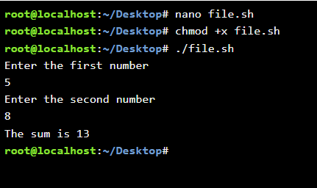
Figure 31: Description Bash shell
bash
#!/bin/bash

Example 2:

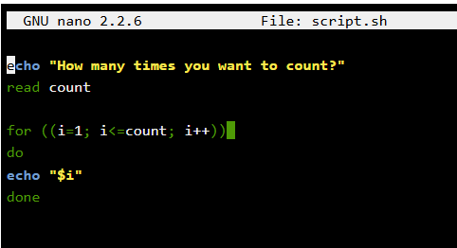
Figure 32: Bash shell script named script.sh .

bash
echo "How many times you want to count?"
read count

for ((i=1; i<=count; i++))
do
echo "$i"
done

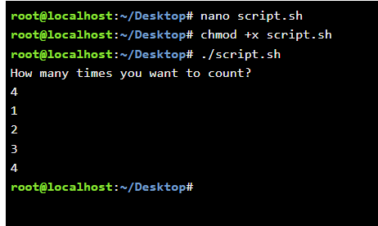
Figure 33: Description desktop
Here is the exact code required to replicate the behavior shown
bash
#!/bin/bash

# Ask the user for input
read -p "How many times you want to count? " count

# Loop from 1 to the user's input number
for ((i=1; i<=count; i++))
do
echo "$i"
done

Conclusion
what I have learned, an operating system provides a set of convenient, high-quality services with low-level hardware. Because most apps use operating systems, and programmers learn every day with technology advancing as we speak and need to understand the operating systems on a deeper level, making the operating system as a whole much easier to design, understand, and modify. In conclusion, Linux stands out as a powerful, secure, and versatile operating system that caters to a wide range of users—from casual home enthusiasts to enterprise-level professionals. Its open-source nature fosters innovation, collaboration, and transparency, allowing individuals to tailor the system to their specific needs. With strong community support, frequent updates, and robust security features, Linux offers a reliable alternative to proprietary systems. Whether for servers, development, or personal computing, it delivers stability and efficiency. Ultimately, adopting Linux is not just a technical choice but a step toward greater control, freedom, and participation in the open-source ecosystem.

REFERENCES [ 1 ]
DEVELOPMENT OF A MICROSOFT ACCESS-BASED ADMINISTRATIVE INFORMATION SYSTEM FOR GUIDANCE AND COUNSELING (E-BK) AT SMK NEGERI 2 … S Sabriani, A Saman, F Aryani available at al Konseling Pendidikan Islam jurnalalkhairat.org
Jurnal Konseling Pendidikan Islam, 2026
[ 2 ] (2004) George Robertson et,al ,Scalable fabric: Flexible task management. Available at: https://www.patrickbaudisch.com/publications/2004-Robertson-AVI04-ScalableFabric.pdf (Accessed: 21 July 2026).

[ 3 ] (2022) murtadhu,j,Assi,et,al Root cause analysis and improvement in Windows system based on Windows Performance Toolkit WPT | Iraqi Journal of Science. Available at: https://ijs.uobaghdad.edu.iq/index.php/eijs/article/view/5252 (Accessed: 21 July 2026).

[ 4 ] (2019) Jackie,E ,Turner ,Andrea,E,Galloway Naval Postgraduate School Monterey, California Applied Cyber Operations. Available at: https://apps.dtic.mil/sti/pdfs/AD1073689.pdf (Accessed: 21 July 2026).

[5] (2022) matthew,E,Hudson university ,united states Moving towards a modern desktop by migrating group policy to Intune policy - proquest. Available at: https://www.proquest.com/openview/fc795a97d4a20b8657b3e41b5ef911e9/1?cbl=1056382&pq-origsite=gscholar (Accessed: 21 July 2026).

[6]
Article title | Windows Internals - David A. Solomon, Mark E. Russinovich, Alex Ionescu - Google Books
URL | https://books.google.com/books/about/Windows_Internals.html?id=WZdCAwAAQBAJ
Date accessed | July 21, 2026

[7] (2014) Ian,milligan,james,baker The programming historian introduction to the Bash Command Line. Available at: https://pdfs.semanticscholar.org/5064/b658ec66078c860b6247152f7733d0fa7c09.pdf (Accessed: 21 July 2026).

[8] (2021) Linux with Operating System Concepts - 2nd Edition - Richard Fox - Rou. Available at: https://www.routledge.com/Linux-with-Operating-System-Concepts/Fox/p/book/9781032063454 (Accessed: 21 July 2026).

[9] (2011) Batch installer inoculation for Digital Repository Software Open Source DSpace by Bharat Chaudhari :: SSRN. Available at: https://papers.ssrn.com/sol3/papers.cfm?abstract_id=2237843 (Accessed: 21 July 2026).

[10] Introduction to linux (2022) remo suppi boldrito [PDF] uoc.edu [PDF] Introduction to Linux available at : openaccess.uoc.edu (universitat Oberta de Catalunya )

Appendices
Online Course name: Linux Unhatched
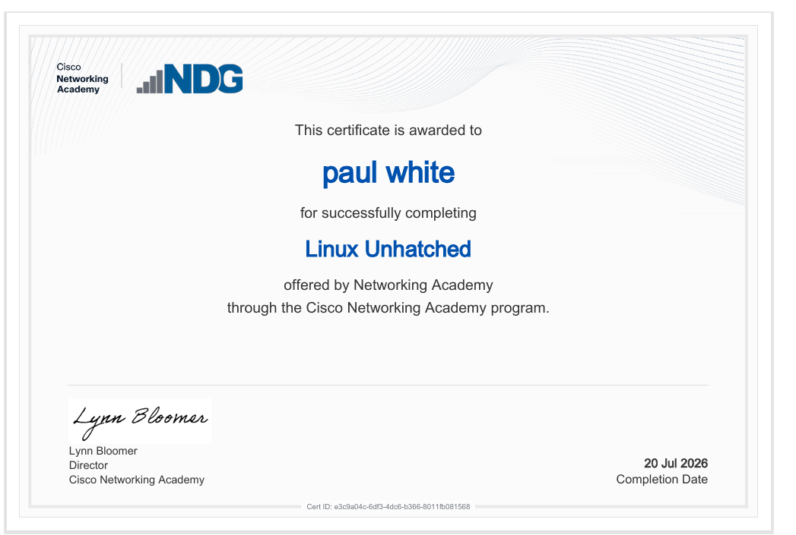
Figure 34: Certificate of completion

