Liam Jackson
(2022666)

The Decline of Marks and Spencer
Problem Solving and Decision Making

Table of Contents
Introduction 2
Report 3
nature 4
scope 4
impact 4
conclusion 5
Appendices 6
References list 7

Introduction

Within this report Liam Jackson will be looking at the fall and decline of Marks and Spencer’s in recent years. Taking a deep dive investigation into some of the reasons that the company has declined in sales and in the opinion of their customers over the past few years. Liam will look at a particular problem that Marks and Spencer’s face and look at the nature, scope, and scale of said problem, within this report the reader will find a swot analysis and PESTLE analysis on the Macro environment and a conclusion.

Please see Appendices for the swot analysis and PESTLE analysis this is where these will be available.

Report

Marks and spencer’s now a retail giant within the UK once had humble beginnings according to (www.theguardian.com, 2008) founded by Michael Marks a polish refuge and Thomas Spencer. They came together in Leeds in the year 1884 to make the retail heavy hitter store that customers know and love today. M and S clothing gained popularity in the 1970s due to the company sourcing a large portion of their retail items from Britain unlike the competition at the time who sourced their material international. This improved their popularity in the eyes of the British customer. This improved their reputation as they sold British quality goods. In 1998 they were the first British retailer to make over £1 billion in profit. In 2006 the brand saw massive growth not only did they have 600 UK store, but they had a combined 240 store in 34 different countries. But over the recent years M and S have struggled to keep up in today economic climate with declined sales and a decline in the opinion of their customers. Marks and spencer’s have faced a number of problems over the past few years According to (Schofield, C 2021) M and S have made a £201 million loss within the last few years of operation and are now closing 30 of their stores as a result of their financial struggle. one of the few problems that the retail giant face is it have been accused of not having a target demographic within the retail section of the company. according to (Russon, M 2020) Marks and tend to target an older demographic with the clothes they sell but use younger models and marketing strategies to show off their clothing products leaving the targeted demographic felling confused and left out. They have been accused of trying to appeal to everyone but in turn leave customers left out and end up appealing to no one. This tends to lead to the apparel of Marks and Spencer’s labelled as unfashionable and outdated. According to (Telling, O 2021) a drop in sales is due to be expected due to customers having less money to spend during lock downs but M and S have always struggled to stay competitive and on trend unlike some of their major competitors such as NEXT who adapted quicker to the online shopping market and customer habits. The retail section of the company is likely going to continue to shrink if they cannot meet the demands for good quality trendier clothing items that their customers demand. M and S have reported a 1.3 percent increase in food sales but a 31.5 percent drop in clothing and home sales from last year’s figures. As a result of the loss in revenue M and S are set to let go of 7000 of their staff members and close a further 30 stores according to (www.bbc.co.uk, 2020) due to a marital shift in trade. At the height of the pandemic M and S chief executive Steve Rowe was reported saying that customers may never shop the same way again. According to (Skeldon, P 2021) Although customers footfall has fallen within the store the brand is seeing a positive increase in online sales teaming up with online supermarket Ocado which brought into the company a net income worth £78.4 million. Steve Rowe the chief executive of M and S has said that the company needs to shift to their online incentive at a faster pace if they want to keep the company healthy. Although the change to online grocery shopping seems to be a step in the right direction for the company, they are still closing stores and making staff redundant due to their lack of brand awareness. the covid 19 pandemic only accelerated the problems that the company already faced and shined a light onto the actions they need to put in place to correct these issues.

nature
the nature of Marks and Spencer’s problems are that they do not have a strong brand identity. According to (Hoare, C 2021) customers feel confused to who marks and spencer’s are marketing to. Leaving customers less likely to make purchases instore. This plus the decline in sales due to the covid pandemic only accelerated the problems they faced. Not only are the clothes outdated at M and S but there has been a recent change in consumer habits brought on by the covid pandemic have massively change the retail industry. According to (Schofeild, C 2021) although the company has seen some positive changes due to the fact of teaming up with online supermarket Ocado which saw a 6.9 percent increase in online sales. According to (Chapman, B 2021) Despite the success of the brands online presence this could not make up for declining sales else where they are still struggling to keep store open on the high streets of the UK and are set to close a further 30 stores in the near future.

scope
Marks and spencer’s are set to close 30 stores and are leaving go around 7000 staff members. According to (Munbodh, E 2021) The company have 250 store that sell both clothing and grocery goods but are going to lower the number of stores to 180 despite the company doing well for itself within the online portion of the business the extra revenue and funds are not enough to save the high street estate and the workers’ jobs that operated within these stores. Most of the stores that remain open will be converted to food only stores. M and S had 254 full line stores at the end of the year. While practically all Clothing & Home departments in these stores contribute positive cash flow, these numbers have been in long term decline since then.

impact
This problem not only affects the staff members that work at these store but also the local economy for said town that the store may had been located in. not only will there be an increase in unemployment within the local area but also a sharp decrease of cash flow within the these local area, marks and spencer’s being the much beloved first choice retail store for many people the sudden decrease in store may lead to less consumers visiting the local high street in the absence of M and S. not only leaving the workers of these stores out of pocket put also the local economy around the local area. The back lash from these stores closing down will be felt throughout all of the high street and local area.

conclusion

in conclusion a major reason for marks and spencer’s decline is their total lack of brand awareness. they struggle to engage with their target audience leaving once loyal customers disheartened to visit their stores. they have also been accused of not keeping up with the times with the fashion they sell. They have been accused of being outdated and not trendy with the time. leaving customers with an even less of an incentive to visit local stores. this in turn leads to less customers that visit store which leaves the store with less money with a drop in sales. And this is reflected with the company decision to close a further 30 stores and let go of around 7000 members of staff which will not only affect the livelihoods of the staff that worked at these stores but also the area and local economy around the area of the store closure. The decrease in work in these local areas will lead to an increase of unemployment within these local areas and negatively affect the amount of cash flow within these areas. Although M and S were late to put and enthuses on online shopping markets, they seem to have taken a step in the right direction lately with the company decision to team up with online supermarket Ocardo and delivery services Deliveroo. Even though the company has taken major steps in the right direction with their decision to advance in online markets this does not escape the fact that the company needs a total brand overhaul and make over the target the right demographic that they are trying to get to visit and make purchases in their stores. Not only will customers and staff feel the negative effects of the closers of the stores, but M and S will see a decrease in retail market share within the high street retailers’ market, a market that is already decreasing due to the covid pandemic and a change in customer habits. This in turn will leave M and S a difficult task to regain market share that was lost.

Appendices
Swot analysis according to (www.marketline.com 2021)
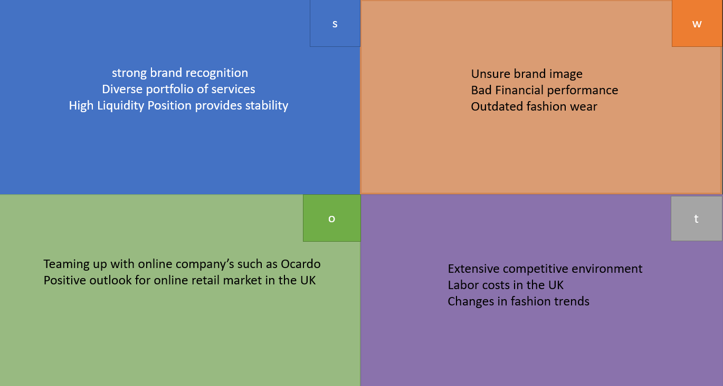
Marks and Spencer’s SWOT analysis

Marks and Spencer’s PESTAL analysis.

political | • UK tax laws.  • UK worker contract obligations.
economical | • Covid pandemic negative affect of the economy  • Less cash flow for customers to spend.
social | • Less customers due to social distance measures  - Less customers are likely going to visit local high streets.
Technological | - A shift to online sales due to customer habits changing, using sites like Orcardo and Deliveroo.  - Increased app use and sales due to more customers shopping online
legal | - Covid guidelines need to be followed by staff and customers within stores.  - Complying with consumer rights law within the UK
Environmental | - The use of bags for life to help deduce waste.  - Less clothing waste due to closure of retail stores.  - Use of recycled packaging in store.

References list

Chapman, B. (2021). Marks & Spencer to close 30 stores after slumping to £201m loss. Retrieved from https://www.independent.co.uk/news/business/marks-and-spencer-sales-results-loss-b1854047.html
Hoare, C. (2021). Marks and Spencer’s 'painfully apparent' cause of decline pinpointed by expert: 'Outdated'. Retrieved from https://www.express.co.uk/life-style/life/1445042/marks-and-spencer-ms-waitrose-channel-5-fashion-online-shopping-retail-spt
Munbodh, E. (2021). Marks & Spencer announces 30 store closures after £200million loss due to Covid. Retrieved from https://www.msn.com/en-gb/money/other/marks-26-spencer-announces-30-store-closures-after-c2-a3200million-loss-due-to-covid/ar-AAKo8X0?ocid=BingNewsSearch
Russon, M. (2020). M&S: Five reasons the retailer is struggling. Retrieved from https://www.bbc.co.uk/news/business-53478403
Schofeild, C. (2021). Marks and Spencer closing 30 more stores after suffering £201m loss amid pandemic. Retrieved from https://www.scotsman.com/read-this/marks-and-spencer-closing-30-more-stores-after-suffering-ps201m-loss-amid-pandemic-3250531
Skeldon, P. (2021). Online, Ocado and overseas selling now crucial for survival as M&S records a £201.2m pre-tax loss. Retrieved from https://internetretailing.net/industry/industry/online-ocado-and-overseas-selling-now-crucial-for-survival-as-ms-records-a-2012m-pre-tax-loss-23215
Telling, O. (2021). Unfashionable Marks and Spencer in need of a makeover. Retrieved from https://www.investorschronicle.co.uk/news/2021/05/26/unfashionable-marks-and-spencer-in-need-of-a-makeover/
www.bbc.co.uk. (2020). M&S to cut 7,000 jobs over next three months. Retrieved from https://www.bbc.co.uk/news/business-53817598
www.Marketline.com. (2021). Marks and Spencer Group plc. Retrieved from https://advantage-marketline-com.ezproxy.uwtsd.ac.uk/Company/Profile/marks_and_spencer_group_plc?swot
www.theguardian.com. (2008). The history of M&S: From a stall on Leeds market to Britain's biggest clothing retailer. Retrieved from https://www.theguardian.com/business/gallery/2008/jul/09/marksandspencer.history

