A Report based on types of surveying and the application of digital surveying technologies in surveying listed buildings.

Prepared For:
Jamiu Dadua

Prepared By:
Akeel Jack
2113721

Table of Contents: PG:

Introduction 3
Geodetic Surveying 4
Plane Surveying 5
Digital surveying technologies 6-9
References 10

Introduction

“Surveying is a means of making relatively large-scale, accurate measurements of the Earth’s surfaces. It includes the determination of the measurement data, the reduction and interpretation of the data to usable form, and, conversely, the establishment of relative position and size according to given measurement requirements”. Lyman, J. and Wright, John Wilfrid (2019, May 30). surveying. Encyclopedia Britannica.
Surveys are conducted for different reasons, which in turn affects the types of instruments used, the measurements taken, and subsequently the results produced from processing those measurements. Surveying is usually classified by their purpose, the method, the equipment, and primarily. Their purpose includes several types of surveys such as cadastral, city, construction, forestry, hydrographic, route, topographic, industrial, mine, and photogrammetric surveys. The method is based on three types, which are triangulation, traversing, and trilateration. The equipment is based on traditional instruments such as pacing and modern/digital instruments which would be used. Finally, primarily which are two types being Geodetic and Plane surveying.

Geodetic Surveying

Geodetic surveying takes into account the theorized shape of the Earth. The accuracy of geodetic surveys is often high, and it covers vast areas of land. Geodetic surveying according to Merriam-Webster. (n.d.). December 13, 2021, is “surveying in which account is taken of and corrections made for the curvature of the earth's surface.”
Geodetic surveying. (n.d.) Collins Dictionary of Astronomy. (2006). Defines geodetic surveying as the “theory and practice of determining the position of points on the earth's surface and the dimensions of areas so large that the curvature of the earth must be taken into account. It is distinguished from plane surveying.”
Geodetic surveys are carried out on areas larger than 250km2 or 300sq.mi. and is not generally the most commonly used surveying technique. In geodetic surveying, two points, called stations, are selected many miles apart and the latitude and longitude are calculated by astronomical methods. The baseline, which also connects these two points, is measured with great precision. The angle formed by the third station with either end of the baseline determines its location. Its fundamental goal is to establish a very precise and rigid control for the coordination of all other surveys, rather than just to discover the exact Figure of the Earth. The line joining at stations is considered to be spherical making the angles spherical as well. Instruments that are more precise and modern technologies such as Global Positioning Systems (GPS) are used. To be able to carry out geodetic surveying there must be knowledge of spherical trigonometry.

Plane Surveying

In-plane surveying the assumption that the area to be surveyed is typically smaller the 250km2 or 300 sq. mi. is a flat plane is always made. Plane surveying is also the most commonly used type of surveying.
Plane surveying is an “ordinary field and topographical surveying in which the curvature of the earth is disregarded”. Merriam-Webster. (n.d.). December 13, 2021. Plane surveying as defined by McGraw-Hill Dictionary of Architecture and Construction. Copyright © 2003 by McGraw-Hill Companies, Inc. is “A branch of the art of surveying in which the surface of the earth is considered a plane surface; curvature of the earth is neglected, and computations are made using the formulas of plane geometry and plane trigonometry.”
As the earth’s surface is considered a plane surface the curvature of the earth is neglected making it 2 dimensional or 2D. The lines joining two stations are considered to be a straight line and the triangle being formed by any three points is considered as a plane. Its objective is to prepare plans and collect topographical details. The survey accuracy of plane surveys is quite low. The instruments such as chain, measuring tape, and theodolite are used to carry out plane surveying, therefore knowledge of simple instruments and plane trigonometry is required.
In the image (2) below you can see how plane surveying would look like whilst being done. The three joining stations can be seen labeled B, D, and C. All lines joining stations are straight as the earth’s surface is considered to be flat. The triangles can be seen as well-formed by the lines of two stations joining. These triangles formed are planes.
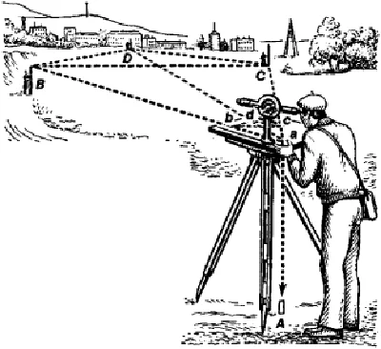
Image 2 taken from https://civiljungle.com/plane-surveying-and-geodetic-surveying/ retrieved 2022.

The improvement and reliability of information gathered from the surveying of buildings over the years have been helped by the advancement and evolution of surveying technologies since surveying became a profession. A vast range of equipment has been created to aid in modern surveying.
A listed building according to the Cambridge Advanced Learner's Dictionary & Thesaurus © Cambridge University Press as “a building of great historical or artistic value that has official protection to prevent it from being changed or destroyed. “Listed building surveys can be explained simply as the surveying of buildings with a great historical or architectural value that has a certain level of protection. The surveying of listed buildings is important as it highlights the present and existing condition of the building, the details between the plan and elevation of the building, aid in planning the retrofitting or renovation plan based on the information and allow for the fulfillment of building legislation. The tools used to do and conduct building surveys has seen improvement from pacing for linear measurements to measuring tapes and now digital technologies such as disto. In building surveying many factors must be taken into consideration when assessing existing buildings, therefore each tool in building surveying serves a different purpose. The most commonly used tools are:
Disto/ Laser Measuring:
This digital linear measurement tool is often used in building surveys. This tool provides quick and efficient measuring at the touch of a button. The disto utilizes modern laser technology by using laser beams in the measurement of distances reliably and precisely. It is a tool that saves time as it is quite easy to use for the time-consuming task of measuring distances, especially if working alone. The tool has built in features such as indirect height, area, volume, and add/subtract to aid the process of measurement. Modern innovations have allowed newer versions of the tool to calculate the area of rooms, volumes as well as angled slopes. Below in image 3 there is a picture of the disto/ Laser measuring instrument.
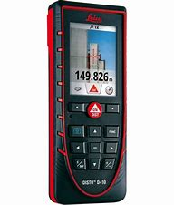 Image 3 taken from 0-leica-disto-d410-82-900x900-1.jpg (900×900) (cientecinstrumentos.cl) retrieved 2022.
The disto works after identifying the target you then point the disto laser at the target. The laser bounces off or is reflected from the target into the laser transmitting and receiving hole.
Below see image 4 which shows the disto laser measurement process of work.
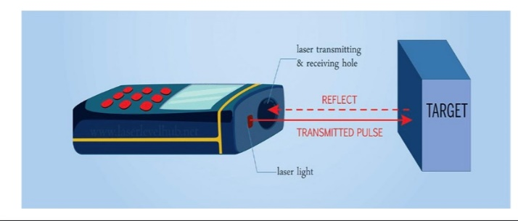
Image 4 taken from J.Dadua Lecture notes (2021)

Thermal Camera:
This tool is used to give a visible indication to the efficiency of the structure. It determines areas of energy loss from buildings. Thermal Imaging can map the distribution of energy from objects, by detecting the level of radiance emitted from an object. As there are numerous conditions that can signify regions of greater or lesser temperatures the information on the efficiency of the structure must be used sparingly. The imagery often only indicates that further investigation is required in the areas where irregularities are found. Thermal cameras convert infrared radiation into a two-dimensional (2D) picture, even the slightest of deviations of temperature produce a large change in the amount of radiation emitted from a material. Below in image 5 the thermal camera can be seen.

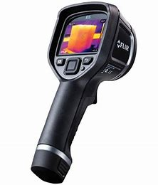
Image 5 of thermal camera taken from FLIR-E5-Rent-Hire-Thermal-Imaging-Camera_grande.jpg (514×600) (shopify.com) retrieved 2022.
Moisture Meter/ Protimeter:
This tool is used to measure the dampness of areas or the water ingress both humidity and moisture levels. The protimeter can measure both surface and sub-surface moisture of walls in the building being surveyed. The tool has two pins at the top to measure the surface moisture and deep wall probes to measure the sub-surface moisture of the wall. The readings for the wall whether using the pins or deep wall probes would be produced on the LED scale on the device.
The protimeter measures surface moisture by simply holding the instrument with the pins touching the walls surface and readings for the moisture level will appear on the LED scale. A low or no reading will occur if the pins are placed onto a painted or varnished walls.
When establishing the sub-surface moisture readings, the surveyors can utilize a set of deep wall probes which connect to the protimeter through the external auxiliary port. To use the Deep Wall probe, drill two clearance holes and connect the deep wall probes to the instrument and push the two probe rods into the clearance holes. Below in image 6 a photo of the protimeter can be seen.
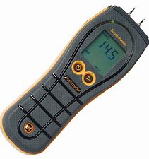
Image 6 of protimeter taken from PRTBLD5365.jpg (2000×2000) (itslondon.s3.amazonaws.com) retrieved 2022.
Telescopic inspection camera:
These are cameras with long poles, which are used for the purpose of inspecting roofs, gutters, chimneys etc. The tool is used mainly for areas that are normally inaccessible but need to be inspected whilst doing building surveys. Simply placing the telescopic inspection camera and taking pictures of the targeted area is the process of how this tool works. Below you can see in image 7 a photo of the telescopic inspection camera.
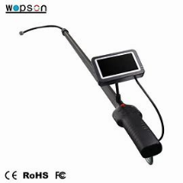 image 7 of the telescopic inspection tool taken from 3-6m-telescopic-pole-video-camera-for-the18370753713.jpg (640×640) (drainsewerpipecamera.com) retrieved 2022.

Optical distance measurement:
A tool used for the purpose of measurement. The tool uses a telescope and then calculations are solved using triangulation method to find out the distance. It is mainly used to produce building plan.
Digital Camera:
Used mainly for the recording of information in the building surveying process. Normally of high quality the camera is used to take pictures to highlight the most miniscule of details for the technical report by the surveyor conducting the building survey. Below in image 8 a photo of a digital camera can be seen.

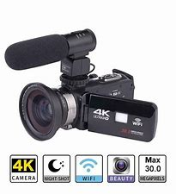
Image 8 of a digital camera taken from 4f38ce_f2000d5fba6347b693a856e0cc8a5c5c~mv2.jpg (1000×1000) (wixstatic.com) retrieved 2022.

References:

Merriam-Webster. (n.d.). Geodetic surveying. In Merriam-Webster.com dictionary. Retrieved December 13, 2021, from https://www.merriam-webster.com/dictionary/geodetic%20surveying
Merriam-Webster. (n.d.). Plane surveying. In Merriam-Webster.com dictionary. Retrieved December 13, 2021, from https://www.merriam-webster.com/dictionary/plane%20surveying
Geodetic surveying. (n.d.) The Columbia Electronic Encyclopedia®. (2013). Retrieved December 13 2021 from https://encyclopedia2.thefreedictionary.com/Geodetic+surveying
plane surveying. (n.d.) McGraw-Hill Dictionary of Scientific & Technical Terms, 6E. (2003). Retrieved December 13 2021 from https://encyclopedia2.thefreedictionary.com/plane+surveying
Britannica, T. Editors of Encyclopaedia (2003, February 5). surveying summary. Encyclopedia Britannica. https://www.britannica.com/summary/surveying
Lyman, J., and Wright, John Wilfrid (2019, May 30). surveying. Encyclopedia Britannica. https://www.britannica.com/technology/surveying
https://civiljungle.com/plane-surveying-and-geodetic-surveying/
https://www.icsm.gov.au/education/fundamentals-mapping/surveying-mapping/surveying-methods
https://dictionary.cambridge.org/dictionary/english/listed-building
0-leica-disto-d410-82-900x900-1.jpg (900×900) (cientecinstrumentos.cl)
FLIR-E5-Rent-Hire-Thermal-Imaging-Camera_grande.jpg (514×600) (shopify.com)
PRTBLD5365.jpg (2000×2000) (itslondon.s3.amazonaws.com)
3-6m-telescopic-pole-video-camera-for-the18370753713.jpg (640×640) (drainsewerpipecamera.com)
4f38ce_f2000d5fba6347b693a856e0cc8a5c5c~mv2.jpg (1000×1000) (wixstatic.com)

