
Module Assignment Submission
Student Name: | D.Harrison
Student Number: | 1604367
Module Code: | BMSK6006
Module Title: | Developing Emotional Intelligence and Skills for the Workplace

Statement of Confirmation of Authenticity
By the act of making this submission, the student declares that this is the work of the student named above. The work has not, in whole or in part, been knowingly presented elsewhere for assessment, or where assessment has been built on a previous assessment, this has been identified. Where materials have been used from other sources it has been properly acknowledged. If this statement is untrue, the student acknowledges that an assessment offence has been committed.
Attention is drawn to the plagiarism and unfair practice policies of the University.

Table of Contents
Introduction 2
1. Critically evaluate theories of emotional intelligence and their relevance to workforce development and business performance. 2
1.2 Emotional intelligence theories. 2
1.3 Goleman’s EI and relevance to workforce development. 3
1.4 Workforce development and organisational relationships. 4
1.5 Bar-On’s theory of EI. 5
1.6 Workforce development and Bar-On. 5
2. Critically evaluate theories of emotional intelligence and their relevance to business performance. 6
2.1 How emotional intelligence influences business performance. 6
2.2 Goleman and business performance. 7
2.3 Bar-On and business performance. 8
2. Use theories of emotional intelligence and mindfulness to review the effect of emotions on your own workplace performance. 9
References 12
Appendices 16
Bibliography 19

Introduction

This assignment will critically evaluate how emotional intelligence influences workforce development and business performance, looking at the impact emotional intelligence has on organisations, including the employees and managers. Drawing on the work of Goleman which supports the critical analysis of emotional intelligence, along with the work from Bar-On which delves into interpersonal and intrapersonal factors. For this assignment, the workforce and business performance focus will be the University of Wales Trinity Saint David. The assignment will further draw on theories of emotional intelligence with a specific focus on mindfulness and how this influences and has an effect on emotions.

Critically evaluate theories of emotional intelligence and their relevance to workforce development and business performance.

Emotional intelligence (EI) in its simplest form it is to understand one’s own emotions and allow this understanding to inform the way the emotions of others are perceived. It is about utilising this intelligence in the right way to build relationships, make decisions and affect situations. To expand, Mayer et al. (1999) defines EI as:
“The ability to recognize the meanings of emotion and their relationships, and to reason and problem-solve on the basis of them. Emotional intelligence is involved in the capacity to perceive emotions, assimilate emotion-related feelings, understand the information of those emotions, and manage them.”
(Mayer et al., 1999)

1.2 Emotional intelligence theories.

Salvoy and Mayer (1990) define EI as ‘the ability to monitor one’s own and other’s feelings and emotions’, this being the initial discovery of the theoretical evidence of EI. Exploring how EI is a method of understanding and perceiving emotions to help make decisions in a personal capacity, as well as the ability to read others and their emotions. Goleman (2009), although agreed with this concept, further delved into the understanding of EI and explored the fundamental psychology and knowledge of EI and how it is applied in a managerial environment, implying that if a manager has excellent EI, they will be a successful leader.
Exploring how EI contributes to managerial performance in the workplace, Goleman researched how a successful leader is an emotionally intelligent individual, he also outlined that EI outweighs IQ in this instance. Goleman’s (2009) theory introduced five key components that contribute to being emotionally intelligent (appendix 1) these being; self-awareness, self-management, motivation, empathy and social skills. These components will be explored below in the context of workforce development and business performance, using the University of Wales Trinity Saint David (UWTSD) to provide context.

1.3 Goleman’s EI and relevance to workforce development.

Workforce development is the focus on developing employees, giving them the tools and resources to upskill which in turn sets them up for long-term success. Harris and Short (2014) define workforce development as;
“Drawing on human resource and management, workforce planning and workforce capability development, and is often highlighted in debates on skills shortages where there is a need to increase the pool of skilled workers in industry.”
(Harris & Short 2014)
To expand, workforce development requires leaders to be competent in recognising skills shortages within their teams and in turn the training needs of their employees. This extends to ensuring that training solutions identified not only meet the needs of the individual but also the team and the wider organisation aligning with organisational strategic goals and objectives. Leadership effectiveness is driven by EI, according to Rosete and Ciarrochi (2005), which suggests that EI is important when highlighting the needs and skills gaps in employees. Having this awareness enables a manager to have the skills to identify gaps through communicating and observation of the team.
At the University of Wales Trinity Saint David (UWTSD), professional development in the context of workforce development is embedded into the culture of the organisation, to corroborate this, the marketing team recently undertook a digital marketing workshops to upskills and develop the team’s skills. As a higher education institute, UWTSD leads by example, by actively encouraging their employees to further study through the University itself or its leading partners. This proves to be an advantage to the nature of the organisation, which allow staff to further their studies, enrolling onto a University course, in which the University can then waiver the course fee. However there is more to developing individuals than merely in an academic sense (Joyce & Showers,1983). For an organisation to thrive it is essential that it develops employees to have the practical skills and understanding to undertake tasks relevant to their role and occasionally beyond their job description, in order to benefit the wider organisation and reach strategic goals. For this to happen successfully managers are required to effectively prioritise workforce development and actively identify opportunities to develop their staff and their teams.
Self-awareness, one of Goleman’s five pillars is a key underpinning element to EI and whilst this is relevant to all life situations its importance for managers within an organisation should not be overlooked. Corroborated by Tjan (2012) who argues that the best quality a leader can have is self-awareness, making them more aware of what motivates them as individuals which therefore makes them better placed to identify what motivates their team members. This extends to having the capacity to understand and control their own emotions, whilst being able to empathise and manage their relationships. Effectively developing staff is a key element of workforce development (Mathews, 1999), therefore a self-aware manager would be competent in identifying training and development for employees. A competent level of self-awareness becomes critical in understanding the strengths and weaknesses of the team as a whole as well as individuals within that team.
However, CIPD (2022) noted other factors should be considered when a manager is planning workforce development. The ability to handle stress and emotional state are to be considered, along with Goleman’s pillars. To expand, if an employee that becomes overwhelmed at work when dealing with multiple projects was encouraged to undertake a 12-month training programme, they might find this additional workload difficult and challenging. This would arguably create unnecessary stress, rendering the process and purpose of personal development counterintuitive to overall workforce development. A manager without the experience or knowledge of how to identify professional development routes along with workforce development planning, would be an inefficient manager (El-Sabaa, 2001), causing detrimental damage to organisational performance. For example, prior to the marketing team undergoing restructuring, the previous manager did not engage in staff development, resulting in the team unable to upskill and stay relevant in the digital marketing industry. Empirical evidence suggests that many organisations get staff development wrong, making staff training more problematic rather than productive (Woolsey, 2022).
There are many reasons such issues may arise in an organisation, one such contributory factor could be a manager who exhibits high levels of competency across some of Goleman’s pillars but not all. In other words, what makes an emotionally intelligent individual? Is an individual with adequate social skills, good self-management, self-awareness and empathy, but who lacks motivation and confidence considered an emotionally intelligent individual? Arguably not, however, they would be a more effective leader than someone who exhibits none of those traits. This is supported by empirical evidence which shows that a blend of balanced strengths across the EI competencies is what constitutes an emotionally intelligent individual (Goleman & Boyatzis, 2017).
To conclude, an emotionally intelligent manager has the ability to identify strengths and weaknesses in the team and considers this when planning workforce development. Whilst self-awareness plays a crucial role in being empathetic and understanding in order to recognise the key factors that motivate their employees, it is also required that a manager needs adequate experience in understanding training methods that are relevant and realistic for their employees to undertake, to reap the benefits of personal development and staff development.

1.4 Workforce development and organisational relationships.

To further explore Goleman’s pillars, empathy and social skills are other factors in being emotionally intelligent and apply when communicating with colleagues and stakeholders in an organisation. Empathy allows a leader to have control over how they react and relate to others. As established, EI equips a person with the skills to manage their own and others’ emotions, which in turn builds trust and creates a safe environment for employees. According to Downey et al. (2011) trustworthiness of a leader was correlated to their team’s EI, their job satisfaction and organisational commitment. This is directly correlated with the trust between the team and manager, therefore a healthy workplace relationship between the employee and manager promotes a positive working environment, allowing workforce development to thrive.
Goleman (2009) suggests that social skills allow us to communicate, influence and collaborate with others, which allows relationships to develop. ‘Trust between individuals and groups within an organization is a highly important element in the long-term stability of the organization and the well-being of its members’ (Cook & Wall, 1980). Trust in the workplace improves efficiency and reinforces a positive working environment, it also motivates and encourages employees to progress and develop their skills to further their career prospects. This increased trust also creates an environment where employees respond more positively to demanding deadlines set by managers. Without a supportive and trusting relationship built between the manager and their team, this can detrimentally impact productivity, morale and ultimately profit and revenue. For example, the marketing team have a target of 15 working days to deliver on a service-level agreement, in order to meet the requirements of the organisation. In addition, the time-based nature provides the manager with a mechanism to measure performance and give feedback. When this was implemented there could have been some negativity from colleagues given that this is an additional task placed on an already pressured team. Clear communication and effective relationships built over time between the managers and the team proved key and has created an environment of mutual respect.
With adequate social skills and self-motivation, two components of Goleman’s theory, it allows a leader to create an open and productive environment. In addition, a leader who embraces their emotion also creates a trusting environment between them and their team. This trust can be used to encourage employees to develop their skills and knowledge, creating more engaged employees. According to Rutledge (2009) an engaged employee is more loyal and one that is more likely to recommend the organisation as a good employer, improving the organisation’s brand and reputation.

1.5 Bar-On’s theory of EI.

Following on from Goleman’s ground-breaking research and development on EI, Bar-on (2003) further explores the behavioural aspect of EI, focussing on the connection between emotional social intelligence, social competencies and the skills to express ourselves and others. The theory comprises of five emotional and social competencies (appendix 2). To define EI from Bar-On’s perspective;
“To be emotionally and socially intelligent is to effectively understand and express oneself, to understand and relate well with others, and to successfully cope with daily demands, challenges and pressures.”
(Bar-on, 2003)

1.6 Workforce development and Bar-On.

The context of any organisation is the environment and habitat of that business, workforce development plays a crucial role in creating a positive and innovative working environment. Drucker (1992) indicates that it is key for an organisation to resonate with its employees and show its willingness to be a supportive institution. To expand, a key driver of the Bar-On (2003) theory focuses on the intrapersonal and interpersonal factors which allow a manager to draw on their employees’ strengths and weaknesses, whilst recognising their own self-expression and relationship with others.
Similarly to Goleman’s self-awareness principles, Bar-On (2003) takes it further by drawing on the different concepts of emotional awareness and intelligence. Understanding one’s own intrapersonal and interpersonal abilities are the foundation of building healthy relationships (Paolini, 2020). Intrapersonal is being aware of oneself and interpersonal relates to being aware of others’ feelings. Having a good working relationship between colleagues and their manager is vital in developing an organisation, as explored by Drucker in the context of workplace culture.
At UWTSD, an annual appraisal is the primary method utilised to review colleagues’ performance but the process also provides an opportunity for open and clear communication between the manager and the employee. In practice this works well within the marketing team at UWTSD, with the appraisal process serving as one method of building trust and creating a holistic working environment. This has proven successful through buy-in from the team in relation to new projects and a renewed sense of motivation with regards to job roles following a department restructure. A key element of this has been utilising emotional intelligence to manage emotions and promote a collaborative working environment.
As has already been explored, whilst it is advantageous for managers to be emotionally intelligent the same also applies to employees. Bar-On’s theory explored how general mood has a direct correlation to EI, which applies to all aspects of the organisation, regardless of hierarchy. For example, an employee with a positive attitude to work, would enhance job satisfaction for the individual, which directly relates to productivity. However, if the general mood of an individual in a team is negative, this would affect the individual’s attitude at work which would promote a less favourable behaviour in the workplace and also impact others in the team. A negative workplace environment is undoubtedly detrimental to workforce development.
An emotionally intelligent individual would be able to recognise this behaviour and poor attitude at work but also have the ability to understand why this particular individual’s behaviour is this way. Intrapersonal and interpersonal skills clearly play a role with regards to problem solving in this capacity, by being ‘emotionally and socially intelligent means to effectively manage personal, social and environmental change by realistically and flexibly coping with the immediate situation, solving problems and making decisions’ (Bar-On, 2003).
Empirical evidence highlights a further problematic phenomenon for organisations recently coined as ‘quiet quitting’ (Salem, 2022). This term relates to employees that feel a sense of detachment from their work and occurs when the employee’s focus shifts towards their well-being and work-life balance rather than going above and beyond in their role. An emotionally intelligent manager that is able to recognise these traits will be better placed to identify suitable measures to support the individual and guide them towards a path that reinforces personal development in strengthening the individual’s skills to progress their career.

Critically evaluate theories of emotional intelligence and their relevance to business performance.

As outlined, EI plays a key role in workforce development, however, there are factors that business performance is influenced by which correlates to the level of EI an individual has. Business performance is defined as an organisation’s ability to manage and achieve its key performance indicator’s (KPI’s) which align with the overarching goals of the organisation. With this in mind, according to Smith and Reece (1999) Business performance is directly affected by business strategy, external fit, and productivity; and indirectly affected by business strategy and external fit through productivity.

2.1 How emotional intelligence influences business performance.

Business performance can be measured by several factors, such as productivity, employment growth and profit. At UWTSD student recruitment is the main income driver and the main business performance metric for the marketing team. However, there are objectives set to achieve KPI’s that align with the marketing and wider university strategy. For a team to be effective, the leader must ensure that their team understands their role in driving success. This is directly correlated to the levels of motivation within the team and individual attitudes with regards to success as well shared responsibility Barna (2013).
To expand, Goleman describes motivation as being one of the key factors in EI competencies. In the case of the marketing team, it is crucial for team members to feel motivated to achieve within their individual roles as this directly affects the performance of the team as a whole.
Motivation can be dependent on either intrinsic or extrinsic motives as highlighted by Maslow (1974) who outlines the basic needs that motivate people. For example, the marketing team have open-day bookings and student application targets, if those targets are not met, employees are neither rewarded or punished through salary incentives. Employees at UWTSD, as would be the case with the majority of public sector organisations are driven by different demands that aren’t extrinsic motivational incentives. Leaders at UWTSD therefore, are faced with the challenge of creating a healthy working environment where business targets are met with achieving a balance of flexibility to avoid overworking employees. EI plays a role in understanding how their team is motivated and what drivers allow the team to thrive.

Goleman and business performance.

Having explored the importance of self-awareness, there is an opportunity to expand and look at how this can affect business performance. Arguably good self-awareness allows an individual to recognise their thoughts, feeling and emotions. For example, someone with low self-esteem will find it difficult to process their own emotions, in turn making it difficult to moderate their behaviour and attitude towards others.
This would be particularly challenging for a manager, arguably hindering their ability to effectively manage to get the best out of their team and ultimately affecting business performance. On the other hand a manager with good self-awareness and self-regulation (Goleman, 2009) will be able to understand and read the room when it comes to their own emotion and thought process, allowing them to recognise behaviours, making them aware of those around them.
Goleman’s principals, most notably self-awareness and empathy play a crucial role in conflict management (Thomas, 1992), with a manager effectively gauging the emotional environment and identifying a clear pathway to resolution. Conflict, usually viewed as negative Verma (1998) and therefore often avoided can actually lead to suppression within a team. It is argued that conflict is healthy and allows a team to bond and thrive, especially if managed by an effective leader. Actively listening and responding with a calm demeanour will help with conflict, as Goleman (2001) argued all pillars (appendix 3) relate to conflict management.
Research shows Jordan (2002) that employees in a workplace with high EI were more likely to look for a collaborative approach to resolve conflict. Therefore a team consisting of individuals with below-average levels of EI, would need further support and a different approach when confronted with conflict. Empirical evidence highlights (Pandey et al., 2015) that EI in relation to dealing with conflict is developed over time with experience, within industry, claiming 10+ years is optimum.
However, if an employee is new to a managerial role, they may have little experience of conflict in a work setting. Conflict arises from differences, Hill (2003) argues that being politically aware is key in managing conflict. ‘Political conflict is at the heart of how organisations function’, Hill (2003). Arguments that ultimately lead to what is best for the organisation are surrounded by ambiguous and complex issues, that raise political conflict. Having shared values helps to reduce the risk of conflict arising. This indicates that a team which share the same values and beliefs would be a more effective and efficient team as there is more likely less conflict and arguments to be had.
To conclude, Goleman explains the importance of how empathy and social skills lead to being EI which contributes to workplace development. However, being politically aware, is another factor that may need to be considered.

Bar-On and business performance.

As mentioned, the main KPI for UWTSD as a higher education provider is student recruitment. Although the institution has targets to hit to keep the University above the profit margin, UWTSD has a relaxed approach towards its goals and targets. To expand, UWTSD could be functioning at a higher calibre and perform better at meeting the organisational needs. Bradberry and Greaves (2009) show that 58% of a leader’s performance is linked to EI and 90% of high achievers have a high level of EI, however only 20% of low achievers have high EI. This shows that EI is directly related to job performance on any level at in any industry.
For example, an extensive portfolio review has been conducted within the marketing team, highlighting the University’s product and which courses drive revenue and which programmes aren’t performing. Engagement and communication with internal stakeholders (mainly academics) is at the forefront of the marketing team’s mission, especially when delivering data insights that affect the programme portfolio of UWTSD moving forward.
EI plays a key role in the communication with stakeholders, ensuring that the message is delivered in a respectful yet confident way (Kelly & Kaminskienė, 2016). Academics involved in these conversations will be running programmes that could potentially be underperforming, making the data received difficult to communicate in some instances. Bar-On (2003) emphasises intrapersonal and interpersonal factors, which are absolutely critical in these instances, ensuring that communication is clear in these difficult situations.
A further business performance metric for UWTSD is staff recruitment. A common indicator of success in terms of staff recruitment are job applications. Arguably if EI is such an important trait for employees then it would be prudent that UWTSD develops a recruitment system which allows for the identification of these competencies. As noted, the benefits to an organisation of employing more emotionally intelligent employees are undeniable in terms of business performance. This relates to both management roles and other roles.
To conclude the advantages EI bring to the workplace are evident and how this contributes to business performance. Being emotionally aware allows effective collaboration, communication and motivation, ultimately leading to efficiency in terms of business performance.

Use theories of emotional intelligence and mindfulness to review the effect of emotions on your own workplace performance.

Mindfulness is the ability to be fully present and aware within the moment, to expand;
“Mindfulness is a way of relating to all experience that can reduce suffering and set the stage for positive personal transformation. It is a core psychological process that can alter how we respond to the unavoidable difficulties in life—not only to everyday existential challenges, but also to severe psychological problems such as suicidal ideation, chronic depression and psychotic delusions.”
(Siegel et al., 2009)
Mindfulness is a state of mind, it enables the individual to be completely present in the moment, giving them mental clarity, self-control and a sense of being at peace mentally and physically. Kabat-Zinn (2015) argues that mindfulness is about being aware and paying attention to what is happening in the current moment. Mindfulness is a practice that everyone has the ability to do, it’s a skill that can be taught and developed. Schaufenbuel (2014) explores how mindfulness can be applied to the workforce, by encouraging mental awareness to help reduce stress, among other benefits, which give employees a healthier work mentality, that will in turn improve their work-life balance (Wood, 2022).
Kabat-Zinn (2003) developed the mindfulness based stress reduction (MBSR) method which is a coping mechanism using mindfulness to help people reduce stress (appendix 4). Stress is the leading cause of many health issues, for example; musculoskeletal, respiratory and cardiovascular (APA, 2023). Given that on average people spend 50% of their total waking hours on a working day, at work (Statista, 2023) and stress is the leading cause of sickness and mental health issues reducing stress and developing a healthy workplace environment is crucial to developing a sustainable organisation. Kirk (2022) indicates that half of workers in the UK say they are stressed at work and a further 39% are stressed when thinking about work outside of their working hours. This is therefore a factor that must be taken seriously by employers. Applying mindfulness practice in a working environment, could become a solution to ease stress and anxiety within the workplace, given that mindfulness is proven to reduce stress mentally and physically (Chapman-Clarke, 2017).
As established EI, allows us to be in tune with our thoughts and feelings, whilst also being self-aware and showing empathy towards ourselves and others, there is therefore a strong correlation between EI and mindfulness. To expand, a crucial element of EI is Goleman’s work highlighting self-awareness, motivation and social skills, these are all arguably intrinsic to practicing mindfulness. For example, being more self-aware allows for a better understanding of one’s own emotions, which in turn makes it easier for someone to practice mindfulness as they are able to manage their emotions better to become more present and in tune with themselves. Practicing regular mindfulness allows one to be more present in their current thoughts and feelings, a study revealed that practicing meditation allows one to practice a calm state of mind Batchelor (2011).
When someone is in a better state of mind it allows them to make better decisions, problem solve and the ability to be more rational. Siegel et al. (2009) quick and irrational decisions are made when an individual operates on autopilot, taking time to be present and mindful will help one make decisions based on their true values (Siegel et al., 2009). Developing this mental capacity, allows room for empathy, as well as the ability to have those difficult conversations with individuals. Having the time and mental capacity to understand someone else’s perspective if their opinion differs, to understand their point of view, not jumping to conclusions and instantly becoming angry or deflective.
In turn, promoting mindfulness as well as practicing it would result in a positive and healthy working environment, decisions would be made in a better state of mind whilst also considering others opinions without deflecting or jumping to conclusions. Applying the key pillars of EI to mindfulness allows employees to be fully present in the workplace, encouraging creative thinking, open-mindedness, and the ability to apply oneself. Furthermore, Kaoun (2019) states that the practice of mindfulness enables an individual to tap into a higher emotional state of mind, which enhances one’s emotional intelligence. Therefore both EI and mindfulness compliment one and other, which means both need to practiced simultaneously to establish success.
As a marketing officer, having a healthy work-life balance is a factor I value and consider very important with mindfulness playing a big role in achieving it. At UWTSD, employee wellbeing is something that is prioritised (UWTSD, 2022) and a factor that the University is focusing on embedding throughout the organisation. One such example includes the flexibility offered with regards to working patterns, this extends to family-friendly policies, including part-time, full-time and term-time only working arrangements. Although these factors are welcomed by employees, (Austin-Egole et al., 2020), arguably the organisation could do more in terms of its offer. For example, an increased focus on team-building opportunities would prove invaluable to both the employees and the organisation itself. Team building days would serve as an opportune time for employees to identify opportunities to enhance their wellbeing and practice mindfulness within a workplace environment but away from the traditional surroundings of the office.
Furthermore, although the marketing team at UWTSD adopt a flexible working style, this could be extended to further reap the benefits for both the organisation and the employees, through the adoption of a four-day working week. From personal experience, there is little consideration given to overtime which occurs in addition to the traditional 9-5pm during particularly busy periods, adding pressure and stress on to already hard-working individuals. These individuals do their utmost for the organisation and are trying to balance their working life with their personal commitments, therefore adopting the four-day working week at UWTSD would increase the likelihood of achieving a healthy work-life balance (Chainey, 2019).
To expand, there are numerous advantages to adopting a four-day working week which clearly correlate with employee wellbeing. Empirical evidence highlights Iceland’s journey to adopting this working cycle across the country (Murphy, 2020), with the trial producing strong evidence. Main findings deduced showed increased productivity, enhanced employee wellbeing and mental health and an increase to overall happiness and job satisfaction. Placing this in the context of employee wellbeing, this corroborates with evidence indicating how increased mindfulness and wellbeing help reduce work-related stress and anxiety, resulting in a strong case to the possible benefits resulting from the adoption of a four day working week. In a Welsh context this is further substantiated by a recent report commissioned by the Future Generations Commissioner for Wales (A Future Fit for Wales, 2022) which highlighted the benefits of adopting this new way of working. The report outlines the feasibility and roadmap. Advantages included; increased jobs in Wales, reduced pressure on NHS staff, enhanced wellbeing and addressing ongoing mental health strains in the public sector.
To conclude, the four-day working week can clearly lead to benefits and adopting it at UWTSD would likely improve employee wellbeing, job satisfaction and motivation. However, it is clear that there are other factors to consider in the context of workplace mindfulness, to expand, consideration should be given to improving the factors that contribute to wellbeing and mindfulness during working hours. For example, increasing the time employees spend outside of work, provides them with time spent socially, such as with family, friends and hobbies, but does not address the stress and anxiety which results from increased pressure and demands within the workplace.
A study by CIPD (2018) concluded that ‘poor mental health was the most common cause of long-term sickness absence in the UK’. They further highlighted that only ‘49% of employees felt their employer supports their mental health’ (CIPD, 2018), this identifies that further work is needed on tackling mental health at work. Mindfulness practice as discussed poses benefits to employees especially by incorporating techniques such as meditation. For example, employees at apple (Apple, 2023) spend 30 minutes a day, during their core working hours, meditating. The purpose of this is to promote mental capacity for their employees to embrace innovation and creative, along with reducing stress. A technique that has further been adopted by global brands such as Google, Nike and Yahoo! (Duffy, 2022). Therefore, as demonstrated, meditation is a key element to achieving increased mindfulness at work, however, it should be noted that 30 minutes is not a practical solution for many organisations, especially if working in industries that are unpredictable and demanding, such as working the front-line in the NHS or a paramedic.
Further research highlights that a possible barrier to achieving increased mindfulness at work is a reluctance by employees to share or highlight their personal mental health and anxiety worries at work. Evidence suggests that ‘43% of employees would not feel comfortable in disclosing unmanageable stress or poor mental health to their employer’ (CIPD, 2016). For instance, if an employee knows they are stressed, but is reluctant to confide in their manager due to the risk of how they may be perceived, this could lead to further issues. Arguably this is how EI can become a factor in tackling this stigma and using it to its advantage, in turn complementing mindfulness at work. If managers shy away from raising this issue of mental health and stress at work, then this can lead to issues worsening and resulting in individuals trying to deal with the issue themselves. This will undoubtedly lead to increased stress and pressure and may result in that individual becoming unwell and therefore taking time away from work.
From personal experience, developing EI pillars, such as self-awareness and self-motivation allow the identification of certain triggers when workloads becomes overwhelming, or if a certain individual is behaving in a way that creates a negative working environment. Having a trusting relationship with management reinforces safety when confiding in them but also an element of professionalism, which reinstates confidence and solidarity to the employee. The workplace is changing and organisations, and the leaders and managers within them are adopting a people-based style of leadership, encouraging openness (Goleman et al., 2002). With this in mind, it provides a safe space for employees to talk about their mental health openly and not worry about discrimination that may harm their career progression. From personal experience, UWTSD offer support if work becomes stressful, they offer a counselling service as well as support if needed through HR and the occupational health service.
To conclude, mindfulness is a topic with evident research to suggest that practices such as meditation can help aid well-being and mental health, promoting mindfulness. However, without key EI pillars in place, mindfulness becomes a difficult element to unpick and understand. Key factors such as self-awareness allow us to identify triggers that unbalance our mindfulness. Empathy, another EI pillar allows us to empathise and recognise when others may be stressed or anxious. Both EI and mindfulness are inter-dependent and beneficial within and outside the workplace. It is clear that performance is affected by many factors and many of these factors can be positively influenced by EI and improved mindfulness. It would be prudent, therefore, for organisations to take an active approach to promoting increased mindfulness in the workplace and ensure that their managers and leaders utilise emotional intelligence in the right way to the benefit of themselves and their teams. This could lead to improved employee mental health, emotional intelligence, work and life satisfaction and therefore performance.

References

A Future Fit for Wales: The roadmap to a shorter working week – The Future Generations Commissioner for Wales. (2022). https://www.futuregenerations.wales/resources_posts/a-future-fit-for-wales-the-roadmap-to-a-shorter-working-week/
Absence Measurement & Management | Factsheets | CIPD. (2018). CIPD. https://www.cipd.co.uk/knowledge/fundamentals/relations/absence/factsheet
Apple Store Online. (2023). Apple (UK). https://www.apple.com/uk/store?afid=p238%7Cs4Xr4OfDd-dc_mtid_187079nc38483_pcrid_651483376972_pgrid_15144742573_pntwk_g_pchan__pexid__&cid=aos-uk-kwgo-brand--slid--bran-product-
Austin-Egole, I. S., Iheriohanma, E. B., & Nwokorie, C. (2020). Flexible working arrangements and organizational performance: An overview. IOSR Journal of Humanities and Social Science (IOSR-JHSS), 25(5), 50-59.
Barna, G. (2013). The power of team leadership: Achieving success through shared responsibility. WaterBrook.
Bar-On, R. (2003). BarOn Emotional Quotient-Inventory (BarOn EQ-i®). El Consortium, 1(8).
Bradberry, T., & Greaves, J. (2009). Emotional Intelligence 2.0. TalentSmart.
Chainey, R. (2019, January). It’s time to switch to a four-day working week, say these two Davos experts. World Economic Forum.
Chapman-Clarke, M. (2017). Why mindfulness at work matters–the ‘reboot’for emotional intelligence development. Development and Learning in Organizations: An International Journal, 31(2), 1-4.
Cook, J., & Wall, T. (1980). New work attitude measures of trust, organizational commitment and personal need non‐fulfilment. Journal of occupational psychology, 53(1), 39-52.
Downey, L. A., Roberts, J., & Stough, C. (2011). Workplace culture emotional intelligence and trust in the prediction of workplace outcomes. International Journal of Business Science & Applied Management (IJBSAM), 6(1), 30-40.
Drucker, P. F. (1992). Organizations. Harvard business review, 20(7), 281-293.
Duffy, J. (2022, March 31). 10 Big Companies That Promote Employee Meditation. More Than Accountants. https://www.morethanaccountants.co.uk/10-big-companies-promote-employee-meditation/
El-Sabaa, S. (2001). The skills and career path of an effective project manager. International journal of project management, 19(1), 1-7.
Goleman, D. (2001). An EI-based theory of performance. The emotionally intelligent workplace: How to select for, measure, and improve emotional intelligence in individuals, groups, and organizations, 1(1), 27-44.
Goleman, D., Boyatzis, R. E., & McKee, A. (2002). The new leaders: Transforming the art of leadership into the science of results.
Goleman, D., & Boyatzis, R. (2017). Emotional intelligence has 12 elements. Which do you need to work on. Harvard Business Review, 84(2), 1-5.
Goleman. (2009). Working with emotional intelligence. Bloomsbury Publishing.
Harris, R., & Short, T. (2014). Exploring the notion of workforce development (pp. 1-16). Springer Singapore.
Hill, L. A. (2003). Becoming a manager: How new managers master the challenges of leadership. Harvard Business Press.
Jordan, P. J., & Troth, A. C. (2002). Emotional intelligence and conflict resolution: Implications for human resource development. Advances in developing human resources, 4(1), 62-79.
Joyce, B. R., & Showers, B. (1983). Power in staff development through research on training. Publications, Association for Supervision and Curriculum Development, 225 North Washington Street, Alexandria, VA 22314 (ASCD Stock No. 611-83304; $7.50)..
Kabat-Zinn, J. (2003). Mindfulness-based stress reduction (MBSR). Constructivism in the Human Sciences, 8(2), 73.
Kabat-Zinn, J. (2015). Mindfulness. Mindfulness, 6(6), 1481-1483.
Kelly, E. J., & Kaminskienė, N. (2016). Importance of emotional intelligence in negotiation and mediation. International Comparative Jurisprudence, 2(1), 55-60.
Kirk, I. (2022, July 18). Half of British workers say they feel stressed at work. YouGov. https://yougov.co.uk/topics/society/articles-reports/2022/07/18/half-british-workers-say-they-feel-stressed-work
Maslow, A. (1974). A theory of human motivation. Lulu. com.
Matthews, P. (1999). Workplace learning: Developing an holistic model. The learning organization, 6(1), 18-29.
Mayer, J. D., Caruso, D. R., & Salovey, P. (1999). Emotional intelligence meets traditional standards for an intelligence. Intelligence, 27(4), 267-298.
Mental Health at Work. (2018). mind.co.uk. https://www.mind.org.uk/media-a/4660/mental-health-at-work-1_tcm18-10567.pdf
Murphy, R. (2022). The Icelandic “4 day work week” study and other, recent international trials. EMPLOYMENT LAW BULLETIN, 27(1), 2-6.
Pandey, S., Sajjanapu, S., & Sangwan, G. (2015). Study on effect of emotional intelligence on conflict resolution style. Indian Journal of Science and Technology, 8(6), 71-81.
Paolini, A. C. (2020). Social Emotional Learning: Key to Career Readiness. Anatolian Journal of Education, 5(1), 125-134.
Rosete, D., & Ciarrochi, J. (2005). Emotional intelligence and its relationship to workplace performance outcomes of leadership effectiveness. Leadership & Organization Development Journal, 26(5), 388-399.
Rutledge, T. (2009). Getting engaged: The new workplace loyalty. Mattanie Press.
Salem, N. (2022). Quiet quitting. Dental Nursing, 18(10), 480-481.
Salovey, P., & Mayer, J. D. (1990). Emotional intelligence. Imagination, cognition and personality, 9(3), 185-211.
Schaufenbuel, K. (2014). Bringing mindfulness to the workplace. UNC Kenan-Flagier Business School, 1, 13.
Siegel, R. D., Germer, C. K., & Olendzki, A. (2009). Mindfulness: What is it? Where did it come from?. Clinical handbook of mindfulness, 17-35.
Smith, T. M., & Reece, J. S. (1999). The relationship of strategy, fit, productivity, and business performance in a services setting. Journal of Operations Management, 17(2), 145-161.
Statista. (2023, March 14). Average weekly hours of work for full-time workers in the UK 1992-2023. https://www.statista.com/statistics/280763/average-working-hours-uk/#:~:text=As%20of%20January%202023%2C%20the,the%20same%20period%20of%202020.
Stress effects on the body. (2023, March 8). https://www.apa.org. https://www.apa.org/topics/stress/body
Thomas, K. W. (1992). Conflict and conflict management: Reflections and update. Journal of organizational behavior, 265-274.
Tjan, A. K. (2012). How leaders become self-aware. Harvard Business Review.
UWTSD, W. D. T.-. (2022). Mission and Vision | UWTSD. https://www.uwtsd.ac.uk/mission/
Verma, V. K. (1998). Conflict management. The project management institute: Project management handbook, 353-364.
Wood, S. W. (2018). Work–life balance supports can improve employee well-being. CIPD. Retrieved March 23, 19 C.E., from https://www.cipd.co.uk/Images/work-life-balance-supports_tcm18-57294.pdf
Woolsey, B. (2022, February 25). The German 'Quereinsteiger' ending career-changing stigma. https://www.bbc.com/worklife/article/20201222-the-german-quereinsteiger-ending-career-changing-stigma
Workforce Planning | Factsheets | CIPD. (2022). CIPD. https://www.cipd.co.uk/knowledge/strategy/organisational-development/workforce-planning-factsheet#gref
Workforce planning practice | CIPD | Guidance. (2022, February). CIPD. https://www.cipd.co.uk/knowledge/strategy/organisational-development/workforce-planning-practice

Appendices

Appendix 1

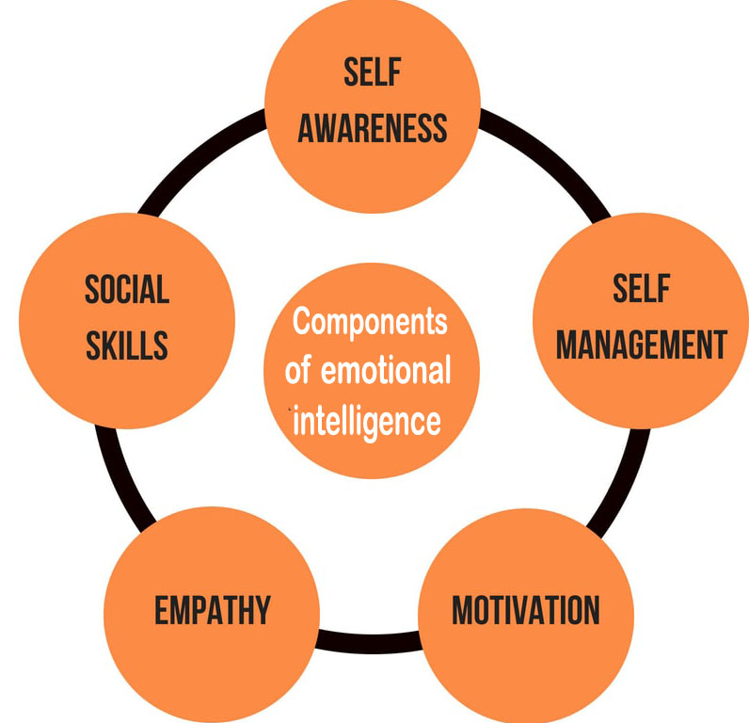

Goleman (1998)

Appendix 2
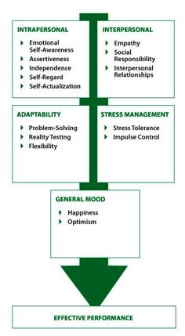

Bar-On (1997)

Appendix 3
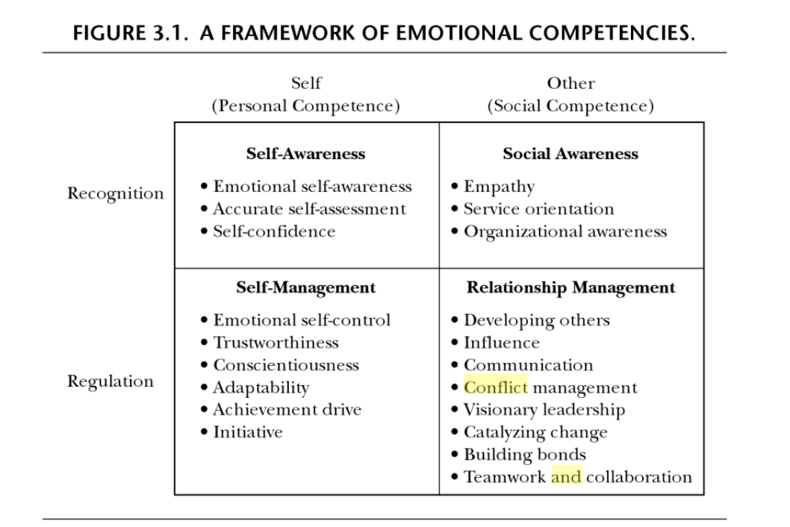
Goleman (2009)

Appendix 4
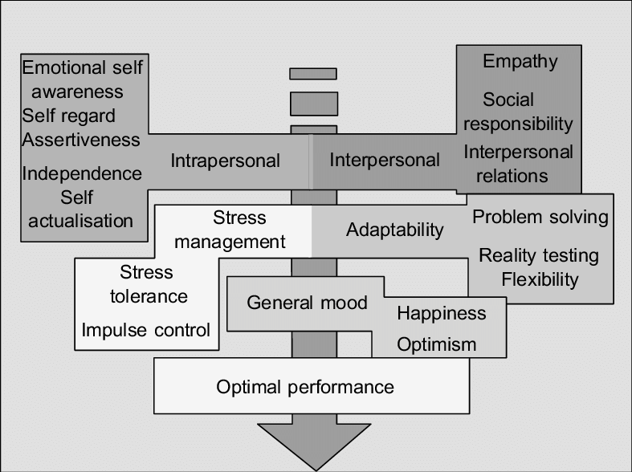

Jon Kabat-Zinn (1979)

Bibliography

Bishop, S. R. (2002). What do we really know about mindfulness-based stress reduction?. Psychosomatic medicine, 64(1), 71-83.
Cascio, W. F. (2001). Knowledge creation for practical solutions appropriate to a changing world of work. SA Journal of Industrial Psychology, 27(4), 14-16.
Carruthers, C., & Hood, C. D. (2011). Mindfulness and wellbeing. Therapeutic Recreation Journal, 3, 171-189.
Creswell, J. D., & Lindsay, E. K. (2014). How does mindfulness training affect health? A mindfulness stress buffering account. Current directions in psychological science, 23(6), 401-407.
Gonzalez-Benito, J. (2007). A theory of purchasing's contribution to business performance. Journal of operations management, 25(4), 901-917.
Hashem, T. N. (2010). Impact of Managers’ Emotional Intelligence on Marketing Creativity in Jordan Commercial Banks. Innovative Marketing, 6(3), 78-86.
Herzberg, F. (2017). Motivation to work. Routledge.
Hill, L. A. (2003). Becoming a manager: How new managers master the challenges of leadership. Harvard Business Press.
Hoerl, R. W., & Snee, R. D. (2020). Statistical thinking: Improving business performance. John Wiley & Sons.
Jayne, M. E., & Dipboye, R. L. (2004). Leveraging diversity to improve business performance: Research findings and recommendations for organizations. Human Resource Management: Published in Cooperation with the School of Business Administration, The University of Michigan and in alliance with the Society of Human Resources Management, 43(4), 409-424.
Nwokah, N. G., & Ahiauzu, A. I. (2009). Emotional intelligence and marketing effectiveness. Marketing Intelligence & Planning, 27(7), 864-881.
Pardee, R. L. (1990). Motivation Theories of Maslow, Herzberg, McGregor & McClelland. A Literature Review of Selected Theories Dealing with Job Satisfaction and Motivation.
Roche, A. M., Pidd, K. E. N., & Freeman, T. (2009). Achieving professional practice change: From training to workforce development. Drug and Alcohol Review, 28(5), 550-557.
Rodríguez-Ledo, C., Orejudo, S., Cardoso, M. J., Balaguer, Á., & Zarza-Alzugaray, J. (2018). Emotional intelligence and mindfulness: Relation and enhancement in the classroom with adolescents. Frontiers in psychology, 9, 2162.
Rosen, J., Stiehl, E., Mittal, V., Fox, D., Hennon, J., Jeste, D., & Reynolds, C. F. (2013). Late-life mental health education for workforce development: brain versus heart?. The American Journal of Geriatric Psychiatry, 21(11), 1164-1167.
Sadri, G. (2012). Emotional intelligence and leadership development. Public Personnel Management, 41(3), 535-548.
Sako, M. (2006). Does trust improve business performance. Organisafional trust: A reader, 267-294.
Schindler, P. L., & Thomas, C. C. (1993). The structure of interpersonal trust in the workplace. Psychological Reports, 73(2), 563-573.
Stanley, S., Purser, R. E., & Singh, N. N. (2018). Ethical foundations of mindfulness (pp. 1-29). Springer International Publishing.
Thakrar, M. (2019, June 11). How To Develop Emotional Intelligence Using Mindfulness. Forbes. https://www.forbes.com/sites/forbescoachescouncil/2019/06/11/how-to-develop-emotional-intelligence-using-mindfulness/?sh=5420db753f3a
Williams, T. O., Ernst, J. V., & Clark, A. C. (2018). Profile of Workforce Development Educators. The Journal of Technology Studies, 44(1), 14-27.

