Jacob Evans
2311160@student.uwtsd.ac.uk
Screenshots of configuring virtual machines
ACCA5023-
Network Operating Systems and Service
Assignment PART 2
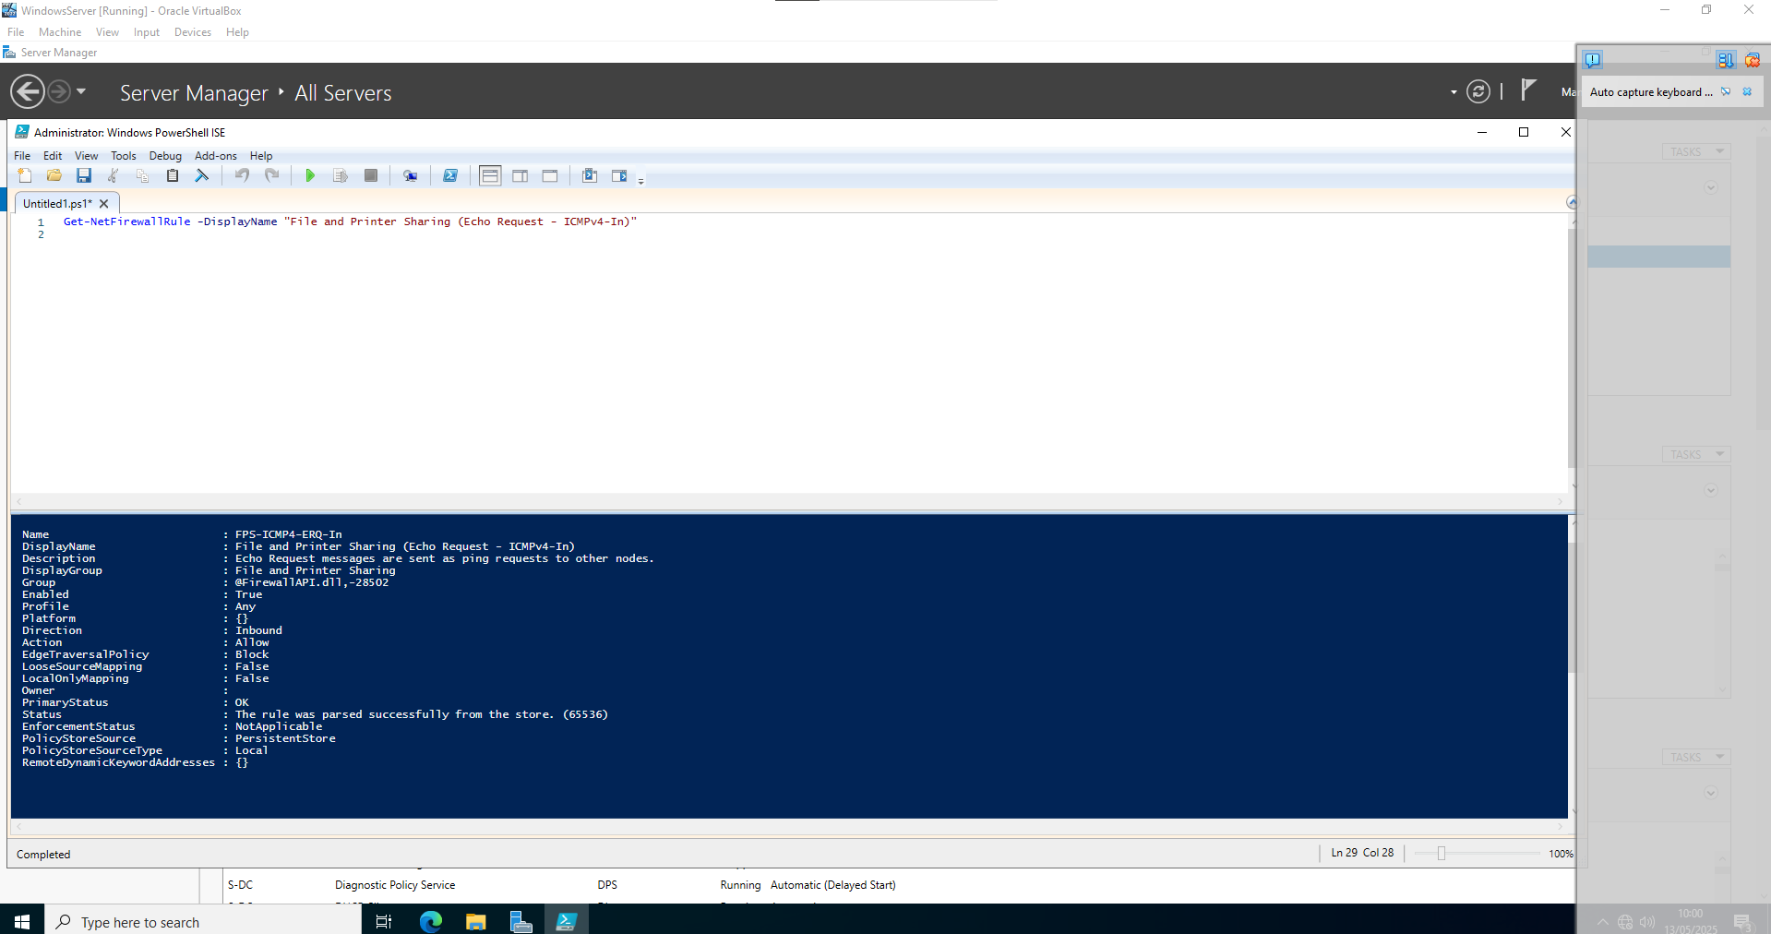
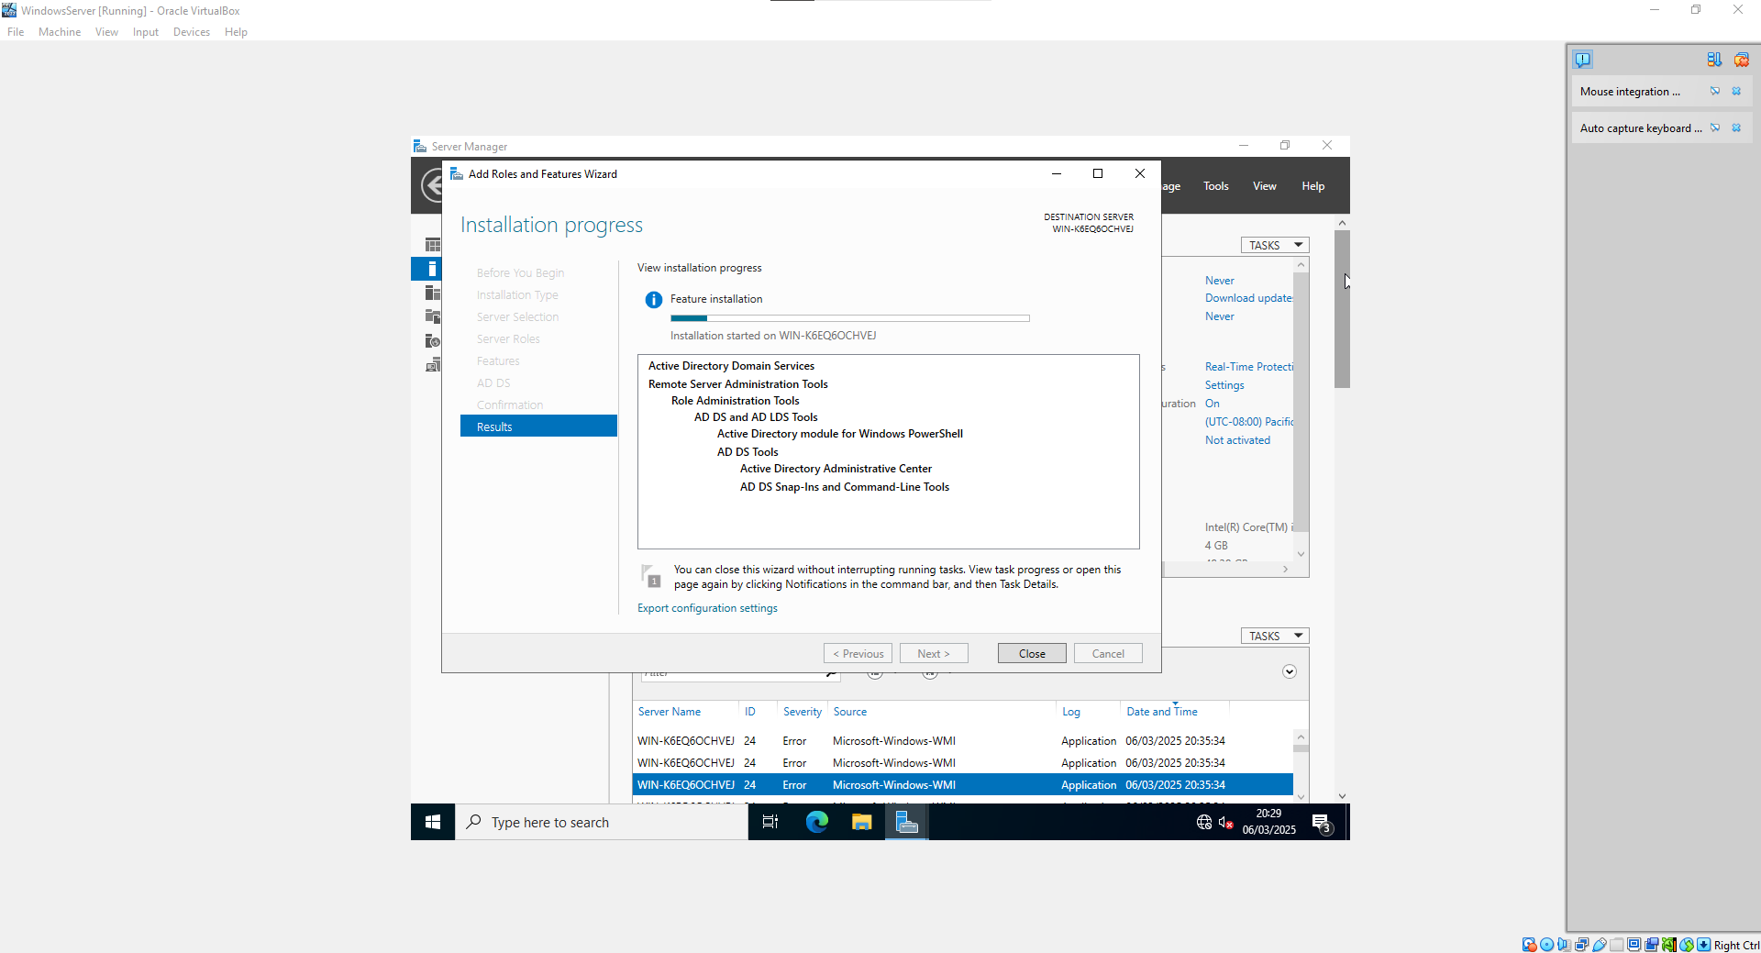
Figure 1.1 FireWall and ICMPv4
Figure 1.1 Routing and Remote Access

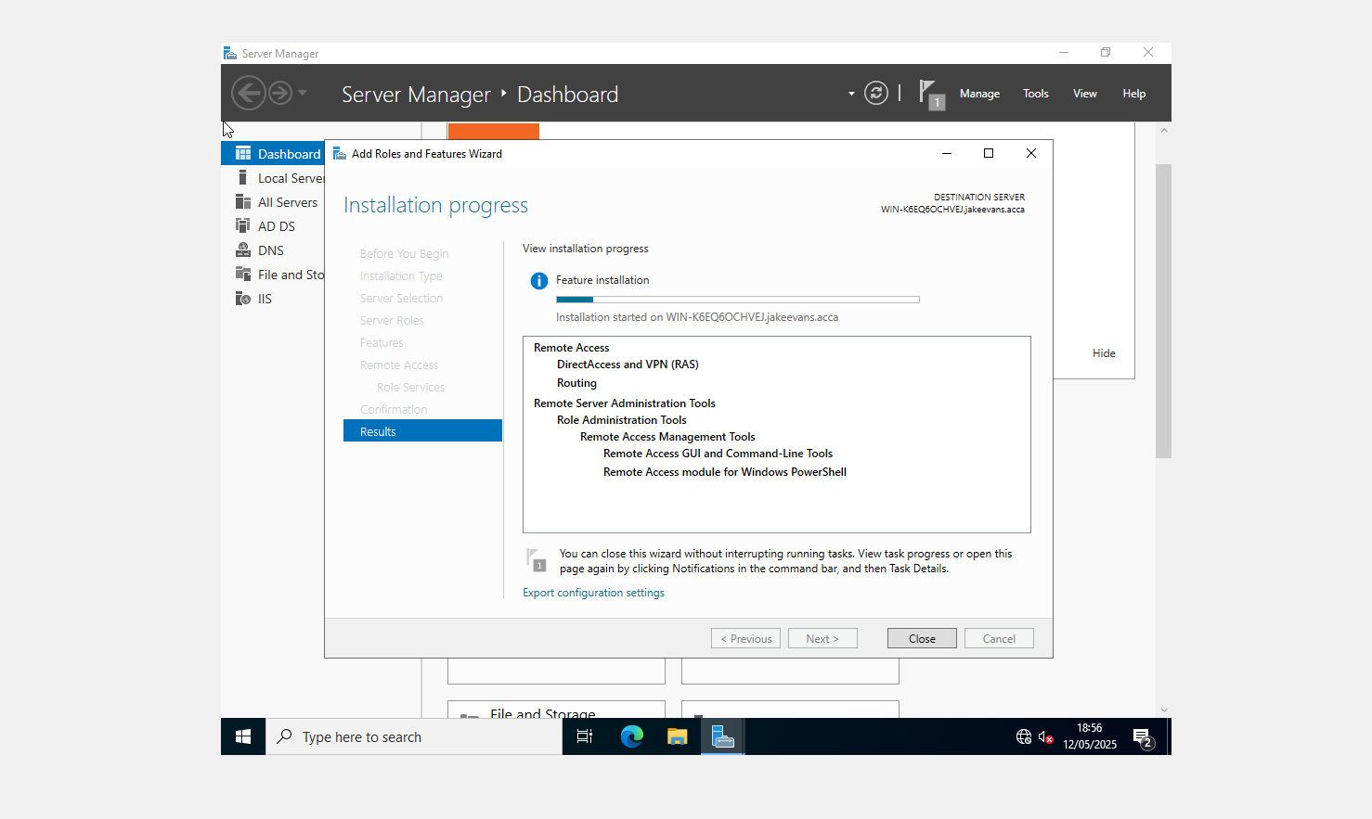
Figure 1.2 Site to Site VPN Install

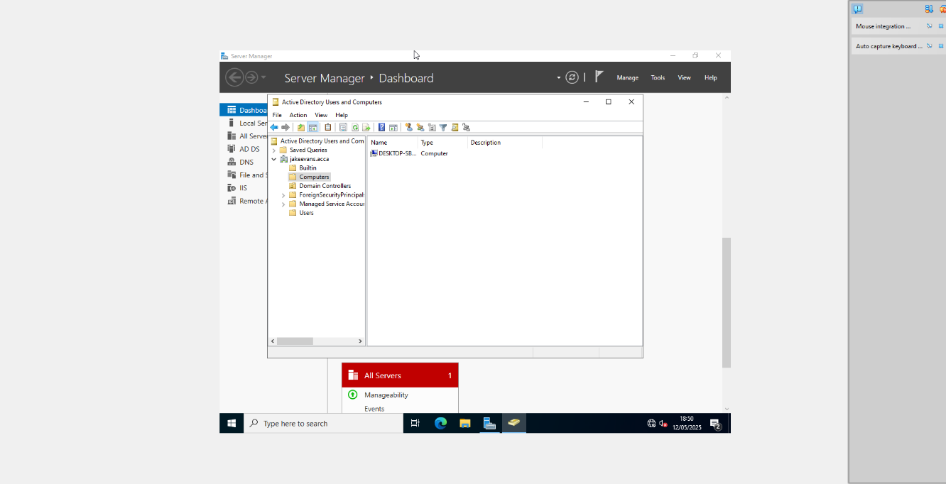
Figure 1.3 Forest jakeevans.acca

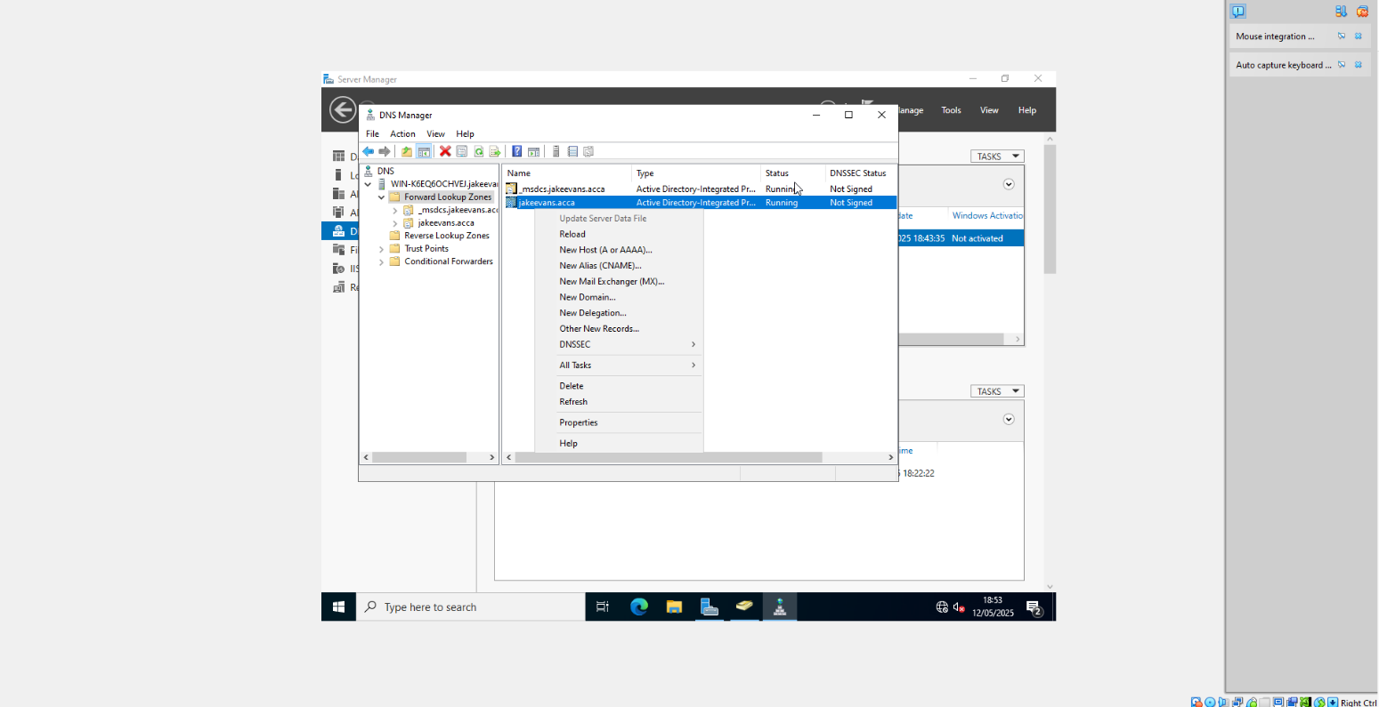
Figure 1.4 Appropriate A Records for 10 Servers each

Figure 1.5 reverse Lookup zone PTR
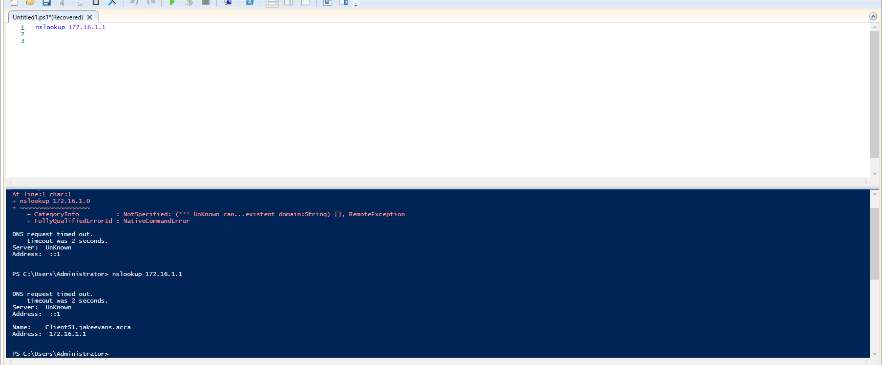
Figure 1.5 PTR Test to Client S1

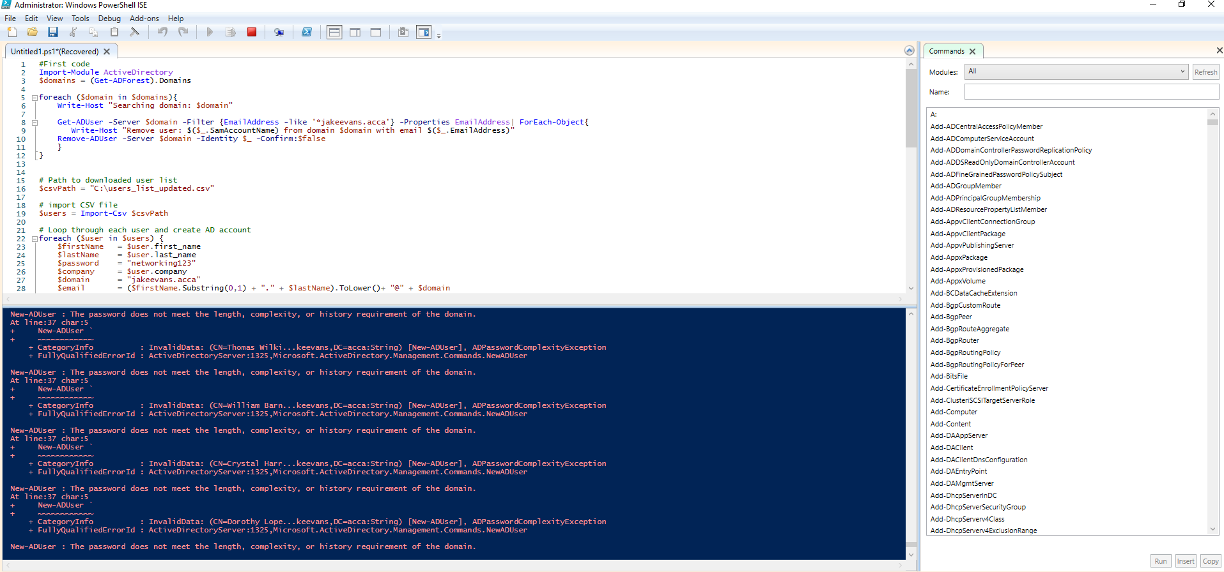
Figure 1.6 User List script created

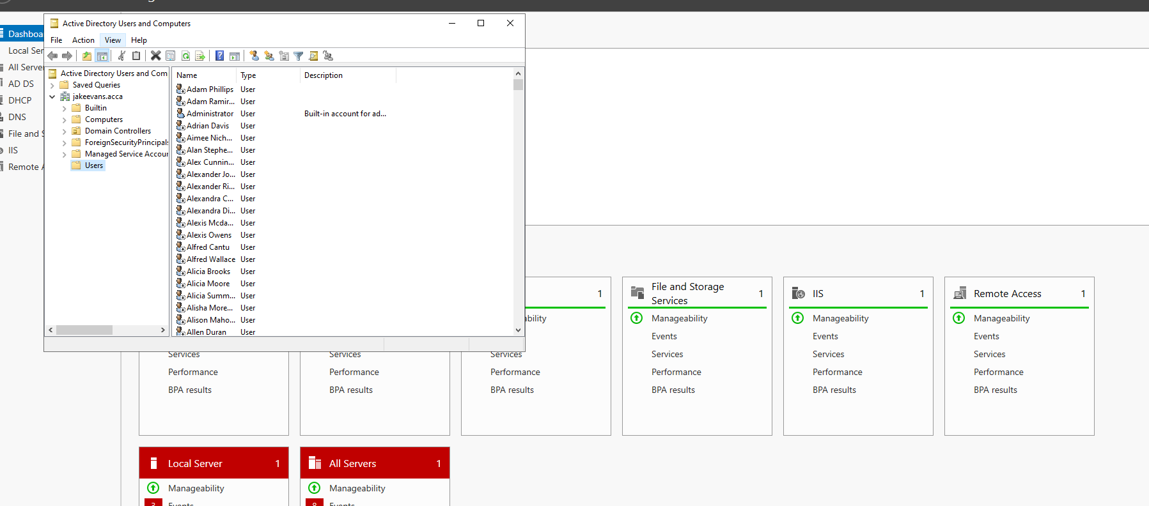
Figure 1.6 Users in Active Directory
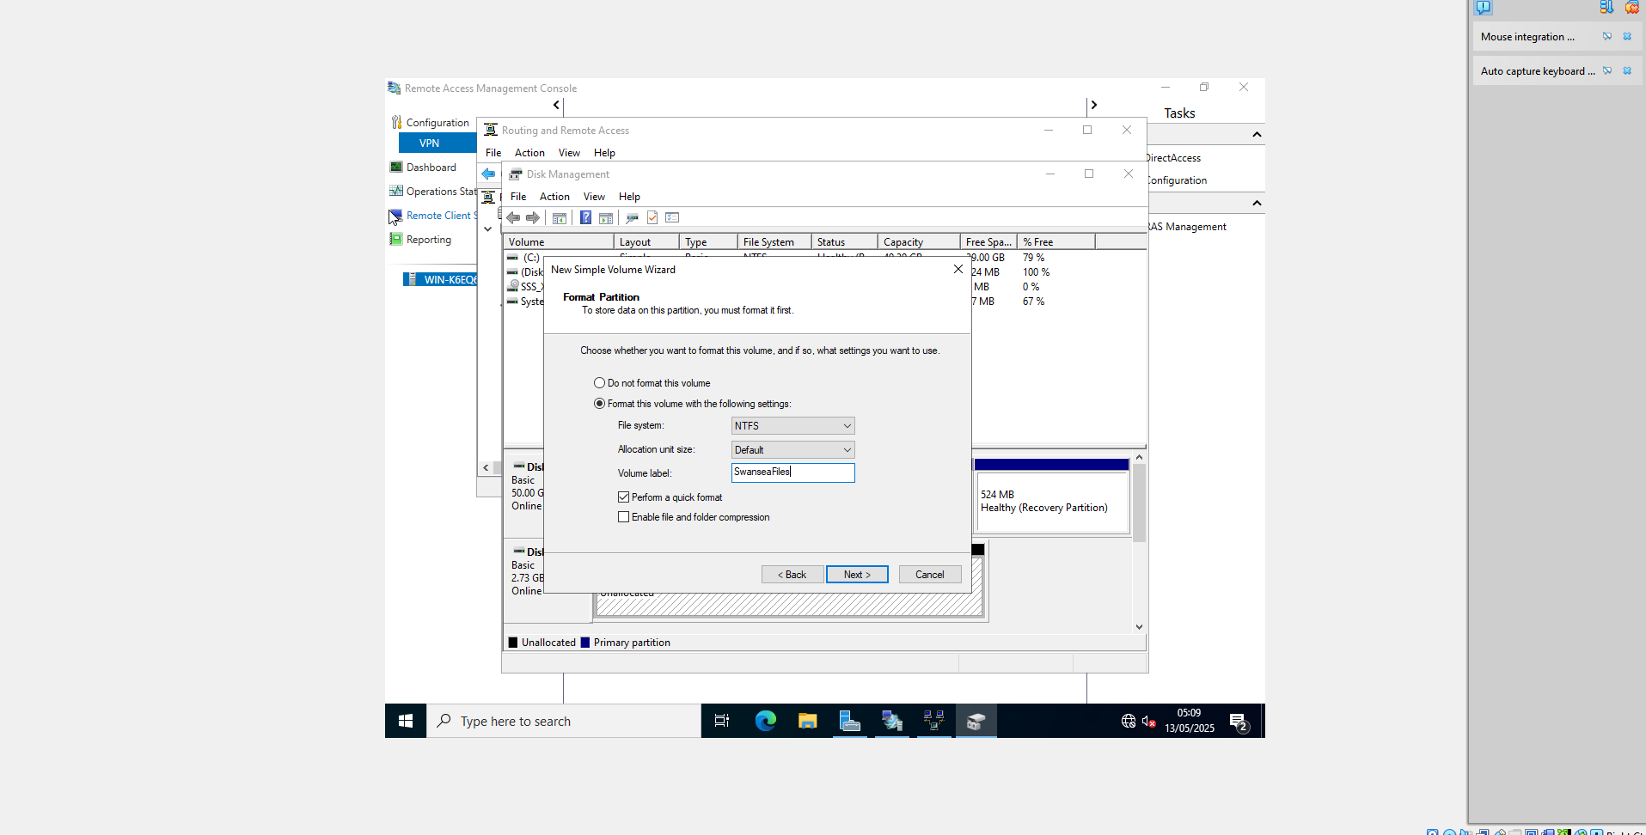
Figure 1.7 Mounted Disk Configuration E:Swansea

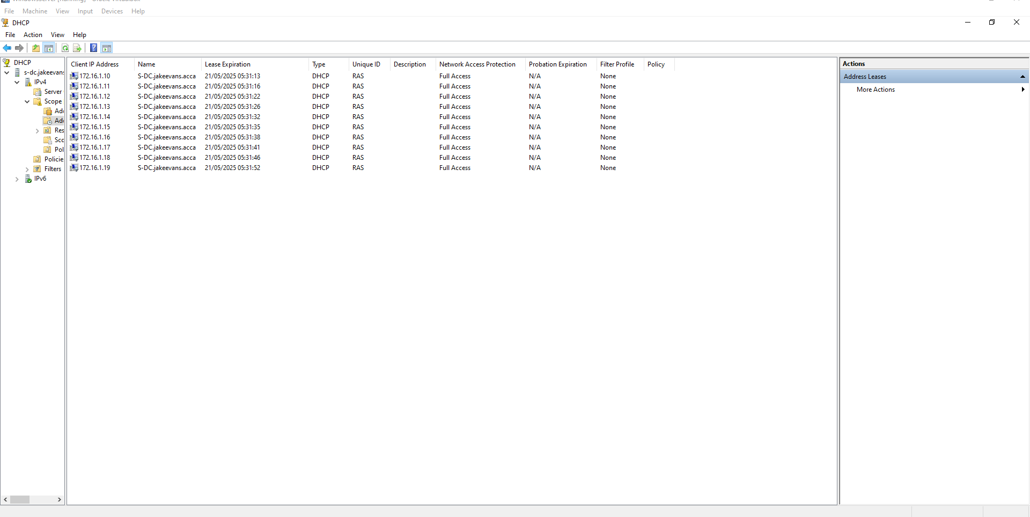
Figure 1.8 Configure DHCP Services in range

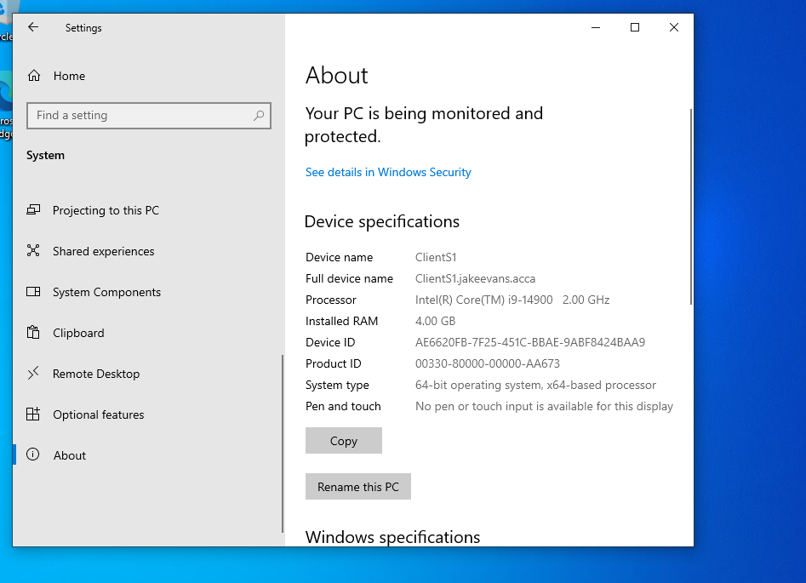
Figure 1.9 ClientS1 joined jakeevans.acca domain
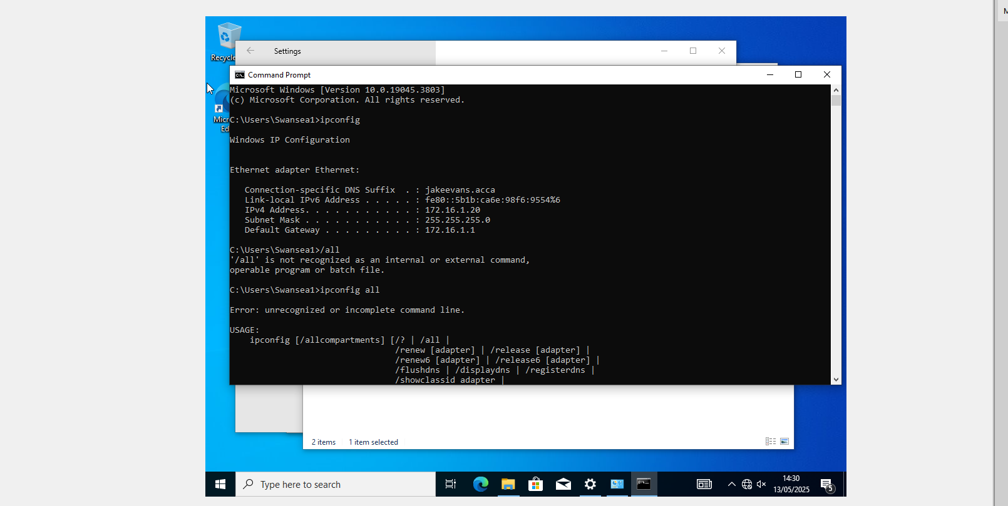
Figure 1.10 Automatic DHCP IP Assignment

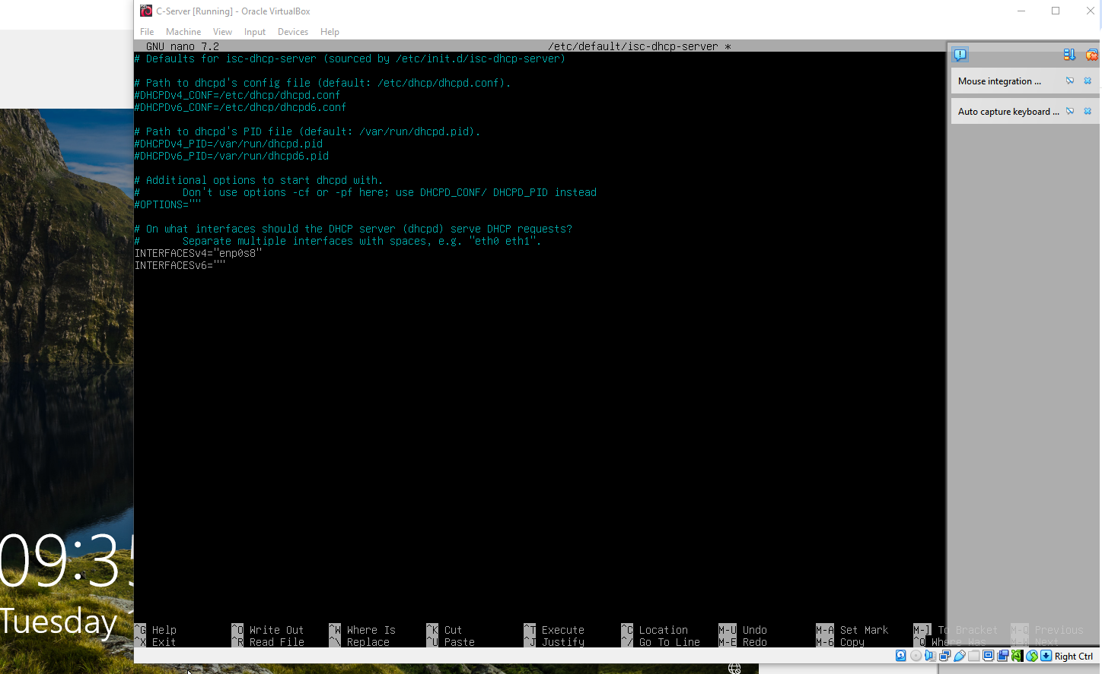
Figure 2.4/2.5 Routing and Remote Access DHCP

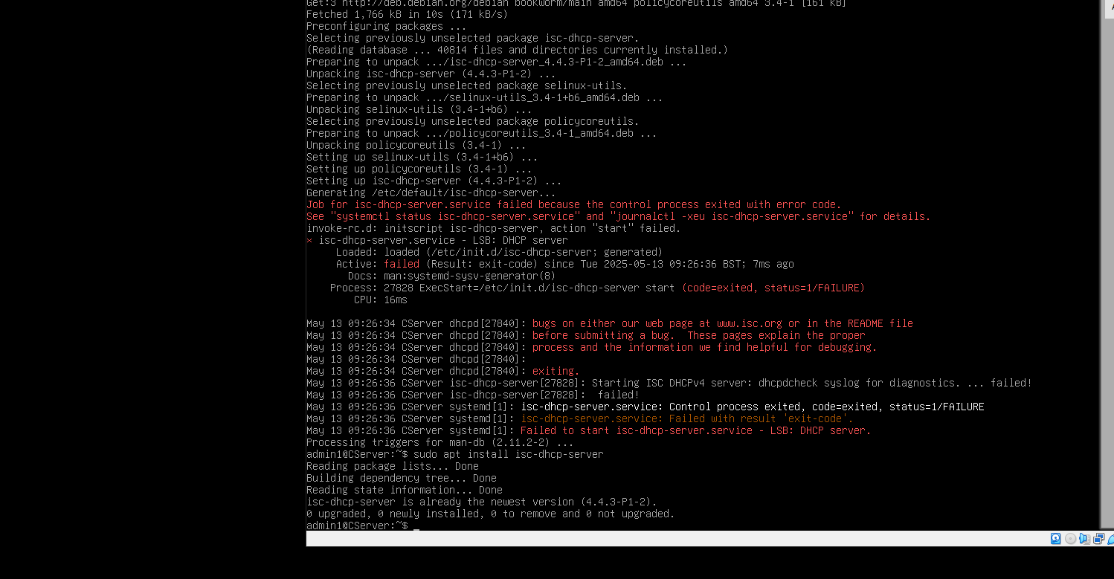
Figure 2.4 DHCP Services on Debian

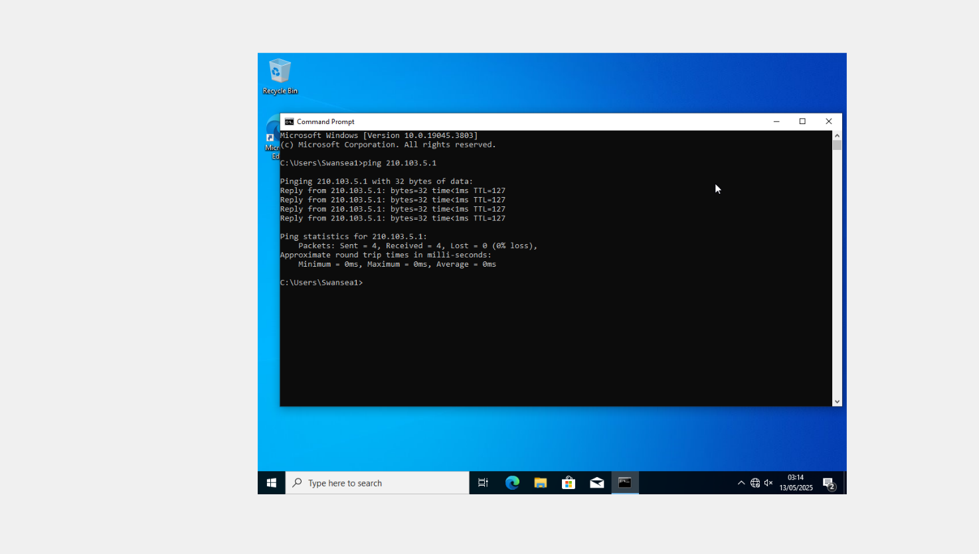
Figure 3 Test client S1 pinging NAT IP address

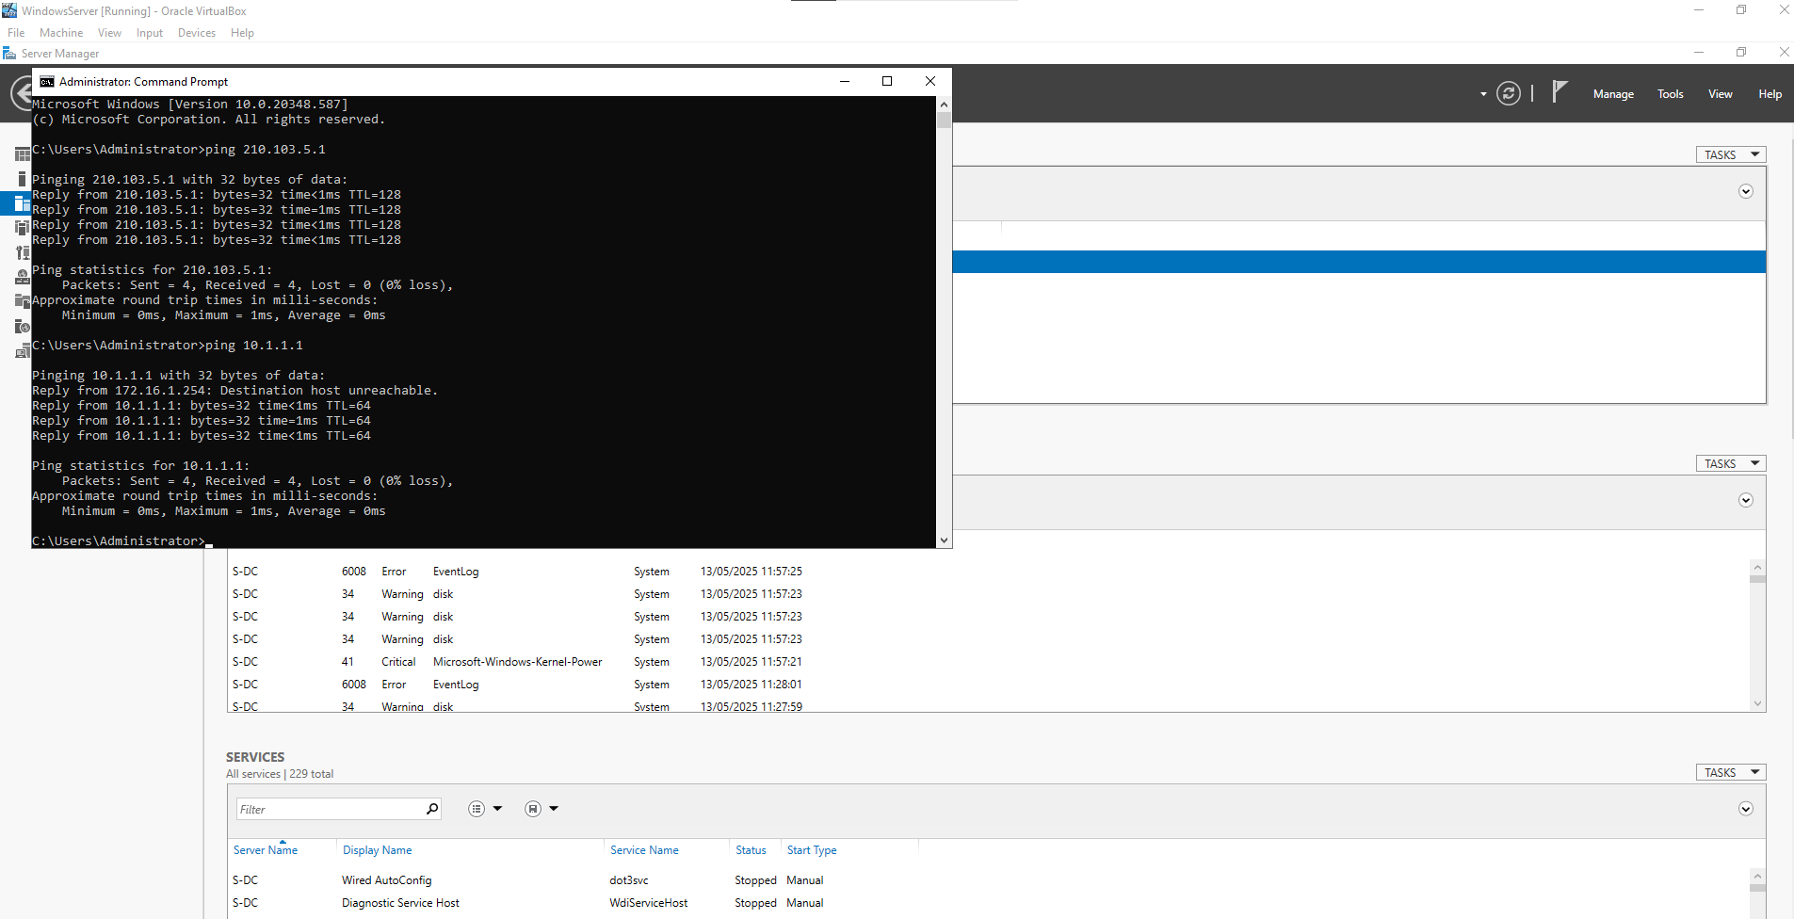
Figure 3 – Ping Test – Server can ping all devices/IP addresses

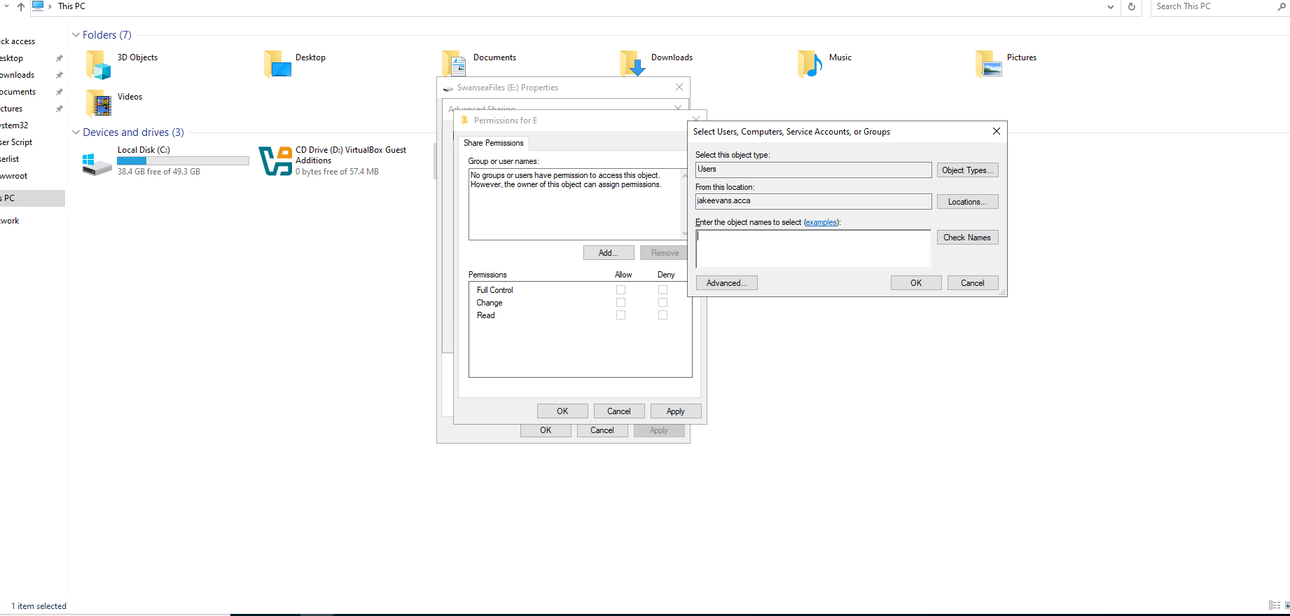
Figure 4 Removing and giving Permissions to E:SwanseaFiles
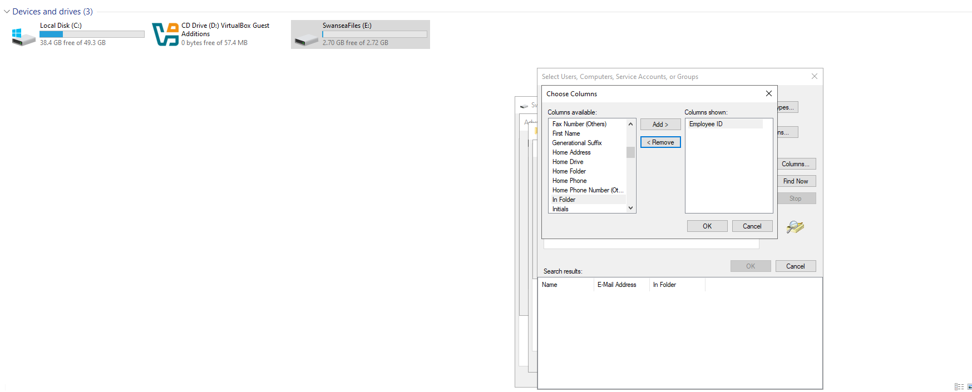
Figure 4 Permissions

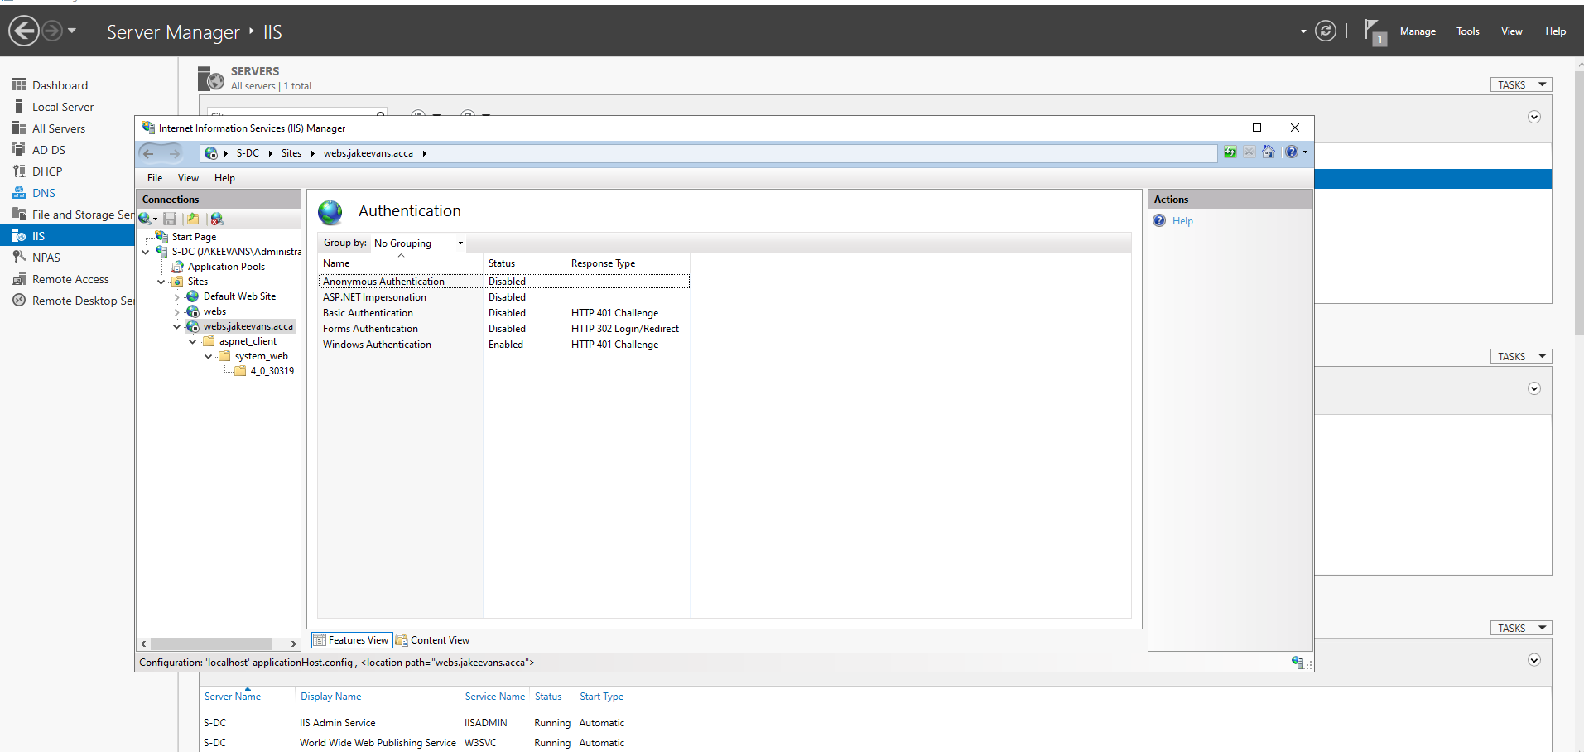
Figure 5 IIS Manager Configuration
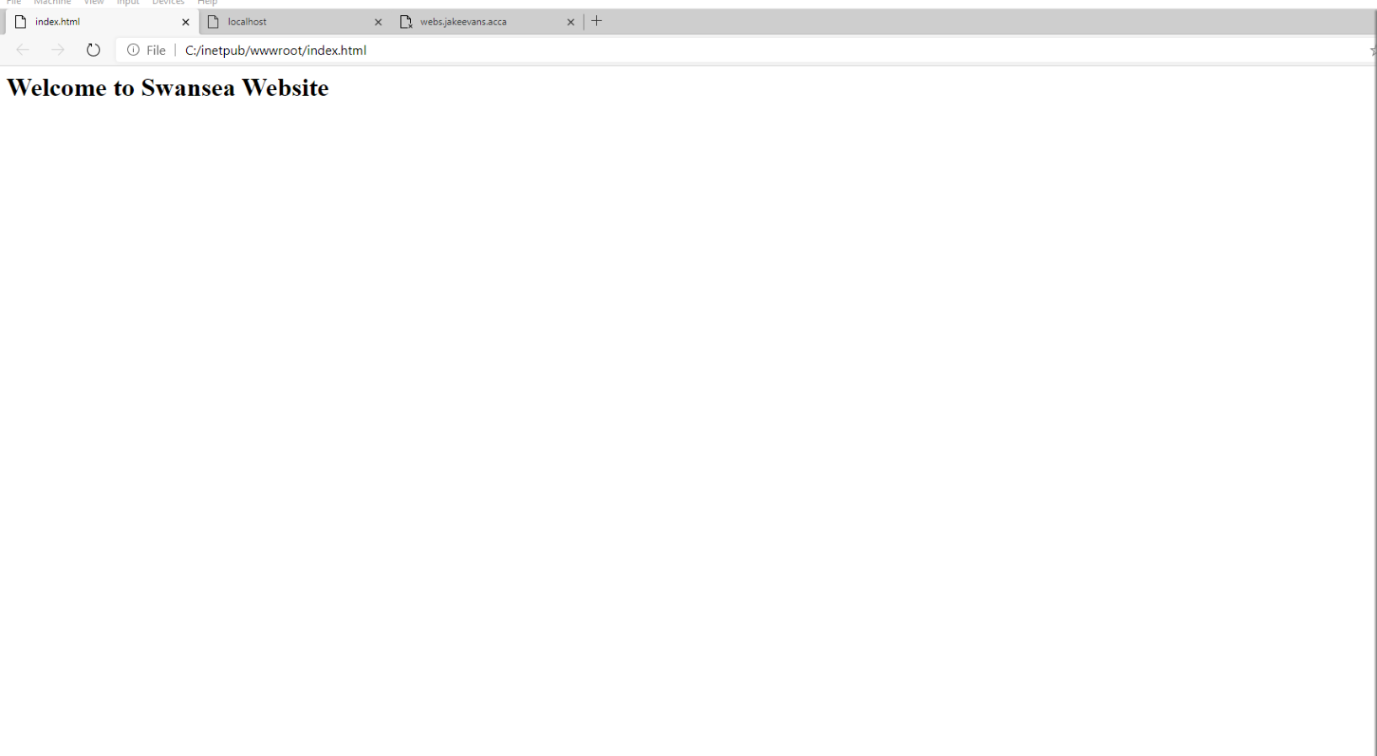
Figure 5 “Welcome to Swansea Website”

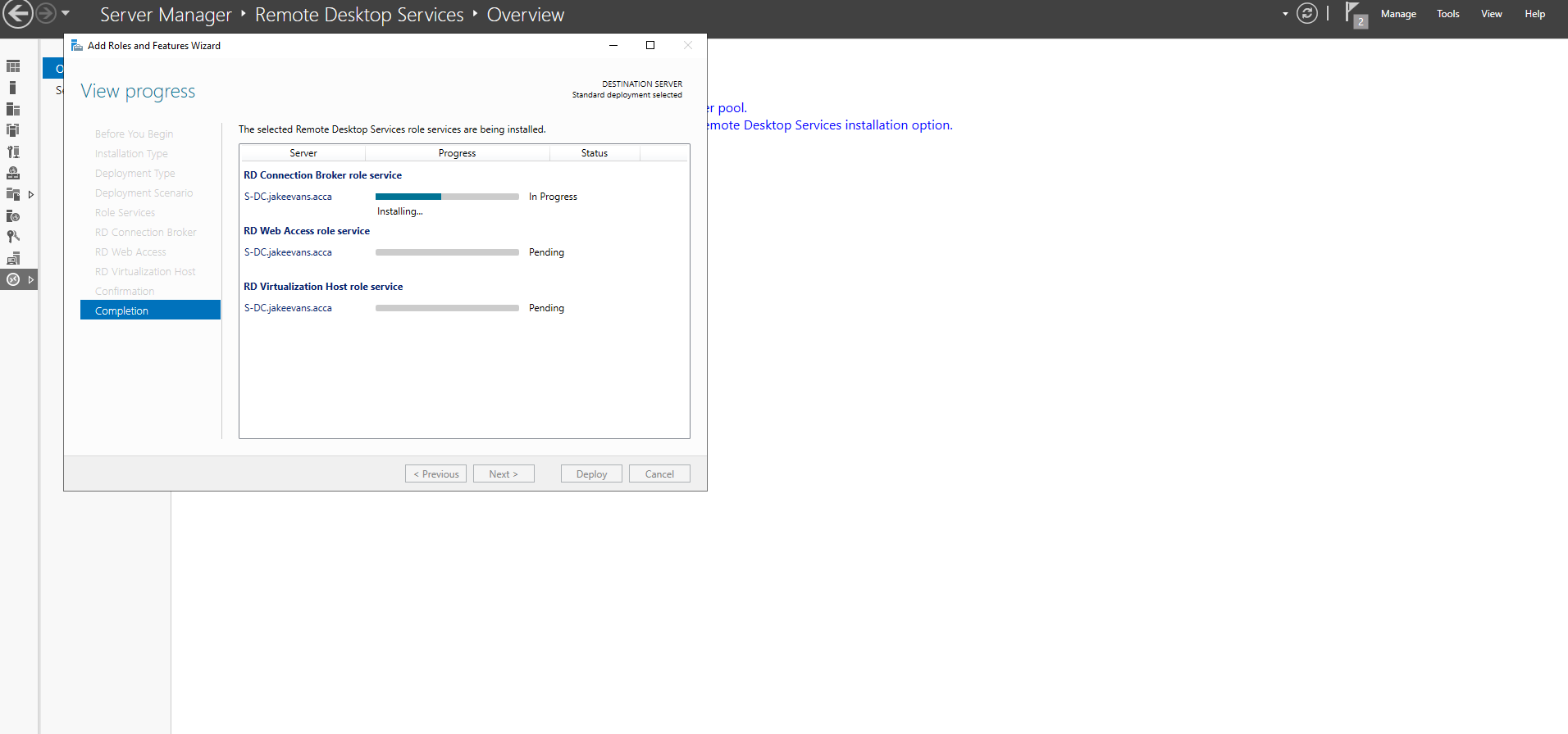
Figure 6 – RDS Install

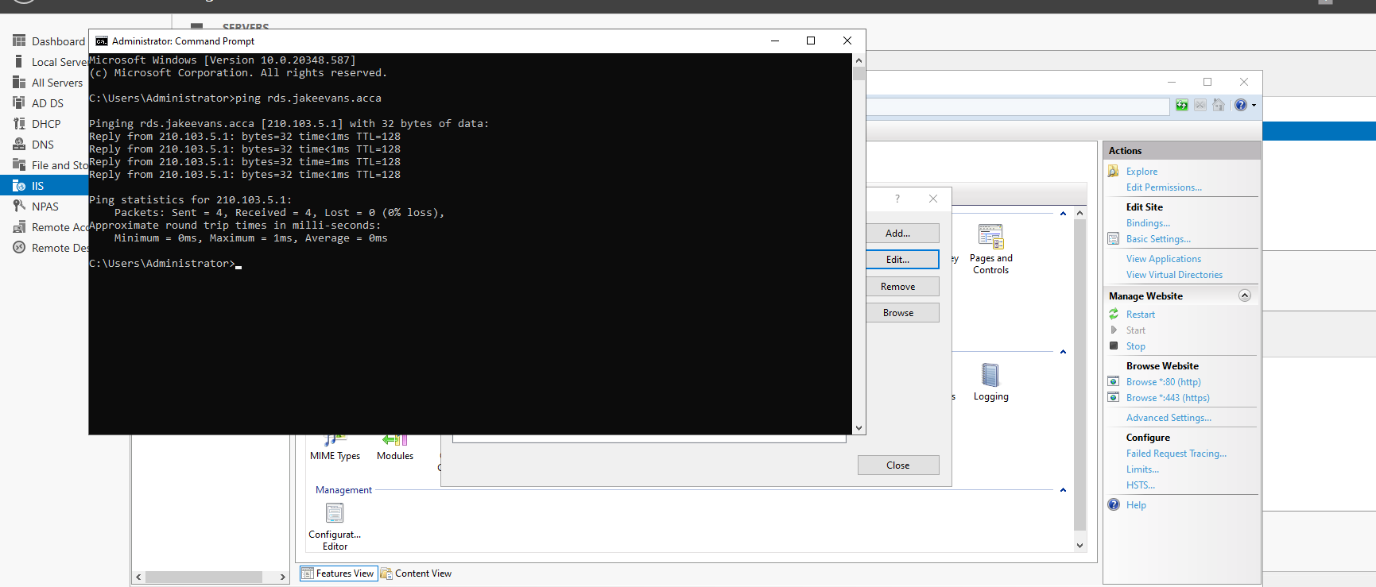
Figure 6 – RDs Ping TEST

