

Data Warehousing
Logan Evans
268764

Contents
OLTP database 3
Data Warehouses and benefits of using a data warehousing system. 3
Architecture of a Data Warehouse and its source systems 3
ETL Process 5
Data Marts 5
Managing Director 6
Finance Director 7
Sales and Marketing Director 8
Difference between OLTP and Data warehousing systems 8
Internal and external Source Systems 10
Star schema for the system 12
Yearly Earnings for each property and change of valuation per month 12
Source data 13
Dimensions and facts 13
Total customers per city 14
Source Data 14
Dimensions and Fact table 15
Leases monthly profit 15
Source data 15
Dimensions and fact table 16
Data Marts 16
comparing against competitor prices 17
Customers living in the republic of Ireland 17
ETL Plan 18
data quality and information governance issues 19
Bibliography 20

OLTP database

OLTP is used to utilise data taken from transactions that take place on a day-to-day basis. ⁽¹⁾ As a result of this, OLTP databases can be a critical tool for a business to gain help understand these transactions and making sure that they are all running smoothly. One of the main differences that is present between an OLTP database, and a data warehousing system is that an OLTP database only holds current data, so unlike a data warehouse does not make use of historical data, ⁽¹⁾ which leads to the Data warehouse being a much larger size. An OLTP also makes use of Atomicity, which helps to ensure that transactions that go incomplete do not impact the OLTP database ⁽²⁾ When combined with the lack of historical data this leads to an OLTP database containing only data that is relevant with no data redundancy, unlike a data warehouse which is more likely to contain redundant data.

Data Warehouses and benefits of using a data warehousing system.

Data Warehouses are used for utilising much larger datasets which a data warehouse will utilise to perform queries to help a business make better informed decisions. ⁽³⁾ Data warehouses extract data from either one or multiple different sources utilised by a business based off what is required, then transforms this data based off what the business needs to be analysed which will finally be loaded into the Data warehouse. This Extract, transform and load process is a critical part to the data warehouse being used to its maximum efficiency as it can lead to a data warehouse query providing much better results after a query is completed. Unlike an OLTP making use of day-to-day data on an operational level, a data warehouse is much more likely to make use of data on a strategic level to help the business to make better informed long-term decisions. ⁽⁴⁾ As a result of this, a data warehouse is a very important part of improving Business Intelligence as by picking out data from different sources and organising the data based off what is needed for analysis. For example, if a business needs to find out the total sales for the previous month, The data warehouse can be setup by applying the Month required, as well as all of the sales for that month in dimension tables, then by including a Total field as a fact which provides a sum of sales, the business is able to quickly query how much money had been made in that month and as a result will be able to use this data to see
whether the company requires any changes to improve their number of sales by applying a discount or other solutions.

Architecture of a Data Warehouse and its source systems

Before a data warehouse can be built, the source of the data must first be identified. This data source is then extracted from the source and is loaded into the Data warehouse. By transforming the data to fit the format of a relational database, the data is then cleaned and extracted into the data warehouse, this ETL process is a vital part of linking the data warehouse to the source systems and is what makes the link possible. For example, the external data could be competitor sales price data, while the internal data could be your own sales price data, which can later be compared using the warehouse.

Source systems are data sources which exist outside of the data warehousing system and are the original source of all the data that is to be analysed by the data warehouse. This data can come from both internal data sources and external data sources which will be combined to conduct analysis on the warehouse.

The purpose of the data warehouse is to help assist the business with making decisions, ⁽⁴⁾ which is done through its three-tier architecture. ⁽³⁾
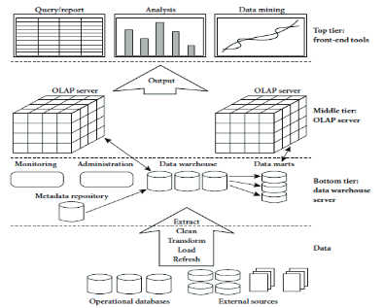 ⁽⁵⁾

The first tier of the data warehouse is the relational database system, which is where all the data is stored. The main reason that a relational database is used is that the structure allows each of the different tables within the database to link with one another using one-to-one, one-to-many and many-to-many relationships. ⁽⁶⁾ These relationships allow all the data to interact with the rest of the database, which leads to the ability to start utilising the data warehouse for analysis.
within the middle tier you will find OLAP cubes.⁽⁶⁾ These cubes are used to analyse the data that is being stored within the data warehouse through the use of dimensions.⁽⁷⁾ This format makes it so that when performing an analysis on financial data, a large range of dimensions which have been place into the cube can be implemented such as Date, Cost, Product type, volume sold, and more⁽⁸⁾ which will each be combined to form a fact, which is able to take these dimensions and provide an analysis ,such as the number of products sold in the month of January.
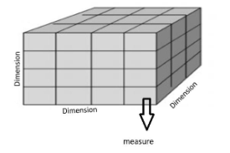

⁽⁶⁾
At the end of this, the user will be able to visualise the process that has been conducted through performing a query or report on the system ⁽⁶⁾ which allows those with little to no knowledge as to how a database operates to be able to use the data warehouse to obtain the data they require.

ETL Process
ETL, also known as Extract, Transfer and load is a process which is conducted when building a data warehouse to obtain the necessary data from a source for analysis. ⁽⁹⁾ Once the data sources have been identified, the data is first extracted from the source to make sure the integrity of the data remains intact. This data will then be loaded from the source data and cleaned to remove any redundancies within the data to make sure that when querying the data, the results that are provided are accurate. This data then gets loaded into the data warehouse so that it can be analysed.
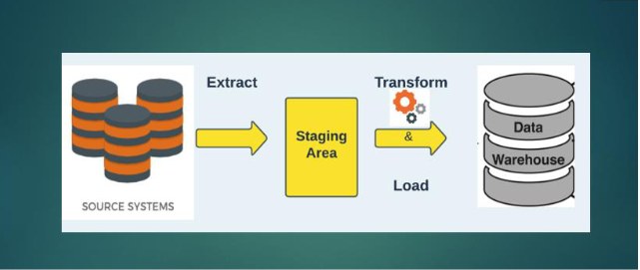⁽⁹⁾
The process of ETL does not affect the day-to-day operations of the company as the data used within the ETL process does not impact the source data, so there is no risk that the day-to-day operations of the business are affected in any way, outside of the analysis of data which will be drastically improved, and ETL can also be performed periodically for non-operational data warehouses as it would be a waste of resource to perform live updates on the data warehouse if the data being analysed is over a large period of time utilising historic data, so the ETL process can be set to occur after a certain period of time depending on how concurrent the data needs to be.⁽³⁾

Data Marts
Once a data warehouse manages to reach a large enough scale where it is no longer feasible to utilise all the data, so data marts are employed to separate data warehouses into more focused on the needs of specific departments ⁽¹⁰⁾ or users. This benefits the use of data marts greatly, as it saves a lot of time that would be spent searching through a data warehouse for specific information, and by using data marts everyone who requires the use of the system would be able to identify their Data Mart. easily and quickly For example, The three Roles will now be discussed and how they can use a data mart.

Managing Director
The managing director requires a way to view the performance metrics and key performance indicators. Using data marts, the managing director would be able to analyse the performance of the business much sooner than implementing the functionality into a data warehouse as it takes significantly less time at a much lower cost. ⁽¹¹⁾ and as a result its implementation will help to make sure that the performance of the company is as expected by checking to see if and where Cambrian would need to make changes to optimise their performance by accessing data drawn from the customer database to view how many new customers the company has per quarter, to evaluate whether or not the business’ growth is as expected to meet up with the desired performance. 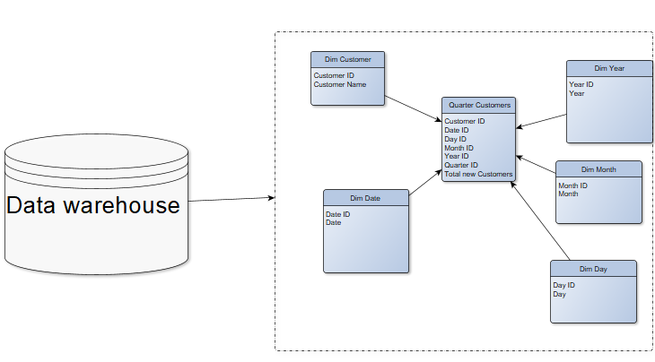

Finance Director
The finance director of Cambrian requires Accurate financial reports and projections, so a big part of using data marts that the finance director could make use of is the ability to have multiple focused data marts to identify the reports and projections for different parts of the business when required rather than having to navigate a data warehouse, which is much easier for the finance director to understand and much faster to access due to the data mart containing less data and therefore loading faster.⁽¹¹⁾ For example, if the finance director would need to check the total profit that Private homes or other types of real estate have been making, which a data mart can be utilised to make this information much faster to access whenever it is needed. This kind of targeted information within data marts is very valuable for helping the finance director to be able to make informed decisions based off data as efficiently as possible.
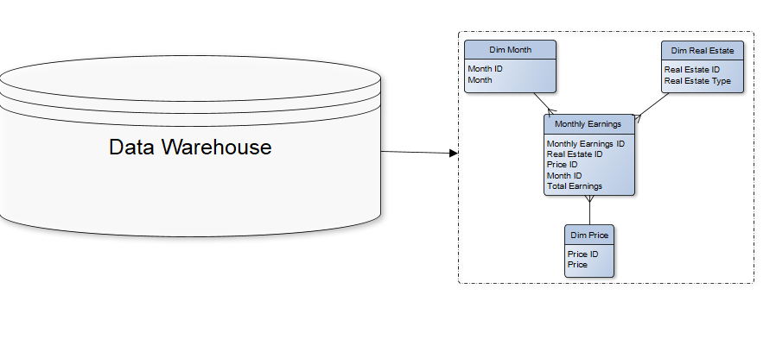
Through using the price, type of real estate and the month, a small data mart can be applied to query the total earnings for each month within the data mart, which would be very useful for the financial director to be able to compare the different forms of real estate offered to see which ones are performing well and which are underperforming.

Sales and Marketing Director
The sales and marketing director is the one who has the highest variety in what’s required with them wanting to see Insights on customer behaviour, sales insights, and market trends. By utilising a data warehouse. There are many ways that the sale and marketing director could utilise a data mart for each of their tasks. For example, by utilising a data mart showing the total sales for each of the different real estate types, which of the real estate options that the company provides is receiving the least buyers to identify which sectors are doing the worst and need more marketing by viewing the quantity each real estate type sells per month.
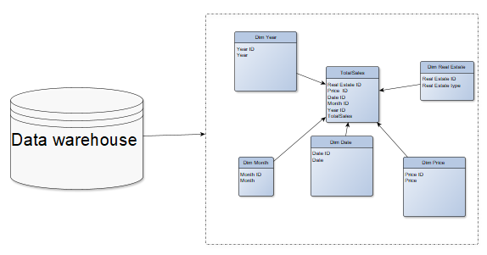
In addition to this, external sources can be utilised to view the competitor sales data and by comparing that against this data, then the Sales and Marketing Director will be able to make more informed decisions about where the competitors are performing better than them to help improve their overall success.

Difference between OLTP and Data warehousing systems

One of the differences between an OLTP system and a data warehousing system is that dimensional databases are utilised using much larger sets of data, which includes a range of historical data and even some unnormalized data, which is something you do not see within a normalised OLTP database. ⁽¹²⁾ In addition to this, an OLTP database focuses on an application-oriented database approach ⁽¹³⁾ which is drastically different a data warehouse which is subject oriented which focuses on the analysis of a subject such as in the case of Cambrian a data warehouse can be used to look at the total number of sales by utilising historic data,⁽¹⁴⁾ while an OLTP will exclusively look at transactions done on a day-to-day basis.
By utilising dimensions and facts, a star schema can be developed where the fact table draws data from each of the different dimensions to perform a query and generate information for the user. For example, if the finance director wanted to use data from the financial database and the property valuation data from the external sources, then the financial director would be able to use the data warehouse to achieve this by combining fields from the wide range of different data sources.
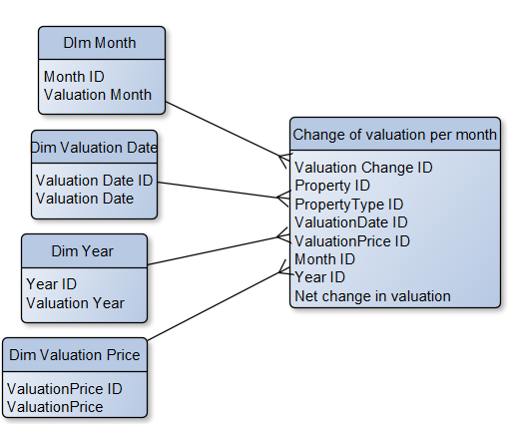
The above star schema demonstrates the data being pulled into a fact table from the different Dim/dimension tables. By using this fact table, a Valuation change ID will be set to the table, which will update with the information on the real estate property, as well as the valuation information, as well as the time the valuation was made. The fact takes the Valuation price from the previous

Internal and external Source Systems
When looking into all the data sources used by Cambrian, the Internal sources of data are the Customer database, property listings database, lease agreement database and the financial database. The external data sources Market trends data, property valuation data, demographic data of different locations and competitor data.

The diagram below shows how the data could potentially look for each of these tables, as without being provided the metrics within these sources it is impossible to fully gauge what information is being stored, however this demonstrates a range of data that can be important for the business when utilised within a data warehousing system.

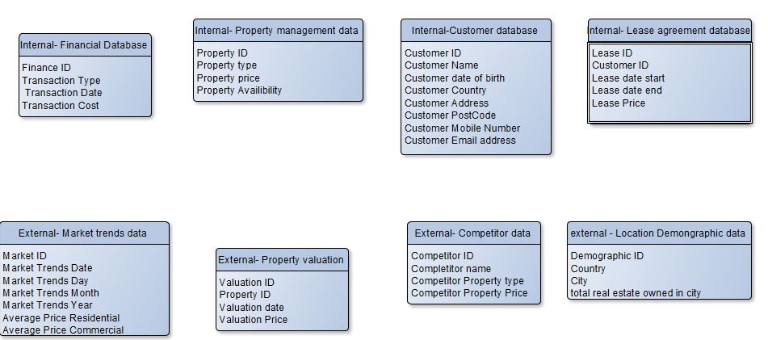
An important point to consider regarding the source data is that it is in different places, with some of it being cloud-based and some of the data being based on the Swansea HQ.
As a result of this, the two locations the internal and external data will be drawn from are these two locations. While the specific locations of the data are left vague, for this visualisation an assumption that the internal data is stored within the Swansea HQ building and the external data will be assumed to be stored in the cloud because of this being the most secure option for the business due to the internal data being more sensitive.
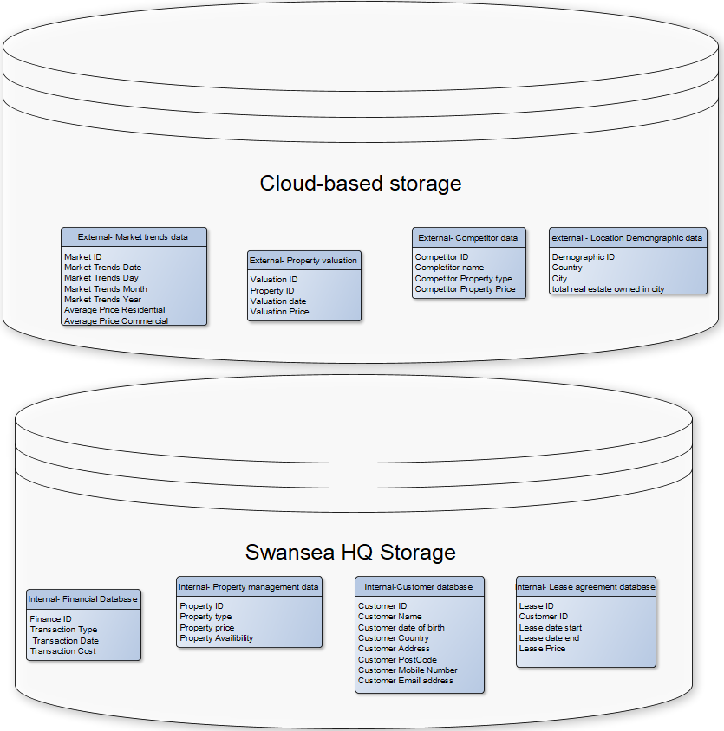

Star schema for the system

For the system, four fact tables have been developed to help generate data that can be utilised by the business. Across these fact tables, the Dim Property type table and the Dim year are shared between the Valuation per month and yearly earnings for each property.

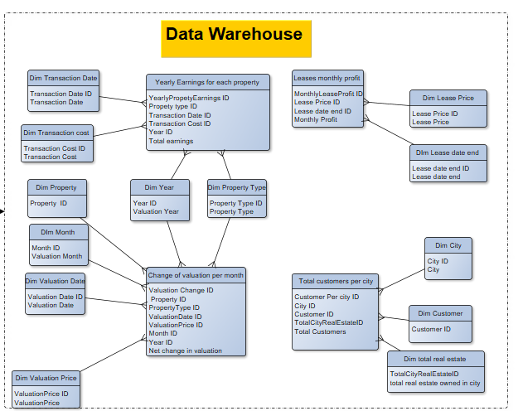

Yearly Earnings for each property and change of valuation per month

Source data
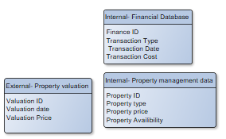

For the yearly earnings table, the source data that has been utilised the Property management data and the financial database from the internal source data, while the Change of valuation per month also makes use of the external property valuation data source, as it is a key part of the fact.

Dimensions and facts
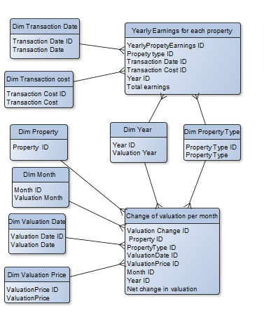
The yearly earning for each property table makes use of the Property Type, Transaction Date and Transaction Cost dimensions so that the type of real estate that is being evaluated can be show, as well as the date to be able to evaluate the earnings for the year through the inclusion of the year dimension, which is calculated from the Transaction Date.
To generate the Total earnings for the year, each instance of property types within the database are to be selected, and the sum of Transaction Cost is generated to identify how much had been earnt for that property within the year.

Total customers per city

Source Data
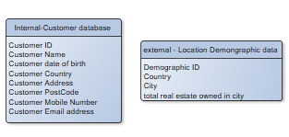
The source data utilised for the total customers per city were the Internal customers database so that the customer ID can be called upon for the query, as well as the external location demographic data so that the Address can be cross-referenced with the city to determine the total customers within the city.

Dimensions and Fact table
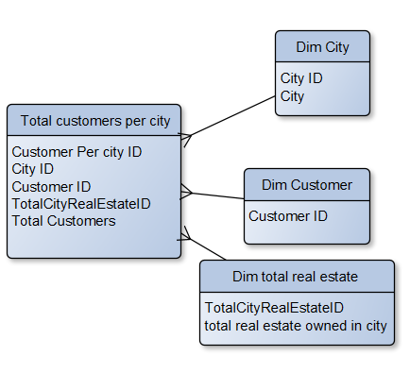

The dimensions which have been utilised for the Total customers per city are the City ID to determine which city is going to be queried, the Customer ID to call upon the Customer table to find out how many Customers are living in the city, as well as the total real estate ID to determine how much real estate Cambrian owns within the city. By using this data, a comparison can be made between the total number of customers and the total real estate within the city as a way to determine whether the company is both choosing the correct cities to sell their real estate in, but also to determine whether they should increase the advertising for cities where there are either much less people to increase how many people from that city are purchasing the real estate, or in the city with the most people already customers as it’s likely that the customers from that city will stay with the company.

Leases monthly profit

Source data
All of the data for this table is taken from the internal Leases agreement database.
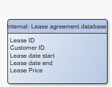

Dimensions and fact table

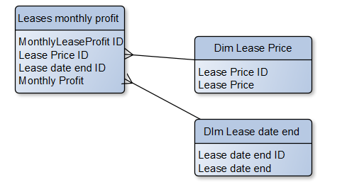

The fact that had been determined for this table was monthly profit, which takes the end date of the leases and the price of the leases to determine which leases are currently still actively paying their monthly lease and as a result determines how much money The business is earning from leasing out real estate for the month to identify whether the data is trending towards increasing or decreasing and making informed decisions based off of the result.

Data Marts

For these data marts, the use of dependent data marts will be utilised, as they should be developed in accordance with the data extracted into the data warehouse. ⁽¹⁶⁾

comparing against competitor prices
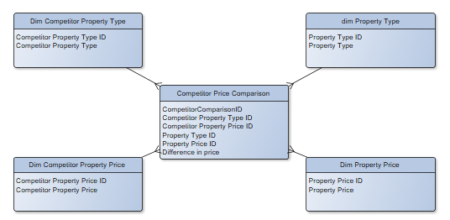
By providing a comparison of the Competitor’s Property price for certain types of property against Cambrian’s, the result will either be a positive or negative number based off how much more or less Cambrian’s properties cost compared to the different competitors.

Customers living in the republic of Ireland

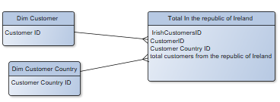
As Cambrian had recently started purchasing real estate in the Republic of Ireland, it is very important to determine how many customers this decision has led to buying real estate from the company. By using this metric, the Marketing and Sales Director will be able to determine whether the resources invested into this decision were worth it, and potentially either reconsider the investment or withdrawing from Ireland.

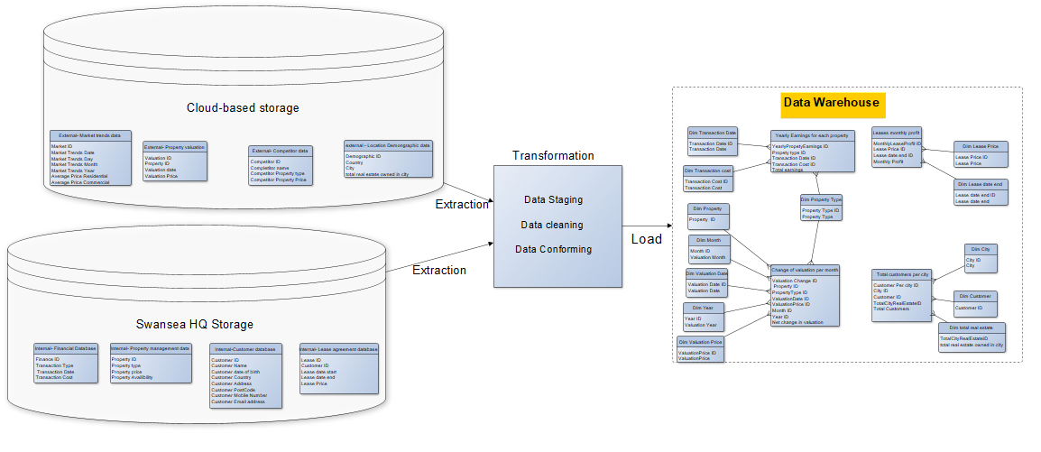

ETL Plan
During the extraction phase, the data that is kept within the data storage, which in the case of Cambrian are the Swansea HQ data store and the cloud storage is extracted from the database so that it can be later transformed and loaded. The extraction occurs in a way that makes sure that the source data does not get touched, and the integrity of the data remains intact.⁽¹⁵⁾ Due to the fact that no actual data has been provided, the transformation step is unable to be applied, as there is no data to transform provided, but if data was included the transformation step would put the data through a data staging step, where the data is first cleaned and then conformed to make sure that all of the data is able to correctly load into the data warehouse. Once loaded, this data will then be applicable to the data warehouse to conduct analysis on the data. ⁽¹⁵⁾ In this case, A wide range of data has been utilised to generate dimensions that led to fact tables being created for analysis.

data quality and information governance issues

The first potential information governance issue that exists is to make sure that the data is being used properly in compliance with regulations such as the GDPR.⁽¹⁷⁾ This may be an issue if not careful, as the Customer data that is being passed around is sensitive data, as businesses need to make sure that all of the customer data is kept secure.⁽¹⁷⁾ Cambrian will also need to be careful when conducting the ETL processes for the first time, as they will need to make sure that they aren’t impacting the source data when extracting as this can cause major issues for Cambrian regarding both their own data integrity and complying with legal regulations.⁽¹⁵⁾ Finally, Cambrian will need to make sure that the data is correctly transformed when conducting ETL, as if the data is not transformed correctly, it can lead to results being both inconsistent and in some cases incorrect, leading to the Conclusions drawn from the Data warehouse to be inaccurate.

Bibliography

- Lutkevich B, “OLTP (online transaction processing) November 2021 (accessed 19/01/2024) available at: https://www.techtarget.com/searchdatacenter/definition/OLTP
- Sidorov V, “Privacy-Preserving OLTP Database Systems with OLAP Support” May 2016 (accessed 20/01/2024) available at: https://www.researchgate.net/profile/Vasily-Sidorov/publication/331114925_Privacy-Preserving_OLTP_Database_Systems_with_OLAP_Support/links/61a8e7ee092e735ae2d5b121/Privacy-Preserving-OLTP-Database-Systems-with-OLAP-Support.pdf
- Ali F, “A survey of real-time data warehouse and ETL”, 9th July 2014, (accessed 19/01/2024) available as: https://www.ef.uns.ac.rs/mis/archive-pdf/2014%20-%20No3/31_Fahd%20Sabry%20Esmail%20Ali%20v5.pdf
- Septoff D, Simmons K, “Seleecting a data warehouse architecture” (accesse 20/01/2024) available at: https://www.lexjansen.com/scsug/2000/SCSUG00030.pdf
- Karmani M, Mustafa G, Sarwar N, Wajid S, “A Review of Star Schema and Snowflakes Schema” May 2020 (accessed 22/01/2024) available at: https://www.researchgate.net/publication/341264133_A_Review_of_Star_Schema_and_Snowflakes_Schema

- Dimitra C, “Data Warehousing in Business Intelligence and ETL process” January 2023 (accessed 19/01/2024) available at: https://repository.ihu.edu.gr/xmlui/bitstream/handle/11544/30200/DATASCIENCE_DIMITRACHATZISTEFANOU_THESIS2022%20%281%29.pdf?sequence=1

- Devangavi A, Aggarwal P, “Overview of OLAP cubes, importance, build onsiderations and querying with MDX.” 15th July 2013, (accessed 22/01/2024) available at: https://www.researchgate.net/publication/324986147_Overview_of_OLAP_cubes_importance_build_Considerations_and_querying_with_MDX/link/5af04e11a6fdcc8508b97466/download

- Snowflake, “What are olap cubes?” (accessed 21/01/2024) available at: https://www.snowflake.com/trending/olap-cubes/

- Dimitra C, “Data Warehousing in Business Intelligence and ETL Process” January 2023 (accessed 22/01/2024) available at: https://repository.ihu.edu.gr/xmlui/bitstream/handle/11544/30200/DATASCIENCE_DIMITRACHATZISTEFANOU_THESIS2022 %281%29.pdf?sequence=1 - %5B%7B%22num%22%3A127%2C%22gen%22%3A0%7D%2C%7B%22name%22%3A%22XYZ%22%7D%2C87%2C198%2C0%5D
- Talus, “A practical guide to building data marts” (accessed 18/01/2024) available at: https://zoomcorp.com/media/documents/guide.pdf
- (the source I keep using text for that was good) University of Pretoria, “Chapter 3 data marts as management information delivery mechanisms” (accessed 20/01/2024) available at: https://repository.up.ac.za/bitstream/handle/2263/27061/03chapter3.pdf?sequence=4&isAllowed=y
- GeeksforGeeks, “Difference between Data Warehousing and Online transaction processing (OLTP)” 12 September 2022, (accessed 22/01/2024) available at: https://www.geeksforgeeks.org/difference-between-data-warehousing-and-online-transaction-processing-oltp/
- Astera, “Characteristics of a data warehouse” (accessed 22/01/2024) available at: https://www.astera.com/type/blog/data-warehouse-concepts/
- Rana K, “Data Warehouse” 30th May 2023, (accessed 22/01/2024), available at: https://artoftesting.com/data-warehouse
- Yulianto A, “Extract transform load (ETL) process in distributed database academic data warehouse” June 10th 2019 (accessed 22/01/2024) available at: https://www.researchgate.net/publication/336091915_Extract_Transform_Load_ETL_Process_in_Distributed_Database_Academic_Data_Warehouse
- Pahwa P, Chhabra R, “Data Mart Designing and Integration Approaches” (accessed 22/01/2024) available at: https://www.ijcsmc.com/docs/papers/April2014/V3I4201424.pdf
- European Parliament and the council of the European union, “regulations” 27 April 2016, (accessed 22/01/2024) available at: https://eur-lex.europa.eu/legal-content/EN/TXT/PDF/?uri=CELEX:32016R0679
- Parker R, “Data Storage, information governance and ethics” 4th July 2019, (accessed 22/01/2024) available at: https://wp.lancs.ac.uk/dclinpsy/data-storage-information-governance-and-ethics/

