Reflective Project Report
Module Code – ACMA5009
Group Project
William David Davies
Student Number – 2114617
UWTSD

Contents
Report Scope: 3
Introduction 4
The Project 4
Project Feasibility 6
Project Charter: Prolonged & Overcomplicated Hotplate Changeovers 6
Pros and Cons of Pursuing Issue 7
Project Evaluation 8
DMAIC Overview 8
Define 9
What Went Well? 9
What Could Have Been Improved? 9
Measure 11
What Went Well? 11
What Could Have Been Improved? 11
Analyse 13
What Went Well? 13
What Could Have Been Improved? 13
Improve 15
What Went Well? 15
What Could Have Been Improved? 15
Control 17
What Went Well? 17
What Could Have Been improved? 17
Project Time Management 19
What Went Well? 19
What Could Have Been Improved? 20
Project People Management 21
What went well? 21
What Could Have Been Improved? 21
Solutions Compliance with the product design specification 22
Conclusion 27
Reference List 28
Appendices 29

Report Scope:
The aim of this written report is to critically analyse the overall success of this Six Sigma Project. In order to do this, we will be analysing the overall project and comparing it against the DMAIC Six Sigma Project steps along with a detailed analysis of the Project Time management, through Gantt charts and weekly communication logs.
These project steps will be compared to the standards outlined within the report, in order to critically analyse the overall project implementation and its effectiveness. In order for this project to be deemed a success it needs to be able to:
- Define – Define the problem at hand.
- Measure – Measure the extent of the problem.
- Analyse – Analyse the extent of the problem and possible solutions that would fix/improve it.
- Implement – Implement a solution to solve the problem.
- Control – Control the solution to the problem in order for it to remain effective.
- Time Management - Effectively manage the overall projects timelines and budgets
- Project People Management – Effectively manage all companies employees and external contractors throughout the project.
- Product Design Specification – the solution meets the points outlined in the PDS to satisfy the customers needs.
The content of the report below is an in depth breakdown of each section and comparison to the standard. From this evaluation and reflection the team were able to take a step back and make suggestions for potential methods that could be utilised in future projects from the lessons learned when seeing this project through to completion.

Introduction
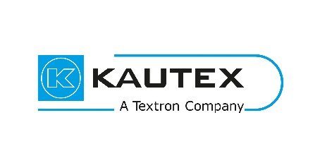
Kautex Textron CVS LTD is a multinational company, which specialise in clear vision systems. These are windscreen wash systems, camera cleaning systems and headlamp wash systems for the automotive industry. As a business Kautex Textron CVS Ltd have been coming under an increasing amount of pressure in improving all aspects of HSE, Improving SMED and Reducing Maintenance Technician workload by improving production processes.
Kautex (2022)
Hengoed Plant:

Hengoed is the global Head Quarters for CVS division within Kautex with 5 other International Plants creating all of the systems mentioned above with combinations of manual assembly, Blow Moulding, Injection Moulding and Corrugated Extrusion.
Kautex (2022)

CVS System:
The CVS System consist of:
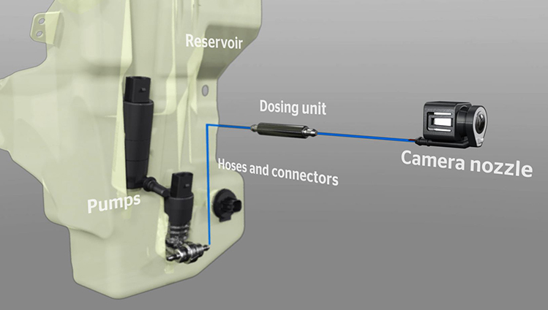
Reservoir – Holds the Wash fluid.
Figure 4
Low Level Sensor – Alerts the driver when the wash fluid is at a low level and needs replenishment.
Hose & Connectors – Carries the fluid to the situated CVS Dispenser mounted to the car.
The Dispenser – Spray the required area to clean.
Kautex (2022)

The Project
One of the main issues faced by Maintenance and Production Technicians since the implementation of hotplate welders is the Hotplate and Teflon changeover procedures. Since change in management and departmental reorganisations this issue has been highlighted as a huge waste and potential for very beneficial savings with slight modifications to tooling and procedures. When these machines were originally commissioned they were designed to hold 1 variant of hotplate and run 1 product per welder. As time has progressed and the company has won more business, the company have then added different variants and different products to existing lines, resulting in several hotplate variants and welder tools needing to be changed over in-line with customer call-offs. This has resulted in long and overcomplicated changeover times due to the process not evolving in-line with its increased demands.
With the welders being used so often, Teflon sheeting rolls were added to ensure that the hotplates were protected and to minimise them wearing. This has also added another intricate step to the process, which needs regular maintenance and replenishment. As well as this process being overcomplicated it is also very wasteful due to the lack of tensioning on the rolls, which creates issues when changing over and using too much sheeting in order to achieve the correct tension of the sheet against the hotplate.
The combination of these 2 design oversights in the past have created a huge amount of unnecessary downtime and undue stress on the Maintenance and Operator technicians due to the volume of changeovers that they are required to do and the wasted time where they could be utilised elsewhere. Due to increased pressures and breakdowns within the factory, time saved is a massive driver. This waste has been highlighted and the manufacturing team have been tasked to heavily reduce this to enable Maintenance to have more time to deal with other issues, which will increase overall output and profits within the company. William Davies (Manufacturing Engineering Apprentice) was nominated to be the owner/champion for this project due to his heavy involvement with the Hotplate welder production line and good understanding of it.

Project Feasibility
Prolonged & Overcomplicated Hotplate Changeovers

Project Charter: Prolonged & Overcomplicated Hotplate Changeovers
Process Name & Purpose:  Container area hotplate changeovers when changing product variant and/or when Teflon sheeting breaks and quality of weld is put at risk. | Process Owner:  Joshua Swift & William Davies
Workshop Leader:
David Kristek – Focus Factory 2 Production Manager.
Process Boundaries:  Welded Container Assembly Section  Starting Point:  Teflon sheeting failure/variant changeover.  Ending Point:  Teflon sheeting failure/variant changeover. | Team Members:  Operators, Stephen Mills, David Kristek, Rhys Lewis, Maintenance Technicians, Operator Technicians, Lee Stinton, Packham Engineering.
Process Sponsor:  David Kristek  Stephen Mills | Process Sponsor Expectations:  Stephen Mills & David Kristek would expect:  - At a minimum of halving downtime due to hotplate changeovers.  - Simplification of changeover procedure.  - Reduction in machine downtime.  - Standardisation of the process.  - Improvements in maintenance spares.  - Increased productivity and throughput/output.
Resource Team:
Operators
Stephen Mills
Joshua Swift
David Kristek
Rhys Lewis
Maintenance technicians
Stakeholders:
David Kristek, Rhys lewis, Stephen Mills, William Davies, Wayne Palmer, Joshua Swift.

A large issue faced by Maintenance & Operations Technicians Teams are the volumes of overcomplicated and long changeovers of product-specific hotplates and renewal of non-stock Teflon sheeting when it breaks away. When these changeovers are required the technicians have to down-tools and deal with the issues as these lines are the most critical in the factory and downtime comes at a high premium. Due to the fact that these changeovers are so overcomplicated and lacking in the correct equipment means that every time they have to be conducted there is a huge amount of time and materials wasted.
Budget Code for solving this problem - £2500 per welder (7 welders).

Pros and Cons of Pursuing Issue
Pros | Cons
Huge scope for improvement. | Could be costly.
Relieves technicians time and resources to focus on other issues. | Large project to be undertaken.
Has the potential to SMED.
Has the potential to improve safety aspects of changeover.
Potentially improves overall machine made piece part spares storage.
Potentially improves machine cell output by minimising downtime.

Project Evaluation

DMAIC Overview

The Six Sigma Project method used was the DMAIC technique. DMAIC is a quality improvement and problem solving method used to improve company performance by the reduction in waste, improve customer satisfaction and improve defect levels. The utilisation of this methodology allows the project team to maintain motivation and drive to achieve the next goal outlined. It gives a structured framework to base the project from which is full of proven quality performance tools to aid defining the problem through the gathering of correct data and driving it through to the implementation of a solution whilst holding the gains going forward.
Although, this was the chosen method for the team at Kautex, there can be some drawbacks to the utilisation of this method. When using this tool it is paramount that the team does not become too focused on just using the tool as a posed to finding the correct solution to the problem. Some would even go as far as saying this technique has a one size fits all approach and this is not beneficial for organisations who operate in a less data driven and more creative mind set. This method could also have the potential to draw out and overcomplicate a ‘quick-win’ project that does not rely on the 5 step approach.
N/A (2021)
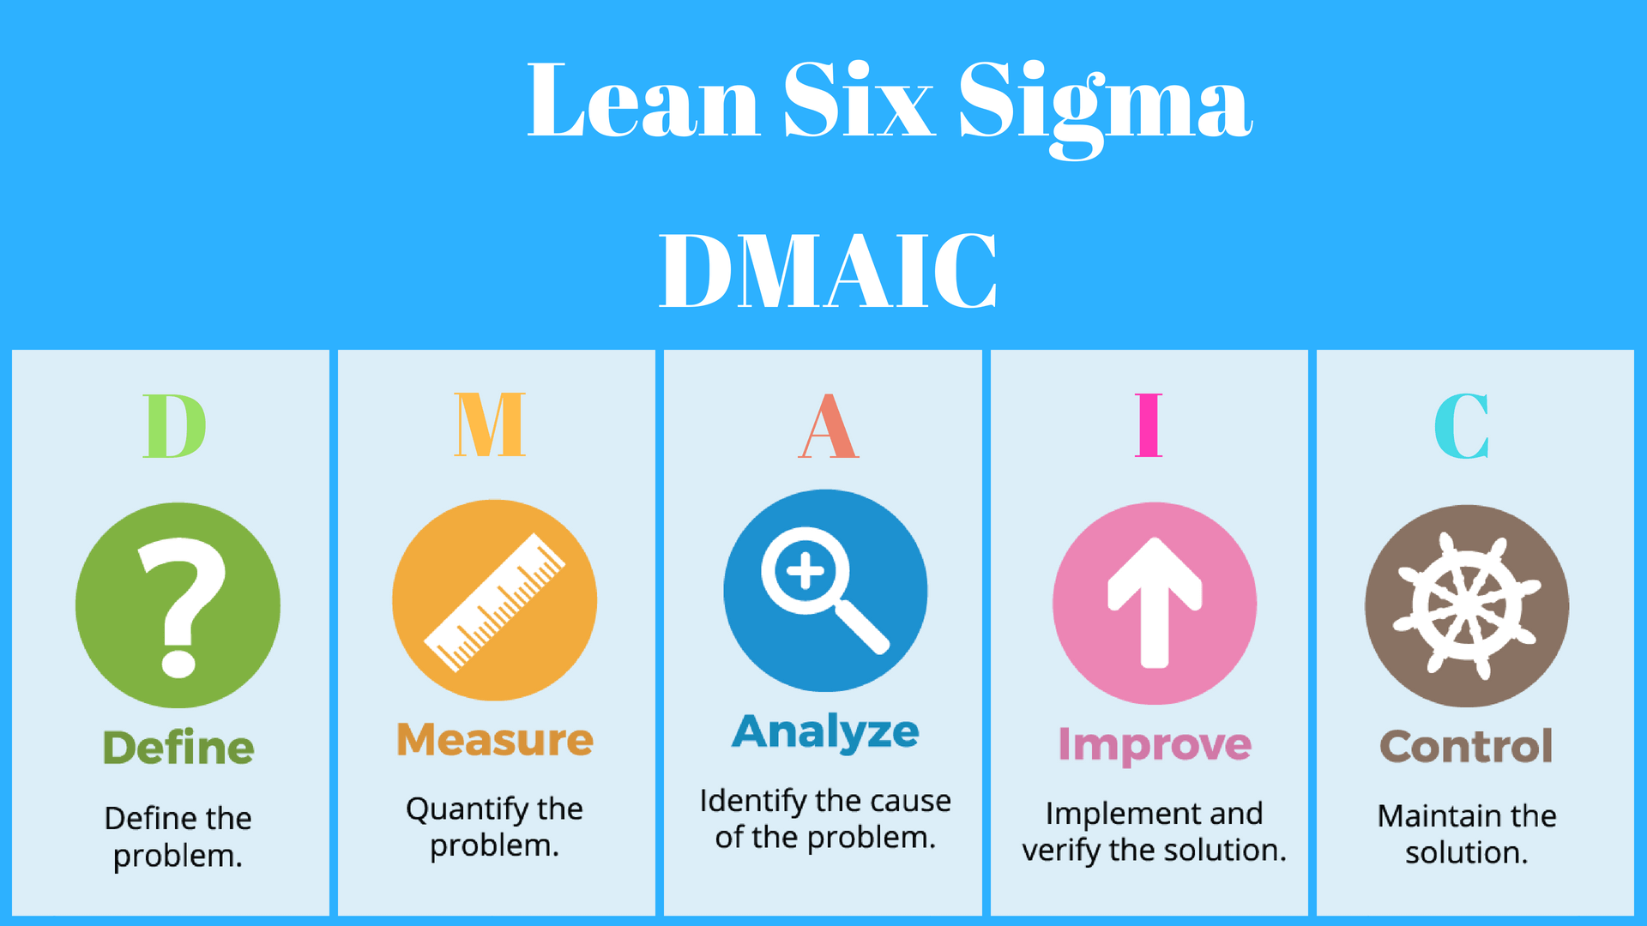

Define

The first step of the DMAIC process is to DEFINE the problem at hand. The key to this section is to ask the relevant questions to the relevant individuals to extract all stakeholders and effected peoples experiences and opinions. This can be collected by using the methods below:

- Stakeholder analysis
- Collection of the voice of the customer using the voice of the customer matrix
- Voice of the customer to critical to quality translation
- High-level process map (SIPOC diagram)

What Went Well?

When looking back to the start of the project it was clear to see that a lot of time and effort was put in by the team to define the perfect Maintainability problem within the company to take forward for improvement and complete an in depth project on. They were able to conduct brainstorming and further analysis activities on a number of different problems and whittle them down into 1 main problem. This problems was then further broken down, analysed and evaluated for its potential impact on the company if it were improved and met the specification and budgets allocated. They were then able to dig down into the most pressing maintainability issue and effectively define the exact problem at hand via the customer brief and then converted this into an industry standard product Design Specification which outlines the exact issue.

What Could Have Been Improved?

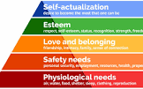
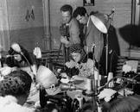
One main improvement which has been highlighted on reflection of the project is the lack of inclusion of the key stake holders from the production line. When defining the problem it is essential to have full involvement and total transparency across the project team and who the project would potentially effect. Galbraith (2018) goes on to support this by making the statement “according to one survey of more than half a million U.S. employees, almost one third don’t understand why changes are happening within the organization.” This can often be extremely detrimental to the company as, if the employees to understand the changes occurring, they will often push back against them and are not willing to take ownership of the new systems/change. The assumption should not have been made that the employees understand the driving forces for the change. A drastic improvement on the project definition phase would’ve been further surveys, brainstorming sessions and workshops conducting with the production teams to further involve them from the very start of the project. By involving them from the start it would encourage them to take ownership going forward to increase the likelihood of maintaining the gains along with them sharing valuable knowledge they have gained from significant experience running and working on the machines. This also satisfies areas of Maslows Hierachy Of Needs by boosting employees self worth and giving them the sense of love and belongingness Mcleod (2007). Although the overall solution was extremely effective, further improvements which were added after the initial pilot welder was reviewed could’ve been done up-front and avoided extra costs due to retrofitting activities which had to be undertaken. as touched on above High level process mapping could have been undertaken to better understand the movements and tasks required during the change over procedure and highlight potential wastes which may have been overlooked during this define stage. In future projects going forward time and motion studies would be undertaken during the define phase . Tarsilli (2022) talks about how time and motion studies can benefit working relationships by spending time with people to understand their day-to-day tasks and listen to their improvements, it would also highlight the non-value added tasks which could be eliminated to save time, money and effort.
Mcleod (2007)
Tarsilli (2022)

Measure

The second step of the DMAIC process is to MEASURE the scale of the defined problem at hand. The key point of this phase is where the project team begins assessing the current baseline performance of the problem, collecting and interpreting the available data on current performance. This often leads to a redefining of the problem to focus on the most pressing or ‘vital few issues.’ There are many measurement tools available for this phase, such as:

- Juran’s Pareto Analysis
- Data Collection Plan
- Detailed Process Mapping
- 6S
- Value Stream Maps

What Went Well?

Once the problem was defined and set upon, the team went and gathered a large amount of data to support the problem statement and further highlight the impact the problem is having on the company. They were able to gather live production data to measure against and gain feedback from the effected individuals on exactly the issues they face and what they think needed to be done to improve it. The utilisation of the production data was extremely effective and avoided the element of subjectivity by basing the scale of the problem from automatic data collection, not only peoples opinions. This can often mislead the team during projects, due to the fact that people often will hide their downfalls due to not having the appetite for change.

What Could Have Been Improved?

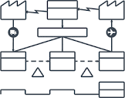
One area which could have been more effectively undertaken was that the team could have expanded on the initial process map to further highlight the wastes, which would have given them a quantifiable value to base their savings from. If a value stream mapping exercise would’ve been undertaken it would have further highlighted the non-value added tasks which could have made further improvements and increase the overall project savings. Steger (2022) goes into great detail of the benefits of Value Stream Mapping during a project and if this was to be undertaken in future projects it would aid in the identification of wastes, aligns cross-functional teams for a greater buy-in to the project, focuses the team on the right target areas and improves overall efficiency.
lucidchart.com (2022)

One further area of improvement could have been an increase in the feedback sample group. Although, all cross-functional teams were consulted and gave feedback, all members of staff affected by this could have been consulted to give a better understanding of the problem and paint a better picture. By increasing the sample number it would have given a more reliable result to base the design solution from. This is supported by Zamboni (2018) who suggest that larger sample sizes during any data collection activity allows the individual to get a more reliable average value/response, which strengthens their research and incorporates every employees input which should always be valued.

Analyse

The third step of the DMAIC process is to ANALYSE the data collected from the previous step. During this phase, the project team collects and uses data to prove theories of root cause or causes of the problem. These root causes are known as ‘Project Xs’. By the conclusion of this phase, the team will have narrowed down their multiple theories to a vital potential few root causes to test and prove true or false. Some examples of the different tools that can be utilized in this section can be found below:

- Calculating Sigma Level
- Graphs and Charts
- Brainstorming
- Stratification
- Histograms
- Box Plots
- Scatter Diagrams
- Cause and Effect Diagrams
- 5 Why Analysis
- Failure Mode and Effect Analysis
- Impact Control Matrix

What Went Well?

When all of the data was gathered the team took time to analyse it and further understand the issue at hand. This then gave them the correct knowledge and understanding to develop a solution to the problem. The utilisation of group analysis sections proved to be very beneficial and allowed all parties to have sufficient input into the data analysis.

What Could Have Been Improved?

The main downfall that can be highlighted in the project analysis phase, was the minimal data analysed. This goes back to the previous section not capturing enough data to further break down to understand the project fully. Further techniques could have been deployed within this area, which could have improved the overall result and boosted team involvement.

In future projects going forward, further recognized tools will be utilised to better understand and analyse the data generated. With SMED (single minute exchange of dies) projects, the 2 most preferred methods to incorporate would be:
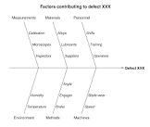
- Cause and Effect Diagrams (Ishikawa/Fishbone), The Institute of Healthcare Improvement support the use of these tools, suggesting that it aids teams in understanding the many issues that may effect the problem at handby graphically presenting all of the data. When outline the data can then be further analysed and results in the areas of improvement being more identifiable.
mindtools.com (2020)
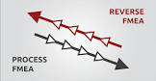
- Failure Mode Effect Analysis, Smith (2022) supports the use of this tool, due to the fact that it is a proactive tool, which allows failure modes to be identified and mitigated to an acceptable level of risk. With future projects, reverse FMEA’s would be particularly useful to highlight and challenge the current process controls and highlight how they could be further improved upon.
sneci.com (2020)

Improve

The fourth step in the DMAIC process is to IMPROVE on failure mode/problem area identified in the steps beforehand. This is when the project team begins the remedial journey and begins acting on what they have learned by making improvements. During this section, the team should have:
- Generate alternative solutions
- Design the solution (including designs for culture, and designs for control)
- Prove the effectiveness of the solution
- Implement the solution

Some useful tools for this section include:

- Brainstorming
- Solution Matrix
- Barriers and Aids Chart
- Pilot Study
- Mistake Proofing
- Benchmarking
- Pugh Matrix

What Went Well?

With a vast amount of lessons learned on the problem at hand the team were able to develop and implement a robust solution which was felt to meet all specification criteria and that was within the allocated budget. The team put a lot of time and effort into ensuring the solution was controlled during the implementation phase and had full support and buy in from the company. All activities were done safely and effectively. An extremely in depth analysis of the 3 potential solutions was undertaken considering all aspects which would have had a direct impact on the product as a whole. This area of the project set up an firm foundation to roll the project out on and gave the team a high level of confidence that the solution was the correct one for the job and overall benefits would be seen by all employees involved.

What Could Have Been Improved?

It was felt by all members on reflection that the implementation stage of the project was extremely successful. One small area for improvement would be the overall cost of the pilot welder could have been reduced by requesting a cost reduction for the bulk purchase of the units which would be retrofitted across all welders and not accepted the first cost given. Further cross-quotations could have also been gained in order to drive down further project costs. But, Packham engineering were a designated and trusted supplier for the business who have a vast amount of experience in dealing with Kautex’ style of hot plate welders.

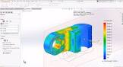
If the project were to be repeated and on future projects, Solidworks functions and tools would have been better utilised, stress analysis and further testing methods available with the software could have potentially enabled further cost reductions by using different materials at different thicknesses to give the same result as the traditional method which was very closely stuck to during this particular project. Javelin tech (2021) emphasizes the benefits by suggesting that it improves product efficiency and reduces development costs.
solidworks.com (2022)

Control

The fifth and final phase of the DMAIC process is to CONTROL the improvement. This is when the project team ensures that gains made during the improve phase are held, and the problem does not recur. To ensure this, the team needs to:

- Identify control subjects
- Establish a measurement for control
- Establish standards of performance
- Measure actual performance
- Compare actual measured performance to standards
- Take action on the difference

Tools for DMAIC Control Phase

- Process Control Plan

What Went Well?

Once implemented the team took time to properly train and validate the solution, which had been implemented. They also revised all process documentation for future reference and to act as a training aid. During the control stage they took the time to fine tune the solution and took on board the feedback from the technicians which allowed them to make slight adjustments to the design so that it was more effective and further improve the solutions compliance to the brief, from a HSE and overall improvement perspective.

What Could Have Been improved?

Although, the overall project control plan was in-depth and covered all areas, the team felt that they moved into this phase too quickly. If the project were to be repeated they decided the optimal solution would have been to remain in the implementation phase for a longer period of time and to gather the necessary data to refine the design prior to the transition into the project control phase. The reason behind this is that the control phase should’ve been where the solution had bedded in and adherence to the new process was tracked. As a posed to continuing to modify the solution throughout this stages, which caused more changes, downtime and retraining of the members of staff effected.

On projects moving forward the emphasise on the change champions who have direct impact on the process on a daily basis will be applied to fully bed in the change and ensure full participation and buy in. once the gains are in a position to be held and all directly impacted individuals accept and are supportive of the change it will ensure success and that the gains will not slip back into their old ways. Giovino (1999) states that the continuous improvement mind set is critical if changes are to be successful throughout companies.
giovino (1999)

Project Time Management

A Gantt chart is a project management tool assisting in the planning and scheduling of projects of all sizes, although they are particularly useful for simplifying complex projects. Project management timelines and tasks are converted into a horizontal bar chart, showing start and end dates, as well as dependencies, scheduling and deadlines, including how much of the task is completed per stage and who is the task owner. This is useful to keep tasks on track when there is a large team and multiple stakeholders when the scope changes.
As it's in a bar chart format it is possible to check on progress with a quick glance. You can easily see:
- A visual display of the whole project,
- Timelines and deadlines of all tasks,
- Relationships and dependencies between the various activities,
- Project phases
Project management solutions that integrate Gantt charts give managers visibility into team workloads, as well as current and future availability, which allows for more accurate scheduling. Gantt charts have been around for nearly a century, having been invented by Henry Gantt, an American mechanical engineer, around 1910.

What Went Well?

As a whole the overall project time management was very well executed. An in depth logbook was generated on a weekly basis to highlight and reflect upon the current condition of the project, how the status of the project tied in with the overall Gantt chart and what potential challenges had arisen in the previous week including what was done to overcome them in order to deliver the project goals/metrics.
The Gantt chart was very well layed out and the project report details how this developed over time and became more sophisticated as the project evolved and increased in complexity. By breaking the tasks down into quick more attainable goals the team were able to maintain a clear direction of the tasks at hand and did not become overwhelmed by the size of the project. It also maintained motivation and drive to achieve the next goal in order to progress the project into its next phase and achieve the overall objective.
The utilisation of critical path analysis was also very effective throughout the report. This tool enabled the team to maintain focus on the critical tasks to ensure that timelines were met to allow the project to be delivered within the allocated timeframe. Breaking down the implementation stage of the pilot welder into a smaller timing plan was also an extremely beneficial decision as this smaller, simplified chart could be shared with production along with external contractors who did not need to have any experience with Microsoft Project could easily see the outlined implementation plan with the removal of any subjective analysis.

What Could Have Been Improved?

Due to the fact that this was the project managers first experience using the Microsoft Project application the overall Gantt chart has the potential for further development in order to include further information to be shared within the team. Some different features which could have been of benefit and that would be used in any further projects include:
- Running a weekly project adherence report and reviewing this with the team on a bi-weekly basis to highlight any downfalls or deviations from the project plan. This would be extremely useful to maintain drive and emphasis within the team to achieve goals in a timely manner.
- The Gantt chart could’ve have been broken down into multiple views to allow the manager to track a variety of metrics from different perspectives and would allow the team to delve much deeper into specific project areas rather than a high level overall project plan.
- Increased levels of collaborated by creating a Microsoft teams folder, which would hold all of the project information in a cloud based format and allows each key stake holder to upload and contribute necessary information to the plan. This would also allow a team dashboard to be generated to further maintain focus and motivation to achieve the outline goals.

Project People Management

Without the correct involvement and buy in from employees, a Project of any scale will fail. It is extremely important that team members are engaged from the very start of the project, which allows them to gain a sense of ownership and commitment. It is extremely important that all members of the team are given an opportunity to give their input and feel involved.

What went well?

As a whole the people management was a great success throughout the project. A cross functional team was established very early on within the project through the Project Charter and this ensured the correct individuals were involved to ensure the project was sufficiently resourced. Weekly meetings enabled the team to keep a close eye on the project developments and a large amount of collaboration occurred through the design and development stages of the project to ensure all parties had their input.
The Gantt chart also played a huge part in ensuring that all individuals knew exactly what their roles and responsibilities were, this gave a visual representation of the project and allowed the team to refer to their actions and how each critical action impacted the overall project objectives.

Throughout the project there was a huge level of communication, as can be seen in the communications log and this was the main reason why the project was a success.

What Could Have Been Improved?

On reflection, one thing that could have been improved in the people management area of the project was the communication during the initial install of the pilot system. This is due to the fact that more time could have been taken to involve the engineers and technicians leading up to the installation to run through the overall design prior to implementation. If this was done the team could have avoided the snag list and addressed the issued initially seen prior to implementation.

Solutions Compliance with the product design specification

Specification Points | Does it meet the Specification | Reason
Performance/Functionality | Yes | The implemented solution gives over a 50% reduction in changeover times, as a result of simplifying the operations and reducing the volume of time-consuming steps.
Reliability | Yes | The solution ensures that every changeover cycle is within the pre-set timescale and no issues have been experienced with the pilot welder since the launch including the new modifications highlighted.
Operational Conditions | Yes | The solution has had no effect on the manual and automated welding process and has actually improved the weld quality and strength due to the new Teflon coated plates.
Scale of Operation | Yes | This solution can be retrofitted across all welders within KHE within the timescale and a further 2 welders are planned in to be modified before the end of May.
Maintenance | Yes | The solution has heavily reduced the reliance on maintenance technicians by speeding up and simplifying their involvement, with all piece parts of the system being new it has also meant that no breakdowns have been encountered since the implementation.
Cost | 1/2 | The cost of fixture implementation came in at a cost of £2300 per welder which is significantly under targeted costs and TPM also costs will be at it’s highest of £400 for the first year but will be decreased significantly in on going years due to the spare plates requiring Teflon coating.
Aesthetics | Yes | The solution encompasses all specified materials and components in accordance to the specification.
Ergonomics | Yes | The solution has no effect whatsoever on the overall on cycle time or operational conditions, the removable elements of the system (hotplates) can easily be transported by hand.
Size/Weight Restrictions | Yes | The solution attached onto original tooling carriage which does not impact tooling footprint and weighs 200Kg which is well within KHE’s lifting capabilities.
Capacity | Yes | The solution is fully standardised and will not deviate from the set standard procedure across any welders where it is implemented.
Health & Safety | Yes | The solution has all edges/materials free from burrs and sharp edges, it also does not have any impact on the push forces which were within the specified limits before the modification, the fixture also remains a 1 person lift due to the decrease in hotplate weight. All hand operations have not been effected and doesn’t increase the risk of injury when using the modified tooling.
Legislation | Yes | The solution is within compliance of the Rula and KIM recognised standards within the Kautex organisation. It also complies with all other stated regulations within the specification.
Installation | Yes | The solution only required 12 hour of operational downtime and only required 2 employees at the time on implementation. It included a full SOP update along with a full company standard risk assessment.
Disposal | Yes | All materials used are easily recyclable and require no specialist treatment.
Environmental Impact | Yes | All aspects of the solution can be recycled.
Customer requirements | Yes | No impact at customer.

Conclusion

To conclude, this has been a very large and vital project within KHE and Kautex globally. Many different techniques and people were involved within all aspects of the project in order to take it to its completion date. Overall it is felt to be a great success and milestone which the Manufacturing Team at Kautex has overcome, resulting in a very robust process being implemented and avoiding large and serious downtime and extra work for all technicians allowing them to be freed up for other maintenance tasks. All aspects of the project have gone ahead to plan with very little adjustment. Within the Automotive industries often, fast paced and frantic environment it is very often that full project completion isn’t achieved and a quick fix is implemented, but this has not been the case. Each step of the project was completed to the highest standard achievable, with little to no points missed. This is why the result was one of the most robust process improvements implemented within the business in recent times. Not often that a project is implemented with little or no comebacks but this one most certainly has. On reflection and comparison to other globally recognised methods of completing projects similar to this there have been many areas highlighted where further techniques would have been of benefit and will be taken into consideration on any future projects.

Reference List

N/A . (2019). Clear Vision Systems . Available: https://kautex.com. Last accessed 20 May 2022.
N/A . (2021). How is Lean Six Sigma DMAIC Process Defined?. Available: https://www.leansixsigma.school/how-is-lean-six-sigma-dmaic-process-defined/. Last accessed 20 May 2022.
Morgan Galbraith. (2018). Don't just tell employees about organisational change - Explain why. Available: https://hbr.org/2018/10/dont-just-tell-employees-organizational-changes-are-coming-explain-why. Last accessed 20 May 2022.
Dr Saul Mcleod. (2007). Maslow's hierarchy of needs. Available: https://www.simplypsychology.org/maslow.html. Last accessed 20 May 2022.
Anthony Tarsilli. (2022). Time and motion study - benefits beyond the numbers . Available: https://minset.com/time-motion-study/. Last accessed 20 May 2022.
Dr Steger. (2022). Benefits of value stream mapping. Available: https://www.techsolve.org/value-stream-mapping-benefits/. Last accessed 20 May 2022.
N/A . (2022). What are your value stream mapping needs?. Available: https://www.lucidchart.com/pages/value-stream-mapping. Last accessed 20 May 2022.

Jon Zamboni. (2018). Advantages of a large sample size. Available: https://sciencing.com/advantages-large-sample-size-7210190.html. Last accessed 20 May 2022.
N/A . (2022). Cause and Effect Analysis. Available: https://www.mindtools.com/pages/article/newTMC_03.htm. Last accessed 20 May 2022.
N/A . (2020). Reverse FMEA. Available: https://www.sneci.com/blog/new-training-module-reverse-fmea-methodology/. Last accessed 20 May 2022.
James M. Giovino . (1999). Holding the gains in quality improvement . Available: https://www.aafp.org/fpm/1999/0500/p29.html. Last accessed 20 May 2022.

Appendices

Appendix 1 – Full DMAIC Project Report

Appendix 2 – Final Gantt Chart

