8/14/2026
Databases and Application Development - ACCA5026
Lecturer: Fahad Ahmed
Higor Scaffi Dutra do Nascimento-2413595
University of wales trinity saint david – East london
Contents
PART A – MedAssist Clinic Database Design and Implementation 2
Introduction 2
Aim 4
Objectives 4
MySQL Environment 4
Requirements Analysis 5
Business Requirements 5
Functional Requirements 5
Non-Functional Requirements 5
Justification for Using a Relational Database 6
Database Design 6
Entity Relationship Diagram (ERD) 6
Entity Design 7
Relationships 8
Database Normalisation 8
ER Diagram from phpMyAdmin Designer. 9
Database Implementation 9
Table Creation 10
Integrity Constraints 13
Sample Data 13
Implementation Summary 14
Advanced Database Features 14
Stored Procedures 14
Transaction Management 17
Database Triggers and Auditing 19
Performance Tuning Enhancement 20
PART B – GameVault Database-Driven Website 22
Database Design 22
System Implementation 22
Home Page and Game Catalogue 23
Administrator Authentication and Dashboard 24
Administrator Dashboard 24
CRUD Functionality 25
Search Functionality 29
SQL Injection and Security 30
SQL Injection Defence 31
Security Testing 32
Conclusion and Reflection 34
References (IEEE) 35

PART A – MedAssist Clinic Database Design and Implementation

Introduction
Relational databases provide a structured approach to storing, organising and retrieving information while maintaining relationships and data integrity. When combined with server-side web technologies, databases can also support interactive applications that allow users to access and manage information dynamically. This assignment demonstrates these principles through two practical projects involving database design, implementation and web development.
Part A focuses on the design and implementation of a relational database for MedAssist Clinic. The system was developed using MySQL and phpMyAdmin to manage patients, doctors, departments, appointments, treatments and patient feedback. The database applies normalisation, primary and foreign keys, integrity constraints, stored procedures, transaction management, triggers and indexing. These features demonstrate how relational database techniques can support reliable data management, maintain consistency and improve query performance [1]–[4].
Part B extends these database principles through the development of GameVault, a database-driven video game catalogue created using HTML, CSS, PHP and MySQL. Public users can browse and search game records, while authenticated administrators can perform Create, Read, Update and Delete (CRUD) operations. PHP Data Objects (PDO) prepared statements are used when processing user-controlled data to reduce the risk of SQL Injection.
Together, both parts demonstrate the progression from designing and implementing a relational database to integrating a database with a functional web application. The report presents the design decisions, implementation methods, testing procedures, performance considerations and security measures used throughout the development process.

Aim
The aim of this project is to design and implement a relational database management system for MedAssist Clinic that supports patient management, appointment scheduling, treatment recording and patient feedback while ensuring data integrity, consistency and efficient database performance.

Objectives
The objectives of this project are to:
- analyse the operational requirements of MedAssist Clinic;
- design a normalised relational database using an Entity Relationship Diagram (ERD);
- implement the database using MySQL and phpMyAdmin;
- establish relationships through primary and foreign keys;
- populate the database with representative sample data;
- implement stored procedures, triggers and transaction handling;
- improve query performance through indexing;
- evaluate the completed database against the project requirements.

MySQL Environment
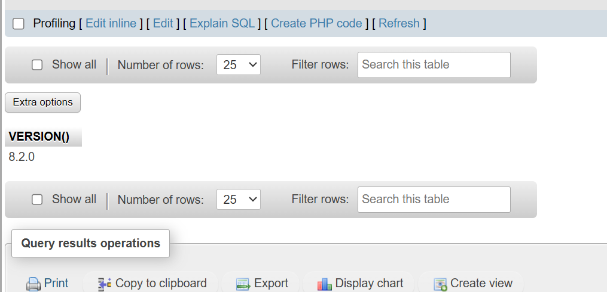

Figure 1: Verification of the MySQL 8.2.0 database server used to develop the MedAssist Clinic database.

Requirements Analysis
The first stage of the project involved analysing the operational requirements of MedAssist Clinic to determine the information that needed to be stored and how different business processes interact. Understanding these requirements was essential for designing a database capable of supporting the clinic's daily activities while maintaining data integrity and reducing duplication [1], [2].

Business Requirements
MedAssist Clinic required a centralised database to manage patient information, medical staff, appointments, treatments and patient feedback. The database needed to replace manual record management with a structured system capable of storing accurate information and supporting efficient retrieval by authorised users. In addition, relationships between patients, doctors and appointments had to be maintained to ensure that medical records remained complete and consistent throughout the system.

Functional Requirements
Based on the case study, the database was designed to provide the following functions:
- register and maintain patient records;
- manage doctors and their assigned departments;
- schedule appointments between patients and doctors;
- record diagnoses, prescriptions and treatment notes;
- collect patient feedback after consultations;
- support Create, Read, Update and Delete (CRUD) operations;
- implement transaction handling to ensure reliable appointment booking.
These requirements formed the foundation of the database structure and influenced the entities, attributes and relationships identified during the design stage.

Non-Functional Requirements
Alongside the functional requirements, several non-functional requirements were considered during development. Data integrity was maintained through the use of primary keys, foreign keys and validation constraints, preventing invalid or inconsistent records from being stored. The database was also designed to support multiple users and provide efficient query performance through indexing of frequently searched columns. Transaction management using COMMIT and ROLLBACK further improved reliability by ensuring that incomplete operations could not leave the database in an inconsistent state [3].

Justification for Using a Relational Database
A relational database was selected because the clinic's information naturally consists of related entities, including patients, doctors, appointments and treatments. Using tables connected through primary and foreign keys allows these relationships to be managed efficiently while reducing data redundancy through normalisation. MySQL was chosen because it provides reliable support for relational database management together with advanced features such as stored procedures, triggers and transactions, all of which are required to satisfy the project specification [1], [3].

Database Design
The design of the MedAssist Clinic database was based on the business requirements identified during the analysis stage. The objective was to produce a relational database capable of storing operational data efficiently while maintaining integrity and reducing redundancy. The database was modelled using an Entity Relationship Diagram (ERD), allowing the relationships between entities to be defined before implementation. This structured approach helps ensure that the database accurately represents the clinic's workflow and supports future scalability [1], [2].

Entity Relationship Diagram (ERD)
The ERD provides a visual representation of the database structure by identifying the entities, their attributes and the relationships between them. For MedAssist Clinic, the database consists of six operational entities—Department, Doctor, Patient, Appointment, Treatment and Feedback together with an AuditLog table used to record changes made by database triggers.
Each entity represents a specific part of the clinic's daily operations, while the relationships ensure that related information can be linked without unnecessary duplication.
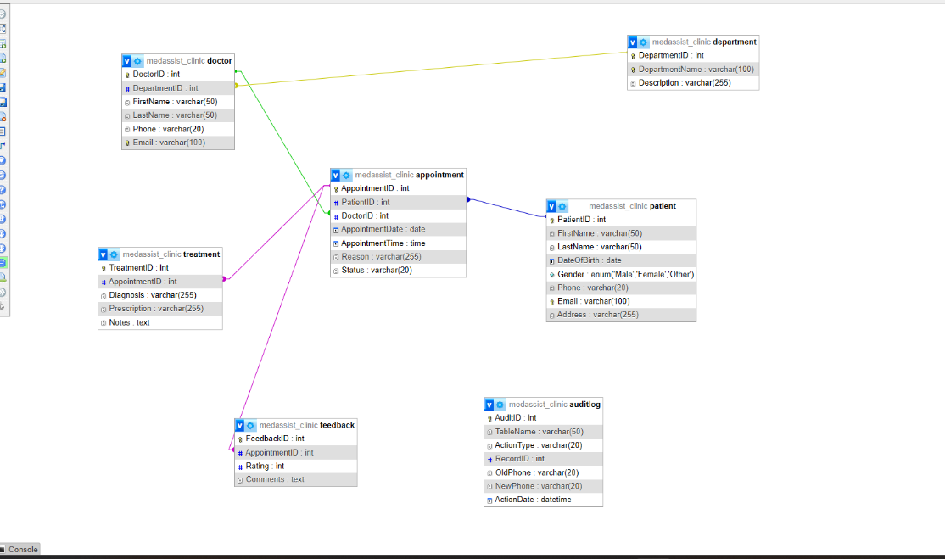

Figure 2. Entity Relationship Diagram (ERD) illustrating the relationships between the MedAssist Clinic database tables.
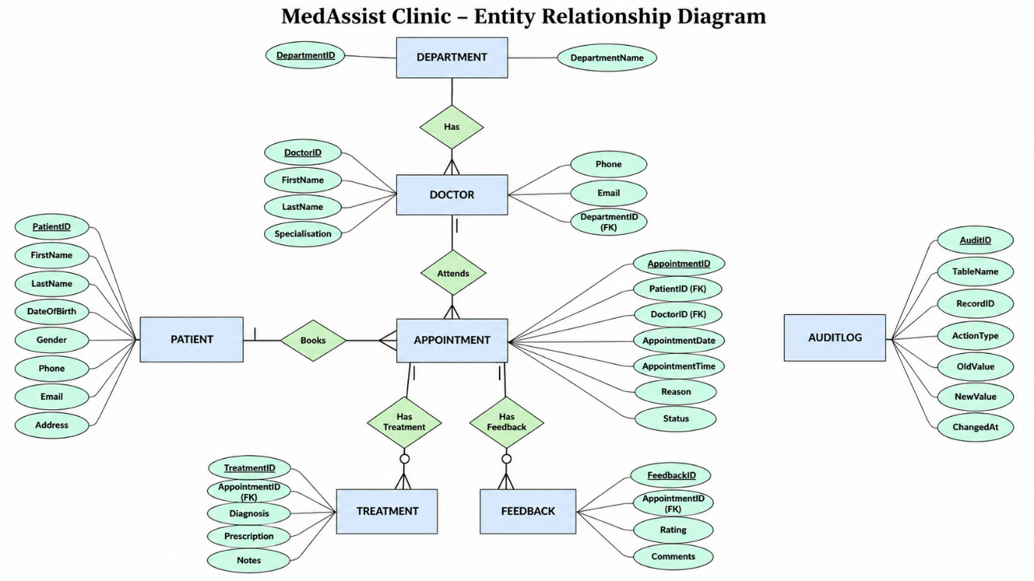
Figure 2.1: Entity Relationship Diagram (ERD) for the MedAssist Clinic database, showing the main entities, attributes, primary and foreign keys, and relationships using Crow’s Foot cardinality notation.

Entity Design
Each entity was designed to store a single type of information, reducing redundancy and improving maintainability.
The Department entity stores the different medical departments available within the clinic, such as General Medicine and Dermatology. Each department is uniquely identified by DepartmentID.
The Doctor entity stores information relating to medical professionals. Every doctor belongs to one department, creating a one-to-many relationship between the Department and Doctor tables.
The Patient entity stores demographic and contact information for registered patients. Patient details are stored independently from appointment records so that personal information only needs to be maintained in one location.
The Appointment entity acts as the central link within the database by connecting patients and doctors. Each appointment records the consultation date, appointment time, reason for the visit and appointment status.
The Treatment entity stores the outcome of each consultation, including diagnosis, prescribed medication and clinical notes. Finally, the Feedback entity records patient ratings and comments following completed appointments.
An additional AuditLog table was implemented to support trigger-based auditing. Unlike the other entities, this table records system-generated information rather than business data.

Relationships
Relationships between tables were established using primary and foreign keys to maintain referential integrity. One department can have many doctors, while one doctor can attend many appointments. Similarly, one patient may have multiple appointments throughout their treatment history. Each appointment may also have one associated treatment record and one feedback record.
Implementing these relationships ensures that records remain connected while preventing orphaned data. For example, an appointment cannot be created unless both the patient and doctor already exist within the database [1], [3].

Database Normalisation
The database was normalised to Third Normal Form (3NF) to minimise redundancy and improve consistency. Each table contains atomic values, satisfying First Normal Form (1NF). Second Normal Form (2NF) was achieved by ensuring that all non-key attributes depend entirely on the primary key. Finally, Third Normal Form (3NF) was satisfied by separating related information into individual tables so that non-key attributes depend only on the primary key and not on other non-key attributes [1], [2], [4].
Applying normalisation simplified data maintenance and reduced the possibility of update anomalies. For example, department information is stored only once within the Department table rather than being repeated for every doctor assigned to that department.

ER Diagram from phpMyAdmin Designer.
First Normal Form (1NF)
The database satisfies First Normal Form because each table contains atomic values, with no repeating groups or multivalued attributes. Every row is uniquely identified by a primary key, and each attribute stores only a single value.
Second Normal Form (2NF)
Second Normal Form was achieved by ensuring that every non-key attribute is fully dependent on its primary key. Since each table uses a single-column primary key, partial dependencies were eliminated during the design process.
Third Normal Form (3NF)
Third Normal Form was achieved by removing transitive dependencies. Information relating to departments, doctors, patients, appointments, treatments and feedback is stored in separate tables, ensuring that non-key attributes depend only on their respective primary keys. This design reduces data redundancy while improving data consistency and simplifying future database maintenance [1], [2].

Database Implementation
The MedAssist Clinic database was implemented using MySQL 8.2.0 through phpMyAdmin within the UniServer local development environment. The implementation followed the database design developed during the planning stage by creating the database, defining the required tables, establishing relationships through primary and foreign keys, and applying integrity constraints. This structured approach ensured that the database accurately reflected the clinic's operational requirements while maintaining data consistency [1], [3].
The database was created using the SQL CREATE DATABASE statement before implementing each table individually. Once the database had been established, the remaining SQL scripts were executed to define the database schema and prepare the system for data entry.
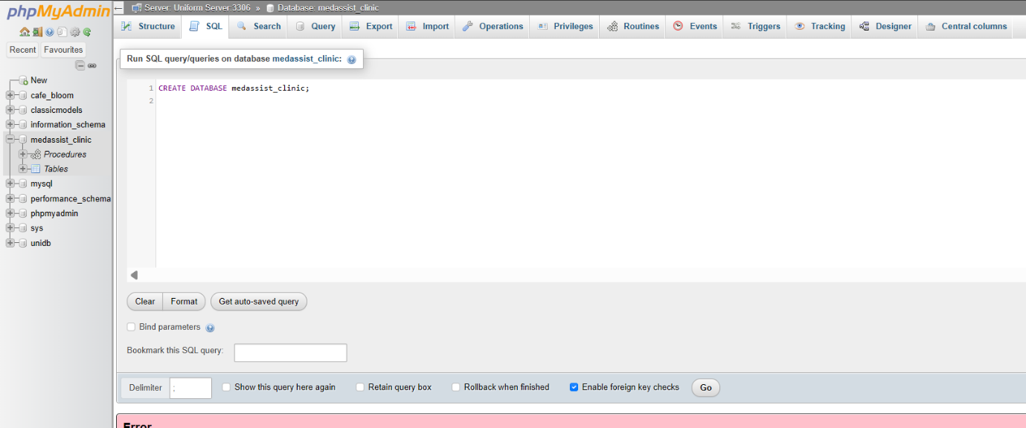
Figure 3. Creation of the MedAssist Clinic database in phpMyAdmin.

Table Creation
Seven tables were created to support the clinic's operations: Department, Doctor, Patient, Appointment, Treatment, Feedback, and AuditLog. Each table was designed to store a specific type of information, ensuring that data remained organised and avoiding unnecessary duplication.
The Department table stores the medical departments available within the clinic and provides the basis for organising doctors according to their speciality.
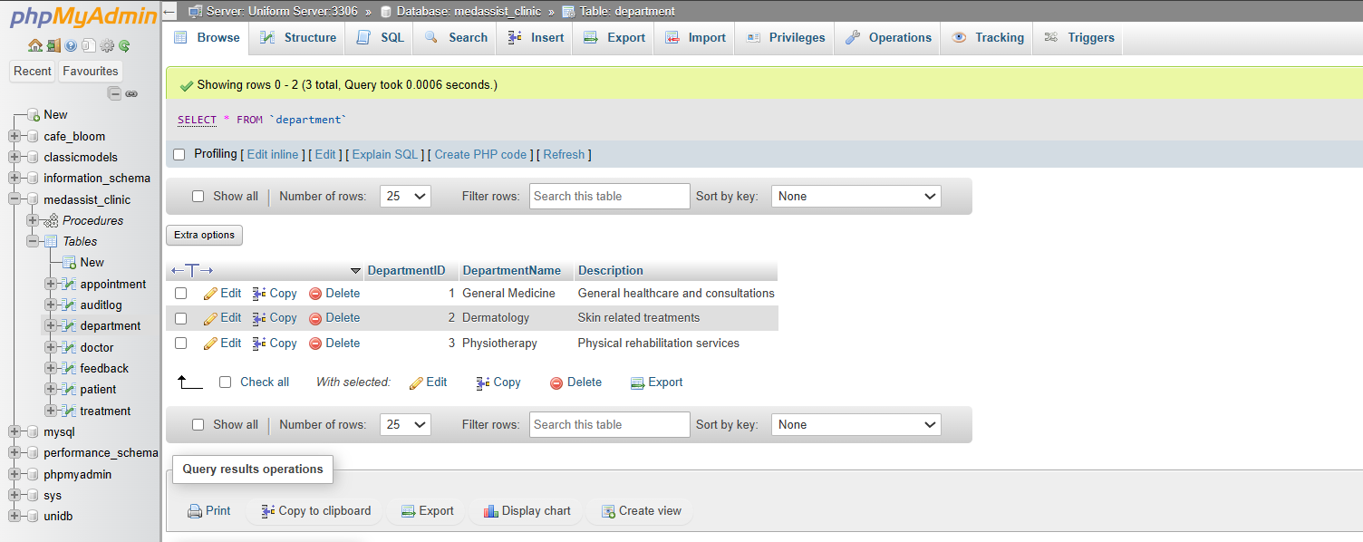
Figure 4. Structure of the Department table.

The Doctor table stores information relating to medical staff. A foreign key links each doctor to a department, ensuring that every doctor is assigned to a valid department.
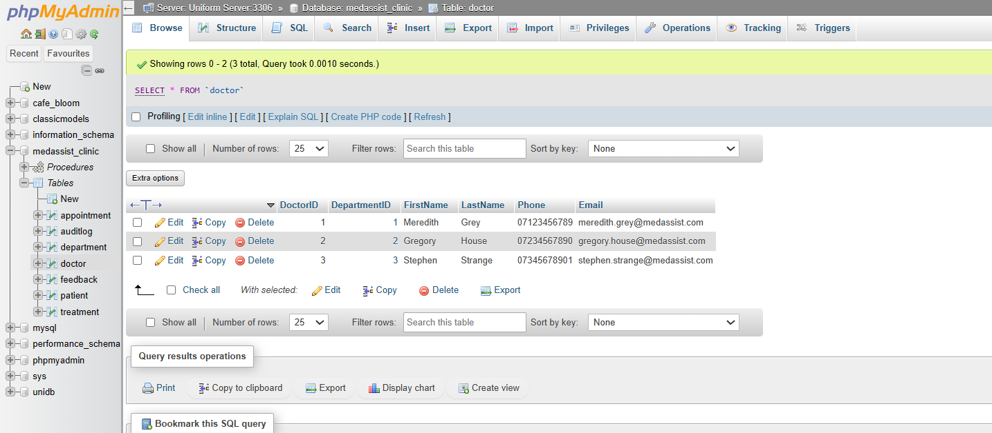
Figure 5. Structure of the Doctor table.
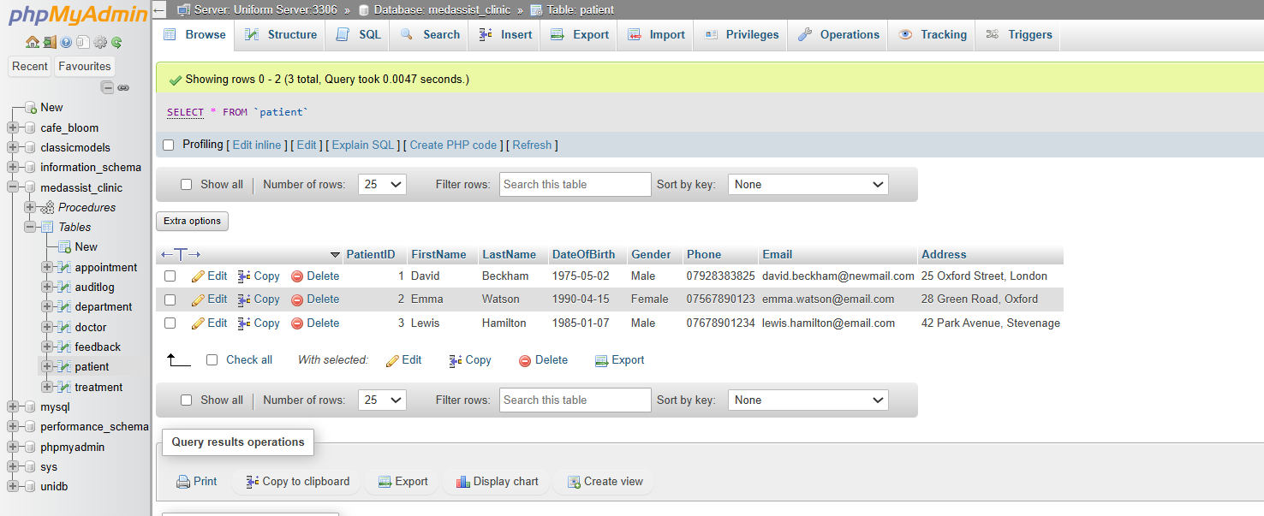
The Patient table stores patient demographic and contact details. A unique patient identifier allows each record to be referenced by appointments while maintaining patient information separately from consultation records.
Figure 6. Structure of the Patient table.
The Appointment table connects patients and doctors by recording consultation dates, appointment times, reasons for visits and appointment status.
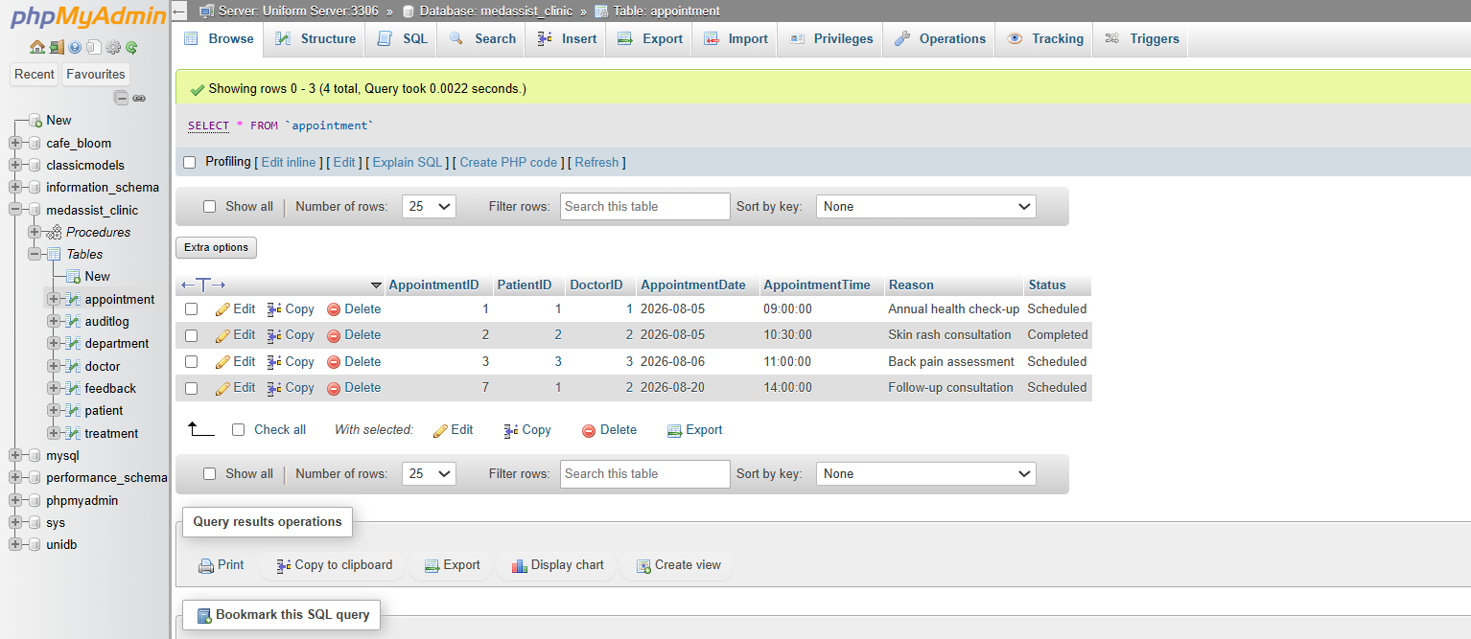
Figure 7. Structure of the Appointment table.
Following each consultation, diagnosis and treatment information is stored within the Treatment table, while patient satisfaction ratings and comments are stored within the Feedback table.
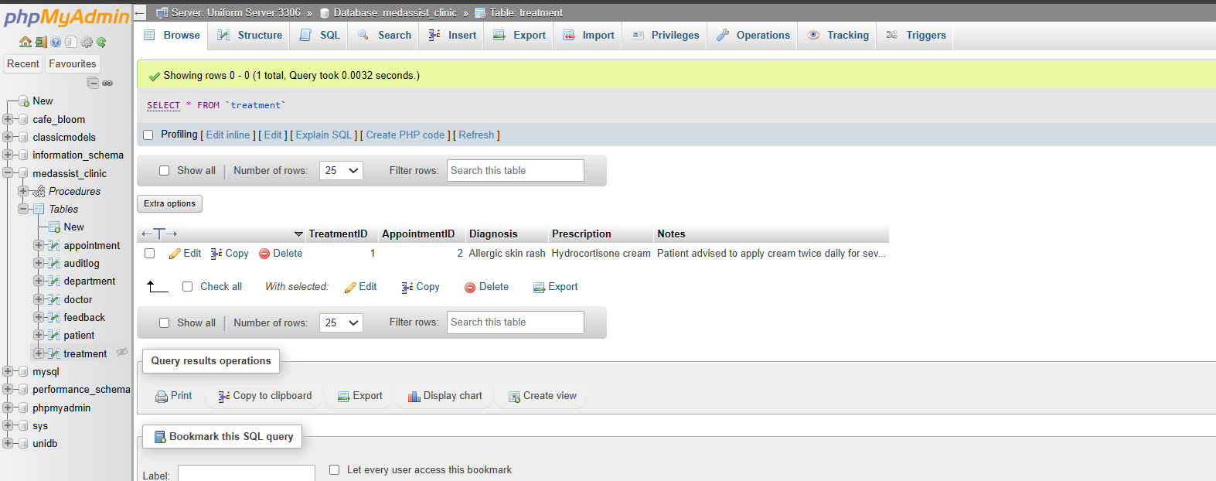
Figure 8. Structure of the Treatment table.
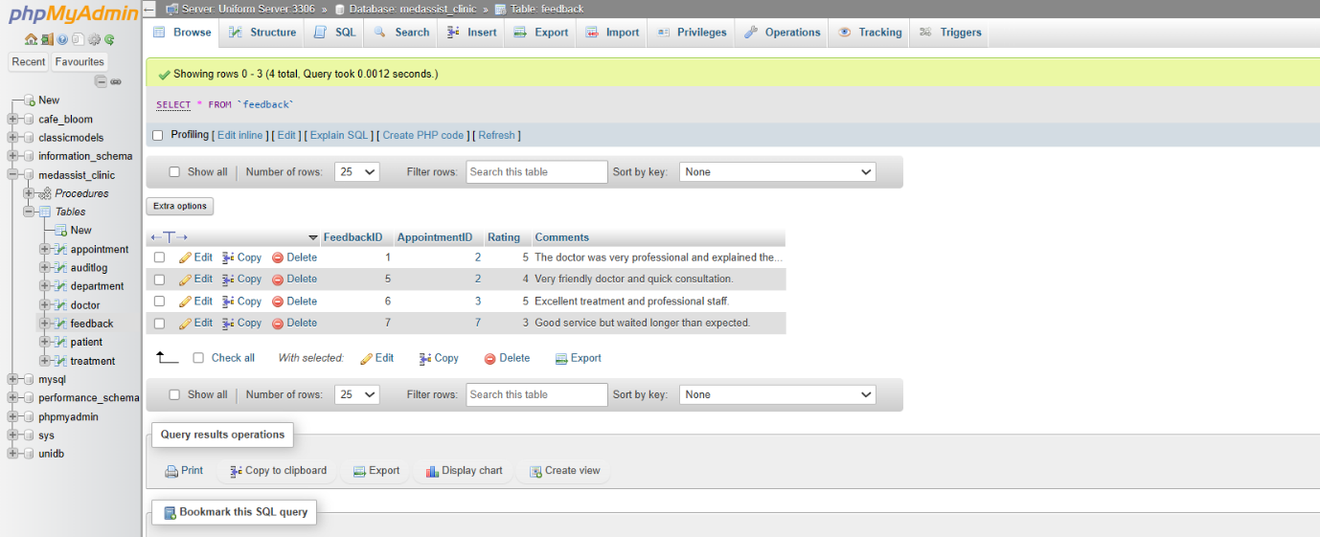Figure 9. Structure of the Feedback table.

Integrity Constraints
To maintain data accuracy, several integrity constraints were implemented during table creation. Every table includes a primary key, ensuring that each record can be uniquely identified. Foreign key constraints were then used to establish relationships between related tables, preventing invalid references from being inserted into the database [2], [4].
Validation rules were also applied using CHECK constraints where appropriate. For example, appointment status values were restricted to predefined options, while patient feedback ratings were limited to values between one and five. These constraints help reduce data entry errors and ensure that only valid information is stored within the database.

Sample Data
After the database structure had been completed, representative sample data was inserted into each table. The dataset included departments, doctors, patients, appointments, treatments and patient feedback, allowing the database to simulate the daily operations of a healthcare clinic.
The sample records were subsequently used to test table relationships, SQL queries, stored procedures and transaction processing. Using realistic data made it possible to verify that relationships between tables operated correctly and that information could be retrieved accurately through SQL JOIN queries.

Implementation Summary
The implementation stage successfully translated the database design into a working relational database. By combining structured table creation with integrity constraints and representative sample data, the completed database provides a reliable foundation for the advanced features discussed in the following chapter, including stored procedures, transaction management, database triggers and performance optimisation.

Advanced Database Features
To improve database reliability and automate common operations, several advanced MySQL features were implemented within the MedAssist Clinic database. These include stored procedures, transaction management and database triggers. Together, these features reduce repetitive SQL code, improve data integrity and ensure that critical operations are executed safely and consistently [1], [3], [5].

Stored Procedures
Stored procedures were developed to automate the Create, Update and Delete (CRUD) operations for patient records. Three procedures were implemented: AddPatient, UpdatePatient and DeletePatient. Each procedure accepts input parameters, executes the required SQL statement and uses transaction handling to ensure that changes are either completed successfully or cancelled if an error occurs. Implementing stored procedures centralises business logic within the database, improving code reusability and reducing the risk of inconsistent SQL operations [1], [5].
The AddPatient procedure inserts a new patient into the Patient table after validating the supplied information. If the insertion is completed successfully, the transaction is committed. Otherwise, the transaction is rolled back to prevent incomplete records from being stored.
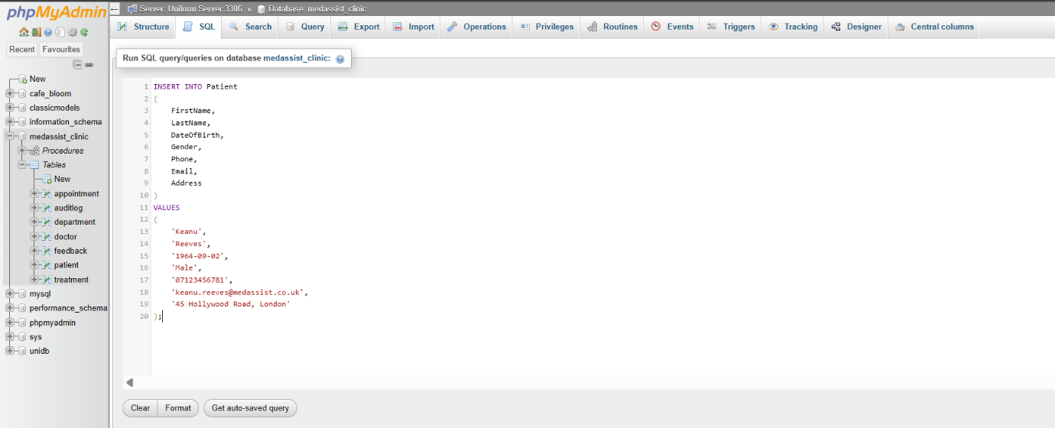
Figure 10. SQL implementation of the AddPatient stored procedure.
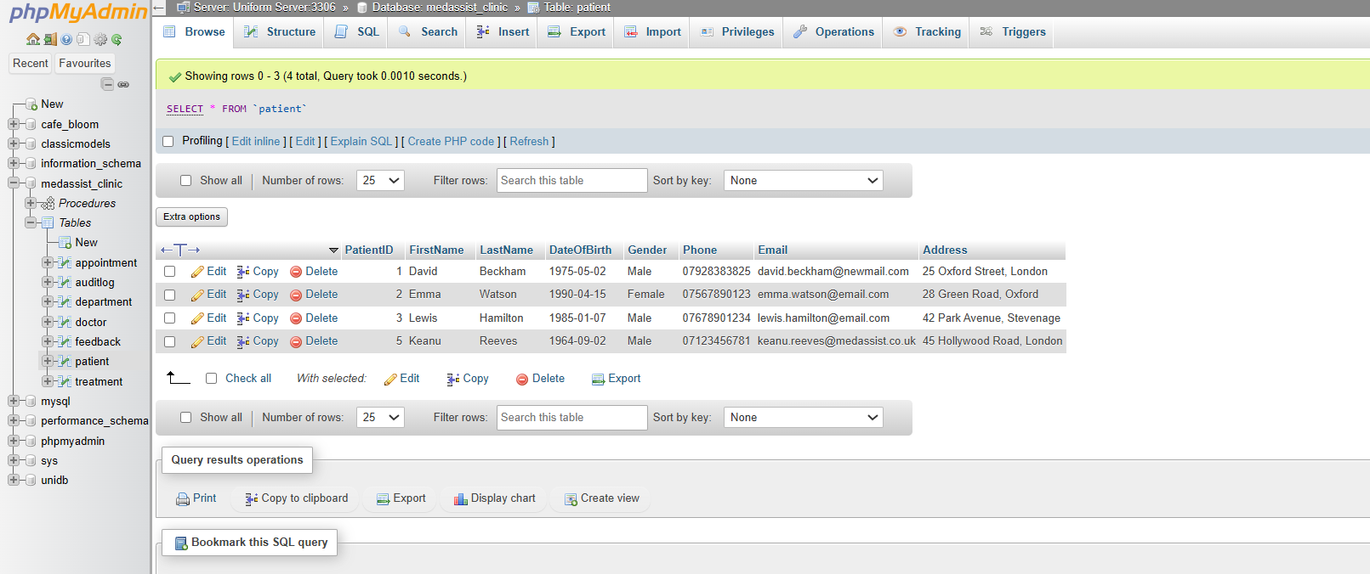
Figure 11. Successful execution of the AddPatient stored procedure.

The UpdatePatient procedure modifies an existing patient's information using the patient identifier supplied as a parameter. Similarly, the DeletePatient procedure removes patient records only when referential integrity is maintained, preventing the deletion of records that are linked to existing appointments.
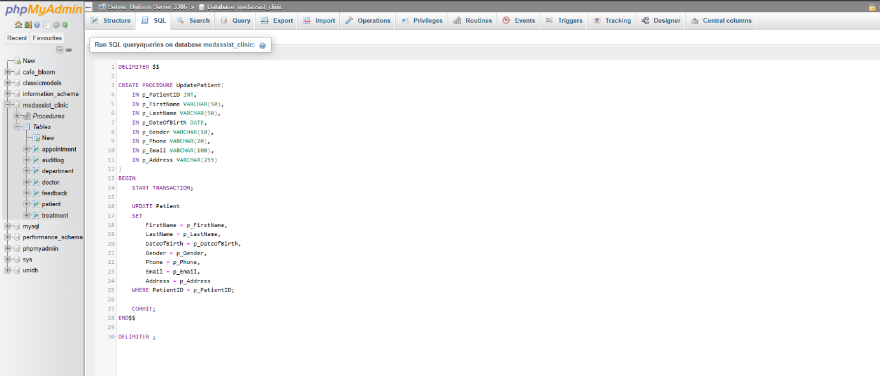Figure 12. SQL implementation of the UpdatePatient stored procedure.
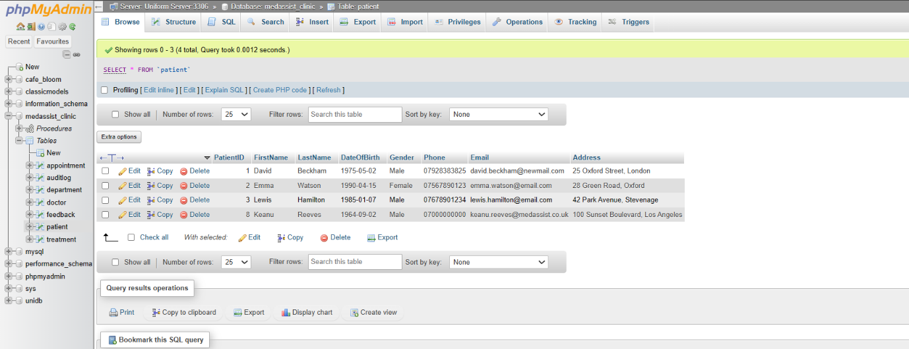
Figure 13. Patient record after executing the UpdatePatient procedure.
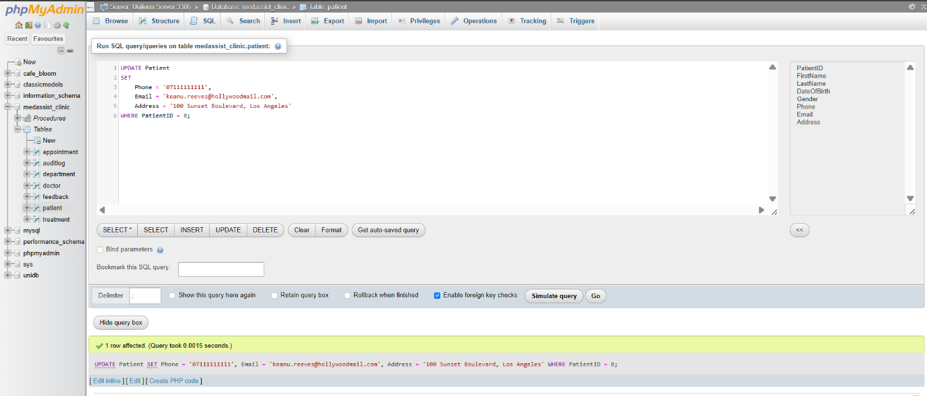
Figure 14. SQL implementation of the DeletePatient stored procedure.
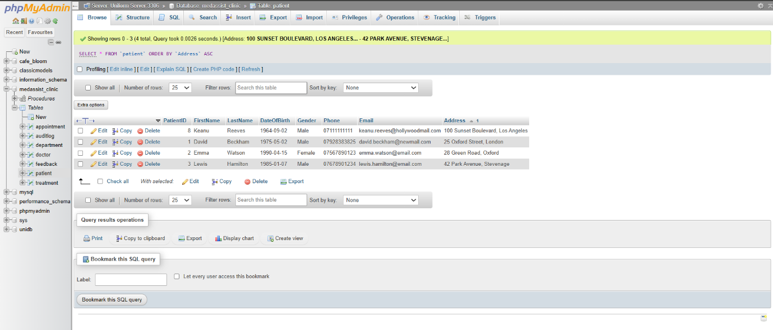
Figure 15. Patient table after successful execution of the DeletePatient procedure.
The successful execution of these procedures confirmed that patient records could be inserted, updated and deleted while preserving database consistency. Using stored procedures also simplifies application development because database operations can be performed through reusable routines instead of repeatedly writing SQL statements [3], [5].

Transaction Management
Transaction management was implemented to ensure that multiple database operations are completed as a single logical unit of work. The BookAppointment stored procedure demonstrates this functionality by verifying that both the patient and doctor exist before creating a new appointment. If either validation fails, the transaction is rolled back automatically, preventing incomplete or invalid records from being inserted into the database [4], [6].
During testing, a valid appointment booking completed successfully and the transaction was committed.
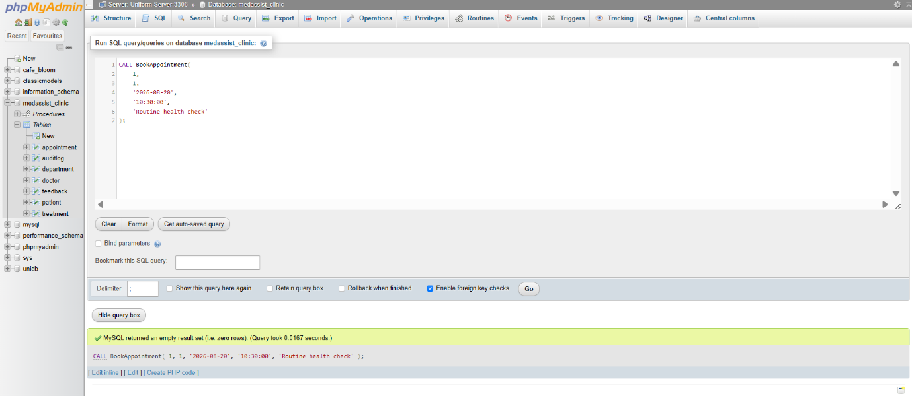
Figure 16. Successful execution of the BookAppointment transaction.
A second test deliberately used an invalid PatientID. As expected, the validation failed and the stored procedure executed a ROLLBACK, ensuring that no appointment record was added to the database.
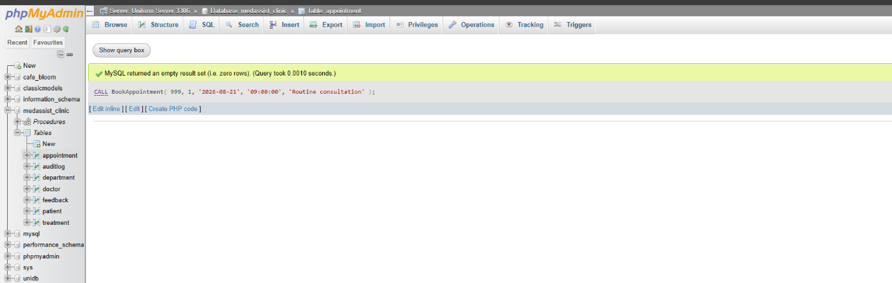
Figure 17. Failed transaction demonstrating automatic rollback.
The Appointment table was then examined to confirm that the failed transaction had not inserted any additional records.
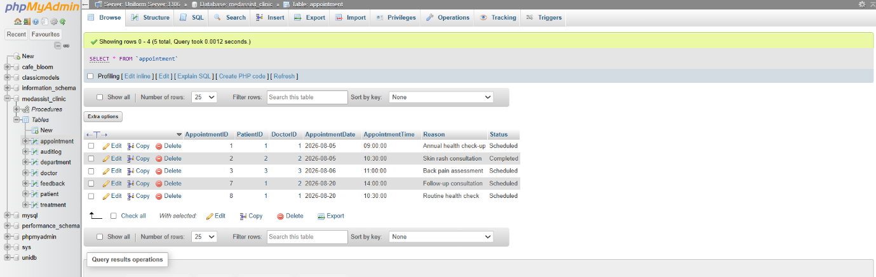
Figure 18. Appointment table after transaction rollback.
This implementation demonstrates how transaction processing protects data integrity by ensuring that all related operations either succeed together or fail together, satisfying the principles of reliable database management [4], [6].

Database Triggers and Auditing
To provide automatic monitoring of database changes, an AFTER UPDATE trigger named trg_Patient_Update was created on the Patient table. Whenever a patient's contact details are modified, the trigger automatically records the change in the AuditLog table, including the previous value, the updated value and the date and time of the modification [5], [7].
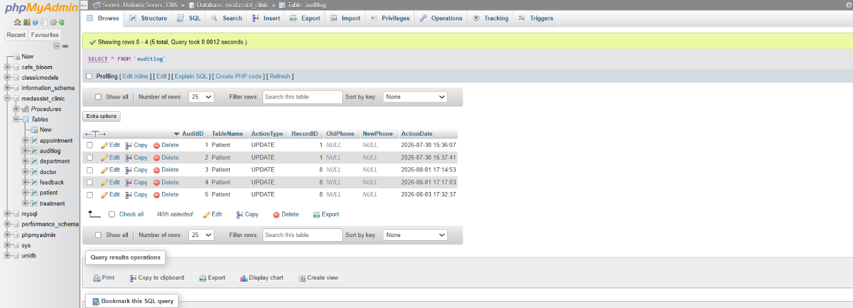
Figure 19. Structure of the AuditLog table.
The trigger was tested by updating a patient's phone number using the UpdatePatient stored procedure. Following the update, a new audit record was automatically generated, confirming that the trigger executed correctly without requiring manual intervention.
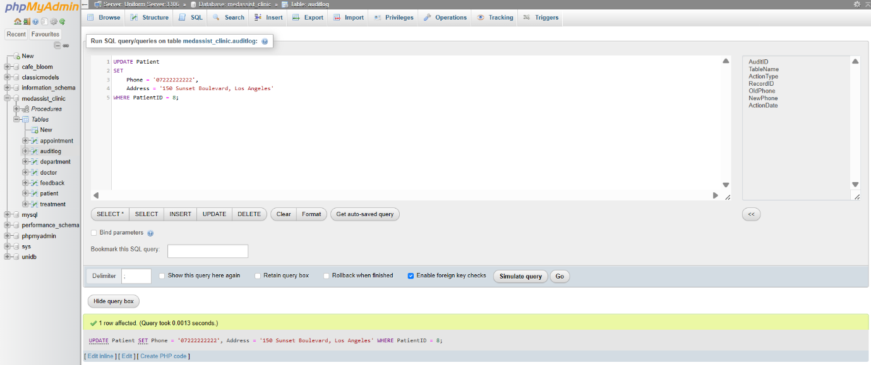Figure 20. Audit log recording changes made to patient information.
The implementation of audit logging improves accountability by maintaining a history of important database changes. Although the current implementation records updates to patient contact details, the same approach could be extended to other tables within the database to support more comprehensive auditing and monitoring.

Performance Tuning Enhancement
Efficient query performance is an important consideration in database design, particularly when managing increasing volumes of data. As the number of patients, appointments and treatments grows, searching large tables without optimisation can reduce system performance. To improve data retrieval, several secondary indexes were created on attributes expected to be searched frequently during the daily operation of MedAssist Clinic [1], [3], [8].
The indexing strategy was based on anticipated user activity within the clinic. A composite index was created on the LastName and FirstName columns of the Patient table to improve searches performed by reception staff when locating patient records. Additional indexes were created on the AppointmentDate column within the Appointment table and the DepartmentID column within the Doctor table to optimise appointment scheduling and department-based queries.
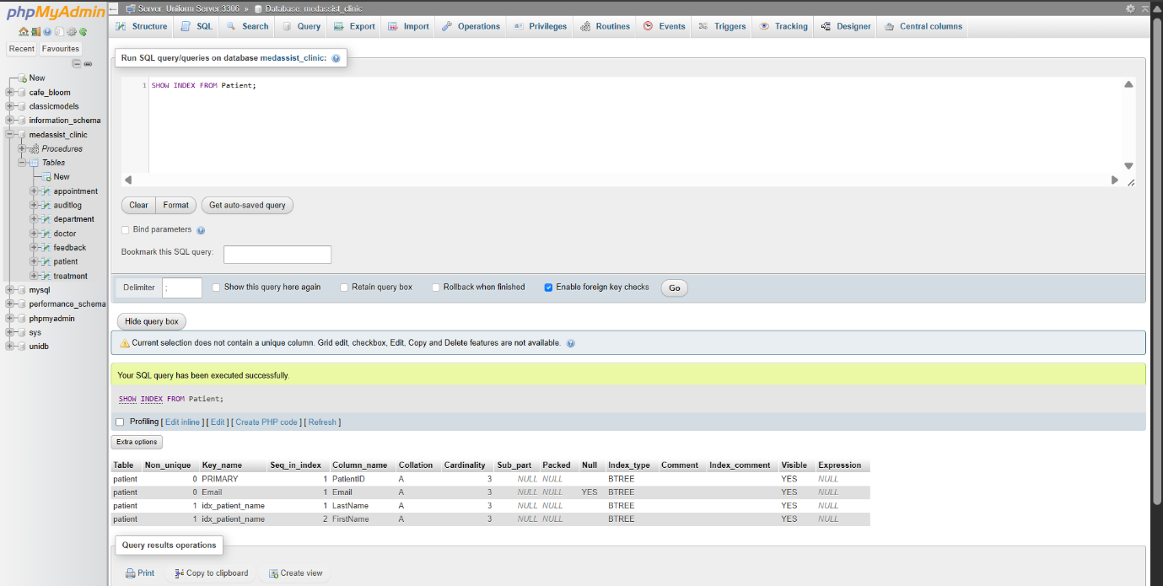
Figure 21. Indexes created on the Patient table using the SHOW INDEX statement.
To evaluate the effectiveness of the indexing strategy, a query was executed to retrieve appointments scheduled for a specific date. Since the AppointmentDate attribute was indexed, MySQL was able to use the index when locating the required records instead of performing a full table scan.
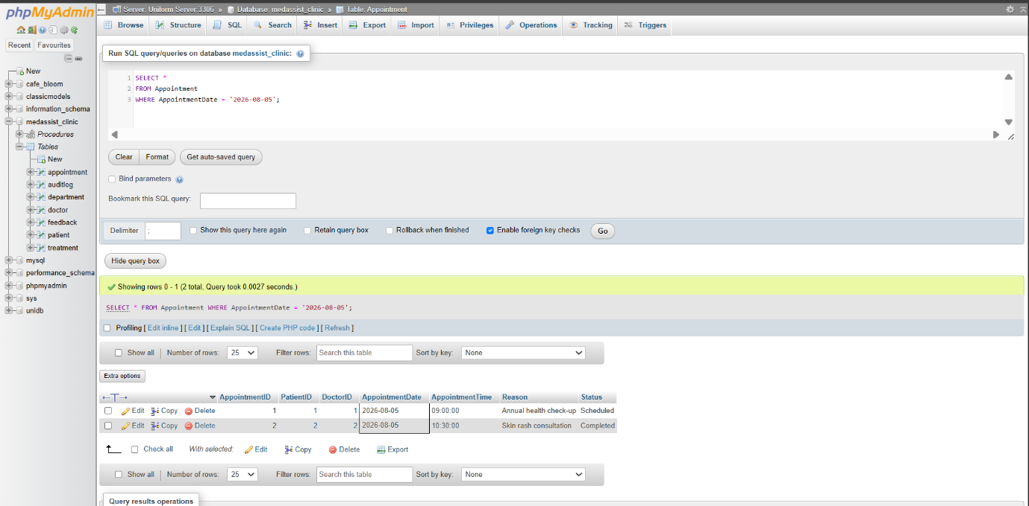
Figure 22. Query retrieving appointments by appointment date.
The query execution plan was analysed using the SQL EXPLAIN statement. The output confirmed that MySQL selected the idx_appointment_date index during query execution. Using the index reduces the number of rows examined and improves query efficiency, particularly when the database contains a much larger volume of appointment records.
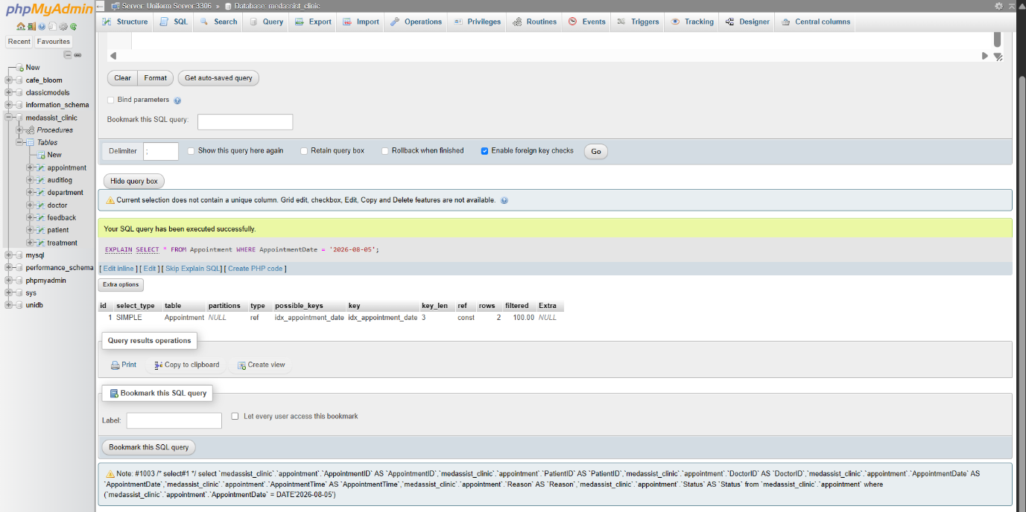Figure 23. EXPLAIN output confirming the use of the idx_appointment_date index.
Although the current database contains only sample data, implementing indexes demonstrates good database design practice and prepares the system for future growth. Careful index selection improves query performance while avoiding unnecessary overhead caused by indexing columns that are rarely searched. This balance contributes to a more efficient and scalable database solution [2], [4], [8].

PART B – GameVault Database-Driven Website

Database Design
GameVault uses a relational MySQL database containing four tables: Admin, Games, Developers and Genres. The Games table is the central table and references Developers and Genres through foreign keys. This structure reduces unnecessary duplication and maintains relationships between game information [2].
The Admin table stores credentials used by the authentication system. The Developers and Genres tables store information that can be associated with multiple game records, while the Games table stores the main catalogue information. SQL JOIN operations are used to combine related game, developer and genre information when records are displayed.
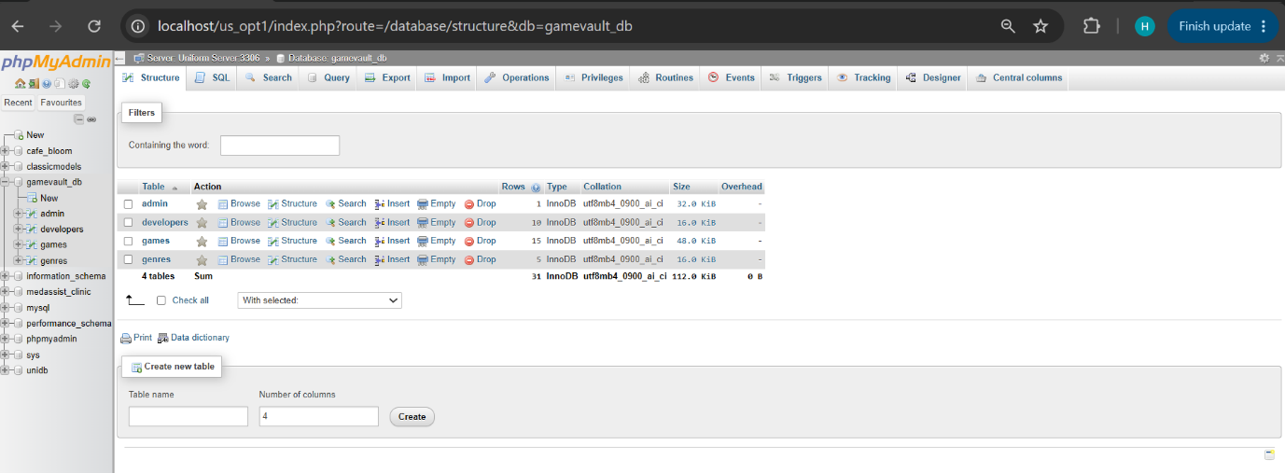
Figure 24. Database structure of the GameVault database showing the Admin, Games, Developers and Genres tables.

System Implementation
GameVault was implemented as a database-driven web application using HTML, CSS, PHP and MySQL. PHP provides the server-side functionality required to communicate with the database, process requests and dynamically generate content. PHP Data Objects (PDO) are used to connect PHP to MySQL and execute database operations. PDO also supports prepared statements and parameterised queries [10].
The application provides two levels of functionality. Public users can view and search the video game catalogue, while authenticated administrators can access Create, Read, Update and Delete (CRUD) operations. CRUD represents the fundamental operations used to create and maintain persistent database records [4].

Home Page and Game Catalogue
The home page acts as the main public interface of GameVault. Navigation links provide access to the Home, Administrator and Search Games sections.
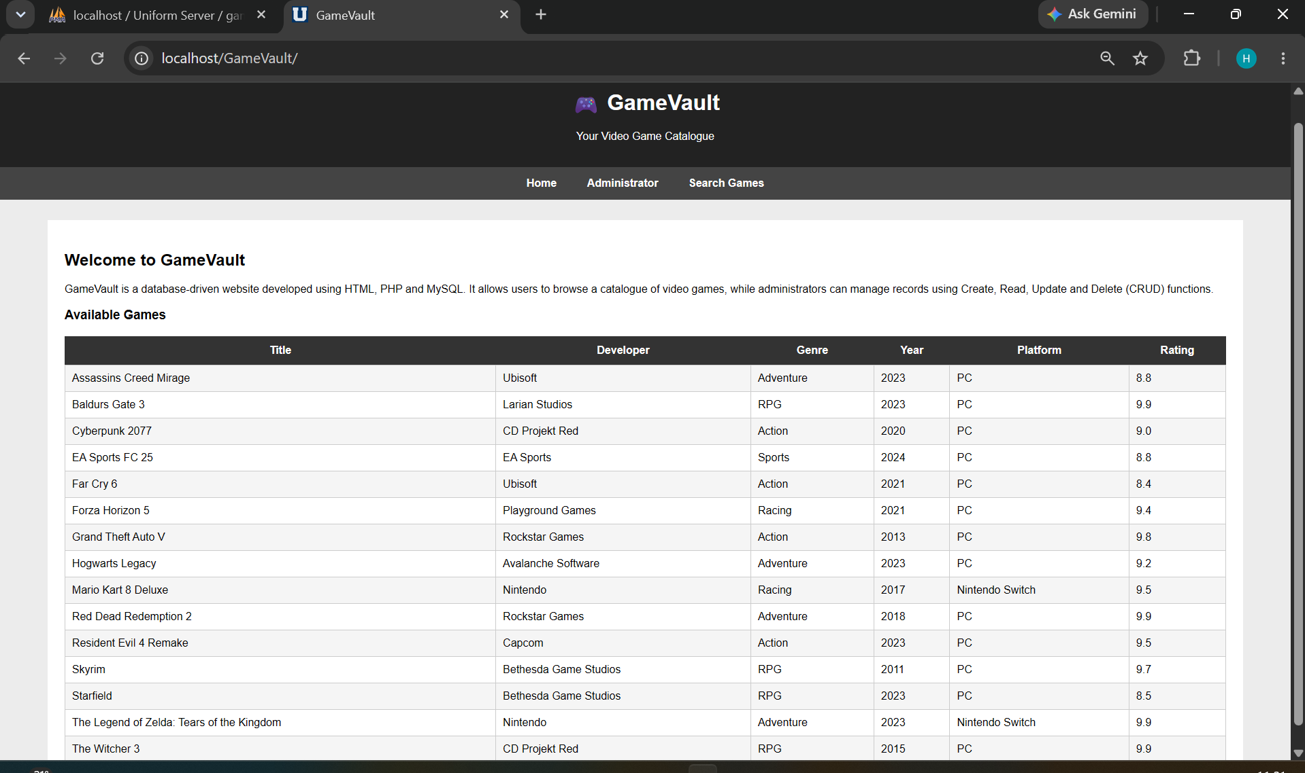
Figure 25. GameVault home page displaying the video game catalogue retrieved from the MySQL database.
The available games are displayed dynamically in a table containing the title, developer, genre, release year, platform and rating. The records are not manually entered into the HTML page. Instead, PHP retrieves them from MySQL each time the catalogue is loaded.
An SQL SELECT statement combined with INNER JOIN operations retrieves related information from the Games, Developers and Genres tables. The DeveloperID and GenreID foreign keys allow the application to obtain the corresponding names while maintaining a normalised relational structure [2].
CSS is used to control the presentation of the interface, including the header, navigation menu, content area and tables. Using an external stylesheet separates presentation from the underlying HTML content and makes the visual design easier to maintain [15].
The successful retrieval and display of database records demonstrate the Read operation of CRUD.

Administrator Authentication and Dashboard
Administrative functionality is restricted through a login system because operations that modify database records should only be available to authorised users. Authentication verifies the identity of a user before protected functionality is made available [13].
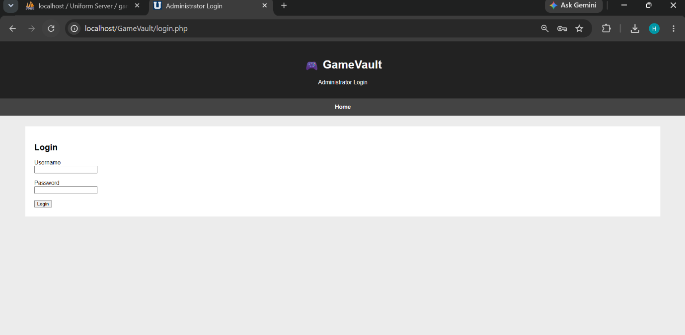
Figure 26. Administrator login interface used to restrict access to GameVault management functions.
Following successful authentication, a PHP session is created. PHP sessions allow information to be maintained between requests using the $_SESSION mechanism [9].
Protected administration pages check whether the administrator session exists before displaying their content. If an unauthenticated user attempts to access the dashboard directly, the application redirects the request to the login page.

Administrator Dashboard
Following successful authentication, the administrator is redirected to the GameVault dashboard.
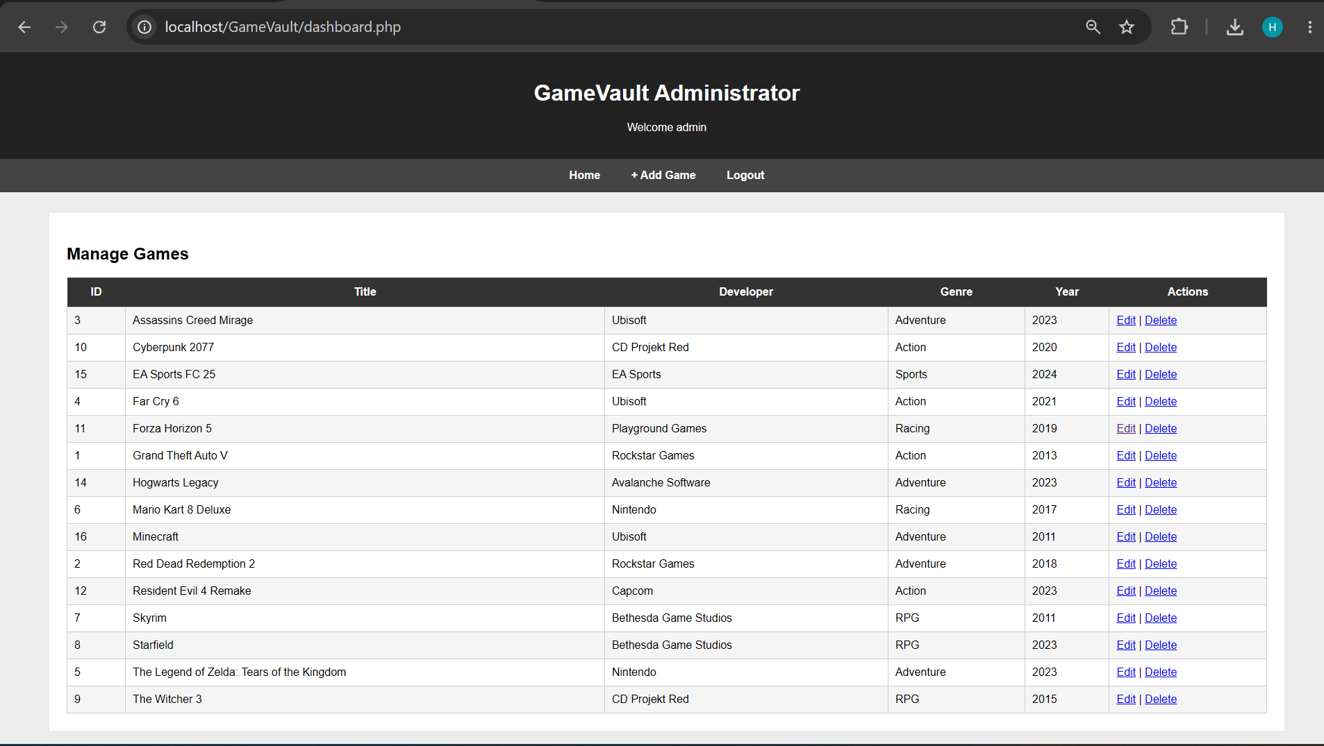
Figure 27. GameVault administrator dashboard displaying game records and management options.
The dashboard retrieves the existing game records and displays them in a table. Each record provides Edit and Delete controls, while an Add Game option allows new records to be created.
A logout function is also available. Logging out ends the authenticated session and returns the user to the public area. Appropriate session termination is an important aspect of web session management [14].

CRUD Functionality
The administrator interface implements Create, Read, Update and Delete (CRUD) functionality, allowing authorised users to manage GameVault records without directly accessing phpMyAdmin.
Create
The Add Game function allows an administrator to insert a new video game into the database. The form collects information including title, developer, genre, release year, platform and rating.
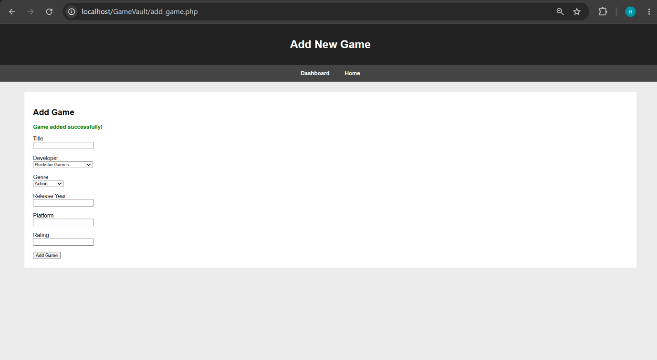Figure 28. Successful addition of a new game record through the administrator interface.
The insertion is performed using a PDO prepared statement. Parameterised statements allow input values to be supplied separately from the SQL command, reducing the risk that user-controlled values will be interpreted as executable SQL [10].
Update
Existing records can be modified using the Edit option. The selected GameID identifies the required record and its existing information is loaded into the edit form.
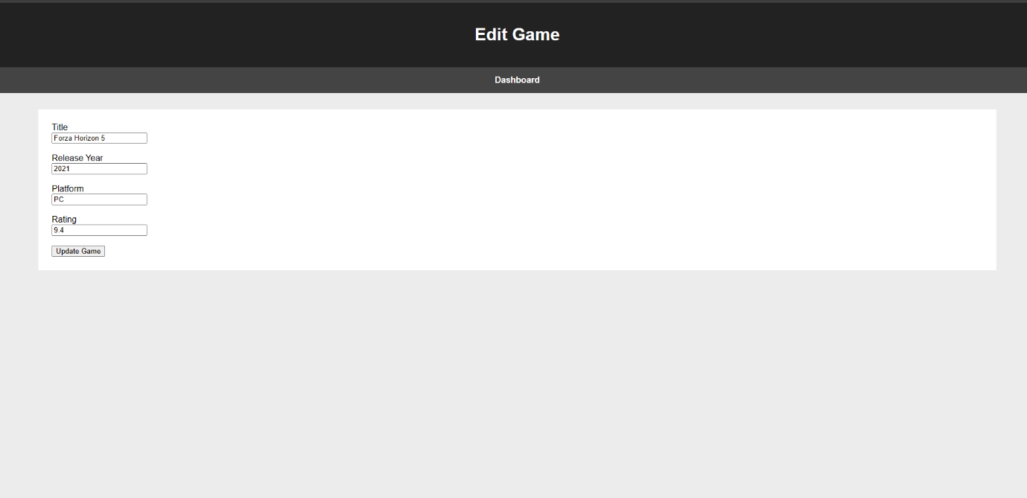
Figure 29. Administrator interface used to modify an existing game record.
After the administrator submits the changes, an SQL UPDATE operation saves the new values.
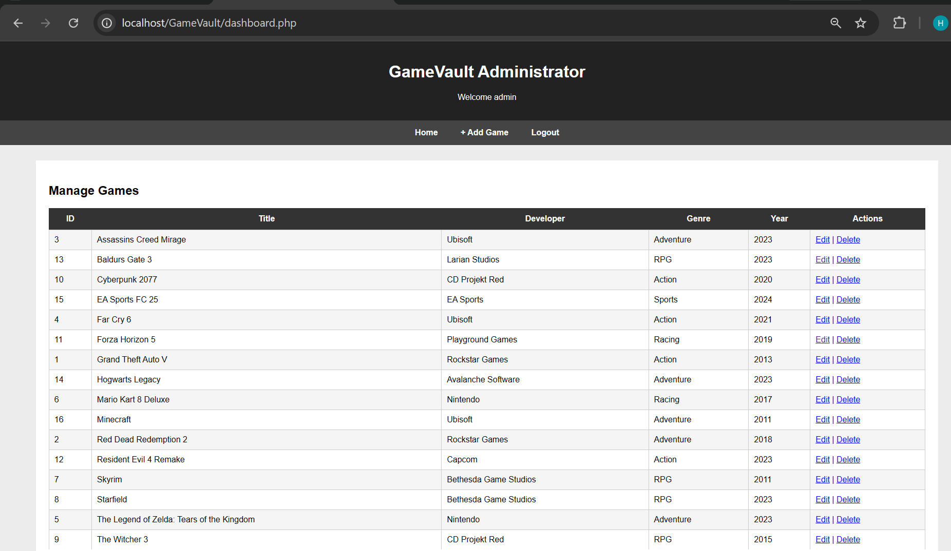
Figure 30. Updated game record displayed on the administrator dashboard.
Prepared statements are also used when processing the updated values, keeping the supplied data separate from the SQL statement [10].
Delete
The Delete function allows an administrator to remove an unwanted game record. Before deletion takes place, a confirmation dialog is displayed to reduce accidental removal.
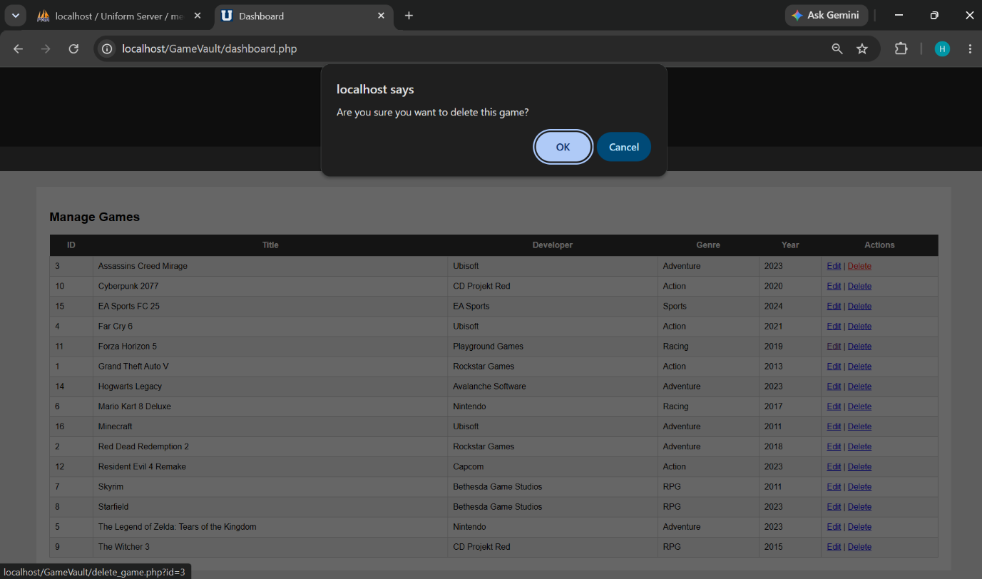
Figure 31. Confirmation dialog displayed before deleting a game record.
After confirmation, the selected GameID is supplied to the deletion script and a parameterised SQL DELETE statement removes the corresponding record.
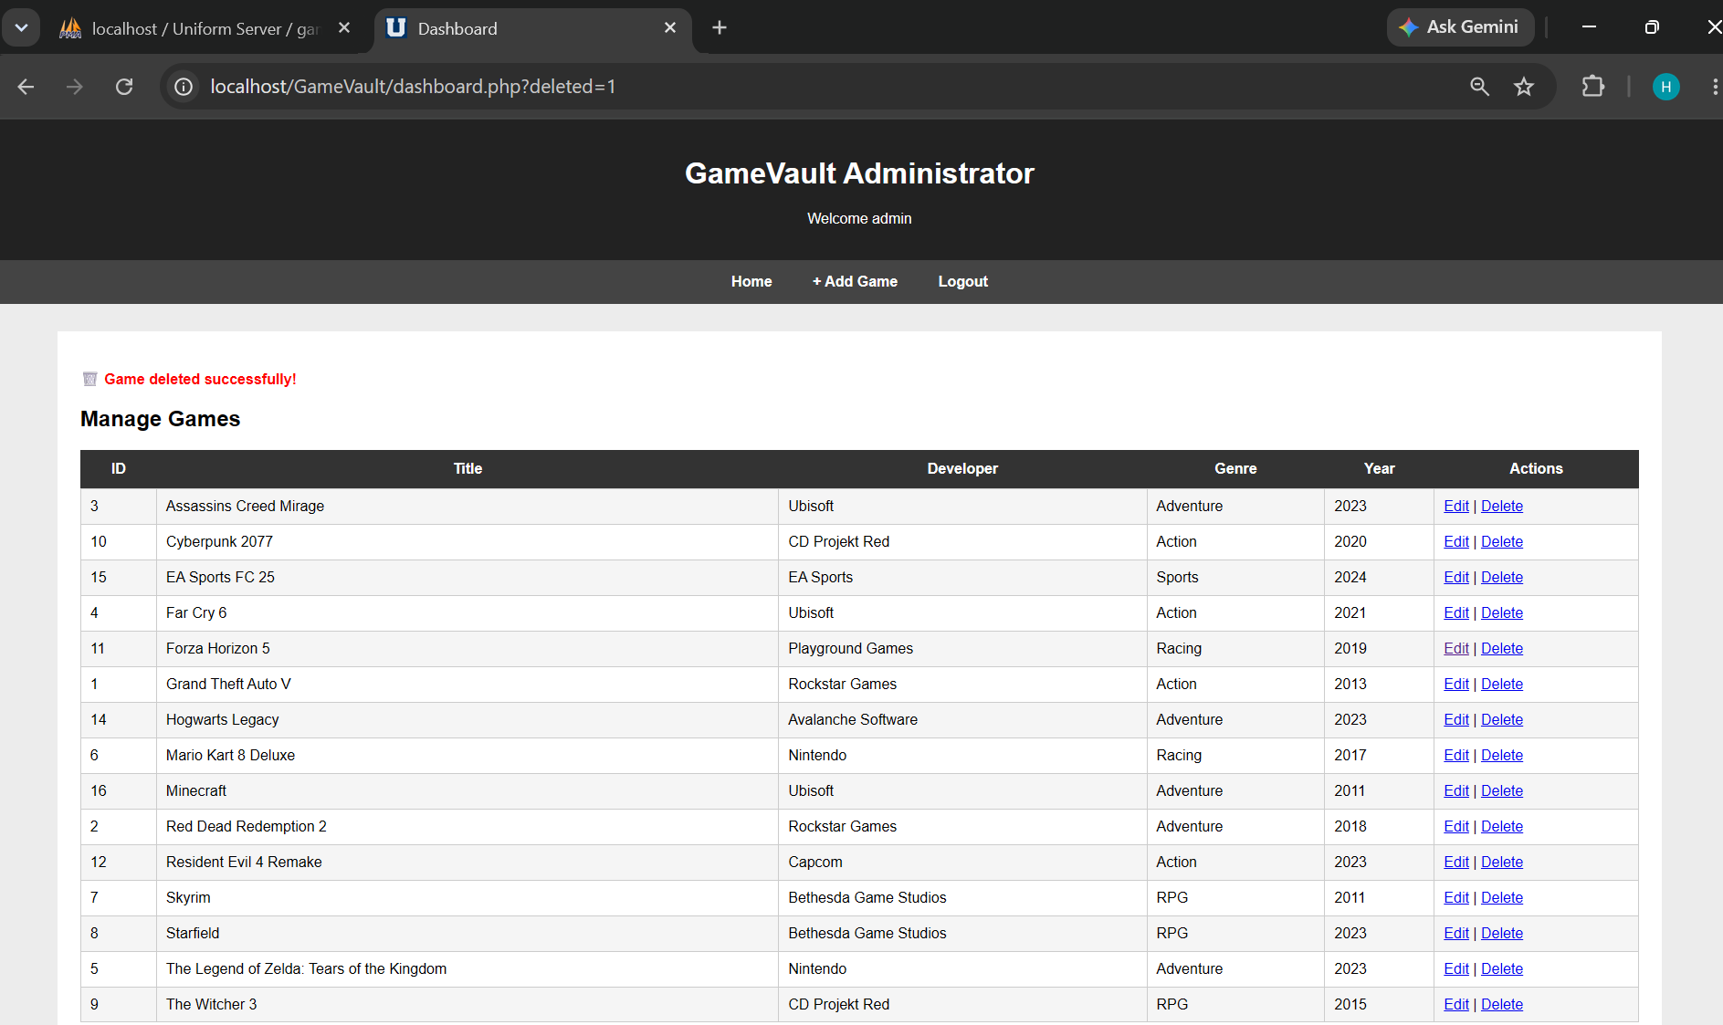
Figure 32. Administrator dashboard confirming successful deletion of a game record.
Together with the catalogue and dashboard, these operations demonstrate all four CRUD functions required by the website specification.

Search Functionality
A search facility was implemented to allow users to filter the GameVault catalogue by game title. This allows users to locate relevant records without manually browsing the complete catalogue.
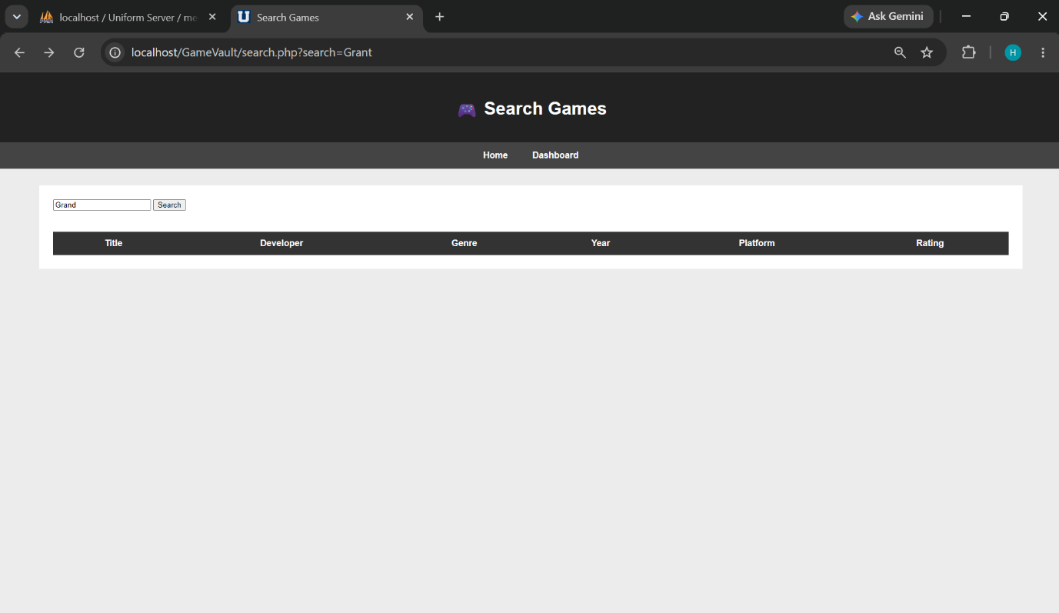
Figure 33. GameVault search interface allowing users to search the catalogue by title.
The search page accepts part or all of a game title. PHP receives the submitted value and executes a parameterised query using the SQL LIKE operator. Wildcards allow partial matches to be returned.
The query also joins the Games, Developers and Genres tables so that complete information about matching games can be displayed. Importantly, the search term is processed using a PDO prepared statement rather than being directly concatenated into the SQL query. Prepared statements are recommended as an important defence against SQL Injection [10], [11].
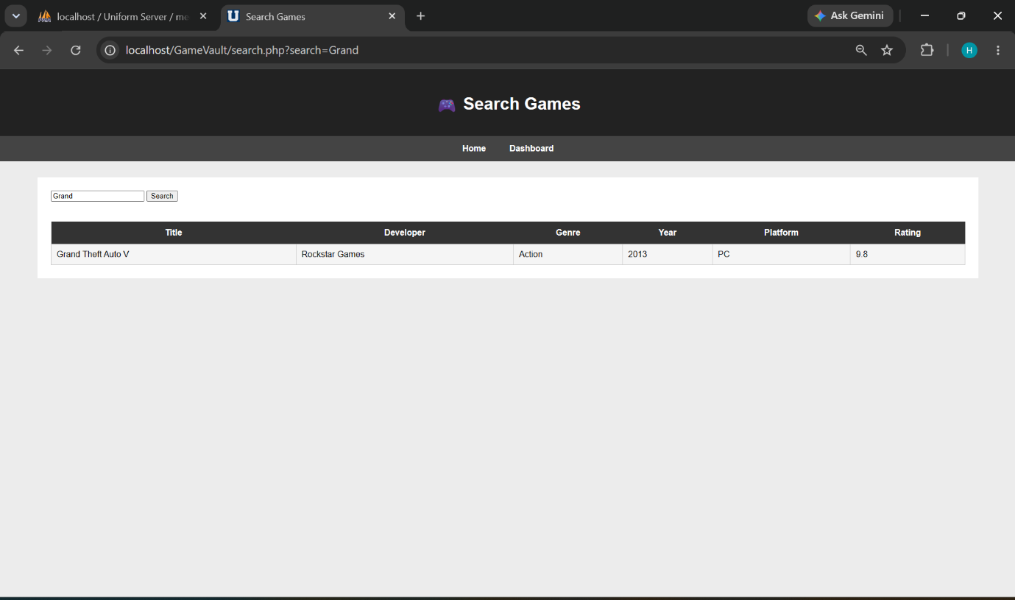
Figure 34. Search results returned for the search term “Grand”.
The successful result demonstrates that the application can filter dynamic database content and return relevant game information to the user.

SQL Injection and Security
SQL Injection is a web application vulnerability that occurs when untrusted input is incorporated into an SQL statement in a way that allows the input to change the intended query. Database-driven applications are particularly exposed because information from login forms, search boxes and data-entry forms is commonly processed by server-side code before being submitted to a database. OWASP identifies dynamically constructed queries containing user-controlled input as a major cause of SQL Injection vulnerabilities [11].
For example, an insecure authentication query could be constructed as follows:
$sql = "SELECT * FROM Admin
WHERE Username='$username'
AND Password='$password'";
In this example, the username and password are inserted directly into the SQL statement. An attacker could attempt to enter:
' OR '1'='1
If an application constructed its query insecurely, input of this type could alter the logical conditions of the SQL statement. Depending on the affected query and database permissions, successful SQL Injection can potentially allow unauthorised access to information, modification of records or authentication bypass [11], [12].
This risk is relevant to GameVault because several areas accept user-controlled data, including the administrator login, search page, Add Game form and Edit Game form. If values from these inputs were concatenated directly into SQL commands, they could potentially create injection points.

SQL Injection Defence
GameVault uses PDO prepared statements for database operations involving user-controlled values. Prepared statements separate the SQL statement from the values supplied by the user. The PHP documentation recommends using parameter markers for input values instead of inserting user-controlled data directly into an SQL query [10].
For example, the administrator login uses:
$stmt = $pdo->prepare(
"SELECT * FROM Admin
WHERE Username = ?
AND Password = ?"
);

$stmt->execute([$username, $password]);
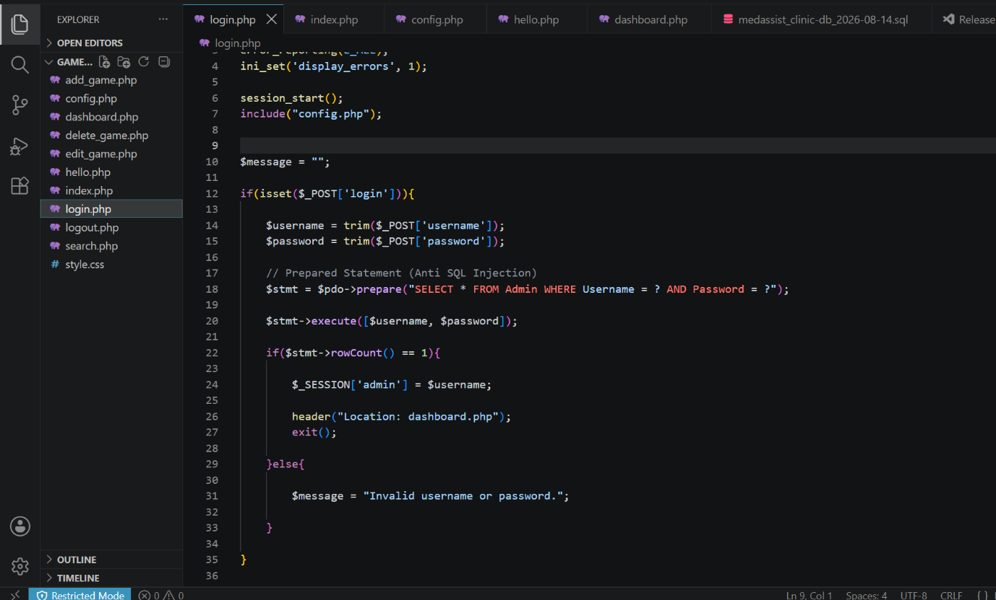
Figure 35. PDO prepared statement implemented in the GameVault administrator login.
The question-mark placeholders represent parameter values that are supplied separately when execute() is called. Therefore, SQL-like input entered into the form is treated as a data value rather than being incorporated into the structure of the SQL command. OWASP recommends prepared statements with parameterised queries as a primary defence against SQL Injection because the technique separates SQL code from supplied data [11].
The same approach is applied to other GameVault operations involving user input, including adding, editing, deleting and searching for game records. This is particularly important for the public search facility because its value can be entered by any visitor.

Security Testing
The SQL Injection protection was tested through the administrator login form. The following value was entered into the username field:
' OR '1'='1
An invalid password was also supplied. In an insecure application, input of this type may be capable of modifying the logical conditions of a dynamically constructed SQL statement. In GameVault, however, the prepared statement processes the complete input as a parameter value rather than executable SQL.
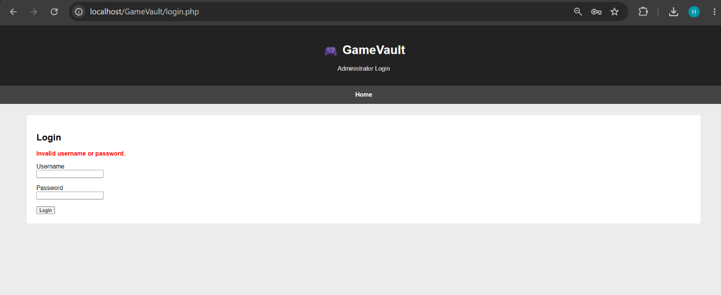Figure 36. Failed SQL Injection attempt against the GameVault administrator login.
The application rejected the authentication attempt and displayed an invalid username or password message. The result provides practical evidence that the supplied injection string did not alter the login query sufficiently to bypass authentication.
Prepared statements significantly reduce SQL Injection risk when user-controlled values are correctly parameterised [10], [11]. However, prepared statements should be part of a wider security strategy. Additional measures include validating expected input, restricting database privileges and securely managing authentication [11]–[14].
One limitation of the current GameVault implementation is that the administrator password is stored directly in the database rather than using secure password hashing. A production version should use PHP's password-hashing functionality and stronger validation, database privilege restrictions and session-security controls. These improvements would provide defence in depth in addition to the prepared statements already implemented.

Conclusion and Reflection
This assignment successfully demonstrated the design, implementation and practical use of relational database systems through the MedAssist Clinic and GameVault projects.
In “Part A”, the MedAssist Clinic database provided a structured solution for managing operational information including patients, doctors, departments, appointments, treatments and feedback. Normalisation and relational constraints reduced unnecessary duplication and maintained relationships between records. Stored procedures demonstrated reusable CRUD operations, while transaction management using `COMMIT` and `ROLLBACK` protected database consistency during appointment booking. Trigger-based auditing automatically recorded selected changes, and indexing demonstrated how query performance could be improved as the database grows.
In “Part B”, these database principles were applied within a web environment through the development of GameVault using HTML, CSS, PHP and MySQL. The completed application dynamically retrieves game information from related database tables and provides catalogue searching, administrator authentication and CRUD functionality. PDO prepared statements were used for database operations involving user input. Testing with an attempted SQL Injection demonstrated that the malicious input was treated as data and did not bypass the administrator authentication process.
The development process also highlighted opportunities for improvement. MedAssist could be extended with more comprehensive auditing and role-based access controls. GameVault would benefit from secure password hashing, stronger input validation and additional session-security measures before use in a production environment.
Overall, both projects demonstrate how effective relational database design, appropriate SQL functionality and secure server-side programming can be combined to produce reliable information systems. The assignment also reinforced the importance of normalisation, integrity constraints, systematic testing and security when developing applications that store and process persistent data.

References (IEEE)

[1] R. Elmasri and S. B. Navathe, Fundamentals of Database Systems, 7th ed. Harlow, U.K.: Pearson, 2017.
[2] T. Connolly and C. Begg, Database Systems: A Practical Approach to Design, Implementation, and Management, 6th ed. Harlow, U.K.: Pearson Education, 2015.
[3] Oracle Corporation, MySQL 8.0 Reference Manual. [Online]. Available: https://dev.mysql.com/doc/refman/8.0/en/ [Accessed: 14-Aug-2026].
[4] A. Silberschatz, H. F. Korth and S. Sudarshan, Database System Concepts, 7th ed. New York, NY, USA: McGraw-Hill Education, 2020.
[5] Oracle Corporation, “CREATE PROCEDURE and CREATE FUNCTION Statements,” MySQL 8.0 Reference Manual. [Online]. Available: https://dev.mysql.com/doc/refman/8.0/en/create-procedure.html [Accessed: 14-Aug-2026].
[6] Oracle Corporation, “Transactional and Locking Statements,” MySQL 8.0 Reference Manual. [Online]. Available: https://dev.mysql.com/doc/refman/8.0/en/sql-transactional-statements.html [Accessed: 14-Aug-2026].
[7] Oracle Corporation, “CREATE TRIGGER Statement,” MySQL 8.0 Reference Manual. [Online]. Available: https://dev.mysql.com/doc/refman/8.0/en/create-trigger.html [Accessed: 14-Aug-2026].
[8] Oracle Corporation, “Optimization and Indexes,” MySQL 8.0 Reference Manual. [Online]. Available: https://dev.mysql.com/doc/refman/8.0/en/optimization-indexes.html [Accessed: 14-Aug-2026].
[9] PHP Documentation, “Sessions,” PHP Manual. [Online]. Available: https://www.php.net/manual/en/book.session.php [Accessed: 14-Aug-2026].
[10] PHP Documentation, “PDO::prepare,” PHP Manual. [Online]. Available: https://www.php.net/manual/en/pdo.prepare.php [Accessed: 14-Aug-2026].
[11] OWASP Foundation, “SQL Injection Prevention Cheat Sheet,” OWASP Cheat Sheet Series. [Online]. Available: https://cheatsheetseries.owasp.org/cheatsheets/SQL_Injection_Prevention_Cheat_Sheet.html [Accessed: 14-Aug-2026].
[12] PHP Documentation, “SQL Injection,” PHP Manual. [Online]. Available: https://www.php.net/manual/en/security.database.sql-injection.php [Accessed: 14-Aug-2026].
[13] OWASP Foundation, “Authentication Cheat Sheet,” OWASP Cheat Sheet Series. [Online]. Available: https://cheatsheetseries.owasp.org/cheatsheets/Authentication_Cheat_Sheet.html [Accessed: 14-Aug-2026].
[14] OWASP Foundation, “Session Management Cheat Sheet,” OWASP Cheat Sheet Series. [Online]. Available: https://cheatsheetseries.owasp.org/cheatsheets/Session_Management_Cheat_Sheet.html [Accessed: 14-Aug-2026].
[15] Mozilla Developer Network, “Getting started with CSS,” MDN Web Docs. [Online]. Available: https://developer.mozilla.org/en-US/docs/Learn_web_development/Core/Styling_basics/Getting_started [Accessed: 14-Aug-2026].

