Name
Student number
E-portfolio report
Learning in the Digital Era – BMPL4007/BMPS4009

Table of Contents

Task 1 – Written summary 2
Task 2 – Mind map 3
Task 3 – Presentation 4
Task 4 – Reflection 5
Reference list 6

Task 1 – Written summary
Beginning higher education is an inherently demanding and somewhat intimidating endeavour, particularly from my personal perspective. As an individual who is not a native speaker of this language, navigating its complexities poses significant challenges. Since commencing my online studies, I have observed that maintaining focus can be challenging due to the abundance of distractions. Consequently, sustaining a productive state of mind necessitates a substantial amount of discipline and dedication. According to research (Jaffe, 2013), the tendency to delay studying until the final moments is often attributed to the recognition of the difficulty and mental exertion associated with the task. Personally, I found this statement to be highly relatable, prompting me to make the decision to refrain from further procrastination. Upon introspection, I have come to the realisation that my tendency to procrastinate stems from occasional feelings of being overwhelmed by an excessive amount of information. Initially, I experienced a sense of incapacity due to my struggles with anxiety and depression, rendering me unable to embark on the task at hand. On certain occasions, the mere contemplation of commencing my studies becomes an insurmountable challenge. Nevertheless, it is imperative to acknowledge that each day presents unique circumstances, thereby necessitating our continuous efforts to improve our personal circumstances incrementally. One significant error I made was engaging in haphazard reading practises without taking diligent notes, and relying on sources lacking credibility. In retrospect, a more effective approach would have involved tackling tasks sequentially and documenting observations or insights along the way. Upon reflection, I have discovered that I inadvertently neglected to properly reference certain sources. This oversight occurred due to my failure to diligently record notes during the reading process, subsequently leading to a loss of recollection regarding the origins of the information. I encountered difficulties in locating the necessary information subsequently. One of the notable benefits derived from this experience is the initiation of my pursuit of higher education. Additionally, I have effectively applied the knowledge and skills acquired since commencing my university studies. The process of cultivating and refining one's self-perception on a daily basis, while actively engaging in personal growth to achieve incremental advancements. The completion of my initial assignment proved to be a protracted endeavour primarily attributable to time constraints. Additionally, my unfamiliarity with the educational system in England engendered a sense of uncertainty, thereby impeding my ability to anticipate the requirements and expectations associated with the task at hand. The experience of engaging in distance learning can be challenging, as it is susceptible to potential distractions that may hinder one's focus on academic pursuits. According to historical evidence, it is evident that no single technology or platform can be considered a universal solution for enhancing online learning through technology (Online learning is still challenging for students – they need our support, 2022).

Task 2 – Mind map
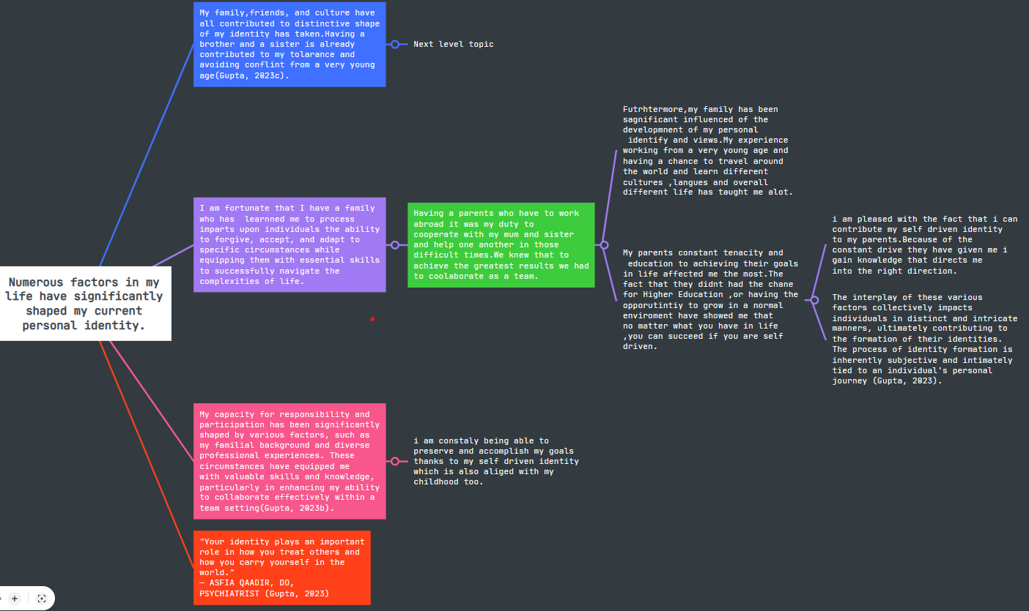
https://mm.tt/app/map/2861309639?t=T9heA8BMo9

Task 3 – Presentation
Please follow this link to view my presentation:
Becoming Digital Learner - YouTube

Task 4 – Reflection
The maintenance of academic integrity is of paramount importance within the educational environment, as it establishes the fundamental basis for the acquisition of knowledge, the generation of new ideas, and the development of intellectual capacities. Academic integrity refers to a collection of moral principles and values that guide students, educators, and researchers as they acquire knowledge and scholarly pursuits. There are several significant rationales that underscore the paramount significance of academic integrity. Having considered the importance of integrity, we will now explore why is essential. Firstly, academic integrity cultivates a milieu in which the pursuit of knowledge is highly regarded. Nonetheless, academic integrity promotes the fundamental principle of intellectual honesty, whereby individuals assume accountability for their work and ideas. The implementation of measures to discourage plagiarism, cheating, and fabrication serves to uphold the authenticity and reliability of the knowledge being presented(UWTSD Moodle 2022/23: Log in to the site, no date c). Secondly, integrity plays a pivotal role in fostering trust and credibility within the academic community. Further, upholding academic integrity serves to safeguard the excellence and benchmarks of education (Bordia, 2022). The implementation of this practice guarantees that evaluations effectively and precisely depict the knowledge and capabilities of students, enabling educators to administer impartial assessments and pinpoint areas that require enhancement. Next, by demonstrating a respectful attitude towards the ideas and contributions of others, as well as adhering to proper citation practises, students and researchers have the ability to expand upon pre-existing knowledge and generate significant advancements within their respective academic disciplines(Assistance, 2022). Finally, the cultivation of skills and values associated with academic integrity is essential for preparing individuals for success in their professional endeavours. What is more, is regarded as a crucial attribute for professional growth, as employers highly esteem individuals who exhibit integrity, honesty, and a steadfast dedication to ethical principles(Indeed Editorial Team, 2022). As suggested by (UWTSD Moodle 2022/23: Log in to the site, no date c) one of the strategies that can be employed is referencing, which entails the recognition and attribution of utilising external sources such as words, concepts, visuals, or research in one's own scholarly endeavours. It is imperative to present these particulars in an identified reliable manner, commonly referred to as referencing style, along with the practice of paraphrasing, which entails discussing the findings of one's research using one's own language. Another, notable tool in this context is Turnitin, which serves to enhance students' writing abilities and detect instances of textual similarity (Turnitin, 2023). In summary, the preservation of academic integrity is crucial for upholding the integrity of the educational system, cultivating a climate of scholarship, and fostering the development of conscientious, morally upright individuals. The establishment of a solid foundation is crucial for fostering intellectual growth, achieving professional accomplishments, and facilitating the progression of knowledge.

Reference list
Assistance, P. (2022) Why are citations so important in the academic research world? - PhD Assistance. Available at: https://www.phdassistance.com/blog/why-are-citations-so-important-in-the-academic-research-world/ (Accessed: July 15, 2023).
Bordia, D. (2022) “Importance of academic integrity,” Teachmint Blogs [Preprint]. Available at: https://blog.teachmint.com/importance-of-academic-integrity/(Accessed: July 15, 2023).
Gupta, S. (2023b) “Why identity matters and how it shapes us,” Verywell Mind [Preprint]. Available at: https://www.verywellmind.com/why-identity-matters-and-how-it-shapes-us-7504546(Accessed: July 15, 2023).
Indeed Editorial Team (2022) “How to maintain professional integrity in the workplace,” Indeed.com [Preprint]. Available at: https://www.indeed.com/career-advice/career-development/maintaining-professional-integrity(Accessed: July 16, 2023).
Jaffe, E. (2013) Why wait? The science behind procrastination. Available at: https://www.psychologicalscience.org/observer/why-wait-the-science-behind-procrastination(Accessed: July 20, 2023).
Lieberman, M. (2019) “Colleges want students to think critically about digital tools in the classroom and beyond,” Inside Higher Ed | Higher Education News, Events and Jobs [Preprint]. Available at: https://www.insidehighered.com/digital-learning/article/2019/03/13/colleges-want-students-think-critically-about-digital-tools(Accessed: July 20, 2023).
Turnitin (2023) Empower students to do their best, original work. Available at: https://www.turnitin.com/regions/uk(Accessed: July 15, 2023).
UWTSD Moodle 2022/23: Log in to the site (no date d). Available at: https://moodle.uwtsd.ac.uk/mod/scorm/player.php?a=4556¤torg=unit_0_topic_3_ORG&scoid=9959&sesskey=EBqj547A0O&display=popup&mode=normal(Accessed: July 15, 2023).

