Project Management
Alexander Tzafos

Module: Changemakers: Creativity and Value Creation
Module code: ACCA5033
Lecturer: Gareth Jones

Table of Contents
Introduction 3
Task 1 4
Q1 4
Q2 5
Task 2 6
Task 3 7
References 8

Introduction
This following assignment will feature several different tasks and will use the units which can be located on the Moodle page. Aside from this the project that was discussed during the first assignment will be mentioned once again for one of the tasks. Lastly in this assignment there will be a project reflection which is where the project will be reviewed and a small 500-word reflection will be writing by using the unit 2 section 4 part of Moodle in order to aid the reflection.

https://sites.google.com/view/alextzafoschangemakers/home

E-portfolio link.

Task 1

Q1
In the field of research, quantitative analysis is a method that employs mathematical and statistical models to comprehend phenomena. The resulting information is presented in numerical values, making it easier to analyse the data. For instance, in the business world, this technique helps companies collect and evaluate measurable and verifiable data such as revenues, market shares, and wages. This data provides companies with a clear picture of how well they are performing. The two types of statistics used in quantitative analysis are descriptive and inferential. Descriptive statistics help describe the data, while inferential statistics enable making inferences from the data.

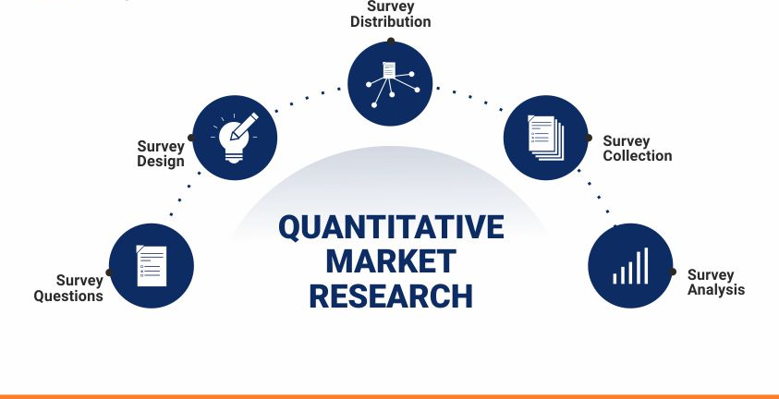
https://www.questionpro.com/blog/quantitative-market-research/

Descriptive statistics provide concise information about a given data set, whether it represents the entire population or just a sample. They help to describe and comprehend the characteristics of a particular data set, presenting it in brief summaries of measurable data. The most commonly used types of descriptive statistics are measures of centre, such as the mean, median, and mode, which are applied in various levels of mathematics and statistics. Descriptive statistics are also useful for transforming complex quantitative insights from a large data set into small, easily understandable descriptions.[1]Descriptive statistics are the numerical and graphical techniques used to organise, present, and analyse data.

Inferential statistics employs statistical methods to infer information from a smaller sample size compared to descriptive statistics. This helps in making predictions and drawing conclusions about a larger population. The approach utilizes probability theory and statistical models to estimate population parameters and test population hypotheses using sample data. By employing inferential statistics and a representative sample, researchers can generalize a population. The process requires logical reasoning to reach these conclusions. [2]The main goal of inferential statistics is to provide information about a larger population by using a smaller sample, this will then make the conclusion more accruable and reliable.

When comparing descriptive statistics and inferential statistics, their differences are easy to see. Descriptive statistics provide a summary of the features or attributes of the dataset, while inferential statistics enable hypothesis testing and evaluation of the applicability of the data to a larger population. Descriptive statistics are better suited for organizing, analysing, and presenting data in a meaningful manner making it easier to understand. On the other hand, inferential statistics allow for comparing data and making hypotheses and predictions. Another critical difference is how they are achieved, with descriptive stats using charts, graphs, tables, etc., while inferential stats rely on probability.

Q2

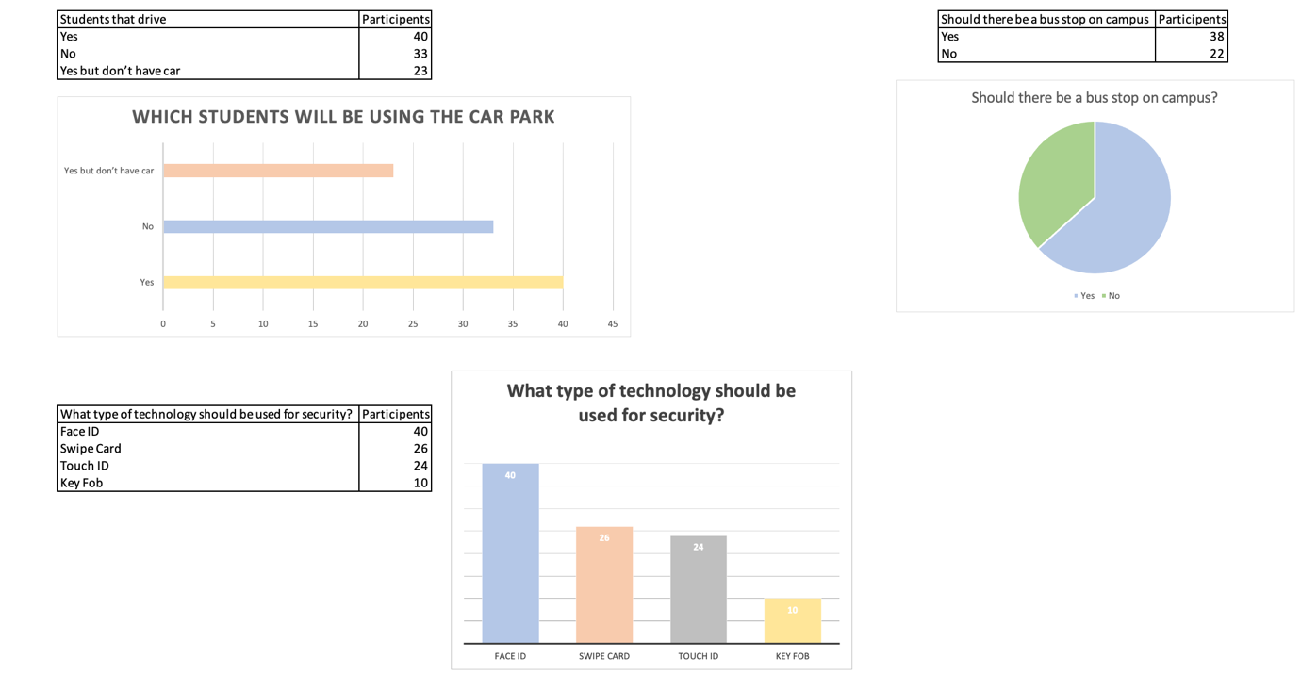
3
2
1

- The first diagram that can be seen is to find out the number of students who drive and will be using the car park which is on campus. The conclusion is that the majority of students will be using the parking facilities.

- The second diagram was to find out how many students would like a bus stop feature on campus as it would make it easier for them to across the town centre. Upon conducting research, it is clear to see that a bus stop feature would be heavily used.

- Lastly the final diagram is finding out what type of technology the students would like when it comes to security, this would be used when entering the campus and accessing classrooms, and the library building. By conducting this research, it was found that a high number of students would like to see a face ID scanner as it would be quick and easy to use. [3]The purpose of a graph is to present data that are too numerous or complicated to be described adequately in the text and in less space.

Task 2
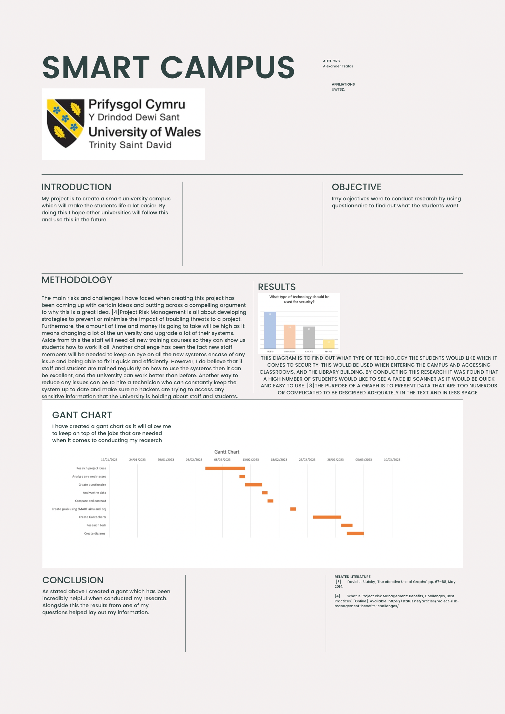

Task 3
The project I decided to undertake was all about improve the students of a student life by creating a smart campus which can then be used across all the universities across the country in the feature. Upon, reflection I have gained some valuable skills when it comes to research, how to conduct properly and how to take notes. Apart from this it will allow me to develop and further improve my existing skills when it comes to creating ides and brainstorming. However, I do believe that my abilities to conduct analysis are growing from strength to strength which will only help when it come to the real world after university.

Personally, I do believe that my project can have a significant impact of society and the university overall, this is because a smart campus can work flawlessly when created. My ideal smart campus would feature a parking system which indicates how many spaces are free and a barrier which scans the number of the student’s car, by doing this it will stop random people from using these facilities. I do think this is very important as it will stop the students from driving the car park aimlessly looking for spaces and avoid the risk of being late to their lectures. Furthermore, I think this can help the local area as it will limit the amount of noise pollution as there will be less cars constantly driving round in circles. Another idea I had was to install some sort of renewable energy system which could come from solar panels or wind turbines which be installed on the roofs. By doing this the university will be using fewer fossil fuels and the renewable energy can be used by the locals in the surrounding areas. On the other hand, I believe that the skills I have gained from conduct this project can seriously help me later in life, when it comes to research, analyse and coming up with new ideas. Lastly, I think that a smart campus if done correctly can positively impact the life of a student as it will allow them to create their own ideal experience, doing this it could lead to improved productivity and allow them to focus a lot more. By them focusing it could in turn lead to improved grades, this would then make the university a lot more appealing from people looking to come and join.

The main risks and challenges I have faced when creating this project has been coming up with certain ideas and putting across a compelling argument to why this is a great idea. [4]Project Risk Management is all about developing strategies to prevent or minimise the impact of troubling threats to a project. Furthermore, the amount of time and money its going to take will be high as it means changing a lot of the university and upgrade a lot of their systems. Aside from this the staff will need all new training courses so they can show us students how to work it all. Another challenge has been the fact new staff members will be needed to keep an eye on all the new systems encase of any issue and being able to fix it quick and efficiently. However, I do believe that if staff and student are trained regularly on how to use the systems then it can be excellent, and the university can work better than before. Another way to reduce any issues can be to hire a technician who can constantly keep the system up to date and make sure no hackers are trying to access any sensitive information that the university is holding about staff and students.

References
[1] Murray J. Fisher, Understanding descriptive statistics, vol. 22. [Online]. Available: https://www.sciencedirect.com/science/article/abs/pii/S1036731408001732
[2] ‘Inferential Statistics: Definition, Types + Examples’, [Online]. Available: https://www.questionpro.com/blog/inferential-statistics/
[3] David J. Slutsky, ‘The effective Use of Graphs’, pp. 67–68, May 2014.
[4] ‘What Is Project Risk Management: Benefits, Challenges, Best Practices’, [Online]. Available: https://status.net/articles/project-risk-management-benefits-challenges/

