

Programme: Master of Business Administration

Module code: LCMB7026
Module: International Marketing: Principles and Practices

International Marketing Strategy of Deliveroo and Personal Reflection

Lecturer: Dian Mayasari (Birmingham) and Tushara Balendran (London)

Student Name: Bogdan Pacuraru
Student ID: 2245496
Final Word Count: 5052
Submission date: Birmingham, Thursday 16th Nov 2026 by 2 PM

Table of contents
Task 1: Report 3
a. Introduction 3
b. Brand Profile 3
c. Situational Analysis 4
PESTLE 4
Hofstede’s country culture comparison 10
d. International STP and Marketing Mix (7Ps) 11
STP Analysis 11
Marketing Mix (7Ps) 15
e. Market Entry Strategy 17
f. Ethical and Sustainability Considerations 18
g. Conclusion 19
h. References 20
Task 2: Reflection 24
a. Introduction 24
b. Reflective Analysis 24
c. Conclusion 27
d. References 28

Task 1: Report

a. Introduction
International marketing strategy is a corporate effort to develop marketing and promotional campaigns that can enhance the brand reach globally. In this report, Deliveroo is selected as the company and the USA and Japan as the prospective markets where the company will enter. This report will provide a brief overview of Deliveroo followed by a situational analysis using PESTLE and Hofstede cultural dimension analysis. The STP and marketing mix will be conducted, along with market entry modes being selected, and ethical and sustainable considerations for entering both markets will be evaluated.

b. Brand Profile
Deliveroo is a UK-based food delivery and technology company established in 2013 and headquartered in London (Deliveroo, 2026a). Will Shu and Greg Orlowski founded the firm to transform how people consume food by making it feasible to access healthier meals in their neighbourhood.

Figure 1: Company logo
(Source: Deliveroo, 2026a)
Deliveroo operates with a mission statement of transforming the manner in which consumers tend to shop and eat food, while connecting customers directly to the restaurants, supermarkets and the delivery riders. Following this mission statement, Deliveroo (2026a) highlighted that, in the current operational terms, Deliveroo functions in a hyperlocal three-sided marketplace, where the customers/clients are connected to the restaurants, and riders to fulfil their needs.
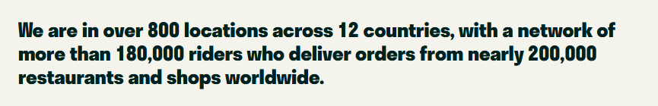
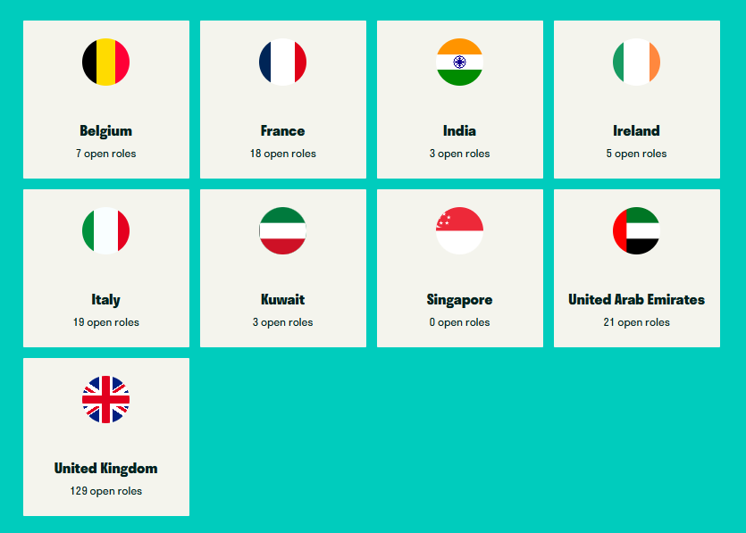
Figure 2: Operational locations of Deliveroo
(Source: Deliveroo, 2026c)
Apart from this, the company has an operational presence in 12 countries, with over 800 locations where they serve customers (Deliveroo, 2026c). Their delivery operations are supported by 200,000 shops or restaurants, while around 180,000 riders are linked with the company and restaurants to deliver products to customers' doorsteps in a timely and efficient manner (Deliveroo, 2026c). In October 2025, Deliveroo was acquired by DoorDash under Part 26 of the UK Companies Act (DoorDash, 2025). Focusing on financial performance, the company, as of 2025, generated revenue of £2.1 billion, which was a 2% YoY increase. Besides this, the company's gross transaction volume was worth £7.8 billion, with a user base of 7.6 million, mainly concentrated in the UK (Curry, 2026). Compared to the 2025 financial performance, Deliveroo became one of the top 5 food delivery companies internationally; in 2023, the company’s global revenue was estimated at £2 billion (Statista, 2025). These figures demonstrate the operational and financial excellence of the firm.

c. Situational Analysis

PESTLE
PESTLE Factors | United States of America | Japan
Political | - USA scored -0.1 as of 2024 in Political stability, where -2.5 is weak and 2.5 is strong, implying the US political scenario is quite unpredictable (The Global Economy, 2025a)  - State rules like Assembly Bill 578 of California require food delivery companies to have mandatory human support and refund policies for customers (Liberto, 2026)  - The US government supports and protects Gig workers like delivery personnel and riders from antitrust liabilities (Federal Trade Commission, 2025)  Impact: Regulatory compliance can negatively impact Deliveroo’s financial prospects by raising operational costs because of varied state regulations and political unpredictability. Conversely, customer trust, rider/gig worker retention and operational legitimacy can be bolstered by safeguarding stakeholders’ rights and meeting customer support obligations. | - Japanese Political stability was 1.13 as of 2024, implying that Japan’s political environment is sound and predictable (The Global Economy, 2025b)  - Japanese government has developed an integrated package of services for food distribution and delivery to support and foster a sound business environment (Global.Fujitsu, 2025)  - “The Freelance Act, 2024” prohibits “kaitataki” practices, where gig workers and freelancers are paid significantly lower than the ordinary price paid for similar work (Cloete, 2024)  Impact: While Deliveroo's market entry is positive due to Japan's political stability, government delivery programs and the Freelance Act's protections can improve operational conditions. However, Deliveroo's labor costs might rise as a result of responsibilities for fair gig workers' compensation, even for less money.
Economic | - The US GDP as of 2025 was $30.77 trillion (World Bank, 2026b)  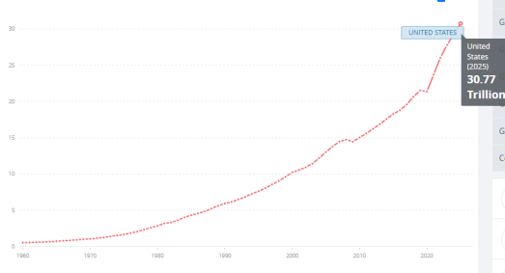  Figure 2: US GDP  (Source: World Bank, 2026b)  - The inflation rate was 3.4% in July 2026, down from 3.5% in June 2026 (Trading Economics, 2025c)  - US food delivery market value, as of 2025, was $34.88 billion (£25.73 billion) (IMARC Group, 2025)  Impact: With a monumental and world's largest GDP, and a food delivery market valuation of $34.88 billion (£25.73 billion), this can positively impact Deliveroo to operate feasibly and grow. However, 3.4% inflation can pose a negative outcome as it may raise the operating costs for restaurants and riders, which will affect Deliveroo's pricing. | - The Japanese GDP as of 2025 was $4.44 trillion (World Bank, 2026a)  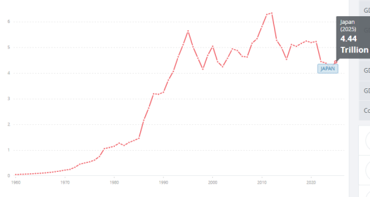  Figure 3: Japan GDP  (Source: World Bank, 2026a)  - The inflation rate was 1.90% in July 2026, increased from 1.60% in June 2026 (Trading Economics, 2025a)  - Japanese food delivery market value was $18 billion in 2024 (£13.28 billion) (Grandviewresearch, 2025)  Impact: A strong GDP and a $18 billion (£13.28 billion) food delivery market value in 2024 can positively attract Deliveroo to serve customers in Japan. However, higher inflation rates, which increased from 1.60% in June to 1.90% in July, can negatively impact Deliveroo’s profit margins by increasing operational costs.
Social | - 42.8% of the population aged 25-39 and 41.5% aged 40-54 hold a bachelor’s degree or higher as of 2024 (Census Gov, 2025)  - The national unemployment rate of the US, as of August 2026, was 4.1%, whereas the youth unemployment rate was 9.10% in August 2026, increased from 8.50% in July 2026 (Trading Economics, 2025d)  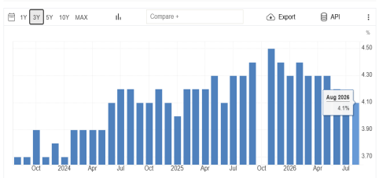  Figure 4: US Unemployment rate  (Source: Trading Economics, 2026d)  Impact: Higher educational qualification of 42.8% among the younger population between 25-39 will create opportunities for Deliveroo to gain a skilled workforce. Nevertheless, higher youth unemployment rates can also allow Deliveroo to recruit more gig workers/riders and deliver food. | - The Tertiary attainment (completed higher education) of the Japanese population has increased to 66% in 2024 from 62% in 2019 (OECD, 2025)  - Japanese unemployment rate, as of July 2026, was 2.40%, whereas the youth unemployment rate decreased from 4.20% in June 2026 to 3.40% in July 2026 (Trading Economics, 2025b)  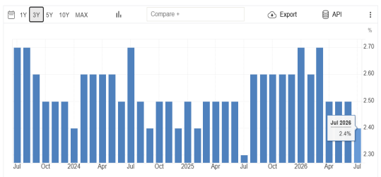  Figure 5: Japan Unemployment rate  (Source: Trading Economics, 2026b)  Impact: Japan’s high level of tertiary attainment of 66% can create more job opportunities while creating scope to operate efficiently for the company. However, low unemployment rates can negatively impact Deliveroo because of this; rider scarcity may occur, while narrowing the scope for Deliveroo to hire skilled riders.
Technology | - USA ranked 3rd in the Global Innovation Index 2025 (WIPO, 2025)  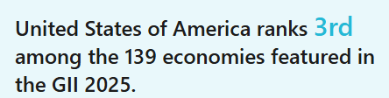  Figure 6: GII rank of USA  (Source: WIPO, 2025)  - The US technology sector is increasingly investing in future-gen AI and related technologies to support innovative businesses.  Impact: Deliveroo can implement advanced AI algorithms, predictive analytics and automation to improve delivery efficiency and customer experience, as the USA’s business environment invests in technology-aided services | - Japan ranked 12th in the Global Innovation Index 2025 (WIPO,2025)  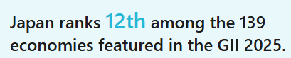  Figure 7: GII rank of Japan  (Source: WIPO, 2025)  - Japan has been investing in future technologies, including robotics and automation powered by AI and ML technologies.  Impact: Although technology integration may necessitate a larger investment, Japan’s investment in AI-supported robotics and automation can help Deliveroo’s delivery operations while lowering the dependency on labour/gig workers, given the lower unemployment rates as aforementioned.
Legal | - Fair Labour Standards Act (FLSA) is the regulatory act that oversees minimum wages for workers, overtime payment and prohibits child labour practices (U.S. Department of Labor, 2024)  - The classification of gig workers and collective bargaining of gig workers with ordinary jobs can create legal uncertainties (Federal Trade Commission, 2025)  Impact: FLSA compliance can create high labour expenditure, which can negatively impact Deliveroo as it may face operational and legal concerns due to unclear gig worker classifications and bargaining regulations | - Labour Standards Act, Act No. 49 of April 7, 1947, updated by Act No. 71 of 2018, governs the maximum working hours (8 Hours), rest time of 1 hour, working conditions, and safety standards in the workplace (Japanese Law Translation, 2018)  - “The Freelance Act, 2024” prohibits “kaitataki” practices, requiring businesses to offer similar wages to gig workers/freelancers for similar types of jobs done ordinarily (Cloete, 2024)  Impact: Fair working conditions and rider relationships can be strengthened by the Labour Standards Act and the Freelance Act obligations, but they may also raise labour expenses and compliance. This can positively impact the operations of Deliveroo.
Environment | - Clean Air Act (CAA) governs commercial and industrial emissions, requiring businesses to obtain operating permits (US EPA, 2026).  - In 2025, the US government rejected the UN Sustainable Development Goals and the United Nations' 2030 Agenda due to political ideologies on climate change (Segal, 2025)  Impact: Weaker climate commitments by the US government may lessen the sustainability targets and result in Deliveroo not investing more in climate change commitments. However, US emissions regulations may raise compliance costs for Deliveroo. | - Air Pollution Control Act (Act No. 97 of 1968) was created to oversee and reduce air pollution risks and protect its citizens (UNEP ORG, 2026)  - Japan has set net zero 2050 targets, aiming to reduce GHG emissions (Climateactiontracker, 2026)  Impact: Japan’s net zero 2050 targets and strict pollution regulations can positively impact and create environmentally friendly delivery methods for Deliveroo.
Table 1: PESTLE comparison between USA and Japan

Hofstede’s country culture comparison
Hofstede’s cultural dimensions are referred to as a framework where there are five core and original traits that analyse the cultural influence of society and the behavioural aspect of each member. For this case study, the chosen organisation is Deliveroo, which is a UK-based organisation, and it is looking forward to expansion in the USA or Japan. Therefore, the Hofstede cultural comparison would be done for three countries such as the USA, the UK and Japan for Deliveroo.
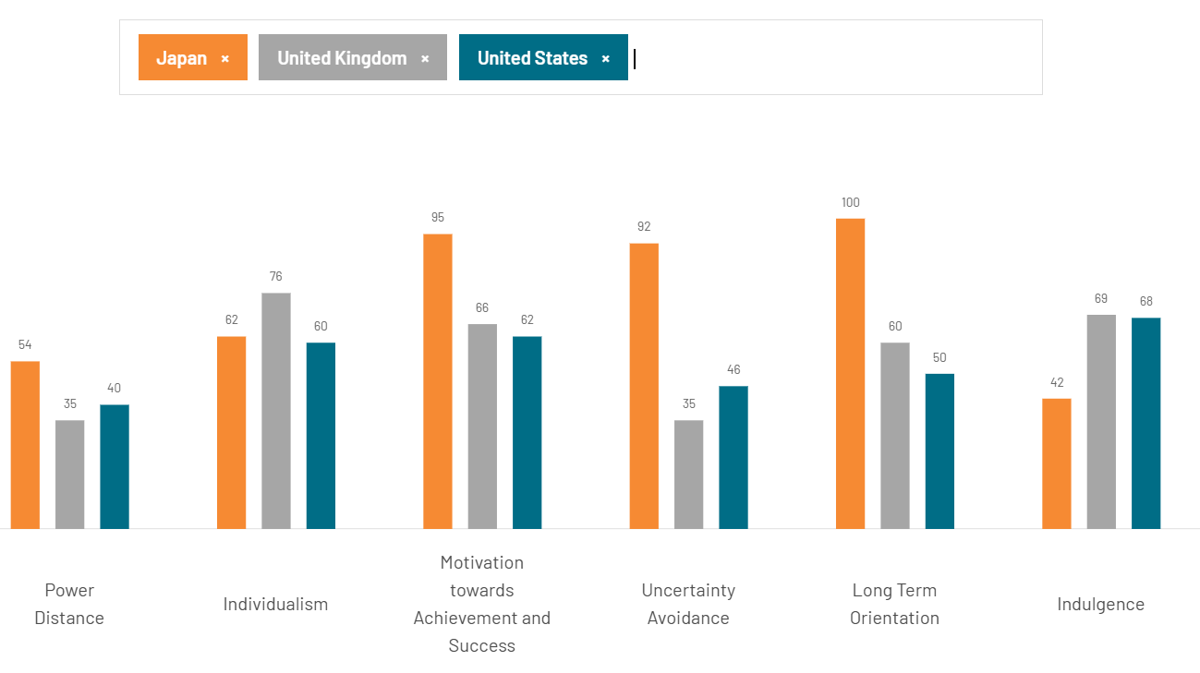
Figure 8: Hofstede cultural comparison between UK, USA and Japan
(Source: The Culture Factor, 2026)
The scores for each country in Figure 3 indicate that Japan has more masculinity, power distance, long-term orientation and uncertainty avoidance compared to the UK and the USA. However, both the UK and the USA are more individualistic and indulgent.
Power Distance
The power distance score of the UK is 35, which indicates limited acceptance of hierarchical inequality, and the United States has a score of 40, highlighting the presence of liberty and a sense of justice (The Culture Factor, 2026). A power distance score of 54 indicates a hierarchical division of responsibility to ensure a scope of equality. Liberty and justice for all are ensured in the social structure, along with the strategy to manage coordination in the division of power in the nation.
Individualism
The UK's score in the individualism index is 76, indicating that individual opinion and perceptions are given priority in different activities. Japan holds a score of 62 in the individualism index, which highlights the system of collectivist society in which group loyalty remains influential (The Culture Factor, 2026). The USA holds a score of 62, indicating a moderately achievement-oriented structure of society.
Motivation towards achievement and success
The UK's motivation towards success score is 45, which indicates a culture-oriented and collaborative social structure, indicating the scope of transparency (The Culture Factor, 2026). Japan has a score of 95, indicating that an achievement-oriented culture is prevalent in the society. On the contrary, the score of the USA is 62, indicating the presence of an achievement-oriented culture.
Uncertainty avoidance
The uncertainty avoidance index score of the UK is 35, which highlights that the chances of risk factors are comparatively higher (The Culture Factor, 2026). USA holds an uncertainty avoidance index score of 46, which is below the estimated level for structured balance. Japan's score in this index is 92, which indicates that despite the continuous exposure to natural calamities, it has an adequate sense of coordination to prevent existing external risk factors.
Long-term orientation
The UK's long-term orientation score is 60, which indicates that chances of growth potential and determination to progress are required (The Culture Factor, 2026). USA’s score in the index is 50, highlighting the scope for success in reaching adequate potential for growth in reaching the targets. Japan has a long-term orientation score of 100, indicating the potential for success in achieving the targeted objective.
Indulgence
The indulgence score of the UK is 69, indicating that the potential for cultural coordination is higher in the country (The Culture Factor, 2026). Japan's indulgence score is 42, which provides insights into gaining value along with the measures to achieve adequate objectives. The United States holds a score of 68, which indicates the presence of an indulgent society that values fun and leisure activities.

d. International STP and Marketing Mix (7Ps)

STP Analysis
STP analysis | Description
Segmentation | Demographics:  - Gen Z demographics prefer to order food from online platforms (Statista, 2026a)  - Female customers order 1–2 times per month (Statista, 2026a)  Geographic:  - Online food delivery demand is high in the South (28.7%), followed by the West (26.1%), Northeast (23.4%), and Midwest (21.8%) (IMARC Group, 2025)  Behavioural and Psychographics:  - 72.3% of customers used mobile applications to order food in 2025 (IMARC Group, 2025)  - 81.6% of customers preferred online payment, whereas 18.4% preferred CoD services (IMARC Group, 2025)  To expand in the US, Deliveroo can target the Gen Z audience, more specifically female customers who prefer to order online once or twice a month. Focusing on this demographic, Deliveroo can ensure localised marketing and expedite digital ordering because Gen Z customers are most digitally active.
Target | - Deliveroo’s primary target will be Gen Z audiences, with a robust restaurant network connection in the Southern region of the US (IMARC Group, 2025; Statista, 2026a)  - Deliveroo's secondary target will be millennials and mid-aged adults who prefer to consume healthy meals at their offices/workplaces.
Positioning | 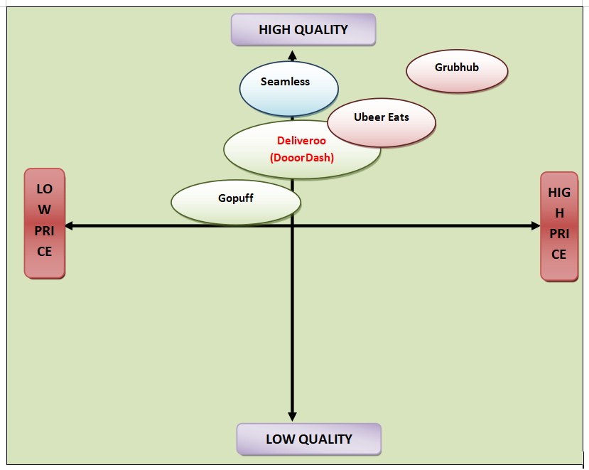  Figure 9: Positioning map of Deliveroo in the US  Deliveroo is positioned in the high-quality and low-to-mid price quadrant since the company offers quality products at a reasonable price point.
Table 2: USA STP analysis
STP analysis | Description
Segmentation | - Demographics: Younger demographics aged 18 and above prefer healthy consumption of meals  Geographic:  - The Kanto region, especially Tokyo, followed by the Kinki region and the Kyushu-Okinawa region, has a major concentration of fast food and food delivery services (The Mainichi, 2024)  Behavioural and Psychographics:  - Based on a survey of 5,000 Japanese people, aged 18-69, 51.6% feel cooking meals is “Burdensome” (The Mainichi, 2024)  - 21.8% stated they prefer meal delivery services (The Mainichi, 2024)  Deliveroo can target cities like Tokyo and focus on younger demographics to provide healthy meals and advertise convenient delivery services, since the demographics prefer to order meals rather than cooking.
Target | - The primary target audience for Deliveroo in Japan will be younger adults, who prefer to order food from delivery applications.  - The targeted city will be Tokyo, where Deliveroo can establish a strong network of restaurants and riders to connect with customers.
Positioning | 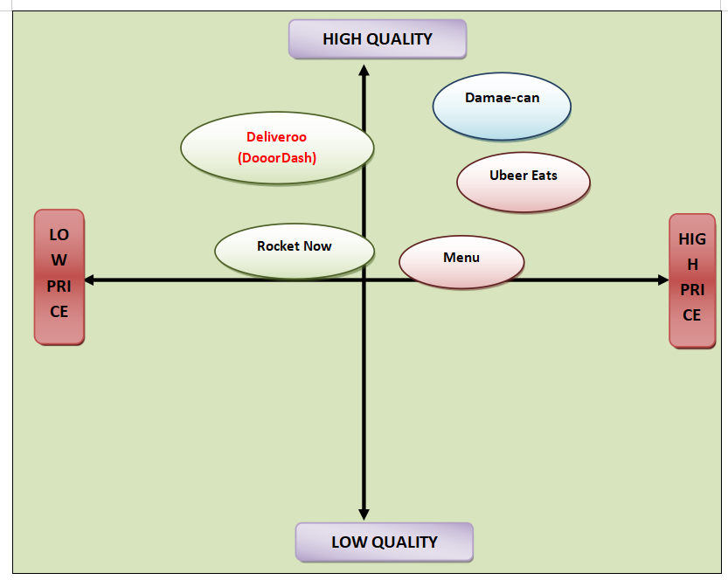  Figure 10: Positioning map of Deliveroo in Japan  For Japan, Deliveroo is positioned in the high-quality and low-price quadrant, where the company will offer meal kits with higher quality at an affordable price for customers.
Table 3: Japan’s STP analysis

Marketing Mix (7Ps)
Factors | Evaluation
Product | Deliveroo offers an online, on-demand strategy for product development, connecting consumers with prepared meals and retail goods (Deliveroo, 2026b). Real-time business performance tracking is adopted by Deliveroo, with shopping category expansion and personalised payment tracking. A customer-centric, data-driven product development strategy can be beneficial for Deliveroo in the USA, and in Japan, a Hyper-focused item management strategy can achieve success. A customer-centric, data-driven product development strategy in the USA will help in combining real-time user feedback with behavioural metrics. As per reports, 67% of consumers’ market leaders state that customers have an inclination towards precise market research prior to making a purchasing decision (PWC, 2025). Hyper-focused item management in Japan will provide an opportunity for Deliveroo to prevent mental fatigue of team members.
Price | A multi-layered pricing strategy is followed by Deliveroo that helps in balancing revenue from commission from restaurants and subscription tiers (Deliveroo, 2026c). TDA profit of the organisation reached 4% growth in 2025, and gross value remained at $9 billion (£6.65 billion). UK's Deliveroo reported experiencing a 7% increase in orders and 6% in the final quarter (Reuters, 2025). In the USA, a value-based pricing strategy can be most effective to manage the scope of revenue maximisation for premium clients. A value-based pricing strategy might provide scope for Deliveroo in managing the process of product differentiation. Considering the business environment of Japan, tax-inclusive pricing along with a point-based loyalty programme is beneficial. Tax-inclusive pricing in Japan will be selected in order to ensure a sense of trust, along with an obvious upfront increase for digital transactions.
Place | Deliveroo operates its business network across 800 locations in 12 countries, covering different regions of Europe and the Middle East (Deliveroo, 2026d). In the UK, it has major business segments in London, Manchester, Bristol, and Edinburgh. The online food delivery business segment is expected to reach US$1.51tn (£1.11 trillion) by the end of 2026, and the projected CAGR growth rate by 2031 will be 6.24% (Statista, 2025a). Referring to business expansion in the USA, the potential best places for Deliveroo are Texas, Northern California, and Florida. On the other hand, Japan can provide the best locations for investment, such as Tokyo, Osaka, and Nagoya. These locations will be beneficial because they are centres of trade activities, so the scope of having extensive leads becomes easier.
Promotion | End-to-end co-marketing strategies are followed by Deliveroo in the UK to execute joint marketing measures successfully (Deliveroo, 2026e). Translating the central initiative into a high-impact UK campaign creates scope for Deliveroo with a large-scale, multi-channel "Now Just Got Even Better" campaign. The culture of the USA has an achievement-oriented social structure that prioritises leisure activities too (The Culture Factor, 2026). A social-first campaign will provide a better opportunity for Deliveroo to establish better brand interaction. In Japan, 107 million users are using social media platforms, and this is 87% of the total population (Kemp, 2025). Considering the cultural scenario, Deliveroo will need to adopt a soft-sell approach with a localised market focus in Japan to achieve aggressive market expansion.
People | Collaboration with restaurant partners and targeted digital marketing campaigns are the processes of attracting people followed by Deliveroo (Deliveroo, 2026c). Hyper-personalised discounts and promos can help to increase the speed of conversion to attract the targeted market segment. US Business Compliance Guide of 2006 provides structured guidelines for small business resource optimisation along with export-import balance (National Business Law Authority, 2025). Referring to the regulatory policy, Deliveroo will be able to attract the targeted customer segment in the USA to establish a stable business identity. Business policy regulations of Japan are administered by multi-ministry compliance along with mandatory compliance standards (Smartstartjapan, 2026). Deliveroo will focus on structured market segment identification along with multi-factor collaboration in case of business expansion in Japan.
Process | Deliveroo follows a three-sided strategy of business expansion in the UK, such as customers, merchants, and delivery riders. During 2024, it acquired 44% growth in orders from Plus subscribers, and a 20% reduction was reported in weighted sales markup. The online food delivery business is expected to achieve CAGR growth of 6.83% during 2026-2031 (Statista, 2026b). Deliveroo will focus on selling high-margin and self-stable items to create scope to implement a profitable business model. In Japan, obtaining a legal network expansion permit, along with enforcement of mandatory hygiene standards, will help in business process expansion.
Physical evidence | In the UK, Deliveroo adopts a digital-first approach in order to access a tangible, highly visible organisational footprint to manage brand relevance (Deliveroo, 2026d). Deliveroo has the most widely accepted physical evidence of 140,000 active riders, which transforms its unique digital services through street-level presence. Physical evidence in the USA will include a business operational network and trade collaboration with local market players.
Table 4: 7P Marketing Mix

e. Market Entry Strategy
United States of America
In order to enter the US market, Deliveroo can concentrate on a strategic alliance strategy of market entry. Strategic alliance, as per Bolivar et al. (2023), is a market entry strategy where a new company joins forces or forms a cooperative agreement with two or more companies to enter a new or international market together. Strategic alliance entry strategy enables the companies to share the risks, losses and profits equally or on mutually agreed terms. In the context of the US, with a GDP of $30.77 trillion and a $34.88 billion (£25.73 billion) food delivery market, it will create a monumental opportunity for Deliveroo to form a strategic alliance to enter the market (World Bank, 2026b; IMARC Group, 2025). Additionally, Deliveroo's app-based business model benefits from high digital penetration and technological innovation, eventually creating a more favourable perspective for American citizens towards Deliveroo. However, the operational risks and expansion into the market independently can be challenging due to the fragmented legal structures and regulatory policies in different states of the US.
Japan
In order to enter Japan, Deliveroo is advised to use a Joint Venture. Aib (2024) stated that a JV is a market entry mode where a new entrant partners or forms a collaborative venture with local companies in the host or new markets. The joint venture enables the new and existing firms to effectively access the existing resources, clientele bases, and supply chain network of the existing company. This eventually helps the new company to gain a deeper understanding of the new market without heavily investing in establishing the supply chain or infrastructure that are required by companies that enter a market independently. In Japan's context, with a stable political environment (1.13 political stability score as of 2024), this creates a politically sound and safeguarded business environment (The Global Economy, 2025b). Japan's high levels of uncertainty avoidance (92), masculinity (95), and long-term orientation (100) show a strong preference for dependability, quality, well-established relationships, and thoughtful decision-making (The Culture Factor, 2026). Additionally, a joint venture can enable Deliveroo to share operational and investment risks with a Japanese counterpart, while gaining a deeper understanding of the market for its effective operations.

f. Ethical and Sustainability Considerations
In the course of Deliveroo’s entry into the US and Japan, the strategic alliance (USA) and joint venture (Japan) can help the firm achieve SDG 8 and SDG 12. SDG 8: Decent Work and Economic Growth states the efforts of business strategists to create employment opportunities while ensuring decent economic activities that can help the economy sustain for longer terms (The Global Goals, 2026). Since the youth unemployment rate in the US increased from 8.50% in July 2026 to 9.10% in August 2026, Deliveroo’s entry in the US can help create new employment opportunities for gig workers and youths looking for job positions (Trading Economics, 2025d). Concerning Japan, despite the unemployment rate being 3.40% in July 2026, Deliveroo’s entry can sustainably contribute to the Japanese food delivery economy (Trading Economics, 2025b). Aligned with SDG 12: Responsible Consumption and Production, which focuses on responsible consumption of resources (The Global Goals, 2025). Herein, by entering Japan and leveraging robotic delivery services, since Japan invests in robotics and automation, will reduce the issues of carbon emissions from motorcycles. This will ensure timely delivery of meals and reduce the issue of carbon emissions, ensuring sustainable consumption. Aligned to the Deontological ethics framework, the operations of Deliveroo in both markets will be driven by right operations with an appropriate morale of contributing to the national economies of the US and Japan.

g. Conclusion
It can be concluded from the above evaluation that understanding differences in cultural dynamics is necessary to fulfil the business requirement. USA and Japan focus on establishing coordination in the business environment along with the implementation of guidelines. Understanding the diversity in the market structure of Japan and the USA is necessary to accomplish success in decision-making. Japan has already set a goal to achieve a Net Zero Target by the end of 2050, creating extensive growth for the company to achieve adequate vision. It is necessary for Deliveroo to implement market-specific initiatives to achieve a scope of effective customer engagement. Proactive evaluation of measures is necessary to mitigate the risk factors in terms of market expansion and reach the vision.

h. References
Aib, H. (2024) ‘Stability of international joint ventures: When experience and age overshadow host country risk’, Journal of International Management, 30(6), pp.101205.
Bolivar, L. M., Casanueva, C., and Castro Abancéns, I. (2023) ‘International alliance networks, expansion modes and coopetition’, Multinational Business Review, 31(2), pp.197-219.
Census Gov (2025) Census Bureau Releases New Educational Attainment Data. Available at: https://www.census.gov/newsroom/press-releases/2025/educational-attainment-data.html (Accessed: 7 September 2026)
Climateactiontracker (2026) Net zero targets. Available at: https://climateactiontracker.org/countries/japan/net-zero-targets/ (Accessed: 7 September 2026)
Cloete, C. (2024) Japan gives millions of freelancers new protections. International Employment Lawyer. Available at: https://www.internationalemploymentlawyer.com/news/japan-gives-millions-freelancers-new-protections (Accessed: 7 September 2026)
Curry, D. (2026) Deliveroo Revenue and Usage Statistics (2026). Available at: https://www.businessofapps.com/data/deliveroo-statistics/ (Accessed: 6September 2026)
Deliveroo (2026a) About us. Available at: https://deliveroo.co.uk/about-us (Accessed: 7 September 2026)
Deliveroo (2026b) Business model. Available at: https://corporate.deliveroo.co.uk/about-us/business-model/ (Accessed: 9 September 2026)
Deliveroo (2026c) Deliveroo. Available at: https://deliveroo.co.uk/ (Accessed: 9 September 2026)
Deliveroo (2026d) Locations. Available at: https://careers.deliveroo.co.uk/locations/ (Accessed: 9 September 2026)
Deliveroo (2026e) Partner Marketing. Available at: https://careers.deliveroo.co.uk/role/partner-marketing-marketing-f022c742f59a/ (Accessed: 9 September 2026)
DoorDash. (2025) DoorDash Completes Acquisition of Deliveroo. Available at: https://ir.doordash.com/news/news-details/2025/DoorDash-Completes-Acquisition-of-Deliveroo/default.aspx (Accessed: 4 September 2026)
Federal Trade Commission (2025) FTC Issues Policy Statement Clarifying that Independent Contractors, Gig Workers’ Organizing Activities Are Shielded from Antitrust Liability. Available at: https://www.ftc.gov/news-events/news/press-releases/2025/01/ftc-issues-policy-statement-clarifying-independent-contractors-gig-workers-organizing-activities-are (Accessed: 7 September 2026)
Global.Fujitsu (2025) Fujitsu launches an integrated package of core system support services for food distribution industry. Available at: https://global.fujitsu/en-global/pr/news/2025/11/20-01 (Accessed: 7 September 2026)
Grandviewresearch (2025) Japan Online Food Delivery Market Size & Outlook, 2030. Available at: https://www.grandviewresearch.com/horizon/outlook/online-food-delivery-market/japan (Accessed: 7 September 2026)
IMARC Group (2025) United States (US) Online Food Delivery Market Size & Trends 2021-2026. Available at: https://www.imarcgroup.com/united-states-online-food-delivery-market (Accessed: 5 September 2026)
Japanese Law Translation (2018) Labor Standards Act - English - Japanese Law Translation. Available at: https://www.japaneselawtranslation.go.jp/en/laws/view/3567/en (Accessed: 7 September 2026)
Kemp S (2025) Digital 2026 Japan. Available at: https://datareportal.com/reports/digital-2026-japan (Accessed: 9 September 2026)
Liberto, D. (2026) New law forces food delivery apps to issue full cash refunds. Here’s how it works and whether it applies to you. Available at: https://finance.yahoo.com/news/law-forces-food-delivery-apps-121500301.html (Accessed: 7 September 2026)
National Business Law Authority (2025) Business Regulatory Compliance. Available at: https://nationalbusinesslawauthority.com/business-regulatory-compliance/ (Accessed: 9 September 2026)
OECD (2025) Education GPS - Japan - Overview of the education system (EAG 2019). Available at: https://gpseducation.oecd.org/CountryProfile?primaryCountry=JPN&treshold=10&topic=EO (Accessed: 7 September 2026)
PWC (2025) Next In Consumer Market. Available at: https://www.pwc.com/us/en/industries/consumer-markets/library/consumer-markets-trends.html (Accessed: 9 September 2026)
Reuters (2025) UK’s Deliveroo reports stronger orders. Available at: https://www.reuters.com/business/retail-consumer/uks-deliveroo-reports-stronger-order-growth-first-quarter-2025-04-17/ (Accessed: 9 September 2026)
Segal, M. (2025) U.S. Rejects UN Sustainable Development Goals. Available at: https://www.esgtoday.com/u-s-rejects-un-sustainable-development-goals/ (Accessed: 4 September 2026)
Smartstartjapan (2026a) Business Regulations In Japan. Available at:https://smartstartjapan.com/business-regulations-in-japan/ (Accessed: 9 September 2026)
Statista (2025a) Online Food Delivery. Available at:https://www.statista.com/outlook/emo/online-food-delivery/worldwide/?srsltid=AfmBOoqOgO3IJdQ10UJwJdB0VX_wFeAeXbHHr-NJ7LjlK4S6J9uG0bA3 (Accessed: 9 September 2026)
Statista (2026a) Online Food Delivery. Available at: https://www.statista.com/outlook/emo/online-food-delivery/united-states/?srsltid=AfmBOoocrqeAZKGrgKdpNSN2fsSBfrVifUuJRGJ1NhOUUuuNdeo2zW79 (Accessed: 9 September 2026)
Statista. (2025b) Topic: Deliveroo. Available at: https://www.statista.com/topics/10043/deliveroo/ (Accessed: 7 September 2026)
Statista. (2026b) Topic: Online food delivery in the U.S. Available at: https://www.statista.com/topics/3294/online-food-delivery-services-in-the-us/ (Accessed: 4 September 2026)
The Culture Factor (2026) Country Comparison Tool. Available at: https://www.theculturefactor.com/country-comparison-tool?countries=japan%2Cunited+kingdom%2Cunited+states (Accessed: 9 September 2026)
The Global Economy (2025a) USA Political stability - data, chart. Available at: https://www.theglobaleconomy.com/USA/wb_political_stability/ (Accessed: 6 September 2026)
The Global Economy (2025b) Japan Political stability - data, chart | TheGlobalEconomy.com. Available at: https://www.theglobaleconomy.com/Japan/wb_political_stability/ (Accessed: 6 September 2026)
The Global Goals (2025) Goal 12: Responsible consumption and production. Available at: https://globalgoals.org/goals/12-responsible-consumption-and-production/ (Accessed: 5 September 2026)
The Global Goals (2026) Goal 8: Decent Work and Economic Growth. Available at: https://globalgoals.org/goals/8-decent-work-and-economic-growth/ (Accessed: 5 September 2026)
The Mainichi (2024) 50% in Japan say cooking for themselves is a burden, but only 20% use meal deliveries: poll - The Mainichi. Available at: https://mainichi.jp/english/articles/20240126/p2a/00m/0na/045000c (Accessed: 8 September 2026)
Trading Economics (2025a) Japan Inflation Rate. Available at: https://tradingeconomics.com/japan/inflation-cpi (Accessed: 6 September 2026)
Trading Economics (2025b) Japan unemployment rate. Available at: https://tradingeconomics.com/japan/unemployment-rate (Accessed: 4 September 2026)
Trading Economics (2025c) United States Inflation Rate. Available at: https://tradingeconomics.com/united-states/inflation-cpi (Accessed: 7 September 2026)
Trading Economics (2025d) United States unemployment rate. Available at: https://tradingeconomics.com/united-states/unemployment-rate (Accessed: 7 September 2026)
U.S. Department of Labor (2024) Wages and the Fair Labor Standards Act. Available at: https://www.dol.gov/agencies/whd/flsa (Accessed: 7 September 2026)
UNEP ORG (2026) Air Pollution Control Act (Act No. 97 of 1968). | UNEP Law and Environment Assistance Platform. Available at: http://www.fao.org/faolex/results/details/en/c/LEX-FAOC040740 (Accessed: 7 September 2026)
US EPA (2026) Summary of the Clean Air Act. Available at: https://www.epa.gov/laws-regulations/summary-clean-air-act (Accessed: 7 September 2026)
WIPO (2025) GII Innovation Ecosystems & Data Explorer.. Available at: https://www.wipo.int/gii-ranking/en/japan/ (Accessed: 5 September 2026)
WIPO (2025). United States of America ranking in the Global Innovation Index 2025. Available at: https://www.wipo.int/gii-ranking/en/united-states-of-america (Accessed: 4 September 2026)
World Bank (2026a) GDP (current US$) - Japan | Data. Available at: https://data.worldbank.org/indicator/NY.GDP.MKTP.CD?locations=JP (Accessed: 7 September 2026)
World Bank (2026b) GDP (current US$) - United States. Available at: https://data.worldbank.org/indicator/NY.GDP.MKTP.CD?locations=US (Accessed: 7 September 2026)

Task 2: Reflection

Introduction
Reflection plays a vital part in identification of individual strengths and weaknesses through the process of self-evaluation. Reflecting on the experiences gained from the events helps in fulfilling the goal of self-development in the long run. Implementation of practical measures to identify individual weaknesses is necessary to achieve success in long-term aspirations.

Reflective Analysis
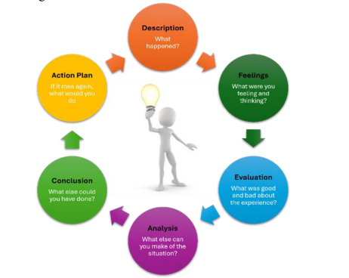
Figure 1: Gibbs’ Reflective Cycle
(Source: Praveena et al. 2025)
Description
I would like to explore insights regarding the diversity in market structure shaping the overall market scenario and the contribution of policy regulations. Comprehensive analysis of product performance creates an opportunity to gain competitive advantage and determine the scope of success (Prachi, 2024). The goal of our project is to analyse the effectiveness of the market structures of the USA and Japan for the business expansion of Deliveroo. I was assigned the responsibility of data collection, and initially I found it difficult to select the appropriate sources of information. As a result, evaluating the business environment of the USA and Japan appeared to be difficult for me, considering expansion measures by Deliveroo.
Initially, my priority was to conduct an external business analysis to understand the scenario of the USA and Japan for Deliveroo's market expansion. It is necessary to interpret the diverse market structures of the USA and Japan in order to determine the scope of progress. Evaluation of the market scenario is the most notable factor to be considered in order to analyse the scope of growth (Ringland and Young, 2007). I have observed that I need to work on my skill of cultural analysis of a nation based on the cultural scores of the USA and Japan. Initially, I used to miss instructions given by senior members regarding cultural analysis due to my weak skill of active listening. I would like to state that the requirement is to gain insights into the principles of collaboration along with reaching an adequate scope of success. Therefore, I need to focus on the identified skill gap to increase individual efficiency in the concerned project work.
Feeling
I have felt less confident during the project because, due to my weakness in time management skills, the entire team finds it a challenge to manage coordination. Time management skills help in increasing opportunities to achieve project objectives associated with the strategy (Pamuji et al. 2024). Though the practitioner from the target markets might see the situation differently because their focus can remain on the local-restaurant partners collaboration due to better market scenario insights. Initially, I started analysing the purchasing power parity of the customers to predict the scope of business growth, though the data keeps on changing. Furthermore, I missed the aspect of how the increase in global fuel prices has compelled different nations to bring modifications to their tax structure, resulting in difficulty for foreign business entry into their markets.
Evaluation
Self-reflection is an important part of achieving success in individual development and determining objectives (Gavriliuk, I. and Zabrodskyi, 2026). It has been observed that, due to my weakness in the skill of information selection, the team's working speed was reduced. Deliveroo believes in optimising product quality and fulfilling customers' requirements by understanding market trends. Due to my weak research skills, I skipped aspects of contemporary global issues, such as the Iran war affecting overall economic growth and the purchasing index. Later, one of my fellow team members suggested that the factor of global socio-economic crisis needs to be given consideration prior to selecting the nations for business selection for Deliveroo.
Analysis
I would like to state that the requirement is to determine the process of coordination and fulfil objectives to achieve an adequate scope of progress. At the time of communicating ideas with team members, I found that I find it difficult to convey ideas to fellow team members due to my weak communication and active listening skills. Practical evaluation of the skill set helps in reaching the goal, along with the strategy to mitigate the issues concerned (Kopac et al. 2025). Practitioners from the markets of USA and Japan might consider these nations as better scope of business for Deliveroo for value creation because of people's inclination in online food ordering. During analysis of the business strategy of Deliveroo, I have identified that both the nations USA and Japan will provide distinct opportunities and challenges. I have observed that it is necessary to gain insights into the strategy so that fulfilling goals of self-development becomes easier.
Conclusion
It can be concluded from the above evaluation that the need is to implement determination of measures along with reaching targeted outcomes. Reaching the successful outcome is associated with the process of reaching the objectives and fulfilling the vision appears to be helpful in determining optimal results. Deliveroo needs to prioritise the partnership with the local restaurant network in order to enter the markets of the USA and Japan. Practical evaluation of skill sets creates opportunities for collaboration along with the process to achieve optimal results. Continuous self-reflection helps in gaining success in individual development along with the process to achieve growth.
Action plan
Areas of improvement | Strategy to improve | Timeframe
Time management skill | - Breaking task-related activities into small segments, along with setting a particular deadline to manage the scope of coordination. I would like to focus on the principles of coordination along with the process to reach the targeted goal. | 3 months
Research skill | - I would like to focus on the strategy of appropriate source selection to determine insights on increasing the quality of research. It helps in the strategy of collaboration along with the process to reach the goal. Addressing the skill gap is necessary in order to mitigate the issues and reach success in the allocated project. | 5 months
Table 2: Action Plan

Conclusion
It can be concluded from above evaluation that the requirement is to gain insights regarding the goal of future success. Proactive implementation of measures helps in reaching the goal and achieving a successful outcome. Therefore, it is essential to achieve adequate success, and the practical evaluation needs to be beneficial.

References
Gavriliuk, I. and Zabrodskyi, I. (2026) ‘Reflection in the Formation of the Self and Personality Development: A Review of Recent Studies’, STREDOEVROPSKY VESTNiK PRO VEDU А VYZKUM, 2(4), pp. 244-255.
Kopac, L., Weber, M., Volkmann, U., Berner, M.R. and Altnau, C.H.P. (2025) ‘Enhancing managerial effectiveness through systematic self-reflection and structured self-assessment practices’, Journal of Organizational Behavior Research, 10(2-2025), pp.169-182.
Pamuji, S., Baharuddin, K.M., Novianto, A.Y., Kasmin, K. and Wibowo, E.P. (2024) ‘Time management: The key to success in managing complex projects’, Journal Markcount Finance, 2(3), pp.361-370.
Prachi, N.K.M. (2024) ‘Selection and performance of sensory panelists: A comprehensive review of factors influencing sensory evaluation outcomes’, J. Nutrition and Food Processing, 7, p.15.
Praveena, K.S., Juslin, F., Patil, C.M. and Bhargavi, K. (2025) ‘Using gibb's reflective model approach for enhancing project-based learning among students through reflective assessment’, Journal of Engineering Education Transformations, pp.148-155.
Ringland, G. and Young, L. (2007). Scenarios in Marketing: From vision to decision. John Wiley & Sons.

