

International Marketing: Principles and Practices
Module CODE: LCMB7026
Assessment component 1: Individual report
Word count: 5000 (±10%)
Submission Deadline: 24th April 2026 by 2pm

Student name: Kazi Mahmud Ul Islam
Student ID: 2510576
Lecturer’s Name: Dr Mustakkima Afrin

Table of Contents
1.0 Introduction 3
1.1 Report’s Overview 3
1.2 Overview on KFC 3
2.0 Section 1 4
2.1 Comparative analysis of the market in both countries: India & United Kingdom 4
2.2 Comparative Analysis of STP (Segmentation, Targeting, and Positioning) of KFC in India and the United Kingdom 10
2.3 Comparative Analysis of International Marketing Mix (7Ps) of KFC in India and the United Kingdom 14
2.4 Directional Development Strategy of KFC in India 19
2.5 Ethical Issues in KFC’s Marketing Mix in India 20
2.6 Recommendations for Future International Marketing Strategy of KFC 21
3.0 Section 2 22
3.1 Reflective Account Using Kolb’s Cycle of Reflective Practice 22
4.0 Conclusion 25
Reference 26

List of Figures
Figure 01: Yum! Brands Inc (Parent Company of KFC) 4
Figure 02: FDI Inflows in India 5
Figure 03: UK’s Trade Openness is lagging 6
Figure 04: GDP of India 7
Figure 05: UK GDP 2025 7
Figure 06: New Items Launched by KFC in India 10
Figure 07: Brand Value of KFC 11
Figure 08: KFC’s STP Strategy 12
Figure 09: KFC Emerges on top in India 13
Figure 10: KFC India’s Average Daily Sales 15
Figure 11: Marketing Mix 16
Figure 12: UK Ad of the Month KFC 17
Figure 13: KFC Offers in India 19
Figure 14: News by Times on Ethical Case 20
Figure 15: News by WAP India on Yum (Parent Company of KFC) 21
Figure 16: Kolb’s Reflective Model 23

1.0 Introduction

1.1 Report’s Overview
This report is a critical analysis of the international marketing mix of KFC in two opposite markets in India and the United Kingdom. The objective is to assess the extent to which the brand will be able to adjust its global strategies to meet various macro-environmental factors, cultural and consumer behaviour. The report will begin by having a comparative PESTEL analysis of the two countries and it can be seen that there are significant differences in political, economic and most significantly social factors such as eating habits and lifestyle trends. After that, it examines the strategies of Segmentation, Targeting, and Positioning (STP), then compares the 7Ps marketing mix in details, under the product adaptation, pricing strategy, distribution channel, and promotion strategies. Besides this, the report considers the directional development strategy of the brand in one of the selected markets, ethical concerns relating to its marketing strategy, and strategic recommendations. The goal is to demonstrate how MNCs balance global standardisation and local responsiveness of their brands.

1.2 Overview of KFC
KFC (Kentucky Fried Chicken) is a fast-food chain headquartered all over the world and founded in 1952 and owned by Yum! Brands (KFC, 2024). The company handles fried chicken foods and is based in more than 150 countries in the world. The competitive advantage of KFC is the strong brand name, standard recipes, and the capacity to localise the menu to local preferences, including vegetarian food in India.
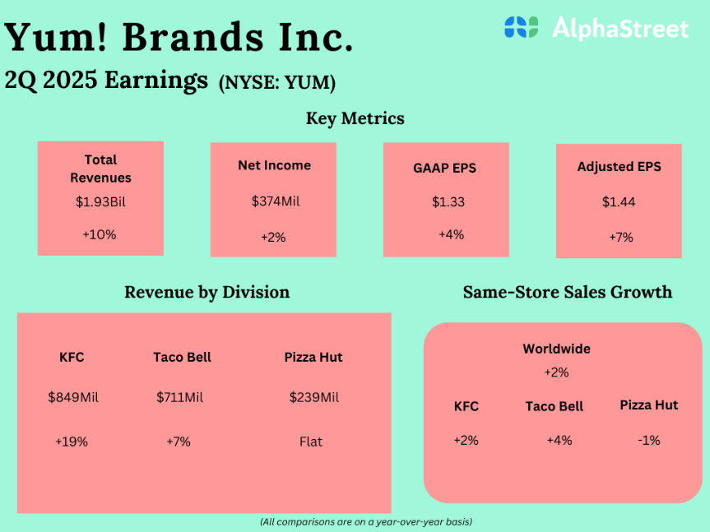
  - Figure 01: Yum! Brands Inc (Parent Company of KFC)
Source: (Alphastreet, 2025)
In the financial year 2025, Yum! Total revenues used by the brands were estimated to be around $7-8 billion, with KFC providing the biggest part of it due to its wide range of international activities (Umesh Ellichipuram, 2026). This globalisation and localisation have rendered KFC an appropriate case to study international marketing strategies.

2.0 Section 1

2.1 Comparative analysis of the market in both countries: India & United Kingdom
Comparative PESTEL analysis underscores the differences between the environment in which KFC has to function, India (emerging, high growth) and the United Kingdom (developed, mature market).
Political Factors
India
The political climate in India is fairly stable and open to foreign investments, especially in the retail and food service industries (Kaushal, 2022). The government has taken the initiative through its programmes like make in India and liberalised FDI policies to promote multinational growth. For example, as illustrated below, India's FDI inflows have grown since 1999–2000, according to information obtained from the Reserve Bank of India and S&P Global. Data is accurate until the fiscal year 2022–2023, which concluded in March 2023 (Lu, 2023). But the complexity of regulations remains with differences in the ways of states governing and bureaucracy which might slow down operations (UDO, 2024). However, the long-term business opportunities of international brands are promoted by constant investment in infrastructure and digitalisation.
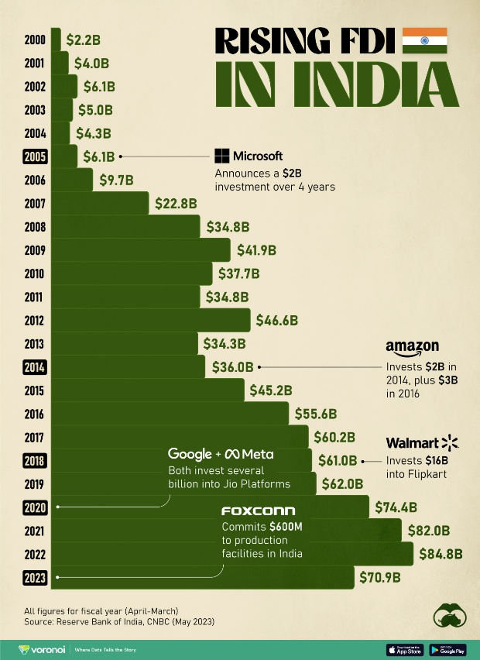
  - Figure 02: FDI Inflows in India
Source: (Lu, 2023)
United Kingdom
On the contrary, the political system in the United Kingdom is very stable and transparent with well-developed institutions. Multinational companies have been affected by the changes in policy since Brexit that influenced the cost of imports, and the chain of supply (Bosio et al., 2025). Its regulatory environment is more predictable and consumer protection and compliance are highly emphasised. Although this stability is advantageous in long term planning, it also puts more strict operational requirements than India (David, 2023).
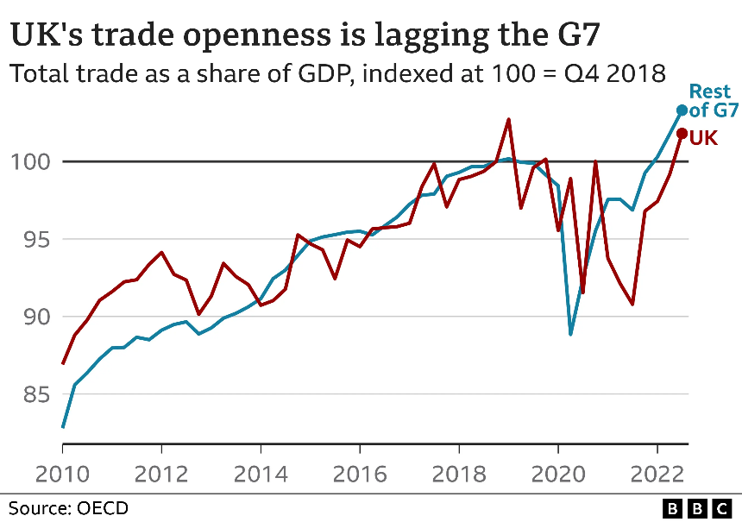
  - Figure 03: UK’s Trade Openness is lagging
Source: (David, 2023)
Economic Factors
India
The economy of India still shows a good growth momentum with GDP growth estimated at around 6.3% to 7% by 2025-26. Inflation has reduced considerably and the rates have dropped to about 1.7% in some sections of 2025, which Favors the consumer purchasing power (Pib.gov.in, 2026). There is an increase in disposable income, high rates of urbanisation and growth of the middle classes which are contributing to the rising demand of the quick service restaurants. Nevertheless, economic disparity and price responsiveness are the major limitations, which affect the consumption habits and pricing mechanisms.
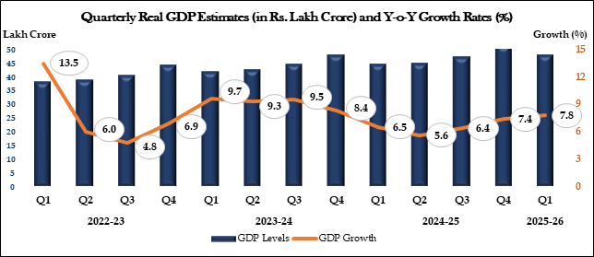
  - Figure 04: GDP of India
Source: (Pib.gov.in, 2026)
United Kingdom
United Kingdom, on the other hand, is a high income yet low growth economy. The GDP growth was comparatively low in 2025 standing at 1.3%, with some quarters showing low growth of approximately 0.1% (Milliken, 2025). By early 2026, inflation stood at 3 per cent resulting in a long-term cost-of-living crisis. Consumer spending is also high, at almost 59% of GDP, but decreasing real disposable income has limited discretionary income. This poses a hard situation to fast-food brands that have to balance value provision with increased costs of operation.
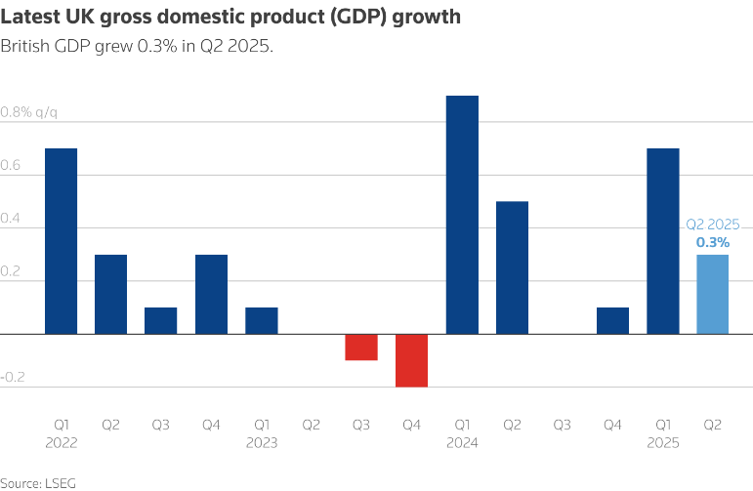
  - Figure 05: UK GDP 2025
Source: (Milliken, 2025)
Social Factors (In-depth Comparison)
India
The most crucial factor that may affect the market strategy of KFC is social and cultural differences between the UK and India (KFC, 2024). The population of India is above 1.4 billion and is young as the number of those below the age of 35 is high (IBEF, 2025). This population trend leads to demand towards fast foods, convenience, and international brands. Cultural and religious diversity are however a big influence on the consumption behaviour. A significant number of vegetarians and dietary restrictions because of religious reasons demand changes to the menu (Asante et al., 2021). Taste towards localised and spicy tastes also affect product development. Similarly, rising urbanisation and hectic lifestyles have enhanced the use of online food delivery services and online interaction especially to younger consumers.
United Kingdom
Demographic profile in the United Kingdom is relatively older and more stable, having well-developed consumption pattern (Kang et al., 2022). Economic strains have also affected behaviour as real disposable income is expected to fall by about 1% in early 2025. In addition, there are wider wellbeing issues, with a relatively low percentage of 70.9% of people stating that they are in good health in 2025 (Ruggeri et al., 2025). These are some of the reasons that lead to more cautious consumption and a shift towards value-oriented but healthier food options.
In general, affordability, taste, and convenience are the key factors influencing the consumer behaviour of Indian people, whereas the UK consumers are more concerned with health, ethics, and value money (MSN, 2026). This deviation necessitates KFC to make major changes in its products such as having vegetarian products in India and healthier products in UK.
Technological Factors
India
The country of India is undergoing a high rate of technological development, which is facilitated by the high use of smartphones and cheap internet (Mangal, 2025). UPI and the growth of food services delivery platforms have disrupted the fast-food restaurant industry through digital payment systems.
United Kingdom
In its turn, the United Kingdom is a country that has a highly developed technological history and near universal internet penetration and digital integration. The consumers are accustomed to digital experiences, including mobile ordering, contactless payment, and self-service kiosks (Wadud et al., 2025). Businesses have been extensively applying data analytics and artificial intelligence to enable them to enhance their customer interaction and operations. Though both the UK and India are equally digitally active, the former is more technologically developed, and the latter is a rapidly developing digital space with a high growth potential.
Legal Factors
India
The Indian legal system of the food and retail industry is in its evolutionary stages, and the regulatory bodies like food safety and standards authority of India (FSSAI) make sure that the food safety standards are met (Dabade et al., 2024). But the legal procedures may be complicated and different in different states, especially regarding labour legislation and franchise activities. This poses a problem to multinational companies that want to be consistent in their operations.
United Kingdom
Conversely, the United Kingdom has a well organised legal framework where food safety, employment legislation and advertising rules are strongly enforced. Regulations guarantee high rates of consumer protection and consistency in operations, yet they also raise the compliance costs (Segbedzi, Ansah and Apaak, 2025). The legal environment is also predictable than in India; therefore, long term strategic planning can be done easily.
Environmental Factors
India
The environment is becoming a major concern in India especially regarding waste management and plastic. Sustainability programs by the government are on the rise though implementation is still weak (Kibria et al., 2023). One of the issues facing effective environmental management is infrastructure constraints.
United Kingdom
The UK is more developed in terms of environmental sustainability, which is backed by good regulatory policies and consumer awareness (Li, 2025). The businesses will be supposed to use sustainable sourcing, lower carbon emission, and limit packaging wastage. Environmental responsibility is not only a regulatory condition, but also one of the major determinants of brand perception.

2.2 Comparative Analysis of STP (Segmentation, Targeting, and Positioning) of KFC in India and the United Kingdom
Segmentation
India
KFC in India uses multi-layered segmentation approach, which is segmented in terms of demographic, geographic, psychographic and behavioural variables. The brand is mostly demographically targeted at young consumers between 18 and 35 years old with a preference to western fast food, especially the students and the early professionals in their careers (Gajanova et al., 2023). KFC focuses geographically on the urban and semi-urban cities like Delhi, Mumbai, Bengaluru and Hyderabad, which have more disposable income and exposure to international brands.
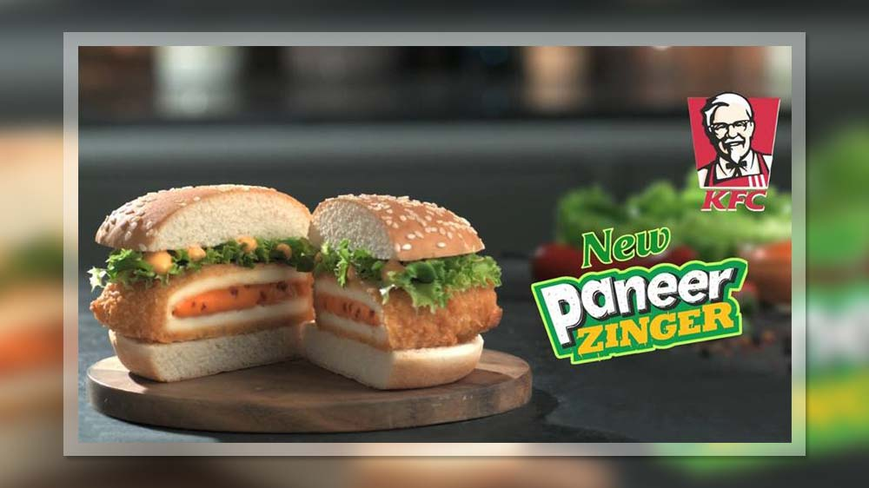
  - Figure 06: New Items Launched by KFC in India
Source: (Restaurant India, 2025)
As per the graph below, in FY 2024, the brand value of KFC was 6.70Bn, which makes a clear sense for Indian segmentation for better brand visibility. An evident instance of segmentation in India is the KFC launching of a series of vegetarian product brands like the Veg Zinger and Paneer Zinger specifically to the huge vegetarian market. Similarly, there are spicy versions such as the Hot and Crispy Chicken, which attracts the taste of the Indians, which exhibits behavioural and cultural segmentation (Restaurant India, 2025). Digital segmentation is also used where the company targets consumers using apps by using applications such as Zomato or Swiggy to provide personalised discounts and combo offers.
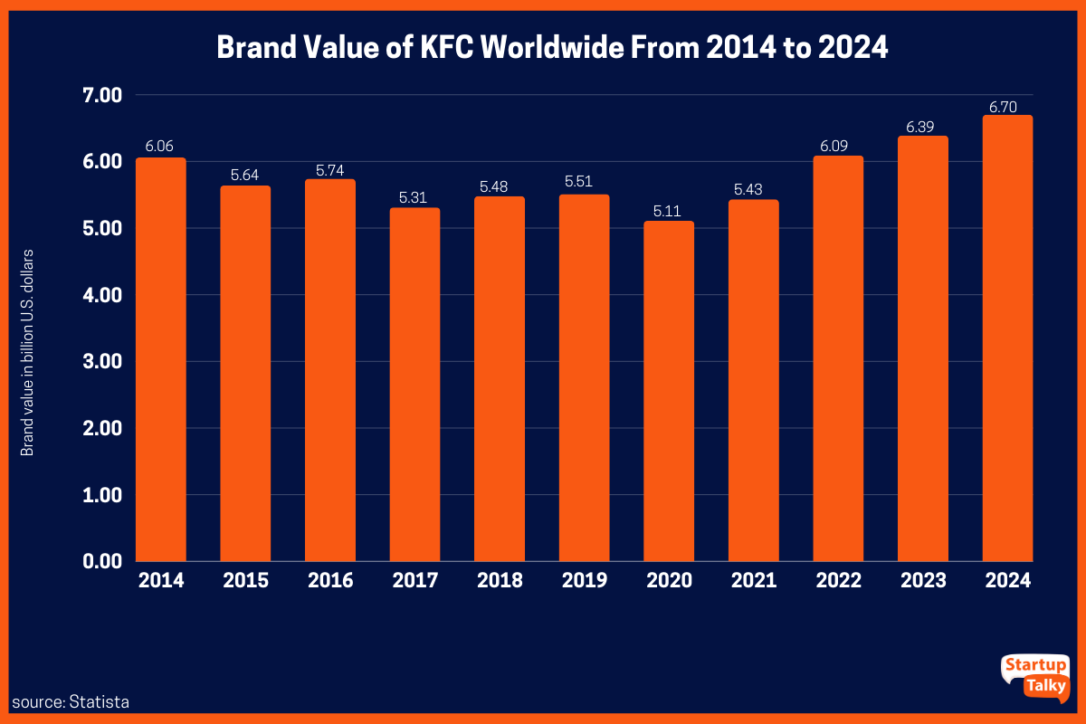
  - Figure 07: Brand Value of KFC
Source: (Karthikeyan, 2023)
United Kingdom
KFC is more mature and refined in its segmentation process in the UK. Demographically, it caters to a wide age range though it concentrates on young adults and families (Habachi et al., 2023). The purchasing power is higher in UK market and KFC are able to serve the value-seeking consumers and those who are ready to afford the premium fast-food experience.
Psychographically, the UK consumers are classified according to their lifestyle and values especially health conscious and ethical values. Behavioural segmentation involves the regular fast-food consumers, late-night diners, and convenience-based consumers (Jenkins et al., 2021). A good case of segmentation based on healthier eating habits is the KFC case where the company came up with grilled chicken products and low salt food to attract health-conscious customers.
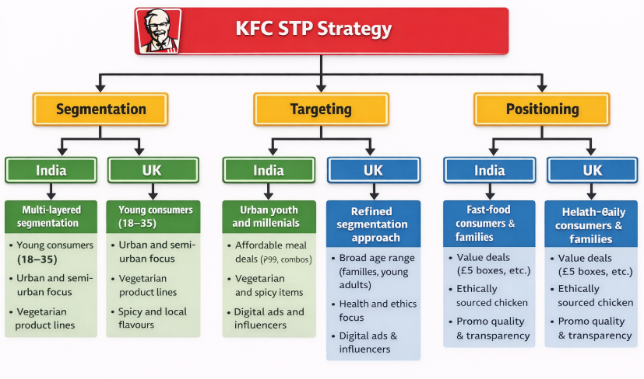
  - Figure 08: KFC’s STP Strategy
Source: (Migkos, Giannakopoulos and Sakas, 2025)
Targeting
India
KFC uses differentiated targeting in India, where it targets various consumer groups with differentiated products. Its core market consists of urban youth and millennials who are the products of Western culture and digital trends (Migkos, Giannakopoulos and Sakas, 2025). The group is very sensitive to social media marketing, influencer marketing, and in-app promotions. The middle-income households that are pursuing low-cost meals are the second targeted group.
The company is also tactical in targeting the value-sensitive market with the cheap meal packages such as the 99 deals and the combo meals. In the meantime, it caters to culturally different markets with vegetarian menus and dishes that are locally flavoured (Chen, 2023). As an example, the variants of Peri and rice bowls of KFC India are aimed at capturing local preferences without losing the brand name. This is indicative of a powerful localisation strategy of targeting.
United Kingdom
KFC in the UK employs a narrower targeting strategy with the focus on the convenience-based consumers and families (Gan et al., 2024). Its main target market consists of young adults and working professionals who would like to have fast and cheap food. Secondary segments are family and group diners especially with the bucket meals that are meant to be shared.
KFC UK has also been focusing on price-conscious customers when the economy is performing poorly and providing some bargains like the 5 meal box deals which have gained popularity during the cost-of-living crisis (Okur and Saricam, 2025).
Positioning
India
It is a global and local brand simultaneously with its orientation on taste, convenience, and value-based prices (Wang and Yang, 2024). Leap forward to March 2024 and KFC is the order of the day. According to a recent QSR (quick service restaurant) study by Elara Capital, the fried chicken brand was the quickest expanding QSR chain in India from FY19 to FY23 (Singh, 2024). Its positioning position draws on indulgence and flavour, frequently relying on taglines and campaigns as well as bold and spicy tastes that are in line with Indian tastes.
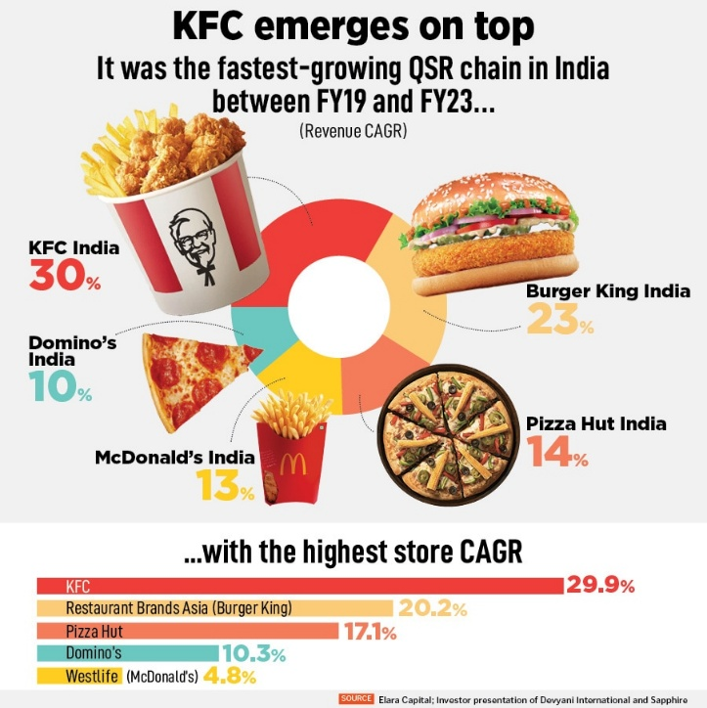
  - Figure 09: KFC Emerges on top in India
Source: (Singh, 2024)
To illustrate, the campaigns of KFC India are often cantered around experience of finger-licking good and the presentation of the locally modified menu options like the Chicken Popcorn Rice Bowl (KFC, 2024). The brand is also represented as a contemporary and youth-focused restaurant by the good digital presence and partnerships with food delivery services.
United Kingdom
KFC in the UK presents itself as a high-quality fast-food brand which has a strong heritage and is trusted (Morkūnas and Grišmanauskaite˙, 2023). Its focus is on genuineness, quality of products and emotional relationship with customers. To support the aspect of trust and familiarity, the brand uses its long-standing existence and iconic recipes.
One of them is the advertising campaigns of KFC UK, which focused on the initial recipe and humorous brand voice, as well as the most famous campaign around FCK, which talked about the issue of the supply chain in an open and transparent manner and made the brand more trustworthy (Novoa, 2025). The brand also positions itself as more responsible and sustainable, which matches the requirements of consumers in the ethical sourcing and environmental impact.

2.3 Comparative Analysis of International Marketing Mix (7Ps) of KFC in India and the United Kingdom
Product
India
KFC embraces powerful product differentiation in India in order to conform to cultural and food choices. The menu accommodates vegan recipes like the Veg Zinger, Paneer Zinger, as the vegan community is a significant portion of the Indian population (Chauhan and Shiwang, 2025). Further, such items as the Chicken Popcorn Rice Bowl and hot versions such as Hot and Crispy Chicken are adjusted to the Indian taste preferences of bold flavors.
United Kingdom
KFC in the UK has a more standardized product strategy and is responsive to health trends. The menu consists of grilled chicken dishes, vegan burgers (e.g., Vegan Burger created in collaboration with Quorn), and low-salt dishes. The changes are a response to the growing health awareness and the need to have plant-based alternatives (Madhavedi et al., 2024).
Price
India
India has a penetration and value-based pricing strategy to serve the price sensitive consumers. KFC has low prices including 99 or 199 boxes and meal combo offers aimed at students and middle-income earners (KFC, 2024). Competitive pricing is necessary because of the high competition with local QSR brands and the necessity to appeal to the mass-market consumers. As illustrated below, although the number of stores has consistently risen from 540 in 2QFY24 to 734 in 2QFY26, average daily sales have significantly declined—from a high of ₹109,000 per day in 2QFY24 to ₹83,000 in 4QFY25, before partially rebounding to ₹89,000 in 2QFY26 (Datum Intelligence, 2025).
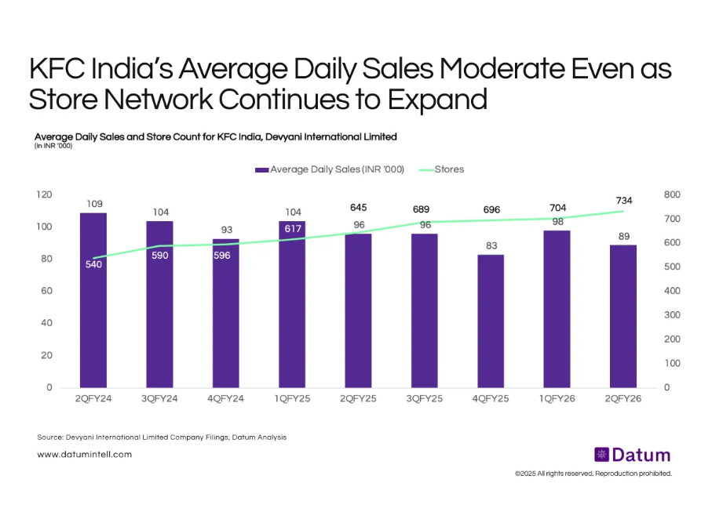
  - Figure 10: KFC India’s Average Daily Sales
Source: (Datum Intelligence, 2025)
United Kingdom
KFC has adopted a value-based pricing strategy in the UK, which is in line with purchasing power (KFC, 2024). Prices are comparatively high to India, however; the brand has promotions like the use of £5 meal boxes to attract consumers who are cost-conscious especially at the time of the cost-of-living crisis.
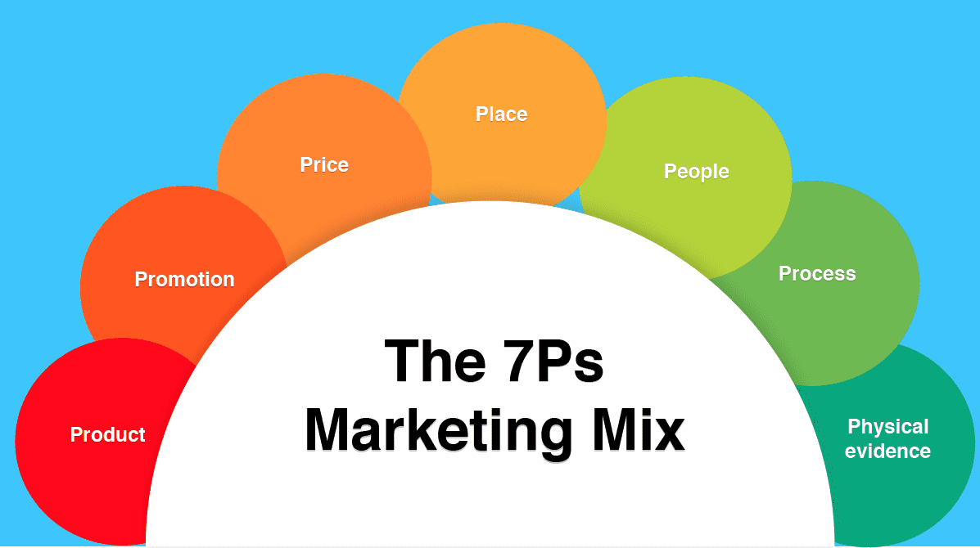
  - Figure 11: Marketing Mix
Source: (Hanlon, 2023)
Place (Distribution)
India
The distribution of KFC in India is concentrated on the growth of the urban and semi-urban territories (Hanlon, 2023. The brand exists in big urban areas, and it is progressive to the tier-2. One of the major focuses is on digital distribution by collaborating with other websites like Zomato and Swiggy, and their mobile application. The changing consumer lifestyles favor delivery and takeaway forms.
United Kingdom
The distribution network of KFC in the UK is very developed and covers a large area in the cities, suburbs and high streets (Aziz, 2021). The brand utilizes dine-in, takeaway, drive-thru, and delivery channels. The UK market has an advanced infrastructure which enables easy omnichannel distribution.
Promotion
India
KFC has a highly digital and youth-focused Indian promotional strategy. The brand engages in social media, influencer marketing, and promotions through apps so as to access younger demographics. Affordability, flavor and new product launches are some of the aspects of campaigns.
United Kingdom
KFC in the UK is a combination of both traditional and digital marketing whereby the brand personality and humor are highly pronounced (Sari and Dermawan, 2023). For example, as illustrated below, in 2020, KFC obtained highest uplift regarding AD awareness with 10.7% rise. Sustainability initiatives and product quality are also reflected in promotions, which are in line with consumer expectations in terms of ethics and responsibility.
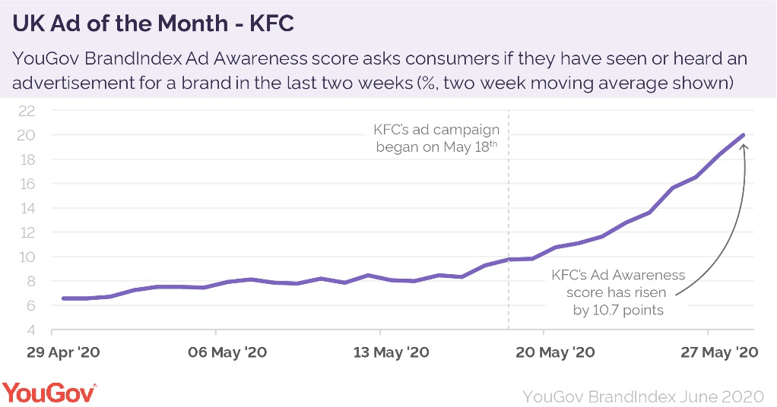
  - Figure 12: UK Ad of the Month KFC
Source: (YouGov, 2023)
People
India
KFC in India concentrates on service and customer interaction which is efficient especially in busy urban outlets. Employees are educated to provide speedy service without compromising the brand standards (Aziz, 2021).
United Kingdom
Training staff in UK focuses on the quality of customer service, hygiene and adherence to rigid labor laws (Timothy, 2023). The employees will be instrumental in ensuring uniform delivery service among the outlets, as this is part of the brand-new relationship developed over the years and has increased customer expectations.
Process
India
The Indian processes are made fast and convenient especially in delivery services and takeaway services. Connectivity with online ordering and mobile applications simplifies business. Infrastructure variability can, however at times, lead to inconsistency between locations.
United Kingdom
UK has highly standardized and technologically integrated processes. The use of self-service kiosks, contactless payments and well-managed kitchen operations make the delivery of services a fast and consistent one (Adibah et al., 2021). Advanced supply chain systems promote operational efficiency.
Physical Evidence
India
KFC stores in India also have a contemporary and energetic ambient that is usually structured in such a way that it attracts younger buyers (KFC, 2024). The stores are usually found in malls and high streets, and the branding is focused on affordability and accessibility. The packaging is modified to accommodate heavy consumption patterns of takeaway and delivery.
United Kingdom
KFC restaurants in the UK focus on brand heritage, comfort, and cleanliness. Store designs are more standardized and they involve sustainability (KFC, 2024). Quality, trust and environmental responsibility are strengthened by packaging and in-store images.

2.4 Directional Development Strategy of KFC in India
The long-term interest of KFC in one of the quickest growing quick-service restaurant (QSR) markets in India is the main cause of its directional development strategy in the country, which is characterized by the combination of market penetration, product development, and geographic expansion (Chauhan and Shiwang, 2025).
One of the key aspects of the KFC approach in India is localisation of its products. The brand has also launched menu innovations like the Veg Zinger, Paneer Zinger, and Chicken Popcorn Rice Bowl to reach out to the high number of vegetarians in India and the local taste. This is in line with the product development strategy of the Ansoff Matrix that involves the launching of new products in the already existing markets in order to secure a larger market share (Crawler IQ, 2025). Moreover, customisation of flavours, such as spicy ones such as Hot & Crispy Chicken and Peri, enhances cultural resonance and consumer acceptance.
The other strategic direction is the market penetration basing on value-based pricing and online interaction. KFC India also has a tendency to provide low prices on some of the meals (e.g., 99 or combo offers) in order to target buyers who are price-sensitive and encourage them to buy more frequently (Sah and Arora, 2025). In the meantime, the brand leverages online platforms such as mobile apps and partnerships with food delivery apps, such as Zomato and Swiggy to deliver accessibility and customer experience, particularly among the youth in urban regions.
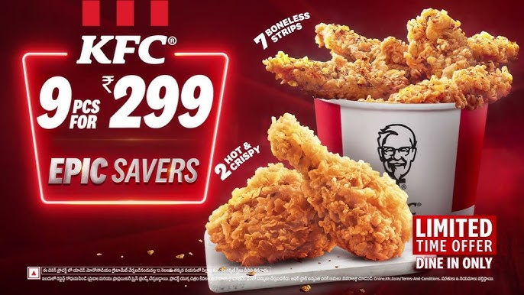
  - Figure 13: KFC Offers in India
Source: (KFC India, 2025)
Similarly, expansion to tier-2 and tier-3 cities is a key growth strategy. New store opportunities exist outside of big metros with rising disposable incomes and urbanisation in smaller cities (KFC, 2024). This is backed up by a franchise-based model that can facilitate quick scaling but at an efficient cost of operation.

2.5 Ethical Issues in KFC’s Marketing Mix in India
Ethical concerns have been intertwined with the KFC marketing mix in India, but they do not nullify the overall success of the brand in the market. The greatest issues are associated with product ethics, health responsibility, and supply-chain welfare. KFC in India has been subject to food-safety inspection on the product side. In July 2024, a KFC restaurant in Thoothukudi, Tamil Nadu, landed under regulatory action following the use of magnesium silicate in oil filtration, yet the company said that it was in compliance with the FSSAI standard, and the agent was permitted (TOI, 2024). The controversy itself demonstrates that the food handling practices may turn into an ethical concern due to the demand of consumers that an international food brand should be completely safe, transparent and compliant.
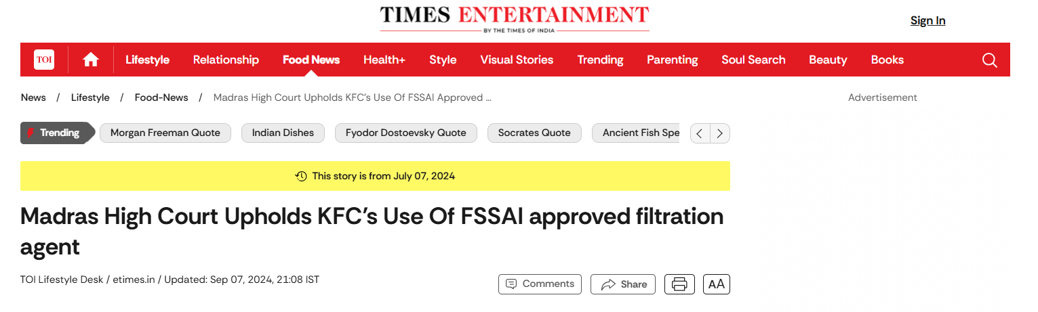
  - Figure 14: News by Times on Ethical Case
Source: (TOI, 2024)
The second problem is related to animal welfare, which is very pertinent to KFC since its main product is chicken. Yum! has been publicly called on by World Animal Protection India. Brands India to improve the welfare of chickens, and yum! According to Brands, it has a global animal welfare policy and the principles of sustainable animal protein throughout the supply chain (Worldanimalprotection.org.in, 2021). This raises an ethical dilemma: the company demonstrates the idea of responsible sourcing as its brand image, but the external advocacy groups believe that greater efforts should be made in India.
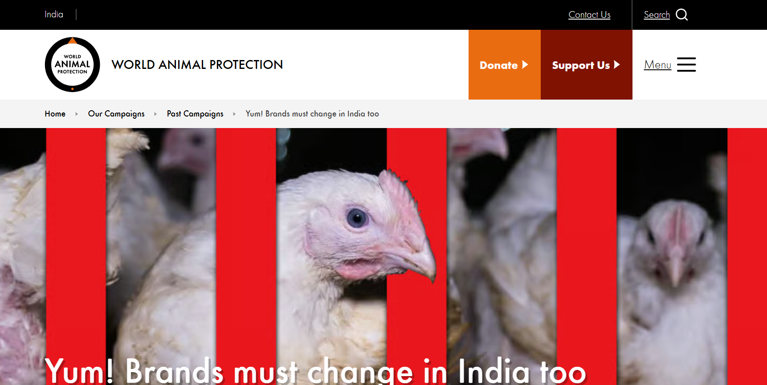
  - Figure 15: News by WAP India on Yum (Parent Company of KFC)
Source: (Worldanimalprotection.org.in, 2021)
A question of promoting and consumption is also a larger ethical question. Commercially, KFC has achieved success with its youth-targeted advertising, value meals, and intensive promotions of delivery, though it can be criticised as promoting more frequent fast-food consumption in a market where nutrition and public-health issues are on the rise (Bagnato et al., 2023). This does not render the strategy an unethical one per se, but rather it implies that the company would have to weigh sales growth and ethical marketing.

2.6 Recommendations for Future International Marketing Strategy of KFC
Strengthening Localisation with Strategic Standardisation
KFC needs to keep on improving on its global strategy, balancing between global brand consistency and greater local adaptation. Markets such as India can be further penetrated by investing in culturally orientated products such as plant-based and geographical based products in the menu (Araia, 2022). Data-driven location strategies should also enable the company to penetrate emerging urban clusters and tier-2 cities. KFC ought to optimize its menu in the mature markets such as the UK, by adding healthier and high-quality foods to serve changing consumer demands. The dual strategy will enable the brand to be competitive in a variety of economic and cultural settings.
Enhancing Ethical, Digital, and Sustainability Focus
The ethical marketing and sustainability should be the key elements of KFC international strategy. Enhancing brand trust by strengthening transparency in sourcing, enhancing animal welfare standards, and minimizing environmental impact by using sustainable packaging will increase brand trust worldwide (Guandalini, 2022). Moreover, the company ought to widen its digital ecosystem through the exploitation of AI-based personalisation, loyalty programmes, and mobile solutions to enhance the interaction with customers. Health issues should be addressed by promoting responsible marketing, especially to the younger age groups. Combining digital innovation with sustainability, KFC will be able to develop a competitive advantage in the long term and match the expectations of consumers all over the world.

3.0 Section 2

3.1 Reflective Account Using Kolb’s Cycle of Reflective Practice
Concrete Experience
The researching, analysis and preparation of the international marketing report on KFC in India and the United Kingdom was a well-organized but difficult academic experience. Firstly, I did a significant amount of secondary research to determine what information was available on macro-environmental factors, STP strategies, and 7ps marketing mix (that was current and up to date). This involved reviewing the reports in the industry, company reports, and reliable sources of data to guarantee the accuracy and academic rigour. I also paid attention to finding practical examples, like the vegetarian menu of KFC in India and ethical sourcing in the UK to reinforce the analysis. In this phase, I needed to analyse information, especially with theoretical models such as PESTEL and STP. The experience demanded solid time management, critical reading as well as the refinement of pertinent information amidst a mass of sources. The need to create the report in a logical, coherent way and at the same time, keeping the required word count and academic tone increased the complexity of the task.
Reflective Observation
Reflectively, I realised that the research undertaking was fruitful and challenging. The use of the structured frameworks was one of the major strengths of my approach as it assisted in organising the analysis in a systematic manner. The use of models like PESTEL and STP enabled me to make comparisons between India and the UK appropriately and made sure that the discussion was analytical and focused but not descriptive. Also, the use of actual company examples enhanced the richness and authenticity of the report. Nevertheless, I also had some difficulties, especially when it comes to finding quality and recent statistical information. Sometimes, it was challenging to tell the difference between a general information and an academically credible source, which also needed further validation. The other limitation was balancing between the global theory and local application. Although I could use frameworks, I needed to make sure that every aspect was contextualised to KFC. Moreover, it was difficult to be clear and not to repeat the information in different sections like STP and marketing mix analysis.
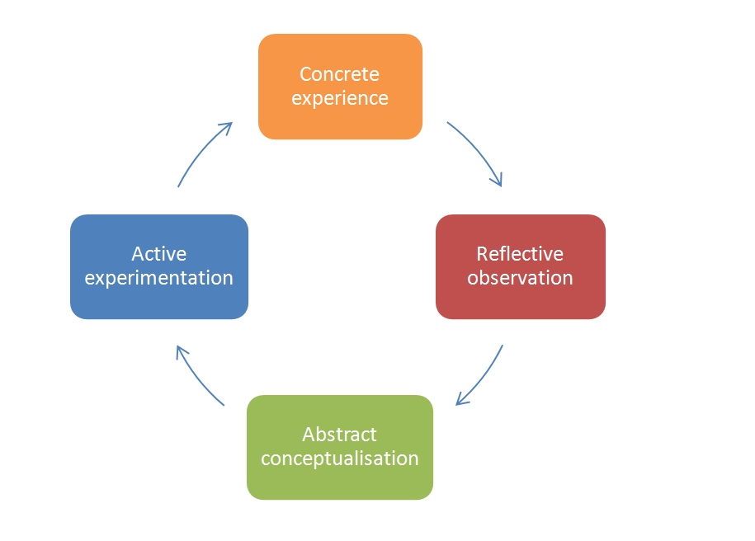
  - Figure 16: Kolb’s Reflective Model
Source: (Brown, 2024)
Abstract Conceptualisation
The experience helped me to develop my knowledge of the application of theoretical concepts in practical business settings. I gained a greater understanding of international marketing as an active process which demands standardisation and adaptation. This task helped me to realise that such frameworks as PESTEL and STP are not only theoretical tools but effective approaches to the analysis of complex market environments. In the case of India versus UK, the vast divergence in social and cultural aspects of the two countries showed that consumer behaviour has a direct impact on marketing strategies. Skills-wise, I have become a better critical thinker because I have enhanced my skills in evaluating information critically, synthesising the information of various sources and finally presenting an argument in a coherent way. This process also helped to reaffirm the need to use credible and recent data to justify analysis, which is fundamental to attaining high academic quality.
Active Experimentation
According to this learning experience, some of the changes would be embraced in future academic work are as follows. To start with, the research would initiate the research process sooner and develop a more comprehensive research plan to have adequate time to source out data of high quality. Another priority I would give to the use of academic journals and industry databases at the very beginning would save me time on source checking in the future. Secondly, I would also improve my analytical strategy and approach by incorporating more comparative knowledge throughout the report as opposed to highlighting them individually. This would enhance the whole coherence of analysis and the depth of critical analysis. I would also utilise more visual aids like charts and diagrams during the planning phase to plan ideas better before writing. Lastly, I would be working on my skills of critical reflection by constantly assessing my progress and determining what I can improve during the research process as opposed to at the end of the research.

4.0 Conclusion
This report illustrated that KFC manages to balance its global and local marketing strategies to suit India and the United Kingdom by balancing global uniformity and local sensitivity. The analysis shows that the macro-environmental differences, consumer behaviour as well as cultural expectations play a big role in the determination of STP as well as marketing mix. Whereas India needs high levels of localisation and value-based strategies, UK needs quality, ethical orientation, and health-sensitive products.

Reference
Adibah, F., Che, A., Samengon Harnidah and Bakar, A. (2021). The Implementation of Self-Ordering Kiosks (SOKs): Investigating the Challenges in Fast Food Restaurants. [online] ResearchGate. Available at: https://www.researchgate.net/publication/355921267_The_Implementation_of_Self-Ordering_Kiosks_SOKs_Investigating_the_Challenges_in_Fast_Food_Restaurants.
Alphastreet (2025). Yum! Brands (YUM) Q2 2025 Earnings: Key financials and quarterly highlights. [online] Alphastreet - Earnings Decoded. Market Intelligence Delivered. Available at: https://news.alphastreet.com/yum-brands-yum-q2-2025-earnings-key-financials-and-quarterly-highlights/ [Accessed 7 Apr. 2026].
Araia, D. (2022). (PDF) Standardization Vs Localization strategies, influence of Culture on consumption and Market Research in International Marketing Strategies. [online] ResearchGate. Available at: https://www.researchgate.net/publication/321371202_Standardization_Vs_Localization_strategies_influence_of_Culture_on_consumption_and_Market_Research_in_International_Marketing_Strategies.
Asante, M., Frimpong, B., Intiful, F., Nkumsah-Riverson, P., A. Nkansah, S., Ofori-Amanfo, B., Y. Dogbe, Y. and A. Asare, G. (2021). Food consumption pattern and dietary diversity of a vegetarian population in Ghana. Ghana Medical Journal, 55(1), pp.26–33. doi:https://doi.org/10.4314/gmj.v55i1.5.
Aziz, M. (2021). Research on KFC Consumer Satisfaction in UK and India. [online] doi:https://doi.org/10.13140/RG.2.2.13936.33288.
Bagnato, M., Roy-Gagnon, M.-H., Vanderlee, L., White, C., Hammond, D. and Potvin Kent, M. (2023). The impact of fast food marketing on brand preferences and fast food intake of youth aged 10-17 across six countries. BMC public health, [online] 23(1), p.1436. doi:https://doi.org/10.1186/s12889-023-16158-w.
Bosio, A.O., Butticè, V., Crisanti, A., Croce, A. and Signore, S. (2025). How Brexit reshaped venture capitals market: An analysis of UK and EU investments. Research Policy, [online] 54(8), p.105289. doi:https://doi.org/10.1016/j.respol.2025.105289.
Brown, N. (2024). Reflective Model according to Kolb. [online] Dr Nicole Brown. Available at: https://www.nicole-brown.co.uk/reflective-model-according-to-kolb/.
Chauhan, S. and Shiwang (2025). Marketing Strategies of KFC in India. International Journal of Research Publication and Reviews Journal homepage: www.ijrpr.com, [online] 6, pp.10076–10087. Available at: https://ijrpr.com/uploads/V6ISSUE6/IJRPR49003.pdf.
Chen, L. (2023). Effective Strategies for Attracting and Engaging Target Audiences in Today’s Competitive Market. Journal of Education, Humanities and Social Sciences, 16(16), pp.141–147. doi:https://doi.org/10.54097/ehss.v16i.9587.
Crawler IQ (2025). KFC’s Marketing Strategy: Key Actions Behind Its Success. [online] Trackandtactic.com. Available at: https://www.trackandtactic.com/2025/05/kfcs-marketing-strategy-key-actions.html.
Dabade, A.S., Gudekar, S., Kadam, A., Dhekane, A. and Rawat, L. (2024). FOOD SAFETY AND STANDARD LAWS AND REGULATION IN INDIA. Futuristic Trends in Agriculture Engineering & Food Sciences Volume 3 Book 14, [online] pp.88–100. doi:https://doi.org/10.58532/v3bcag14p4ch3.
Datum Intelligence (2025). Average Daily Sales Decline Even as KFC Scales Its National Footprint. [online] Datumintell. Available at: https://www.datumintell.in/average-daily-sales-decline-even-as-kfc-scales-its-national-footprint/ [Accessed 7 Apr. 2026].
David, D. (2023). What impact has Brexit had on the UK economy? BBC News. [online] 31 Jan. Available at: https://www.bbc.com/news/business-64450882.
Gajanova, L., Nadanyiova, M. and Moravcikova, D. (2023). The Use of Demographic and Psychographic Segmentation to Creating Marketing Strategy of Brand Loyalty. [online] ResearchGate. Available at: https://www.researchgate.net/publication/333208991_The_Use_of_Demographic_and_Psychographic_Segmentation_to_Creating_Marketing_Strategy_of_Brand_Loyalty.
Gan, K.H., Ng, W.C., Chia, X.Y., Chen, S. and Mui, D. (2024). Analyzing the Fast-Food Marketing Strategies Impacting Consumer Buying Behavior. International Journal of Accounting & Finance in Asia Pasific, [online] 7(3), pp.395–409. doi:https://doi.org/10.32535/ijafap.v7i3.3574.
Guandalini, I. (2022). Sustainability through digital transformation: A systematic literature review for research guidance. Journal of Business Research, [online] 148(1), pp.456–471. doi:https://doi.org/10.1016/j.jbusres.2022.05.003.
Habachi, S., Matute, J. and Palau-Saumell, R. (2023). Unlocking the Effect of the Gameful Experience on Brand Loyalty and Intention to Use: The Mediating Role... [online] ResearchGate. Available at: https://www.researchgate.net/publication/376514150_Unlocking_the_Effect_of_the_Gameful_Experience_on_Brand_Loyalty_and_Intention_to_Use_The_Mediating_Role_of_Customer_Brand_Engagement.
Hanlon, A. (2023). How to Use the 7Ps Marketing Mix. [online] Smart Insights. Available at: https://www.smartinsights.com/marketing-planning/marketing-models/how-to-use-the-7ps-marketing-mix/.
IBEF (2025). The Talent Tsunami: Harnessing India’s Demographic Dividend for Global Impact. [online] India Brand Equity Foundation. Available at: https://www.ibef.org/research/case-study/the-talent-tsunami-harnessing-india-s-demographic-dividend-for-global-impact.
Jenkins, E.L., Legrand, S., Brennan, L., Molenaar, A., Reid, M. and McCaffrey, T.A. (2021). Psycho-Behavioural Segmentation in Food and Nutrition: A Systematic Scoping Review of the Literature. Nutrients, 13(6), p.1795. doi:https://doi.org/10.3390/nu13061795.
Kang, J.Y., Park, S. and Ahn, S. (2022). The effect of social pension on consumption among older adults in Korea. The Journal of the Economics of Ageing, [online] 22, p.100364. doi:https://doi.org/10.1016/j.jeoa.2021.100364.
Kaushal, L.A. (2022). Outward foreign direct investment: the Indian experience. Transnational Corporations Review, 10(1), pp.86–97. doi:https://doi.org/10.1080/19186444.2018.1436658.
Karthikeyan, A. (2023). KFC’s Marketing Strategy: Recipe for Quality and Creativity. [online] StartupTalky. Available at: https://startuptalky.com/kfc-marketing-strategy/.
KFC (2024). HISTORY OF THE BRAND AND COLONEL SANDERS. [online] Kfc.com. Available at: https://global.kfc.com/ [Accessed 7 Apr. 2026].
KFC India (2025). Epic Savings! 9pcs for ₹299 Only 🍗 | Limited Time Offer. [online] YouTube. Available at: https://www.youtube.com/watch?v=uSD1aEXD4ls [Accessed 7 Apr. 2026].
Kibria, Md.G., Masuk, N.I., Safayet, R., Nguyen, H.Q. and Mourshed, M. (2023). Plastic waste: Challenges and opportunities to mitigate pollution and effective management. International Journal of Environmental Research, 17(1).
Li, X. (2025). Sustainable Business Practices in the UK: Benefits and Challenges. Advances in Economics Management and Political Sciences, 162(1), pp.161–167. doi:https://doi.org/10.54254/2754-1169/2025.20389.
Lu, M. (2023). Charted: India’s FDI Inflows Over the Last 20+ Years. [online] Visual Capitalist. Available at: https://www.visualcapitalist.com/indias-fdi-inflows/.
Madhavedi, Dr.S., Sudhaker, P., Prathima, Ch. and Chakradhar, G. (2024). A STUDY ON MARKETING MIX ELEMENTS (PRODUCT, PRICE, PLACE, PROMOTION) AND THEIR INTERPLAY IN DRIVING CUSTOMER ACQUISITION, RETENTION. Turkish Journal of Computer and Mathematics Education, 11(3), pp.2649–2655. doi:https://doi.org/10.61841/turcomat.v11i3.14490.
Mangal, A. (2025). India’s Glorious Success in UPI Adoption: What is Working, What is Not and What Can be Done Better? [online] doi:https://doi.org/10.58445/rars.2589.
Migkos, S.P., Giannakopoulos, N.T. and Sakas, D.P. (2025). Impact of Influencer Marketing on Consumer Behavior and Online Shopping Preferences. Journal of theoretical and applied electronic commerce research, [online] 20(2), pp.111–111. doi:https://doi.org/10.3390/jtaer20020111.
Milliken, D. (2025). UK economic growth slows in second quarter after rapid start to 2025. Reuters. [online] 30 Sep. Available at: https://www.reuters.com/world/uk/uk-economy-grew-03-q2-2025-2025-09-30/.
Morkūnas, M. and Grišmanauskaite˙, M.K. (2023). What really drives loyalty in the fast-moving consumer goods market? IIM Kozhikode Society & Management Review, 12(2). doi:https://doi.org/10.1177/22779752231154645.
MSN (2026). MSN. [online] Msn.com. Available at: https://www.msn.com/en-us/money/economy/yum-brands-outlines-8-operating-profit-growth-for-2025-with-taco-bell-and-kfc-momentum/ar-AA1DVUpL?apiversion=v2&domshim=1&noservercache=1&noservertelemetry=1&batchservertelemetry=1&renderwebcomponents=1&wcseo=1 [Accessed 7 Apr. 2026].
Novoa, S. (2025). KFC FCK Campaign: A Masterclass in Crisis Management and Brand Authenticity. [online] Science of Retail. Available at: https://scienceofretail.com/kfc-fck-campaign-crisis-management-case-study/.
Okur, N. and Saricam, C. (2025). The Role of Social Marketing on Promoting Sustainable Fashion Consumption. Sustainable Textiles: Production, Processing, Manufacturing & Chemistry, pp.113–162. doi:https://doi.org/10.1007/978-3-031-97419-9_4.
Pib.gov.in (2026). QUARTERLY ESTIMATES OF GROSS DOMESTIC PRODUCT FOR THE FIRST QUARTER (APRIL-JUNE) OF 2025-26. [online] Pib.gov.in. Available at: https://www.pib.gov.in/PressReleseDetailm.aspx?PRID=2161834®=3&lang=2.
Restaurant India (2025). RestaurantIndia. [online] Restaurant India. Available at: https://www.restaurantindia.in/news/kfc-introduces-vegetarian-menu.n8207 [Accessed 7 Apr. 2026].
Ruggeri, K., Valenzuela-Catarí, G., Polemiti, E., Galla Abderahaman, Adawi, T.R., Agopian, T., Al-Dhahli, D., Al-Hoorie, A.H., Rami Al-Sharif, Narjes Al-Zahli, Amani AlAmeeri, Fawziah Alammar, Ali, H.M., Taif Aljaberi, Almahjoob, S.M., Qais Ibrahim AlMeqdad, Sama Alsewaidi, Amara, M., Mali, M.A. and Hansika Ambahelagedara (2025). Global well-being in 2025: A multidimensional analysis of mental, financial, and social health in 92 countries. doi:https://doi.org/10.31234/osf.io/3jyda_v1.
Sah, K. and Arora, T. (2025). An Analysis of Consumer behaviour Pattern in KFC Marketing Strategies. International Journal of Research Publication and Reviews Journal homepage: www.ijrpr.com, [online] 6, pp.108–115. Available at: https://ijrpr.com/uploads/V6ISSUE9/IJRPR52467.pdf.
Sari, A.K. and Dermawan, R. (2023). The Influence of Social Media Marketing and Perceived Quality on KFC Brand Equity (Consumer Study KFC Mulyosari Surabaya). Indonesian Journal of Business Analytics, [online] 3(5), pp.1917–1928. doi:https://doi.org/10.55927/ijba.v3i5.5731.
Segbedzi, C.E., Ansah, E.W. and Apaak, D. (2025). Compliance to food safety standards: Determining the barriers within the hotel industry. PLOS Global Public Health, [online] 5(11), pp.e0002771–e0002771. doi:https://doi.org/10.1371/journal.pgph.0002771.
Singh, R. (2024). Fried & Tested: KFC Tops The Pecking Order. [online] Forbes India. Available at: https://www.forbesindia.com/article/take-one-big-story-of-the-day/fried-tested-kfc-tops-the-pecking-order/92167/1.
Timothy, D. (2023). Effect of Staff Training on Customer Service. [online] ResearchGate. Available at: https://www.researchgate.net/publication/339106723_EFFECT_OF_STAFF_TRAINING_ON_CUSTOMER_SERVICE.
TOI (2024). Madras High Court Upholds KFC’s Use Of FSSAI approved filtration agent. [online] The Times of India. Available at: https://timesofindia.indiatimes.com/life-style/food-news/license-of-fast-food-giant-suspended-by-fssai-for-use-of-magnesium-silicate-synthetic/articleshow/111557767.cms [Accessed 7 Apr. 2026].
UDO, A. (2024). REGULATORY COMPLIANCE AND ACCESS TO FINANCE: IMPLICATIONS FOR BUSINESS GROWTH IN DEVELOPING ECONOMIES. [online] ResearchGate. Available at: https://www.researchgate.net/publication/378506641_REGULATORY_COMPLIANCE_AND_ACCESS_TO_FINANCE_IMPLICATIONS_FOR_BUSINESS_GROWTH_IN_DEVELOPING_ECONOMIES.
Umesh Ellichipuram (2026). Yum! Brands posts double-digit profit growth in Q4 2025. [online] Yahoo Finance. Available at: https://finance.yahoo.com/news/yum-brands-posts-double-digit-101721292.html [Accessed 6 Apr. 2026].
Wadud, I., Liang, Y.D. and Polkinghorne, M. (2025). Digital Transformation in the UK Retail Sector. Encyclopedia, [online] 5(3), p.142. doi:https://doi.org/10.3390/encyclopedia5030142.
Wang, Z. and Yang, T. (2024). Research on the Product Positioning Strategy of the Independent Seller under Platform Encroachment. Systems, [online] 12(1), pp.36–36. doi:https://doi.org/10.3390/systems12010036.
Worldanimalprotection.org.in (2021). Yum! Brands must change in India too. [online] India. Available at: https://www.worldanimalprotection.org.in/our-campaigns/past-campaigns/food-systems/yum-brands-must-change-in-india-too/ [Accessed 7 Apr. 2026].
YouGov (2023). Ad of the Month UK - KFC. [online] Yougov.com. Available at: https://yougov.com/en-gb/articles/30073-ad-month-uk-kfc.

