Portfolio 4 components

BMIH5003 Foreign Languages and Cultural Awareness

Student Name: Loredana Turner
Student ID: 2242724
Word Count : 2000
Lecturer: Giulia Chifari

Contents
Personal Reflection 3
Explanation 3
Reflection and Skills Development: 3
Training Plan 5
Student Self Reflection 7
Description 7
Feelings 7
Evaluation 7
Analysis 7
Conclusion 8
Action Plan 8
Training 9
Introduction 10
Benefits of Multilingualism 10
Example Language: French 11
Example from the Hotel Industry 12
Language Awareness Skills 13
Example Scenario 14
Conclusion 15
References 17

Personal Reflection
A misunderstanding can occur during dinner service in the hotel restaurant where I, as a waiter have encountered a cultural misunderstanding with a guest from Japan. This specific incident happened with the guest, accustomed to a different dining etiquette, ordered his food and proceeded with his meal. As part of my daily routine and job responsibility, I cleared the plate when I saw that the guest was chatting with his friends and left the plate on a side of the table. The food was not completely finished and a small portion of the food was left. The customer was uncomfortable because I took his plate before finishing his meal. I committed and worked to be able to provide effective service, but my action did not say this, and this offended the guest. Due to my actions, it led to a communication interruption and customers dissatisfaction with their dinner experience.

Explanation
Cultural misunderstandings like the one mentioned above can easily occur in the hospitality industry because the employees usually serve the customers directly(Walker, 2019). The customers may belong to various cultural background which can make it difficult to communicate among each other, hence the misunderstanding (Seymour, 2012). In this scenario, the cultural norm in Japan dictates that clearing plates before the guest finishes eating is considered rude and the Japanese make effort to complete all the food present in the plate at one sitting. They do not leave any food on the plate which is their inherent behaviour or habit. Clearing the plate before the guest completed his food has been interpreted as a signal that the guest is being rushed. It is customary to wait until everyone has finished eating before clearing any plates to showcase response.

Reflection and Skills Development:
To prevent such misunderstandings in the future, there are some steps that can be taken. Firstly, I need to develop a deeper understanding of cross-cultural communication and sensitivity. I must recognize and appreciate the diversity of cultural norms and practices among guests. This can be obtained with the help of ongoing education and awareness to get to know various cultures, particularly those frequently encountered in the hotel's clientele (Nadda, Arnott and Sealy, 2022).
Secondly, I need to work on developing my observational skills to so that it becomes possible for me to catch non verbal cues from guests. The reason behind it is that the people from other culture may show various non verbal cues can be a good indication regarding their comfort level and preferences. This means that I need to focus on actively listening to verbal cues but also paying attention to non-verbal signals such as body language and facial expressions.
Furthermore, I need to cultivate empathy and patience in my interactions with guests as these are extremely valuable when working with potential cultural differences (Berkovi, 2016). I also need to be interested to understand the point of view of the customers as a good listener which can ease up the process. To ensure that, I may need to ask questions and clarify where necessary so that effective communication can be implemented.
The incident with the Japanese guest serves where my attempt to clear the plate as early as possible has become a valuable learning experience where it shows why the cultural competence is important for every person related to hospitality industry.

Training Plan
Following a recent incident involving a cultural misunderstanding with one of our esteemed guests, I propose the implementation of a comprehensive staff training plan. Research shows that cross cultural competence can significantly enhance customer satisfaction and service quality in hospitality setting (Blohm, 2012). This training is designed with the aim to equip our staff with the necessary skills and knowledge so that they can ensure proper communication with the people that belongs to different backgrounds.
Training Objectives:
Provide staff with insights into the various cultural norms, practices, and values prevalent among our guests and while doing so, it can be helpful to identify people from which culture frequently visits so that that specific culture can be identified (Blohm, 2012). Data from our guest demographics over the past year shows that a significant portion of our clients came from a few specific countries, and those are Japan, China, Middle East, and so on.
Equip staff with effective communication strategies for engaging with guests from different cultural backgrounds, including verbal and non-verbal cues (Blohm, 2012).
Cultivate an mindset among staff members where they feel encouraged to communicate with the people from other culture instead of being nervous. Encourage a mindset among the staff members where they will value cross cultural interaction. Hofstede has studied the cross cultural interactions, and found that empathetic service leads to higher guest satisfaction and loyalty, so it should be followed (Hofstede et al., 2002).
Enable staff to adapt their service approach according to the cultural preferences and needs of individual guests, thereby enhancing the overall guest experience (Tomalin and Stempleski, 2013).
Training Components:
Interactive workshops can be arranged to provide staff with an overview of key cultural dimensions like the ones mentioned by Hofstede et al. (2002) which are power distance, individualism vs collectivism, uncertainty avoidance, etc. which will be helpful for them to be able to communicate with the people from other culture more effectively (Tomalin and Stempleski, 2013). Encourage active participation and discussion to facilitate learning and knowledge sharing among staff members (Hofstede et al., 2002).
Organize role-playing scenarios can also be offered and practiced as part of the organizational culture. Research shows that various types of experimental learning such role playing can be helpful to be able to improve the retention of cultural competence skills (Tomalin and Stempleski, 2013). The staff members will need to work on obtaining feedback as much as possible as it will be helpful for them to identify their lacking and improve themselves.
It is important to present various real life case studies which will help to identify the issues that may come up as well as the benefits that can be obtained. If the staff knows the harm that can be done with misunderstanding, then they will be more serious about avoiding misunderstanding (Tomalin and Stempleski, 2013).
The staff should be encouraged to access to online resources, articles, and academic literature on cross-cultural communication (Hofstede et al., 2002). Providing access to various types of resources can be helpful to ensure ongoing learning and development which can not be neglected while working on evolving cultural dynamics in hospitality (Hofstede et al., 2002).
Evaluation and Feedback:
Regularly evaluate the performance based on the feedback left by the guests to identify if the training is being effective. Feedback from staff members regarding their learning experience and areas for further development should also be collected and action needs to be taken based on their opinion as well.

Student Self Reflection

Description
Initially, my understanding of the importance of cultural awareness within the hospitality industry was limited. To me, the cultural awareness felt like a way to be able to communicate with the customers better so that it becomes possible for me to be able to keep them happy while communicating with me. However, as I gained more experience in the field, my perception evolved, and I came to recognize cultural awareness as a fundamental aspect of providing exceptional service.

Feelings
At first, I felt anxious about dealing with the complexities that exists within cultural diversity. So, it seemed difficult to me to be able to communicate with various types of people who belongs to other cultures. There are a number of nuances and practices in other cultures which varies from my culture (Buck et al., 2013). Also, I was worried that I might do something which will causing offense by me unintentionally. However, as I engaged in training and gained practical experience, my confidence grew, and I became more comfortable embracing cultural diversity as an enriching aspect of my role.

Evaluation
Through my experiences interacting with guests from diverse cultural backgrounds, I encountered situations where my lack of cultural awareness led to misunderstandings and dissatisfaction (Christiansen et al., 2020). For example, once I unintentionally offended a guest from China by offering knife to eat. This practice is not suitable for people of China, but I did not know that at that time. This experience helped me to understand the importance of cultural sensitivity.

Analysis
I realized that my initial understanding of cultural awareness was not very good. I did not take the perspective of the guest into consideration, instead I was offering the same service to them as I did to people belonging to a culture that I know of (Buck et al., 2013). I have been able to identify the importance of having clear knowledge about the cultural differences to be able to obtain customer loyalty and satisfaction.

Conclusion
My journey of self-reflection and learning has deepened my understanding of the importance of cultural awareness within the hospitality industry. Moving forward, I will work on remaining committed to continuously upgrading myself with the knowledge of various culture so that I can serve the guests better.

Action Plan
I will work on learning non verbal cues with time (Christiansen et al., 2020). The non verbal cues can be helpful for me to communicate with people from various cultural background.
Before taking an action, I will ensure that I make necessary communication while actively listening to them so that their demand or expectation can be effectively understood. I will work on receiving feedback from the guests directly to be able to evaluate my communication and behaviour with them.
I will need to read and learn more about various cultures (Maheshkar and Sharma, 2018). There are various types of manners and interpretation of signs related to different cultures. I will need to work on learning these so that I can better understand the guests from different cultural background.

Training
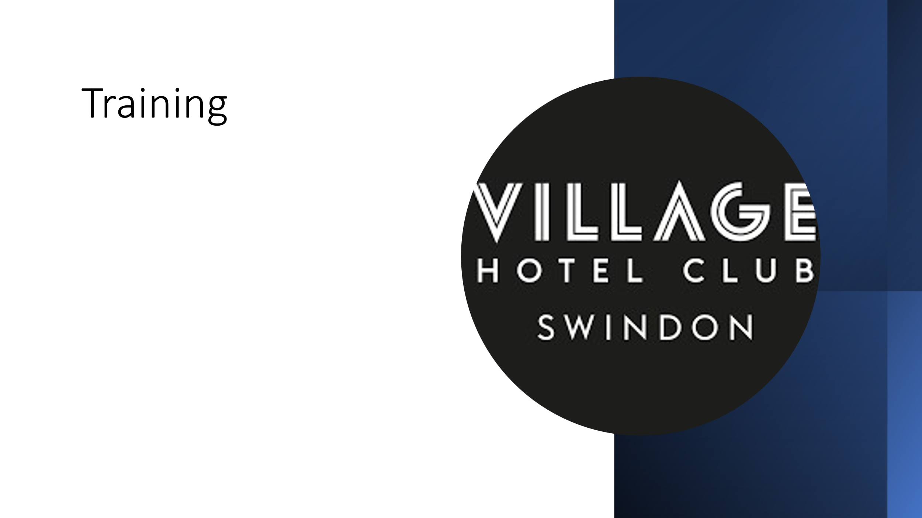
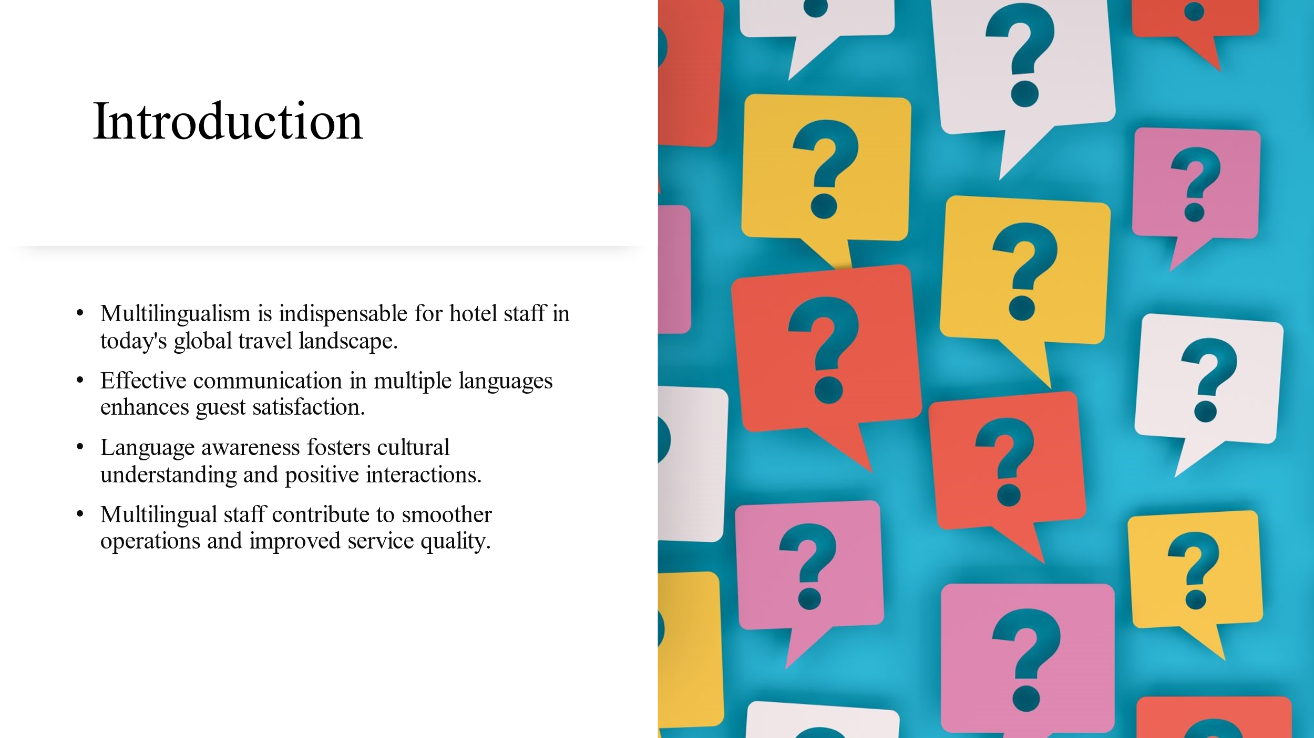

Introduction
The topic of this presentation has been chosen to be the importance of multilingualism and language awareness for hotel staff. In an increasingly globalized world, the people are travelling a lot and under the circumstances, the ability to communicate effectively in multiple languages has become essential. Without it, it is very difficult to be able to provide exceptional service and enhance the guest experience.
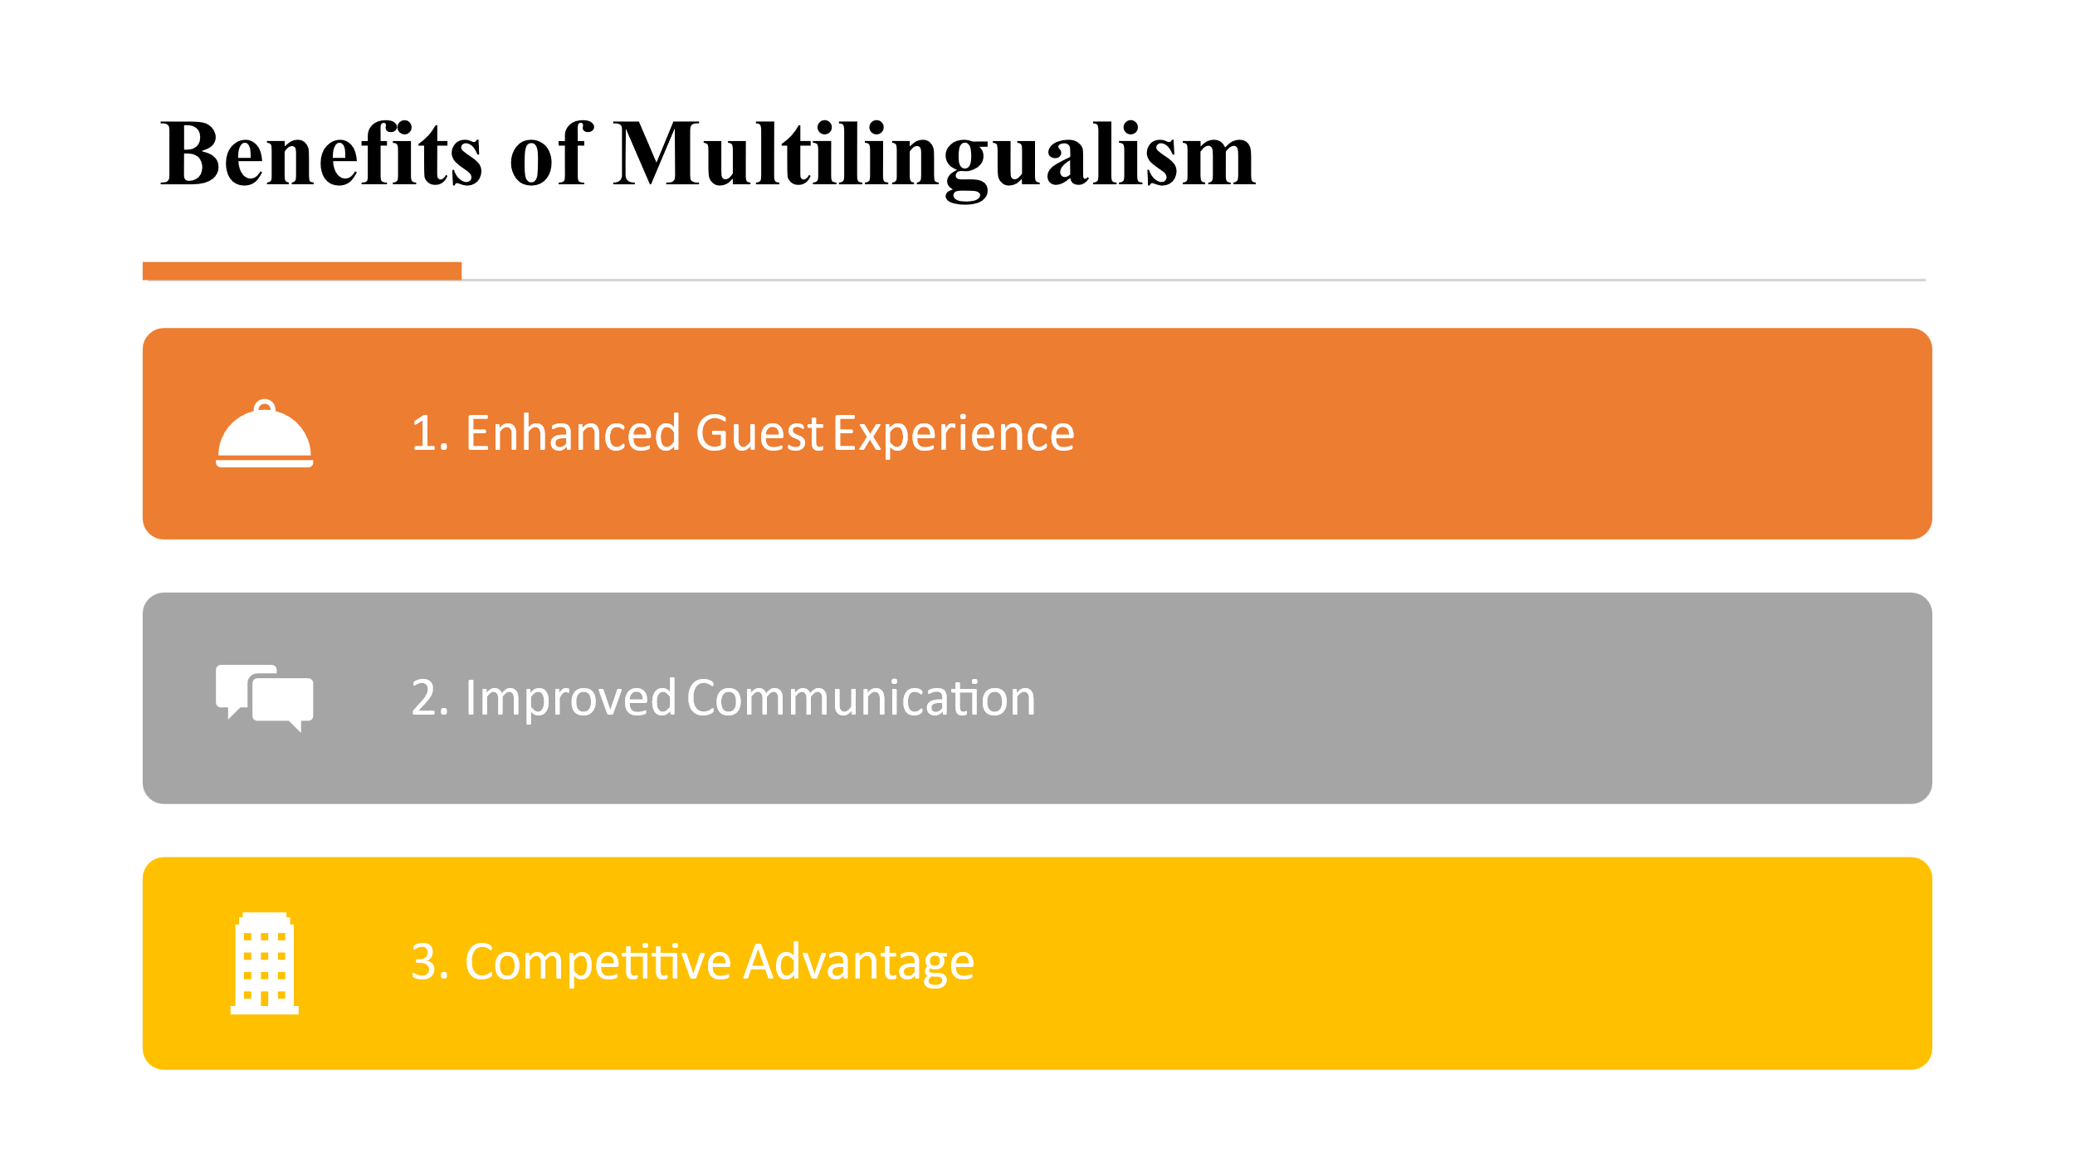

Benefits of Multilingualism
Speaking the guest's native language creates a personalized and welcoming atmosphere which can be helpful in a restaurant setting to be able to increase guest satisfaction and loyalty (Abramson and Moran, 2018). Multilingual staff can effectively communicate with a diverse range of guests, as a result the chance of misunderstandings may get effectively minimized (Abramson and Moran, 2018). Hotels with multilingual staff have a competitive edge in attracting international clients.
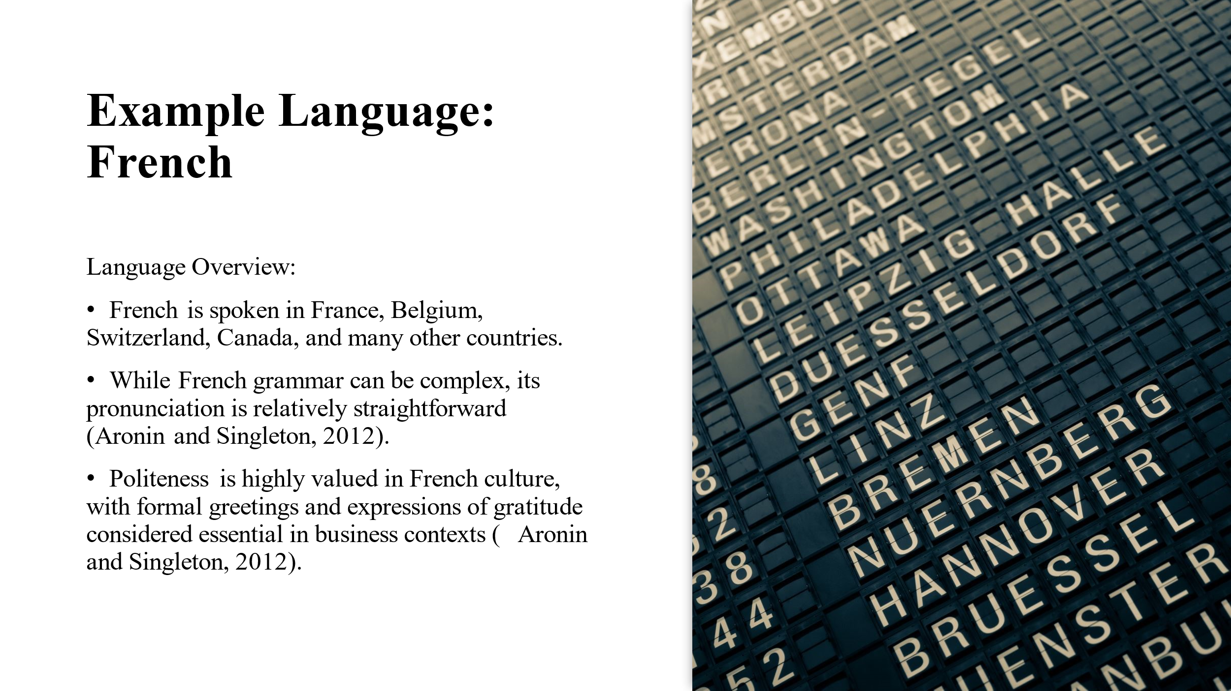

Example Language: French
French is widely spoken in France, Belgium, Switzerland, Canada, and various other countries. French pronunciation is generally straightforward (Aronin and Singleton, 2012). In French culture, politeness holds significant importance, especially in business settings, where formal greetings and expressions of gratitude are considered indispensable (Aronin and Singleton, 2012).
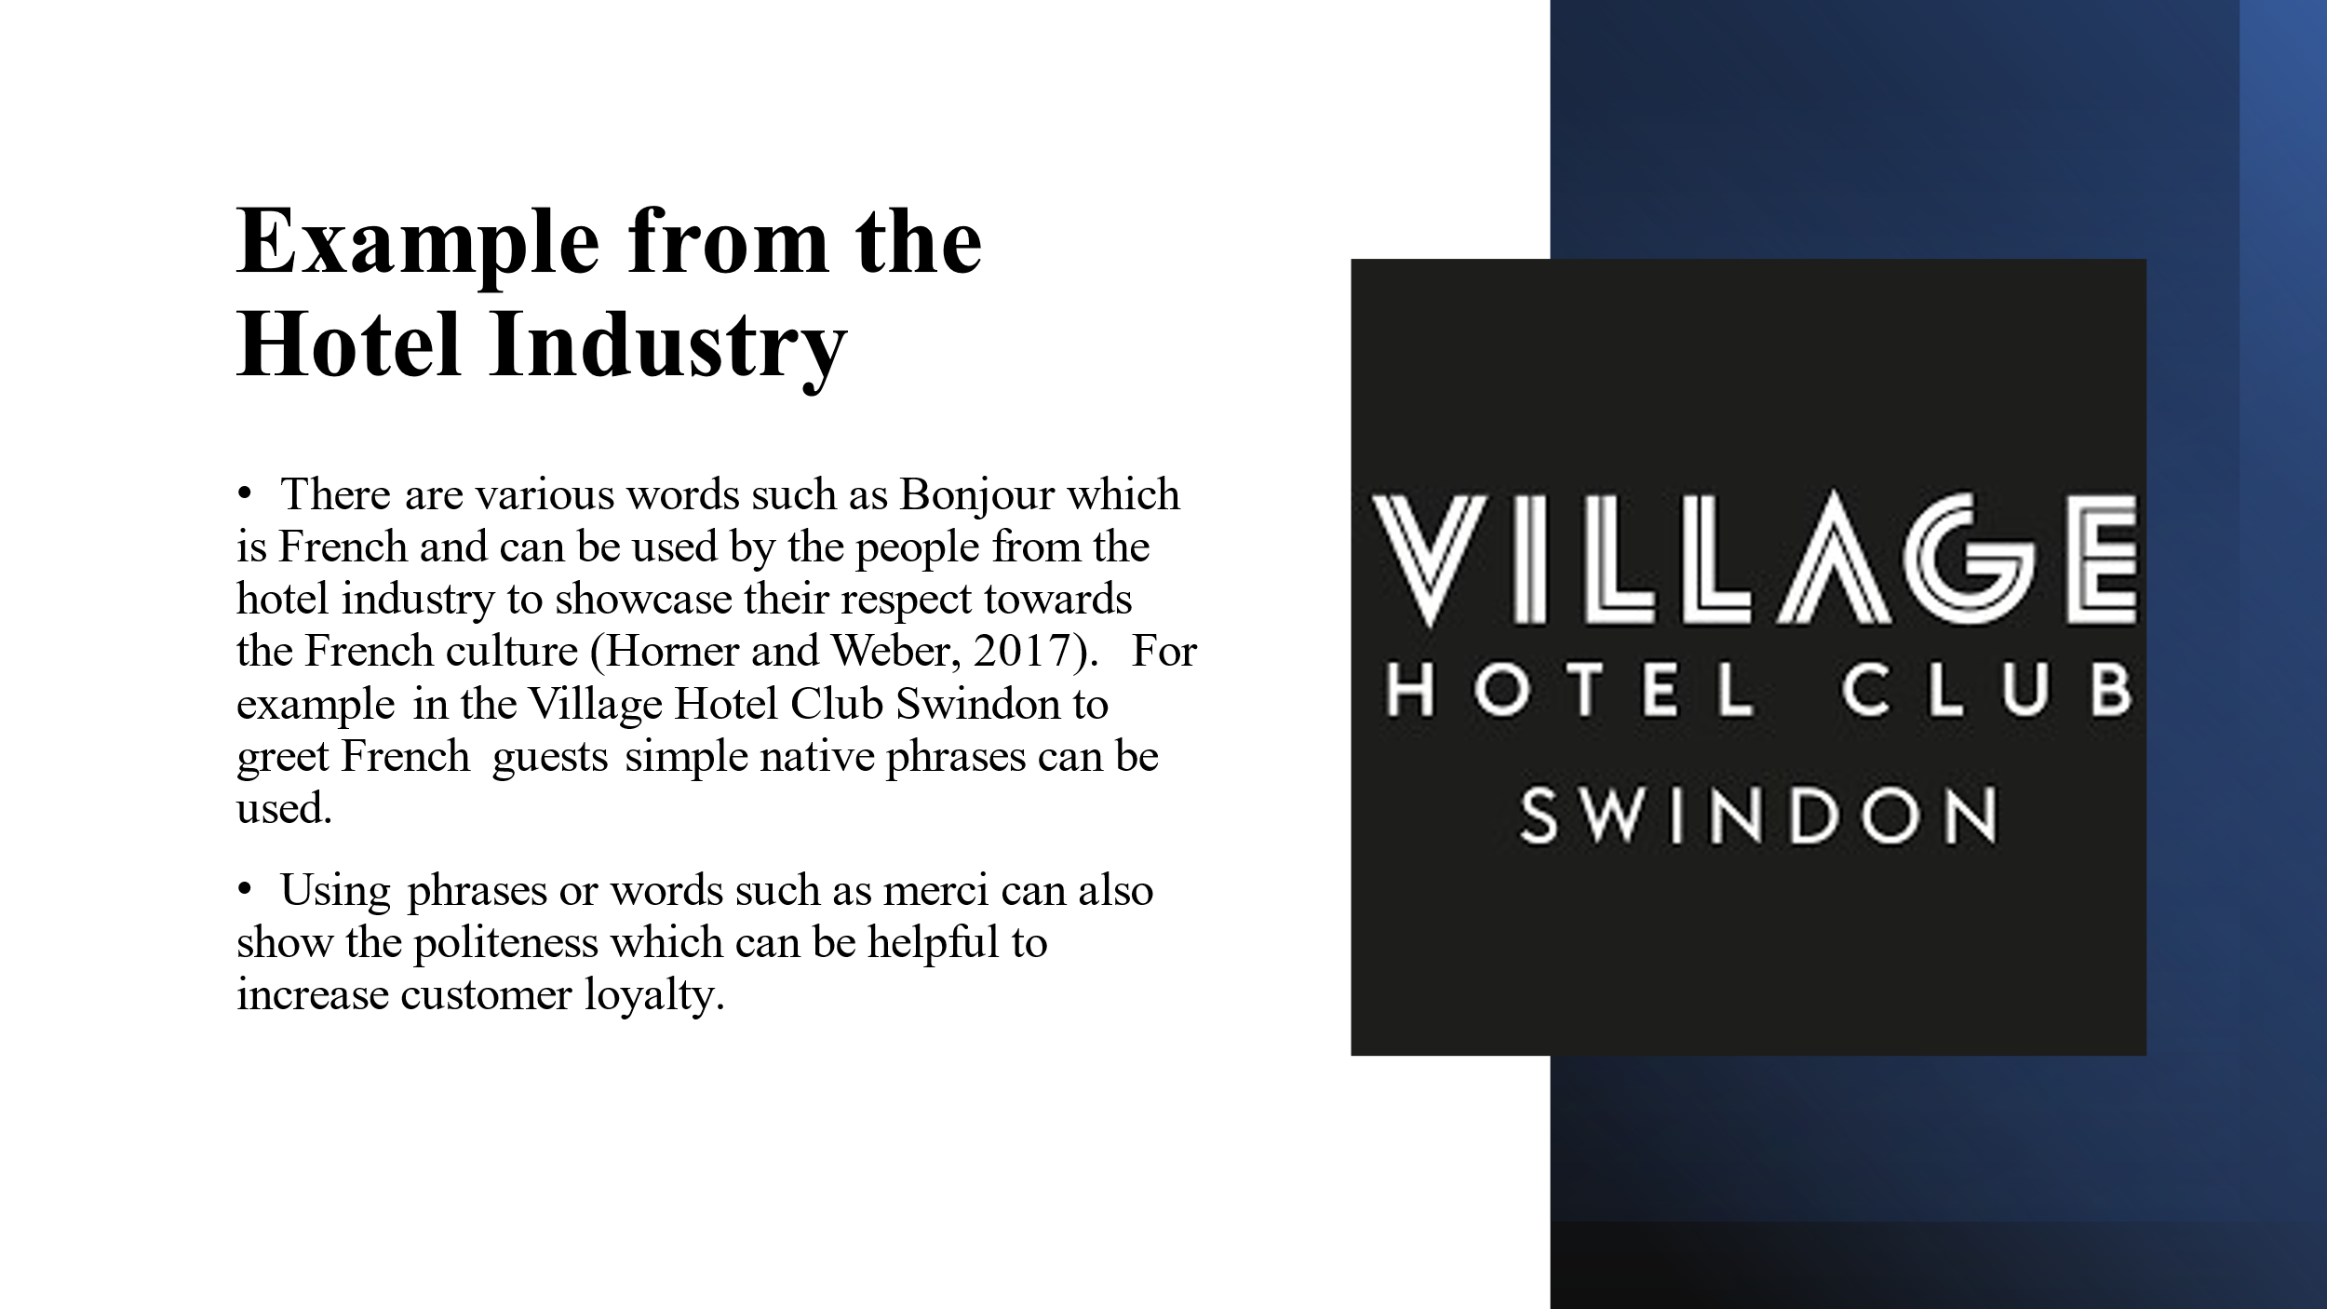

Example from the Hotel Industry
In the hotel industry, incorporating words like "Bonjour" (hello) from the French language can demonstrate respect for French culture and create a welcoming atmosphere for French-speaking guests (Horner and Weber, 2017). Similarly, using phrases like "merci" (thank you) showcases politeness and can enhance customer satisfaction, potentially leading to increased customer loyalty. These small gestures of linguistic and cultural awareness can make a significant impact on guest experiences and overall satisfaction levels.
.
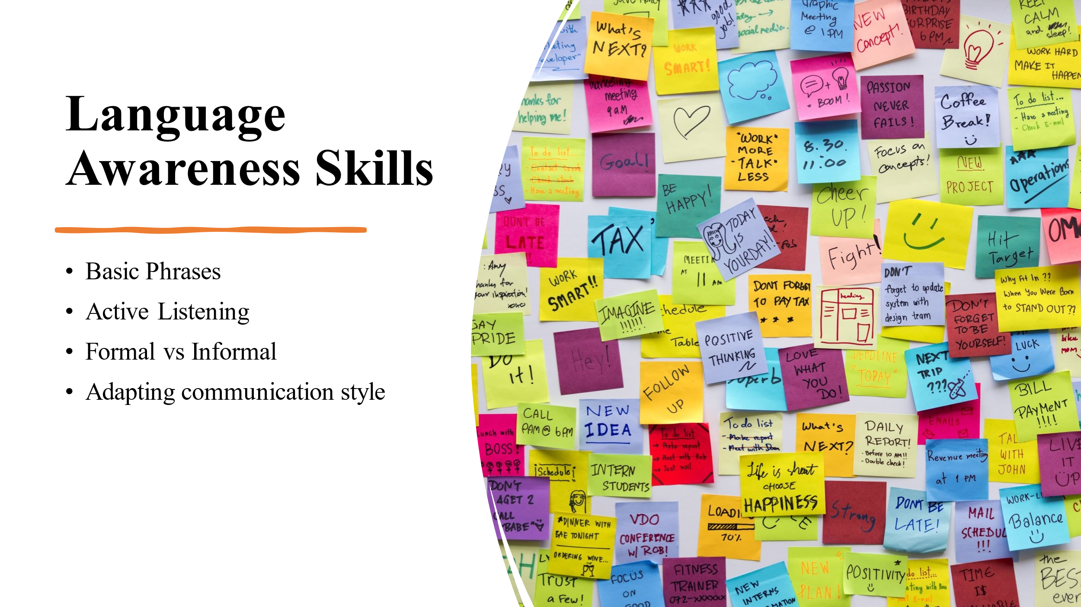

Language Awareness Skills
The staff should be trained with essential phrases in multiple languages so that they can deal with various customers better (Lee, 2016). Encouraging the staff to actively listen as the non verbal cues can be helpful to identify if the approach taken by the staff is ideal for the situation (Lee, 2016).
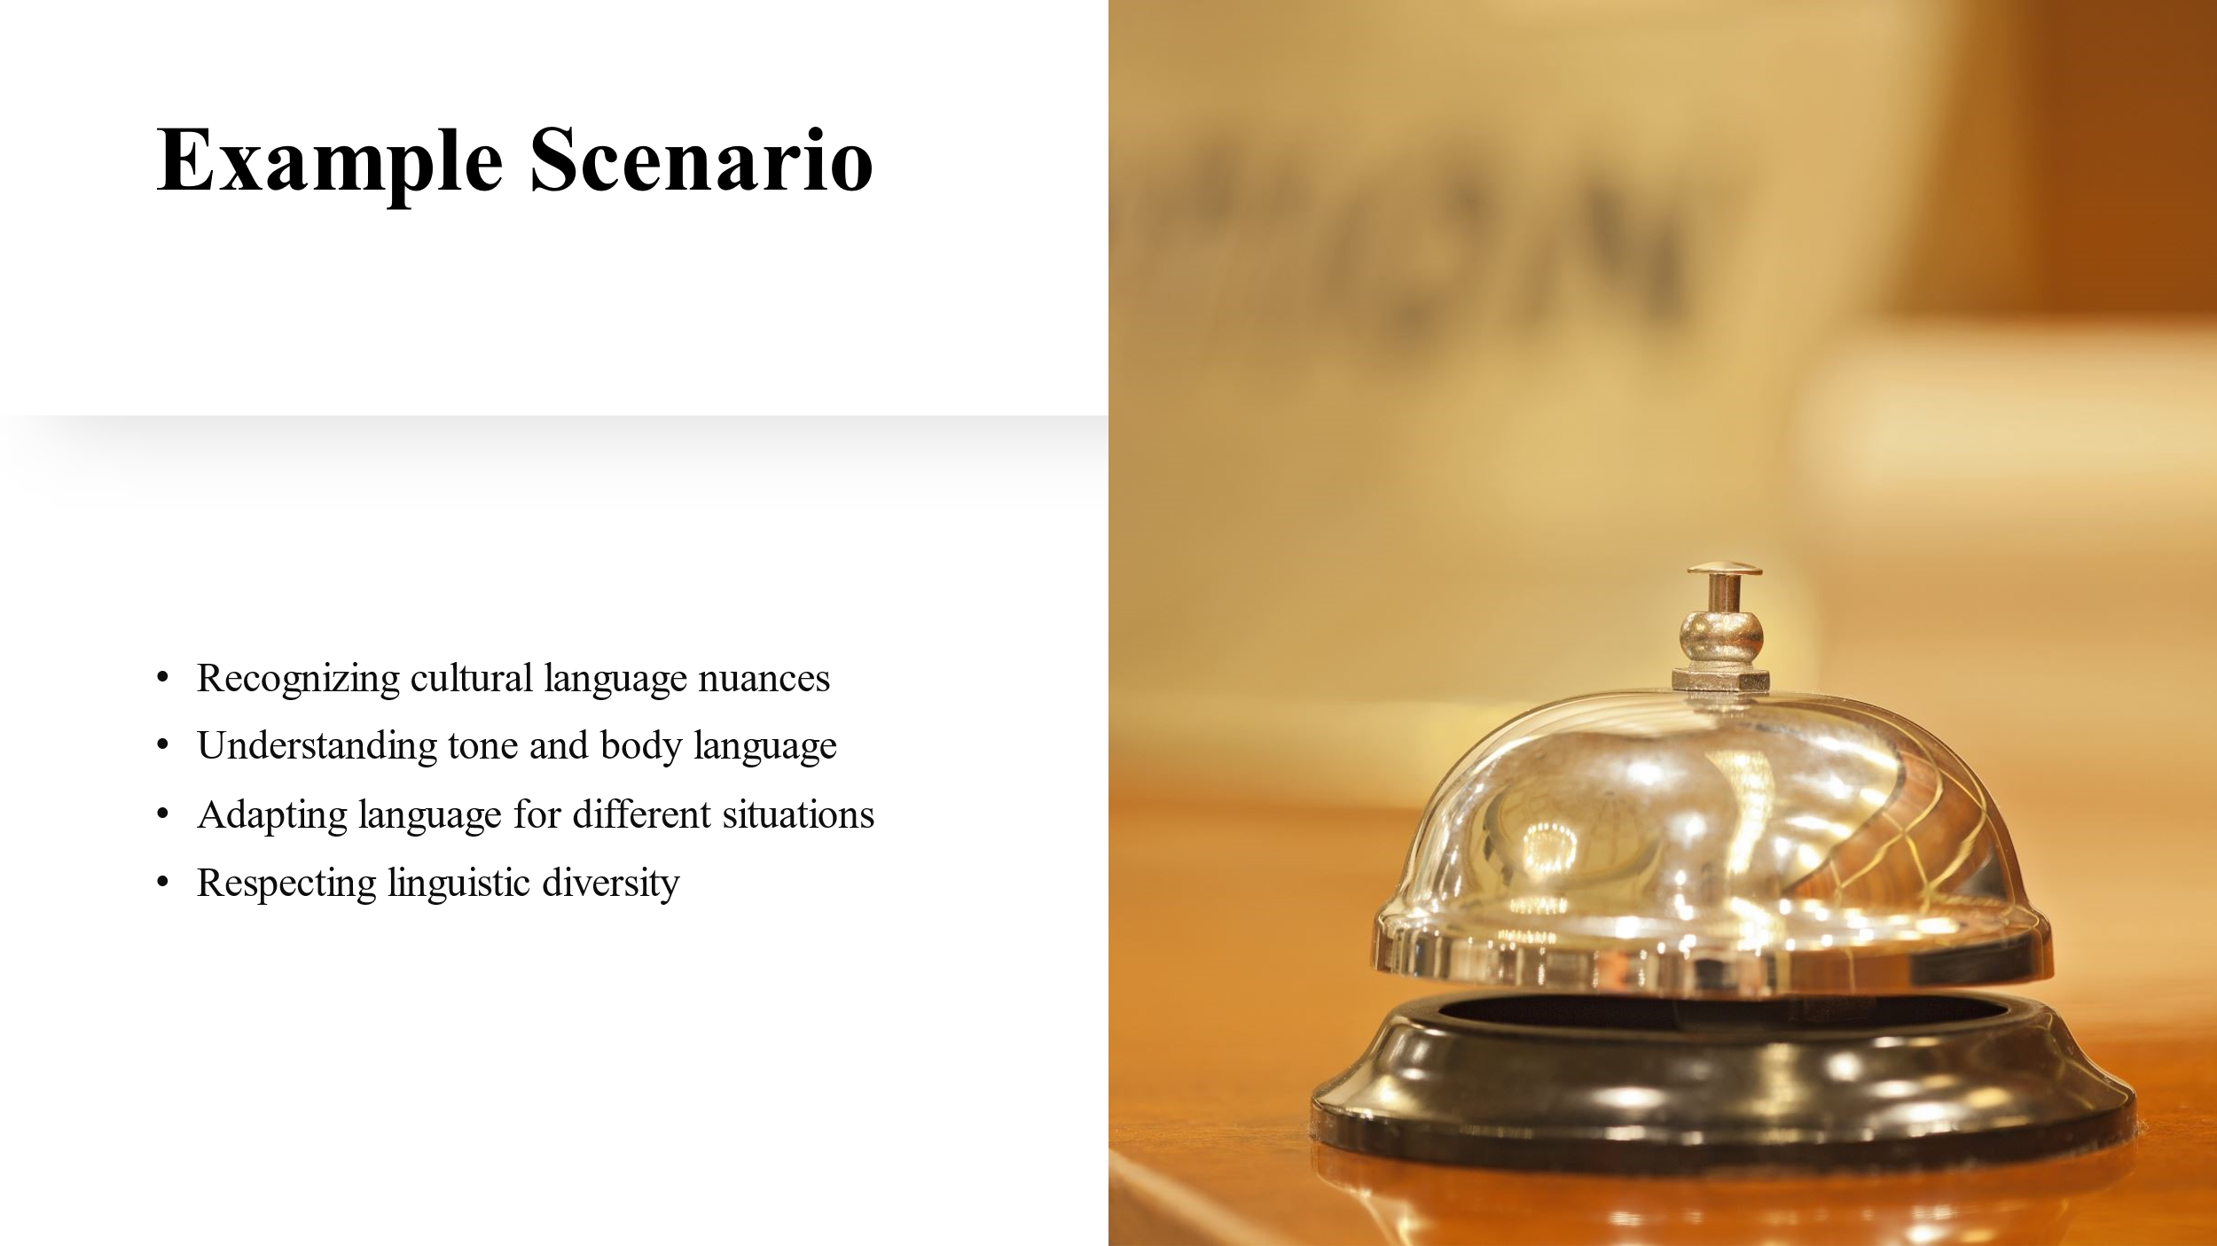

Example Scenario
A French-speaking guest may arrive at the hotel who will be requiring various types of assistances. If the receptionist can greet them in French language, then they will feel welcomed at the hotel which will be helpful to obtain customer loyalty (Bhatia and Ritchie, 2014).
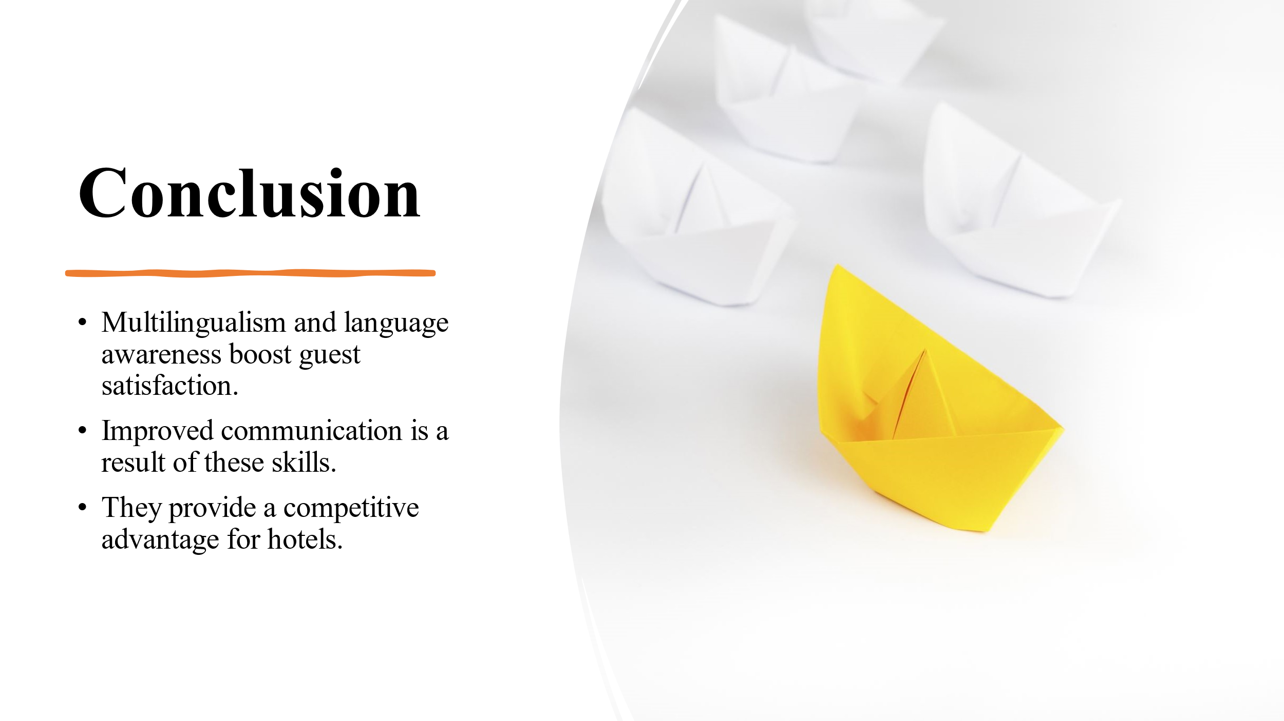

Conclusion
Multilingualism and language awareness skills are invaluable assets in the hospitality industry as it has been found to be contributing to enhanced guest satisfaction. Not only that, it is acting to improve communication, and a competitive edge for hotels. By investing in language training and fostering a culture of linguistic diversity, we can create memorable experiences for our guests and elevate the standard of service across our hotel.
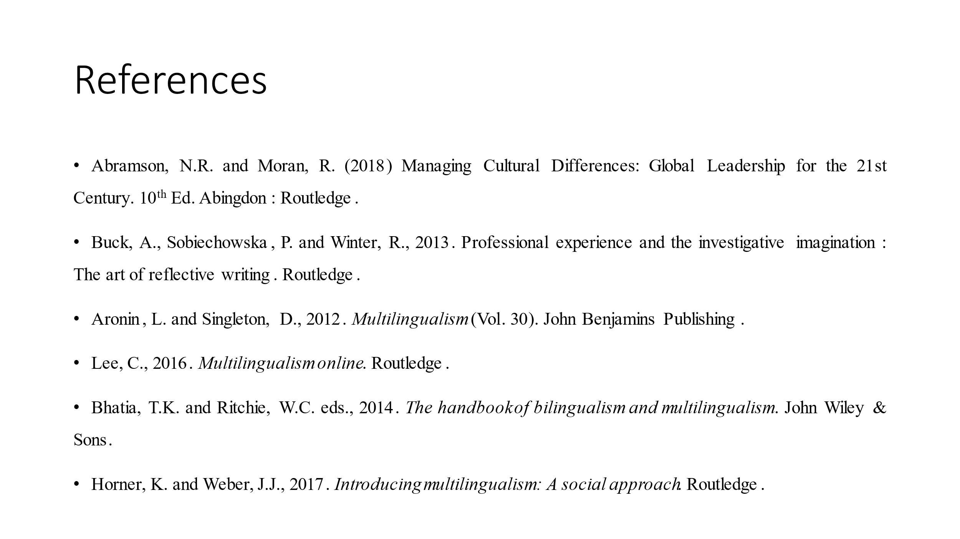

References
Abramson, N.R. and Moran, R. (2018) Managing Cultural Differences: Global Leadership for the 21st Century. 10th Ed. Abingdon: Routledge.
Aronin, L. and Singleton, D., 2012. Multilingualism (Vol. 30). John Benjamins Publishing.
Berkovi, J. (2016). Effective Client Management in Professional Services. Routledge.
Bhatia, T.K. and Ritchie, W.C. eds., 2014. The handbook of bilingualism and multilingualism. John Wiley & Sons.
Blohm, J.M. ed., 2012. The NASAGA training activity book. John Wiley & Sons.
Buck, A., Sobiechowska, P. and Winter, R., 2013. Professional experience and the investigative imagination: The art of reflective writing. Routledge.
Christiansen, B., Branch, J.D. and Karmowska, J. (2020) Cultural Factors and Performance in 21st Century Businesses. Hershey : IGI Global.
Hofstede, G.J., Pedersen, P.B. and Hofstede, G., 2002. Exploring culture: Exercises, stories and synthetic cultures. Nicholas Brealey.
Horner, K. and Weber, J.J., 2017. Introducing multilingualism: A social approach. Routledge.
Lee, C., 2016. Multilingualism online. Routledge.
Maheshkar, C. and Sharma, V. (2018) Handbook of Research on Cross-Cultural Business Education. Hershey: IGI Global.
Nadda, V., Arnott, I. and Sealy, W. (2022). Employability and Skills Development in the Sports, Events, and Hospitality Industry.
Seymour, M. (2012). Hotel & hospitality English. London: Harpercollins.
Tomalin, B. and Stempleski, S., 2013. Cultural Awareness-resource Books For Teachers. Oxford University Press.
Walker, J.R. (2019). Exploring the hospitality industry. Upper Saddle River: Pearson.

