​
​
​
Subject: Academic Employability Skills Assignment​
Student Name: Achiaa Boakye​
Student Number: 1916597​
Lecturer: Timothy Hopkins​
Dated: 18/04/2020
1.
2.
Table of Contents ​
​
1 Introduction---------------------------------------------------------------------p.3​
2 Employability Skills-----------------------------------------------------------p.3​
3 Definition Communication---------------------------------------------------------------p.4​
3.1 Transferable Skills----------------------------------------------p. 4​
3.2 Team working-----------------------------------------------------------------------------p4
3.3 Time Management-----------------------------------------------------------------------p.4
3.4 Conclusion------------------------------------------------------------------------------------p.5
4 Swot analysis Introduction​………………………………………………………………………………..p6
4.1 Process​-------------------------------------------------------------------------------------p6
4.2 Conclusion​………………………………………………………………………………………p7
5.1 Personal Development Plan (PDP)……………………………………..p7
Referencing……………………………………………………………………………p8

Introduction​
Enhancing employability skills is a key factor within the modern workforce societies. The labor market always looking for employers requirements and skills from graduates vary from one person to another, however the current business changes environment has highlighted the importance of education for employability, not focusing only on developmental skills but also focusing on practical experience.​
More so, to be able to enhance competitive advantage for graduate employment, students need to develop employability skills in addition to the acquisition of specific subject knowledge.​
In this report will talk about my own skills and abilities to perform successfully in the health care environment and the existing research findings, my class excises , and present reviews on about eight core aspects:​
Definition of employability skills and employer's demand, and expectations from employers and university student nature of employability, team working , time management, effective communication and employability as a whole.​
​
Definition of Employability Skill​
According to Monte Yorke (2004) "A set of achievements- skill, understandings and personal attributes that make graduates more likely to gain employment and be successful in their chosen occupations, which benefits themselves, the workforce, the community and the economy" Examples are communication skills, Personal skills, Time management , Team working skills, leadership skills are all importance’s attributes to good job.
​
​
Monte Yorke (2004)

3.
https://www.jobberman.com.gh/blog/employability-skills/https://www.jobberman.com.gh/blog/employability-skills/​
Communication Skills
According to Shannon-Weaver (1949) model of communication process explained why sometimes communication goes wrong. Communication is not only about listening also is about contributing to the topic been discuss. To be able to communicate effectively in any workplace the factors that hinder the communication process needs to be address.
Effective communication is more than just exchanging information, but the feelings and intention behind the message being given. however, it's always two ways part, it’s about the tone of the message send to the receiver and how the receiver digests the message. To communication effectively factors like environment (noise), channel and message to needs to be check.
​
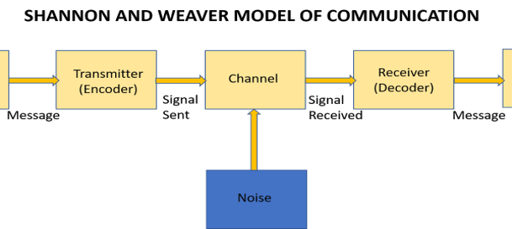
4.

SHANNON, (1949) (HUMPHREY, 1960)
5.
3.1 Transferable Skills​
In this twenty- first century employers mostly looks for individuals with different qualities of skills. Employees should also have some suitable personal transferable skills, motivation and specific skills for a job description and personality (i.e.) attitude towards risk, willingness to learn in order to improved. These qualities will be different from one organization to another. Employers who are graduate always looks for motivated self – starter, confident individuals who are independent and can be good team player, and who can also be assets to their business. As indicated above there are few better places to demonstrate how much of a self- starter you are by taking the initiative and getting involved in university life. Typically, examples are as follows (Quality Assurance Agency 2007) ​
​
Cognitive skills of critical thinking, and analysis.
Effective problem solving and decision making​
Communication Skills verbal and non-verbal, using modern technology
Use of communication IT​
Self-management​ Skill
Reflective and critical​ analysis
Interpersonal skills of effective listening, persuasion and negotiating
Ability to do research in business and management critical issues​
​
3. 2 Team working: ​
A team is several individuals working towards one aim which they all mutually committed, everyone has their own skills to perform effectively in order to meet their target. To become good team leader needs a lot of skills by communicating effectively, accommodating each individual, listening and getting feedback from colleague and reflecting on your work. Also working in group speed up the progress of the work and through brainstorming create a better idea of the said company.
​
3.3 Time Management: ​
Time management is very important tools in any workplace. Be a good time management needs the ability to control use of time to set up planner for daily activities from most important ones to less important. A person with good time management skill always punctually at workplaces and meetings. ​
​
3.3 Conclusion​
In short employability skills is about being competent of acquiring and care for fulfilling work through all these sort skills(i.e.) communication skill, time management skill and team leader. Employability skill also have two-way side equation needs many ways of support to overcome physical and mental channelling in learning and developing.
Strengths | Weakness | OPPORTUNITIES | Threats
Punctuality | Exams preparation | Extra help from lectures | Study skills​
Researching | Being available to study | opportunity for personal development | paraphrasing
Reading | Time management | use of technology device such as recordings | Referencing
Time pressure​ | Spellings |  | Relating important points​
Classroom discussion | Self-discipline
IT Skill | Motivation
Note-taken in lectures | Concentration
6.
SWOT analysis introduction
This report will assess my own skills by recognize my strength and weakness through SWOT analysis techniques. Upon my own strength, weakness will be addressed by away of diagnostic plan created by (A Humphrey, 1960). SWOT analysis is an effective way of interpreting strength, weakness opportunity and threats available to me. My time management skill, note taking in class, concentration and research has highlights the skills I need to improved and develop. Completing a SWOT analysis will help me to pay attention into my skills I have already. ​

​

Conclusion​
This report was to introduced to the reader how my point of view is when it comes to skillset to find job in this computer aged system. This has been through critical analysis and research finding on various companies. ​
​
Personal Development Plan (PDP)​
Upon my personal SWOT analysis, according to my own strength I make my personal development plan.
Personal development is lifelong process. In order to acquire these skills and qualities needs to set up aims and goals to maximise their potential. Through this easy I have realized that in order to achieved my goals needs to research more, read more to improved myself, reflect on my daily activities and concentrate on my study to achieve what I want to become.

T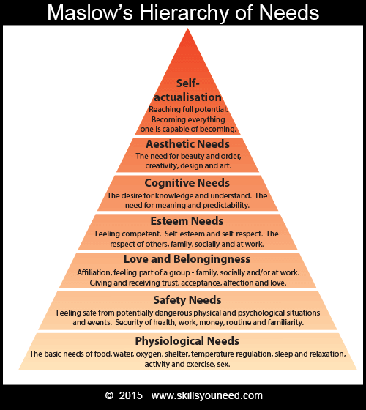
​
​
​According to Maslow, (1970)” suggests that all individual have in-built needs for personal development which occurs through a process called self-actualization”.

(https://www.jobberman.com.gh/blog/employability-skills/https://www.jobberman.com.gh/blog/employability-skills/)
7.
8.
9.

(Professor Monte Yorke(2004) Employability in Higher Education : what it is not) (https://michellemathiasfsp.blogspot.com/2018/11/shannon-and-weavers-model-of.html)
Maslow, Abraham Personal Skills (1970)
(HUMPHREY, 1960)
WEAVER, (1949) Model of Communication

10.

