Name: Sophie Foyle

Student Number: 2506393
__________________________________________________________

WORKSHEET 2 – TESTING (Tiles)
SIDE NOTE – apologies, when we uploaded it in class I only uploaded worksheet 2 code, and I uploaded it into the section for worksheet 1. The below code has been copy & pasted from what I entered into moodle at that time.

- Original code:

import math

print("Please enter the width of your wall in cm")
wallWidth = int(input())
while wallWidth <= 0:
print("Invalid width, please try again")
wallWidth = int(input())

print ("Please enter the height of your wall in cm")
wallHeight = int(input())
while wallHeight <= 0:
print ("Invalid height, please try again")
wallHeight = int(input())

totalWall = wallWidth * wallHeight
print ("The total surface area of your wall is", totalWall, "cm²")

tilesAcross = math.ceil(wallWidth / 20)
tilesDown = math.ceil(wallHeight / 20)

totalTiles = tilesAcross * tilesDown

print ("The total number of WHOLE tiles you require is",totalTiles)

# I attempted to refine the code to find the absolute minimum tiles required, but couldn't quite get it right – here is the code >>>

import math

print("Please enter the width of your wall in cm")
wallWidth = float(input())
while wallWidth <= 0:
print("Invalid width, please try again")
wallWidth = float(input())

print ("Please enter the height of your wall in cm")
wallHeight = float(input())
while wallHeight <= 0:
print ("Invalid height, please try again")
wallHeight = float(input())

tileArea = 20 * 20

totalWall = wallWidth * wallHeight

totalTiles = math.ceil(totalWall/tileArea)

if totalTiles % 2 ==0:
totalTiles = totalTiles + 1

print ("The total number of WHOLE tiles you require is",totalTiles)

Code Testing

For each test below (i – vii), run your code and enter the values provided. Present a screenshot of the of what happened when the programme ran. Did the programme behave correctly or did it do something unexpected, and if so, why?

Input:

- Enter dimensions of wall: Width 40 Length 45
- Enter dimensions of wall: Width 100000 Length 200000
- Enter dimensions of wall: Width -16 Length -20

Logic:
- Enter dimensions of wall: Width 80 Length 80. The result should be 16 tiles
- Enter dimension of wall: Width 40 Length 45. The result should be 6 tiles
- Enter dimensions of wall: Width 85 Length 90. The result should be 25 tiles.
- Enter dimensions of wall: Width 15 Length 15. The result should be 1 tile.

Note: If you decided to include logic within your program to allow a tile to be cut such that 2 pieces can be used from the same tile where possible (therefore reducing the total number of tiles required), your results may differ from the above. In this case, explain your logic as part of your answer. If you did not, consider adding this logic to your final code.

Fill in a box for each test above. You should present 7 separate boxes, 1 for each test. (Note: the first box is provided as a template)

Test i:
Input i. - Enter dimensions: Width 40 Length 45

Screenshot(s) of output:

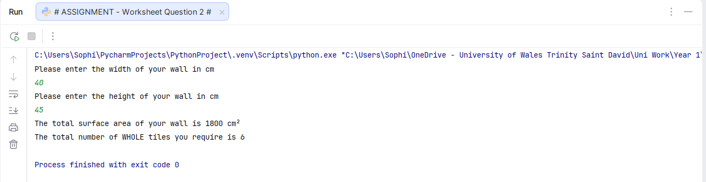
Result: Did the programme behave as expected ie syntactically and logically correct?
Yes.
It would require 6 whole tiles to cover this space. Four tiles would cover 40x40 and then partial tiles would be required to cover the remaining 5cm on the length/height. However one tile could be used to cover the remaining 5cm at the bottom, but considering the logic question states the answer would be 6, this seems like it would work.

Continue the rest of the tests below. (Copy and paste a box for each one)

Test: ii. Enter dimensions of wall: Width 100000 Length 200000

Screenshot(s) of output:
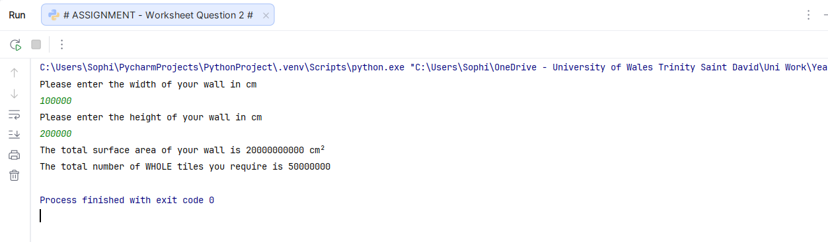
Result: Did the programme behave as expected ie syntactically and logically correct?
Yes.
It has correctly worked out how many tiles would be used. The walls surface is incredibly large and although it is possible these dimensions would be entered, it could be a sign of a typo or incorrect input, so improved validation could include requesting the user to double check they have entered the correct dimensions.

Test: iii. Enter dimensions of wall: Width -16 Length -20

Screenshot(s) of output:
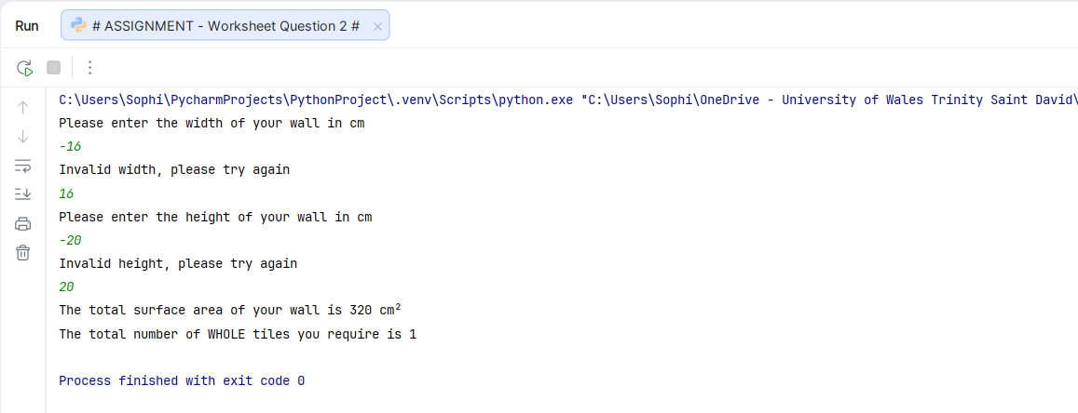
Result: Did the programme behave as expected ie syntactically and logically correct?
Yes.
It is not possible to have a negative figure for the height or the width/length. Both input areas have identified an invalid input, displayed the correct error message and looped to allow the user to re-enter the correct figures.

Test: logic iv. Enter dimensions of wall: Width 80 Length 80. The result should be 16 tiles

Screenshot(s) of output:
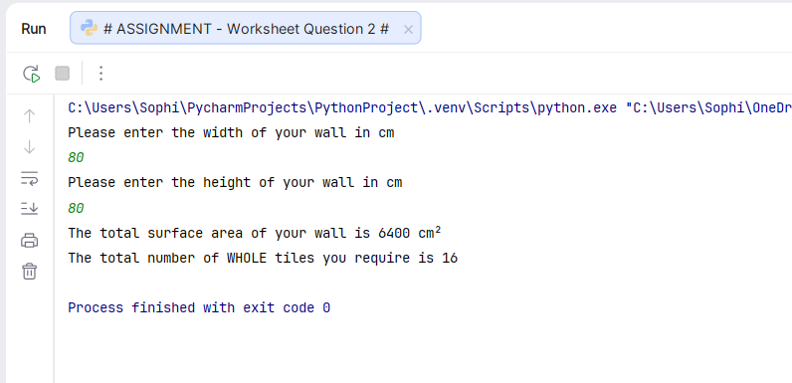
Result: Did the programme behave as expected ie syntactically and logically correct?
Yes. The program has generated the correct answer based on the input.

Test: logic v. Enter dimension of wall: Width 40 Length 45. The result should be 6 tiles

Screenshot(s) of output:

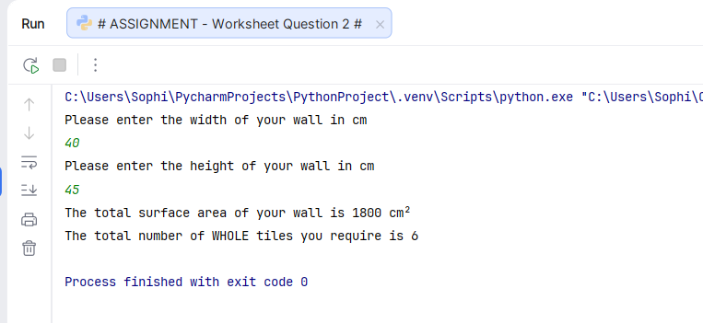
Result: Did the programme behave as expected ie syntactically and logically correct?
Yes.
The program has again identified the correct number of tiles to be used.

Test: logic vi. Enter dimensions of wall: Width 85 Length 90. The result should be 25 tiles

Screenshot(s) of output:
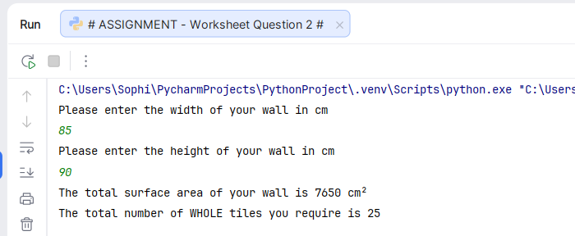
Result: Did the programme behave as expected ie syntactically and logically correct?
Yes.
The program has identified the correct number of tiles to be used.

Test: logic vii. Enter dimensions of wall: Width 15 Length 15. The result should be 1 tile.

Screenshot(s) of output:

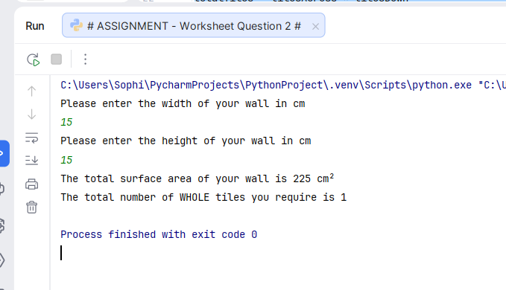
Result: Did the programme behave as expected ie syntactically and logically correct?
Yes.
There is less than 1 tile of surface area to cover, therefore the correct number of tiles has been calculated.

- Consider the results of the above tests and revisit your code in order to solve any problems discovered at the testing phase. (Note: you may not be able to solve all of them, but solve as many as you can.)

Paste your revised code here:

# IMPROVED WORKING CODE

import math
print("Please enter the width of your wall in cm")
wallWidth = int(input())
while wallWidth <= 0:
print("Invalid width, please try again")
wallWidth = int(input())
if wallWidth > 1000:
print ("This seems very large, please check your input")
wallWidth = int(input())
print ("Please enter the height of your wall in cm")
wallHeight = int(input())
while wallHeight <= 0:
print ("Invalid height, please try again")
wallHeight = int(input())
if wallHeight > 1000:
print ("This seems very large, please check your input")
wallHeight = int(input())
totalWall = wallWidth * wallHeight
print ("The total surface area of your wall is", totalWall, "cm²")
tilesAcross = math.ceil(wallWidth / 20)
tilesDown = math.ceil(wallHeight / 20)
totalTiles = tilesAcross * tilesDown
print ("The total number of WHOLE tiles you require is",totalTiles)

# USING LOGIC TO TRY AND MINIMISE TILE USE (Unfortunately, does not give correct figures but this was the closest I could get

import math
print("Please enter the width of your wall in cm")
wallWidth = int(input())
while wallWidth <= 0:
print("Invalid width, please try again")
wallWidth = int(input())
if wallWidth > 1000:
print ("This seems very large, please check your input")
wallWidth = int(input())
print ("Please enter the height of your wall in cm")
wallHeight = int(input())
while wallHeight <= 0:
print ("Invalid height, please try again")
wallHeight = int(input())
if wallHeight > 1000:
print ("This seems very large, please check your input")
wallHeight = int(input())
tileArea = 20 * 20
totalWall = wallWidth * wallHeight
totalTiles = math.ceil(totalWall/tileArea)
print ("The total number of WHOLE tiles you require is",totalTiles)

Validation was added to request the user to double check their width and height/length if the value entered is above 1000. The while loop was used to ensure the value could not be 0 or below, as this is physically not possible. However, an ‘if’ was used to validate the dimensions being over 1000, as if this is correct, the program would need to allow the user to proceed with the initial figure.

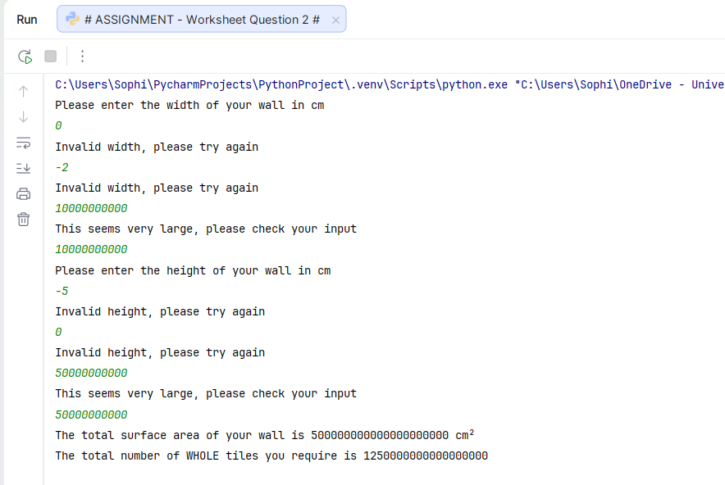
Figure 1: Demonstration of the ‘while’ loop preventing the user from proceeding with an invalid entry. However, if the dimension is over 1000, it simply asks the user to double check but will allow them to proceed if they re-enter the figure. This allows for occasions where there is a large surface area to cover.

