Cristina Elena Chirea

2026624

BMSW4002

Effective Team Work and Communication

Lecture Name: Lloyd Beharry

Table of Contents:
Introduction 4
The three models of communication 5
Shannon and Weaver’s Model of Communication 5
Berlo's Model of Communication 6
Schramm’s Model of Communication 7
Communication skills 9
Advantages of technology in communication. 10
Disadvantages of technology in communication 10
An example of poor communication 12
Conclusion 13
Reference List 14

Introduction
Communication is the process of transferring information either to an individual or to a group of people. Every act of communication involves a minimum of one sender and one receiver. Though it sounds simple, the process is quite complex and involves many intermediary stages regarding the transmission of the message. To understand this process in a better way, many theorists have postulated certain models which are applicable in everyone's daily life. In this report, some of the case studies have been considered to understand the importance of these models and to understand the advantages and disadvantages of technology in communication. In addition, the importance of active and empathetic listening as an integral part of communication skills has been discussed.

1) The three models of communication

Shannon and Weaver’s Model of Communication
This model is also known as the “mother of all models” and has been specifically designed to establish active communication between the sender and the receiver. While postulating the model, Shannon and Weaver presented concepts that are an integral part of the model (Businesstopia, 2018).
- The sender (Information source) is the person who is responsible for developing the message and then choosing the channel to send the message.
- The encoder (Transmitter) is the machine that is being used by the sender to convert the message into binary data or signal.
- Channel is the medium through which the message is being sent by the sender.
- Decoder (Reception) can be either the machine or the receiver that is converting the binary data or signal into the message.
- The receiver (Destination) is the person to whom the message is being intended to get delivered. The receiver then replies accordingly to the message.
- Noise is the physical disruption of people, the environment and others that create a hindrance in transferring the message.
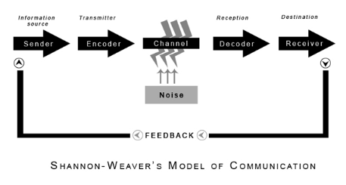
Figure 1: Shannon and Weaver’s Model of Communication
(Source: Inspired by Kubota, 2019)
As per the case study of Pedro and Maria, the sender of the message was Maria and the message was Maria asking Pedro to bring some chicken when he gets home. In this case, the encoder is Telephone Network Company and the channel is a mobile network. The decoder is the other mobile phone that is being used by Pedro and the receiver of the message is Pedro himself. In the case study, it can be seen that Pedro has failed to understand Maria's message and instead of bringing chicken, he went straight to the kitchen. The confusion was created by the surrounding "noise" as Pedro works on a building site.

Berlo’s Model of Communication
David Berlo postulated the SMCR model that portrayed communication as a circular system where the receiver gives feedback to the sender and vice versa. According to Kuznar and Yager (2020), this model highlights four important aspects present in the communication process. Each of these aspects can be a cause of message failure. A sender can misinterpret a receiver's preferences and even if the right channel is used, it can be the wrong time or even the wrong choice of vocabulary can confuse the receiver.
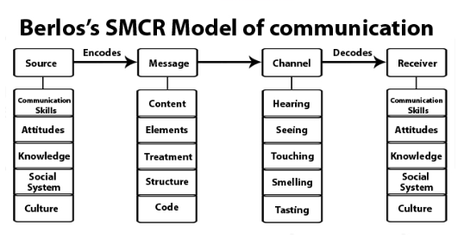
Figure 2: Berlo’s SMCR Model of Communication
(Source: Inspired by Kuznar and Yager, 2020)
As per the case study of Barry and Communication Barriers: Effective Communication as a Motivator, Barry is the “Source” as he is knowledgeable regarding kitchen principles, and he is very particular about food safety and measures. His message said “KEEP HOT FOOD HOT AND COLD FOOD COLD and WASH YOUR HANDS OFTEN” was clear and concise, but he used the channel of “seeing” as he used large signs all over the kitchen. The receivers of this message were employees, ranging from 16 years to 55 years old and they were receiving on-the-job training.
Even after Barry communicated with clear signs and provided the required tools to his employees regarding food safety, still some of the employees failed to decode his message and kept several trays of uncooked meat at normal temperature for some period. From this case study, it can be understood that even though Barry used the best channel to disseminate his message, still some of the employees failed to decode because the communication channel was not preferred by some the employees.

Schramm’s Model of Communication
This model of communication was proposed by Wilbur Schramm in 1954. According to Lin and Lin (2020), the sender encrypts his thoughts into a message and sends it to the receiver. The receiver then takes the information and tries to interpret the meaning of the message that the sender tried to convey. This is called decoding information. Following this, the recipient provides feedback to the message sender to express their understanding of the message. This way, the sender continues to explain more about their thoughts if the receiver fails to decode the message.
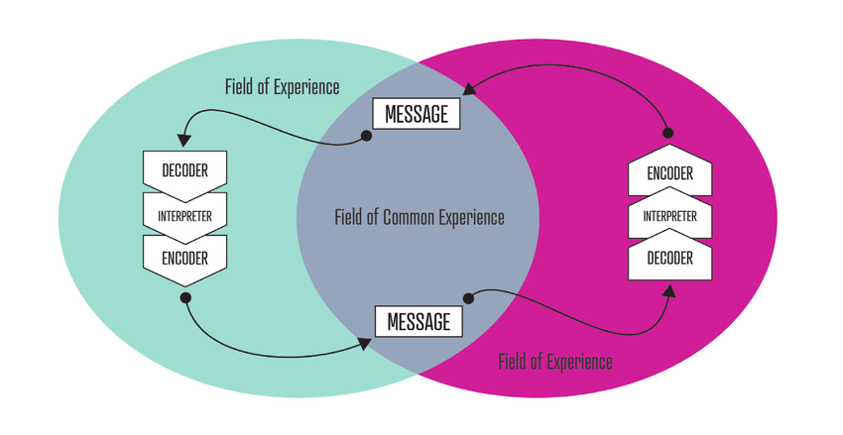
Figure 3: Schramm’s Model of Communication
(Source: Inspired by Lin and Lin, 2020)
Encoding and decoding are two essential factors in effective communication and the communication becomes more precise as the sender has the opportunity to explain more according to the understanding level of the receiver. As per the case study of “a day with the chief”, Mark was extremely nervous about meeting with the CEO of his company, Alana Brown, who has been described as the 'Wicked Witch of the West by the people because of her attitude toward the employees. When Mark finally met the CEO, she was smiling while welcoming Mark. She made her comfortable and asked many questions regarding his work approach, and professional goals.
It can be observed that both the ends of the communication have entered the cyclic communication model by Schramm where both the parties are communicating effectively till the time when Mark became completely relaxed and started sharing his thoughts about the wrong happenings in the London office. Soon, the CEO without much further communication disrupted the communication and asked Mark to leave. This might be because the decoded information was clear to Mrs Brown, and she did not want to provide any feedback on Mark's thoughts and immediately stopped the communication process.

2) Communication skills
There are various types of communication skills that an individual needs to send a message or make conversations with others effectively. These skills are categorised into verbal, non-verbal and written communication and among these skills, active and empathetic listening are the two most important skills.
- Active listening
This means being attentive while listening to the person who is speaking. Individuals who have the skill of active listening are well-considered by others because they have been paying not only attention but respect to the speaker (Indeed, 2021). This is an important and difficult skill to adopt and needs to be improved regularly. One can be an active listener only when the person knows how to avoid distractions and solely focus on the listener. In addition, an active listener mentally prepares comments, questions, or ideas to respond to the speaker thoughtfully.
- Empathetic Listening
This type of listening means one has the ability to understand and share the emotions of other people. Empathetic listening is an important skill required in both one-and-one communication and team communication. Both the cases require one's sense of understanding of other people's emotions and appropriately responding to them (Indeed, 2021). As per the case study of Max the Multitasker, when Max shared with Tamara that he cannot afford to employ a helper because his mother was suffering from an incurable illness, and he, therefore, needs the money to pay for her nursing home. Listening to that, Tamara responded "Oh, I am sorry to hear", which is a great example of empathetic listening.

3) Advantages and disadvantages of technology in communication
Advantages
- Time and Speed
Technology has made communication faster thereby saving several minutes for an individual. With the emergence of the internet, technology has enabled a more efficient and faster transformation of information across the globe. Advanced technology has enabled face to face communication from any part of the world at any time. Connecting through text messages and emails instantly is one of the merits of technology in communication.
- Easy retrieval and archiving
Technology has enabled documentation of communication much easier and quicker. With the help of databases and cheap storage, one can easily save emails and other messages for future use like enquiring about them. The emergence of technology has reduced the use of pen and paper, which was way more challenging and inefficient to document communication (Applegate, 2019).
- Inexpensive
The cost of technology used for communication is relatively lower than mail delivery, which is way expensive and takes a longer time to deliver. As technology is becoming standard and more effective, the cost of its usage is becoming more inexpensive. On the other hand, the cost of traditional methods of communication like mailing might be very less but when letters are misplaced, it creates more problems and people do not have the time to fix these issues (Applegate, 2019).
Miscommunication problems could have been easily resolved if both the companies communicated in a proper manner. As per Schramm's model of communication, both companies should have been engaged in the cyclic model of communication constantly (Lin and Lin, 2020). Where the sender of the message, in this case, the client could have explained more as per the understanding of the event company. Moreover, the event company also should have done clear communication with their catering service and made them understand what exactly their client wants in their food menu. Poor communication led to a lack of interpretation that ultimately led to a huge failure of the event.
Disadvantages
- Overwhelming
The key disadvantage of technology in the communication process is that it leads to overwhelming information. When individuals receive more than an ample amount of information through multiple technical channels, they get confused and might not have the time to digest all of them. The Interaction Design Foundation stated that as developing and sharing information through several mediums is extremely simple it creates an overburden of information. For instance, employees dealing with tons of emails and several other forms of messages in a day can create stress and pressure as they need to review them all. This further creates the problem of missing out on important messages, which can be detrimental to a company (Ahmed, 2020).
- Choosing the wrong platform for conversation
Another drawback of communication technology is that everyone is not aware of exactly which platform or medium to use for communicating with others. For instance, emails are used for sharing important information, updates, memos, and other official information while casual conversations can be done through instant messaging technologies (Ahmed, 2020).
My friend works in an event management company, where they organise all types of events from weddings to business events. Recently they closed a deal with a major company for organising their annual conference. On the day of the event, my friend's company faced several setbacks. The food that they arranged was not to their client's demands, the decorations in the venue were disorganised and did not look clean and professional and the guest list did not include all their client's guests. These led to a major problem on the day of the event. Eventually, the conference was not up to the mark and the client was heavily disappointed, which created a negative impact on both the companies' reputations.
All the mishaps happened due to poor communication. While curating the guest list, the event company did not follow up with their client to check if there is any inclusion of new guests and on the other hand, the client did not inform about the changes. Further, the client has provided the food menu, but my friend's company failed to check with the catering service which delivered a different menu on the day of the event. All the issues created were due to a lack of communication and poor understanding.

Conclusion
In conclusion, it can be stated that the process of communication is an important phenomenon that requires certain interpersonal skills, channels, or mediums to connect with others and the world. Theorists have laid down the basic framework of communication which has been modified by others according to the advancement of the world. Traditionally, long-distance communication was done through telephone and letters but with digital intervention, the process has become easier and cheaper. Besides, good communication skills are extremely important in running a business or an organisation as it requires training employees and serving customers effectively. Communication is solely responsible for knowledge sharing.

Reference List
Ahmed, A. 2020. Disadvantages of Business Communication Technology [online] Available at: https://smallbusiness.chron.com/disadvantages-business-communication-technology-1799.html [Accessed 5 April 2022]
Applegate, M. 2019. Advantages of Technology-Based Communication [online] Available at: https://smallbusiness.chron.com/advantages-technologybased-communication-24971.html [Accessed 5 April 2022]
Businesstopia, 2018. Shannon and Weaver Model Of Communication [online] Available at: https://www.businesstopia.net/communication/shannon-and-weaver-model-communication [Accessed 5 April 2022]
Indeed, 2021. Communication Skills: Definitions and Examples [online] Available at: https://in.indeed.com/career-advice/resumes-cover-letters/communication-skills [Accessed 5 April 2022]
Kubota, M., 2019. What is “Communication”?―Beyond the Shannon & Weaver’s Model―. International Journal, 13(1), pp.54-65.
Kuznar, L.A. and Yager, M., 2020. The Development of Communication Models, Quick Look. Joint Staff J39, Strategic Multi-layer Assessment Washington, DC United States.
Lin, X. and Lin, C., 2020, March. Communication theories applied in mentimeter to improve educational communication and teaching effectiveness. In 4th International Conference on Culture, Education and Economic Development of Modern Society (ICCESE 2020) (pp. 870-875). Atlantis Press.

