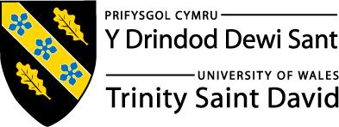
Skills for the Workplace
Module Assignment Submission
Student Name: | Kirsty Jones
Student Number: | 1708509
Module No: | BMSK4003
Module Title: | Digital Skills and Research Methods

Statement of Confirmation of Authenticity
By the act of making this submission, the student declares that this is the work of the student named above. The work has not, in whole or in part, been knowingly presented elsewhere for assessment, or where assessment has been built on a previous assessment, this has been identified. Where materials have been used from other sources it has been properly acknowledged. If this statement is untrue, the student acknowledges that an assessment offence has been committed.
Attention is drawn to the plagiarism and unfair practice policies of both the University and of ILM.
Permission for ILM to use this script
ILM uses learners’ submissions – on an anonymous basis – for assessment standardisation. By submitting, both the centre and the learner agree that ILM may use this script on condition that identifying information is removed. However, if you are unwilling to allow ILM use this script, please refuse by ticking the box: □

Table of Contents
What has been the impact of 21st Century Technologies on the modern workplace? 3
Part 1 3
An Overview of the 21st Century Workplace 3
An in-depth look at the technologies used in own workplace 3
Part 2 4
An exploration of the use of social media in the workplace generally 4
An in-depth look at the use of social media in own workplace 4
The use of social media to enhance networking and career prospects 4
LinkedIn Profile 4
Conclusion 5
References 6
Appendix 1 7
Appendix 2 8

What has been the impact of 21st Century Technologies on the modern workplace?

By doing research on the 21st technology in the workplace I found that it has changed greatly by making it easier for the way that employers communicate. With employers now using emails or video calls it makes things much more easier for those who aren’t always flexible instead of meeting in person. With facetime, skype, whatsapp and many other ways to video call being introduced it makes things more efficient to communicate for employers who are on the go, at the office or even just at home. Remote working and teleconferencing has now been introduced to the new modern workplace technology. Employers and employees are now able to access their work files from anywhere instantly and this is down to mobile and cloud technology with this technology being introduced it means they can be more flexible and not tied down to one location to work it also means that they are able to access work whilst on the go. Due to the new modern workplace technology employees and employers are able to jump on s video call straight away when away from work if they need help and advice, they are also able to do group calls. 21st technology in the workplace is also extremely helpful with keeping files and documents in order as things are much more simple when they are organized. With having files on paper it puts them at risk of being lost or incorrectly positioned. Having the files put onto a computer makes it much more safe as it will be backed up on the system you saved it on or even better, the cloud storage. With the cloud you are able to access the files at any location and also any device whilst being connected to the internet making it easier and flexible for employers. It will also help companies keep up to date and keep track of their progress making sure they hit their goals in time. It will then help the managers to keep track of all their employee’s progress and also be able to check that they are on target for achieving their personal goal at the end of every month. It will also help the managers check to see if their employees are performing as well as they should be.

An in-depth look at technologies used in own workplace

Wifi - Employers connect to the internet through their wifi provider. The internet is useful to employers so that they can save their work online and also access their work at any location whether it is at home, work or on the go. With everything being saved online it takes away the risk of any work being lost. Wifi is a great advantage to have for any businesses whether they are small or large. With using the internet employers can help meet the needs of their customers, helping the business expand. For in store workers wifi is great to have as customers can research any product that they are thinking of buying in the store making them feel more strongly and confident about the product that they want. Having customer wifi could also help employees create new marketing opportunities. Employees can create branded customer portal to deliver things such as loyalty rewards, news, coupons, customized recommendations and so many more. By doing this you can collect customers email addresses and data to help you make smart choices in the future. With using wifi it can also help employers communicate with others through social media such as whatsapp, facebook, twitter, instagram and so many more.
Cloud Storage - The cloud storage is great for employers and employees so that they can store all of their emails, files, documents and more. Instead of everything being stored on one device, with the cloud you have the chance to access your information on any other device at any location without being at the office and long as you're connected to the internet. For businesses it is a great idea to invest in a back up plan as cloud storage can be used by creating another copy of the important files. So there's no risk of any loss.
Machines - In the modern workplace these days you are able to interact with machines instead of going straight to reception and communicating with the receptionist. With the machinery invented you are able to get things done more quickly sometimes depending on what it is you need or want. Machines these days are a quicker and easier way to order and pay for food. Some work places still hire employees because some of the people are not able to use modern technology as some people find it difficult to understand or just because their machines may stop working on time. There are many pros and cons to the new technology. It will cost employers less money as once its purchased the cost ends. You also do not need to pay out holidays or over time. The new technology can work many hours without needing to take any breaks so that means earning more money. They are also able to follow tasks and instructions more easily and quickly without making any mistakes. The downside to the new technology is that many people are losing the opportunity to work and also people are becoming more lazy.
Apps - The get busy app is a great app if you tend to work more from home. Employers tend to encourage employees to use the get busy app so that they are able to keep in contact with their managers and other members of their team all from the comfort of their own home or even someone public if they have access to wifi. Get busy is also an app that automatically reminds managers to send updates to their employees until they have managed to get word done that was set for them. You are also able to assign a take to yourself, someone else in your team or even be able to assign tasks to your clients for them to do. People use get busy as it will always tell you who does what tasks so it does not cause any confusion. Get busy is an app that helps employees organise their clients as well as their employees, it also helps them to share files with sensitive information safely, and get busy also helps you to document everything. This app is about people getting on with their work and not having people having noise conversations around them like they would get if they were working in the office. Get busy app allows you to have a to do list so that you are able to keep track of what you need to do and what you have done, this is a more efficient way of working as everything that you need to do is in a list in from of you and not just in a number different emails in your inbox. The get busy app helps to organise your team as well as keeping your team focused and concentrating on the tasks that they have been set and need to do. This app also helps people to know who is doing what tasks and when they have to do them by, it also helps you to know what tasks you have been set to do and when you need to complete them by. Get busy is also an app that comes with smart tags, smart tags helps you to sort out and communicate issues that may occur when working in a large number of teams.
CDM - most bank branches have had a new cash and deposit machine put in, cash and deposit machine can also be known as CDMs. When needing to deposit notes or cheques into your bank account you are able to use the new cash and deposit machines rather than lining up to see the bank worker at the counter. At the cash and deposit machine it allows you to cash in up to fifty notes cheques at one time. You are also able to cash in up to fifty notes at one time. Some cash and deposit machines also allow you to cash in up to one thousand coins at the same time the coins are also allowed to be mixed. By introducing the new cash and deposit machines into the banks branches across the uk it makes it easier and quicker for the customers that are in a rush to deposit their money into their account. The machines also provide you with an image receipt when you deposit any kind of money. It will also give you a detailed breakdown of what notes, coins or cheques you have deposited and the quantity of each item you have deposited.
Robots - Having modern technology such as machines and bota working within your business can benefit you in a number of different ways such as people can sometimes fall sick and not be able to make it into work and with modern technology the bots and machines do no get sick so they are able to your products out on time without having any types of setbacks. Another positive to having machines and robots working for your business is that they do not require holiday days as having human employees they have the right to a number of paid holiday days a year by law. Employees are also obligated by right to have a break during their shifts as well as having a lunch break where as bots and machines do not require any type of break and are able to operate throughout. You do not have to time track when it comes to robots and machines as they are programmed to make a product within a set time and they are able to deliver that product in the time frame set without fail. When having people work for you you're obligated to have more than one person to do that pacific job as they are only able to work for a certain amount of hours until they then have to switch shifts with another employee. With having bots and machines working for you they do not require and sort of training what so ever as people have to go on courses to learn the skills required for the certain job role and then after number of sears they go on a refresher course where as a bot or machines only have to get programmed to do the job just once. Having a machine or bot work for you gives you consistent results every time where as some people may mess up and there for have to start all over again costing your business more money.
Online - When looking into the twenty first century workplace it shows that communication and connectivity mark some of the most important developments in the human society just in general, but with it now bringing the potential for employees to discuss and collaborate with their other employees online without having to be in the same room. Skype and Microsoft teams are two of the most used apps within a business. Businesses intend to use these two apps the most so they are able to do a video conference call from the office or from home or even another country. This can also help members of the team that are not able to make it to work as they may be at home sick join in on the conference calls. The benefits of using skype and microsoft teams is that the apps are free and they are also very easy apps to use. You are also able to use skype and microsoft teams with your mobile phone whilst being out and about and on the go.
Email - Research into the modern workplace shows that emails are an effective way of sending maybe a one way message or even engaging in a two way interaction system when it does not have to be answered with such urgency. By using emails in the modern workplace companies have been able to help spread out and diverse work teams throughout their composite. Emails can also help employees interact and collaborate with each other and not have the need to have face to face conversations all the time. When using emails throughout the company it has become a less personal way of communicating with other employees. When emails became a part of the modern workplace group members started to not communicate as much as they used to do as the majority of the group members prefer to just sit at their desk to send an email across the room to another group member rather than getting up and walking just across the room to speak to their other group members, this has caused workplaces to become less involved with each other as employees are becoming more reliable on emails to interact. The downfall to having emails in the modern workplace is that some companies are overwhelmed with the amount of emails that they receive and sometimes it is hard for the employees to catch up with all the emails that they received and sometimes this could cause some neglect to some of the other emails it can also cause neglect to some of the critical job duties. Some managers have less time to try and train, coach and even motivate their employees as most of their time is spent going through emails reading and replying to their partners, suppliers, customers and even their work staff that could be off sick or on holiday. Most companies now try to hav e30 minutes to an hour each morning to reply to as many emails as they can, Some companies may even have certain employees to handle the emails only.

Part 2

An exploration of the use of social media in the workplace generally

Social media is easily accessible for employers and also employees (Bernoff and Schalder. 2010; Curtis et al, 2010; strolley, 2009). Social media is a powerful information technology application that a number of different industries use through a number of different organizations. Social media is also a friendly platform.
When using social media it opens up a number of different opportunities and also opens up a number of challenges for numerous organizations. With different workplaces introducing social media to their organizations employees and employers can mobilize resources and be able to test out their new ideas quickly and more efficiently (Vaast, 2010). Social media can be used for organizations to respond to customers in better and quicker ways into dealing with whatever the customer needs help with. The customers are powerful and more equipped with social media in the modern days (Gallaugher and Ransbotham, 2010). With the employees use of social media it has had a big impact on their organization internally (e.g. related to culture, innovation process; McAfee, 2006) as well as externally (e.g. what organizational image employees might project on public social networking sites; Kane et al, 2009). Certain use of social media within an organization is encouraged when it is more beneficial to their type of work.

An in-depth look at the use of social media in own workplace

When doing research of how social media is used within the workplace there was a number of social media platforms that came up the the majority of the organisations tend to use to promote their businesses, this would be whether it is posting about their businesses themselves or just their adverts popping up on people's facebooks as they are strolling through their own social media.Some of the social media platforms that many companies use are facebook, twitter, instagram and even youtube. Twitter and Instagram are two of the main social media platforms as most companies tend to use and pay celebrities to promote their best products, so celebrities are more likely to promote businesses through their personal Instagram and and twitter accounts and then depending on how well the company do after the celebrities post they get a percentage of the income that the company make. Facebook and youtube are also social media platforms that organisations use, but facebook and youtube are tend to use more as a platform for their adverts and promoting their businesses and products through videos and adverts.
Instagram - Instagram is the new app to be introduced to the modern workplace. Instagram has a number of different selling points. One of them is that they are totally photo bases. This has a massive impact on their interaction with people who use the app and this is getting bigger each day. Instagram is getting bigger in it’s community due to them making it easier to scroll through the posts and making it easier for the public to tag their location and tag the people into the photos they are posting.
Instagram is a platform where businesses like to promote their events and make contests for their customers. It is also a place where businesses can create a more personal sense of community for their brand and also their customers. It is also a fun social media app that more and more people are using in the modern days. Businesses can also share their customers pictures with consent.
One way to build your business community on instagram is to engage with your customers that use the social media app. Engaging with your customers through the app means replying to their comments that they leave on your post and giving them a like. You can also ask customers questions about what they would like to see. Thanking your customers for service and loyalty and responding to their feedback will also promote a good quality of customer service. By following your customers back and liking their posts is a good way to interact with them and gain their trust.
Facebook is a low - costing marketing platform. Facebook is a cheaper way for you to market your business. Instead of paying out thousands or maybe even millions when you can use a good platform for a fraction of the price. Small or medium sized businesses intend to use facebook more often than bigger businesses which only use facebook as a starting point.
Facebook is a platform where you share your business's name, your businesses address and also your contact details. When using facebook you can use it to briefly describe your company's services and describe the products that you sell as a business. It is also a great platform where you can talk about the history of your business and your staff. Speaking about other aspects of your company that will likely attract other people to your business is always a good way to start.
With facebook you are able to post photos and videos to promote your company’s products. You can also use customers' photos wearing your product to also gain more custom. You can only use their image if you have received their permission. This way other customers are able to see their feedback.
Twitter is a social media platform that holds a lot of value for any size or type of businesses. Twitter is a good way to spread your company’s message. Twitter is a good platform to do this on.
With using twitter to promote your business you can use hashtags. Using your own hashtag along with a hashtag that is trending is a good way to boost up your business.
Twitter is a great way to deal with customer service. They can contact you through direct message. Using direct messages to deal with your customers queries because it does not have a word count and is able to write as many words as you like. It is also good to direct messages as it builds up a good relationship with that customer. It also stops people reading all the negative comments and complaints and thinking bad about your business.
Using twitter also helps you interact with customers by involving them in decisions. You can do this by making polls for them to vote in. This can involve releasing a new product or what it is they would like to see you realize you can put up as many polls as you with but they only last twenty four hours.

The use of social media to enhance networking and career prospects

For most people, social media is a great start to help make their business grow. The more likes, shares and comments you get on your posts the more chance you get of helping your business grow. The more shares your post will get the better your chances of finding and reaching out to new customers. With the amount of people using social media today the more your business will build and expand. The more the business grows the more it will attract new customers. So that could mean thousands or millions of people depending on how well the business is going.
Making yourself available, engaging with your customers and responding to any questions they may have will show an example of good customer service. It will give the customers a chance to write good feedback about your business.
With social media you can keep up to date with other businesses and to see their reviews, that way you can learn a little more about what it is most customers like and dislike. Social media also helps give you an idea of what is new and what type of things people are into for all ages and genders.
Using social media you can even collaborate your business with other another sharing what is new and what takes people's interests helping the business expand more.
Most companies use social media to make their businesses grow but most businesses used a website called linked in. Linked in is a site used to keep in touch with their employees on a more professional level. Where as social media is a good platform for people to communicate through and keep in touch, linked in is just a website that is mainly focused on the profesional side of the organisation and the people in it. Linked in does not have any of the unnecessary information like other social media such as facebook and twitter have. Linked in is focused on the people only and not focused on everything that may not be relevant.

LinkedIn Profile

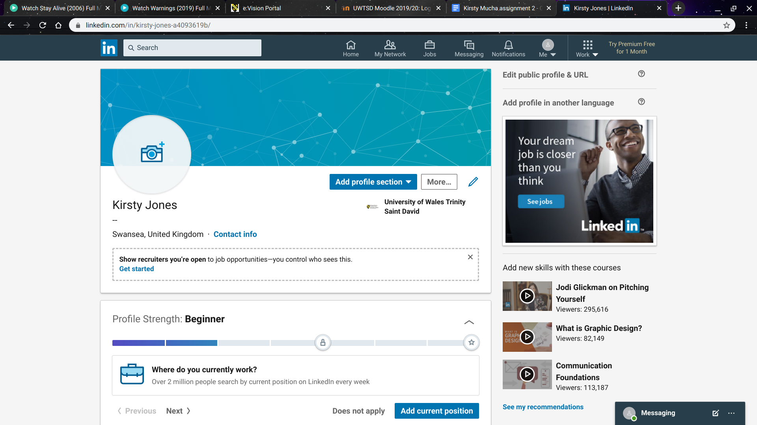

References

https://blog.hootsuite.com/social-media-for-business/
https://datafloq.com/read/robots-in-the-workplace-pros-and-cons/5692
https://www.comparethecloud.net/articles/6-pros-and-cons-of-cloud-storage-for-business/
https://www.coxblue.com/4-important-benefits-of-wifi-that-can-create-a-competitive-advantage-for-your-small-business/
https://academic.oup.com/jcmc/article/19/1/78/4067520
https://www.businessnewsdaily.com/7488-twitter-for-business.html
https://www.business.qld.gov.au/running-business/marketing-sales/marketing-promotion/online-marketing/facebook/benefits
https://socialnicole.com/instagram-for-business-why-and-how/
https://www.getbusy.com/?utm_source=google&utm_medium=cpc&utm_campaign=G_Search_NonBrand_BMM&utm_content=Team_App_BMM&utm_term=%2Bteam%20%2Bapp&utm_creative=426231554856&gclid=Cj0KCQjwyPbzBRDsARIsAFh15JYxUdC59-4IQFooNI6Dpzgxtt2EvOZi_P5Pp8TE_t0WQyTpAywgmFMaAoAIEALw_wcB#tag2
https://work.chron.com/impact-email-workplace-7915.html

