Technical report

Investigation of three forces in equilibrium

Ross Shaddick - 1803900

University of Wales Trinity St David - School of Applied Computing

Contents

Introduction………………………………………………………. Page 3

Literature Review.…………………………………………….. Page 4

Methodology ……………………………………………………. Page 5

Discussion ………………………………………………………… Page 6

Conclusions………………………………………………………. Page 7

References……………………………………………………….. Page 8

Introduction

This experiment will investigate how the angle between two strings varies as the mass they are supporting is gradually increased in increments.

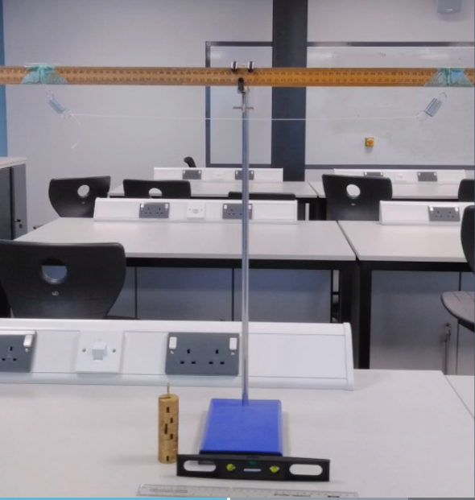

Literature Review

The purpose of this practical experiment is to investigate the resolving forces and to determine the theory of how this would reproduce a comparable simulation of true engineering.
Using an apparatus as shown in the introduction of page 3, the experiment will need to be conducted with the following items listed as follows;
- Retort stand
- Boss clamp
- 1m wooden rule
- Two strings – attached 0.6m apart
- 0.3m rule
- Protractor
- Spirit level
- 0.05kg mass hangar
- 6 x 100g slotted weights

Methology

- A results table is to be created for data to be recorded as below;

Mass | Reading 1 |  |  | Reading 2 |  |  | Derived Data
g | L1 (mm) | L2 (mm) | Angle (0)/Deg | L1 (mm) | L2 (mm) | Angle (0)/Deg | Lm (mm) | Angle (0)/Deg | Mass Cos (0m)/2)

- Apparatus must be set-up correctly using a spirit level to determine a strict level and to securely position the apparatus with the boss clamp
- Using the wooden ruler, measure the length of each spring, starting with zero weight applied
- Apply 100kg weight to the central position of the string
- Measure the length of each extended spring to the point of where each loop ends
- Record each result in millimeters
- Using the protractor measure the angle
- Record the result in degrees
- Repeat the process by adding an additional 100g weight incrementally until 600g of weight has been applied
- At each step take the measurements using the ruler and protractor, then record the results
- To check reliability, remove all weights from the apparatus and repeat the exact same process. This must be duplicated as previous and recording all data for a second time

Discussion

A good practice to implement before carrying out the practical experiment, primarily for the purpose of reducing any uncertainties with obtaining the most accurate measurements would be to make sure the apparatus is strictly level. When handling the apparatus and to maintain taking steady measurements, it is best to rest your elbows on the workstation. Furthermore, hang the weight(s) right on the center of the string and record all data using basic Si units for example; millimeters and grams, as it will aid in simplifying the calculations when formulating tables and graphs.
Another very important point to mention before taking any measurements is to wait for the springs to completely stop oscillating, taking readings at eye level directly in front of the ruler and protractor is highly recommended in order to obtain accurate data.

Mass | Reading 1 |  |  | Reading 2 |  |  | Derived Data
g | L1 (mm) | L2 (mm) | Angle (0)/Deg | L1 (mm) | L2 (mm) | Angle (0)/Deg | Lm (mm) | Angle (0)/Deg | Mass Cos (0m)/2)
100 | 80 | 77 | 123 | 79 | 75 | 124 | 77.75 | 123.5 | 211.2737056
200 | 106 | 104 | 105 | 108 | 102 | 103 | 105 | 104 | 324.8538491
300 | 130 | 130 | 96 | 132 | 128 | 98 | 130 | 97 | 452.7481485
400 | 152 | 152 | 89 | 155 | 148 | 91 | 151.75 | 90 | 565.6854249
500 | 173 | 174 | 83 | 178 | 173 | 85 | 174.5 | 84 | 672.8163648
600 | 194 | 198 | 79 | 200 | 195 | 80 | 196.75 | 79.5 | 780.3945818

Convert to Radians | Angle divide by 2 | Cos of angle | Mass divide by Cos Angle | Length/mm
2.155481626 | 1.077740813 | 0.47331967 | 211.2737056 | Range | Uncertainty
1.815142422 | 0.907571211 | 0.61566148 | 324.8538491 | 5 | 2.5
1.692969374 | 0.846484687 | 0.66262005 | 452.7481485 | 4 | 2
1.570796327 | 0.785398163 | 0.70710678 | 565.6854249 | 2 | 1
1.466076572 | 0.733038286 | 0.74314483 | 672.8163648 | 4 | 2
1.387536755 | 0.693768378 | 0.76884183 | 780.3945818 | 0 | 0
 |  |  |  | -1 | -0.5

Conclusions

On carrying out the experiment whilst implementing these steps it became oddly apparent that each spring when in static oscillation through the process of the weight(s) were being incremented, many of the measurements were not equal between each spring by a difference of a few millimeters. When all weights were removed and the springs returned to their elastic deformation form as stated in Hooke’s Law (1), this exact same trend was apparent the second time the process was carried out and the readings gave a similar impression as the first set of measurements for each spring.

Here is the plotted graph showing the line of best fit straight line;

References

(1) Khan Academy (2019) (Online). Available: https://www.khanacademy.org/science/physics/work-and-energy/hookes-law/a/what-is-hookes-law. (Accessed 27 Jan 2019).

