

Table of Contents
Executive Summary 3
Business Overview 4
Markets and Competition 6
Target Markets 6
Competition 6
Sales and Marketing 8
Product Positioning 8
Marketing and Sales 8
Management 10
Key Personnel 10
Advisors and support services 10
Operations 11
Premises and Equipment 11
Suppliers 11
Financial Forecast 12
Sales, Cashflow and Profitability 12
Financing 12

Executive Summary
I have a celebration and wedding cake baking business that I is operated out of my home kitchen called ‘SLICE’. I will be focusing on on-trend designs and beautifully baked and tasty cakes. I will stand out from the crowd as I use chocolate ganache to cover and decorate my cakes unlike all the cake bakeries in and around Cardiff. My target market are brides and grooms and busy working parents. I plan to market my business in many ways. I will be using social media as this is a free option and should generate many customers. They will be able to view my designs on my business pages, contact me, reserve a date and order cakes through social media. I plan to also network with local bridal shops and florists. I will also attend a few wedding fayres locally to showcase my cakes to brides and grooms to be. Family and friends will also market my business and I already have slots booking for cakes next year.

I am the only employee at SLICE and will handle everything for the business. I work part-time so will have to make sure that I manage my time well to deliver on service. I am prepared to have to work late evenings and weekends as this will be likely when cakes will be ordered for. I must make sure that I keep track of bookings and do not overbook so that I am able to fulfil the orders. Time management will be essential. As I have been baking for a long time, I have the experience to make this work and will not have any start-up costs as I have all the equipment already. My aim is to build this business year on year. I have included the financial forecasts in appendix B for your perusal.

This is a triple layer, raspberry and white chocolate cake I recently made for my Mums birthday. It has hand-made edible flowers, macaroons and mini meringues.

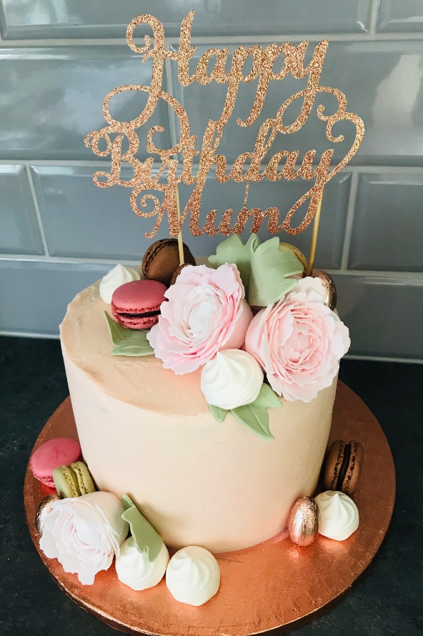

Business Overview

My plan is to open a cake baking business from my home kitchen in Cardiff called ‘SLICE’. I will specialise in making bespoke/on-trend wedding and birthday cakes to order. I have been baking cakes since I had my first child in 2009 for family and friends and have gained a whole wealth of experience over the years. I have always been a very creative person and enjoy designing the cakes as much as I love making them. I started out with cupcakes which helped me understand what flavours work well and then slowly moved onto celebration cakes. I have all the tools and accessories needed so this would mean that there would be very low start-up costs. I have also attended weekly cake decorating classes locally for a year and have completed several online classes. I will setup social media accounts on Instagram and Facebook, using the hashtag #NICESLICE for each post and develop a website showcasing many of my cakes.

I now do not use fondant icing to decorate my cakes after recent research conducted with family and friends informed me that many did not think it added to the cake, feeling that the fondant icing is too heavy and very sickly. It is used mainly for decoration purposes. It also takes up a lot of time to fondant ice a cake so with my technique it should take half of the time which would mean I could potentially have double the amount of orders. I now use techniques that I have personally developed, steering away from outdated fondant icing celebration cakes. This is what makes my cake business different to others. I use chocolate ganache to cover and decorate my cakes. It creates a thin outer layer which creates sharp sleek lines and does not overpower the taste of the cake. I use the latest decorating techniques to produce beautiful eye-catching cakes. I also use cake wraps which have on-trend designs, so I am always up to date with the latest cake fashions. I use a vast range of flavours to suit every taste and the cakes come in an array of sizes and shapes. I make my own preserves and buttercream filling and make sure all ingredients are fresh and of the highest quality. I plan to have a wedding cake tasting service when wedding cakes are booked with SLICE. The bride and groom will receive slices of different flavour cakes so that they can pick which flavour they would like in their wedding cake. This can be arranged with the couple at a place and time that suits them and if difficult this can be posted to them. I will deliver the cakes personally to ensure smooth delivery and set up and can rectify any issues with the cake that may arise from transportation.

I understand that I will come up against tight time constraints so will need to make sure my time management is second to none. I am a very organised person and will make sure I have an electronic calendar and diary to keep on top of bookings and ingredients ordering. We are having a new home kitchen fitted with plenty of storage for my baking accessories and a large fridge has been purchased with this business in mind. I understand that starting a cake business in a city saturated with other cake businesses will be challenging, which could be a potential weakness, but I plan to launch and market this business in a clever way using social media which will create a positive impression and create many cake orders. I know that many of my friends and family will spread the word and the business should gather good momentum. I already have people that would like me to make their wedding cakes on standby. In the future I would like to be able to leave my current job in administration and bake cakes full time once I have the established customers. Further down the line I would like to be making ‘how to bake’ videos online so that I can make an income from that also. There are many baking businesses already set up and many that will be set up in the future so this competition will be a threat to me. I plan to overcome this by keeping my skills up to date by completing relevant training and making sure that I am constantly marketing my business and learning the latest techniques and fashions so that I can win the business ahead of my competitors. I have a unique selling point in that I use chocolate ganache to cover my cakes which means that heavily themed celebration cakes will not be something that I will be making unlike most cake businesses in Cardiff.

Markets and Competition

Target Markets

My customers will be professional couples that have money to spend, aged from 20-40 and have high expectation, so quality is their priority over cost. They will be busy people that are looking for me to handle their needs. They will be avid users of social media and know what’s on-trend. They will live in the Cardiff and surrounding areas. They will buy for weddings, birthdays and special events and will want to stand out and present the very best. They would like to spend hundreds of pounds not thousands. They like premium ingredients, the best chocolate, organic ingredients, natural colouring and the latest trending flavours. They will buy from me around 3 times a year and will spend between £200-£600 over the year depending on the occasions. I expect to get around 5-10 referrals from them a year and would expect the biggest event they will purchase for is their wedding. The couples will be avid gym goers who like a healthy lifestyle but eat out regularly and like good coffee. These customers would all use a variety of social media sites, Instagram, Facebook, Pinterest, YouTube, TikTok and fashion blogs.

Other customers that I may have will be working parents that work full time so are well off. They would be aged from 25-40 and have high expectations with quality as their priority over the cost and live in the Cardiff and surrounding areas. They will be busy people that are looking for me to handle their needs. They will be avid users of social media and know what’s on-trend. They will expect a high level of service from me. They will buy for birthdays and special events and will want to stand out and present the very best. They would like to spend hundreds of pounds not thousands. They will like premium, organic ingredients, the best chocolate, natural colouring and the best flavours. They will buy from me around 3 times a year and will spend between £180-£250 depending on the occasions. I expect to get around 5-10 referrals from them a year and would expect the biggest event they will purchase for is their children’s birthdays. The working parents would also have healthy lifestyles who take their children to lots of after school activities. They would eat out regularly and visit coffee shops often. These customers would all use a variety of social media sites, Instagram, Facebook, Pinterest, YouTube and parents’ blogs and pages.

I have numerous people ask if I sell my cakes after online posts on social media. After family events there is always mention that I should make cakes for a living and that they would pay good money for them. I have recently been asked to make my Brother and Sister-in-laws wedding cake next year.

Competition

I will have lots of competition as there are many cake businesses around Cardiff. I have built up a good number of customers that ask me to make their cakes each year. I have included some of their testimonies in Appendix A. One of my main competitors is a cake business called Cakey Wakey (Appendix C). They have been trading for 14 years but recently shut the shop they had in Llandaff North. It does not say where they are trading from now but that she delivers cakes. They have built a good name for themselves in and around Llandaff North over the years. They also made my wedding cake back in 2008. This was one of the reasons that I started baking. Although the cake looked beautiful on the outside and was exactly what I designed it fell short of the mark on taste. It was very dry inside and I was disappointed. It made me think about the costs involved and I thought that I could do it better. I do think her prices are on the high side and I plan to price a little less after looking through what cake bakers sell their cakes for. The edge she may have over my business is that she makes gluten free, dairy free and vegan cakes which I know may be a big positive in the current climate. It is something I would like to investigate as I’m sure that the clientele that I am aiming for would maybe like the choice of a vegan cake. I do, however, think that their logo and website are both outdated and not very professional. They do have a Facebook page which is updated with her cakes, but I feel that this could also look a little more professional. Cakey Wakey use fondant icing to decorate their cakes which sets us apart from each other. They also make mainly celebration themed cakes which I am steering away from. I feel that we have different clientele so this should not affect my cake sales.

Another competitor for SLICE would be a home cake business in Pontypridd called ‘The Cake Cwtch’ (Appendix C). Their cake designs are beautiful, and their website and social media accounts are very professional. They are all kept up to date which is important for the customer to see. My cake designs are very different to ‘The Cake Cwtch’ but still innkeeping with the sleek modern designs they use. They use fondant and buttercream to decorate their cakes, so we do offer a slightly different service. They are not based in Cardiff, so this is a benefit to my business. Their prices are slightly less than SLICE, but I don’t see this as an issue as their business is outside of Cardiff and I offer free delivery and set up whereas they charge for delivery and setup. The flavours that they offer are similar although I plan to have tropical fruit fillings in my cakes also.

Sales and Marketing

Product Positioning

Having completed some market research of local cake businesses, I have priced my cakes accordingly. I am not the cheapest, but my price point sits just under the highest. I hope that this will help me to attract customers. I will be using quality ingredients and giving a first-class service. I have customer service skills from previous employment and enjoy speaking with customers and understanding what they want and need. I am a perfectionist so will only produce cakes that I am 100% happy with. After making many cakes over the years I now feel that I am confident and have the skills and experience to take this business forward. I believe in the cakes that I make and would expect my customers to have a high expectation of me.

Marketing and Sales

I have identified the target market for SLICE. I will take advantage of social media and post on Facebook and Instagram numerous times throughout the day making sure that the cake photos look professional and have several on-trend tags so that they are seen by many potential customers. I plan to advertise in local shops and spread the word through friends and family and parents at the school. I plan to up-sale for weddings and birthdays offering baked wedding favour ideas and baked birthday party extras. I would also give them a percentage off their next cake when they book their first cake with SLICE. I will hold a cake giveaway competition on Facebook and Instagram and get potential customers to like the page, share with their friends and comment on the post so that its spread far and wide and to customers that would be local. This has the potential to reach numerous customers and would be a minimal cost for myself. It could drum up lots of business for SLICE as it gets people interested in the cakes as they look through my designs, so they understand the type of cakes I make. I also intend on writing a blog for every wedding cake that I make so that people can see my ideas behind the designs.

I also plan to attend Wedding Fayres so that I can advertise and showcase SLICE. I will give brides and grooms tasters of my cakes on the day and talk them face to face what I am able to offer. I will make dummy cakes so that they can see the designs that I create without the costs of ingredient’s involved. The cost of the wedding fayre will be balanced by making one cake booking on the day. Any extra bookings will put me in profit. I can also advertise at wedding fayres without having to be there by paying £20 and they will include my promotional materials in the goodie bags given out on the day.

I also have a friend that owns a wedding dress shop in Cathays, One Bridal. We plan to network and link the businesses. She is willing to mention SLICE when she has brides looking for wedding dresses and is happy to display my information at the shop. I will also do the same for her in return. We will link up through social media so that her customers will see my cake creations and my customers will see her wedding dresses. She has also agreed to serve brides a slice of my cake with the prosecco they receive. We have agreed that she will purchase regular cakes from me at a discounted price so that she can give her brides a great service but also advertise SLICE at the same time. I also plan to network with other bridal shops in Cardiff and surrounding areas.

Having researched cake businesses I can see that most sales are made through social media and word of mouth. I can see that many newer businesses don’t have websites and rely purely on social media. The target market that I am aiming for will regularly use social media. Instagram will be a big pull for potential clients as according to Instagram, 2020 they are the second-most downloaded free app in the Apple store. 1 billion people use Instagram every month and 500 million use Instagram stories each day. One-third of the most viewed stories are from businesses. Instagram users will spend an average of 28 minutes per day on the platform and 62% of people say that they become more interested in a brand or product after seeing it in Instagram stories. I also plan to link up with other businesses on social media so that I can advertise their products that I have used on my cakes and tag them in the posts so that they can show it on their social media accounts. Posting food pictures on Instagram daily is the on-trend thing to do, so I intend on maximising my sales through this avenue also. I think my cake designs will speak for themselves, I don’t see that I will need to make big selling pitches. I know from my own experience, if I see a product online that I like and if their account looks on-trend and professional I am more likely to buy from it.

SWOT Analysis –

Strengths –  - Fresh local ingredients.  - Loyal customers.  - Extensive experience (11 years baking).  - Alternative process for covering cake unlike other cake bakeries. | Weaknesses –  - Hard to stand out among the completion.  - Time constraints with part-time job and family and business.  - No recipes for specific dietary requirements.
Opportunities –  - Social Media – Free online advertising.  - Engaging customers online.  - Increase in visibility for the business. | Threats –  - Lots of competition.  - Without engagement the business can get lost in the crowded market.

Pest analysis –
Political - I use Fairtrade cocoa. This comes from unstable countries and bans on exporting or an increase in taxation could occur. If I cannot import this, my reputation could be damaged. Fairtrade is a big deal for consumers. I also buy fair trade sugar which is used in all my products. The price of sugar is rising, and this is also an issue for me. It pushes the price of the cakes up which could hurt the business in the long run.
Economical – My products are specialised, and the prices are quite high. In the event of extreme inflation or a recession, cakes would become something that can be avoided. In this case, in order to keep the custom, I would have to decrease the price of my products. I may suffer some losses as I do pay a high price for some of the supplies.
Social - People are becoming more health conscious lately so foods like cakes that are high in sugar are becoming less popular. Trends are always changing so I have to try to keep my services updated.
Technological - As technology improves it will help me to make my website better. That should also help me expend my business. New cooking techniques and products could make some processes more effective and increase productivity.
Management

Key Personnel

I am the only personal working within SLICE. I will be responsible for taking cake orders and payments, arranging delivery, ordering ingredients and making cakes. I have been baking and decorating cakes around 11 years. I have also completed several decorating courses and training over the years. I have been making cakes for family and friends for around 10 years and have their full support to go forward with this business venture. I currently still work part time so that I have a steady income while I grow the business. The long-term plan is to grow the business so that I can leave my employment and do this as a full-time job. I am very committed to making this work. I am prepared to work late evenings and weekends so that I can deliver on expectations. I have a passion for baking and design and would love to be able to make this a full-time career.

Advisors and support services

I have experience of accounting processes from my time working in a busy accounts department in a large Cardiff company. I will be using quick books to manage my invoices, pay my bills, take payments and track my cash flows. I will also use it to generate month and year-end financial reports as well as prepare for quarterly or annual business taxes. I am purchasing the essential plan which costs £168 for the first year and £240 for the second year.

Operations

Premises and Equipment

SLICE will be operated from my home kitchen in Rhiwbina, Cardiff. I am very close to the A470 so have good links to other areas when delivering cakes. I have my Level 2 Food Hygiene and Safety Certificate. I have registered my premises with the local authority and am awaiting a date for an inspection of my kitchen. I have all the equipment needed from previously baking for family and friends, therefore there will be no set-up costs involved. I have a large stand mixer and top of the range gas cooker and large fridge. I also have several different size cake tins, digital scales, cooling racks and decorating tools. I also have a large car for transporting cakes and have breakdown cover and insurance with business cover. I have informed my mortgage company that I intend to run a cake business from my home and have the relevant public and product liability insurance.

Suppliers

I have 2 key suppliers for my ingredients and equipment. I use Vanilla Valley for cake boards, boxes, food colours and any cake related equipment. There service is second to none, I can click and collect the things that I need through their website and they also offer delivery. I have a business account trade level discounts and reduced website prices. It also gives me access to exclusive offers. They have great customer service and the employees in the shop are more than willing to help me with any queries. They also hold cake decorating training days from their premises which helps to develop my skills further. I currently buy my organic fresh fruit for my fillings from a local fruit and veg shop in Whitchurch with an agreed discounted price. I buy my ingredients from a wholesale and purchase fresh free-range eggs from a lady that lives locally. I source my Callebaut select white chocolate chips from Amazon for the ganache as this is where I find its the lowest price. All the ingredients needed for baking my cakes are readily available and do not differ much in price so I would have no problem sourcing these from somewhere else if my supplier increased prices or went out of business.

Financial Forecast

Sales, Cashflow and Profitability

I have included the spreadsheet for sales, cashflow and profitability in Appendix B. I have also added a breakdown of the cost to make an 8’’ cake. This shows that I plan to build up the business sales year on year. I have put my prices up slightly in year 3 as I anticipate cost of cakes to rise slightly and I should have built good relationships with customers so will hopefully be in demand. I also understand as it is only myself making the cakes, I must make sure I do not overstretch myself. I would hope that in year 4 I would have an apprentice who I would train so that I am able to take on more orders.

 | Year One | Year Two | Year Three
Total Sales | 43 | 59 | 69
Total Cash In | £9,115 | £10,605 | £12,145
Total Cash Out | £2,985 | £3,340 | £3,707
Total Net Profit | £6,130 | £3,707 | £8,438

Financing

SLICE is operated out of my home kitchen, so I do not require any financing to start up this business. I have all the appliances and equipment needed as I have been baking for the last few years for family and friends.

Appendix A.

Sharon Brooks – Sarah makes the most beautiful cakes and they always taste amazing! I have already booked for my husbands 40th Birthday cake in November.

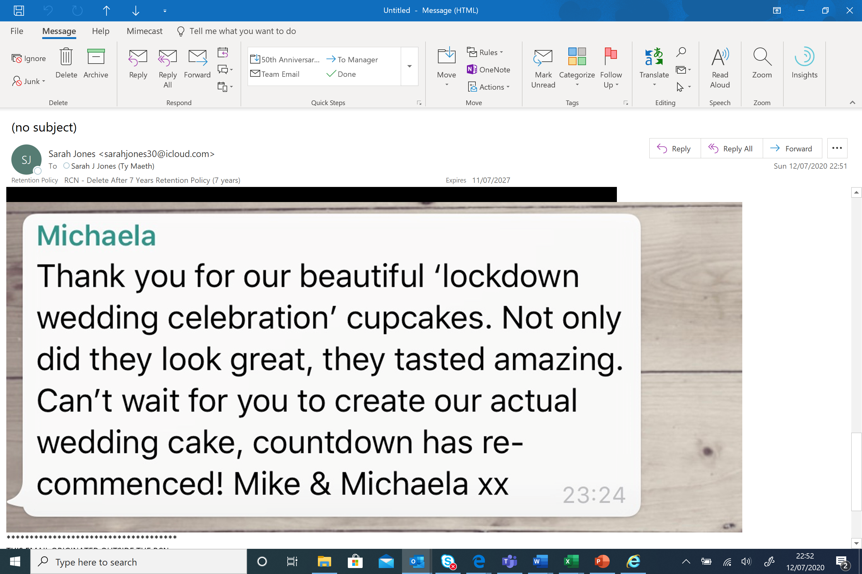

Appendix B.

Year 1 –

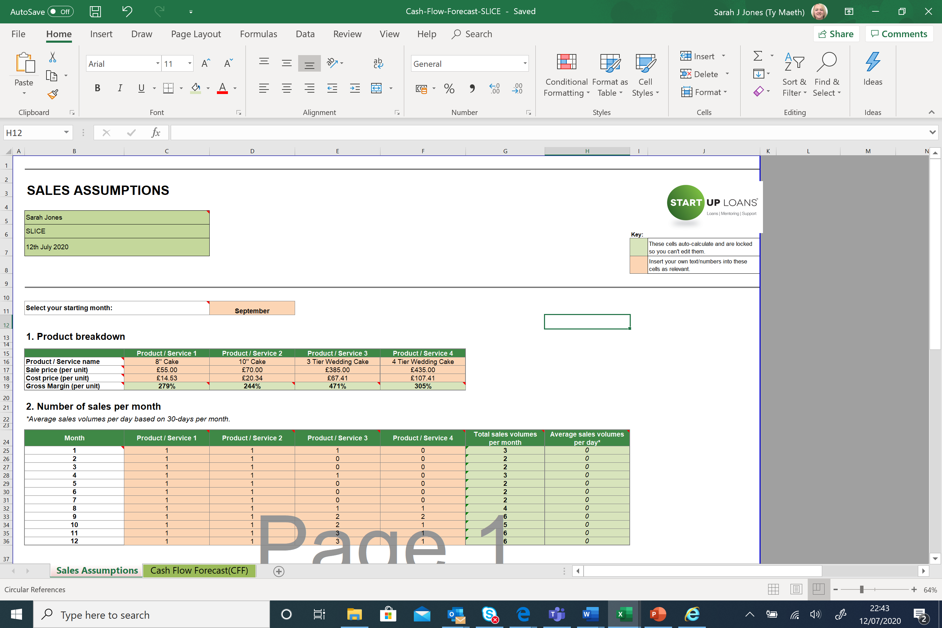
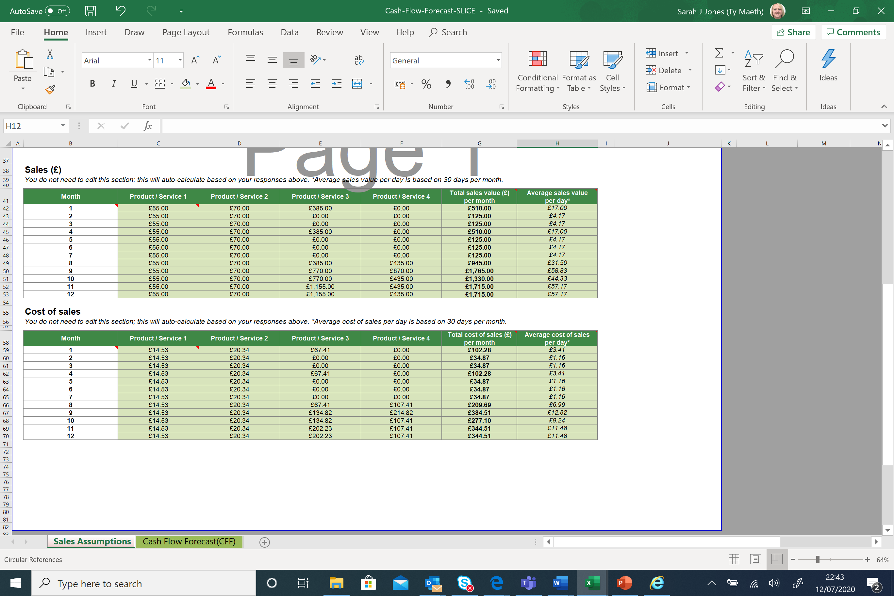
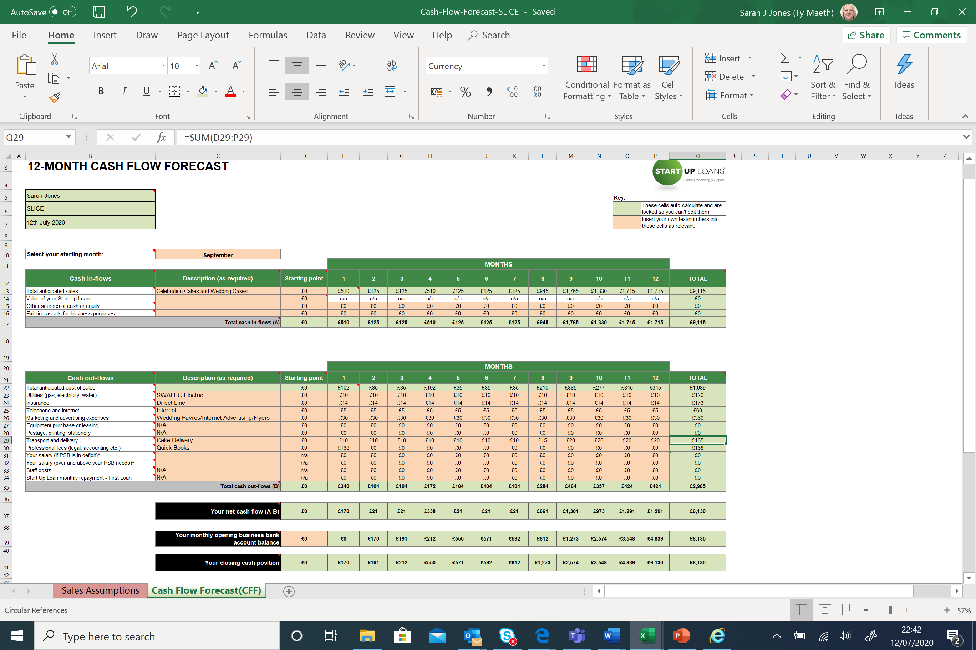

Year 2 –
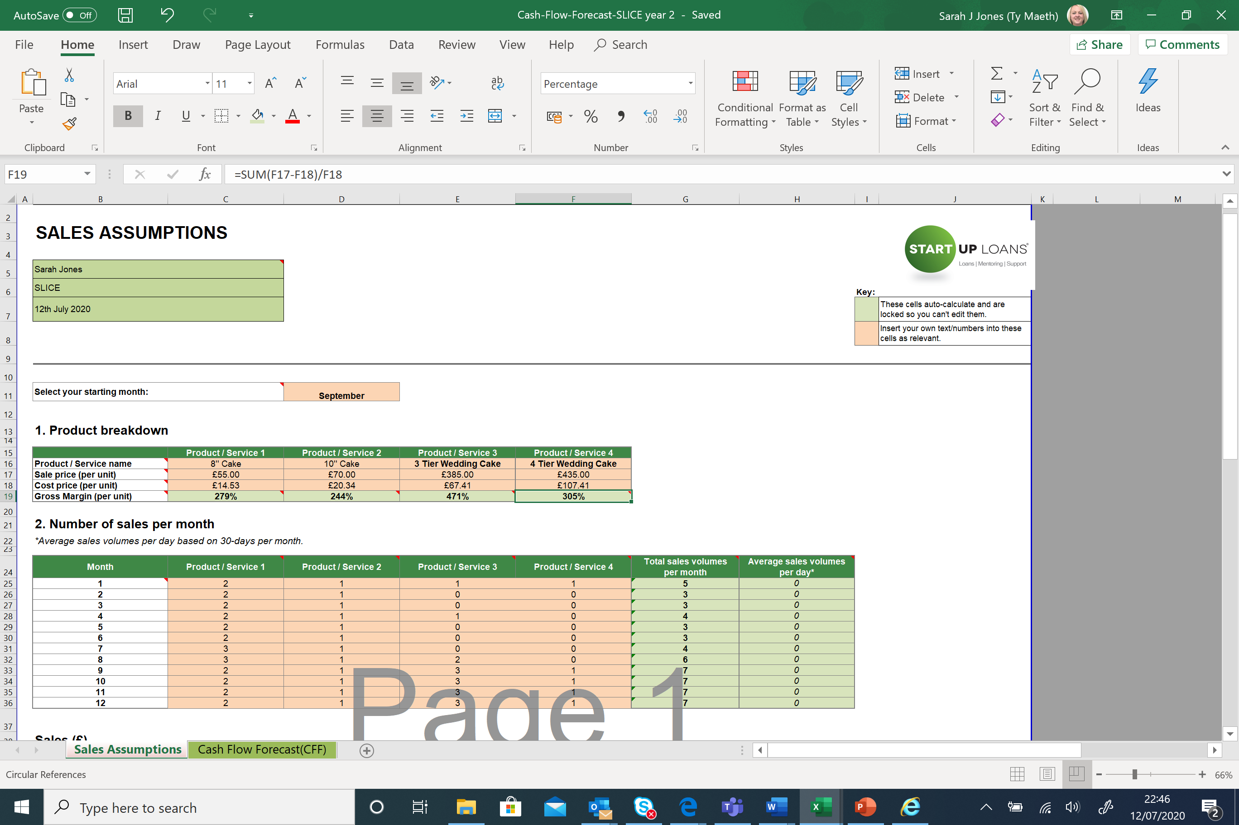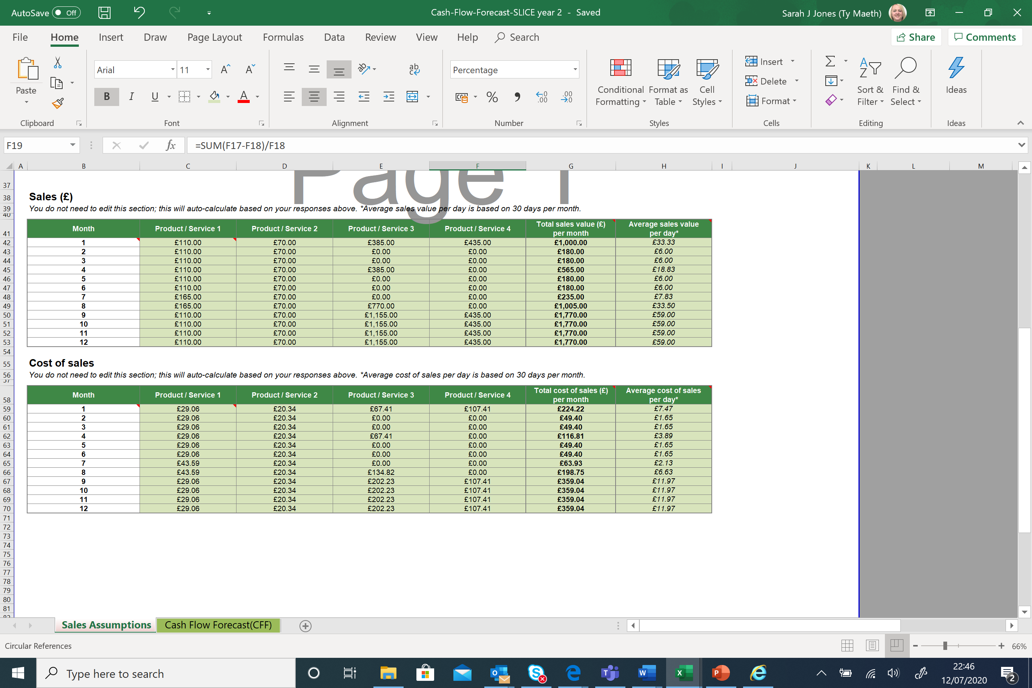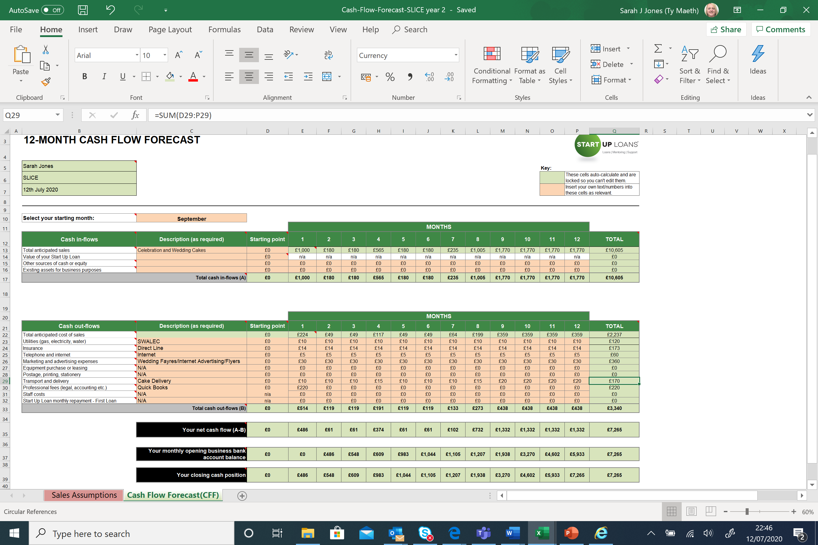

Year 3 –

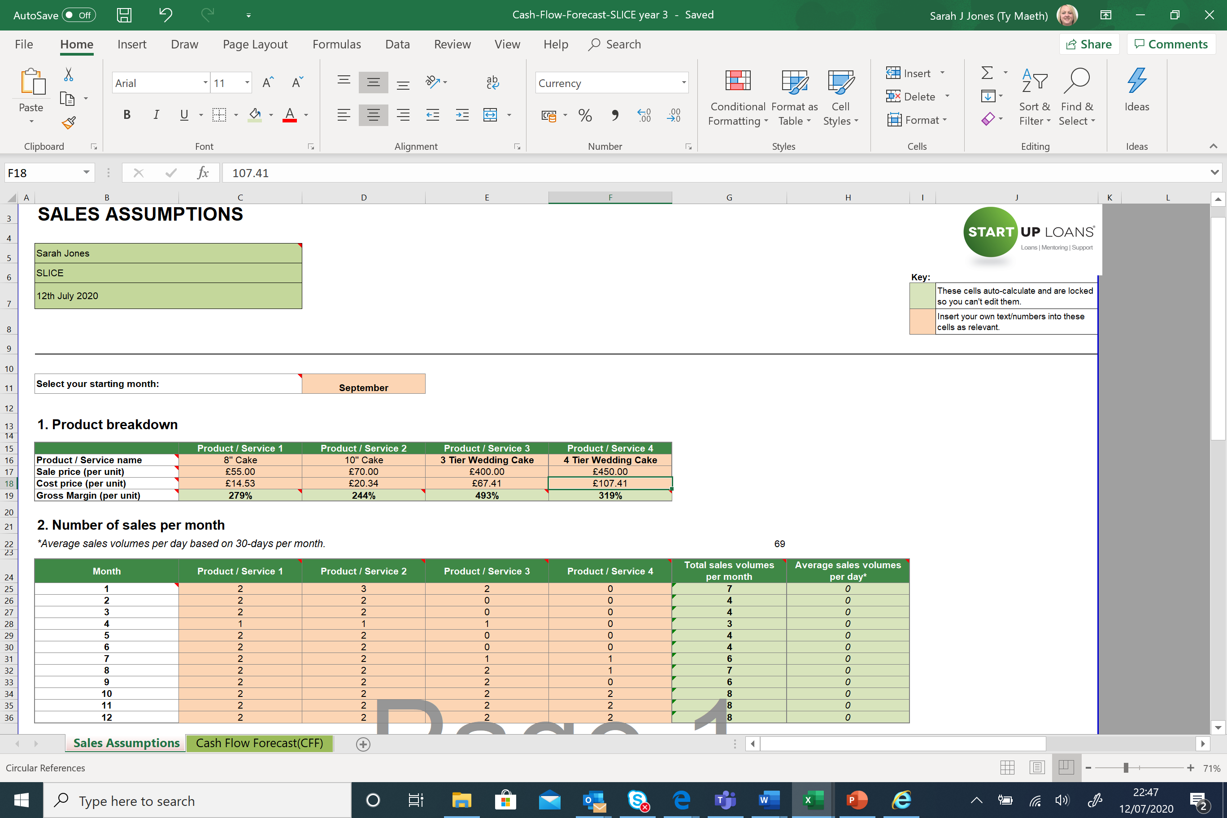
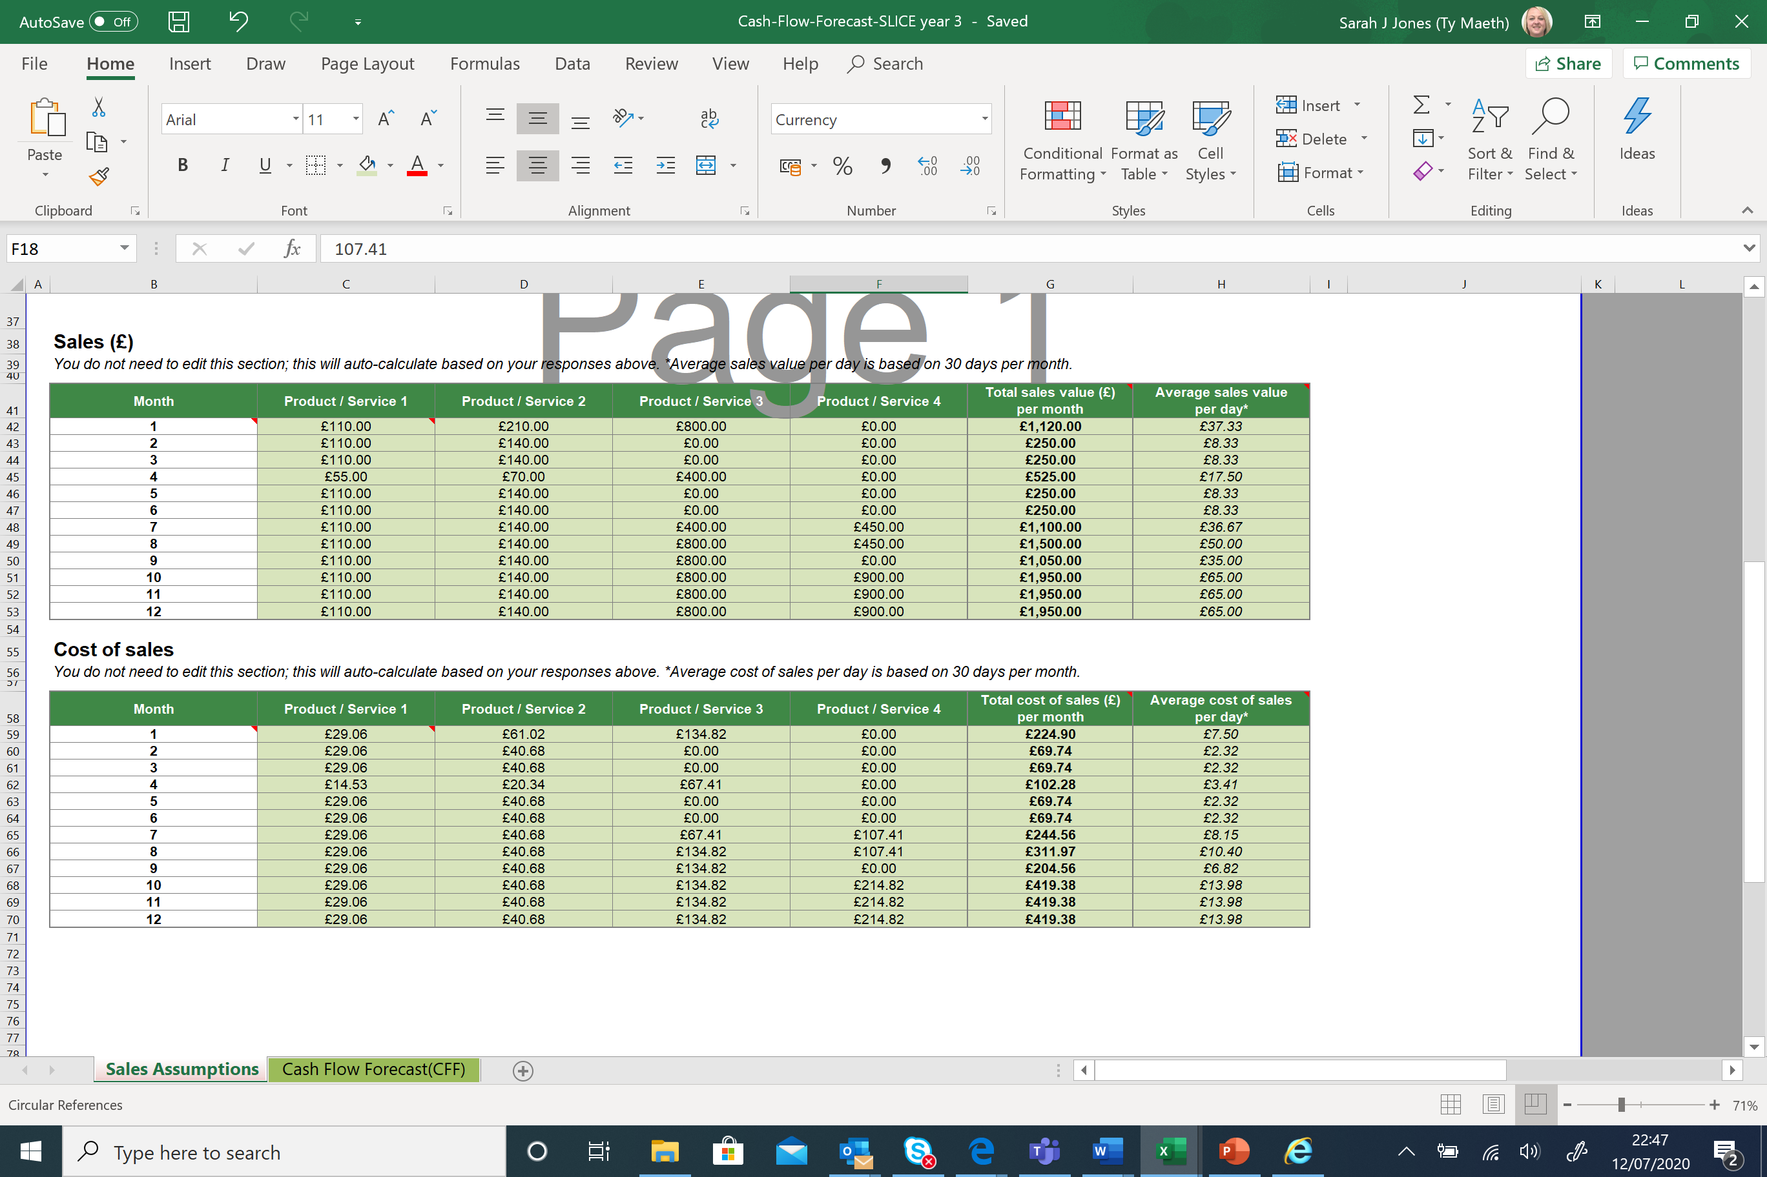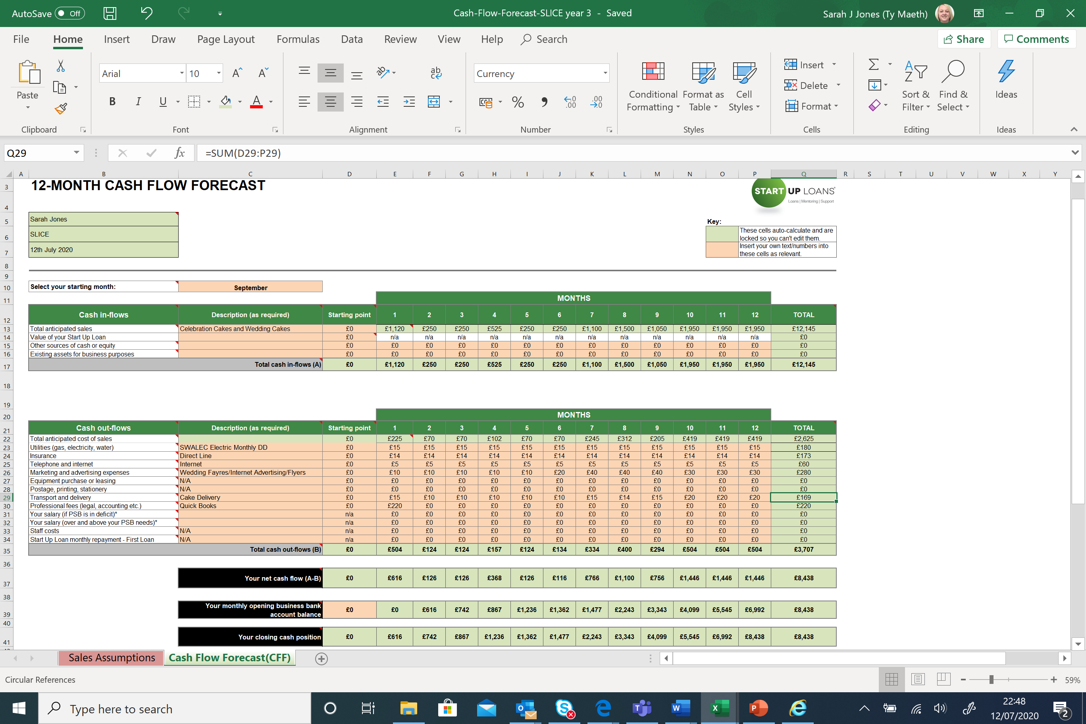

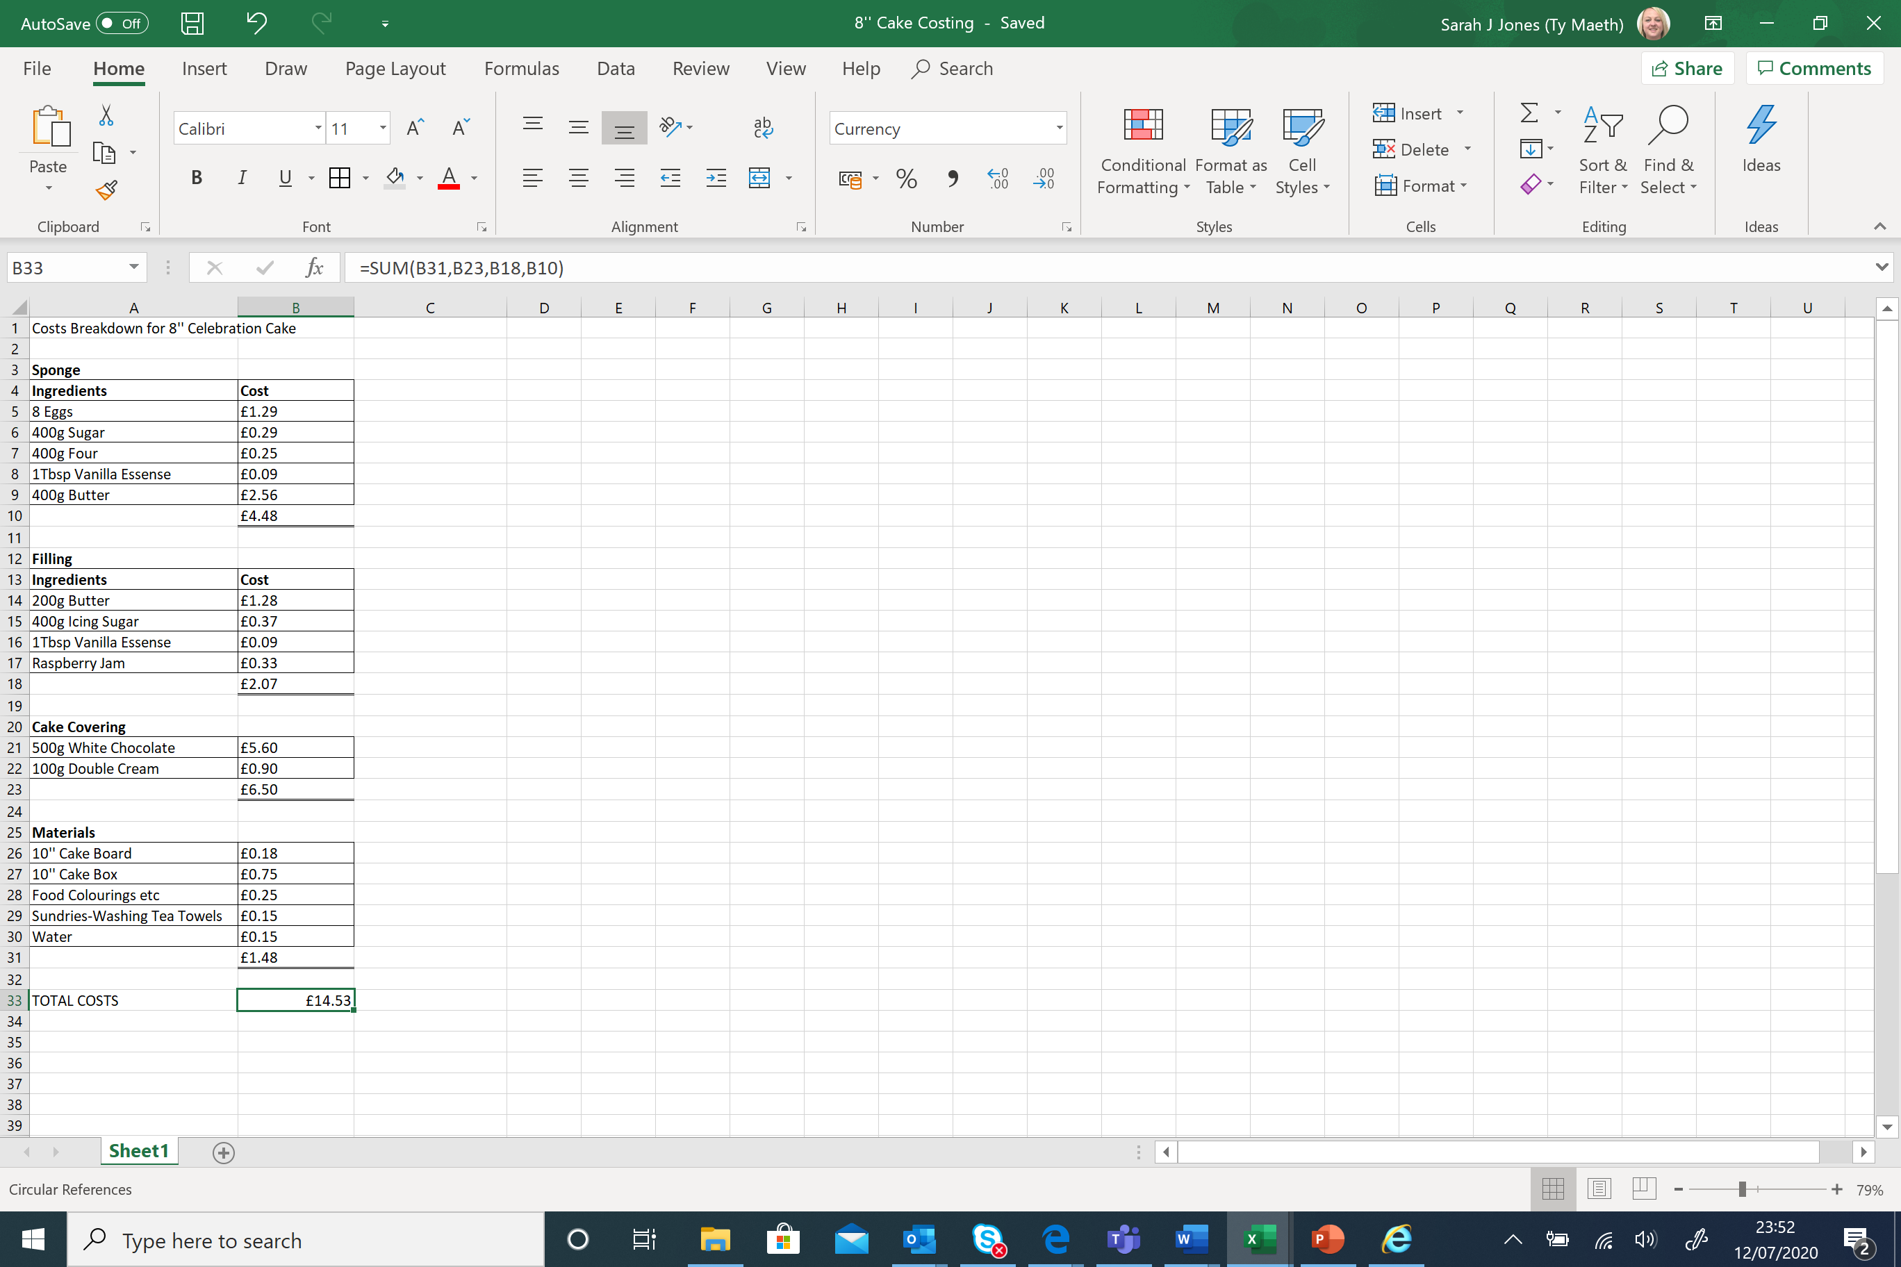

Appendix C.

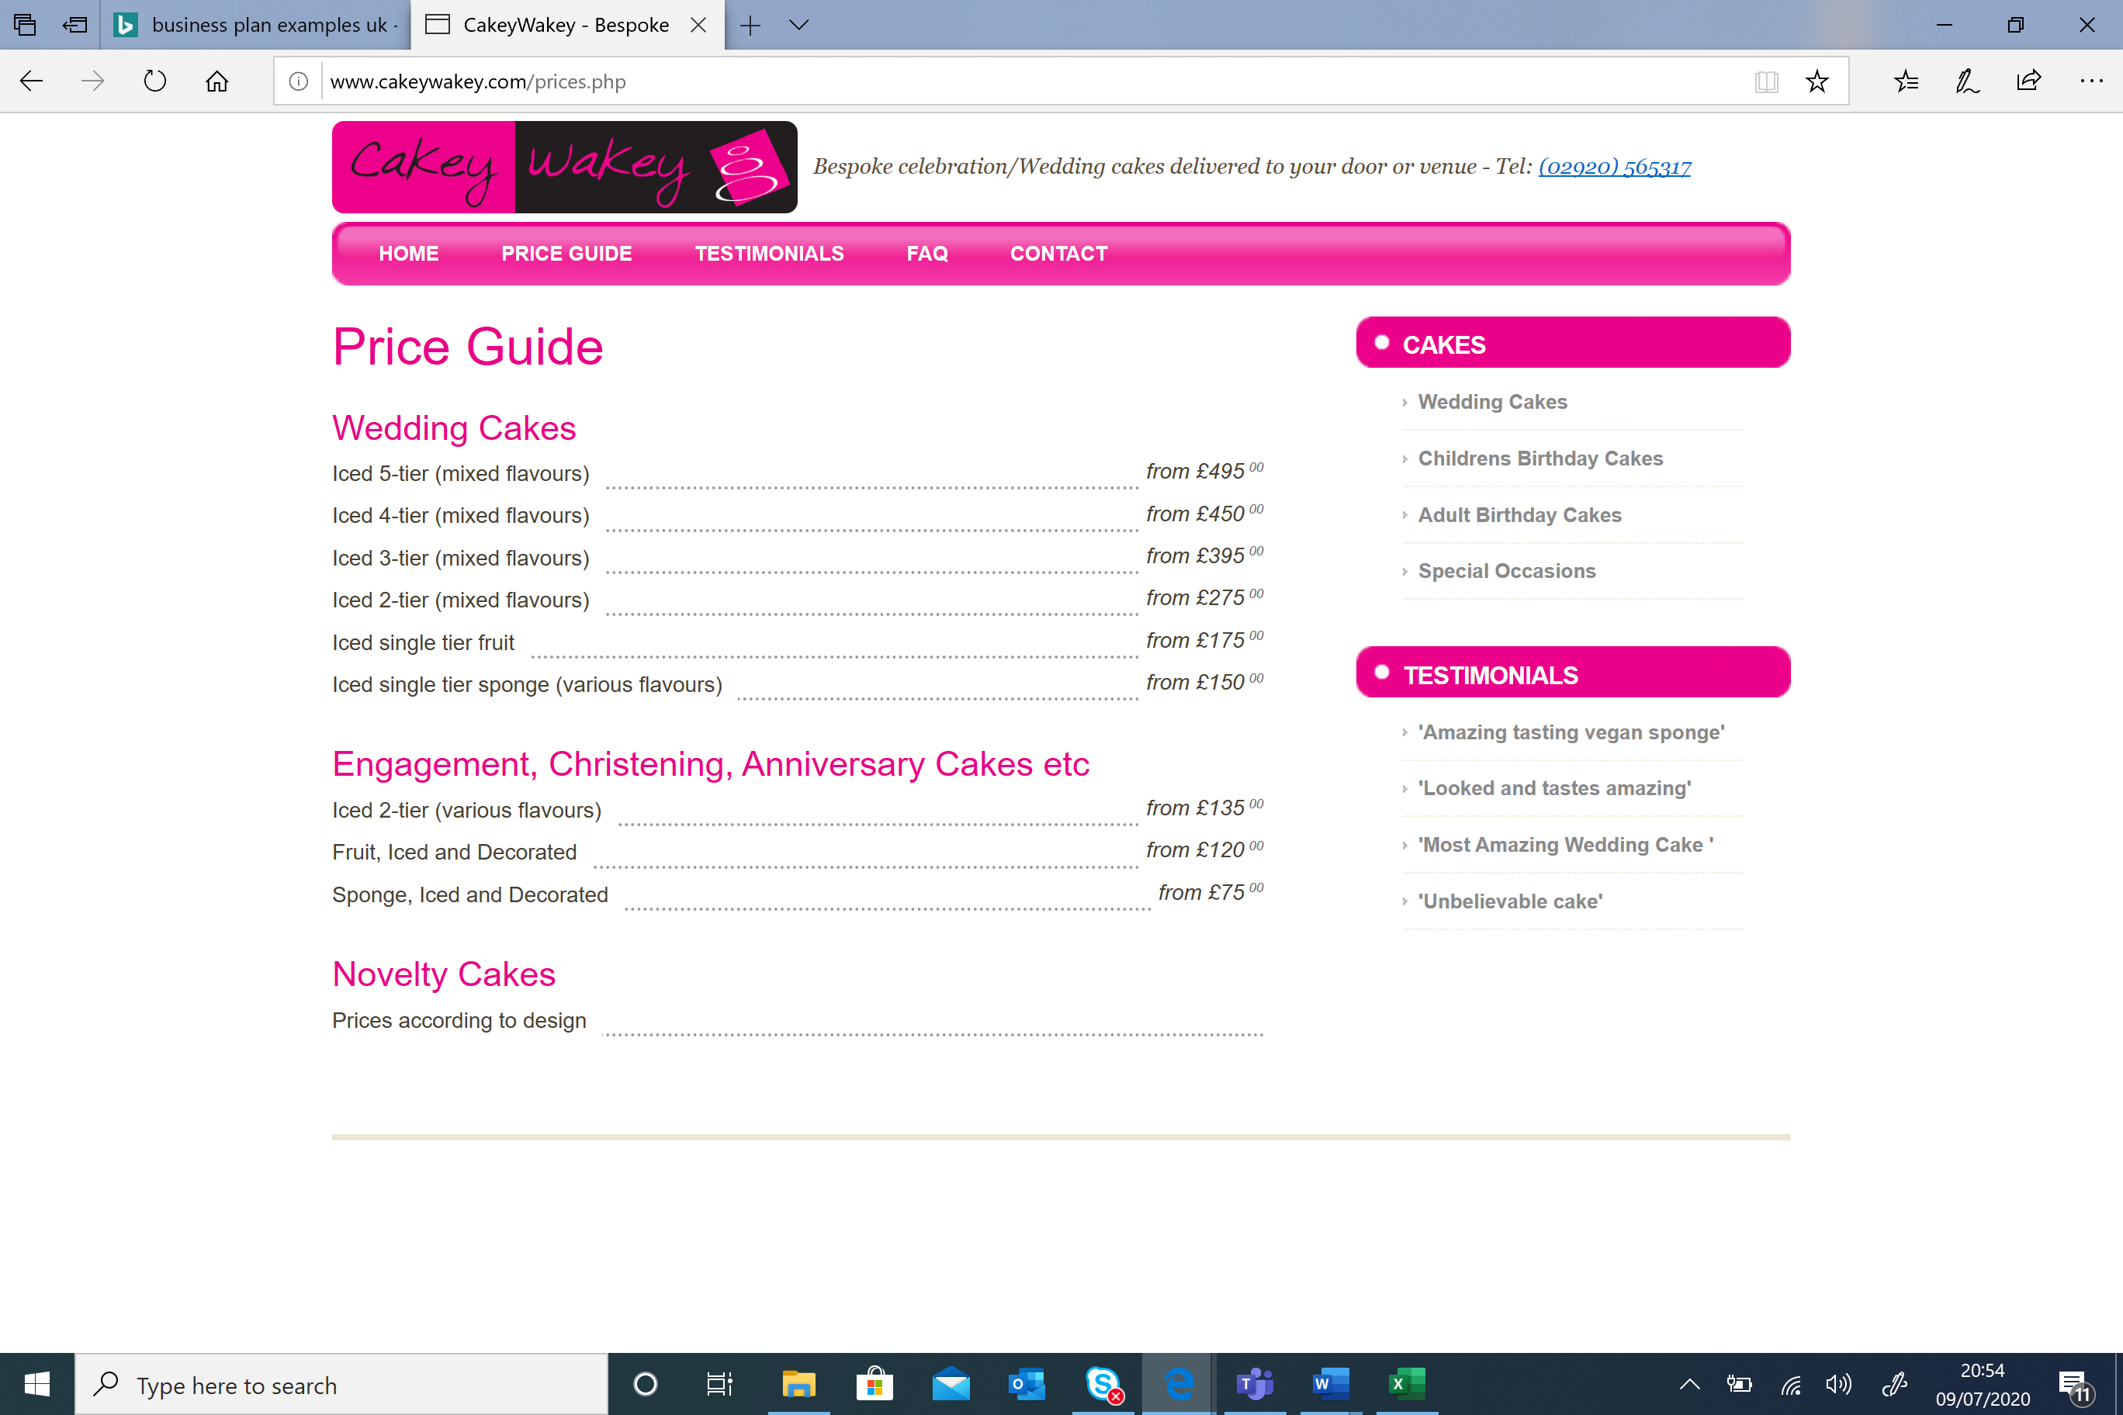
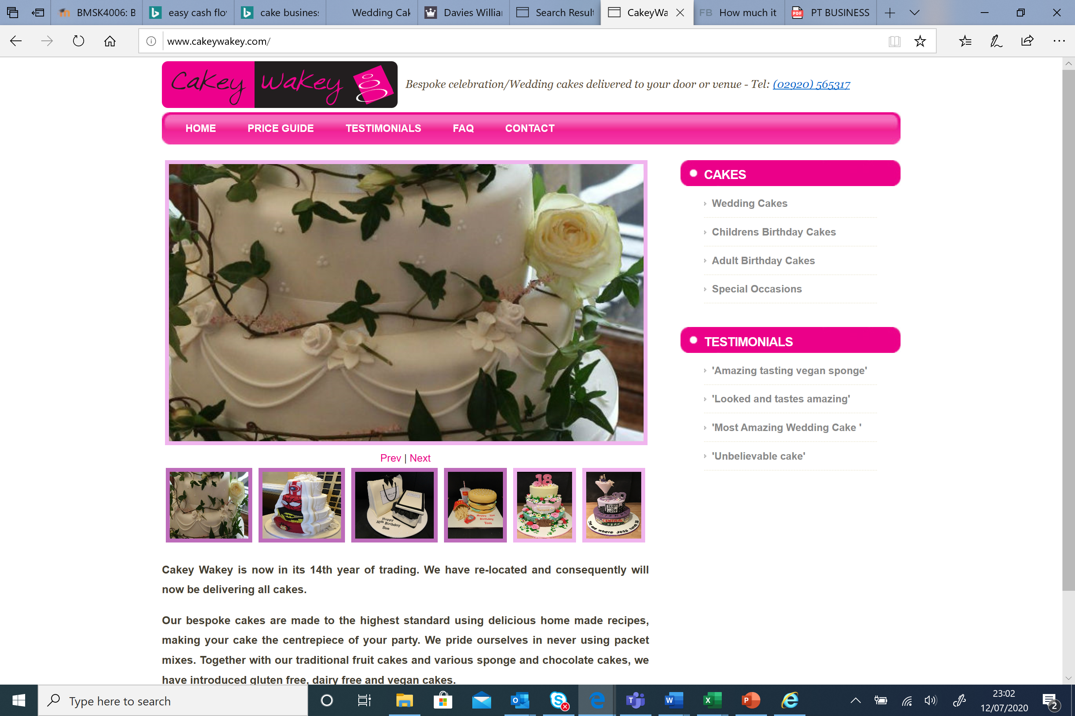
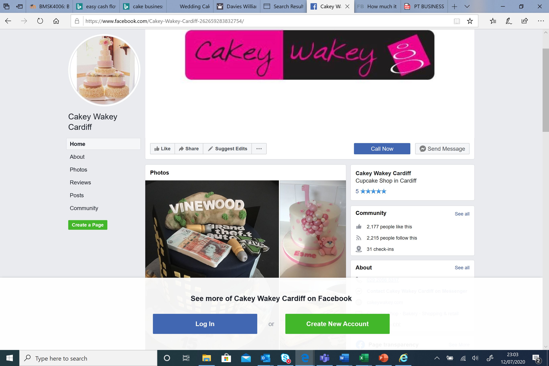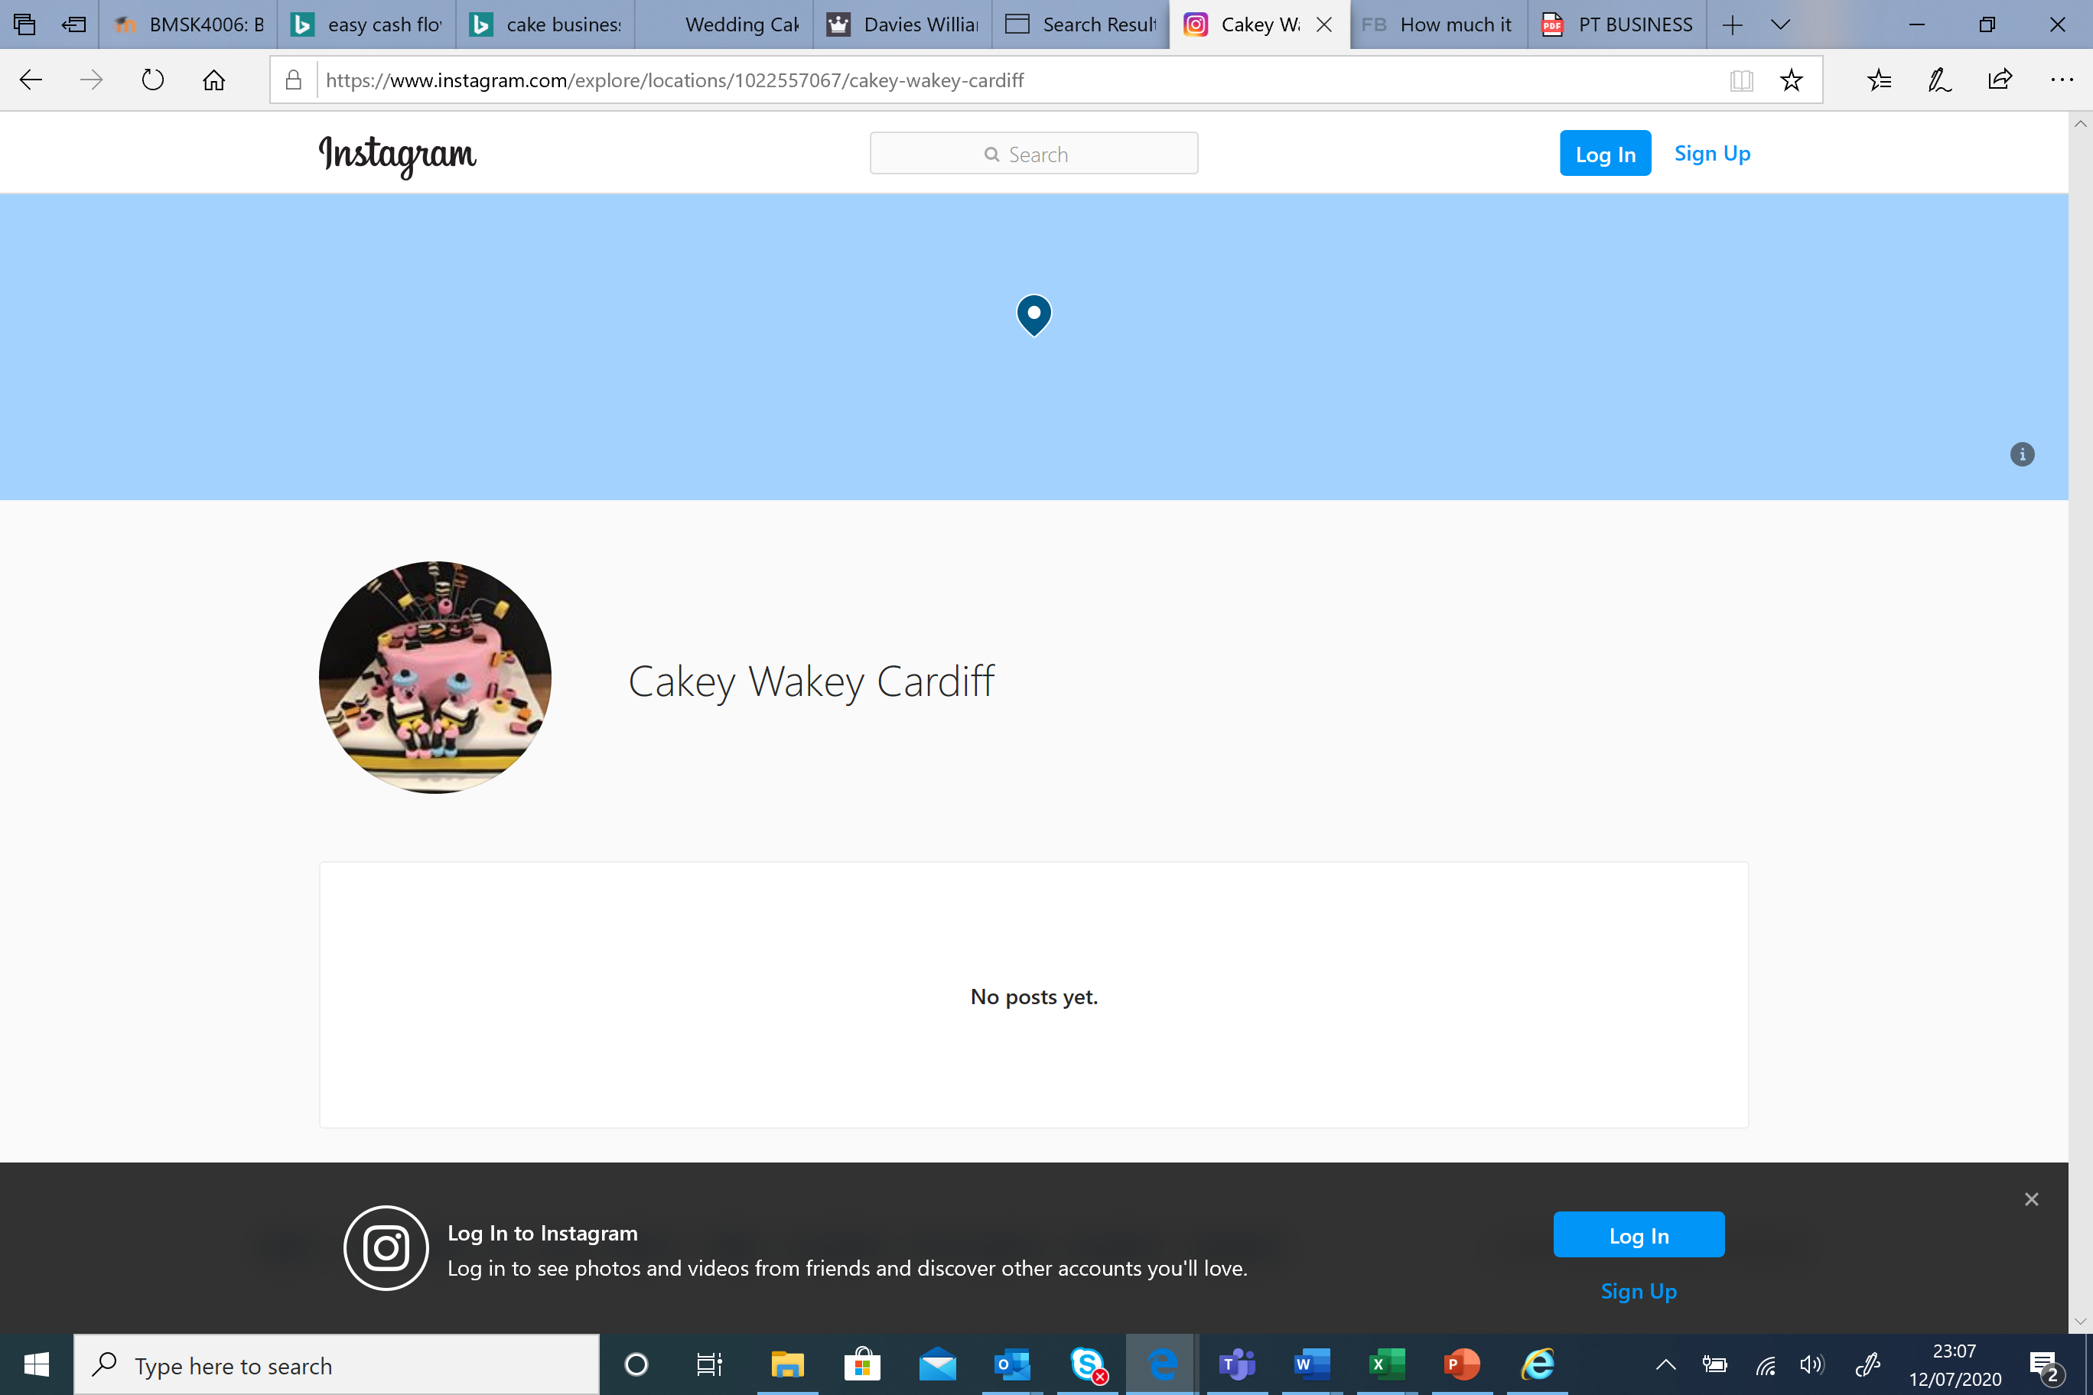
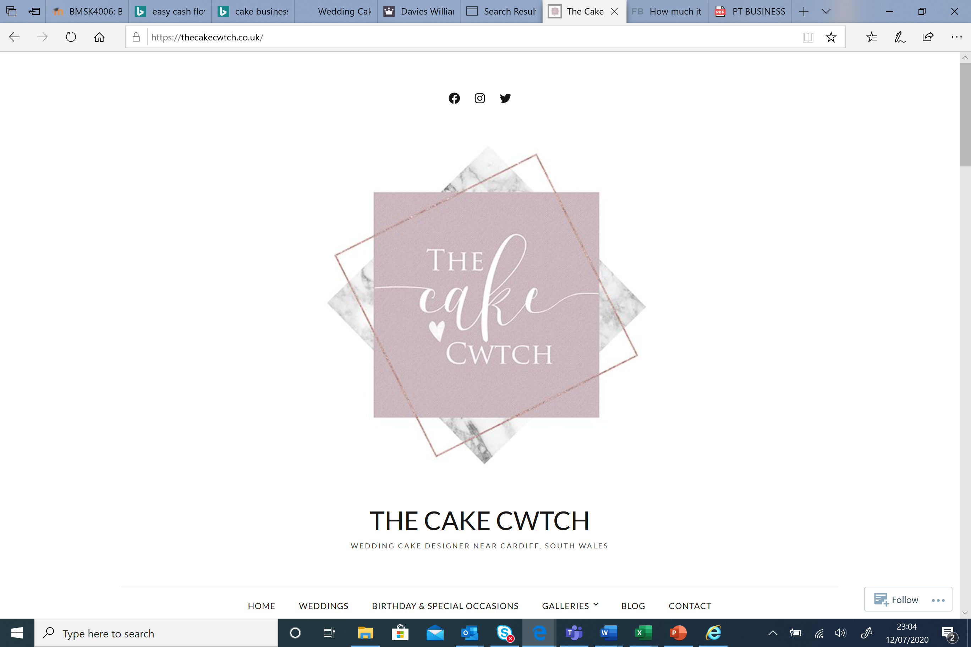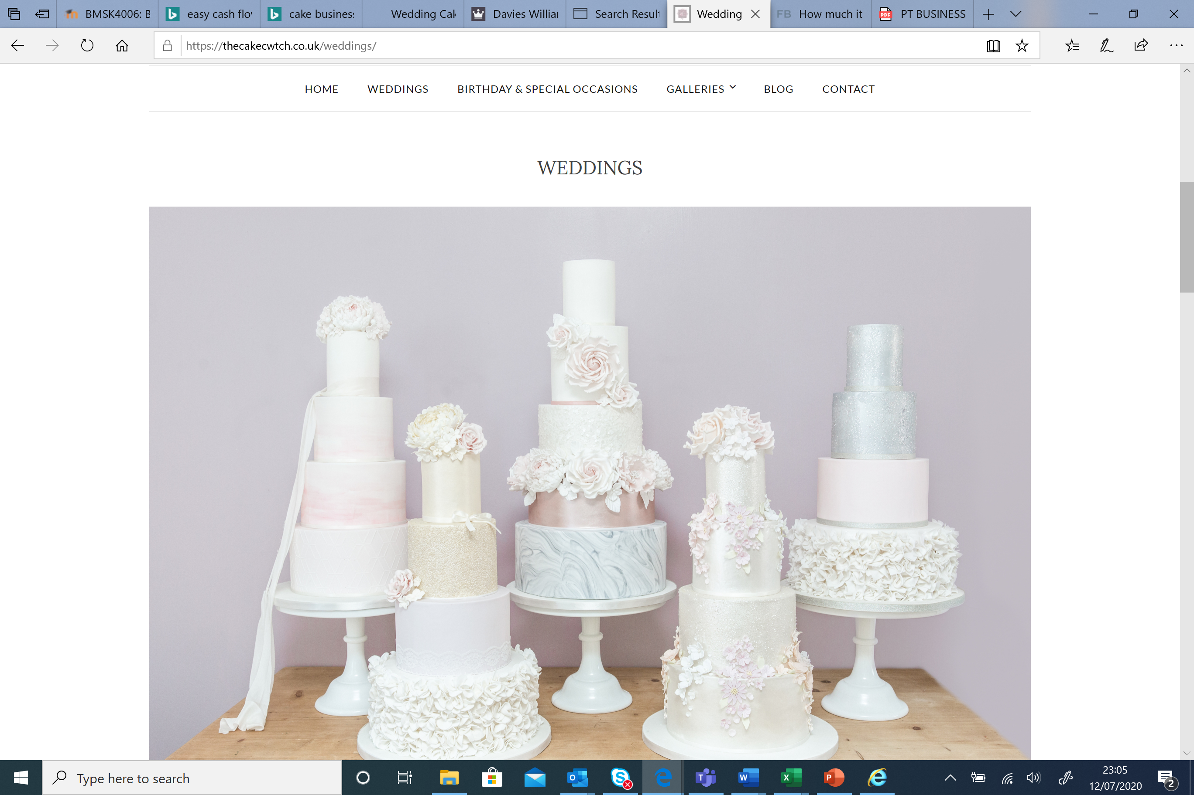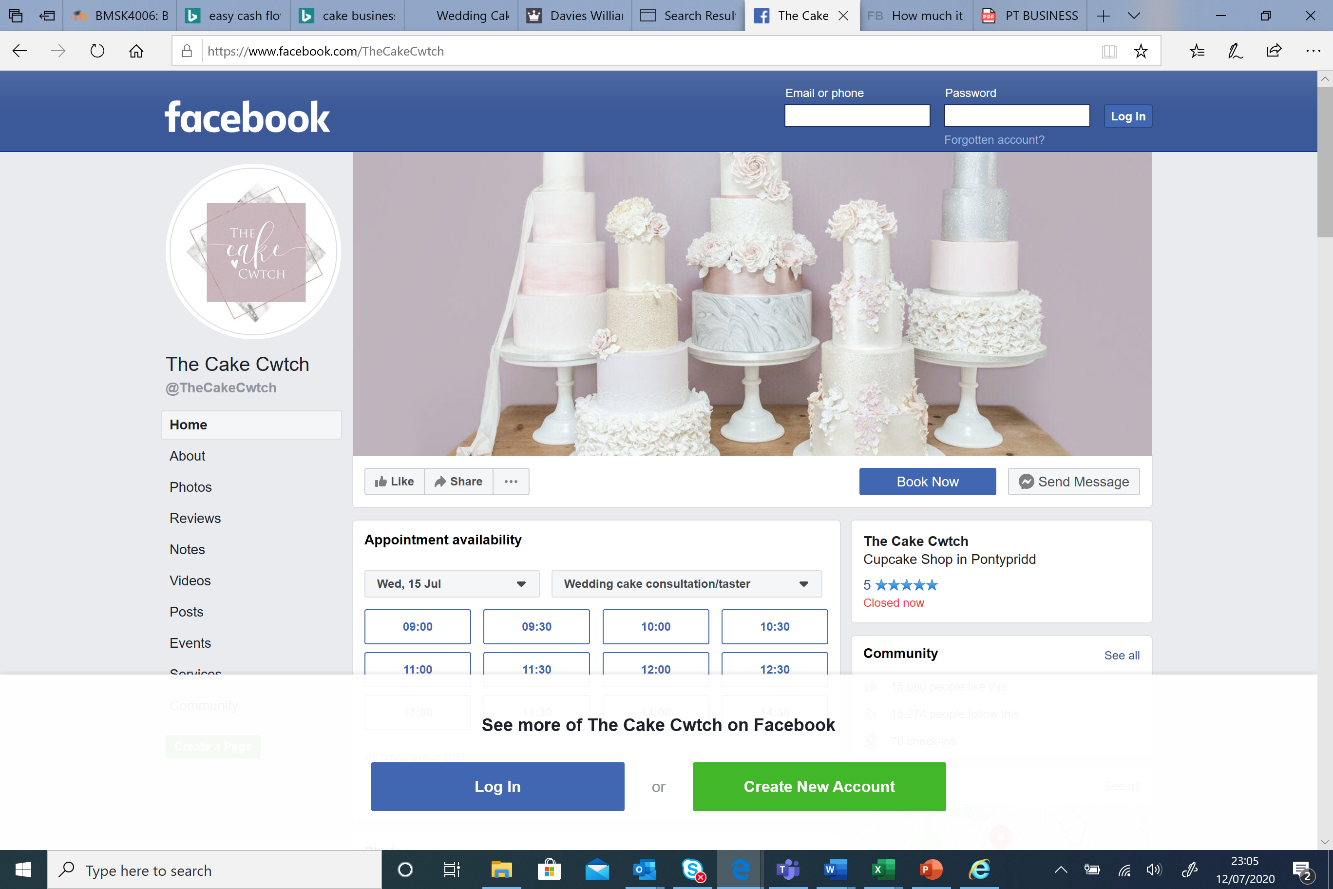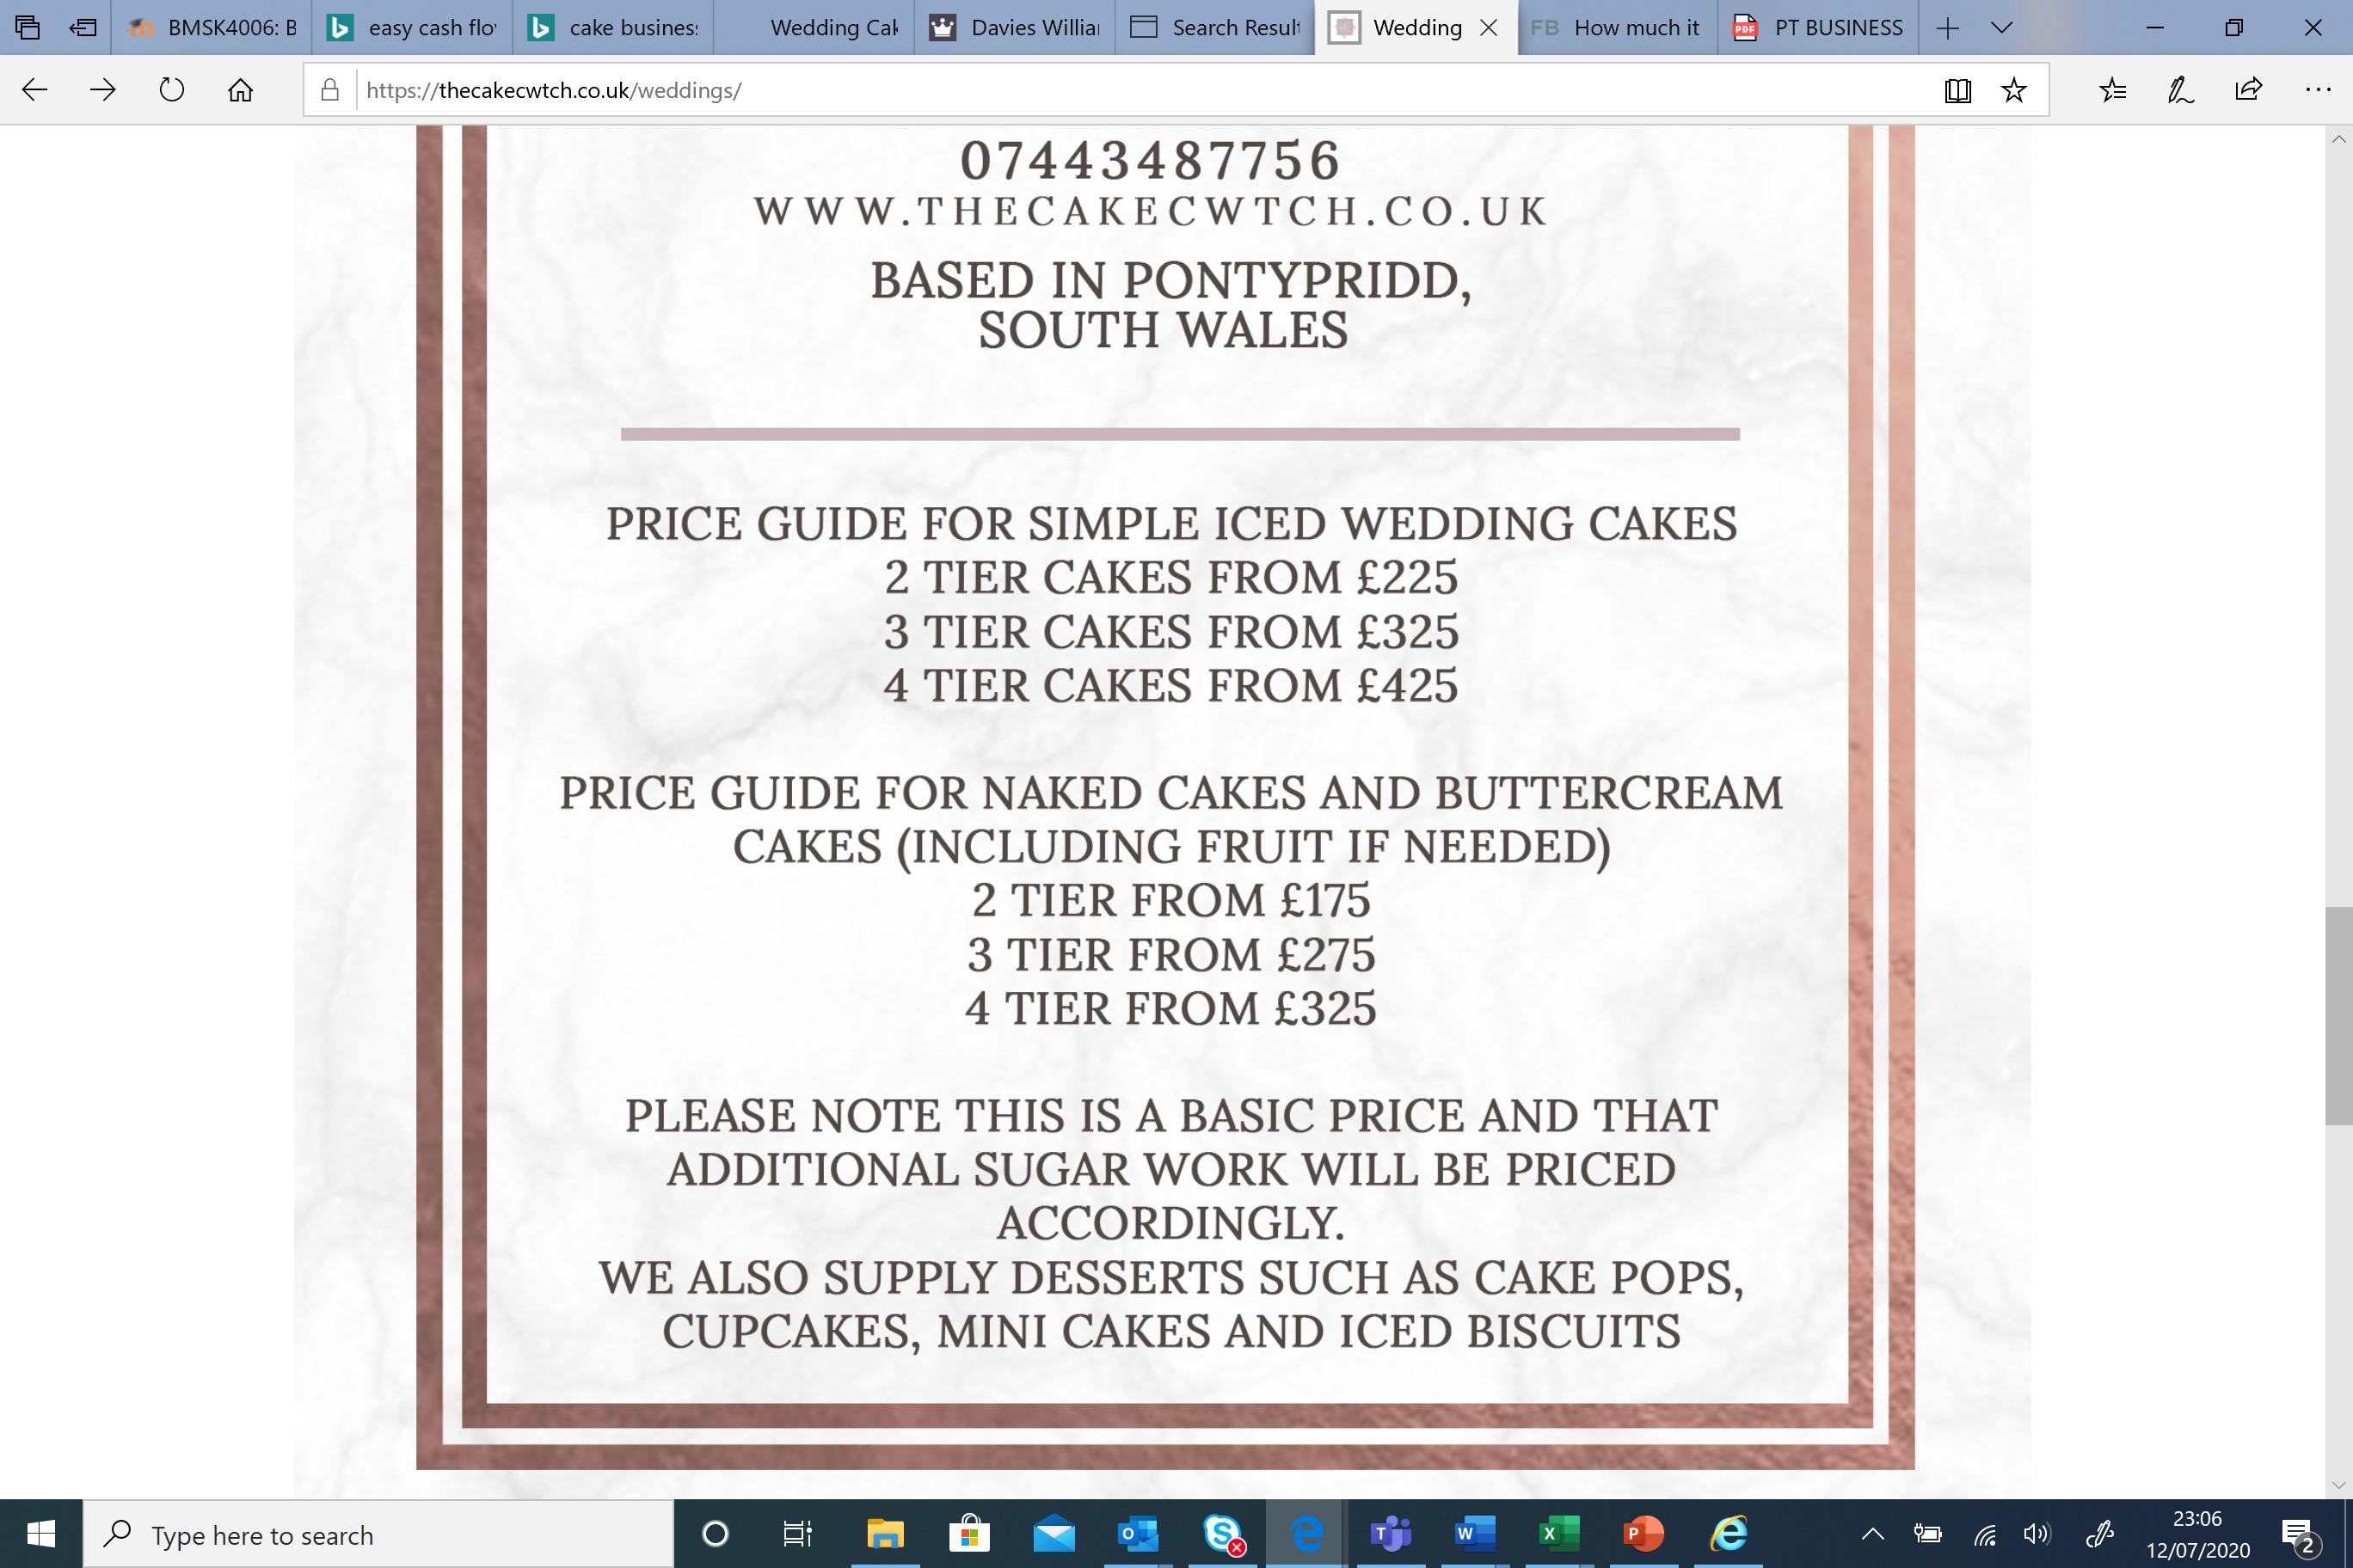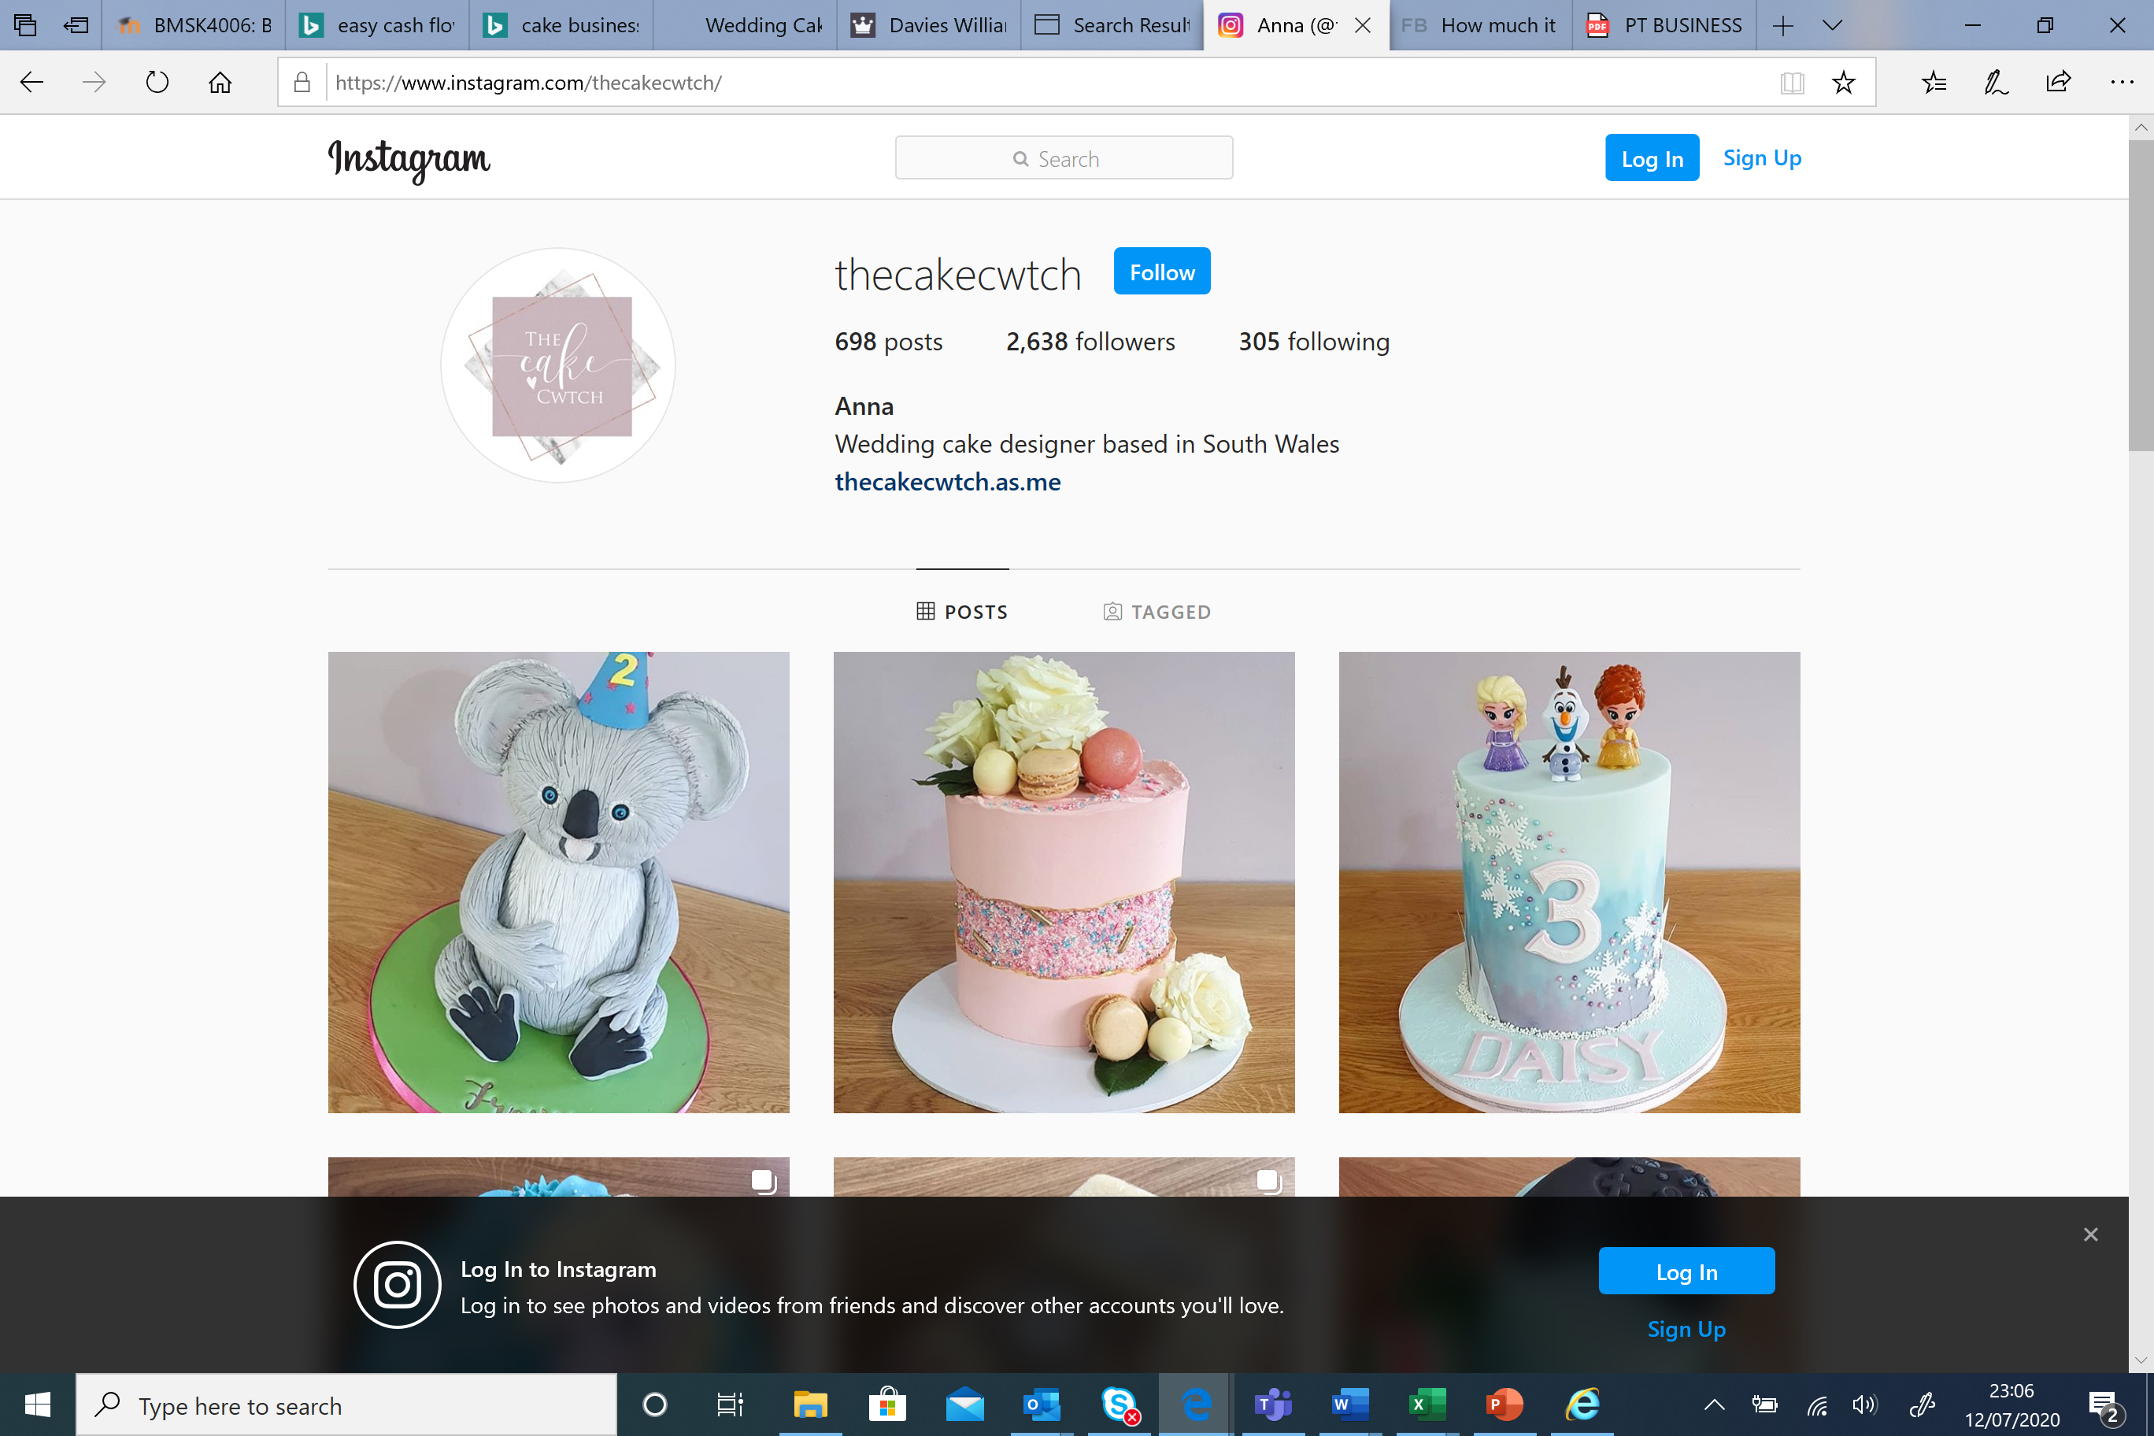

References

http://www.cakeywakey.com/

https://business.instagram.com/?locale=en_GB

https://thecakecwtch.co.uk/

www.facebok.com

www.twitter.com

www.tiktok.com

