

Module Code: ECAD5015

Assignment Title: Deepening Practice
ALN – Part 1 Journal
Student Name: Maisie Llewelyn-Davies
Student Number: 2304024
BA Primary Education (QTS)

AI Acknowledgement
I confirm that I have not presented any AI generated materials as my own work.
I confirm that I have copies of my drafts, notes, and other resources I used, which I may be asked to provide in evidence.
I acknowledge the use of Chat GPT (https://chatgpt.com) on 15/05/2025 to find research. I used the prompt(s):
1. Inclusive strategies and their positives and negatives
2. What researchers agree with this strategy?
I acknowledge the use of Grammarly (https://app.grammarly.com) on 16/05/2025 to check punctuation and spelling.
I confirm that I have not presented any AI generated text as my own work.
I confirm that I have copies of my drafts, notes, and other resources I used before and after the use of AI tools which I may be asked to provide in evidence.

Targets from previous module | How I have worked on these? | An example can be seen on…
Avoid over reliance on websites - try to use the recommended reading list and look for academic papers that have been peer reviewed. | I have tried to find more reliable sources such as books and estyn websites. | I used a book in my research: (Rutherford et al., 2020, pp.11–22)
Use your professional standards and relevant literature to guide next steps. What impact will your findings have on your own future teaching practice? | I related my research to the professional standards and explained how I will used this in my future practice. | In my work:  This standard’s Qualified Teacher Status (QTS) strand on wider reading and research.  In my future practice, I will use the insight of this research to develop my skills further into implementing inclusive strategies.
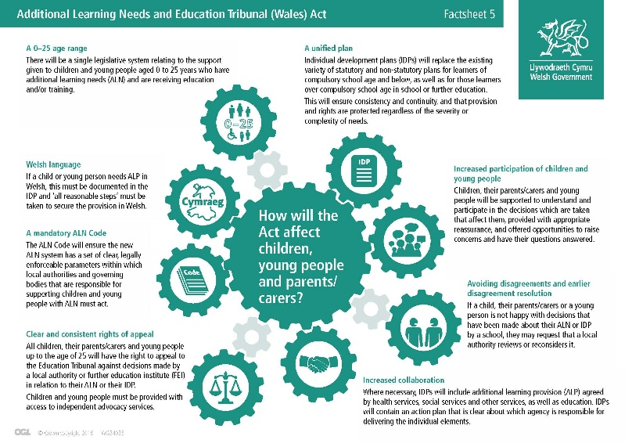
Additional Learning Needs (ALN) in education is grounded in the principles of inclusive practice, which aim to provide accessible learning opportunities for all pupils, regardless of individual differences or difficulties (Welsh Government, 2021). According to the Additional Learning Needs and Education Tribunal (Wales) Act (2018), a person is considered to have ALN if they have a learning difficulty or disability that requires additional support to access or benefit from education in the same way as their peers (Welsh Government, 2022). Wales has undergone a significant transformation in supporting learners with ALN by introducing the Additional Learning Needs and Education Tribunal (Wales) Act 2018. This Act replaces the former Special Educational Needs (SEN) system with a person-centred framework that was gradually introduced in September 2021. Its purpose is to improve the identification of needs, the effectiveness of support, and the monitoring of interventions for children and young people aged 0–25. A key feature of the Act is the replacement of multiple plans with a single statutory Individual Development Plan (IDP), designed to ensure tailored support through coordinated planning, delivery, and review (Welsh Government, 2018).
Figure 1(Gowerton School, 2023)
Despite these ambitions, implementation has not been without challenges. According to Joint Trade Union (2023), many teachers and support staff have received insufficient training on the new ALN system and the completion of Individual Development Plans (IDPs), making effective implementation difficult. The IDP process is time-consuming, contributing to increased workload and reducing the time available for direct student support. Inconsistencies in funding across local authorities have led to unequal access to essential services, while financial pressures have forced schools to make difficult decisions with limited resources. Additionally, a lack of clarity around the roles and responsibilities of schools and local authorities has created confusion, further complicating the delivery of consistent and effective support for learners with ALN (Joint Trade Union, 2023). This is supported by the School Census Data (2022), which found that in February 2022, there were 18,000 fewer pupils identified with ALN compared to April 2021, suggesting potential under-identification or delays in the implementation of the new system (Welsh Government, 2022a).
Vygotsky’s Social Constructivism emphasises the role of social interaction and scaffolding in learning. He proposed that children develop through guided participation in meaningful activities within their Zone of Proximal Development (ZPD). For learners with ALN, support from adults or peers helps bridge gaps in understanding, promoting progression. This aligns with inclusive education, which maintains that all children can learn when appropriately supported (Wibowo, Wangid and Firdaus, 2025). In a case study from Whitmore High School, mixed-ability teaching is used throughout the school to create an inclusive environment where all students can succeed. This approach encourages peer learning and supports individual needs through strategies like questioning, modelling, and scaffolding. It benefits pupils with Additional Learning Needs (ALN) by promoting both academic and social development through collaborative learning (ESTYN, 2024).
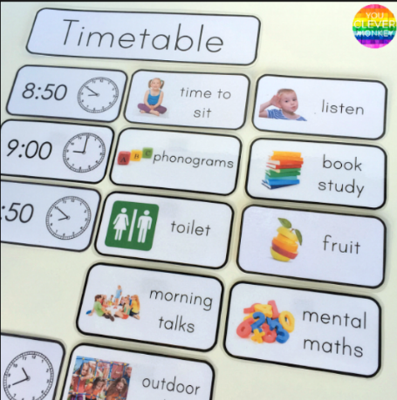
Cr Creating an inclusive classroom involves designing learning environments that are accessible, equitable, and supportive of all learners (ProActive Approaches, 2024). This section critically explores practical strategies and, the use of visual timetables and calm corners, that can make classrooms more inclusive, particularly benefiting learners with Additional Learning Needs (ALN). Using classroom experience, research, and case studies, this section also considers the challenges involved in implementing these strategies and suggests possible solutions.
Figure 2(youclevermonkey, n.d.)
Visual timetables use pictures or symbols to represent daily activities, helping children understand the sequence of events throughout their day (Norfolk, 2025). According to Rutherford et al. (2020), visual timetables support learners with Additional Learning Needs (ALN) by providing clear, structured information about daily activities, which enhances predictability and reduces anxiety. They promote greater independence by allowing students to manage transitions with less reliance on teachers. Additionally, visual timetables help improve communication and understanding, particularly for those with language difficulties or autism, by using symbols and images that are easier to comprehend. In their study, they found that 73% of pupils had used visual timetables frequently during the past week (Rutherford et al., 2020, pp.11–22).
From my own experience, the use of a visual timetable in a year 4 class proved to be valuable for all learners. It helped create a structured and predictable environment, reducing anxiety and improving focus, particularly during transitions between activities. Pupils were more settled and independent, and those with ALN especially benefited from the visual cues that supported their understanding and routine. This simple yet effective strategy contributed to a calmer, more inclusive classroom atmosphere.
However, a study by Waters, Lerman and Hovanetz (2009), found that visual timetables have a limited impact on reducing challenging behaviours. Their research shows that using visual timetables by themselves does not significantly lessen disruptive behaviour, especially when moving from enjoyable to less preferred activities. To overcome this, pairing visual timetables with other methods, such as extinction and differential reinforcement of other behaviour (DRO), visual timetables can be effective for all pupils, especially those with ALN (Waters, Lerman and Hovanetz, 2009). Furthermore, creating visual timetables can be time-consuming for teachers to create and add extra workload, particularly when they need to be tailored to meet the diverse needs of individual learners and updated regularly to reflect changes in the daily routine (Milledge, 2022). From my experience, involving learners in creating their visual timetables not only reduced the teacher’s workload but also led to a more engaging and inclusive lesson. It gave pupils a sense of ownership, helping them feel valued as contributors to the classroom environment.
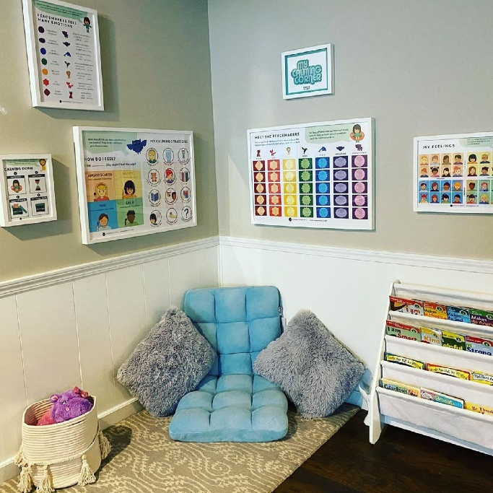
A f A further inclusive strategy that could be used to support learners is calm corners. A calm corner is a specific area within a classroom designed to provide a safe and supportive environment for children to retreat to when they feel overwhelmed, helping them regulate their emotions and regain control (Action for Healthy Kids, 2019). The purpose of a calm corner is to support students in building emotional resilience at school using mindfulness techniques. While often promoted as a trauma-informed or ALN approach, calm corners can positively impact the entire classroom by offering a space for any student feeling overwhelmed, frustrated, or anxious to regain emotional stability. These spaces may feature a variety of calming tools to help pupils refocus and return to a learning mindset. Importantly, they give students the autonomy to choose how they manage their emotions, which can enhance their engagement and willingness to participate in classroom activities (Thompson, 2021).
Figure 3(Moroney, 2020)

A case study from Herbert Thompson Primary School in Cardiff demonstrates the positive impact of calm spaces on pupil wellbeing. The school created ‘Herbies Havens,’ dedicated rooms for emotional regulation, alongside structured routines and a full-time emotional wellbeing assistant. These calm areas led to improved pupil focus, reduced behavioural incidents, and better emotional resilience for all pupils. This example highlights how calm spaces or corners can effectively support learners, particularly those with ALN, by offering a safe environment to self-regulate and return to learning with greater confidence and control (Estyn, 2020).
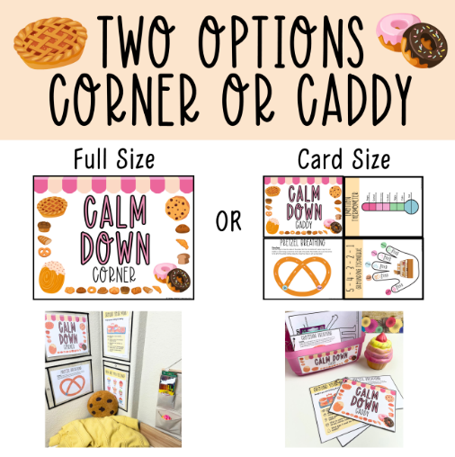
Figure 4 (littleyellowstarteaches.com, 2024)
Nevertheless, some argue that calm corners encourage young people to hide their emotions. Using a calm-down corner may suggest that strong or “negative” feelings are unwelcome. Additionally, placing too much emphasis on calming down might distract from addressing children’s emotions, teaching them to suppress rather than openly express their feelings (Conway, 2021). Furthermore, lack of space can be a barrier for many teachers when incorporating a calm corner. To overcome this, a calm-down caddy provides a mobile and adaptable option compared to a fixed calm corner. It enables students to use self-regulation tools anywhere in the classroom, making it ideal for spaces where dedicated areas are limited (littleyellowstarteaches.com, 2024).
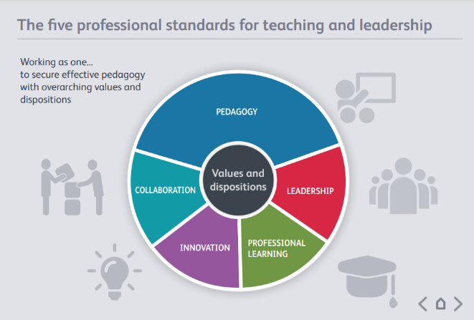
Th The research and strategies related to Additional Learning Needs (ALN) align closely with the Professional Standards for Teaching and Leadership in Wales, especially the professional learning standard for teaching and leadership. This standard’s Qualified Teacher Status (QTS) strand on wider reading and research highlights that teachers are expected to develop confidence in understanding relevant theories and research concerning assessment, pedagogy, child and adolescent development, and learning, which then guide their planning and daily teaching practice. This is especially relevant when planning support for learners with ALN. By engaging with current research and practice, teachers are better equipped to implement inclusive strategies that meet the diverse needs of all learners (Welsh Government, 2017).
Figure 5 (Welsh Government, 2017).
In my future practice, I will use the insight of this research to develop my skills further in implementing inclusive strategies and emotional support techniques for all pupils while supporting those with ALN. I aim to create a classroom environment that values diversity, promotes well-being, and enables every learner to reach their full potential through informed, reflective, and responsive teaching.

Reference list
Action For Healthy Kids (2019). Calm Down Corner. [online] Action for Healthy Kids. Available at: https://www.actionforhealthykids.org/activity/calm-down-corner/ [Accessed 15 May 2025].
Conway, S. (2021). Does a calm down corner teach kids to hide emotions? [online] Mindful Little Minds Psychology. Available at: https://www.mindfullittleminds.com/calm-down-corner-shut-down-emotions/ [Accessed 16 May 2025].
currigan, simon and Shackleton, E. (2023). Quick-fire strategies: Can Visual Timetables Be Bad? [online] beaconschoolsupport.co.uk. Available at: https://beaconschoolsupport.co.uk/podcast/quick-fire-strategies-can-visual-timetables-be-bad [Accessed 15 May 2025].
ESTYN (2024). The additional learning needs system: Progress of schools, settings and local authorities in supporting pupils with additional learning needs. [online] Available at: https://estyn.gov.wales/app/uploads/2024/12/The-additional-learning-needs-system.pdf [Accessed 15 May 2025].
Estyn (2020). Effective School Support for Disadvantaged and Vulnerable Pupils -case Studies of Good Practice. [online] Available at: https://www.estyn.gov.wales/system/files/2022-01/Effective%2520school%2520support%2520for%2520disadvantaged%2520and%2520vulnerable%2520pupils%2520en_0.pdf [Accessed 15 May 2025].
Gowerton School (2023). Additional Learning Needs and Education Tribunal (Wales) Act. [online] Gowerton School. Available at: https://gowertonschool.com/additional-learning-needs-and-education-tribunal-wales-act/ [Accessed 15 May 2025].
Joint Trade Union (2023). Additional Learning Needs and Tribunals (Wales) Act Joint union positions -May 2023. [online] Available at: https://business.senedd.wales/documents/s140950/AEC%2069%20Joint%20Trade%20Union.pdf?utm_source= [Accessed 14 May 2025].
littleyellowstarteaches.com (2024). An Alternative To Calming Corner: The Calm Down Caddy - LittleYellowStar. [online] LittleYellowStar. Available at: https://littleyellowstarteaches.com/2024/08/06/an-alternative-to-calming-corner-the-calm-down-caddy/ [Accessed 16 May 2025].
Milledge, T. (2022). How to transform your classroom with a visual timetable - teachers will love this simple daily schedule template! [online] Mrs Learning Bee. Available at: https://mrslearningbee.com/learn/blog/visual-timetable-2 [Accessed 15 May 2025].
Moroney, M. (2020). At-Home Calming-Corner Ideas. [online] Popsugar UK. Available at: https://www.popsugar.co.uk/parenting/at-home-calming-corner-ideas-47666375 [Accessed 15 May 2025].
Norfolk, J.O. (2025). Visual Timetable. [online] Just One Norfolk. Available at: https://www.justonenorfolk.nhs.uk/speech-language/using-visuals/visual-timetable/ [Accessed 15 May 2025].
ProActive Approaches (2024). Inclusive Education: Creating an Environment that Welcomes and Supports All Students. [online] +ProActive Approaches. Available at: https://proactiveapproaches.co.uk/inclusive-education-creating-an-environment-that-welcomes-and-supports-all-students/ [Accessed 15 May 2025].
Rutherford, M., Lahood-Kullberg, B., Baxter, J., Johnston, L. and Cebula, K. (2020). Pupils’ views on visual timetables and labels in mainstream primary classrooms. [online] pp.11–22. Available at: https://research-ebsco-com.ezproxy.uwtsd.ac.uk/linkprocessor/plink?id=747600ee-a82a-3428-ad5b-f6f065fdaa74 [Accessed 15 May 2025].
Thompson, C. (2021). The Impact of a Classroom Calm Down Corner in a Primary Classroom. [online] Available at: https://nwcommons.nwciowa.edu/cgi/viewcontent.cgi?article=1304&context=education_masters [Accessed 15 May 2025].
Waters, M.B., Lerman, D.C. and Hovanetz, A.N. (2009). SEPARATE AND COMBINED EFFECTS OF VISUAL SCHEDULES AND EXTINCTION PLUS DIFFERENTIAL REINFORCEMENT ON PROBLEM BEHAVIOR OCCASIONED BY TRANSITIONS. Journal of Applied Behavior Analysis, [online] 42(2), pp.309–313. doi:https://doi.org/10.1901/jaba.2009.42-309.
Welsh Government (2017). Professional Standards for Teaching and Leadership. [online] Hwb. Welsh Government. Available at: https://hwb.gov.wales/api/storage/19bc948b-8a3f-41e0-944a-7bf2cadf7d18/professional-standards-for-teaching-and-leadership-interactive-pdf-for-pc.pdf [Accessed 16 May 2025].
Welsh Government (2018). The ALN Transformation Programme. [online] Available at: https://www.gov.wales/sites/default/files/publications/2018-04/the-aln-transformation-programme-presentation_0.pdf [Accessed 14 May 2025].
Welsh Government (2021). The Additional Learning Needs Code for Wales 2021 WG21-23. [online] Available at: https://www.gov.wales/sites/default/files/publications/2024-04/220622-the-additional-learning-needs-code-for-wales-2021%20%282%29.pdf [Accessed 14 May 2025].
Welsh Government (2022a). Schools’ census results: February 2022. [online] GOV.WALES. Available at: https://www.gov.wales/schools-census-results-february-2022-html#104296 [Accessed 14 May 2025].
Welsh Government (2022b). The additional learning needs transformation programme: frequently asked questions [HTML]. [online] GOV.WALES. Available at: https://www.gov.wales/additional-learning-needs-transformation-programme-frequently-asked-questions-html [Accessed 14 May 2025].
Wibowo, S., Wangid, M.N. and Firdaus, F.M. (2025). The relevance of Vygotsky’s constructivism learning theory with the differentiated learning primary schools. [online] ResearchGate. Available at: https://www.researchgate.net/publication/382885430_The_relevance_of_Vygotsky [Accessed 15 May 2025].
youclevermonkey (n.d.). WHY AND HOW TO USE A VISUAL TIMETABLE EFFECTIVELY. [online] you clever monkey. Available at: https://www.youclevermonkey.com/2016/01/visual-timetable.html.

