Recce Sheet

Title of production: Welsh History: Penllergare Valley Woods
Date of recce: 29/07/19
Location: Penllergare Valley Woods, Penllergare, Swansea SA4 9GS
Present:

Please indicate Comments/Details
Yes/No for each area
Local Condition:  • Any known problems  If yes, please detail (including source of information) | No X Yes □ | - A source states how an additional lake was built within the woods to lower the chances of the woods being flooded. Water would filter gather further down the woods into the lake.  Source: https://www.penllergare.org/wp-content/uploads/2014/12/ConservationManagementPlan.pdf
• Aid needed  If yes, please detail name, address and contact numbers for each person/organization  • Permission needed  • Protective clothing needed  If yes, please detail | No □ Yes X  No □ Yes X  No X Yes □ | - Information regarding the woods can be given by the volunteers who work at the café:  Address: Penllergare Valley Woods, Swansea. SA4 9GS  - Permission will most likely be required to film within the woods. An email address and telephone number are given on the Penllergare website:  Telephone: 01792 344224  Email: contact@penllergare.org  - As the area we are filming in, is a public space. We will not be required to wear PPE. E.g. Hard hats, Buoyancy aid.
Viewpoints:  • Appropriate viewpoints isolated  • Any obstructions  • Easy to reach and safe  If no, please detail requirements | No X Yes □  No X Yes □  No □ Yes X | - When filming, we will be using a simple camera on a tripod and camera on a gimbal. The shots we require are easy – moderate in difficulty. As we will be staying on the main paths and/or well-trodden paths to film.
Requirements:  • Power available  If no, please detail alternative arrangements  • Lighting appropriate  If no, please detail alternative arrangements  • Sound equipment (please detail) | No □ Yes X  No □ Yes X | - There is a café with electricity, central to the woods. Extensions can be placed down if we require power farther away from the café.
Anticipated problems:  • Sound  If yes, please detail  • Picture  If yes please detail  • People  If yes, please detail  • Other  If yes, please detail | No □ Yes X  No X Yes □  No □ Yes X  No X Yes □ | - Sound being recorded in the valley woods can be easily contaminated by: Members of the public,  Vehicle noise, unwanted animal sounds etc.  - People and animals are going to be common when filming, as the space is for public use. It’s vital that no one is filmed without their consent first. (Unless they are cast for the production).
Other considerations (please provide details for each):  • Security considered  • Welfare considered (transport, food, First Aid etc.)  • Set dressing required  • Props required |  | - The carpark is directly in view of the café and is a pay and display carpark, no one can park there for long periods of time without being fined. The carpark itself is surrounded by trees and is off the main road.  - As the woods are a 5 minute drive away from the M4 services, you are never far away from any important facilities.
Comments:

Please attach sketches (including power points, anticipated camera viewpoints, position of lighting etc.) and
photographs of the location and its site

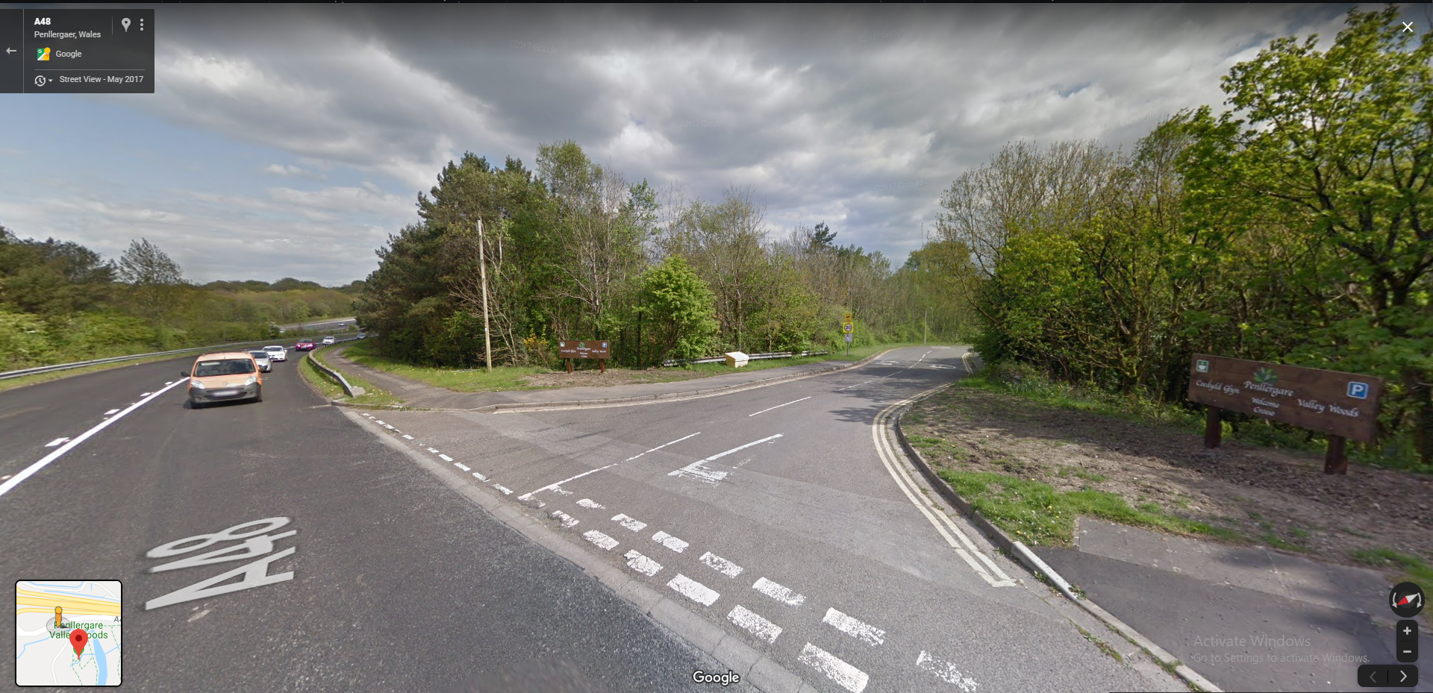
LOCATION REVIEW:

- Tarmacked entrance way
- Wide
- Easily sign posted

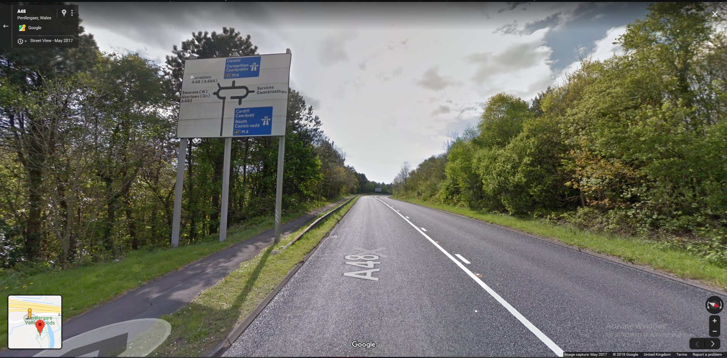
- Easily sign posted
- On a main road
- Good links to M4
- Easy and fast to get to

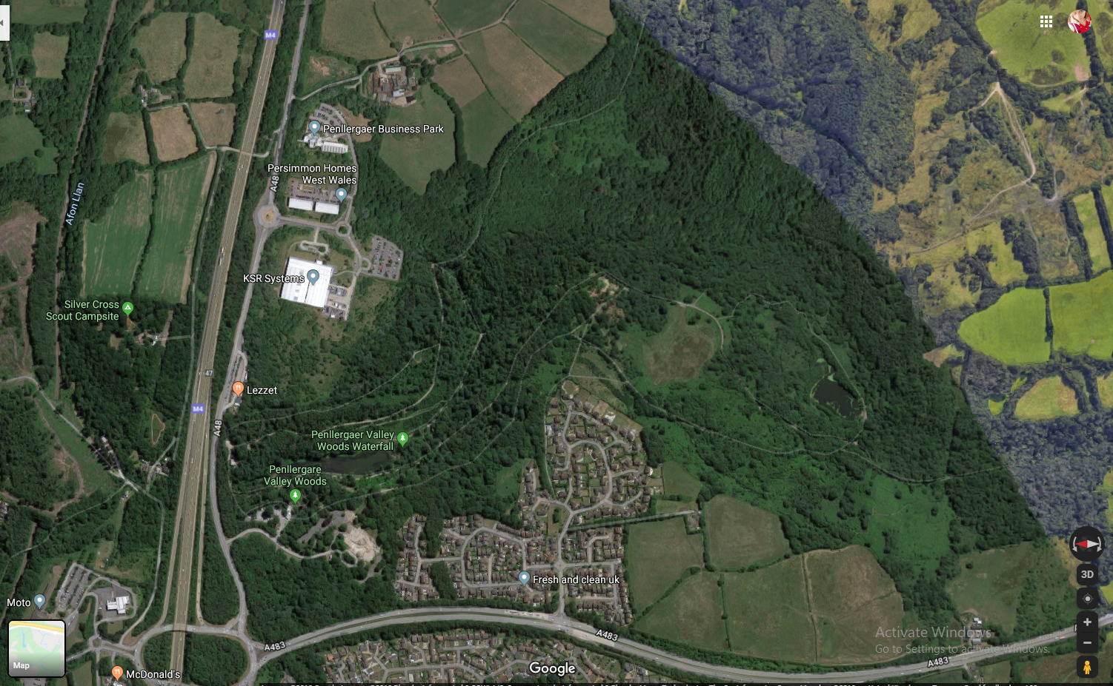

- Large area to work with
- Very green and lush looking (well kept)
- Easy entrance from M4 and ‘A’ Roads
- Very close to hotel/ services

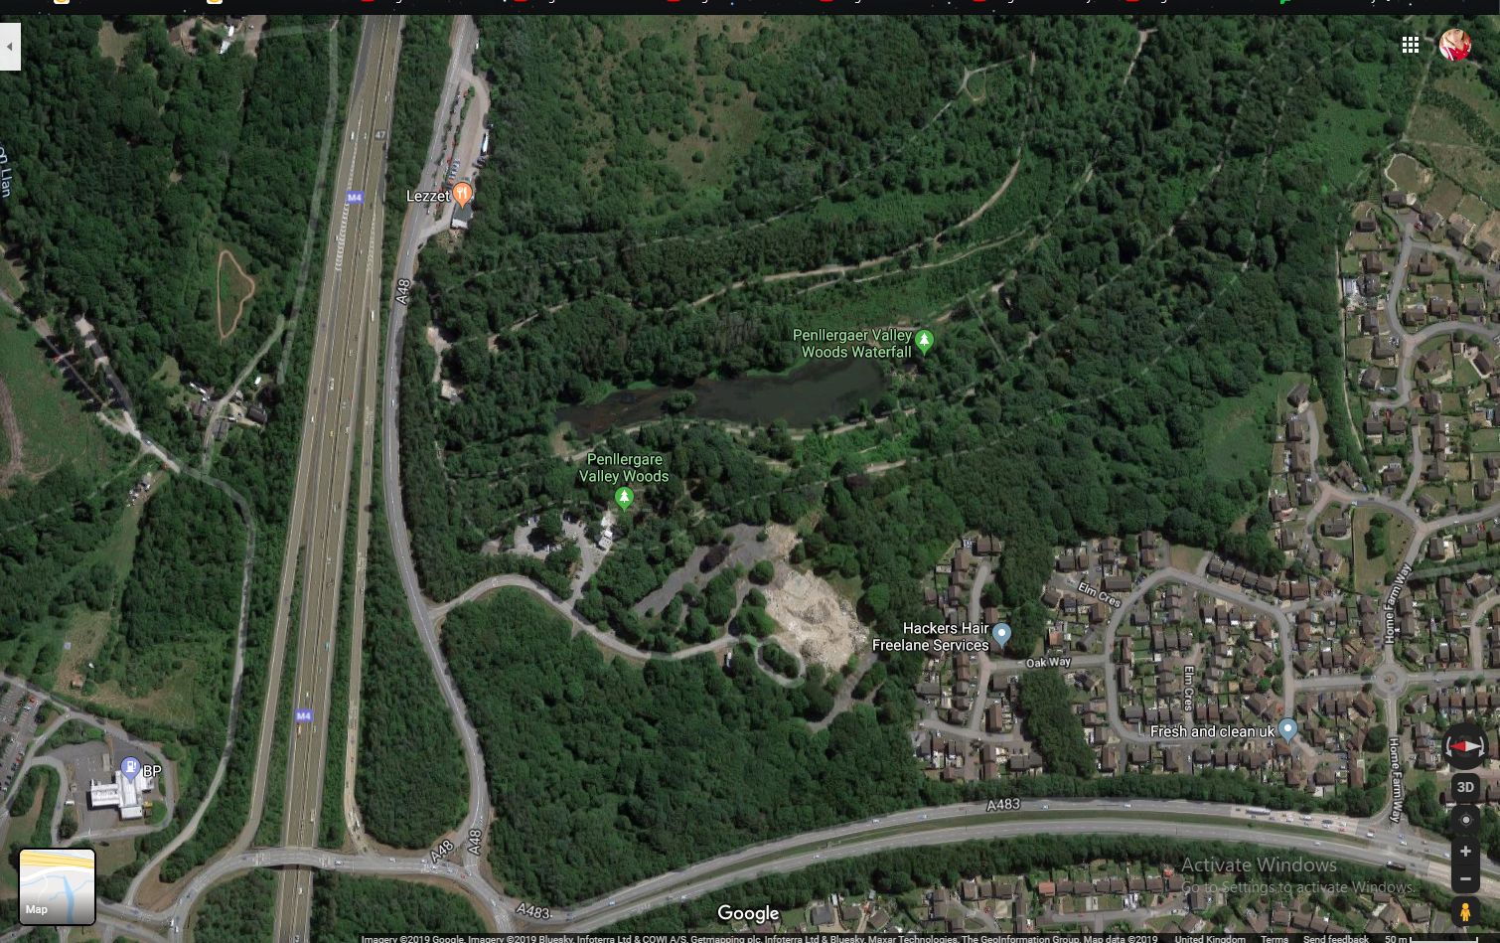

- Facilities on site: Café, Toilets, Car Park

There are also other restaurants and eateries nearby to the location site. The M4 services are a 5 minute drive away and there is a McDonalds in very close proximity to the services too.

This location is both perfect for filming and having the necessary facilities to keep cast and crew satisfied.

