Understanding of the most effective way to motivate the staff
Module | ACADEMIC AND EMPLOYABILITY SKILLS
Module Code | BMSW4001_BIRM
Student Name | Kadiatou L. Diallo
Student ID | 2118524
Lecturer | Doreen Nyaa Amundam

Contents
Introduction 3
Analysis and evaluation of the different ways to motivate the staff 4
Pay 4
Recognition and awards 5
Additional holiday 6
Good working condition 7
Understanding the best way to motivate the employees 8
Conclusion 11
References 12

Introduction
Employee motivation is a dynamic process. It depends on several internal and external forces. Employee motivation is often considered a controversial issue (Sale, 2021). As a result, clear guidance and principles are required to motivate the employees. However, motivational factors can be different for different employees. Play, recognition, award, additional holidays, and good working conditions are considered the motivational factors for employees. However, each of the above factors does not motivate employees in the same way. A clear understanding of the perception and desire of the employee is essential to identify the most effective way to motivate the staff. This report will analyze and evaluate the motivational factors such as pay, recognition and awards, additional holiday, and working conditions to find out the most effective way to motivate the staff.

Analysis and evaluation of the different ways to motivate the staff
Reward management represents the strategies, policies, and practices that are essential to acknowledge the contribution and values of the people within an organization. It recognizes and rewards the contribution of the employees. The value and contribution of different employees are different from the differences in needs and demands of the employees (Murray, 2021). As a result, satisfying a diversified workforce by their contribution is very complex and challenging. Different employees are motivated in different ways. So, designing employee motivation plans by understanding the pros and cons of each motivating tool is essential. An evaluation of different motivating tools is given below:

Pay
Pay is the basic reward made by an employer to the employees. The importance of pay can be explained by Herzberg's motivating factors and hygiene factors. The absence of hygiene factors can result in employee dissatisfaction and the absence of motivating factors can result in ‘not satisfaction’ but not dissatisfaction. So, pay is the most essential element for employee satisfaction. The pay structure should be appropriate and reasonable to motivate the employees. In this regard, pay management comes into action for managing motivation and employee engagement. There are three key drivers of pay management. These are performance, internal relatives such as job content, equal pay issues, grades & organizational pay structure, etc., and external factors such as market rates, market benchmarks, and external influences on hiring and retaining the employees. A fair, flexible, and affordable reward system is required to balance the motivating factors and hygiene factors for high-performance-driven organizational culture. There are guiding principles to be followed for an effective reward system such as business linkage, transparency, clarity, market competitiveness, choice and flexibility, equal pay, performance differentiation, etc. These principles are essential to guide the efforts of the employees towards performance, performance towards rewards, and rewards towards motivation (Armstrong, 2019).
Pay is not only confined to financial rewards only. The non-financial reward is also a kind of pay. A formal reward system should incorporate base pay management, contingency, and variable pay management, employee benefits management, etc.
If the payment system of an organization is contingent on performance it will encourage employees to maintain a high level of effort and a high-level effort is the outcome of a high-level motivation. However, the payment system requires it to be fair and contingent on performance. Different employees prefer different forms of payment structure. According to Fargus, (2017), when the payment system matches the expectations of the employees, it increases their motivation of the employees. So, a fair, clear, and transparent reward system that focuses on base pay management, pay progression through contingency, variable pay, pension and benefits, and allowances has the highest chance to motivate the employees. Vertical and horizontal integration of the reward system with the expectations of the employees can help to explore both the organizational objectives and employees' expectations simultaneously. So, pay is the basic way to motivate the employees.

Recognition and awards
According to Herzberg's two factors, motivational theory recognition and rewards are motivational factors. The hygiene factors such as pay cannot be considered a motivator. There is a positive relationship between motivational factors such as recognition and rewards with employee satisfaction. Recognition and rewards are also called satisfiers that are involved in superior performance in the workplace. It increases intrinsic motivation and it can be characterized as a psychological need for motivation. It increases employee engagement and raises a sense of achievement. Recognition and rewards can be monetary or non-monetary. Monetary rewards such as gift certificates, plaques, trips, etc. are often forgotten once the money is spent or the monetary benefits of the rewards are eliminated. In this regard, non-monetary rewards can be more rewarding for the employees than monetary rewards (Cohen, 2006). For providing any rewards, it is essential to understand the employees and their expectations to match the rewards with their expectations. For providing recognition and rewards the first stage is to understand the staff.
Understanding the personality of the employees based on an employee personality profile can be effective here. It will let the employee know what suited the employee best. Some may prefer monetary recognition and rewards; others may prefer non-monetary recognition. Secondly, delivering the rewards in a timely fashion is important to increase the effectiveness of rewards. Delaying rewards can dramatically decrease the appeal and effectiveness of the rewards. So, providing rewards in a timely fashion increases the effectiveness of rewards. Thirdly, it is essential to be sure that the recognition and rewards are deserving. A psychological match of rewards with the expectations of the employees can pay the highest level of satisfaction. The personality profile of the employees can play the biggest role to find out the best-matched rewards.
There are many approaches to provide recognition and rewards. Phillips et al (2017) suggested that criteria-based recognition and rewards motivate employees. Some basic criteria should be used to recognize the staff. Based on the recognition and rewards criteria, evaluation of the contribution of the employees will be used to recognize the employees. It can be the evaluation of job functions and responsibilities. For understanding the impact of awards on employees’ morale monthly, quarterly, or annual rewards can be used to motivate the employees. Phillips et al (2017), also suggested that a combination of peer and management-nominated awards can be very effective for motivating employees.
Thank you notes, public recognition, etc. are some effective tools that can also be used to motivate the employees. The core objective of recognition tools is to explore the desired behavior and performance. Most of the recognition programs showed a positive relationship between satisfaction and good performance. However, a mismatch between the expectations of staff, delay in providing recognition, etc. can dramatically decrease the effectiveness of recognition and rewards (Stone, 2012).

Additional holiday
Additional holiday arrangements can be included in motivating factors. It is also a kind of reward since additional holiday arrangements are provided to the employees with outstanding performance. It is expected that additional holiday arrangements will increase the intrinsic motivation and satisfaction of the employees. However, the effectiveness of additional holiday arrangements as a motivating tool will depend on the organizational resource portfolio, performance benchmarks, and external relatives.
According to Stone, (2012) providing employees with additional holiday arrangements conveys a positive signal to the employees that their contribution to the organization is valued. He also found that 38% of employees preferred jobs with additional holiday arrangements though their families & friends didn’t approve of the job. Fargus, (2017), added that young and more productive employees prefer additional holiday arrangements to the older staff who prefer a sustainable career. It also works as an organizational branding as it promotes the brand value of an organization positively. However, additional holiday arrangements also have some limitations in satisfying the employees. Firstly, timing is a big issue for exploring the ultimate benefits of additional holiday arrangements from the perspectives of the employee and employers. A mistiming can result in employee dissatisfaction. Secondly, a break from work doesn’t represent employee motivation. Thirdly, the mismatch between the expectations and actual holding arrangements can lead to bad feelings and demotivation. So, the quality and efficiency of work can suffer.
From the above analysis, it can be said that additional holiday arrangements can be effective in motivating the employees but it requires some clear guidance to be followed to ensure that the additional holiday results in employee motivation. In this regard, clear guidance, well-established ground rules, and open communication are required to explore the ultimate benefits of additional holiday arrangements in motivating the employees (Bacal, 2011).

Good working condition
Good working conditions can also be classified as hygiene factors of Herzberg's two factors motivation theory. It is also called maintenance factor or dissatisfiers. Good working conditions are extrinsic to work. Good working conditions are required to avoid workplace dissatisfaction. However, good working conditions can be a very good determiner of employee motivation. Positive values, a sense of humor, a relaxed and productive atmosphere, compassion, passion, good understanding, cooperation, support, open and honest communication, and empowerment are the features of good working conditions. Along with pay, good working conditions are essential to increase productivity, commitment, and engagement of the employees. Building a positive workplace culture is essential here to promote workplace performance and motivation. The absence of good working conditions can dramatically decrease productivity and employee engagement. Dissatisfaction in the workplace can emerge in absence of good working conditions. Sunshine committee, shared governance committee, coaching with team and leaders, team-building meetings, etc. can contribute to creating a positive workplace culture (Bacal, 2011).
Though good working conditions are not motivating factors in Herzberg's two factors theory, it is indirectly related to the intrinsic motivation of the employees. So, good working conditions are also an integral part of employee motivation.

Understanding the best way to motivate the employees
Employee motivation is an integrated package of several motivating factors such as pay, recognition and award, additional holiday, good working conditions, job security, good interpersonal relationship, etc. A single motivating factor cannot be effective on a standalone basis. Motivation works as a system in achieving the organizational goals and goals of the employee simultaneously (Cohen, 2006). There is a win-win situation while an appropriate motivational strategy is applied. The below-described reward system can be effective in motivating the employee:
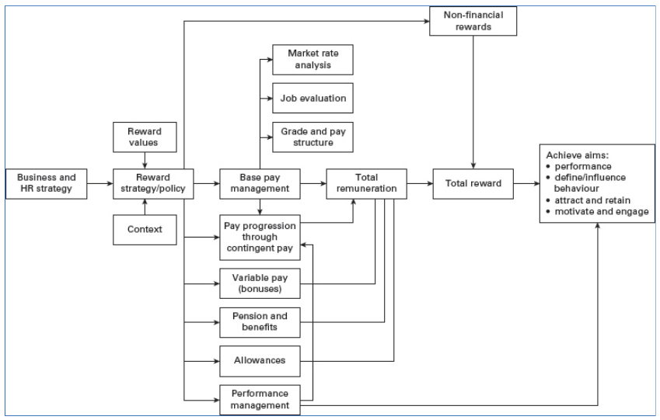
Figure: Reward system (Armstrong, 2019)
Reward system
To motivate the employee an effective reward system is required. An effective reward system should include a base management system, contingent, and variable pay management system, non-financial reward management system, employee benefits management system, performance management system, and total reward management reward system. The below figure shows how performance and reward objectives such as expected behavior and motivation can be achieved by focusing on the business and reward strategies & policies with the influence of organizational values and context (Armstrong, 2019).
Business strategy
While understanding the business strategy is required to focus on the business goals and drivers of the business. A clear understanding of performance expectations, shareholders’ objectives, customers' objectives, etc. are required to be considered for designing an integrated reward system to motivate the employees.
Reward strategy/rewards policy and values & context
Reward strategy/reward policy should make an interconnection between the business drivers and goals of the organization by focusing on the base pay management, variable pay management, additional rewards management, etc. The policy should clearly explain how pay, benefits, and rewards should be managed.
The values should identify and manage how rewards are believed to be important.
The context should analyze and evaluate the efficiency of the organization, legal context, market trends, economic trends, etc.
Base pay management
Based on the legal requirements, market forces, and job responsibilities a base pay should be set. It is also called job-based pay that is attached to a particular job. Job evaluation, market pricing, grade, pay structure design, and operation should be analyzed and evaluated to set a competitive base pay framework.
Pay progression through contingency pay
Pay progression by evaluating the performance, the contribution of the employees, skills, and services is required to add the contingent pay with the base pay. The evaluation should be fair, transparent, and communicated with the stakeholders to increase effectiveness.
Variable pay management
Variable pay is also called pay at risk. It is the extra payment for excessing benchmark performance target. It can be in the form of cash, bonus, additional holiday arrangements, etc. A clear policy and guidance are required to ensure the effectiveness of variable pay management (Armstrong, 2019).
Pension, allowance, and other benefits
Some additional benefit guidance such as a pension, insurance cover, sick pay, special allowance, etc. is required to make the benefits package clear and understandable to the employees. Staff often consider additional pay arrangements in selecting the desired jobs.
Performance management
There should be clear guidance and corporate strategy to evaluate the performance of the employees. Performance should be evaluated based on the benchmarks/expectations of the employees, then provide regular constructive feedback, and monitor performance for continual improvement. Outstanding performance (that exceeds the benchmarks) should be rewarded and below-average performance should be guided for improvement (Armstrong, 2019).
Nonfinancial rewards
Non-financial rewards policy should clarify how recognition, achievement, etc. should be provided to the employees as a motivating instrument.
Total remuneration
Total remuneration will be the ultimate monetary benefit to the employees including base pay, variable pay, other benefits, etc.
Total rewards
Total rewards are the combination of total remuneration and non-financial benefits.
Basic principles to be followed in designing a reward system
To explore the performance, target some basic principles to be followed in designing an effective reward system in motivating the employees. The principles are:
- The system should have a clear linkage with the organization
- Focus on the market competitiveness
- Clear and transparent
- Performance differentiation
- Focus on equal pay
- Choice and flexibility (Armstrong, 2019)
The above principles can help to get the ultimate benefits of a reward system in motivating the employees.

Conclusion
Employee motivation is an integrated package of several motivating factors such as pay, recognition and award, additional holiday, good working conditions, job security, good interpersonal relationship, etc. A single motivating factor cannot be effective on a standalone basis. Motivation works as a system in achieving the organizational goals and goals of the employee simultaneously. There is a win-win situation while an appropriate motivational strategy is applied. In this regard, a formal reward system complying with the basic principles can be effective in motivating the employee as stated above.

References
Armstrong. and Brown, (2019). Reward Management. London, GBR: Kogan Page, Limited.
Bacal, R., 2011. Performance management. New York: McGraw-Hill Professional.
Cohen, S., 2006. Compliment your staff with nonmonetary rewards. Nursing Management (Springhouse), 37(12), pp.10,14.
Fargus, P., 2017. Measuring and improving employee motivation. London: Financial Times Prentice Hall.
Murray, K., CMI (2021) Eight ways bad managers kill conversation - and .... [online] Available at: <https://www.coursehero.com/file/138330682/CMI-2021-Eight-ways-bad-managers-kill-conversation-and-motivationpdf/> [Accessed 2022].
Phillips, H., Bogdanich, I., Carter, K. and Holler, J., 2017. Commentary: Exploring Novel Approaches to Staff Rewards and Recognition. Hospital Pharmacy, 52(11), pp.729-731.
Sale, J., 2021. MAPPING MOTIVATION. [S.l.]: ROUTLEDGE.
Stone, F., 2012. Performance and reward management. Oxford: Capstone Pub.

