Supporting pupil progress: a detailed analysis of one child’s holistic development, with justification for the next steps in learning.

Introduction

The following assignment adopts a ‘Mosaic Approach’ (Clark and Moss, 2011) to gather and analyse a chosen pupil’s data who is in the Foundation Phase (FP), in Wales, so therefore, involves looking at the pupil’s holistic development using the Welsh Government’s (2015) Foundation Phase Framework (FPF) to consider the following areas of learning:
- Personal and Social Development, Well-being and Cultural Diversity;
- Language, Literacy and Communication Skills;
- Mathematical Development;
- Physical Development; and
- Creative Development.
Ensuring analysis is multifaceted it will be structured around Nottingham’s (2013) ‘ASK Model’ (See Appendix A) which considers the role of attitudes, skills and knowledge rather than taking a single-faceted approach. This will allow next steps for the pupil to be suggested in response to expectations, outlined in the FPF (Welsh Government, 2015).

In compliance with the University and Schools safeguarding policies and in accordance with BERA’s Ethical Guidelines for Educational Research (BERA, 2018), the school’s identity, staff and pupils are anonymised. Therefore, the school will be referred to as ‘School A’. This community primary school is situated within South Wales and has 152 pupils on roll (My Local School, 2018). Approximately, 25% of the pupils are eligible for free school meals and 28% of pupils have additional learning needs which are above considerably above the national average (My Local School, 2018). 95% speak English as their first language (My Local School, 2018).

The pupil who will be referred to as ‘Pupil A’ is in a mixed Nursery and Reception unit but is mainly taught in a Reception class consisting of 18 pupils (11 male, 7 female). ‘Pupil A’ is a 5 years old male and is currently a 3b average pupil who is on track to hit most Foundation Phase Indicators (FPI) by the time he leaves Reception. As his levels suggest he is a capable child who was willing to share his opinions throughout.

Data collection

The data collection process as discussed followed the ‘Mosaic Approach’ which developed by Clark and Moss (2011) provides a framework that emphasises listening to the child’s voice, while encouraging them to reflect on their own perspective of themselves as learners. Clark (2005) and Einarsdottir (2005) found this was a very powerful way to discovering what was important to the child without it being limited to conversations, which is often overlooked in similar research approaches. By piecing together multiple approaches to data gathering it grants the child space to take the lead in the research and supports the belief that they have ideas, feelings and opinions worth listening to (Dahlberg, Moss, & Pence, 1999). Fasoli (2003) demonstrated how children can become research partners if given the time and the tools to be involved which strengthens the richness of the data.
Data is gathered through three interlinked stages:
- Multiple research tools are used by the child to gather data, which with the support of the researcher is assessed;
- Data is pieced together providing evidence for further discussion to take place; and
- Findings from the discussion guides decision making and action plans.
This complies with the growing interest in listening to young children (Clark, Kjorhoit, & Moss 2005) which is key within the current curriculum documentation its direction (Welsh Government, 2015). Consequently, data was gathered using a variety of approaches such as observations, learning walks incorporating photographs taken by the child, informal interviews, child conferencing and evidence of pupil’s work and tracking which will be discussed in the following section.

A limitation that must be considered is this approach is often time consuming due to the multiple roles and data-collection tools needed, thus adding to the complexity of the data process, and time needed. However, triangulation and integrity of this data are usually extremely high (Greenfield, 2011) which provides a solid platform to support the desired visibility of the pupil’s voice (Clark & Moss, 2005). It must be stated that this does not suggest the views of adults as unimportant but instead helps to focus adult discussions on the child’s observations and priorities (Clark, 2007). Traditional adult-led research tools are still used such as observations and interviews, which are complimented with child led tools such as cameras, tours and mapmaking which has been shown to be advantageous (Clark & Moss, 2001).

Data generated is therefore predominantly qualitative based, which typically research suggests, better considers the experience of the participants and how they feel closely (Ely, 2006) while supporting a natural classroom environment which Bhattacharya (2017) found to be more effective than taking quantitative approach to following a child closely in classroom research. It facilitates relationships, causes and effects to be explored that is not always possible with qualitative data (Burns, 2000). A limitation to taking a qualitative approach to data and something that was considered is the large volumes of data generated in an often-subjective manner, which is often found easier to control with quantitative data (Burns, 2000). It is also more time consuming, but the advantages clearly outweigh the disadvantages in this case.

As discussed above, the analysis considered a holistic view on the learning taking place and followed Nottingham’s (2013) ‘ASK Model’ to ensure a multifaceted approach to data analysis occurred. Considering the role of attitudes, skills and knowledge rather than taking a single-faceted approach allowed a holistic view to generate the necessary next steps of development for the pupil, in direct response to expectations outlined in the FPF (Welsh Government, 2015).

Ethical considerations for this research were addressed, despite remaining in-line with everyday classroom practice. All school policies were closely followed throughout, as well as abiding to the University’s ‘Code of Practice’ (UWTSD, 2017) and ‘BERA’s Ethical Guidelines for Educational Research’ (BERA, 2018). This ensured the participants involved were always treated equally and fairly with minimal disruptions to themselves, with their welfare always paramount. To support this, a letter was issued to the participating School (See Appendix B) and a second letter to the participants parents/carers (See Appendix C) to gain consent and outlining the aims of the research and ensuring the anonymity of data gathered. Participants assent was monitored closely through body language, and they were aware of their right to withdraw from the research at any point without consequences.

Analysis of the learner

‘Pupil A’s’ FPF (Welsh Government, 2015) outcomes (average of 3b) demonstrate development that is in-line with expectations for when he leaves Reception shortly. From adopting a ‘Mosaic Approach’ to gathering data, it provided the foundations to allow multifaceted analysis using Nottingham’s (2013) ‘ASK Model’ to identify strength and weaknesses against these outcomes to move the learner forward.

Personal and Social Development, Well-being and Cultural Diversity.

During the child-led learning walk which gave ‘Pupil A’ the opportunity to photograph and discuss his favourite areas of his learning environment, he emphasised that Inter-Star, Ice-Blocks and Linking-Stars were his favourites. These all tend to be used socially. However, ‘Pupil A’ emphasised how he only liked building things with his best friend and sometimes his other friend but nobody else. He also declined my offer to help him (See Appendix D) which appears to be something he finds difficult accepting and will be necessary to achieve higher FPF (Welsh Government, 2015) outcomes. This willing to ask for support is also what (Nottingham, 2013) described as a characteristic of an ‘outstanding learner’ and is something that ‘Pupil A’ can work to develop. Furthermore, ‘Pupil A’ stated he doesn’t enjoy carpet building activities because too many people play, which makes it boring (See Appendix D). Again, suggesting cooperation is not a strength which is necessary at outcome 4 of the FPF (Welsh Government, 2015) and recognised within the ‘skill’ section of the ‘ASK model’ (Nottingham, 2013). Vygotsky’s (1978) theory of social constructivism suggests learning through and interacting with others often leads to positive development which could be advantageous to ‘Pupil A’ as research within collaborative in the early years suggests (Reference).

The continuous provisions mentioned above favoured by ‘Pupil A’ were the more practical and explorative hands-on tasks. The desire to improve and master his creations for the opportunity to model to his peers, which he discussed as enjoying people watching him (See Appendix D) demonstrates a desire to succeed and ability to self-regulate his concentration. This is recognised within the ‘attitudes’ section of the ‘ASK model’ (Nottingham, 2013) and is a vital quality to progress learning (an outcome 4 skill within the FPF) (Welsh Government, 2015).

Interestingly ‘Pupil A’ emphasised how within these provisions, unlike others he did not like building/playing with guns or when the others did this. This was also apparent during general observation where he typically likes to comment and correct other pupils’ actions when not following the classroom rules and will often move away from them (See Appendix E). This shows awareness of school rules and acceptable behaviour, and the ability to express his own feelings which demonstrates working towards a level 4 outcome (Welsh Government, 2015) and recognised within the ‘knowledge’ section of the ASK model (Nottingham, 2013). It must be noted however, that he struggles to share adult attention (See Appendix E) which would be required.

Language, Literacy and Communication Skills

Within this area of learning there were some clear elements functioning above expectations set within the FPF (Welsh Government, 2015) but others that ‘Pupil A’ found challenging. It is clear through general observations and semi-structured conversations that his oracy is functioning at outcome 4 (See Appendix F). His confidence and accurate communication skills with both adults and peers comes naturally and he displays a curiosity in his discussions which his recognised within the ‘attitude’ section of the ‘ASK model’ (Nottingham, 2013) that stands out within the class. This ‘sense of wonder’ he often communicates is a characteristic of an ‘outstanding learner’ (Nottingham, 2013). Despite ‘Pupil A’s’ oracy development where he is able to self-regulate his language, he finds acting out real or make-believe roles difficult and expressed how he did not enjoy participating in this during the learning walk ‘all about me’ activity (See Appendix D). This is quite clear from how he takes no interest in any provisions that encourage this style of play and during a literacy lesson that involved acting out scenes from ‘The Gruffalo’ book, he appeared to find it difficult and unenjoyable. Once the task was finished the rest of the group wanted to stay to carry taking on the role of other animals but ‘Pupil A’ moved straight back to his usual provisions mentioned already (See Appendix D). This was also apparent in the previous section where he did not like building certain items in an imaginative way like other pupils did. Both outcome 3 & 4 in the FPF (Welsh Government, 2015) expectations require learners to be able to demonstrate this.

‘Pupil A’s’ reading levels are also operating above expectations (reading age of 8 years plus) and demonstrating a lot of outcome 4 and some outcome 5 criteria (See Appendix F) of the FPF (Welsh Government, 2015). A piece of literacy work also demonstrated his capability of linking visual features to written text, then ordering them in the right sequence (See Appendix F). Despite this, his written work is poor which is particularly let down by his pencil grip and poor control (See Appendix F). He can orally construct sentences and describe how to form a number or letters, but his execution is poor and inconsistent, operating at some outcome 2 and 3 criteria of the FPF (Welsh Government, 2015). This physical skill within the ‘skills’ section of the ‘ASK model’ (Nottingham, 2013) is something that needs to be targeted.

Mathematical Development

From general observations and semi-structured interviews ‘Pupil A’ displays a confidence in his ability and often states something is easy or he can achieve it without first trying (See Appendix G). He shows enthusiasm and admitted enjoying maths (See Appendix G). While this resilience and desire to succeed is desirable within the ‘attitudes’ section of the ‘ASK model’ (Nottingham, 2013) he sometimes fails to succeed and becomes upset due to pressure he places on himself (See Appendix G). His mathematic ability is functioning above expectations however, and he has a firm grasp of many outcome 4 and above criteria (Welsh Government, 2015). This is evident through the structured tasks set, his ‘Big Maths’ levels and observations of his interaction with his chosen provisions. He generally uses a variety of numerical problem solving and self-regulation skills to succeed. This desire was clear when at first, he found subtracting difficult and an area he was unable to complete on his ‘Big Maths’ test. He showed enthusiasm and a desire to learn over the next few lessons, building up an understanding that he took into his next week’s test which he was able to recall and answer successfully (See Appendix G) which demonstrates a variety of positive ‘attitudes’ recognised within the ‘ASK model’ (Nottingham, 2013).
As already discussed, ‘Pupil A’ prefers concrete items which is evident through his free choices in provisions and his engagement with tasks that involve these. Numicon stimulates his engagement when problem solving and when being supplemented with other concrete items his focus and curiosity is clear (See Appendix G). This is supported by Haylock and Cockburn (2008) ‘Connective Model’ when learning mathematics. The practical and visual resources used in this instance has been shown to better support learners to achieve, secure and transfer their understanding to other concepts.
‘Pupil A’ is again let down by his disengagement when attention is not on him. During an observation (See Appendix G) he withdrew himself from the task, focusing on correcting other pupils’ behaviours, despite them following expectations and being prompted to remain on task himself. He re-engaged as soon as it was his turn again which demonstrates some undesirable attitudes that lets down his progression in relation to aspects of the FPF (Welsh Government, 2015).

Physical Development

Data generated from general observations from lessons involving Physical Development and during break-times ‘Pupil A’ appears to enjoy himself and when discussed during his child-led learning walk he photographed some outdoor provisions he enjoyed (See Appendix D). However, he often becomes upset during unstructured outdoor play, struggling with sharing equipment, losing at games or not getting his own way (See Appendix E), in a manner similar to his classroom behaviour patterns. Despite this enthusiasm he demonstrated quite poor fine motor skills and co-ordination which became apparent especially in a P.E lesson (See Appendix H). This also lets him down with his pencil grip and control in the classroom (See Appendix F) which has limited his writing, and again lets him down in his physical development as it is a requirement of outcome 3 in the FPF (Welsh Government, 2015). His lack of ability to often play in a small group became evident and he preferred to go to a corner where nobody could see him performing and got upset when somebody corrected him (See Appendix H) this was the opposite to when he enjoyed people watching him building things. He also struggled to always start and stop on command and his lack of skill to pedal a suitable bicycle or scooter demonstrates some Outcome 2 aspects of the FPF (Welsh Government, 2015) which is surprising as he outlined this as being something he enjoyed on the child-led learning walk (See Appendix D). This lack of physical and social ‘skill’ recognised within the ‘ASK model’ (Nottingham, 2013) does have a detrimental effect on his attainment in Physical Development and due to the cross-curricular nature of the evolving curriculum in Wales, with schools implementing Graham Donaldson’s “Successful Futures Report” (Donaldson, 2015) it can have a knock on effect in other areas. He often sets unrealistic targets before first attempting the task and is overconfident in his expectations he places on himself. He would express being successful at the task even when results suggested differently (See Appendix H). This can be recognised within the ‘knowledge’ section of the ‘ASK model’ (Nottingham, 2013) and ideas and concepts of his attainment could be something to look at to move him forwards. ‘Pupil A’ can however manipulate objects with precision, such as the provisions he enjoys accessing, and he did improve when showing a desire to succeed and resilience with the task. This was less frequent than in a classroom setting but still shows signs of an outcome 4 skill in the FPF (Welsh Government, 2015).

Creative Development

There is less data collected for creative development as this is an area ‘Pupil A’ does not expose himself with unless instructed. His free-choice creative opportunities are limited to the provisions mentioned in the child-led learning walk (See Appendix D). He does demonstrate creativity in his building of objects, but he is still very rigid creatively and builds the same things each day. His lack of desire to engage in roleplay and creativity was evident in a lesson where they all acted out a character from the book ‘The Gruffalo’ by Julia Donaldson. ‘Pupil A’ completed the task with very little enthusiasm despite Oracy being a particular strength of his when talking in a more structured real-life context or allowed to talk about his own topic (See Appendix). This was also noted by him in his ‘All about me’ sheet where he noted that he didn’t enjoy dressing up or roleplay areas (See Appendix D). He also stated that he wanted to be a farmer when he grew up and also discussed this during a PSHE lesson but could not expand on why when asked despite normally relishing an opportunity to discuss things he was interested in (See Appendix I). ‘Pupil A’ is still working at the expected outcomes but to progress with his development he will need to demonstrate some attitudes, skills and knowledge recognised within the ‘ASK model’ (Nottingham, 2013) that he capable of within other areas of the curriculum.

Next Steps

Personal and Social Development, Well-being and Cultural Diversity.

Considering the data gathered and the pupil’s current development, a clear way forward for ‘Pupil A’ in this FP curriculum area would be his ability to work in a group, while accepting support from others and their contribution to the task. This will be required to achieve higher FPF (Welsh Government, 2015) outcomes so addressing it at a young age, is advantageous to his holistic development. Active learning through cooperative play can engage and challenge the learners thinking by encouraging real-life and imaginary situations and Vygotsky (1978) felt a child is at his most able during play. It is important to allow these personalities to develop by engaging in social situations which is required of an adult. By providing continuous and enhanced provisions that require cooperation and group work to succeed and using a ‘challenge wall’ within the classroom to celebrate engagement with these provisions would encourage ‘Pupil A’ and the others to participate as often as possible. Skinner’s (1938) ‘behaviourist theory of operant conditioning’ advocates rewards can promote desirable behaviours in children, but their right to free choice should still be considered (Donaldson, 2015). ‘Pupil A’ already favours the provisions that typically encourage cooperation so this reward would really help expose him more often to the benefits of working as a team. This is also in-line with the FP curriculum aims (Donaldson, 2015) where it is an essential ingredient that should be fun and stimulating. Research suggests cooperative play enhances: physical development, wellbeing and health; personal and social development, and; cultural and emotional development (Sheridan play in the early childhood).

By cooperating to achieve a goal ‘Pupil A’ will be exposed to ideas and skills from other learners’ acting and a ‘more knowledgeable other’ that can be used to scaffold his own development which is in line with Vygotsky’s (1978) beliefs and has been found to lead to better engagement and development (Gillies et al., 2012). By working to develop these current weaknesses will ensure ‘Pupil A’ is on track to achieving outcome 4 of the FPF (Welsh Government, 2015) which he already demonstrates a lot of the criteria.

Language, Literacy and Communication Skills

It is clear from the data gathered and discussed, ‘Pupil A’ is functioning above expectations for both oracy and reading within this FP curriculum area. His oracy is functioning at an outcome 4 of the FPF (Welsh Government, 2015) and he confidently and accurately communicates with adults and peers, but he often lacks an imagination and finds it difficult. Both outcome 3 & 4 in the FPF (Welsh Government, 2015) expectations require this. On his learning walk ‘All about me’ activity he discussed wanting to be a farmer. It could help encourage imaginative thinking if activities were tailored around this as it is something that he has a strong interest in. This could be complimented by books that are themed around this that also encourage imaginative thinking as ‘Pupil A’ enjoys reading and shows an ability to engage with text.

‘Pupil A’s’ development in this FP curriculum area is let down by his writing skills which can also be linked to his physical development which will be discussed further below. I feel that by making writing more fun his engagement will increase as a result. There is extensive evidence that digital technology approaches are more beneficial for writing and mathematics practice than spelling and problem solving, and it has been proven that they are more effective with young learners (Sutton Trust Toolkit, 2019). The low cost of implementing an iPad-based writing App with a tablet pen, to offer instant and tangible feedback and rewards has been stated to have a four-month impact on learners for a low cost (Sutton Trust Toolkit, 2019). This can help with motivation which is something ‘Pupil A’ struggled with due to his lack of ability which often operates at an outcome 2 of the FPF (Welsh Government, 2015) so will need to improve before it starts to affect his holistic development.

Mathematical Development

‘Pupil A’ shows that he is comfortable with a lot of ‘outcome 4 and above’ criteria of the FPF (Welsh Government, 2015). Numeracy is a strength of his and he enjoys engaging with it, in both structured focused tasks and during enhanced and continuous provisions. To ensure more ‘outcome 4’ and above criteria are met he will need to be able to read and write numbers up to 20. This is an area ‘Pupil A’ struggles with due to his letter formation not being secure and his ability to form legible numbers, similar to his problems in literacy above. Again, this could be addressed with an iPad-based numeracy App which allows him to form correct numbers, with instant tangible feedback which the benefits have already been discussed. This App could include some problems from other ‘outcome 4’ criteria that need to be met such as: paying for items up to 20p, calculating the total; calculating change from 10p, and; reading hours on a clock. These learning experiences can be tailored to the learners needs and can have a four-month impact on learners (Sutton Trust Toolkit, 2019) using equipment already in place within the school from other interventions in place. His resilience and desire to succeed would suit these types of activities, and the instant feedback would help with the pressure his over-confident expectations sometimes places on his emotions, as he would become accustomed to instant feedback, so failure would not be so rare. Research has been shown this to be effective with pupils who struggle with written work because of a fear of failure (HTU, 2013). Cedars Primary School found it greatly supported pupils when used to support the writing process.

Physical Development

‘Pupil A’s’ fine motor skills with writing instruments as discussed is a weakness of his but interventions to tackle this have been discussed. More specifically, if he can engage with some classroom provisions that specifically target fine motor skills such as: using tongs; threading; using scissors, and; precise manipulation of objects which should help with his holistic development. This could be tackled by again using the ‘challenge wall’ approach to reward those who engage with the preferred activities or by building them into adult-led focus tasks tailored to Pupil A’s needs. His work could be celebrated on a display or on a chart that will therefore motivate him to continue developing.

Consolidating these skills will then allow him to transfer his knowledge into P.E lessons or general outdoor play where he will be able to engage and get more out of the experiences. ‘Pupil A’ has already shown that he enjoys some of the activities that develop his physical development such as using bicycles and scooters (See Appendix D). However, his skill level is quite low with this equipment and he does not meet the expected outcomes in the FPF (Welsh Government, 2015). By addressing the basic fine motor and coordination aspects of his Personal Development it should facilitate progression across the board and it is why it is so fundamental within the FPF outcomes for young learners as mastery cannot exist without (REF).

Creative Development

‘Pupil A’ struggles creatively as discussed in the previous section and therefore, not much data was collected for this area due to his lack of participation. Again, activities could be built into the ‘challenge wall’ to encourage participation and designed around his interests such as his choice of books he likes to engage with (See Appendix D & F).

I feel ‘Pupil A’s’ rigid play and activity choices (See Appendix D) is limited due to his lack of ability to work in a group and commonly choosing to work alone or with his two best friends (See Appendix D, E & H). This limits his creative development throughout the FPF (Welsh Government, 2015) due to the cross-curricular nature of the evolving curriculum in Wales (Donaldson, 2015). By enrolling ‘Pupil A’ into a ‘Social and Emotional Learning’ intervention I feel this could address a lot of the problems he has creatively, working as a team and setting realistic targets for himself. Extensive research suggests these interventions have an identifiable and valuable impact on attitudes to learning and social relationships in school and have been shown to raise attainment by four months for a low to moderate cost (Sutton Trust Toolkit, 2019). Improvements have been shown to be most effective when staff are trained to embed these approaches into routine educational practice (Sutton Trust Toolkit, 2019). The ‘Thrive’ intervention supports optimal social and emotional development and many schools use this intervention successfully such as Gwauncelyn Primary School who found a dramatic increase in pupils enrolled in the intervention overall wellbeing and social skills. The intervention would be tailored specifically around ‘Pupil A’s’ needs and his progress will be monitored frequently to adjust and change his needs moving forwards. This intervention will also support him with some of the other ways forward mentioned and can be implemented as a whole school approach with the pupils who need extra support.
Conclusion

This assignment focused on gathering data using the ‘Mosaic Approach’ (Clark and Moss, 2011) to analyse a pupil’s data within the FP in Wales. His holistic development was considered in-line with the Welsh Government’s (2015) Foundation Phase Framework and the five chosen areas of learning:
- Personal and Social Development, Well-being and Cultural Diversity;
- Language, Literacy and Communication Skills;
- Mathematical Development;
- Physical Development; and
- Creative Development.
The analysis was multifaceted and structured around Nottingham’s (2013) ‘ASK Model’ (See Appendix A) to consider the role of attitudes, skills and knowledge rather than taking a single-faceted approach. Considering a multifaceted approach explored the pupil’s achievements and gaps in their learning to suggest next steps to be suggested for the pupil in response to expectations, outlined in the FPF (Welsh Government, 2015). This process has allowed me the opportunity to understand how important assessing and monitoring learners are to their holistic development and why their needs and interests need to be considered to get the most out of them and for them to reach their potential. By adopting a ‘Mosaic Approach’ this facilitated the process and ensured the data considered the pupils voice. It can be a time-consuming process as discussed but the data gathered is much richer as a result.

Reference List

Bhattacharya, K. (2017) Fundamentals of Qualitative Research: A Practical Guide. New York: Routledge.

British Educational Research Association (2018) Ethical Guidelines for Educational Research, fourth edition. London: British Educational Research Association.

Burns, R (2000) Introduction to Research Methods, London: Sage.

Clark, A. (2007) A hundred ways of listening: Gathering children’s perspectives of their early childhood environment. Young Children, 62(3) pp. 76–81.

Clark, A., A. KJoindt. & P. Moss (2005). Beyond listening: Children's perspectives on early childhood services. Bristol: Policy Press

Clark, A. & Moss, P. (2001) Listening to children: The mosaic approach. London National Children’s Bureau: Rowntree Foundation.

Clark, A. & Moss, P. (2005) Spaces to Play: More listening to young children using the Mosaic approach. London: National Children’s Bureau.

Clark, A. & Moss, P. (2011) Listening to Young Children: The Mosaic approach. 2nd edn. London: National Children’s Bureau.

Dahlberg, G., Moss, P., & Pence, A. (1999) Beyond quality in early childhood education and care: Postmodern perspectives. London, United Kingdom: Falmer Press.

Donaldson, G. (2015) Successful Futures: Independent review of curriculum and assessment arrangements in Wales. Cardiff: Crown.

Einarsdottir, J. (2005) Playschool in pictures: children’s photographs as a research method. Early Child Development and Care, 175(6), pp. 523–541.

Ely, M. (2006). Doing qualitative research. London: Falmer Press.

Fasoli, L. (2003) Reflections on doing research with young children. Australian Journal of Early Childhood, 28(1), pp. 7–11.

Gillies, R., Nichols, K., Burgh, G. and Haynes, M. (2012) The effects of two strategic and meta-cognitive questioning approaches on children's explanatory behaviour, problem-solving, and learning during cooperative, inquiry-based science. International Journal of Educational Research, 53.

Greenfield, C. (2011) Personal Reflection on Research Process and Tools: Effectiveness, Highlights and Challenges in using the Mosaic Approach. Australasian Journal of Early Childhood, 36(3), pp.109-116.

Haylock, D. & Cockburn, A. (2008) Understanding mathematics for young children: A guide for foundation stage and lower primary teachers. London: SAGE.

My Local School (2017) My Local School. Available at: http://mylocalschool.wales.gov.uk (Accessed 23 April. 2019).

Nottingham, J. (2013) Encouraging Learning: How you can help children learn. London: Routledge.

University of Wales Trinity Saint David (2017) Code of Practice for Research Degrees 2017/18 [Online]. Available at: http://www.uwtsd.ac.uk/academic-office/other-forms-andpolicies/ (Accessed: 30 April 2019).

Vygotsky, L.S. (1978) Mind in Society: The Development of Higher Psychological Processes. Cambridge Massachusetts: Harvard University Press.

Welsh Government (2015) Foundation Phase Framework [Online]. Available at: http://learning.gov.wales/docs/learningwales/publications/150803-fp-framework-en.pdf (Accessed: 30 April 2019).

Appendix List

Appendix A - Nottingham (2013) ‘ASK Model’

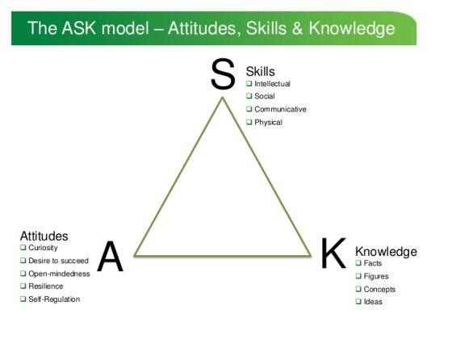

Appendix B - Letter issued to ‘School A’ gaining consent.
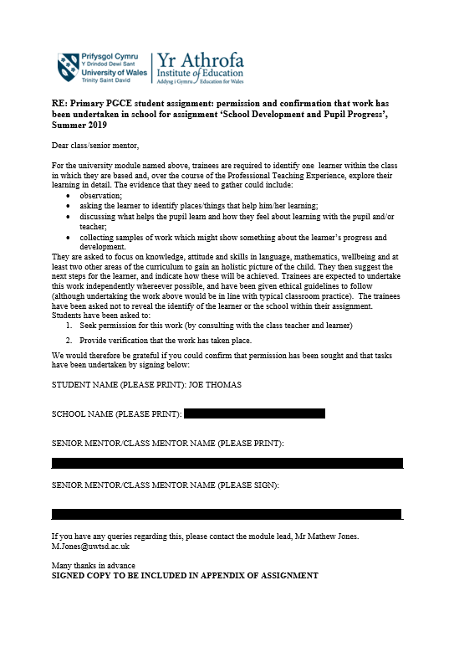

Appendix C - Letter issued to the parents/carers of ‘Pupil A’, gaining consent.
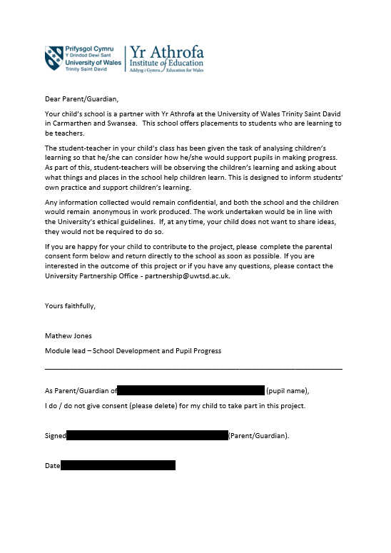

Appendix D – Transcript of the ‘Learning Walk’ led by ‘Pupil A, investigating his favourite things.

Inter Star
“One of my favourite things.”
“Love building things with my best friend ‘Pupil B’.”
When questioned he revealed he sometimes likes ‘Pupil C’ helping him too but nobody else.

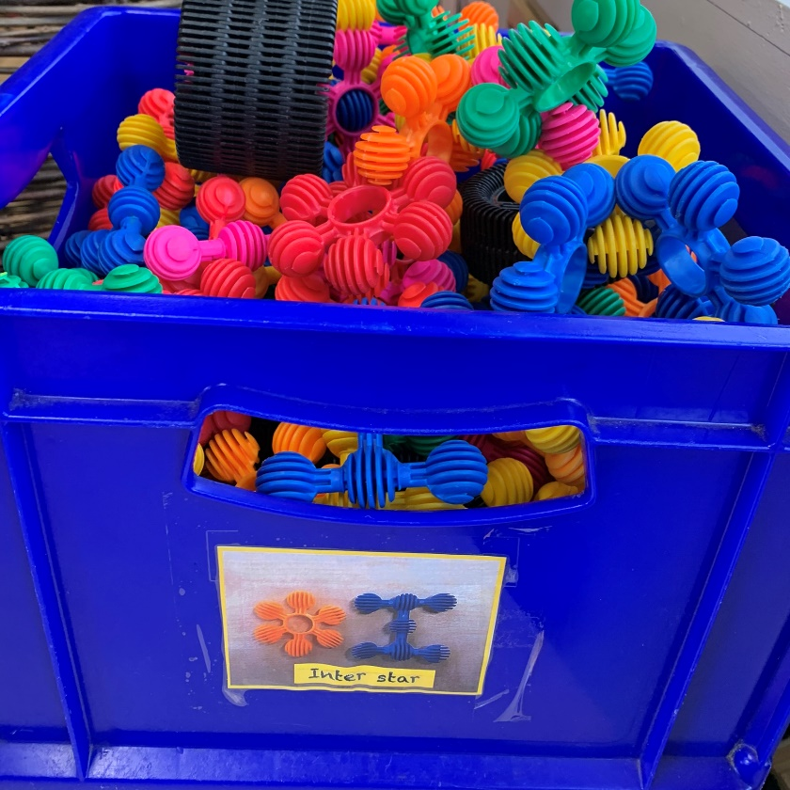

Ice Blocks
“One my favourite things.”

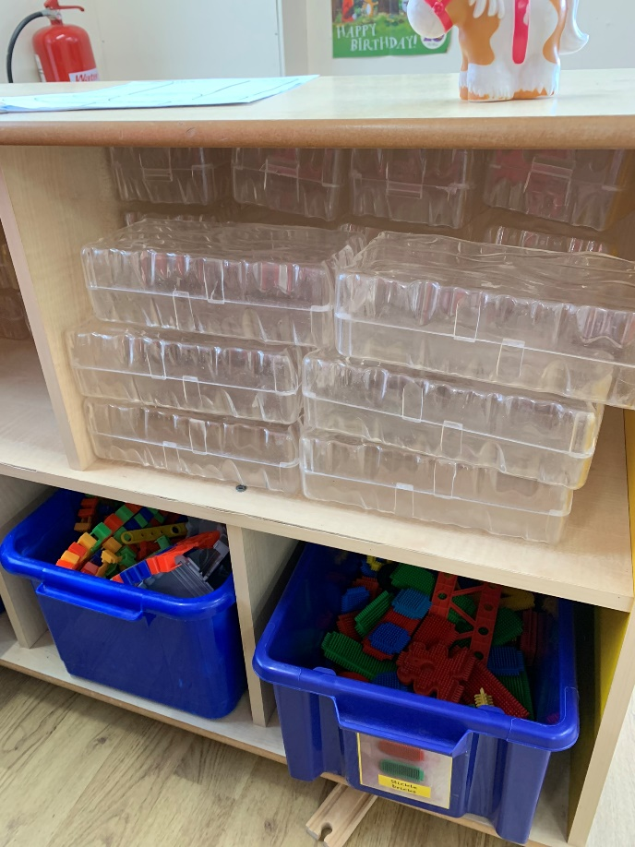

Linking stars on the lightbox
“Another one of my favourites.”
He likes building a shield but when asked why he wasn’t sure.
“I don’t like building guns and stuff like others do.”
‘Pupil A’ didn’t want help when offered.
“I like people watching me build but not helping me.”
Does not like carpet building activities when asked – “they are boring because too many people play.”
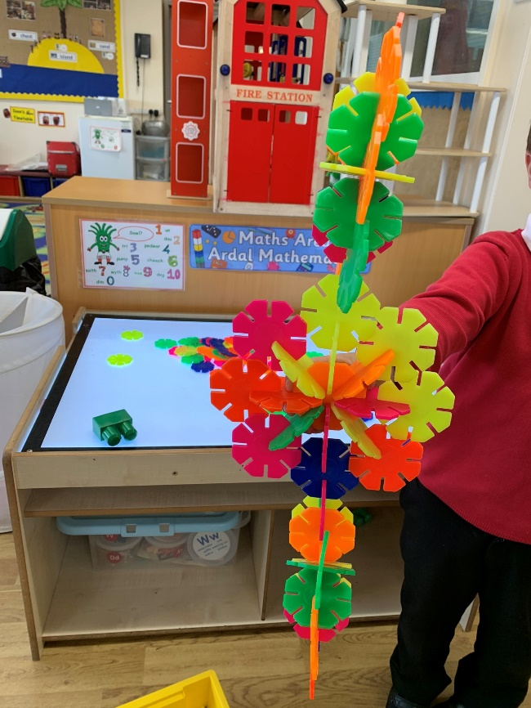

Bikes and Slide
“I like these when I’m outside.”

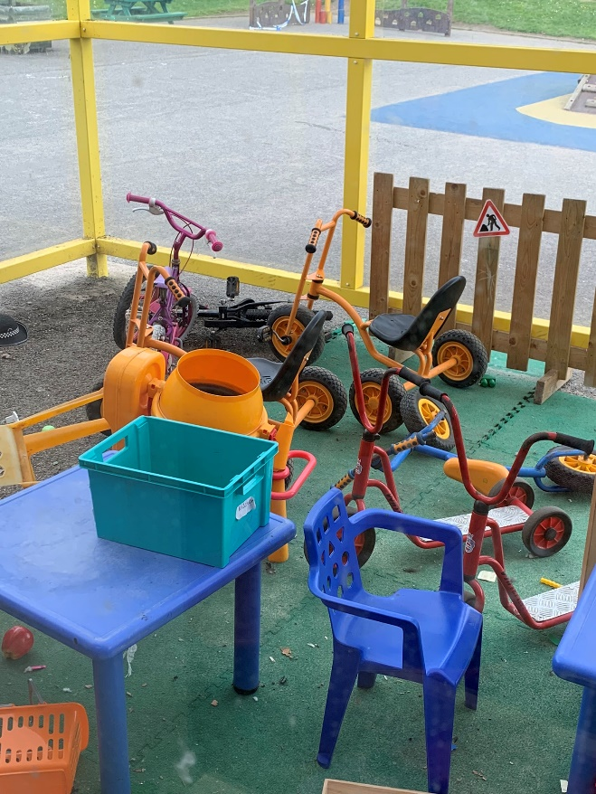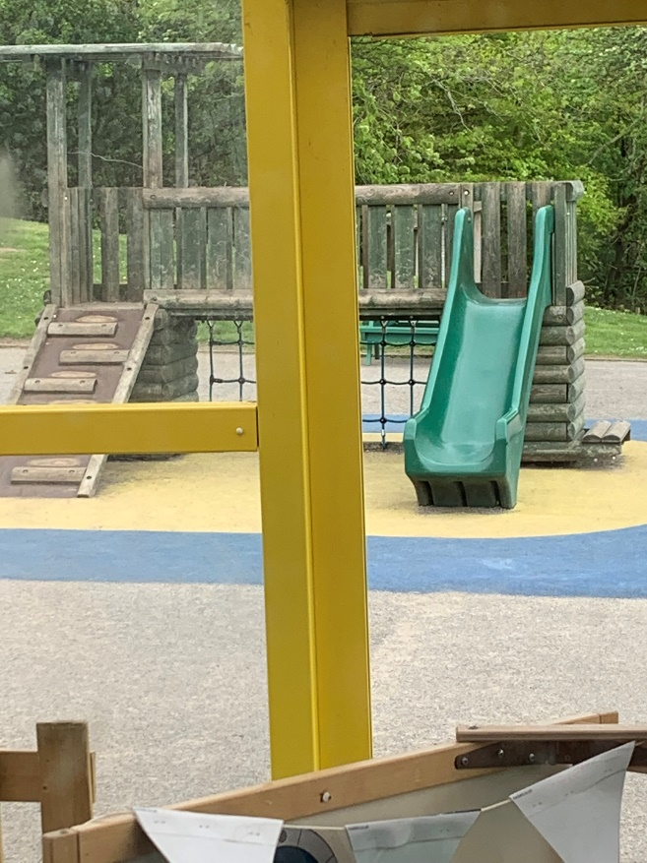

Garry and Dinosaur Puppet
“I like these.”
‘Pupil A’ carries them around throughout the day.

All About Me
This was written by me due to ‘Pupil A’ struggling with his pen grip,

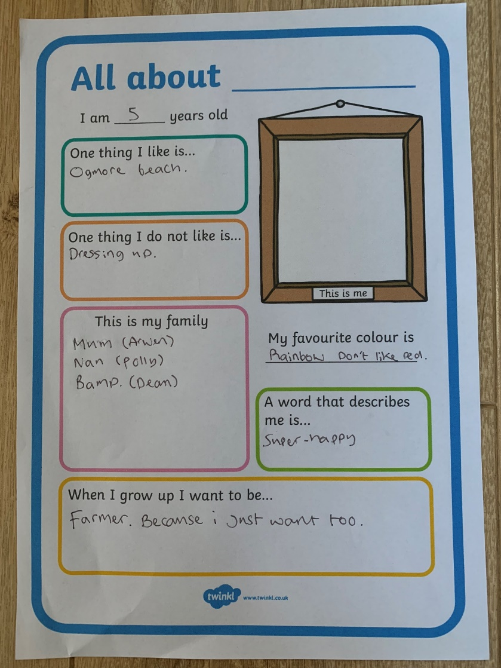

Appendix E – General Observations of ‘Pupil A’.

- 3b average pupil, on track to hit expectation in-line with the FPF expectations by the time he leaves Reception.
- He is a very sensible child but can be sensitive and struggles to interact with others outside of his close friendship group. He is an only child which could be a factor that contributes to this.
- Very confident talking in front of adults and pupils.
- Gets upset when he is told to share.
- Gets upset when he can’t hold an adult’s hand during school transitions. Even when you say that certain children are on their first few days in school and there are only limited adult hands to go around - but he doesn’t seem to process it.
- Likes to comment and correct other children’s’ actions when not following the classroom rules and moves away from them.
- Often gets upset during breaktimes and lunchtimes when playing outdoors.
- Struggles to share equipment and lose at games/not get his own way.
- Does not enjoy dressing up or roleplay.

Appendix F – Literacy based observations of ‘Pupil A’.

General Observations
- Excellent reader (see reading records below).
- Very poor pencil control for his overall ability level. Seems to lack finger and hand strength.
- Very confident talking in front of adults and can converse with peers in a variety of contexts but struggles in a group.
- His range of language and accuracy of language stands out within the class.
Reading Records

30/04/19 Reading - ‘Jack and the Giants’ - Read this book with no problems except the word ‘creature’.

09/05/19 Reading - ‘Don’t look down’ - This book was more of a challenge for ‘Pupil A.’ He was able to sight read the first few pages but will find this more of a challenge which he seems to enjoy. Struggled with the words ‘were, ages and opened’.

13/05/19 Reading - ‘Don’t look down’ - Good progress with this book today. Sounding out more difficult words when needed but pretty fluent with most pages. Struggled with the words ‘insects and gulped’.

17/05/19 Reading - ‘Don’t look down’ - Really confident and fluent reading today despite this book having quite challenging words for ‘Pupil A’. Well done!

22/05/19 Reading - ‘Don’t look down’ - ‘Pupil A’ read this beautifully today. Moved onto a more challenging book.

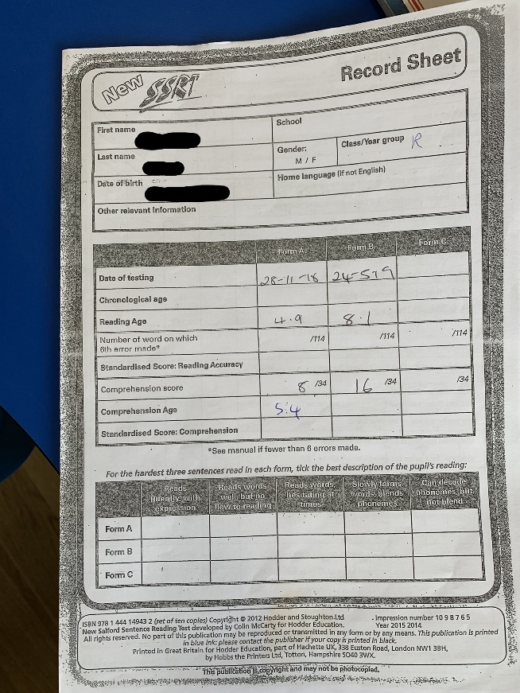

Samples of ‘Pupil A’s’ Literacy work
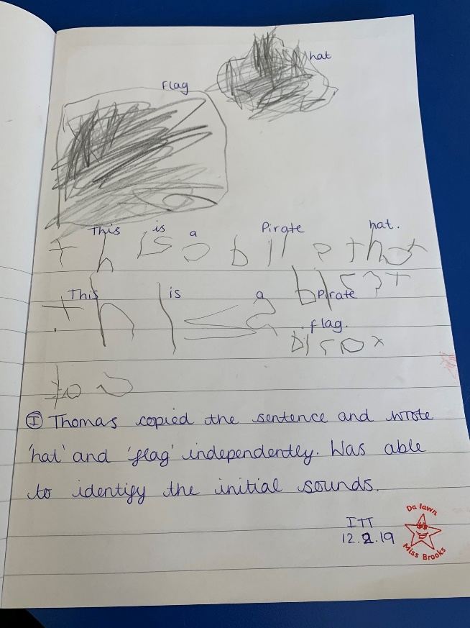

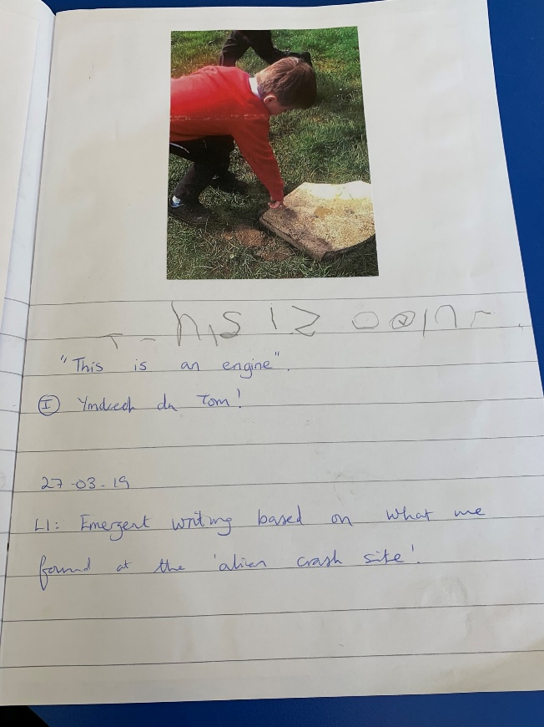

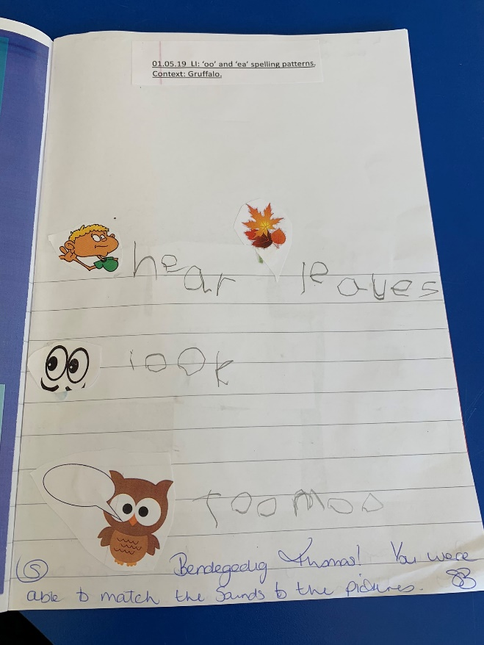

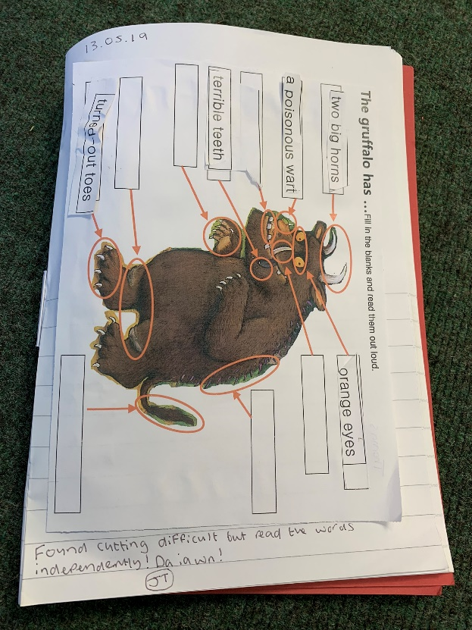

Appendix G – Numeracy based observations of ‘Pupil A’.

General Observations
- He is very confident in his ability and is able in most aspects of numeracy.
- He always likes to share his opinion in numeracy and enjoys elaborating on his answers.
- He enjoys going to the interactive whiteboard to try and show others what he’s done.
- He accesses the provisions that involve building but does not access the rest very often.
03/05/19
- He is working at level 5 in CLIK Maths.
- He is able to recognise numbers up to the value of 200.
- He can write a number than 12 and less than 20.
- He can confidently count 10’s to 100.
- He can confidently recognise the value of two-digit numbers.
- He can double simple numbers.
- He understands fact families.
- He can confidently count numbers up to the value of 15.
- He struggled subtracting numbers under the value of 10.
- 9/10 in his CLICK test.
08/05/19
- Within the Focus Group he stood out and understood doubling very securely.
- He was able to double numbers past the expectation of 5 both using Numicon and without the aid of Numicon.
- He did not work well as part of the shared problem-solving task and wanted to take the lead and help the others before giving them a chance to naturally have a go themselves.
- When asked to give the others a chance and reiterate how I wanted the sequences of Numicon to be set out he began to disengage and remove himself from the task until it was his turn again where he again tried to correct other children’s input despite them following my instructions correctly.
17/05/19
- He is working at level 5 in CLIK Maths.
- He is able to recognise numbers up to the value of 200.
- He can write a number more than 12 and less than 20.
- He can confidently count 10’s to 100.
- He can confidently recognise the value of two-digit numbers.
- He can double simple numbers.
- He understands fact families.
- He can confidently count numbers up to the value of 15.
- He was able to subtract numbers under the value of 10 today.
- Full marks.

Samples of ‘Pupil A’s’ Literacy work

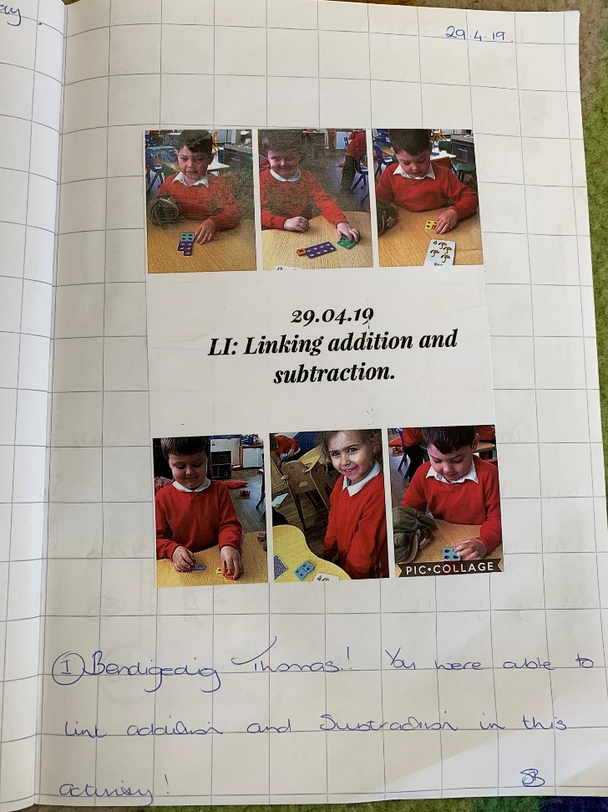

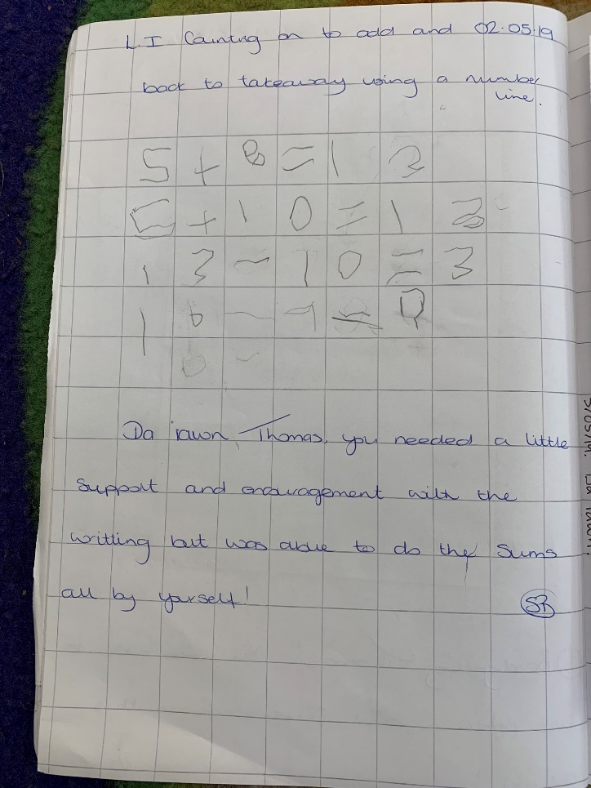

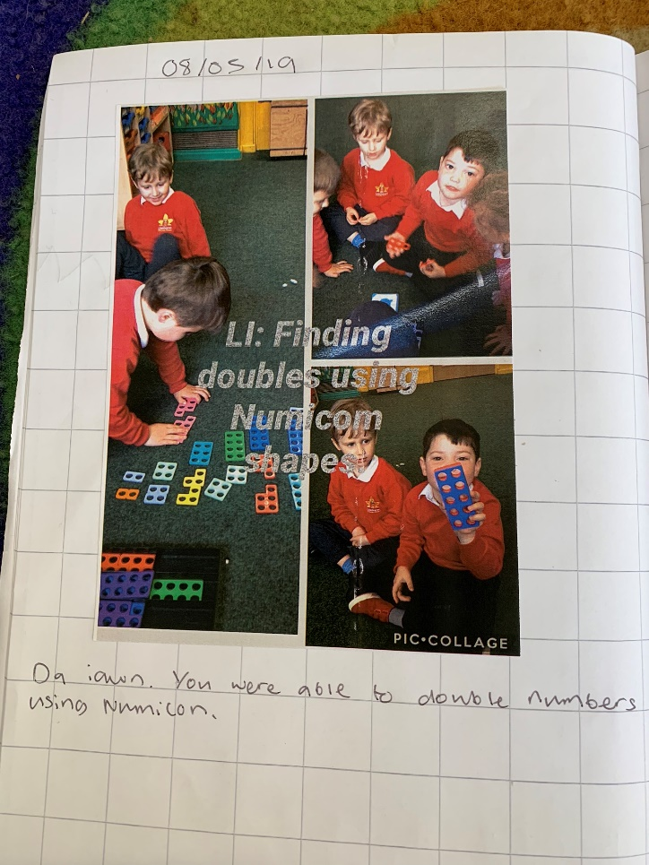

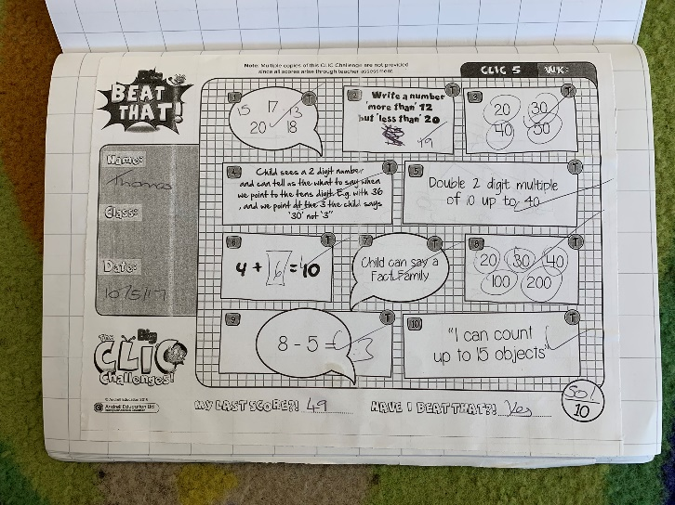

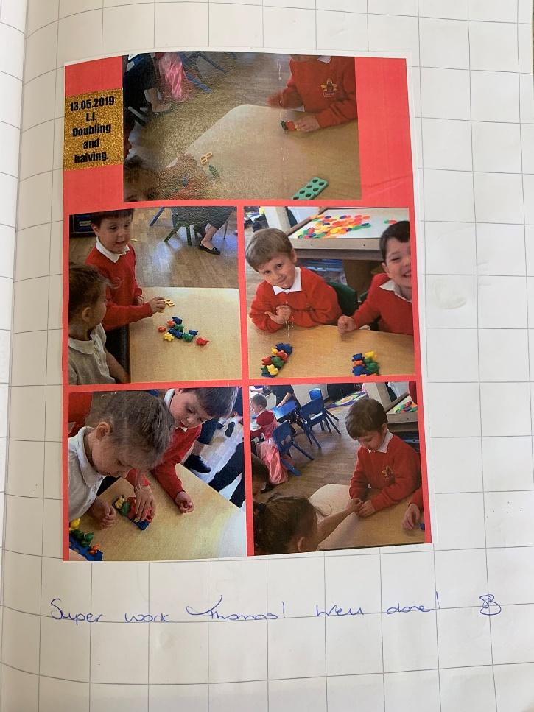

Appendix H – P.E based observations of ‘Pupil A’.

02/05/19
- Very excitable in P.E which stood out immediately.
- Over-confident with his ability and would often say he could do something before he tried or even had the chance to try it first.
- Quite poor fine motor skills and co-ordination.
- Despite struggling to achieve the set goals he would still express his confidence in his attainment.
- When another pupil made a comment that he was not doing it correctly he immediately got upset and cried.
- Stood out to be quite isolated when taking part in the lessons despite other interacting with other pupils when given the opportunity.
- Would go to a corner or quiet place to try completing the activities.
16/05/19
- ‘Pupil A’ found the throwing and catching skill difficult despite him saying he had done it before.
- He did not have much balance and coordination when balancing the ball on a racket.
- He did show improvement as the lesson progressed and was able to throw a ball to a partner.
- He was not able to catch a ball but was able to get his hands in the correct position to receive a pass.
- He found it frustrating and showed signs that he was upset when he saw others were able to perform the skill more successfully.

Appendix I – PSHE based observations of ‘Pupil A’

02/05/19
- He was quite disengaged throughout this session and did not really offer an interest in sharing his opinion except when directly asked which is quite out of character.
- The class teacher for this session was a PPA session which could have contributed.
- He expressed that he would like to be a farmer when he grew up but when asked to elaborate on why he didn’t really have anything to offer.
- He kept quite still and didn’t fidget despite not really engaging with the discussions and putting his hand up like he usually would in other lessons.

