University of Wales Trinity Saint David

Design Portfolio - Catapult Range Experiment
ACDA 5021: Level 5 Systems Engineering

Name - Luke Brown (ID-2309075)
Course – Ordnance, Munitions and Explosives (OME)
Lecturer – Dave Holley
Submission Deadline – 20th April 2026

Table of Contents:

Section 1 – Objectives

  - Introduction to the Taguchi method …………………………………………………………….. (Page 1)
  - Application to a catapult experiment …………………………………………………………… (Page 1)
  - Relevance to defence engineering ……………………………………………………………….. (Page 1)

Section 2 – Method and apparatus

  - Apparatus and equipment ……………………………………………………………………………. (Page 2)
  - Experimental method ……………………………………………………………………………… (Pages 2-3)
  - Variables, control factors and levels ……………………………………………………………… (Page 3)
  - Experimental design …………………………………………………………………………………….. (Page 4)

Section 3 – Experimental data

  - Effects of control factor variation …………………………………………………………………. (Page 5)
  - Prediction of range using control data ………….……………………………………………… (Page 6)

Section 4 – Interpretation of results

  - Analysis of control factor influence ………………………………………………………………. (Page 6)
  - Identification of key control factors ………….………………………………………………….. (Page 6)
  - Range prediction and accuracy …………………………………………………………………….. (Page 7)
  - Noise and sources of error ………….……………………………………………………………….. (Page 7)

Section 5 – Conclusions

  - Summary of key findings ……………………………………………………………………………… (Page 7)
  - Validity of the Taguchi method …………………………………………………………………….. (Page 8)

Section 6 – Reflection

  - Experimental limitations ………………………………………………………………………………. (Page 8)
  - Suggested improvements …………………………………………………………………………….. (Page 8)

Section 7 – References

  - All referenced citations ……………………………………………………………………………. (Pages 8-9)

List of Figures and Tables:

Figures:

Figure 1 – Mechanical catapult [3] …………………………………………………………………………… (Page 2)
Figure 2 – Control factor variation …………………………………………………………………………… (Page 5)

Tables:

Table 1 – L₈ orthogonal array ……………………………………………………………………………………. (Page 4)
Table 2 – Midpoint prediction and comparison matrix …………………………………………….. (Page 4)
Table 3 – Orthogonal array results matrix ………………………………………………………………… (Page 5)
Table 4 – Midpoint prediction and validation results ……………………………………………….. (Page 6)

Section 1 - Objectives:

1.1- Introduction to the Taguchi method:

The Taguchi method is a statistical design of experiments (DOE) approach used to analyse how multiple variables influence system performance. Its primary purpose is to identify key control factors, reduce variability caused by noise, and improve performance efficiently. It uses orthogonal arrays to minimise the number of experiments required while still enabling effective comparison of variables. A key principle is the separation of controllable factors from noise factors, supporting the development of robust designs. The method is widely used as it saves time and resources compared to full factorial testing and provides clear identification of the most influential factors and their optimal settings [1].

1.2- Application to a catapult experiment:

In this experiment, the Taguchi method is applied to analyse how different catapult settings influence projectile range. A mechanical catapult system is used, with several control factors varied systematically. Projectile range is measured as the performance output. An orthogonal array is used to test combinations of settings efficiently across multiple runs. The aim is to identify which factors most significantly affect range and determine an optimal configuration. The results are then used to predict the range at a chosen set of control settings.

1.3- Relevance to defence engineering:

Reliable performance is critical in defence engineering, where systems must operate consistently under varying conditions. Similar principles apply to launch systems, munitions, and missile delivery mechanisms. The Taguchi method helps identify key parameters affecting performance while reducing sensitivity to environmental and operational variability. This supports robust design, ensuring systems remain effective despite noise such as temperature or handling effects. It also improves efficiency by reducing testing requirements. In this experiment, the catapult represents a simplified launch system, demonstrating how performance and consistency can be optimised [2].

Section 2 - Method and apparatus:

2.1- Apparatus and equipment:

- Bench-mounted mechanical catapult (including elastic bands, adjustable pins, an integrated protractor, a projectile cup, and a clamp).
- Rubber ball projectile.
- Tape measure.
- Table setup.

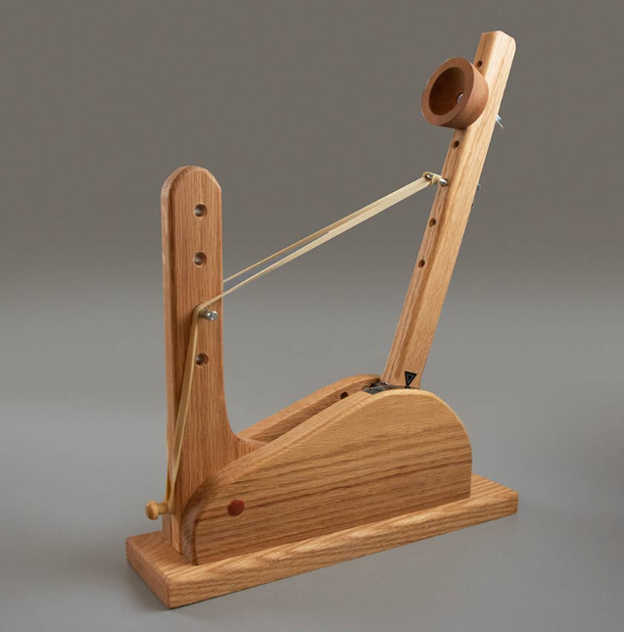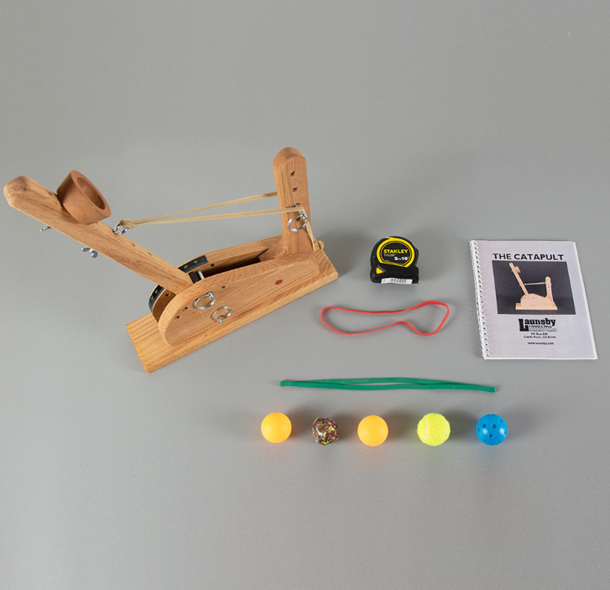
Figure 1 - Mechanical catapult [3]

2.2- Experimental method:

- Prior to the experiment, the catapult risk assessment is reviewed and understood.
- The catapult is clamped securely to a table setup.
- A tape measure is aligned along the expected launch direction.
- Control factors are set according to the Taguchi orthogonal array:
  - The operator is selected.
  - Pin positions are adjusted.
  - The elastic band is attached accordingly.
  - The pull back angle is identified.
- The projectile is placed in the cup.
- The arm is pulled back to the specified angle using the integrated protractor and released.
- The first launch is conducted as a trial and distance is not recorded.
- Three subsequent launches are measured and range is averaged.
- Results are recorded in a structured table.
- The process is repeated for all configurations in the experimental matrix.
- The matrix is used to determine the relationship between control factors and range.
- The two most influential control factors are identified.
- Tests are repeated with only the two most important control factors altered.
- A midpoint combination of dominant factor levels is selected.
- Previously obtained data is used to predict the corresponding range.
- The experiment is repeated at this midpoint setting, and the predicted range is compared to the measured result.

2.3- Variables, control factors and levels:

Control factors are parameters deliberately altered to observe their effect on catapult range; they include:

- Band front position (1 and 3).
- Band anchor position (2 and 4).
- Stop position (1 and 3).
- Pull back angle (140° and 170°).
- Operator (A and B).

The control factors were chosen as they represent realistic variations in catapult setup and operation. Each factor is expected to have a measurable effect on launch performance, allowing their influence on range to be assessed.

Variables are used to understand relationships within a system; they include:

Independent – Control factors.
Dependent – Projectile range.
Control – Type of projectile, catapult setup and environment, measurement method, launch position.
2.4- Experimental design:

A Taguchi orthogonal array was used to structure the experiment. The primary design utilised an L₈ array, as seen in Table 1, where each row represents an experimental run and each column a control factor, with cells indicating level settings [4]. This ensured a balanced comparison of factors while reducing the number of tests. Each configuration was tested and the corresponding range recorded.

Table 1 – L₈ orthogonal array
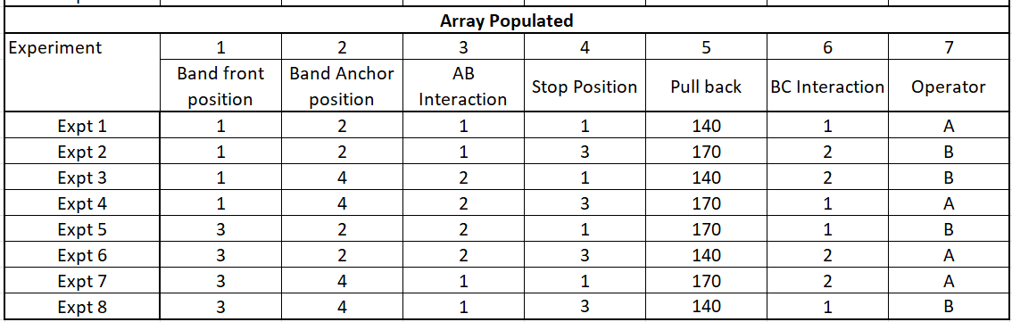

A second matrix, as shown in Table 2, was used for midpoint prediction and comparison. Results from the L₈ array were first used to identify the key control factors. The second matrix was then used to estimate the midpoint range based on these factors, which was subsequently tested experimentally and compared to the predicted value.

Table 2 - Midpoint prediction and comparison matrix
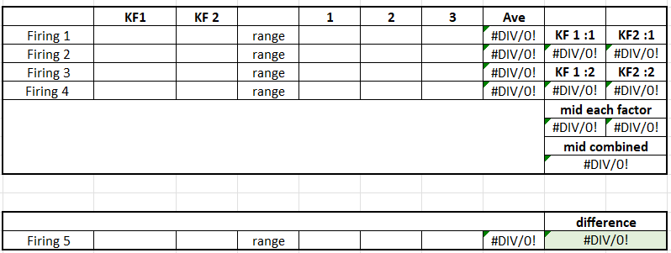

Section 3 – Experimental data:

3.1- Effects of control factor variation:

The results are presented in Table 3, where three launches for each configuration were averaged to improve reliability. These averages were used to generate the plots shown in Figure 2, illustrating the effect of each control factor on range. From these plots, the most influential factors can be identified, with band front position and pull back angle showing the greatest impact on performance.

Table 3 - Orthogonal array results matrix
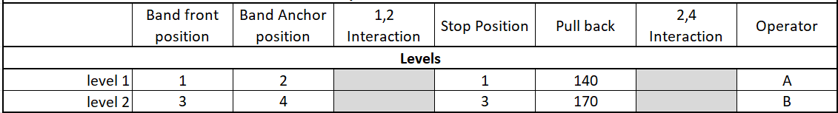
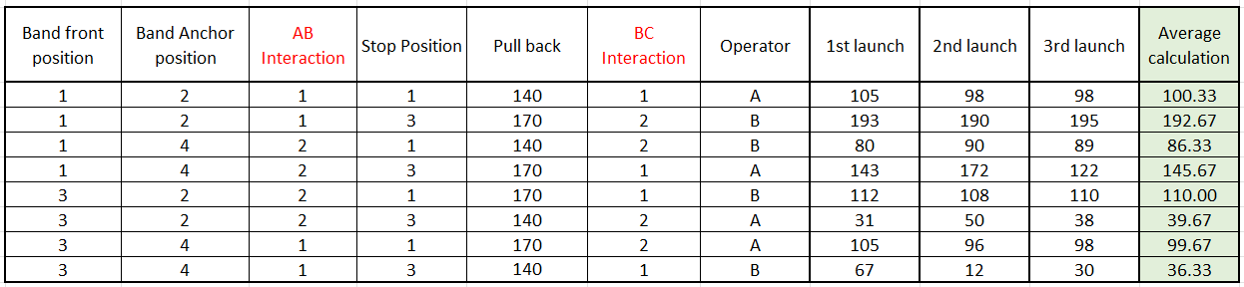

level 1 Level2

Figure 2 – Control factor variation

3.2- Prediction of range using control data:

From previous analysis, it can be predicted that a front position of 1 and a higher pull back angle of 170° will increase projectile range. Using Table 4, additional runs were conducted with other control factors held constant. The midpoint values for the key factors were calculated and combined to predict a range of 140.25cm. A further experimental run (Firing 5) was then performed at this midpoint setting, producing a measured result of 140cm for comparison with the predicted value.

Table 4 – Midpoint prediction and validation results
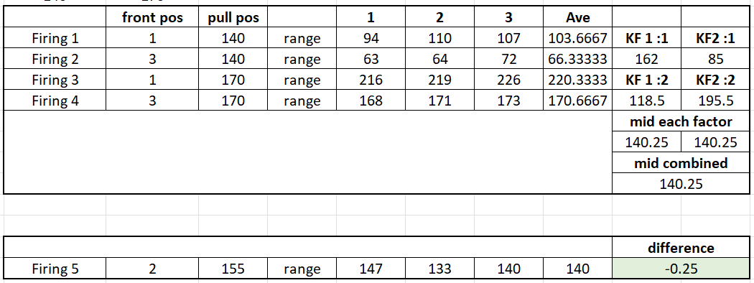

Section 4 – Interpretation of results:

4.1- Analysis of control factor influence:

Each control factor affects range through different physical mechanisms. Increasing pull back angle increases stored elastic potential energy, resulting in greater launch velocity and range. A higher band front position improves force transfer efficiency, increasing range. Band anchor position affects band tension, causing smaller changes in launch force. Stop position influences release angle but showed minimal variation, and operator had little effect. AB and BC interactions showed negligible change, indicating the factors act largely independently.

4.2- Identification of key control factors:

As previously noted, band front position and pull back angle were identified as the most influential control factors due to showing the largest variation in range observed in the plots. This indicates they have the greatest impact on catapult performance. Therefore, these factors were carried forward into the next section for further analysis.

4.3- Range prediction and accuracy:

The key control factors were tested and their midpoint values used to predict the projectile range. This resulted in a predicted value of 140.25cm, compared to an experimental result of 140cm, showing a very close agreement with only a 0.25cm difference. However, this value was an average, with a spread of 14cm across the three runs, indicating limited precision. This demonstrates that the Taguchi method is effective for prediction, although the presence of noise within the system reduces consistency.

4.4- Noise and sources of error:

Noise refers to uncontrolled variables that affect the experimental results and introduce variability into the measured range [5, p. 2]. In this experiment, sources of noise included:

- Variability in elastic band positioning.
- Inconsistent ball placement.
- A loose catapult arm.
- An unstable table setup.
- Loose pins.
- Tape measure misalignment.
- Human judgement in estimating landing points.

These noise factors increased spread in the results, reducing repeatability and prediction accuracy. The Taguchi method aims to minimise sensitivity to such noise and improve robustness of the system.

Section 5 – Conclusions:

5.1- Summary of key findings:

The most influential control factors were identified as pull back angle and band front position. Results showed that increasing the angle and using a higher front pin position increased range. Overall, control factors were found to significantly affect catapult performance. The objective of identifying the key factors influencing range and predicting results was successfully achieved.

5.2- Validity of the Taguchi method:

The Taguchi method proved effective in identifying key control factors and provided an accurate prediction of range. It reduced the number of experiments required while still producing reliable results. Despite noise and variability in the system, the method remained robust, demonstrating it is a valid and efficient approach for this type of analysis [6].

Section 6 – Reflection:

6.1- Experimental limitations:

The experiment was limited by general sources of noise such as loose components and measurement uncertainty. Human factors introduced some variability, and the limited number of trials reduced statistical reliability. Additionally, the setup was relatively simplistic, only loosely representing real-world defence systems rather than accurately replicating their complexity.

6.2- Suggested improvements:

Improvements include securing the catapult arm and pins, fixing elastic band positions, and using a stable, clamped base. Measurement accuracy could be improved with fixed markers and aligned equipment. Human error can be reduced through consistent release and placement, while increasing trials would improve reliability and validation at the cost of time.

Section 7– References:

7.1- All referenced citations:

[1] | S. K. Karna and R. Sahai, “An overview on Taguchi method,” International Journal of Engineering and Mathematical Sciences, vol. 1, pp. 11-17, 2012. [Online]. Available: Link. [Accessed 8th April 2026].
[2] | M. W. Fortanbary, B. K. Mansager and C. F. Newberry, “Supporting acquisition decisions through effective experimental design,” Mathematical and Computer Modelling, vol. 23, no. 1-2, pp. 81-90, 1996. [Online]. Available: Link. [Accessed 8th April 2026].
[3] | Lean Games, “The Lean Six Sigma Catapult kit with soft padded bag,” [Online]. Available: Link. [Accessed 11th April 2026].
[4] | R. K. Roy, A primer on the Taguchi method, Dearborn: Society of Manafacturing Engineers, 2010. [Online]. Available: Link. [Accessed 11th April 2026].
[5] | R. Unal and E. B. Dean, “TAGUCHI APPROACH TO DESIGN OPTIMIZATION FOR QUALITY AND COST: AN OVERVIEW,” Annual Conference of the International Society of Parametric Analysts, 1991. [Online]. Available: Link. [Accessed 18th April 2026].
[6] | 6sigma.us, “The Guide to the Taguchi Method: A Robust Quality and Efficient Experimentation,” Lean Six Sigma Training Certification, 8 October 2024. [Online]. Available: Link. [Accessed 18th April 2026].

