

Assessment 1 – Reading Task Template
PART 1: Upload your photo of your A3 in-class notes here:
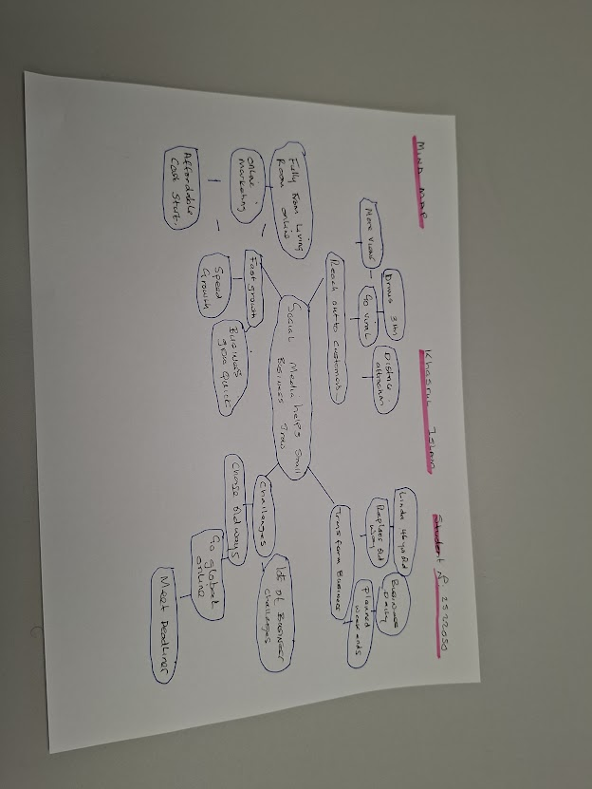

PART 2:
- Answer every question below in 1-3full sentences.
- Use your own words. Do not use generative AI to answer these questions.
- Include a specific detail from the text when asked.
REMINDER
- The main idea is the overall message of the whole text.
- A key point helps to explain the main idea.
- A specific detail or example from the text shows that the key point is true.

- What is the main idea of the whole text?

The Main Idea of the whole text is about business turning live hoods, promoting to social media platform going global online for customers view, attracting customers for business growth going viral.

- What is one key point that supports the main idea, and which specific example from the text shows this?
The one key point support the main idea is low cost budget. reach out, amazing contents customer will love
As an example Honey wood sandwiches a customer post about their chicken burger, and it made people go commuting 3hrs just to try the food this creates business benefit.

- What is a different key point that supports the main idea, and which specificexample from the text shows this?

Social media links changes the old way of working , it appears to open new markets and changes business in new format business in full success operations,and every post comes from online.

Example: Linda Hunter-Lindy Loo’s Boutique.
She sold clothes at local markets in Londonfor 46 years until she ceased
Her stall.

During lockdown her grandson suggested to post videos online.the most challenging flat form via media she started her business from her living room had stock in her van this was a success from social media..

- Which part of the text do you think is most important, and why?

- The most important text was social media platform marketing expert
Murat Matlu . who says was surprised how the sand which shop travellers travelled.
This indicates how the social media flat form is strong and fast growing
Really makes business growth so popular by customer views and readings this ideas provides opportunities in business trends and growth.

Reflection:
- What did you find difficult in this task (including in-class components), and why was it difficult?
This was very difficult I did not have academic skills in the past with the aid
Of learning in the class and reading Pdf in Moodle helped me with academic skills,

- What helped you with this difficulty, and how did it help you?
The TEXT and reading through the articles helped and pictures helped me analyes and find the sources This supported me in understanding the text and assignments, Reading each section and analysing the words helped me and understand the criteria and complete task.

