Modul Code: BMSW4002
Module Name:
Effective Team Working and Communication
Lecturer:
Anita Nan

Assignment task:
Understanding of the models of communication and the communication skills and refer to any case studies done to show how these helped students’ understanding.

Students’ ID: 2010424

Word count: 2,054
UWTSD, 2021

Contents

1. Introduction 3
2. Three Models of Communication 4
2.1. First model of communication: Shannon – Weaver 4
2.2. Second model of communication: Schramm 5
2.3. Third model of communication: Berlo 6
3. Communication Skills 7
3.1. Verbal communication skills – spoken and written 7
3.2. Non-verbal communication skills – body language 8
3.3. Active listening 9
4. Conclusion 10
References 11

Introduction

One of the most basic human abilities is communication. We have been connected since prehistoric times, so it is reasonable to think that we have perfected the art of communication (Harris, 2018). The truth is, however, that most people struggle with this. Especially when it comes to communication in the workplace and that it leads to the desired result. Effective communication in the workplace is the ability to convey meaning in a way that is understandable to the two people involved.
This study seeks to present and analyse in detail the styles of communication and communication skills, as well as all the cases conducted, which show how they have helped students understand. The term communication comes from the Latin "communicate", which means "to make another participant in what he has" (Banwart, 2020). This is the action of communication or communication; it is understood as a process through which information is transmitted and received. Every person and animal have the ability to communicate with others. But in order for a process to take place, the presence of six elements is essential: that there is a publisher, i.e. someone who transmits the information; receiver, someone to whom the information is directed and who receives it; and a channel, which may be oral or written
The Shannon-Weaver model, the Schramm model, and the Berlo model were the three main styles of contact considered at the time. It shows what they are, what their components are and how they are connected. Second, different ways of contact are discussed: spoken, written, and nonverbal. The next segment includes two cases, as well as two explanations for poor contact in the workplace based on personal knowledge. Following the report, five guidelines for improving organizational communication were discussed, along with related findings.

Three Models of Communication

First model of communication: Shannon – Weaver

The components of information systems are sender, encoder or transmitter, noise, decoder or receiver and destination. Shannon and Weaver point out that communication often fails due to the inability of participants to understand that the messages sent and received are rarely identical (Schannon and Weaver, 1948). In order to achieve optimal understanding between the two communication partners, in addition to selecting the most perfect transmission channel possible, the characters and the stock of characters available to the communicator and the recipient must have a number of common elements (Schannon and Weaver, 1948). The transmission of communication signals to the recipient is always done with the intention to provoke a certain reaction depending on human knowledge, senses and behaviour.

Fig 1. Shannon and Weaver model of communication
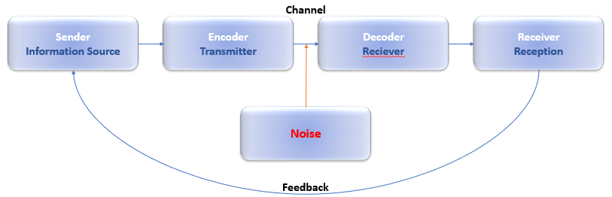
(UWTSD Student team, 2021)

Example: Doctor of Economics is a guest lecturer at the university, has an impeccable biography, many years of experience in elite universities and outstanding research. He stands in front of the audience, starts a lecture, but his accent is extremely strong, and the audience manages to distinguish only a few words from his speech and the message of the lecturer remains misunderstood by his students.
Sender is the guest-lecturer, encoder is the voice of the lecturer, channel is air, noise is the strong accent, receivers are the students, decoder is their brains, feedback: The lecturer might have a great knowledge, but instead of using a translator and to make sure that his message will reach the students and will be understood, they decided to speak English, ignoring their string accent. At the end lecturer lost their time, students understood nothing and the message was not well delivered to them (Schannon and Weaver, 1948).

Second model of communication: Schramm

The main line followed by Wilbur Schramm in his research is for the media. All his publications are related to communication, media and journalism (Schramm, 1954). Communication has developed several models for explaining and analyzing interpersonal communication. In them, he establishes the concept of "field of experience" (Schramm, 1954), explaining that the greater the shared experience of the sender and the recipient, the better the communication will be. The tube model focuses on the development of the communication process from a media perspective. The model proposed by the author is explained in what he calls the "Schramm tube" (Schramm, 1954). In summary, he finds that the process begins when the issuer collects specific facts that have occurred. He then has to decode, interpret and finally codify them again in the form of news so that the last message is spread to a potential audience.

Fig. 2. Schramm model of communication
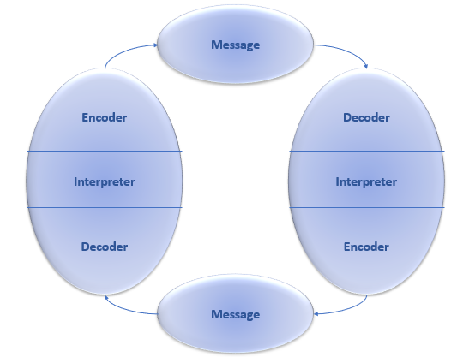
(UWTSD Student team, 2021)

Example: When two colleagues talk to each other in the office. One asks if he can help with something, then the second answers what he is doing at the moment and what type of help he needs. So the first one says what he can help and what he can't. The second sets a deadline.
When the first asks if he can help, he is the sender and encoder of the message sent to the interlocutor, who is the decoder and recipient. However, when he answers what the need is and what the deadline is, then the second acts as the sender and encoder of the message, and the first colleague is the decoder and receiver. Thus, at the same time, a continuous two-way communication connection is obtained, which is based on the communication method of Schramm.

Third model of communication: Berlo

Berlo's model very well reflects the characteristics of the communication process. It provides detailed information on the main factors influencing and relevant to the participants in the communication act (Berlo, 1960). In addition to some important personal qualities of the participants, the socio-cultural environment in which they develop is also taken into account. The most important elements of the message, according to Berlo (1960), are code, content and processing. In the process of communication, the communicator must also select a channel for transmitting the message. The communication channels that Berlo (1960) points to coincide with the five senses - hearing, sight, touch, smell and taste. In this way, it includes both types of communication - verbal and non-verbal, which should act in concert and provide the most accurate idea of the content and accuracy of the message (Berlo, 1960).

Fig. 3. Berlo model of communication
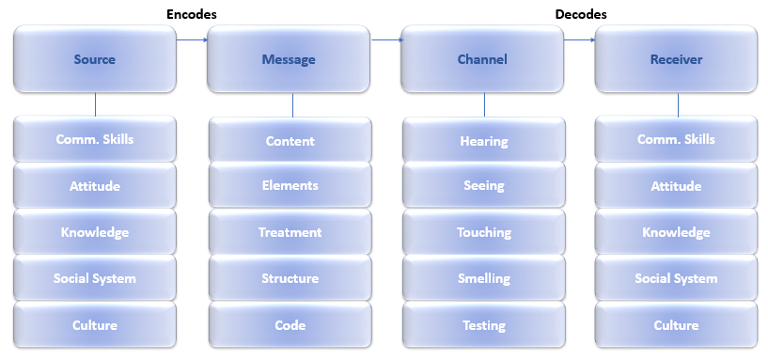
(UWTSD Student team, 2021)

Example: An employee writes a report for his manager, presenting the information seen from his point of view. Thus, the manager can receive data other than real, for example, if the employee writing the report is in a good mood, the data may be far more positive than reality, or vice versa.

Communication Skills

Verbal communication skills – spoken and written

Communication takes place by various means. Distribute verbal and nonverbal communication. Verbal communication (sign) is done with the help of words. Human speech belongs to the verbal means of communication. Communication experts have estimated that modern man speaks about 30,000 words a day, or more than 3,000 words an hour (Mehrabian, 2021). Depending on the intentions of the communicators (to communicate something, to learn, to express an assessment, attitude, to provoke something, to agree, etc.), different speech texts appear (Mehrabian, 2021). Each text (written or oral) applies the language system.
Speech activity is understood as a situation where a person uses language to communicate with other people. There are several types of speech activity:
- speaking - using language to communicate something.
- listening - perception of the content of sounding speech.
- writing - fixing the content of speech on paper.
- reading - the perception of information written on paper.
From the point of view of the form of existence of the language, communication is divided into oral and written, and from the point of view of the number of participants - into interpersonal and mass (Mehrabian, 2021).
Example: Every day in their daily lives, people communicate verbally - both orally and in writing. For example, at home with your family, at work with colleagues, clients and partners, at university or abroad. One of the most common examples from practice is when we share with our partner how our day went or tell a movie he watched on TV.

Non-verbal communication skills – body language

Non-verbal communication takes place through body language. This concept includes distance between people, touch and posture. Much attention is paid to facial expressions and gestures. It is important to pay attention to the fact that this form of communication is less understood. Most people are not able to take complete control of their own body. That is why the movements of the eyes and lips can show the interlocutor the truth of the speaker's words (Hofert et al., 2015).
For the psychology of activity and behavior, non-verbal means of communication are of particular importance. In non-verbal communication, the means of transmitting information are non-verbal signs (postures, gestures, facial expressions, intonation, views, spatial location, etc.). The main non-verbal means of communication include:
- gesture;
- facial expressions;
- pantomime.
Gestures are various movements of the hands and head. Sign language is the most ancient way to achieve mutual understanding. In different historical epochs and different peoples have had their own generally accepted ways of gesturing.
Facial expressions are movements of the facial muscles, the main indicator of feelings. The main characteristic of facial expressions is its integrity and dynamism. This means that in the facial expressions of the six main emotional states (anger, joy, fear, sadness, surprise, disgust), all the movements of the facial muscles are coordinated (Hofert et al., 2015).
Pantomime is gait, posture, posture, general motor skills of the whole body. Gait is a style of human movement (Hofert et al., 2015). Its components are: rhythm, step dynamics, amplitude of body transfer during movement, body weight.
Example: When one person is at a distance from another, but wants to call him to him, just by throwing his hand at him, the other unequivocally understands the message and what is asked of him (Hofert et al., 2015).

Active listening

Active listening is the most important skill for communication and building professional relationships. With its help we can increase productivity, increase trust and reduce errors (Rogers, 2015). Active listening is a skill that can be lost in today's world, which is distracted by digitalization and overloaded with information. That is why successful people strive to improve this important life skill.
Do active listening
Active listening can make us influential, because through it we can look at the person against us and try to understand him, build trust and empathy before we start giving decisions and recommendations.
Maintain eye contact
In conversation, if you look away from the speaker, he feels insignificant, but also remains with a negative impression, which will be difficult to overcome.
Build a connection
At the beginning of each conversation, it takes time to find something in common and build a connection with the other. For some people, 5 minutes of active listening is enough to understand their interlocutor and build a connection with him.
Mirroring
This is the repetition or paraphrasing of what is heard is a guarantee that the listening is careful and accurate, allowing the interlocutor to correct any misunderstandings.
Asking questions
The smartest person is the one who asks good questions and listens to their answers carefully. The one who knows how to listen is a desirable interlocutor. By listening actively, we make connections with each other (Rogers, 2015).
Example: In a lecture on finance, the student is given a task specifying a question to solve the problem. In this way he shows the teacher that he has been careful, has understood the subject and is interested in additional information.

Conclusion

After the study, it can be concluded that the three main examples of communication models such as those of Shannon - Weaver, Schramm or Berlo support successful communication between people in the work or personal environment. The goal is to eliminate the different types of noise so that the recipient of the message can understand it in the way he wants it to be reproduced by his sender and there is no distortion in the channel.
Communication should be effective verbally or non-verbally and listening should be active to ensure the success of proper communication.
Creating an effective work environment that is focused and effective requires the active participation of your employees. This process takes time and open communication from any part of the company to work.
When an environment is created that gives people the freedom to speak openly and honestly without fear of negative consequences, a company is built that has the advantage of having different points of view and not being limited to one way of thinking and working.
The ability to speak freely will allow employees to identify and highlight problems before they turn into crises, as well as to discover and take advantage of the opportunities that open up before the company.

References

- Banwart, M. (2020). Communication Studies: Effective Communication Leads to Effective Leadership. New Directions for Student Leadership, 2020(165), pp.87–97.
- Berlo, D.K. (1960). The process of communication : an introduction to theory and practice. New York, N.Y., Etc.: Holt, Rinehart And Winston.
- Harris, R. (2018). Editorial: Communication about communication. Language & Communication, 1(1), pp.1–2.
- Hofert, S., Burke, M., Balighian, E. and Serwint, J. (2015). Improving Provider-Patient Communication: A Verbal and Non-Verbal Communication Skills Curriculum. MedEdPORTAL Publications.
- Mehrabian, A. (2021). Attitudes inferred from non-immediacy of verbal communications. Journal of Verbal Learning and Verbal Behavior, 6(2), pp.294–295.
- Rogers, C.R. (2015). Active Listening..
- Schannon, C. and Weaver, W. (1948). Mathematische Grundlagen der Informationstheorie. München: R. Oldenbourg Verlag.
- Schramm, W. (1954). Schramm model of communication. Westport Greenwood P.

